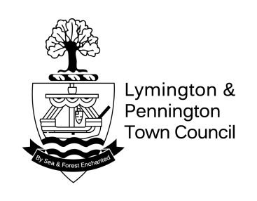
Across street positions for Christmas lights using eyebolt & current power supply for
Christmas Lights for 2020

No on Plan | Catenary Attached (via eyebolt to) | Existing Power Supply | Catenary attached (via eyebolt) to Opposite End | Estimated Watts  Total
1 | Lymington Fish And Chip Bar (front right) | High Street - Street Lamp No.2 | Mines a Pasty (side right) | 65.96
2 | Stanwell House (side left) | High Street - Street Lamp No.3 | Fells Gulliver (front left) | 59.25
3 | Phase 8 (front left) | High Street- Street Lamp No. 4 | Stanwell House (Right front) | 68.67
4 | Barclays Bank/Buttery (side left) | High Street - Street Lamp No. 5 | Esprit (front left) | 69.25
5 | White Stuff (front right) | High Street - Street Lamp No. 6 | Holland & Barrett (side right) | 76.783
6 | The Perfumery (front left) | High Street -Street Lamp No. 7 | Waterstones (front left) | 77.21
7 | HSBC Bank (front) | High Street -Street Lamp No. 8 | Boots Opticians (front) | 71
8 | NatWest Bank (front) | High Street -Street Lamp No. 9 | Burkmars Estate Agents (right side) – No longer allowed to use their building for light attachment. Going to ask Truffles next door who have an approved eyebolt | 74.69
9 | Costa Coffee (on bay window) | High Street -Street Lamp No. 10 | Clarks Shoes (right side) | 74.49
10 | Elliotts clothes shop (side right) | High Street -Street Lamp No. 11 | EE (side right) | 79.54
11 | Moore Blatch (right front) | High Street -Street Lamp No. 13 | TSB Bank (front) | 112.52
12 | British Red Cross (Side left | High Street -Street Lamp No. 14 | Shaw Trust (front) | 100.49
13 | Peacocks (front) | High Street -Street Lamp No. 15 | Lee Johnson Hairdressers (front right) | 68.667
14 | John D Wood (side left) | High Street -Street Lamp No. 16 | Oxfam (side right) | 71.78
15 | Lymington House (front) | High Street -Street Lamp No. 16 | John D. Wood (front right) | 70.22
16 | Post Office (side right) | High Street -Street Lamp No. 17 | Pizza Express (front) | 84.05
17 | Prezzo (side left) | High Street -Street Lamp No. 19 | Abram-Collyers (front) | 71.00
18 | St Thomas Church (side) | High Street -Street Lamp No. 20 | Willow (front) | 62.08
19 | Monmouth House (front) | St. Thomas Street -Street Lamp No.2 | Six Bells Pub (front left) | 76.82
20 | M&S Simply Food (front) | St Thomas Street – No connection currently available | Oakhaven Children’s Shop (side left) | 53.9
21 | Eric Robertson (side left) | St. Thomas Street – No connection currently available | Oakhaven Craft (side left) | 51.6
22 | FW House & Son (Side left) | St. Thomas Street - Street Lamp No. 5 | Lymington Lighting Centre (side right) | 53.15
23 | Well Natural (front) | St. Thomas Street- Street Lamp No. 6 | Domino’s Pizza (side right) | 53.54
24 | Barry Papworth (side left | St. Thomas Street - Street Lamp No. 6 | Hasson Hicks Opticians (side left) | 56.26
25 | Raynsford Furniture (Side right) | St. Thomas Street - Street Lamp No. 7 | Doctor & Natural (side left) | 76.24
 | TOTAL |  |  | 1779

