Lymington High Street Christmas Lighting Location Plan of existing cross street locations of strings
High Street 1
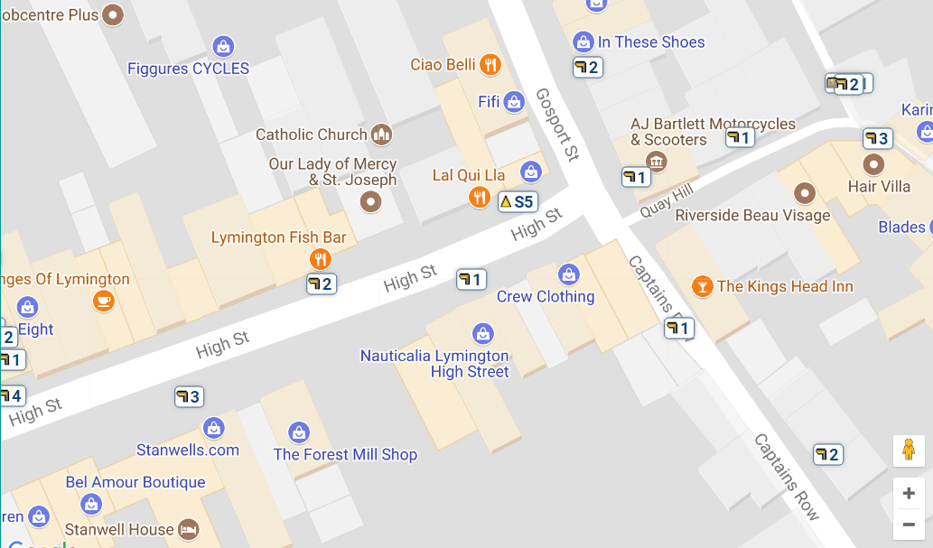
2.
1.
High Street 2
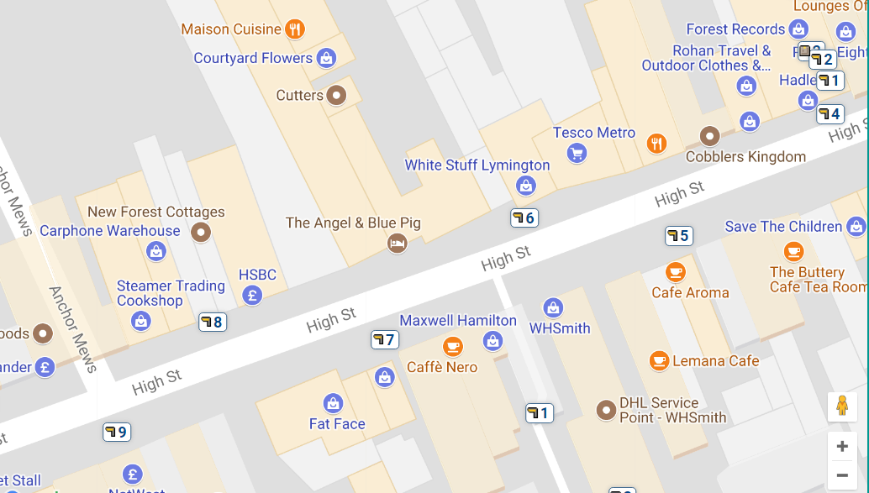
8.
3.
4.
7.
6.
5.
High Street 3
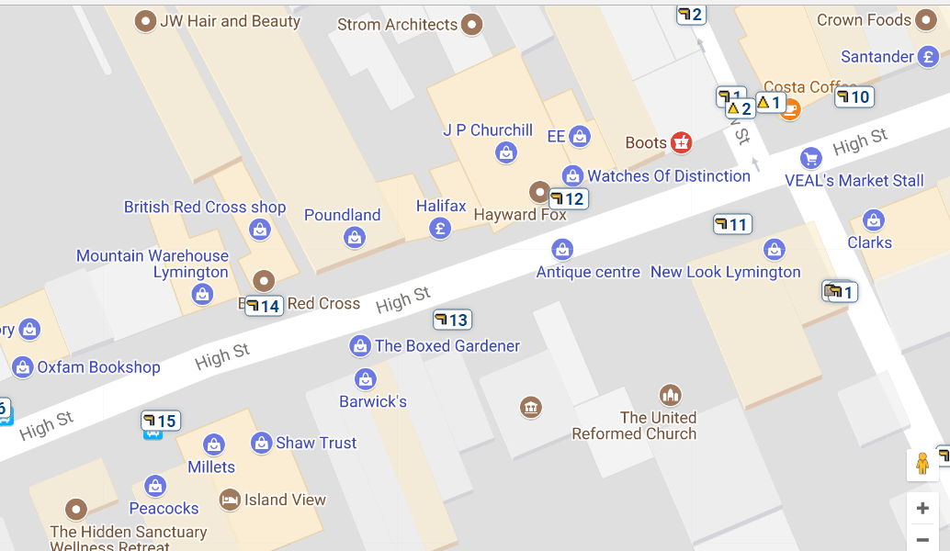
13.
12.
11.
10.
9.
High Street 4/St Thomas Street 1
15.
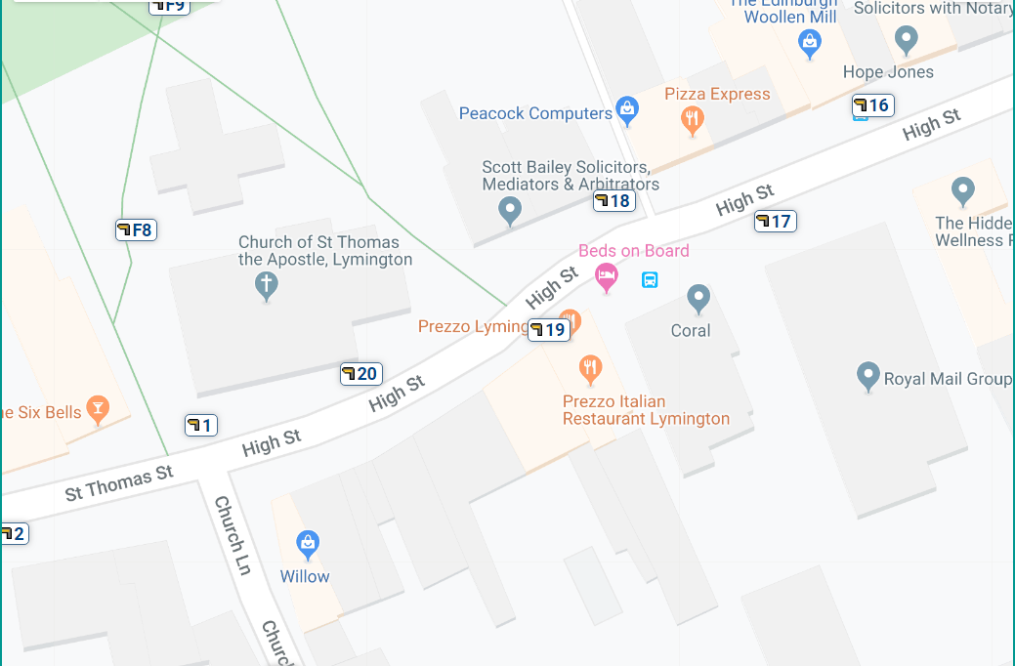
19.
18.
17.
16.
14.
St Thomas Street 2
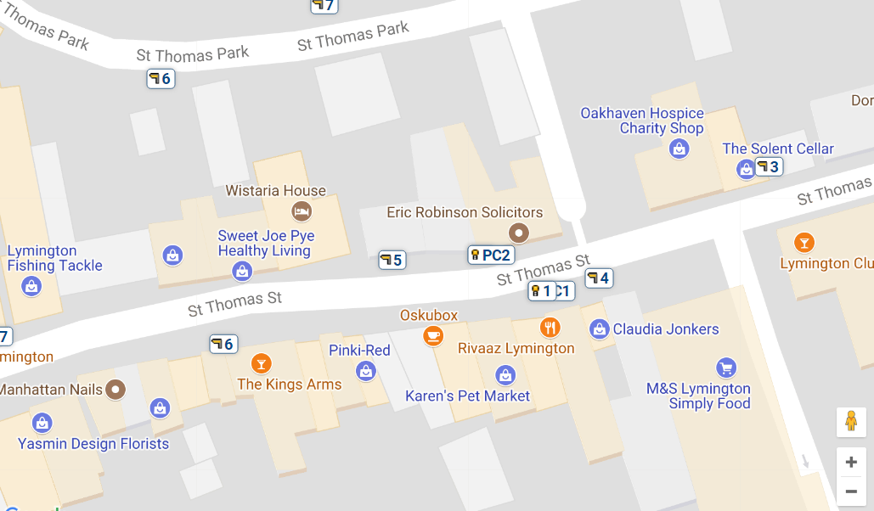
25.
24.
23.
22.
21.
20.

