**WWF-UK Request for Information & Quotation**

**Reward & Recognition – 2022 – 2024 Programme**

**Background – WWF-UK Strategy**

The environmental impact of human activity on both nature and climate now threatens the survival of all life on our planet. Since 1970, we have seen a calamitous decline in vertebrate wildlife population sizes of, on average, 68%. Over the next decade, we face a triple challenge; to meet the needs of a growing human population against a backdrop of a dramatically changing climate and a biodiversity crisis across land and sea.

Underpinned by science, WWF-UK’s strategic vision is that by 2030 nature’s vital signs are improving – we will have halted the loss of nature. We are working to avoid the sixth mass extinction of life on our planet. If we are to ‘bend the curve’ on nature loss, we need to inspire people and institutions to tackle the greatest threats to nature and the future of our planet.

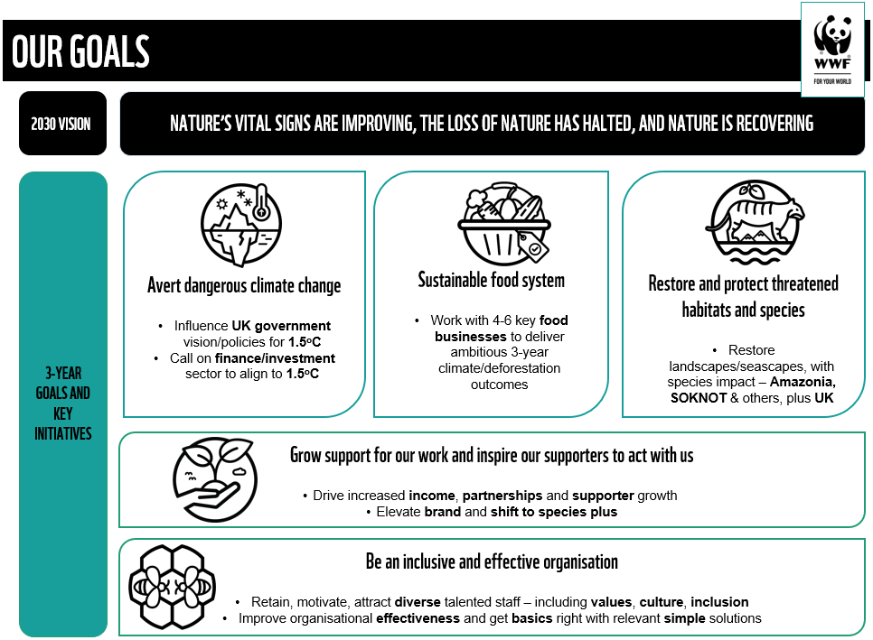This is a Fight for Our World, and we will focus on the following Strategic Goals:

**Background – Reward & Recognition**

To deliver on our vision, mission, and strategic goals, it is important that the organisation has a clear and appropriate total reward and recognition vision, strategy, and policy, with the essential underpin of clear and transparent processes, so that we can attract, recruit, develop, retain, and motivate a talented and diverse workforce.

WWF’s core values – across our whole global network - are centred on Courage, Collaboration, Integrity and Respect and WWF-UK is starting to develop leadership standards and a behavioural framework - ‘values in action’ - that will underpin its working environment and working practices and create an enabling culture.

The organisation commenced a review of pay and reward in 2018 and certain changes were made, especially around job evaluation1 and grading. We invested further in the reward agenda in 2021, with some insightful consultation with employees, but lack of dedicated resource combined with competing organisational priorities caused this work to stall shortly after the ‘discovery phase’ of the project.

Some good high-level planning and early thinking have now been completed, which only shows that we have a challenging reward agenda ahead and some real opportunities to build engagement and strengthen our employer value proposition.

There is now a need for a real ‘stand back’ on total reward. WWF-UK wishes to create a vision and strategy for reward so that:

- The organisation can attract, retain and motivate its diverse workforce, enabling it to compete for talent in challenging markets;

- Modernise its approach to reward and recognition; everything from pay and grading, to pensions and benefits needs to be considered in light of the new strategy and best practice;

- Total reward is fully understood and valued. The primary focus has been on ‘cash’;

- A link between pay and performance is properly considered. The whole PDR approach

needs a review and this work has started;

- There is a strong foundation that brings stability for the next 5-10 years; and

- The reward approach facilitates the cultural and people shifts that WWF has identified as key to its success (See appendix 1).

In addition, certain elements of the reward work, as identified in 2021, need to be accelerated:

- Our Remuneration Committee wishes to appoint an external adviser to work alongside our trustees and to guide and inform best practice in CEO and Executive pay;

- Our approach to the annual pay review (‘one size fits all’) is being challenged as no longer being fit for purpose;

- Our employee engagement survey results indicate that reward and career progression are major areas of concern and are impacting our levels of engagement2;

- We are reviewing the shape of our organisation – the ‘spans and layers’ – and our traditional grading structure is a potential blocker to effective working and meaningful career paths; and

- Our gender and ethnicity pay gaps are unacceptably high. Work has begun to address pay, anomalies but the cause is more complex than just pay.

There is now a need to appoint expert reward consultants to work with our People & Culture team in both and advisory *and* delivery capacity and take forward the work, using outputs from the 2021 discovery phase to ensure delivery of a programme of work that will:

• Create the long-term vision and strategic plan

• Place diversity, equity, and inclusion at the heart of the organisation’s pay, reward and

recognition principles and philosophy

1 Mercer job evaluation scheme.

2 Our total engagement score is 71% which is low in comparison with our peer group. Workload is the number 1 concern across all areas.

• Create a framework for pay, reward and recognition through refreshed policies and processes, which are:

o Are clear, fair, and transparent

o Reward performance

o Enable attraction and retention of skilled and talented employees

o Are modern and flexible, reflecting the Future of Work post Covid

o Enable achievement of our Goals

o Ensure not just ongoing pay equality but enable the closure of the gender and

ethnicity pay gaps as soon as possible, and

o Create an appreciative and recognition-based culture.

• Create a reward and recognition plan and roadmap for the next 2-3 years

• Advise and inform our board of trustees on remuneration policy, practice, and process • Coach our leadership team so they become confident in communicating a clear reward

philosophy and implementing best, inclusive practice

• Support the organisation to identify actions and solutions for the gender and ethnicity

pay gap work (root cause analysis, process improvement, communication)

• Respond to our recent employee engagement survey (June 2021 – Peakon) that

identified reward and recognition as development areas for improving engagement

• Reinforce our enabling goal – ‘Working for Your World’ - to create an inclusive, agile,

accountable, and continuously learning organisation with a shared mission.

**External Reward Partner Requirements**

An external partner must be able to demonstrate and evidence:

• Understanding of the brief and propose options for the approach. *Please outline*   
*possible time frames and requirements from us in a high-level project plan.*

• Depth and breadth of expertise in this field in the charity /not for profit / NGO and commercial / private sectors. *Please include names of recent clients for who you have delivered similar work with high impact and who could act as referees (we wouldn’t approach without permission)*

• A strong team that can provide responsive service – i.e., not key person dependent – continuous service available. *Please provide short biographies for all those who might be involved on the project*

• A strong alignment with WWF’s vision and mission with values that respect diversity, equality and inclusivity and evidence of partnership working. *Please provide a short statement on this and how you evidence your values in your work.*

• Value for money; competitive pricing for expertise. We need fees to be clear and structured in a flexible way. *Please state day / hourly rates and price per project element, ideally with capped fees.*

• Confidentiality and Data protection. *Please provide your confidentiality statement and GDPR principles.*

• Diversity, Equality, and Inclusivity (DE&I). *Please share your approach to DE&I and how you would approach the project in this respect.*

**Application Process**

Please note that WWF-UK would prefer to contract these services using our attached Standard Terms and Conditions. As part of your response, please indicate whether or not you would be content to use these terms or if you would wish to propose alternatives.

WWF-UK prefers to work with sustainable suppliers; organisations that meet their needs in

a way that achieves value for money on a whole-life basis, whilst benefitting society and minimising damage to the environment. Please complete our attached Sustainable   
Procurement Questionnaire, providing copies of any relevant certification where applicable.

**The Selection Process**

In line with our procurement process, we are inviting a small number of organisations who might be able to partner with us.

A panel comprising the Executive Director of People & Culture and members of the People & Culture team, will consider the responses and decide based on the following criteria, with approximate weightings shown:

• **25%: The organisation’s proposed approach, content, and style of delivery** • **25%: Depth and breadth of expertise as evidenced by recent client work**

• **25%: Values, partnership, inclusivity – alignment with WWF**

• **25%: Price – value for money**

**Timelines and Next Steps**

This RFIQ has been issued on 17 March 2022 and we will take questions/requests for clarification until 24 March 2022. We request that all responses are returned to us by 31 March 2022. The selection process and timeframe are outlined in the covering email, and we will be deciding as soon as possible

Potential providers can contact Emma Cannings, Strategic Goal Lead for Working for Your World ([ECannings@wwf.org.uk](mailto:ECannings@wwf.org.uk)) or Tashfeen Islam, Head of HR Business Partnering ([TAIslam@wwf.org.uk](mailto:TAIslam@wwf.org.uk)).

Thank you for expressing an interest in working with and supporting WWF-UK with this important piece of work. We look forward to receiving your response.

Emma Cannings

Strategic Goal Lead – Working for Your World Email: [ecannings@wwf.org.uk](mailto:ecannings@wwf.org.uk)

**Appendix 1 – people and culture shifts**

