**SC1A (Edn 08/18)**

# MOD Terms and Conditions for Less Complex Requirements

# Contract Number IRM19/7373

# Repair of LAPDS SDU and GIU

## Definitions - In the Contract:

**The Authority** means the Secretary of State for Defence of the United Kingdom of Great Britain and Northern Ireland, (referred to in this document as "the Authority"), acting as part of the Crown; **Business Day** means 09:00 to 17:00 Monday to Friday, excluding public and statutory holidays;

**Contract** means the agreement concluded between the Authority and the Contractor, including all terms and conditions, associated purchase order, specifications, plans, drawings, schedules and other documentation, expressly made part of the agreement in accordance with Clause 2.c;

**Contractor** means the person, firm or company specified as such in the purchase order;

**Contractor Commercially Sensitive Information** means the information listed as such in the purchase order, which is information notified by the Contractor to the Authority, which is acknowledged by the Authority as being commercially sensitive; **Contractor Deliverables** means the goods and / or services including packaging (and supplied in accordance with any QA requirements if specified) which the Contractor is required to provide under the Contract in accordance with the schedule to the purchase order;

**Effective Date of Contract** means the date stated on the purchase order or, if there is no such date stated, the date upon which both Parties have signed the purchase order;

**Firm Price** means a price excluding Value Added Tax (VAT) which is not subject to variation;

**Hazardous Contractor Deliverable** means a Contractor Deliverable or a component of a Contractor Deliverable that is itself a hazardous material or substance or that may in the course of its use, maintenance, disposal, or in the event of an accident, release one or more hazardous materials or substances and each material or substance that may be so released;

**Legislation** means in relation to the United Kingdom any Act of Parliament, any subordinate legislation within the meaning of section 21 of the Interpretation Act 1978, any exercise of Royal Prerogative or any enforceable community right within the meaning of Section 2 of the European Communities Act 1972. **Notices** means all notices, orders, or other forms of communication required to be given in writing under or in connection with the Contract;

**Parties** means the Contractor and the Authority, and Party shall be construed accordingly;

**Transparency Information** means the content of this Contract in its entirety, including from time to time agreed changes to the Contract, and details of any payments made by the Authority to the Contractor under the Contract.

## General

1. The Contractor shall comply with all applicable Legislation, whether specifically referenced in this Contract or not.
2. Any variation to the Contract shall have no effect unless expressly agreed in writing and signed by both Parties.
3. If there is any inconsistency between these terms and conditions and the purchase order or the documents expressly referred to therein, the conflict shall be resolved according to the following descending order of priority:
   1. the terms and conditions;
   2. the purchase order; and
   3. the documents expressly referred to in the purchase order.
4. Neither Party shall be entitled to assign the Contract (or any part thereof) without the prior written consent of the other Party.
5. Failure or delay by either Party in enforcing or partially enforcing any provision of the Contract shall not be construed as a waiver of its rights under the Contract.
6. The Parties to the Contract do not intend that any term of the Contract shall be enforceable by virtue of the Contracts (Rights of Third Parties) Act 1999 by any person that is not a Party to it.
7. The Contract and any non-contractual obligations arising out of or in connection with it shall be governed by and construed in accordance with English Law, and subject to Clause 15 and without prejudice to the dispute resolution procedure set out

therein, the Parties submit to the exclusive jurisdiction of the English courts. Other jurisdictions may apply solely for the purpose of giving effect to this Clause 2.g and for enforcement of any judgement, order or award given under English jurisdiction.

## Application of Conditions

1. The purchase order, these terms and conditions and the specification govern the Contract to the entire exclusion of all other terms and conditions. No other terms or conditions are implied.
2. The Contract constitutes the entire agreement and understanding and supersedes any previous agreement between the Parties relating to the subject matter of the Contract.

## Disclosure of Information

Disclosure of information under the Contract shall be managed in accordance with DEFCON 531 (SC1).

## Transparency

1. Subject to Clause 5.b, but notwithstanding Clause 4, the Contractor understands that the Authority may publish the Transparency Information to the general public. The Contractor shall assist and cooperate with the Authority to enable the Authority to publish the Transparency Information.
2. Before publishing the Transparency Information to the general public in accordance with Clause 5.a, the Authority shall redact any information that would be exempt from disclosure if it was the subject of a request for information under the Freedom of Information Act 2000 or the Environmental Information Regulations 2004, including the Contractor Commercially Sensitive Information.
3. The Authority may consult with the Contractor before redacting any information from the Transparency Information in accordance with Clause 5.b. The Contractor acknowledges and accepts that its representations on redactions during consultation may not be determinative and that the decision whether to redact information is a matter in which the Authority shall exercise its own discretion, subject always to the provisions of the Freedom of Information Act 2000 or the Environmental Information Regulations 2004.
4. For the avoidance of doubt, nothing in this Clause 5 shall affect the Contractor’s rights at law.

## Notices

1. A Notice served under the Contract shall be:
   1. in writing in the English Language;
   2. authenticated by signature or such other method as may be agreed between the Parties;
   3. sent for the attention of the other Party’s representative, and to the address set out in the purchase order;
   4. marked with the number of the Contract; and
   5. delivered by hand, prepaid post (or airmail), facsimile transmission or, if agreed in the purchase order, by electronic mail.
2. Notices shall be deemed to have been received:
   1. if delivered by hand, on the day of delivery if it is a Business Day in the place of receipt, and otherwise on the first Business Day in the place of receipt following the day of delivery;
   2. if sent by prepaid post, on the fourth Business Day (or the tenth Business Day in the case of airmail) after the day of posting;
   3. if sent by facsimile or electronic means:
      1. if transmitted between 09:00 and 17:00 hours on a Business Day (recipient’s time) on completion of receipt by the sender of verification of the transmission from the receiving instrument; or
      2. if transmitted at any other time, at 09:00 on the first Business Day (recipient’s time) following the completion of receipt by the sender of verification of transmission from the receiving instrument.

## Intellectual Property

1. The Contractor shall as its sole liability keep the Authority fully indemnified against an infringement or alleged infringement of any intellectual property rights or a claim for Crown use of a UK patent or registered design caused by the use, manufacture or supply of the Contractor Deliverables.
2. The Authority shall promptly notify the Contractor of any infringement claim made against it relating to any Contractor Deliverable and, subject to any statutory obligation requiring the Authority to respond, shall permit the Contractor to have the right, at its sole discretion to assume, defend, settle or otherwise dispose of such claim. The Authority shall give the Contractor such assistance as it may reasonably require to dispose of the claim and will not make any statement which might be prejudicial to the settlement or defence of the claim

## Supply of Contractor Deliverables and Quality Assurance

1. This Contract comes into effect on the Effective Date of Contract.
2. The Contractor shall supply the Contractor Deliverables to the Authority at the Firm Price stated in the Schedule to the purchase order.
3. The Contractor shall ensure that the Contractor Deliverables:
   1. correspond with the specification;
   2. are of satisfactory quality (within the meaning of the Sale of Goods Act 1979, as amended) except that fitness for purpose shall be limited to the goods being fit for the particular purpose held out expressly by or made known expressly to the Contractor and in this respect the Authority relies on the Contractor’s skill and judgement; and
   3. comply with any applicable Quality Assurance Requirements specified in the purchase order.
4. The Contractor shall apply for and obtain any licences required to import any material required for the performance of the Contract in the UK. The Authority shall provide to the Contractor reasonable assistance with regard to any relevant defence or security matter arising in the application for any such licence.

## Supply of Hazardous Contractor Deliverables

1. The Contractor shall establish if the Contractor Deliverables are, or contain, Dangerous Goods as defined in the Regulations set out in this Clause 9. Any that do shall be packaged for UK or worldwide shipment by all modes of transport in accordance with the following unless otherwise specified in the Schedule to the purchase order:
   1. the Technical Instructions for the Safe Transport of Dangerous Goods by Air (ICAO), IATA Dangerous Goods Regulations;
   2. the International Maritime Dangerous Goods (IMDG) Code;
   3. the Regulations Concerning the International Carriage of Dangerous Goods by Rail (RID); and
   4. the European Agreement Concerning the International Carriage of Dangerous Goods by Road (ADR).
2. Certification markings, incorporating the UN logo, the package code and other prescribed information indicating that the package corresponds to the successfully designed type shall be marked on the packaging in accordance with the relevant regulation.
3. As soon as possible and in any event within the period specified in the purchase order (or if no such period is specified no later than one month prior to the delivery date), the Contractor shall provide to the Authority’s representatives in the manner and format prescribed in the purchase order:
   1. confirmation as to whether or not to the best of its knowledge any of the Contractor Deliverables are Hazardous Contractor Deliverables; and
   2. for each Hazardous Contractor Deliverable, a Safety Data Sheet containing the data set out at Clause 9.d, which shall be updated by the Contractor during the period of the Contract if it becomes aware of any new relevant data.
4. Safety Data Sheets if required under Clause 9.c shall be provided in accordance with the REACH Regulations (EC) No 1907/2006 and any additional information required by the Health and Safety at Work etc. Act 1974 and shall contain:
   1. Information required by the Chemicals (Hazardous Information and Packaging for Supply) (CHIP) Regulations 2009 and / or the Classification, Labelling and Packaging (CLP) Regulation 1272/2008 (whichever is applicable) or any replacement thereof; and
   2. where the Hazardous Contractor Deliverable is, contains or embodies a radioactive substance as defined in the Ionising Radiation Regulations SI 1999/3232, details of the activity, substance and form (including any isotope); and
   3. where the Hazardous Contractor Deliverable has magnetic properties, details of the magnetic flux density at a defined distance, for the condition in which it is packed.
5. The Contractor shall retain its own copies of the Safety Data Sheets provided to the Authority in accordance with Clause 9.d for 4 years after the end of the Contract and shall make them available to the Authority’s representatives on request.
6. Nothing in this Clause 9 reduces or limits any statutory or legal obligation of the Authority or the Contractor.

## Delivery / Collection

1. The purchase order shall specify whether the Contractor Deliverables are to be delivered to the consignee by the Contractor or collected from the consignor by the Authority.
2. Title and risk in the Contractor Deliverables shall pass from the Contractor to the Authority on delivery or on collection in accordance with Clause 10.a.
3. The Authority shall be deemed to have accepted the Contractor Deliverables thirty (30) days after title and risk has passed to the Authority unless it has rejected the Contractor Deliverables within the same period.

## 11. Marking of Contractor Deliverables

1. Each Contractor Deliverable shall be marked in accordance with the requirements specified in the purchase order or if no such requirement is specified, the Contractor shall mark each Contractor Deliverable clearly and indelibly in accordance with the requirements of the relevant DEF-STAN 05-132 as specified in the contract or specification. In the absence of such requirements, the Contractor Deliverables shall be marked with the MOD stock reference, NATO Stock Number (NSN) or alternative reference number shown in the Contract.
2. Any marking method used shall not have a detrimental effect on the strength, serviceability or corrosion resistance of the Contractor Deliverables.
3. The marking shall include any serial numbers allocated to the Contractor Deliverable.
4. Where because of its size or nature it is not possible to mark a Contractor Deliverable with the required particulars, the required information should be included on the package or carton in which the Contractor Deliverable is packed, in accordance with condition 12 (Packaging and Labelling (excluding Contractor Deliverables containing Ammunition or Explosives)).
5. **Packaging and Labelling of Contractor Deliverables (Excluding Contractor Deliverables Containing Ammunition or Explosives)**

The Contractor shall pack or have packed the Contractor Deliverables in accordance with any requirements specified in the purchase order and Def Stan 81-041 (Part 1 and Part 6).

## Progress Monitoring, Meetings and Reports

The Contractor shall attend progress meetings and deliver reports at the frequency or times (if any) specified in the purchase order and shall ensure that its Contractor’s representatives are suitably qualified to attend such meetings.

## Payment

1. The Contractor shall raise a commercial invoice per purchase order, except in the event that part delivery has been expressly permitted by the Authority when a commercial invoice shall be raised per delivery.
2. Each Commercial Invoice shall be in the name of Babcock DSG Limited (acting as agent for the Authority) and must include;

(i) Contractor’s name and contact details and registered number and registered address.

(ii) VAT Registration number

(iii) Date & Tax point date

(iv) Invoice Number

(v) Purchase Order Number

(vi) Description of the Goods and/or Services; and

(vii) Net and Gross VAT values

(viii) All supporting documentation required under these conditions and as reasonably requested by the Authority

And submit via email to: [I&RM-accountspayable@babcockinternational.com](mailto:I&RM-accountspayable@babcockinternational.com). The Authority in entitled to reject invoices which do not conform to these requirements.

c. The Authority (acting through its agent, Babcock DSG Limited) shall pay all valid and undisputed claims for payment submitted by the Contractor in accordance with clause 36.b on or before the day which is thirty (30) days after the later of;

(i) the day upon which a valid request for payment is received by the Authority; and

(ii) the date of completion of the part of the Contract to which the request for approval of payment relates.

1. The approval for payment of a valid and undisputed invoice by the Authority shall not be construed as acceptance by the Authority of the performance of the Contractor’s obligations nor as a waiver of its rights and remedies under this Contract.
2. Without prejudice to any other right or remedy, the Authority reserves the right to set off any amount owing at any time from the Contractor to the Authority against any amount payable by the Authority to the Contractor under the Contract or under any other contract with the Authority, or with any other Government Department.

## Dispute Resolution

1. The Parties will attempt in good faith to resolve any dispute or claim arising out of or relating to the Contract through negotiations between the respective representatives of the Parties having authority to settle the matter, which attempts may include the use of any alternative dispute resolution procedure on which the Parties may agree.
2. In the event that the dispute or claim is not resolved pursuant to Clause 15.a the dispute shall be referred to arbitration and shall be governed by the Arbitration Act 1996. For the purposes of the arbitration, the arbitrator shall have the power to make provisional awards pursuant to Section 39 of the Arbitration Act 1996.

## Termination for Corrupt Gifts

The Authority may terminate the Contract with immediate effect, without compensation, by giving written notice to the Contractor at any time after any of the following events:

1. where the Authority becomes aware that the Contractor, its employees, agents or any sub-contractor (or anyone acting on its behalf or any of its or their employees):
   1. has offered, promised or given to any Crown servant any gift or financial or other advantage of any kind as an inducement or reward;
   2. commits or has committed any prohibited act or any offence under the Bribery Act 2010 with or without the knowledge or authority of the Contractor in relation to this Contract or any other contract with the Crown;
   3. has entered into this or any other contract with the Crown in connection with which commission has been paid or has been agreed to be paid by it or on its behalf, or to its knowledge, unless before the contract is made particulars of any such commission and of the terms and conditions of any such agreement for the payment thereof have been disclosed in writing to the Authority.
2. In exercising its rights or remedies to terminate the Contract under Clause 16.a. the Authority shall:
   1. act in a reasonable and proportionate manner having regard to such matters as the gravity of, and the identity of the person committing the prohibited act;
   2. give due consideration, where appropriate, to action other than termination of the Contract, including (without being limited to):
      1. requiring the Contractor to procure the termination of a subcontract where the prohibited act is that of a Subcontractor or anyone acting on its or their behalf;
      2. requiring the Contractor to procure the dismissal of an employee (whether its own or that of a Subcontractor or anyone acting on its behalf) where the prohibited act is that of such employee.
3. Where the Contract has been terminated under Clause 16.a.the Authority shall be entitled to purchase substitute Contractor Deliverables from elsewhere and recover from the Contractor any costs and expenses incurred by the Authority in obtaining the Contractor Deliverables in substitution from another supplier.

## Material Breach

In addition to any other rights and remedies, the Authority shall have the right to terminate the Contract (in whole or in part) with immediate effect by giving written notice to the Contractor where the Contractor is in material breach of its obligations under the Contract. Where the Authority has terminated the Contract under Clause 17 the Authority shall have the right to claim such damages as may have been sustained as a result of the Contractor’s material breach of the Contract.

## Insolvency

The Authority shall have the right to terminate the contract if the Contractor is declared bankrupt or goes into liquidation or administration. This is without prejudice to any other rights or remedies under this Contract.

## Limitation of Contractor’s Liability

1. Subject to Clause 19.b the Contractor's liability to the Authority in connection with this Contract shall be limited to £5m (five million pounds).
2. Nothing in this Contract shall operate to limit or exclude the Contractor's liability:
   1. for:
      1. any liquidated damages (to the extent expressly provided for under this Contract);
      2. any amount(s) which the Authority is entitled to claim, retain or withhold in relation to the Contractor’s failure to perform or under-perform its obligations under this Contract, including service credits or other deductions (to the extent expressly provided for under this Contract);
      3. any interest payable in relation to the late payment of any sum due and payable by the Contractor to the Authority under this Contract;
      4. any amount payable by the Contractor to the Authority in relation to TUPE or pensions to the extent expressly provided for under this Contract;
   2. under Condition 7 of the Contract (Intellectual Property), and DEFCONs 91 or 638 (SC1) where specified in the contract;
   3. for death or personal injury caused by the Contractor’s negligence or the negligence of any of its personnel, agents, consultants or sub-contractors;
   4. for fraud, fraudulent misrepresentation, wilful misconduct or negligence;
   5. in relation to the termination of this Contract on the basis of abandonment by the Contractor;
   6. for breach of the terms implied by Section 2 of the Supply of Goods and Services Act 1982; or
   7. for any other liability which cannot be limited or excluded under general (including statute and common) law.
3. The rights of the Authority under this Contract are in addition to, and not exclusive of, any rights or remedies provided by general (including statute and common) law.

## The project specific DEFCONs and DEFCON SC variants that apply to this Contract are:

DEFCON 531 (SC1) Edn 06/17 -- Disclosure of Information

DEFCON 117 (SC1) Edn 12/16 –

Supply of Documentation for NATO Codification Purposes

DEFCON 502 (SC1) Edn 11/16 – Specification Changes

DEFCON 503 (SC1) Edn 12/16 –

Formal Amendments to Contract

DEFCON 532B (SC1) Edn 05/18 – Protection of Personal Data

DEFCON 534 Edn 06/17 – Subcontracting and Prompt Payment

DEFCON 538 Edn 06/02 -- Severability

DEFCON 566 Edn 12/18 – Change of control of Contractor

DEFCON 601 (SC) Edn 03/15 – Redundant Material

DEFCON602B (SC1) Edn 12/06 – Quality Assurance (without a Deliverable Quality Plan)

DEFCON 606 (SC1) Edn 12/16 –

Change and configuration Control Procedure

DEFCON 608 Edn 10/14 –

Access and Facilities to be provided by the Contractor

DEFCON 609 (SC1) Edn 08/18 – Contractor’s Records

DEFCON 611 (SC1) Edn 08/18 – Issued Property

DEFCON 620 (SC1) Edn 12/16 –

Contract Change Control Procedure

DEFCON 624 (SC1) Edn 12/16 – Use of Asbestos

DEFCON 627 (SC1) Edn 12/16 –

Requirement for a Certificate of Conformity

DEFCON 630 (SC1) Edn 12/16 – Framework Agreements

DEFCON 637 Edn 05/17 – Defect investigation and Liability

DEFCON 646 Edn 10/98 –

Law and Jurisdiction (Foreign suppliers)

DEFCON 656A Edn 08/16 – Termination for Convenience

DEFCON 658 (SC1) Edn 11/17 – Cyber *

DEFCON 691 (SC1) Edn 02/17 –

Timber and Wood-Derived Products

DEFCON 694 (SC1) Edn 08/18 –

Accounting for property of the Authority

* Further to the Cyber Security Condition, the Cyber Risk Profile of the Contract is very low, as defined in DEFSTAN 05-138

**The special conditions that apply to this Contract are:**

1. **Scope of Contract**

The Contract shall be for the Repair of a fixed quantity of Lighting and Power Distribution Systems (LAPDS) as detailed in the Schedule of Requirement contained within the Contract Purchase Order. The full requirement is detailed at Schedule of Requirement (SOR) to the Contract and will be conducted, as required, and in accordance with the specifications detailed with the Statement of Work – at Annex A to the Schedule of Requirement.

1. **Quality**

a. All items listed in Table 1 to the Statement of Work (Annex A to the SOR) are to be repaired in accordance with the latest OEM specification and drawings using reclaimed and new components, incorporating all approved modifications where applicable.

b. The scope of the repairs to be carried out shall be determined from the survey against OEM specification. Assets received by the Contractor shall first be surveyed / Inward Inspected to determine the extent of repairs e.g. No Fault Found (NFF), pricing quoted as per Strip Survey Report or BER. The cause of any failure should be recorded at this stage.

c. When the Contractor considers an Article to be Beyond Repair or Beyond Economical Repair (BER) the Contractor shall immediately advise the Repair Manager of their findings, an Application for BER Form as per the process detailed at Clause 32, a sample of which is at Schedule 6. If agreed, the Repair Manager shall issue AF G1043 which shall detail disposal instructions.

d. Any discrepancies in the items delivered should be reported using MoD Form 445 (Discrepancy Report) – Schedule 5. These reports shall be completed in accordance with the criteria laid down in JSP 886, Volume 4, Chapter 3 and distributed as required by the Contract with one copy to the Material Accounting Cell, Donnington and one to the Babcock DSG Repair Manager.

Other Quality Assurance Requirements:

AQAP 2131 Version 1 NATO Quality Assurance Requirements for Final Inspection and Test – CoC Shall be provided in accordance with Condition 26

AQAP 2070 Edition B, Version 3

AQAP 2009 Edition 3

ISO 9001:2015 – Certification is mandatory

Def Stan 00-056 – Safety Management Requirements for Defence Systems

Def Stan 05-057 Configuration Management of Defence Material

Def Stan 05-061 – Quality Assurance Procedural Requirements – Part 1 – Concessions, Part 4 – Contractor Working Parties and Part 9 – Quality Assurance Procedural Requirements – Independent Inspection Requirements for Safety Critical Items

Def Stan 81-041 – Packaging of Defence Material

Part 4 – Service Packaging and Marking Instruction and Part 6 – Package Marking

Def Stan 05-99 – Managing Government Furnished Equipment

Def Stan 05-135 Avoidance of Counterfeit Materiel

Def Stan 05-138 – Cyber Security for Defence Suppliers *

* Further to the Cyber Security Condition, the Cyber Risk Profile of the Contract is very low, as defined in DEFSTAN 05-138

1. **Responsibility of the Contractor**

a. The Contractor shall be entirely responsible for undertaking the work under the Contract as defined in the Contract Schedule of Requirements.

b. The Contractor shall be responsible for achieving proper completion of the Contract in accordance with its terms and shall be responsible for;

(1) Planning, programming and progressing of the work, within its control, to the satisfaction of the Authority. This includes sub-contracts and appropriate documentation.

(2) Financial Management of the work, including financial control and monitoring of any sub-contracts;

(3) Providing the Authority with the information, on a continuing basis, so as to reasonably assure that work is proceeding to time, cost and performance.

c. If the Contractor fails to complete any part of the work, or supply any of the Articles, as required by this Contract, or to meet any of the acceptance criteria at Clause 10.c, and such failure is not caused by undue delays by the Authority, it shall be the responsibility of the Contractor to rectify that failure to the reasonable satisfaction of the Authority at no additional cost.

d. The Authority reserves the right to refuse payment for alterations or changes made outside of the scope of the Contract which have not been made in accordance with DEFCON 503, or the provisions of DEFCON 606 – Contract Change Process).

e. The Authority will not be bound to accept or pay for any Articles other than those authorised in accordance with the Contract. If the Contractor considers that any requirements made by the Authority are NOT in accordance with the terms of the Contract, they shall seek the agreement of the Authority’s Representative as to the extent of the application of the requirements to that particular order. (See Condition 25 for definition of the Authority’s Representative).

f. The Contractor shall provide an address, and email and telephone Point of Contact with the Contract Acceptance. Unless otherwise notified this shall become the Point of Contact for any resultant Contract.

g. The Contractor shall be responsible for notifying the Authority of any change to the Point of Contact details.

h. The Contractor is entirely responsible for the security of all MOD property in his possession for the purpose of the Contract.

1. **Open Book Accounting**

a. The Authority reserves the right to verify the prices paid by the Contractor for spare parts claimed under this Contract. To enable this, the Contractor shall make the facility available to check prices actually paid to third parties, for the purposes of this Contract, at all reasonable times and subject to prior notice and at no cost to the Authority,

1. **Authority Representatives**

a. Any reference to the Authority in respect of:

(1) the giving of consent;

(2) the delivering of any Notices; or

(3) the doing of any other thing that may reasonably be undertaken by an individual acting on behalf of the Authority, shall be deemed to be references to the Authority's Representatives in accordance with this condition 25.

b. The Authority’s Representatives detailed within the Purchase Order DEFFORM 111 (or their nominated deputy) shall have full authority to act on behalf of the Authority for all purposes of the Contract. Unless notified in writing before such act or instruction, the Contractor shall be entitled to treat any act of the Authority’s Representatives which is authorised by the Contract as being expressly authorised by the Authority and the Contractor shall not be required to determine whether authority has in fact been given.

c. In the event of any change to the identity of the Authority’s Representatives, the Authority shall provide written confirmation to the Contractor, and shall update the DEFFORM 111 in accordance with DEFCON 503.

1. **Key Performance Indicators**

a. The Contractor’s performance of the Contract shall be monitored and measured using the agreed Key Performance indicators (KPIs) (below)

|  |  |  |
| --- | --- | --- |
| KPI Area | Target | Comments |
| Delivery Performance | 95% repairs within 90 calendar days  100% repairs within 120 calendar days | **Any exception to the quoted hours to be agreed with Repair Manager via Strip Survey Report.** |
| Contract Amendments | The Contractor shall complete and return the DEFFORM 10B to the Procurement Branch within 10 Business Days. | As required |
| Obsolescence Issues | Obsolescence issues shall be advised to the Authority within 48 hours (2 working days) of identification | As Required |
| Progress Reports – Repair | 100% of Contract Status Report submissions to the Authority within 5 working days of receipt each month – as specified in Schedule 3 – Contract Data Sheet. To be completed using the Babcock generated Contract Status report detailed at Schedule 8 | Within 5 working days of receipt. |
| Strip Survey Reports | Strip survey reports to be submitted to Repair manager for approval within 10 working days of receipt of the item for repair by Contractor. | **Any exception to the quoted turnaround time for Strip Survey reports to be agreed with Repair Manager.** |
| Notification Of The Discontinuation Of Products | Shall advise the Authority at the earliest opportunity (within 3 working days) of any possible difficulty maintaining future supplies of Articles or the intention to cease production completely of Articles | As required |
| Turnaround Time | Shall report by exception reasons for failure of agree turn round time and advise what actions have been put in place to prevent re-occurrence | As required |
| Quality Registration | Advise immediately of any changes to Quality Registration/ISO Accreditation, or scope of the activity of either. | Repair Manager/ Supplier Quality Manager as required |
| Non-Conformances (Third Party Audit) | Advise immediately if any major non-conformances as a result of a Third Party Audit | Repair Manager/ Supplier Quality Manager as required |
| Certificate of Conformity | Shall be provided to the Repair Manager within 10 business days of request | As required. |
| Warranty Repairs | 100% of repaired Articles shall not require rectification under warranty within 12 months of repair | As required |
| Minutes of meetings | The Contractor will provide 100% minutes of meetings within 5 business days of the Local Equipment/Commercial Review Meetings to the authority | At quarterly intervals commencing 3 months form contract start |
| Management Of Non Conforming Deliveries | Rectify the problem on site or arrange for the Articles to be collected and rectified at the Contractor premises within 5 working days. | As required |

1. **Warranty**

a. The Contractor shall provide a warranty, which should be no less than 12 (twelve) months on any Repair work and from the date of fitting to the vehicle and/or equipment.

b. If, within 12 (twelve) months of the repair date, upon which a repaired Contractor Deliverable is deployed into service, it fails, develops any defect or is otherwise found to be unsatisfactory other than as a result of an act or omission of the Authority under this Contract, the cost of rectification, including all transport costs shall be borne by the Contractor.

c. Under no circumstances shall the Contractor or any Sub-Contractor’s proceed with repair or any other action which would invalidate the current warranty of the equipment. If any such equipment is received which the Contractor recognises as being under warranty, the Contractor should inform the Authority immediately.

1. **Turnaround Time**

a. All repairs shall be conducted, within the timetable, as agreed with the Repair Manager (detailed at Box 2 of the most recently issued DEFFORM 111. The Timetable shall be agreed following the submission of a Strip Survey Report (Schedule 5). Turnaround Time is a figure in business days, and is the time from when a Contractor Deliverable and a Purchase Order (Schedule 3) is received at the Contractor’s premises to when the Contractor Deliverables are packaged and Team Leidos has confirmed a delivery slot, or Schedule 6 has been returned to the Repair/Technical Manager.

b. If the Contractor is unable to undertake the required task within the agreed turnaround times, the Contractor must notify the Authority within one week of receipt of the Contractor Deliverable with detailed reasons why they are unable to meet the turnaround time. The Authority shall have absolute discretion to extend the turnaround time.

c. If the Authority agrees to extend the turnaround time, they shall notify the Contractor of the varied turnaround time by updating Schedule 7 – Contract Status Report as soon as possible. Any variation shall be no longer than 25% of the original turnaround time.

d. The Contractor shall monitor performance of each repair against the turnaround time and shall provide a Contract Status Report (as per example at Schedule 7). This information is to be detailed on a monthly basis in accordance with, and in the format detailed at Schedule 8 of the Contract. The Report shall be sent to the DSG.GRPBabcockRepairOrderbook@babcockinternational.com AND the Repair Manager (as identified at Box 2 of the most recently issued DEFFORM 111).

1. **Novation**

a. The Authority and Babcock DSG Limited (Company Number 09329025) (Babcock) entered into a Land Equipment Service Provision and Transformation Contract dated 31 March 2015 (the SPC) in respect of which certain services transfer, on a phased basis, from the Authority to Babcock.

b. The Contractor acknowledges and agrees that the Authority (in its sole discretion) may transfer its rights and obligations under this Contract to Babcock as part of the transfer of services under the SPC.

c. Following the receipt of a written notice by the Authority to the Contractor, the Contractor shall enter into the novation agreement set out at Schedule 8, (the Novation Agreement).

e. Notwithstanding Clause a above, the Contractor further agrees at the request of the Authority to enter into any further agreement or document and take any formal steps which are necessary or desirable at the time to give effect to these provisions and/or the Novation Agreement.

f. The Contractor shall disclose to Babcock such Confidential Information as may be required for the operation of the Contract. Where third-party consent is required before such Confidential Information can be disclosed, the Contractor shall use all reasonable endeavours to obtain such consent.

**The processes that apply to this Contract are:**

1. **Authority for Work**

a. A Purchase Order will be sent to the Company at the same time as Contractor Deliverables are fed in for repair/remanufacture. The Authority shall not be liable, in any way, for work undertaken by the Contractor without receipt of this Purchase Order (a sample of which is at Schedule 3) each of which shall bear a unique order number and Job No. e.g. PR/19****** (DIIN).

b. The Purchase order will be electronically sent to XXXXXXX

c. To ensure that Purchase orders are sent to the correct location a single mailbox location where all orders can be sent from Babcock DSG Ltd has been provided, as detailed at 29.b.

d. Following receipt of the Purchase Order and Contractor Deliverables for repair/remanufacture the Contractor is to compile a detailed Survey Report (a sample of which is at Schedule 5) of the Contractor Deliverables to establish their overall condition. Where standard repair/remanufacture prices fall within the agreed firm pricing, the Contractor is to proceed with the repairs.

e. Where the standard repair/remanufacture prices have not been agreed within the Contract or if the repair/remanufacture will deviate from the standard price, the Contractor is required to submit the Survey Report to the Repair Manager fully identifying the requirement for all work relating to the equipment including costs within 30 business days (unless otherwise agreed) of receipt of the Contractor’s Deliverable.

f. No rebuild work is to be undertaken by the Contractor until the Survey Report and the associated costs have been sanctioned by the Repair Manager as ‘fair and reasonable’ and Authority is given to proceed.

1. **Deficiencies and Damages in Articles Issued for Repair**

a. The equipment issued for repair is to be checked on receipt for damage and correct nomenclature. Where there appears to be transit damage or deficiencies e.g. major components missing, or incorrect equipment, the Contractor shall, in the first instance, contact the Repair Manager who will decide on an appropriate course of action.

b. Following confirmation from the Repair Manager on the appropriate course of the action, the Contractor is to complete MOD Form 445 (Discrepancy Report - Schedule 4) which should then be sent to:

(1) One Copy to MAC Branch Donnington - DESLCSLS-LogMACTeam@mod.gov.uk

(2) One Copy to the Babcock DSG Repair Manager

1. **Contractor Deliverables Considered Beyond Economical Repair**

a. When the Contractor considers the Contractor Deliverables to be Beyond Economical Repair (BER) he shall immediately advise the Repair Manager (as identified in box 2 of DEFFORM 111) of his findings on an Application for Disposal of BER Form DSD-OP-FO-84, a sample of which is at Schedule 6.

b. BER is defined as when the repair cost exceeds 80% of the replacement cost of the Contractor Deliverable. If approved, the Repair Manager shall issue an Army Form G1043 (AF G1043) which shall detail the disposal instructions.

c. All Contractor Deliverables subject to BER investigation shall be placed in quarantine by the Contractor and retained as such until further instructions are given by the Repair Manager. The Authority reserves the right to inspect/audit BER stock holdings at the Contractors premises at any time throughout the duration of the Contract.

d. No work shall be carried out on any Contractor Deliverable which, after superficial examination, is considered to be BER.

e. Where the Repair Manager considers that a Contractor Deliverable is BER, the Contractor may be instructed to dismantle the Contractor Deliverable if serviceable or repairable parts can be recovered and such action is economical. Details of any parts recovered are to be brought on charge in the Contractor’s Embodiment Loan account where repairable parts are to be segregated and accounted for separately.

f. Serviceable and repairable parts recovered shall be used as far as possible in the repair of other Contractor Deliverables issued under the Contract, subject to the prior approval of the Procurement Branch to a fair and reasonable price being agreed for the Contractor’s purchase of such parts.

g. In the event that a Contractor Deliverable is considered BER and the Babcock DSG Repair Manager’s decision is to proceed with repair, the Contractor shall be paid a ‘fair and reasonable’ price agreed, with the Repair Manager, for all work properly undertaken.

1. **Disposal of Redundant Parts, Materials etc**

a. All parts, materials etc. arising from the Contractor Deliverables issued to the Contractor for repair, whether serviceable or not, shall remain the property of the Authority, and any such parts, materials etc., not used in the repair of the Contractor Deliverables shall be disposed of as follows:

(1) Serviceable and economically repairable parts shall be dealt with in accordance with the instructions of the Authority.

(2) All unserviceable parts, materials etc. certified by the Repair Manager as workshop salvage shall be disposed of by the Contractor on the Authority’s behalf on fair and reasonable terms. Where required by the Repair Manager, such parts, materials etc. shall be dismantled and disposed of under his supervision so as to preclude the possibility of re-sale in their existing form.

(3) Unless other arrangements have been agreed with the Authority, a list of the unserviceable parts, materials etc. disposed of under sub-clause 2. above countersigned by the Repair Manager, shall be furnished to the Procurement Branch together with a statement of the proceeds.

b. If there are no arising’s of unserviceable parts, materials etc., the Contractor shall, on the conclusion of the Contract furnish a certificate to that effect, countersigned by the Repair Manager, to the Procurement Branch.

1. **Non-conforming Deliveries**

a. It is policy for Leidos and sub-contractor Kuehne and Nagel – the Authority’s Contractors for Logistics and Commodities Services (LCS) – to quarantine and reject any Contractor Deliverables that do not conform to the requirements of the contract.

b. Should any Contractor Deliverables be deemed as non-conforming by Leidos, the Authority will notify the Contractor as to the reason(s) for non-conformance within 5 working days of notification. In accordance with Clause 34, it will be the responsibility of the Contractor, within 5 working days of notification, to either rectify the problem on site at Leidos or arrange for the Contractor Deliverables to be collected and rectified at the Contractor's premises and returned to Leidos within 10 working days of collection at no cost to the Authority. The list attached details the reasons upon which a consignment may be rejected.

c. It is advised however that in certain circumstances the Authority may consider it impractical for the Contractor to undertake any rectification due to geographical location, nature of the non-conformance and/or urgency of need, in these situations the Authority may request LCS to undertake the rectification action but will pass on any associated costs to the Contractor as necessary.

d. Reasons for Non-Conformance include:

(1) Incorrect DMC/NSN

(2) Incorrect Description

(3) Part/Batch No’s Incorrect

(4) Incorrect PPQ

(5) Incorrect D of Q

(6) Packaging Level incorrect

(7) No Bar Code Labelling

(8) Insufficient/No Test Certificates

(9) Damaged in Transit

(10) Incorrectly Labelled

11) Incorrect Matcon

(12) No Logo (ISPM 15) Fail

(13) Mixed NSN

(14) Non-Codified Item

(15) No Engineering Record Card

(16) No Labelling

(17) No Paperwork

(18) No weight Label

(19) In adequate Shelf Life

(20) No hazard Data Sheet

(21) Incorrect Quantity – Surplus

(22) No Certificate of Conformity

e. The level of non-conforming deliveries shall be measured in accordance with the Key Performance Indicators detailed at clause 26 and any failure to meet the required level of performance shall be subject to the remedies contained therein.

1. **Contract Status Report**

Within the first 2 working days of each month a Contract Status Report will be generated and issued to the contractor (as per the example at Schedule 7).

The contractor shall update the report in accordance with the instructions in the accompanying email and as follows:

i. Updated Repair price (each);

a. Where standard repair/remanufacture prices have been agreed within the Contract, the contractor shall insert the firm price specific to the PR reference;

b. Where the standard repair/remanufacture prices have not been agreed within the Contract the contractor shall insert the strip and survey value approved by the Repair Manager for that PR reference;

ii. Confirmed delivery date – to be completed in the format DD/MM/YYYY;

iii. Supplier comments – if applicable;

iv. Accrual costs – to be entered as £ and not as a percentage;

No other changes or deletions are to be made.

The completed report is to be returned within 5 working days of receipt to XXXXXXX and copied to the relevant Repair Manager (as identified at Box 2 of the most recently issued DEFFORM 111.

**Schedule 1 – Additional Definitions of Contract**

**Allied Quality Assurance Publications** means standards for Quality Assurance Systemsthat

**(AQAP)** have been developed by NATO for Defence products

**Army Equipment Support Publications** means technical information concerning Army

**(AESP)** Equipment for parties involved with operational use, maintenance or repair of said equipment.

**Baan** means Enterprise Resource Planning Software. A product now owned by Infor Global Solutions.

**Beyond Economic Repair (BER)** means when the cost of repairing an item would more costly than replacing it. (If it costs more than 80% of the replacement value)

**Deficiencies/Discrepancies** means a failing, defect or variation of equipment delivered or collected for the fulfilment of the Contract Requirement.

**Disposal** means method of dealing with surplus or defunct MoD equipment

**Equipment Build Standard** means the required standard for repairs/remanufacture or production of Army Equipment

**Key Performance Indicator (KPI)** means a key performance measurement to evaluate the success of a contract and the activities in which it engages.

**Local Equipment/Commercial Review** means a specific, recurring meeting held

**meeting** to discuss progress toward set objectives.

**NATO Stock Number (NSN)** means a 13 digit numeric code identified all the standardised material items of supply as recognised by all NATO Countries that has come to be used in all treaty countries.

**Nomenclature** means the body or system of terms used in a particular specialist field.

**Non Codified** means material items of supply that are not arranged into a systemised code.

**Non-Conformance** means a failure to comply to accepted standards

**Novation** means the substitution of a new contract in place of an old one.

**Purchase Order (PO)** means a buyer-generated document that authorised a purchase transaction.

**Statement of Work (SOW)** means a document that defines project-specific activities, deliverables and timelines for the contract.

**Surge** means a potential unforeseen increase in requirements (e.g. in times of war)

**Turnaround Time (TAT)** means a period of time for completing a process cycle (such as repair or replacement of a component or equipment), commonly expressed as an average of previous such periods.

**Warranty** means a written guarantee, issued to the purchaser, of an article of equipment or component of such, by its manufacturer/supplier, promising to repair or replace if it is necessary within a specified period of time

**Schedule 2 – Contract Data Sheet**

|  |
| --- |
| **General Conditions** |
| **Condition 6 – Notices:**  Notices served under the Contract shall be sent to the following address: Authority: *(as per DEFFORM 111)*  Contractor:  Notices can be sent by electronic mail?  *(tick as appropriate)* |
| **Supply of Contractor Deliverables** |
| **Condition 8 – Quality Assurance:**  Is a Deliverable Quality Plan required for this Contract?  *(tick as appropriate)*  If required, the Deliverable Quality Plan must be set out as defined in AQAP 2105 Edition C Version 1 January 2019 and delivered to the Authority (Quality) with the Contract Acceptance form. Once agreed by the Authority the Quality Plan shall be incorporated into the Contract. The Contractor shall remain at all times solely responsible for the accuracy, suitability and applicability of the Deliverable Quality Plan.  **Other Quality Assurance Requirements:**  AQAP 2131 Version 1 NATO Quality Assurance Requirements for Final Inspection and Test – CoC Shall be provided in accordance with Condition 26  AQAP 2070 Edition B, Version 3  AQAP 2009 Edition 3  ISO 9001:2015 – Certification is mandatory  Def Stan 00-056 – Safety Management Requirements for Defence Systems  Def Stan 05-057 Configuration Management of Defence Material  Def Stan 05-061 – Quality Assurance Procedural Requirements – Part 1 – Concessions, Part 4 – Contractor Working Parties and Part 9 – Quality Assurance Procedural Requirements – Independent Inspection Requirements for Safety Critical Items  Def Stan 81-041 – Packaging of Defence Material  Part 4 – Service Packaging and Marking Instruction and Part 6 – Package Marking  Def Stan 05-99 – Managing Government Furnished Equipment  Def Stan 05-135 Avoidance of Counterfeit Materiel  Def Stan 05-138 – Cyber Security for Defence Suppliers |
| **Condition 9 - Supply of Data for Hazardous Contractor Deliverables, Materials and Substances:**  A completed DEFFORM 68 (Hazardous Contractor Deliverables, Materials or Substance Statement), and if applicable, Safety Data Sheet(s) are to be provided by e-mail with attachments in Adobe PDF or MS WORD format to:   1. The Authority’s Representative (Commercial) 2. Defence Safety Authority – XXXXX |
| **Condition 11 – Marking of Contractor Deliverables:**  Special Marking requirements: Not Required |
| **Condition 13 – Progress Meetings & Reports:**  The Contractor shall be required to attend the following meetings:   1. Contract Review Meeting   The Contractor is required to submit the following Reports:  Contract Status Reports – The Contractor shall provide a monthly report on the progress of the repair work against the plan to the Babcock I&RM Repair Manager and XXXXXX within 5 workings days of receipt.  Frequency: Monthly and within 5 working days of receipt.  Content: In accordance with Schedule 7  Method of Delivery: Email  Delivery Address: As detailed at Box 2 of the most recently issued DEFFORM 111 and ~DSG.GRPBabcockRepairOrderbook@babcockinternational.com. |
| **Condition 14 – Payment**  The Contractor shall raise a commercial invoice in the name of Babcock DSG Limited and submit via Email to :  XXXXX  Or to the following postal address:  I&RM Accounts Payable Project Manager, Babcock DSG Ltd, Building B15, Donnington, Telford, Shropshire, TF2 8JT |
| **Other Addresses and Other Information** *(forms and publications addresses and official use information)* |
| See Purchase Order DEFFORM 111 |

**Schedule 3 – Purchase Order Template – Sample (For Information Only)**



**Schedule 4 – Discrepancy Report – Sample (For Information Only)**

Copies of the Discrepancy Report MOD Form 445, in pads of 100, can be obtained from the Forms and Publications address on the DEFFORM 111.

This form should be used for reporting discrepancies in consignments of goods sent to the Contractor for repair.

Triplicate copies of the form should be completed in manuscript or typescript. Copies 1 & 2 should be sent to the Consignor, with copy 3 being retained by the Contractor.

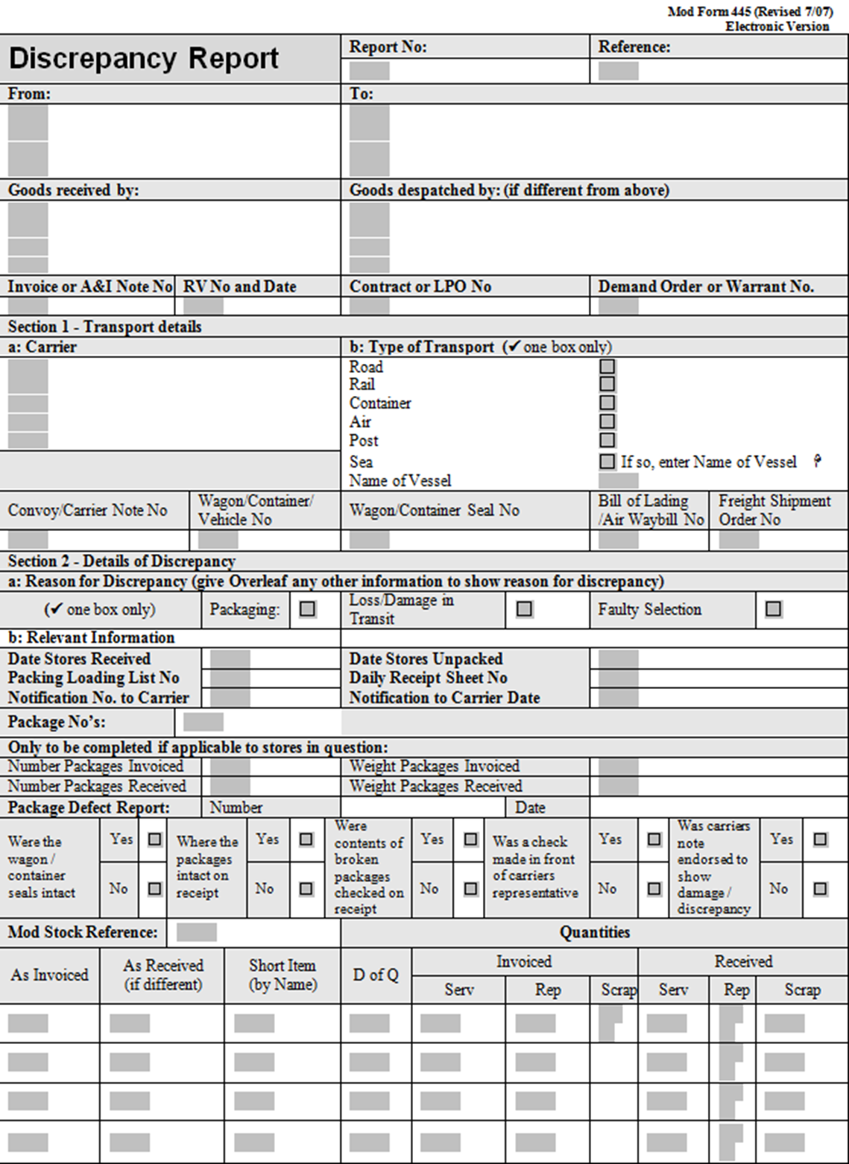

**Schedule 5 – Strip and Survey Report – Sample (For Information Only)**

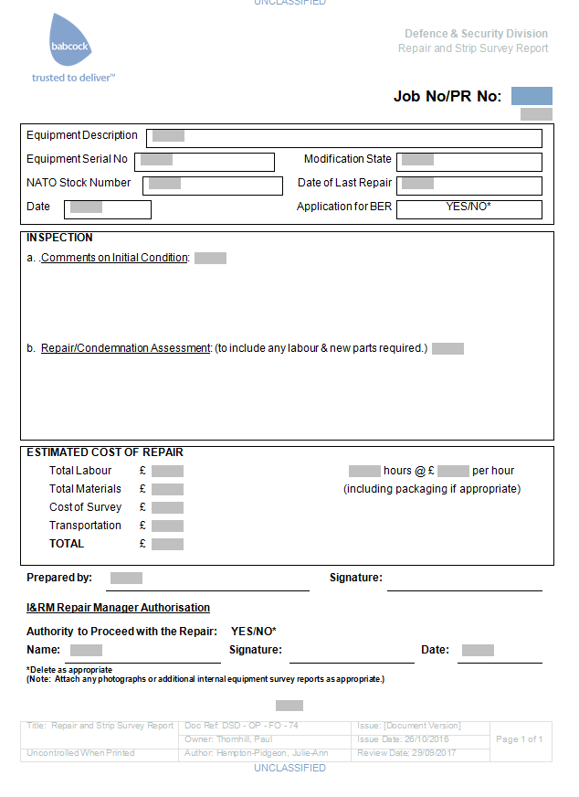

**Schedule 6 – Application to dispose of BR/BER Equipment**

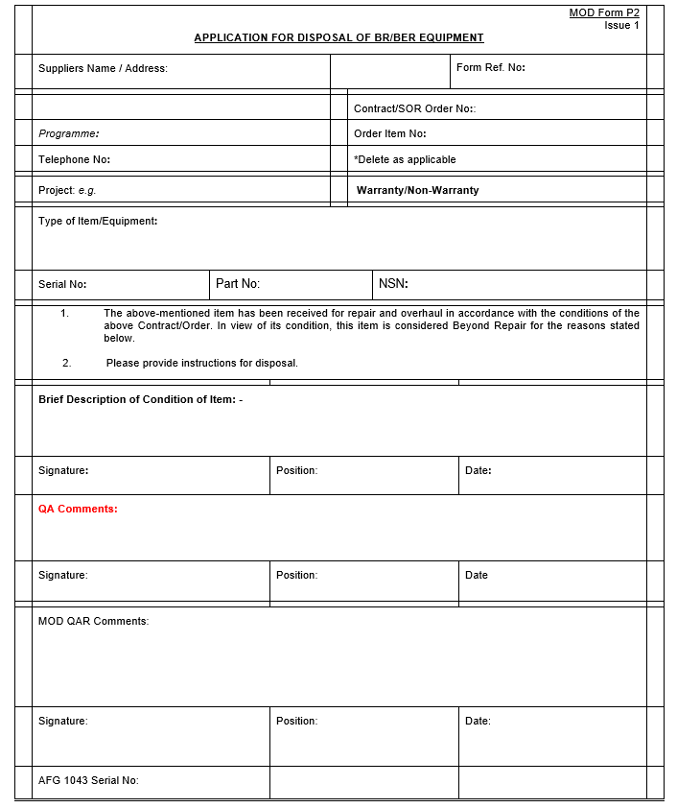

**Schedule 7: Contract Status Report**

This report is for information purposes only. A monthly report will be generated and issued to Contractors. This should always be completed in accordance with the accompanying email instruction.

|  |  |  |  |  |  |  |  |  |  |  |  |  |  |
| --- | --- | --- | --- | --- | --- | --- | --- | --- | --- | --- | --- | --- | --- |
| **Supplier Name** | **Cont. Ref** | **PR Number** | **NSN** | **Description** | **Purchase Order** | **Position Number** | **Sequence Number** | **Outstanding Quantity** | **Updated Repair Price (Each)** | **Most Likely Delivery Date Max** | **Confirmed Delivery Date (DD/MM/YYYY)** | **Supplier Comments** | **WIP** |
|  |  |  |  |  |  |  |  |  |  |  |  |  |  |
|  |  |  |  |  |  |  |  |  |  |  |  |  |  |
|  |  |  |  |  |  |  |  |  |  |  |  |  |  |
|  |  |  |  |  |  |  |  |  |  |  |  |  |  |

**Schedule 8 – Sample Agreement to Novate a Contract (For information purposes only)**

(Will only need to be signed and agreed in the event that the Contract is novated.)

**Dated**

------------

**Agreement to novate a contract**

between

**Continuing Party**

and

**[Secretary of State for Defence]**

and

**[Babcock DSG Limited]**

THIS AGREEMENT is dated [DATE]

**Parties**

[FULL COMPANY NAME] incorporated and registered in England and Wales with company number [NUMBER] whose registered office is at [REGISTERED OFFICE ADDRESS] (**Continuing Party**).

[SECRETARY OF STATE FOR DEFENCE] (**MoD**).

[BABCOCK DSG LIMITED] incorporated and registered in England and Wales with company number [NUMBER] whose registered office is at [REGISTERED OFFICE ADDRESS] (**Babcock**).

**Background**

The Continuing Party and the MoD are party to a contract for [DESCRIBE CONTRACT] dated [DATE] (the **Contract**).

The MoD and Babcock entered into a Land Equipment Service Provision and Transformation Contract dated 31 March 2015 (the **SPC**) in respect of which certain services transfer, on a phased basis, from the MoD to Babcock. The MoD wishes to transfer its rights and obligations under the Contract to Babcock as part of the transfer of services under the SPC.

The MoD shall continue to be liable for any failure by it to perform its obligations under the Contract before the Effective Date, with Babcock assuming responsibility for all other liabilities so arising in the MoD's place.

The parties have therefore agreed to novate the MoD's rights, obligations and liabilities under the Contract to Babcock on the terms of this agreement with effect from [DATE] (**Effective Date**).

**Agreed terms**

**Novation**

With effect from the Effective Date, the MoD transfers all its rights and obligations under the Contract to Babcock. Babcock shall enjoy all the rights and benefits of the MoD under the Contract, and all references to the MoD in the Contract shall be read and construed as references to Babcock.

Babcock agrees to perform the Contract and be bound by its terms in every way as if it were the original party to it in place of the MoD.

The Continuing Party agrees to perform the Contract and be bound by its terms in every way as if Babcock were the original party to it in place of the MoD.

**Release of obligations and liabilities**

The Continuing Party and the MoD release each other from all future obligations to the other under the Contract.

Nothing in this agreement shall affect or prejudice any claim or demand that the Continuing Party or the MoD may have against the other under or in connection with the Contract arising before the Effective Date.

**Governing law**

This agreement and any dispute or claim (including non-contractual disputes or claims) arising out of or in connection with it or its subject matter or formation shall be governed by and construed in accordance with the law of England and Wales.

**Jurisdiction**

Each party irrevocably agrees that the courts of England and Wales shall have exclusive jurisdiction to settle any dispute or claim (including non-contractual disputes or claims) arising out of or in connection with this agreement or its subject matter or formation.

Signed .....................................................

for and on behalf of [SECRETARY OF STATE FOR DEFENCE]

Date ........................................................

Signed ................................................................

for and on behalf of [BABCOCK DSG LIMITED]

Date ........................................................

Signed .....................................................

for and on behalf of [CONTINUING PARTY]

Date ........................................................