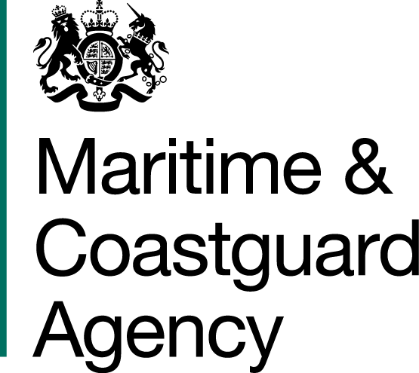

SPECIFICATION

FOR

HYDRAULIC HOSE REPLACEMENT

MCA REFERENCE

The Maritime and Coastguard Agency (MCA) is an Executive Agency of the Department for Transport. The MCA is responsible throughout the UK for implementing and developing the UK Government's maritime safety and environmental protection policy. That includes co-ordinating Search and Rescue (SAR) at sea through Her Majesty’s Coastguard 24 hours a day, and checking that ships meet UK and international safety rules. The MCA work to prevent the loss of lives at the coast and at sea, to ensure that ships are safe, and to prevent coastal pollution: Safer Lives, Safer Ships, Cleaner Seas

The MCA provide a full range of search and rescue, counter pollution, survey, inspection and enforcement activities and has 12 major business activities:

Survey | Seafarers Services
Inspection | Search & Rescue
Enforcement | Pollution Response & Salvage
Ship Registration | Stakeholder Communication
Navigation Services | Ministerial Services
Strategic Prevention Design/Development | Regulatory Process

These activities are supported by support services responsible for providing a range of administrative functions including; infrastructure, MCA people, financial management and administration and corporate management.

In accordance with the Equality Act 2010, in our capacity as a public body we have a statutory duty to eliminate unlawful discrimination, promote equality of opportunity and promote good race relations between people of different groups. Contractors will be expected to ensure that the service they provide promotes good relations between the MCA and its customers and does not directly or indirectly discriminate on the grounds of race in accordance with both the Act and the Duty.

You are invited to submit a tender for the following project:

Hydraulic Hose Replacement

General Requirement

1.1 The MCA requires the replacement of 48 off Hydraulic Hoses.

1.2 The hoses will be part the MCA’s counter pollution equipment stockpile. These are replacement hoses and the MCA will provide the existing hoses so that the quick release couplings can be removed from the existing hoses and then fitted to the new hoses.

1.3 The tenderer will need to dispose of the old hose complying with hazardous waste regulations.

1.4 The new hoses, with the existing end pieces fitted, will need to be six hoses per existing reel – however, we are prepared to consider any other storage system that is proposed by the tenderer.

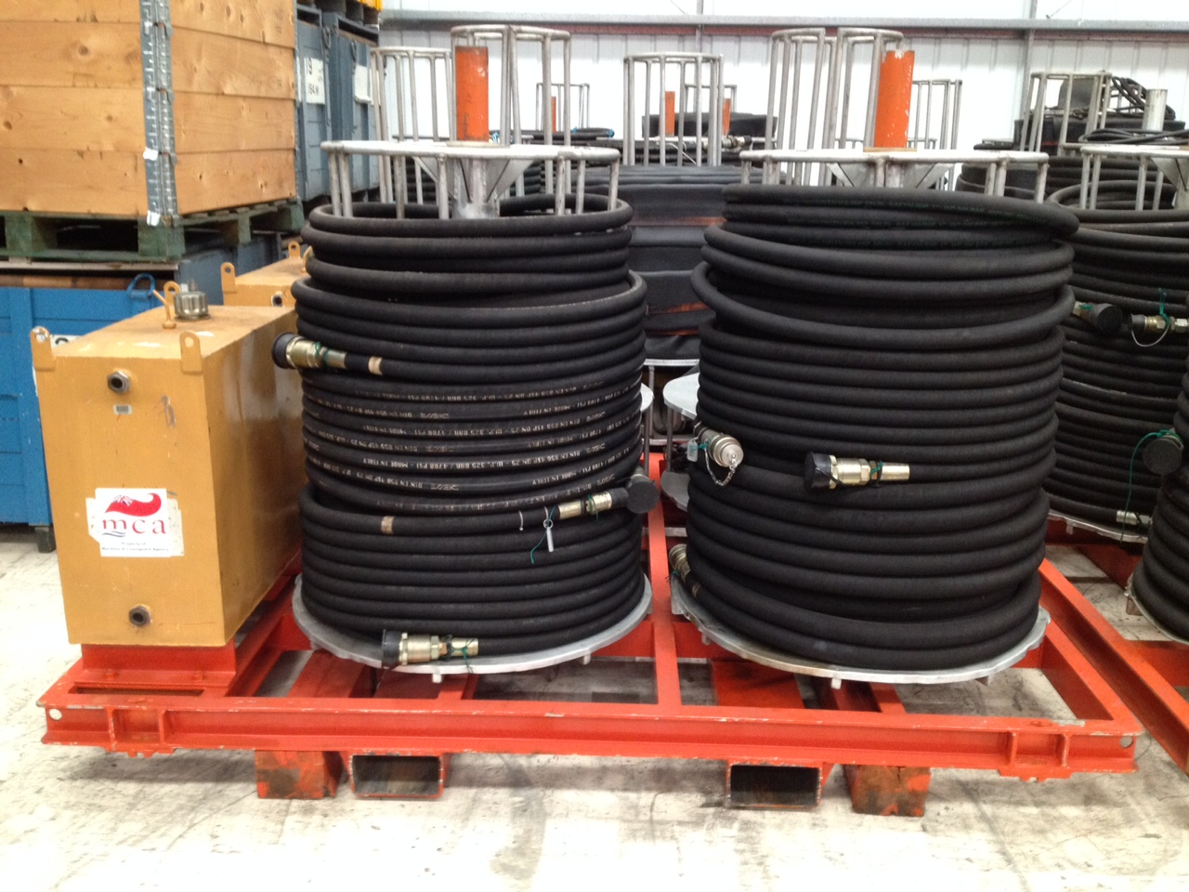

1.5 If the successful tenderer is based on mainland UK, the existing hoses with skid will be delivered to site. Should the successful tenderer not be on mainland UK, the tenderer should include a cost for pick-up of the hoses from Barnsley.

Detailed Specification

Tenderers should comply with the statements below and respond to each of the questions.

2.1 Each hose is to be 18m in length

2.2 24 off hydraulic hoses of 1 inch diameter – 4 x wire multi spiral complete with BSP taper ends and ferrules at 18 meters

2.3 24 off hydraulic hoses of 1.5 inch diameter - 1 x wire complete with BSP taper ends and ferrules at 18 metres

2.4 Operating temperature range?

2.5 Internal hose material?

2.6 External hose material?

2.7 Weight per metre?

2.8 Maximum working pressure for each diameter of hose?

2.9 Please specify ISO accreditation standard met by your proposal.

Storage

3.1 Provision of a preferred method of storage for hoses is essential. The MCA would welcome any recommendations for different storage options, with full technical details and cost given for each recommended option. The hoses will be delivered to the successful tenderer on a skid and the appropriateness of this form of storage should be commented upon in the tender documentation.

Guarantee

4.1 We regard warranties as an important component of achieving overall best value for money. Full details of your warranty on the tendered equipment is required including the period of cover. Please also explain if in-house maintenance affects your warranty terms.

Maintenance

5.1 The maintenance of this equipment will be carried out in house. For this purpose the Tenderer should provide any operating manual in a common electronic format.

5.2 The MCA also requires details of the expected life of the hose, including for any recommended storage options.

Delivery

6.1 The MCA has counter pollution equipment and stockpiles at Barnsley, Bristol and Dundee. However, the price for this tender should be for delivery costs to Barnsley.

6.2 Suppliers should state in their Tender their lead time for delivery to Barnsley. Delivery on or by the 31st March 2016 is essential.

Payment

7.1 Payment shall be made upon delivery of the goods to Barnsley in accordance with the General Conditions of Contract for the Supply of Goods and Associated Services, and subject to the receipt of a valid and correctly submitted invoice. The MCA pays undisputed invoices 30 days in arrears.

7.2 Contractors should note that the MCA has migrated its invoicing activity to the DfT Shared Service Centre (Swansea). Invoices should be provided with full supporting evidence of the goods provided to :

DfT Shared Service Centre
Arvato Bertelsmann
Sandringham Park,
Swansea Vale, Swansea, Wales SA7 0EA

Submission of Tenders

8.1 Tenders must be submitted by the deadline date stated in the Invitation to Tender letter, and in accordance with the Instructions to Tenderers. The MCA reserves the right not to consider any tender that is late or otherwise not in accordance with the Instructions to Tenderers.

8.2 Tenderers must include as part of their bids:

- The MCA’s Form of Tender, signed and dated by an authorised representative of the tendering organisation;
- Their completed Pricing Schedule; this should include separate quotes for the hoses, recommended storage options and delivery costs
- A separate system specification for each proposed storage option
- Details of the guarantee on the tendered equipment;
- Lead time for delivery of the system to Barnsley.

Sustainability

9.1 The MCA is committed to sustainable procurement. This means making the necessary decisions to protect our environment and to operate its procurement activity in an economically, socially and environmentally responsible way. Tenderers should indicate ways in which their organisation promotes and practices sustainable development and how this can impact on this contract.

9.2 Consideration should be taken to account for the following areas;

- Origin and recycled/recyclable content of materials

    - Tenderers should detail the quantities used and recycled content of the product.
    - Recyclability of product once it has reached its end of life.

- Transport mode selected for freight

- Tenderers should detail options to identify and promote measures to reduce emissions during transport of goods. Including rail freight or low emission/fuel efficient heavy goods vehicles

9.3 More information on the environmental consideration can be found at:
https://www.gov.uk/government/policies/making-sustainable-development-a-part-of-all-government-policy-and-operations
https://www.gov.uk/government/collections/sustainable-procurement-the-government-buying-standards-gbs

Selection Process

Evaluation Criteria

Quality Score represents 60% of Total Scores Weightings

Fully meets the Specification and detailed requirements 60%
Quality of product 30%
Delivery timescales, 5%
Sustainability 5%

Quality Points
0 – Inadequate response
1 – Major weaknesses in the response
3 – Minor weaknesses in the response or detail missing
5 – Satisfactory response that fully meets the requirement and includes all relevant supporting evidence

Each Bidder’s Quality Score
Quality Score = _____________________________ x Weightings
Highest Quality Score Possible for the Criterion

Price:
Price Score represents 40% of Total Scores Weightings
Overall hose cost 70%
Hose Disposal cost 20%
Delivery cost 10%

Lowest Bid Cost
Cost Score = _______________________ x Weightings
Each Bidder’s Cost

TOTAL SCORE = Total Quality Score + Total Cost Score

THE MCA INTENDS TO AWARD THE CONTRACT TO THE HIGHEST SCORING TENDERER

