**CTP CONTRACT NOTICE: OUTLINE ITN EVALUATION GUIDE**

1. **Evaluation Overview.** A detailed Statement of Requirement (SOR) together with a full Evaluation Guide will be issued to companies Invited To Negotiate (ITN). This will include scoring of Technical Questions based on Key User Requirements as detailed in the SOR under each of the categories shown in Table 1. Bidders should note that the draft category weights shown are indicative at this stage pending formal confirmation through the Authority’s Governance process.

| ***Category*** | ***Draft Weight*** |
| --- | --- |
| ***Contract Management*** | ***3%*** |
| ***Management of Service*** | ***10.1%*** |
| ***Transition Planning*** | ***10.1%*** |
| ***Analysis and Planning*** | ***8.3%*** |
| ***Accreditation, Skills & Knowledge Acquisition*** | ***11.5%*** |
| ***Outcomes for Service Leavers: Employment, Education or Retirement*** | ***14.3%*** |
| ***Support for ESL & ESP Cohort*** | ***5.1%*** |
| ***Specialist Support Programme*** | ***6.4%*** |
| ***Delivering Digital Solutions*** | **11.5%** |
| ***Social Value*** | **16.7%** |
| ***Performance Measures and Management Reporting*** | **3%** |
| **Total** | **100%** |

**Table 1: CTP Relet Technical Categories and Draft Category Weighting.**

2. The Authority will judge bids using a weighted value for money index such that a combined score will be generated by combining the separate scores for technical criteria and price. Key points to note at this stage are:

1. **Technical Score**. At each stage of the Negotiation phase, bids will be judged on the basis that 60% of the overall score will be based on technical questions contained within the SOR and KUR, grouped according to the categories shown at Table 1.
2. **Cost Score**. At each stage of the Negotiation phase, the CTP relet will be judged on the basis that 40% of the overall score will be based on price quoted.
3. **Overall Score**. The overall score will be calculated by combining Technical and Cost Scores using the Weighted Value for Money Index formula as follows:

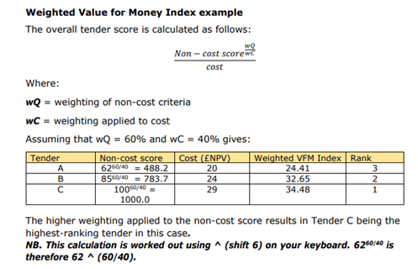

1. The Authority reserves the right to eliminate the lowest scoring bidder(s) after each round of negotiation.

3. **Technical Question Scoring**. Each technical question will be scored according to the scoring table shown at Table 2. Feedback will be provided by the Authority during the negotiation round if the Authority deems that a bid is currently unlikely to meet a given pass/fail criteria. Bidders should note that the draft CTP Relet Technical Scoring Matrix shown are indicative at this stage pending formal confirmation by the Authority. Questions will be presented as either:

PASS/FAIL Questions: Some technical questions will be judged as pass/fail in that a pass will be required for the bid to progress to the next stage and/or Final Contract Award. Any bid that fails a pass/fail question will be considered to have failed overall and therefore be judged as non-compliant, except were agreed otherwise by the Authority at its absolute discretion.

Minimum Score Questions: Each question will have a minimum score requirement which will be clearly articulated in the full Evaluation Guide (that will be issued with ITNs). Any question that fails to attain a minimum score during the negotiation phase may result in the bid being considered as non-compliant. All bids must attain at least minimum scores for all questions against their final bid submission to be awarded the final contract.

**Table 2: CTP Relet Technical Scoring Matrix**

|  |  |  |
| --- | --- | --- |
| **Score** | **Rating** | **Description** |
| 10 | Excellent | The Potential Provider has provided a response:   * that is highly comprehensive and unambiguous. * that demonstrates an effective method of meeting all elements of the requirement and demonstrably exceeds it by offering additional value to the stated requirement; and/or * where the role of the requirement in the wider contract is clearly expressed and is integrated with other requirements and there is a clear process for measuring and addressing good and poor performance. effectively. |
| 7 | Good | The Potential Provider has provided a response:   * that is comprehensive and unambiguous. * that demonstrates an effective method of meeting all elements of the requirement; and/or * where the role of the requirement in the wider contract is clearly expressed and integrated with other requirements and there is a process for measuring and addressing good and poor performance. |
| 5 | Adequate | The Potential Provider has provided a response:   * that addresses the majority of the requirement with no significant exclusions. It requires further refinement to ensure all elements are addressed fully. * where, in those areas of the response which require further refinement, there may be insufficient/limited detail or explanation of how the requirements will be met; and/or * where the role of the requirement in the wider contract is mostly expressed and integrated with other requirements. |
| 3 | Concerns | The Potential Provider has provided a response that:   * that addresses only some elements of the requirement. * that does not detail or explain, or provides limited detail or explanation, on how the Potential Provider would deliver the requirement in full and shows that the Potential Provider does not fully understand the potential impact on the contract; and/or * where the role of the requirement in the wider contract is only partially expressed and integrated with other requirements. |
| 0 | Fail | The Potential Provider:   * fails to provide a response; or * provides an inadequate or irrelevant response; or * fails to demonstrate any performance, capability or relevant experience to address the requirement stated and meet all the contractual requirements. |