

Property Panel Tender Brief

July 2016

Former Lord Mayor Treloar Hospital Site, Alton, Hampshire

Marketing of HCA land for residential development

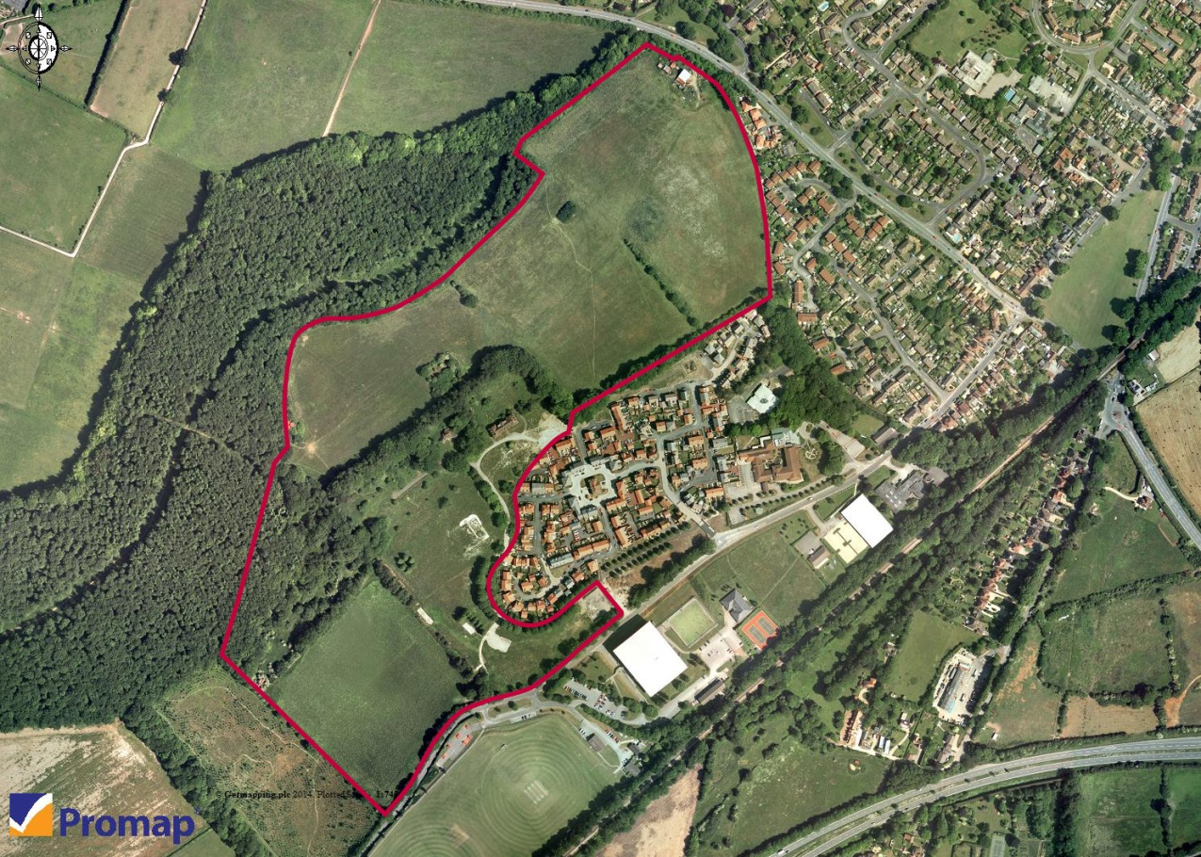

Response to invitation to participate in a mini competition

Panel Name:- Property

Project Name:- Marketing of residential land (Property Panel Appointment) – Lord Mayor Treloar, Alton

Date:- 13th July 2016

Proposal Brief

INTRODUCTION

The Homes and Communities Agency (HCA) is seeking interest from property consultants who offer expertise in the marketing and disposal of residential land, to work on its site at the former Lord Mayor Treloar site (LMT) at Alton, Hampshire (Plans at Appendix A). Interested consultants must have a detailed knowledge of the local market place along with a full understanding of the wider environment.

The project will deliver the following outputs for HCA:

- 280 new homes on HCA owned land (20% affordable)

- Public Open Space (including a country park of 10 ha)

- Significant highway improvements, including bridge widening

- Significant s.106 contribution (through appointed developers) towards a community leisure facility, primary & secondary school education

- An enhanced receipt to the HCA by sharing s.106 costs with adjoining landowners

This project forms part of a collaboration with Harvington Properties who own the adjacent Selborne Road site. The collaboration (formalised in a legal agreement) shares the costs of securing outline planning, the shared infrastructure works costs and will deliver a further 249 homes (529 new homes in total). Harvington Properties are marketing their site separately and the Selborne Road site does not form part of this commission.

Objectives of the Agency Appointment
To ensure that the development opportunity at Lord Mayor Treloar is effectively marketed to potential development partners to ensure timely delivery of housing and a receipt to the Agency by providing:
- A representative to lead on contact with potential development partners throughout the OJEU procurement process
- A resource to run the Competitive Dialogue process and bidder presentations, including timely responses to any bidder clarifications
- A resource to collate, check tender submissions and request any additional information
- A resource to evaluate financial proposals, including the Agency’s DAT Model
- A tender evaluation panel member

- Input into the Agency’s decision making report
- A source of advice on any commercial matters that may arise during the tender, pre contract, conditional contract or unconditional contract stages of the project
BACKGROUND

The Lord Mayor Treloar site in Alton comprises of 26 ha of former hospital land, acquired by the HCA as part of the Hospital Sites Programme in 2005 (see Appendix A for location). The site lies at the south western edge of Alton, situated within East Hampshire at the head of the northern River Wey valley. Alton is a historic market town with a full range of local facilities and benefits from good strategic transport links including:
- Farnham, Aldershot and Guildford lying to the north east and accessible via the A31;
- Winchester, Eastleigh and Southampton located to the south west via the A31;
- Basingstoke and the M3 motorway are situated to the north and accessed via the A339; and
- Direct train connection to London Waterloo.
In addition, the South Downs National Park, which stretches from Winchester in Hampshire to Eastbourne in East Sussex, is located just to the south of Alton and provides a wealth of recreational opportunities.
The site has been constrained from delivering housing development until now for a number of reasons, including;
  - The planning requirement to deliver extensive off-site infrastructure upgrading works, including widening of a local railway bridge owned by the charity, Mid Hants Railway (MHR).
  - The low Local Plan allocation in term of housing numbers on the Lord Mayor Treloar site which is insufficient to fund the infrastructure costs and creates the need to jointly fund the works as part of the development of the neighbouring site at Selborne Road.
  - A need to secure access rights to undertake the bridge widening works from MHR.
  - A need to secure further rights to undertake the bridge works from another eight landowners who collectively form the owners of the neighbouring development site (Selborne Road Landowners), and other third party interests. Appendix A shows the landownerships and the bridge that requires widening.

The costs associated with the off-site infrastructure works are significant. The cost of the bridge-related works is £4.6m, a new roundabout will cost £200,000, and other shared highway works amount to £225,000.
The HCA has worked with the various landowners over the last six years to develop a viable solution to resolve all the issues and the Agency has now:
  - Entered into a legally binding contract with MHR to secure the access rights (29 January 2016).
  - Entered into a legally binding contract with the remaining eight landowners to secure the remaining access rights and share the costs of the infrastructure works ( 8 April 2016).
  - Secured outline planning consent for 529 new homes (on 29 April 2016) and is now free of legal challenge.
The outline planning permission (Ref: 30021/056), includes detailed consent for associated highways works. The selected developer will be responsible for obtaining reserved matters consent for Lord Mayor Treloar, together with meeting the relevant obligations of the s106 agreement.
For full details of the planning consent please visit the Planning Portal or the East Hampshire District Council website.
Section 106 Agreement
The s.106 Agreement sets out a number of obligations to be met by the selected developer for the Lord Mayor Treloar site (and the developer of the neighbouring Selborne Road site). The s106 allows both developments to be brought forward independently, subject to the delivery of the infrastructure works. It should be noted that the legal agreements clearly apportion the s106 responsibilities and cost of the infrastructure works between the Agency’s developer and Harvington Properties.
Collaboration Agreement with Harvington Properties
This agreement outlines the cost sharing provisions for the infrastructure works. The agreement allows for either party to deliver the bridge works but Harvington Properties is close to appointing a developer and will be triggering the clause that they will deliver the bridge. The Agency’s developer will therefore need to reimburse Harvington Properties the proportionate share of the bridge costs. The agreement also provides for step-in rights to deliver the bridge works should they be needed. The selected developer will need to enter into an agreement to comply with the terms of the Collaboration Agreement.
Mid Hants Railway Agreement
This agreement outlines the cost of delivering the bridge and the necessary access rights. Whilst it is expected that Harvington Properties’ developer will deliver the bridge works under the Collaboration Agreement, the Agency’s selected developer will need to enter into an agreement to comply with its terms.
Working with Partners
The conclusion of the legal agreements and achieving planning consent represents a significant milestone in the project and HCA is now able to dispose of the site on the open market. The HCA is required to undertake a full OJEU procurement in order to comply with the terms of the various legal agreements.

THE SERVICES

The scope of the commission will be as follows. The HCA reserves the right to draw down services as required.

Task 1 – Provide professional and commercial property advice to market the site. This work will include:

- To finalise all OJEU documentation, with reference to latest HCA guidance (current OJEU documents largely complete), and liaison with representatives of the Mid Hants Railway and SRL
- To liaise with the HCA Procurement Team on the OJEU process and all necessary advertisements
- The production of a marketing plan for client approval (to be prepared immediately upon appointment)
- Produce all marketing material including literature, signage and advertising both on line and in selected publications.
- To actively market the site at both a local and national level
- Deal with all new enquiries and gather evidence and interest of known business and likely interested parties.
- Provide the HCA with weekly updates on marketing activity
Task 2 – To run the Competitive Dialogue process, to include a Bidders Day on-site, 3 dialogue meetings (to be held at the Agent’s office) and subsequent bidder presentations. This task will include:
- To organise and host all meetings and presentations
- Plan and implement a Bidders day on-site
- The collation and recording of all responses and questions from bidders
- To provide full responses to all queries, circulated to all bidders in accordance with procurement regulations
- To collate and check all submissions, once received from the HCA Procurement Team

Task 3 – To sit on the Tender Panel, fully evaluate the financial proposals, and prepare a full Tender Report and recommendation to HCA. This will include inputting into the Agency’s decision making report on the preferred bidder.

Task 4 – To provide commercial advice during the process of contracting with the selected developer

Task 5 – Any other tasks to ensure the successful completion of the Agency’s objective’s as identified in the tender response.

INDICATIVE PROGRAMME (please confirm timetable in Bid).

HCA issues brief | 13th July 2016
Mini competition return | 27th July 2016 (10.00 a.m)
Consultant interviews (if required) | 28th July
HCA appoints consultant | 2nd August 2016
Consultant to commence instruction | 3rd August 2016
Commence marketing | Early September 16
PQQ’s returned | End of October 16
Returns shortlisted and issue of ITPD | End of December 16
Tenders returned after dialogue (allowing for 3 dialogue meetings) | Early March 17
Evaluation completed | End of March 17
HCA approvals in place | Mid May 17
Issue tender letters and allowance for standstill period | End May 17
Conditional contracts exchanged allowing for 8 week period | July 17

THE CLIENT

The HCA is the client for this commission. Payments for services provided by this commission will be made by HCA. Invoices quoting relevant purchase order and Instruction to Proceed (ITP) numbers to be submitted to HCA Creditors and (Redacted).

Contact:

(Redacted), Area Manager, Homes and Communities Agency, 2 Rivergate, Temple Quay, Bristol, BS1 6EH.

Office: (Redacted)
Mobile: (Redacted)
Email: (Redacted)

Please contact (Redacted) if you have any queries in connection to this brief.

If necessary, you are free to walk around the site unaccompanied, but you must advise HCA at least 2 days in advance.

FEES

Please quote a fixed, lump sum fee for each of the tasks listed above, excluding VAT. Increases will only be accepted where this is an additional commission of tasks and not due to an underestimate of work hours by bidders. Items priced under task 5 will not form part of the evaluation.

A breakdown of hours needs to be provided against agreed framework rates to indicate how the quotation has been determined. As part of their submission, tenderers should provide a schedule of their proposed work hours for each task (broken down as under Appendix C) and the level of staff providing these.

If any of the anticipated work is ultimately not required, the HCA reserves the right to amend or terminate the contract.

Travel costs and other expenses should also be included within your fixed fee proposal and will not be chargeable separately.

The consultant’s fees will be paid at staged intervals throughout the commission.

SKILLS, EXPERIENCE AND KNOWLEDGE REQUIRED

In order to undertake this commission, the panel member must demonstrate that it has the skills, knowledge and experience in the following areas. This will be assessed as part of the submission return to be completed using template in Appendix B. Please answer the prompt questions in Appendix B but in particular highlight:

- Experience of working on similar scale projects using the OJEU procurement process and any other experience relevant to the commission
- Experience of working in residential markets
- Experience of working for public sector clients
- Experience of marketing residential sites of a similar size to LMT on a national basis. National agents with no local knowledge/local presence should not apply unless they show a clear arrangement for local marketing.
- Ability to demonstrate a pro-active approach to the marketing and disposal of residential land

SUBMISSION REQUIREMENTS

The Consultant will be appointed under the HCA Property Panel. The Framework Terms and Conditions will apply.

An electronic copy of your submission should be emailed by no later than 10.00 a.m. on Wednesday 27th July 2016 to (Redacted)

Using the HCA’s template tender response (Appendix B) and Resource Schedule (Appendix C), the submission should include the following: -

- Two clear examples of relevant experience of your organisation in delivering similar commissions, up to a maximum of 1 A4 side each. This should include the nature of the work, your organisation’s role and value of work.
- Confirmation of named consultant team and description of experience and skills. This should be relevant to the examples given above. It should be noted that the HCA expect to have a lead consultant and first point of contact at the Director level (or equivalent) for this project
- CVs will be in addition of up to a maximum of one A4 side;
- A clear presentation of the structure of the team and reporting lines, including how this will include liaising with the Area Manager at the HCA and other consultants.
- Brief introduction and understanding of the commission. Consultants will be expected to show that they have an understanding of the local residential market along with an understanding of the key issues for the project ;
- Methodology for undertaking the commission;
- A statement on how your organisation would get up to speed with all current site and planning/legal issues, including an estimate time for achieving this.
- Anticipated programme for delivering the commission, including key milestones and the specific deliverables detailed in this brief; this should reflect the programme supplied
- Resource Plan, breaking down the project by daily fee rates for the PM and any support staff attributable to the tasks outlined above under Key Deliverables. This must be inclusive of all expenses and travel costs. The HCA requires a fixed cost and further extensions by way of daily rates is only acceptable where additional tasks are commissioned in writing by the HCA’s Area Manager. Note that tasks under section 5 will not form part of the Price evaluation but will support your response on understanding the nature of the project.
- Clear identification of any contingency fees that the consultant considers necessary; and
- Details of any instruction that the consultant may already be handling, or anticipates to be handling in the near future, that may be considered a conflict of interest.
- A summary of key risks identified and how these will be mitigated.

SUPPORTING DOCUMENTS

Appendix A Plans and photographs
Appendix B Tender response template
Appendix C Resource schedule
Appendix D Evaluation form

Evaluation Criteria & Submission

Submissions for this appointment will be evaluated against 50% quality and 50% price.

The proposal should not exceed 10 sides of A4 paper when printed. This excludes CVs (which can be a maximum of 1 A4 side per person). Any additional pages or appendices may be ignored or result in a deduction of scoring.

The ‘quality’ elements of the tender submissions in relation to the work up to the completion of commission will be marked against the following criteria:

- Quality of Proposals (25%). Note that a minimum of 7 out of 10 must be scored to be considered
- Proposed Staff (10%)
- Management and Communication (10%)
- Timescales (5%)

An example copy of the Submission Evaluation Matrix that will be used to assess the submissions against these criteria can be found in Appendix D.

The Agency may request interviews (at its full discretion) to seek clarifications on any points on 28th July 2016.

