PRICE MODEL AND PRICE EVALUATION GUIDANCE CONSTRUCTION PROFESSIONAL SERVICES
REFERENCE NUMBER RM6165 ATTACHMENT 3a

CONTENTS

- Introduction
- Overall Approach
- Groupings
- The Price Model Workbooks
- Abnormally Low Tenders
- Instructions for Completion of the Price Model Workbooks
- Introduction to Evaluation Model
- Price Evaluation Process

Annex A – Qualifications and Experience Definitions
Annex B - Glossary of Abbreviations
Annex C - Deployment Uplift Matrix

These instructions are applicable for all six (6) Lots for the Construction Professional Services Framework.
Bidders responding to this tender shall read and fully understand how the price model workbooks are completed and adhere to these instructions on how to complete the price model and how it will be evaluated.
These instructions apply to Bidders submitting a tender for one or more Lots either in their own name or as part of a Group of Economic Operators.
References to “Client” or “Additional Client(s)” in the CCS Construction Professional Services Framework Alliance Contract and associated documentation shall be interpreted as meaning “Contracting Authority” for the purposes of the Public Contracts Regulations 2015 (and vice versa).
INTRODUCTION TO PRICE MODEL WORKBOOKS

- Introduction
  - These instructions are provided to assist all Bidders in the completion of the price model workbooks. Bidders shall also ensure that they have read these instructions in conjunction with, and comply with any instruction contained within, the individual price model workbooks.

  - Bidders shall note that any definitions or guidance as to coverage of rates and fees and the like provided within these instructions shall be deemed to be incorporated into any framework agreement ultimately entered into if successful and shall subsequently apply to rates and fees included as framework rates and fees.

Overall Approach
  - Bidders are required to submit Prices for time charges and, on lot 3 only, Project Percentage Fees within the price model workbooks, as appropriate for each Lot for which they are submitting a tender.
  - Note that all rates and fees submitted by Bidders are maximums to be applied, unless reduced by further competition or as a result of a negotiated reduction in a single source procurement or other process.
  - Additional Clients have the absolute discretion, when establishing their procurement strategy for a Project Contract(s), to determine the most appropriate method for incorporating the rates and fees into their contract.
  - The Bidder shall complete all necessary cells in the workbook(s) applicable to each Lot for which it is submitting a tender. These cells are highlighted green. No data shall be entered into cells highlighted red. Any Bidder who fails to fully complete a price model workbook for a Lot for which it is submitting a tender, may be excluded from further participation in the procurement of that Lot.
  - The Prices submitted by the Bidder within each completed price model workbook will be evaluated in accordance with the methodology relevant to that Lot described within this document.
Time Charge Rates

  - Please note that grade and discipline weightings are used to calculate the maximum score available for each grade of each discipline, and are not applied directly to Bidders' rates.

Project Percentage Fees (Lot 3 only)

  - Fees are based upon services relating to Project Types including but not limited to;
    - Office Type Accommodation; Schools; Barrack Blocks
    - Technical Office & Workshop Type Accommodation
    - Industrial Warehouse/Workshop & Hanger Type Facilities
    - Housing and Accommodation Units
    - Hardened Facilities (e.g. Hardened Aircraft & Communication Facilities)
    - Complex Facilities (e.g. Medical/Dental & Offices/Communication Facilities
    - Catering / Dining Facilities
    - Roads; Airfield Construction & AGL Systems
    - Civil Engineering Projects (e.g. Maritime & Offshore)
    - Infrastructure (e.g. Electrical Distribution; Heating Systems; POL; Fire, Water & Drainage)

  - Base % Fees are established upon the Project Contract services being delivered in the UK. In instances where the Client requires the Contractor to deliver a Project Contract in an overseas location or location which is deemed to be a restrictive environment the Maximum Fee Percentage will be uplifted as part of the call off arrangement using the Uplift matrix (Annex C). Please note that the deployment cost uplift percentages are an unscored cost element and will not be evaluated or scored. The submitted percentages will, however, be maximums to be applied to the framework.

Groupings
  - The table below sets out the relevant Price Model Workbook by Lot.

Lot Description | Price model workbooks to be completed
Lot 1 - Built Environment & General Infrastructure | Attachment 3b - Price Model Workbook - Lot 1
Lot 2 - Urban Regeneration | Attachment 3c - Price Model Workbook - Lot 2
Lot 3 - International | Attachment 3d - Price Model Workbook - Lot 3
Lot 4 - High Rise | Attachment 3e - Price Model Workbook - Lot 4
Lot 5 - Defence | Attachment 3f - Price Model Workbook - Lot 5
Lot 6 - Environmental & Sustainability Technical Services | Attachment 3g - Price Model Workbook - Lot 6

The Price Model Workbooks
The pricing approach described in this document and adopted for Lots 1, 2, 4, 5 & 6 is consistent across each Lot.
The pricing approach for Lot 3 is consistent with Lots 1, 2, 4, 5 & 6; however, in addition to hourly and daily rates, Project Percentage Fees will also be requested and evaluated.
The worksheets are protected to ensure that only the required information is provided. Worksheets must not be unprotected, copied or amended in any way. Any Bidder who unprotects, copies, amends or otherwise modifies the price model workbooks in any way may be excluded from further participation in this procurement.
Detailed instructions related to each Lot are provided below.

All Lots
  - A separate price model workbook is provided for each Lot (in Microsoft Excel format).
  - The Bidder shall refer to the table at paragraph 3.1 above, to determine the relevant price model workbook(s) applicable to the Lot(s) for which it is submitting a tender.
  - Bidders must comply with all constraints described elsewhere within the Attachment 2
– How to Bid when submitting bids for multiple Lots.

Lots 1, 2, 4, 5 & 6
  - Each price model workbook for lots 1, 2, 4, 5 & 6 contains 3 (three) worksheets, which are described in the table below:-

Tab | Worksheet Title | Description
1 | Title Page and Instructions | Bidders do not complete anything on this sheet.  The title page indicates the Lot included in the workbook and instructions for completion.
2 | Data and Pricing | Bidders shall insert their company name and provide hourly and daily rates for each grade and each discipline.  This worksheet displays the maximum score available for each discipline, and the weightings that are applied to each grade. This is for information only.  Please note that for Lot 6 only, no disciplines are given and rates are required per grade only.
3 | Evaluation Data | Bidders do not complete anything on this sheet.  It is provided for information only to show the data to be taken forward for evaluation.

Lot 3

  - The price model workbook for Lot 3 contains 6 (six) worksheets, which are described in the table below:-

Tab | Worksheet Title | Description
1 | Title Page and Instructions | Bidders do not complete anything on this sheet.  The title page indicates the Lot included in the workbook and instructions for completion.
2 | Data and Pricing - Rates | Bidders shall insert their company name; and provide hourly and daily rates for each grade and each discipline.  This worksheet displays the maximum score available for each discipline, and the weightings that are applied to each grade. This is for information only.
3 | Data and Pricing - % Fees | Bidders shall insert their company name; and provide the fee percentage to be  applied to the Project Cost Banding of a project,  apportioned to each of the RIBA Work 2020 Stages 1 -7.  Fees shall be provided for the 4 different  Procurement Types.  This worksheet displays the weightings that are applied to each Project Cost Band.
4 | Data and Pricing - Uplift | Bidders shall provide the fee uplift % to be  applied to base % fees provided in the Percentage Project Fees tab 3.  Please note that the deployment cost uplift percentages are an unscored cost element and will not be evaluated or scored. The submitted percentages will, however, be maximums to be applied to the framework.
5 | % Project Fee Summary | Bidders do not complete anything on this sheet.  It is provided for information only to show the overall Average Fee Percentage for each procurement type that will be taken forward for evaluation.  This is calculated by applying the Project Cost Banding weightings to Bidders submitted fees, summing these for each Project Cost Band across the RIBA stages 1-7, and averaging the resultant weighted fees to produce 1 Average Fee Percentage per Project Cost Band.
6 | Evaluation Data | Bidders do not complete anything on this sheet.  It is provided for information only to show the data to be taken forward for evaluation.

All Lots
  - Bidders who are submitting a tender for more than one Lot must complete the separate relevant price model workbook for each Lot for which they are submitting a tender.
  - If a fully completed price model workbook is not submitted by the Bidder for each Lot for which the Bidder has submitted a tender, this may be deemed to be a non-compliant bid for the Lot in question. This may result in the Bidder being excluded from further participation in this procurement for that Lot.
  - Bidders must upload the fully completed price model workbook(s) applicable to each Lot for which they are submitting a tender into questions PQ1 - PQ6 (as applicable) within the commercial envelope in the eSourcing Suite.
  - You should also take into account our management charge of 1% which shall be paid by you to us, as set out in the Framework Award form.
  - You should have read and understood the information on TUPE in paragraph 9 of attachment 1 – About the framework. You are reminded that it is your responsibility to take your own advice and consider whether TUPE is likely to apply and to act accordingly. You are encouraged to carry out your own due diligence exercise on the application of TUPE when completing your pricing matrix.

Abnormally Low Tenders
  - Bidders are advised that any tender containing a rate or price that appears abnormally low will be scrutinised. Bidders’ attention is drawn to the requirements of Regulation 69 of the Public Contract Regulations 2015, which permits any tender that is considered abnormally low to be disregarded or rejected.
  - Any Bidder who submits a tender Price that appears abnormally low in relation to other Bidders’ tendered Price for any individual price element (whether that be a percentage addition, fee, time charge or other charge) may be required to explain and/or validate the price or costs proposed in the tender by the Client for that particular price element, as it may be deemed to be abnormally low.
  - This provision may, at the Client’s discretion as deemed most appropriate, be applied to the aggregated averages of a Bidder’s price or to individual price elements of a Lot.

Instructions for Completion of Price Model Workbooks

Instructions for Completion of Price Model Workbooks – Lots 1, 2, 4, 5 & 6
  - Sheet 2: Data and Pricing

a) Company Name | Enter the trading name of the Bidder
b) Hourly rates | Maximum hourly rates to be charged when calculating Project Contract tender prices and for use in calculating the cost of changes instructed in a Project Contract.  A rate must be entered for every discipline at each grade.  Insert the maximum required hourly rate for each grade in each of the green cells.
c) Daily rates | Maximum daily rates to be charged when calculating Project Contract tender prices and for use in calculating the cost of changes instructed in a Project Contract.  A rate must be entered for every discipline at each grade.  Insert the maximum required daily rate for each grade in each of the green cells.
Format rules | Enter number over 0 with no decimal places. E.g.  £30 should be entered as “30”.  Pricing should be rounded to the nearest £1. Any numbers not in this format will be rounded to the nearest £1 during evaluation and also for any successful framework prices.
Definitions | Refer to the appended "Qualifications & Experience Definitions" table for the required Qualifications and Experience of each grade.  Rates shall apply to all hours worked between the hours of 08:00 – 18:00 Monday to Friday and 08:00 – 13:00 Saturday. Any additions required for work to be carried out outside of these hours shall be agreed in advance with the Additional Client of each Project Contract, failing which these rates shall apply.  Hourly and Daily rates are chargeable only for time actually worked. Breaks and time spent on non-project work are not chargeable and any allowance for such items must be included within the rates.  All daily rates shall be based upon an eight (8) hour working day. If the Bidder is commissioned on a daily rate basis, this rate shall apply regardless of the number of hours worked during the working day. Bidders shall note that the daily rate shall not be greater than the hourly rate multiplied by eight (8) hours  The Time Charge (Daily and Hourly) rates shall include the following:  - the provision of management and technical Personnel and personnel engaged in secretarial, accountancy, administrative or other supporting duties including basic salary, any additional payments or benefits and social costs such as insurances or pension payments;  - overheads and profit, office expenses (including rental and heating), non-recoverable personnel-time and administrative personnel who are not chargeable;  - postage, delivery of documents, telephone calls and similar incidental expenses;  - all necessary disbursements, including reasonable number of paper copies of all reports and drawings for statutory approvals, tender purposes, contract documentation, contract requirements, the Authority’s records and circulation to other disciplines within the Bidder team;  - and the Management Charge of the Client as defined within the CCS Construction Professional Services Framework Alliance Contract.  The Time Charge (Daily and Hourly) rates shall exclude the following:  - Travel & Subsistence expenses to the Additional Client's location where the Services are principally to be delivered. The location will be confirmed by the Additional Client in the project Contract Call; and consistent with the Additional Clients travel & subsistence policies;
Weighting and Evaluation | No weighting is applied to this cost element at this stage.  Please note that grade and discipline weightings are used to calculate the maximum score available for each grade of each discipline, and are not applied directly to Bidders’ rates. As such, the evaluation data will be equal to the rates submitted.

  - Sheet 3: Evaluation Data

Generally | Bidders are not required to enter any data on this sheet.  The sheet is provided for information only to show the information that will be carried forward for evaluation.  The rates carried forward will be equal to those submitted.  The grade weightings are applied to the maximum score available for that grade, and not to the Bidders submitted rates.

Instructions for Completion of Price Model Workbooks – Lot 3

  - Sheet 2: Data and Pricing - Rates

a) Company Name | Enter the trading name of the Bidder
b) Hourly rates | Maximum hourly rates to be charged when calculating Project Contract tender prices and for use in calculating the cost of changes instructed in a Project Contract.  A rate must be entered for every discipline at each grade.  Insert the maximum required hourly rate for each grade in each of the green cells.
c) Daily rates | Maximum daily rates to be charged when calculating Project Contract tender prices and for use in calculating the cost of changes instructed in a Project Contract.  A rate must be entered for every discipline at each grade.  Insert the maximum required daily rate for each grade in each of the green cells.
Format rules | Enter number over 0 with no decimal places. E.g.  £30 should be entered as “30”.  Pricing should be rounded to the nearest £1. Any numbers not in this format will be rounded to the nearest £1 during evaluation and also for any successful framework prices.
Definitions | Refer to the appended "Qualifications & Experience Definitions" table for the required Qualifications and Experience of each grade.  Rates shall apply to all hours worked between the hours of 08:00 – 18:00 Monday to Friday and 08:00 – 13:00 Saturday. Any additions required for work to be carried out outside of these hours shall be agreed in advance with the Additional Client of each Project Contract, failing which these rates shall apply.  Hourly and Daily rates are chargeable only for time actually worked. Breaks and time spent on non-project work are not chargeable and any allowance for such items must be included within the rates.  All daily rates shall be based upon an eight (8) hour working day. If the Bidder is commissioned on a daily rate basis, this rate shall apply regardless of the number of hours worked during the working day. Bidders shall note that the daily rate shall not be greater than the hourly rate multiplied by eight (8) hours.  The Time Charge (Daily and Hourly) rates shall include the following:  - the provision of management and technical Personnel and personnel engaged in secretarial, accountancy, administrative or other supporting duties including basic salary, any additional payments or benefits and social costs such as insurances or pension payments;  - overheads and profit, office expenses (including rental and heating), non-recoverable personnel-time and administrative personnel who are not chargeable;  - postage, delivery of documents, telephone calls and similar incidental expenses;  - all necessary disbursements, including reasonable number of paper copies of all reports and drawings for statutory approvals, tender purposes, contract documentation, contract requirements, the Authority’s records and circulation to other disciplines within the Bidder team;  - and the Management Charge of the Client as defined within the CCS Construction Professional Services Framework Alliance Contract.  The Time Charge (Daily and Hourly) rates shall exclude the following:  - Travel & Subsistence expenses to the Additional Client's location where the Services are principally to be delivered. The location will be confirmed by the Additional Client in the project Contract Call; and consistent with the Additional Clients travel & subsistence policies;
Weighting and Evaluation | No weighting is applied to this cost element at this stage.  Please note that grade and discipline weightings are used to calculate the maximum score available for each grade of each discipline, and are not applied directly to Bidders’ rates. As such, the evaluation data will be equal to the rates submitted.

  - Sheet 3: Data and Pricing - % Fees

- Company name | Enter the trading name of the Bidder
- Percentage Project Fees | Maximum fee percentage for the service to be applied to the Project Cost Band. Insert the required percentages, broken down into each RIBA plan of work 2020 stage, in each of the green cells and repeat for each of the 4 Project Cost Bands.  Please Note that RIBA plan of work 2020 stage 0 is not required.  The percentage fee submitted for each stage shall reflect all the Services to be completed in accordance with the scope of Services for that RIBA plan of work (2020) stage. Bidders shall note that the percentage fee entered for each individual stage is specific to that stage.  A table is provided for each Procurement Type.  Each table is identical in respect of Project Cost Banding and the RIBA Plan of Work 2020 Stage. Bidders shall note that they are able to tailor their Price submission to each of the different Procurement Types as follows;  Design & Build (Single Stage);  Design & Build (Two Stage);  Traditional;  Cost Led Procurement.  Bidders shall fully complete each table for all 4 Procurement Types, of which each is broken down by Project Cost Banding and RIBA Plan of Work 2020 Stage.
Format rules | Enter a number between 0 and 100 with a maximum of 2 decimal places. E.g. 9.65% should be entered as “9.65”.  Any numbers with 3 or more decimal places will be rounded to 2 decimal places during evaluation and also for any successful Framework Prices.
Definitions | The Project Fees submitted in the Price Model workbook(s) shall include the following: -  - all UK travel expenses and subsistence;  - the provision of technical Personnel and Personnel engaged in secretarial, accountancy,  - administrative or other supporting duties including basic salary, any additional  - payments or benefits and social costs such as insurances or pension  - payments;  - overheads and profit, office expenses (including rental and heating), non-recoverable Personnel-time and administrative Personnel who are not chargeable; postage, delivery of documents, telephone calls and similar incidental expenses;  - all necessary disbursements, including a reasonable number of paper copies of all reports and drawings for statutory approvals, tender purposes, contract documentation, contract requirements, the Authority’s records and circulation to other disciplines within the Bidder team; and the Management Charge of the Client as defined within the CCS Construction Professional Services Framework Alliance Contract.
Weighting and Evaluation | No weighting is applied to this cost element at this stage.

  - Sheet 4: Data and Pricing - Uplift

- Company Name | Enter the trading name of the Bidder
- Deployment Cost Uplift (%) | - Cost Uplift (%):  Bidders shall fully complete each ‘Cost Uplift %’ Cell against each of the five (5) location ratings indicated. Please note that no Cost Uplift % is required for the sixth location rating (Low), as this covers normal domestic arrangements.  The percentage uplift should cover all additional costs (excluding travel) associated with deployment of the bidders resources to the locations specified in the matrix. This will include for example, additional personnel allowances, Insurance, pre-deployment training and security clearances.  Travel and subsistence costs are excluded from the Deployment Matrix and will be payable separately.  - Personnel Rotation:  Bidders should enter the assumed number of weeks relating to the length of stay for each Personnel resource before they are rotated out of the relevant location.  Please note that Personnel Rotation is only required for location ratings High to Extreme, and is not required for Low or Medium.
Format rules | Enter a whole number between 0 and 100. E.g. 9% should be entered as “9”.  Any numbers with 1 or more decimal places will be rounded to the nearest whole number for any successful Framework Prices.
Weighting and Evaluation | Please note that the deployment cost uplift percentages are an unscored cost element and will not be evaluated or scored. The submitted percentages will, however, be maximums to be applied to the framework.

  - Sheet 5: % Project Fee Summary

Generally | Bidders are not required to enter any data on this sheet.  The sheet is provided for information only to show the  information that will be carried forward for evaluation.
Weighting and Evaluation | a) Total Project Percentage Fees are brought forward from  Sheet 3. Project Cost Band weightings are applied to the four  Project Cost Bands - as indicated in the table in the Project Cost Band Weighting section - resulting in a weighted total fee for each Project Cost Band. The four  weighted total fees are carried forward to the following section.  b) The overall average fee percentage is carried forward to  Sheet 6 – Evaluation Data.

  - Sheet 6: Evaluation Data

Generally | Bidders are not required to enter any data on this sheet.  The sheet is provided for information only to show the information that will be carried forward for evaluation.  The time charge rates carried forward will be equal to those submitted. The grade weightings are applied to the maximum score available for that grade, and not to the Bidders submitted rates.

PRICE EVALUATION

Introduction to Evaluation Model
  - This section describes how Bidders’ Price submissions will be evaluated.
  - The split between the weightings for Quality and Price in respect of this procurement are set out below:-
Quality: 75%
Price: 25%
  - Therefore, 25% of the total weighted score is allocated to the pricing element of each Lot. The Price weighting is further apportioned as follows:
Lots 1, 2, 3 4, 5 & 6:
Hourly Time charges | 12.5%
Daily Time charges | 12.5%
TOTAL | 25%
Lot 3:
Hourly Time charges | 10%
Daily Time charges | 10%
Project Percentage Fees | 5%

TOTAL | 25%

  - Bidders’ Price Scores will be calculated using the combined total scores as defined in 8.3.

Lots 1, 2, 4, 5 & 6
  - Sheet 3 – Evaluation Data in each price model workbook shows the summary data to be carried forward for evaluation. No weighting is applied to this cost element at this stage.

Lot 3

  - Sheet 6 – Evaluation Data in each price model workbook shows the summary data to be carried forward for evaluation.

Rates

  - Please note that grade and discipline weightings are used to calculate the maximum score available for each grade of each discipline, and are not applied directly to Bidders' rates. As such, the evaluation data will be equal to the rates submitted. Please note that for Lot 6, no disciplines are given, and so maximum scores are based on grade weightings only.

  - Bidders shall note that all calculations within the price model workbooks in order to arrive at the final data to be transferred for evaluation are based on rounding calculations to a whole number.

Project Percentage Fees

  - Please note that one Overall Average Fee will be taken forward for each procurement type. This is calculated by applying the Project Cost Band weightings to Bidders submitted fees, summing these for each Project Cost Band across the RIBA Plan of work 2020 stages 1-7, and averaging the resultant weighted fees to produce 1 Average Fee Percentage per Project Cost Band.
  - Bidders shall note that all calculations within the price model workbooks in order to arrive at the final data to be transferred for evaluation are based on rounding calculations to two decimal places.

Price Evaluation Process

  - Introduction
    - The Bidder’s data collated within Sheet 3 – Evaluation Data in each Price Workbook for Lots 1, 2, 4, 5 & 6, and Sheet 6 - Evaluation Data in the Price Workbook for Lot 3, is transferred to the Price Evaluation workbook and evaluated against all other Bidders’ submitted tenders for each Lot.
    - The Client will total all Bidders’ scores within the evaluation workbook.
    - Bidders are reminded that bids will be assessed against a median threshold in accordance with paragraph 5 Abnormally Low Tenders.
    - The general principle of evaluation is that data for each cost element is evaluated using a deviation from the optimal value methodology. For the purposes of evaluation, the optimal value is deemed to be the median value of all valid bids received for that cost element.
    - The evaluation methodologies are the same for each cost element in each Lot and is described in detail in 8.2 below.

Evaluation Methodology

All Lots - Hourly and Daily Rates

    - Evaluation Data (as collated within the Evaluation Data tab in each price model workbook) from all Bidders for each Lot is extracted and evaluated against all other Bidders’ submitted tenders for that Lot.
    - For each grade of each discipline, the optimal bid value is calculated as the median value of all valid submitted bids.
    - The variance of each bid from the optimal bid value is calculated and this is converted to an absolute (i.e. non-negative) value.
    - The remaining bids will have a weighting applied to the variance to favour variances less than the median bid relative to variances greater than the median bid. The weighting is as follows:
      - bid lower than optimal = x 0.5 weighting
      - bid higher than optimal = x 1.5 weighting

This results in a weighted variance for each bid.
    - For each grade of each discipline, the median bid will score full marks. Remaining non-excluded bids will be scored a reducing score according to their weighted variance from the median bid, in proportion to the bid with maximum variance.
    - The maximum score for each discipline is shown in the table in Worksheet 2 Section 2: Core Team Maximum Scores. Within each discipline, the maximum score available for each grade is a fraction of the discipline’s maximum score proportionate to the grade weightings outlined in Worksheet 2 Section 3: Grade Weightings.
    - The weightings for each grade and discipline per lot, and the resulting maximum score available for each grade and discipline, is shown below in section 8.3.
    - Each Bidder’s score will be applied as a percentage to the maximum score for each pricing element to arrive at the pricing element contribution to the maximum total price element score of 25%.
    - The evaluation methodology is illustrated below with example data:

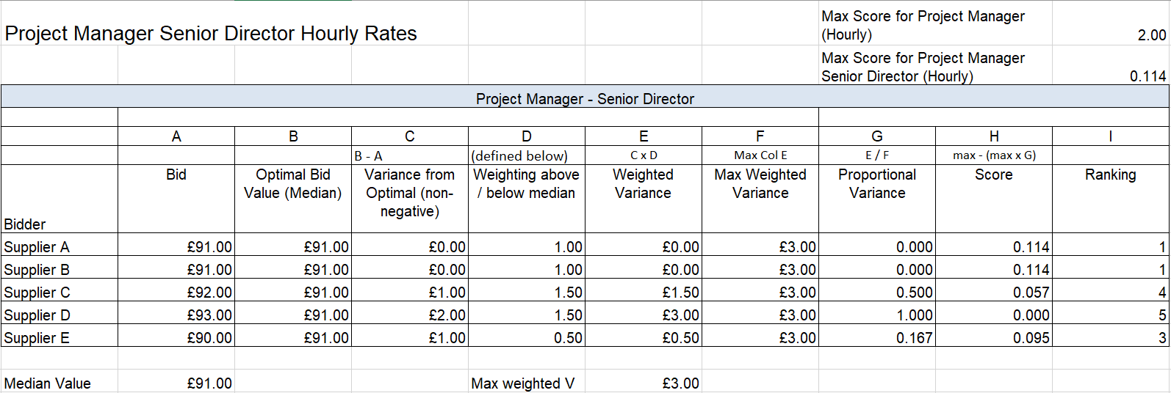

8.2.10 The individual element score contributions are then collated to arrive at the total price score for each discipline. This is illustrated below with example data:

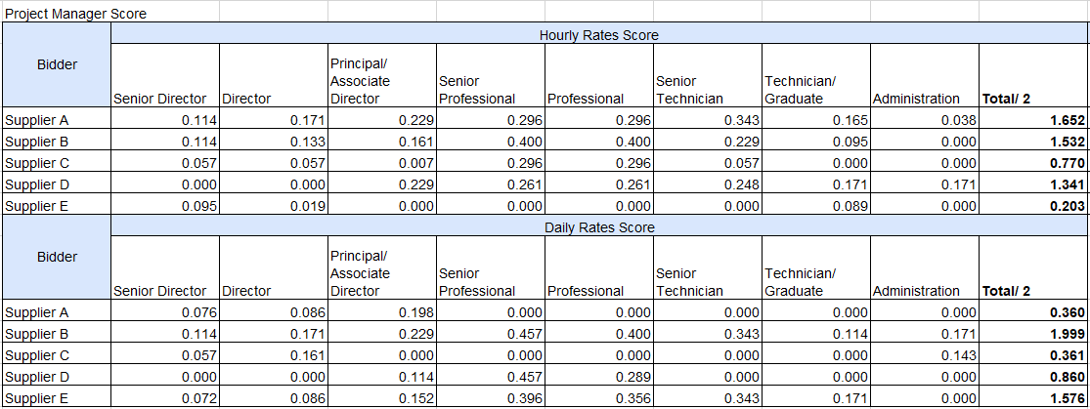

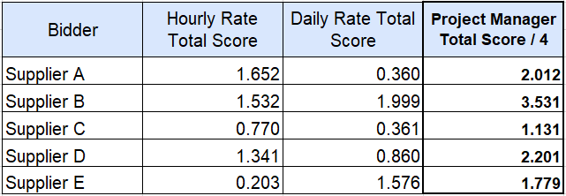

8.2.11 The individual discipline score contributions are then collated to arrive at the total price score out of 25 (for Lot 3, this will be out of 20 as Project Percentage Fees account for the other 5 marks). This is illustrated below with example data:

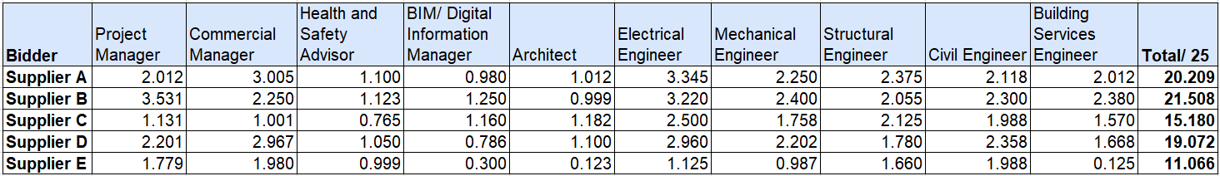

Lot 3 - Project Percentage Fees

    - 8.2.12 Evaluation Data (as collated within Sheet 6 – Evaluation Data in each price model workbook) from all Bidders is extracted and evaluated against all other Bidders’ submitted tenders.
    - 8.2.13 For each Procurement Type, the optimal bid value for each procurement type is calculated as the median value of all valid submitted bids.
    - 8.2.14 The variance of each bid from the optimal bid value is calculated and this is converted to an absolute (i.e. non-negative) value.
    - 8.2.15 The remaining bids will have a weighting applied to the variance to favour variances less than the median bid relative to variances greater than the median bid. The weighting is as follows:
      - bid lower than optimal = x 0.5 weighting
      - bid higher than optimal = x 1.5 weighting

This results in a weighted variance for each bid.
    - 8.2.16 For each procurement type, the median bid will score full marks. Remaining non-excluded bids will be scored a reducing score according to their weighted variance from the median bid, in proportion to the bid with maximum variance.
    - 8.2.17 The weightings for each Project Cost Band are shown in worksheet 3 of the workbook, and also in section 8.3 Weightings and Maximum Available Scores of this document. There is a maximum of 1.25 marks available for each procurement type.
    - 8.2.18 Each Bidder’s score will be applied as a percentage to the maximum score for each pricing element to arrive at the pricing element contribution to the maximum total Project Percentage Fee score of 5%.
    - 8.2.19 The evaluation methodology is illustrated below with example data:

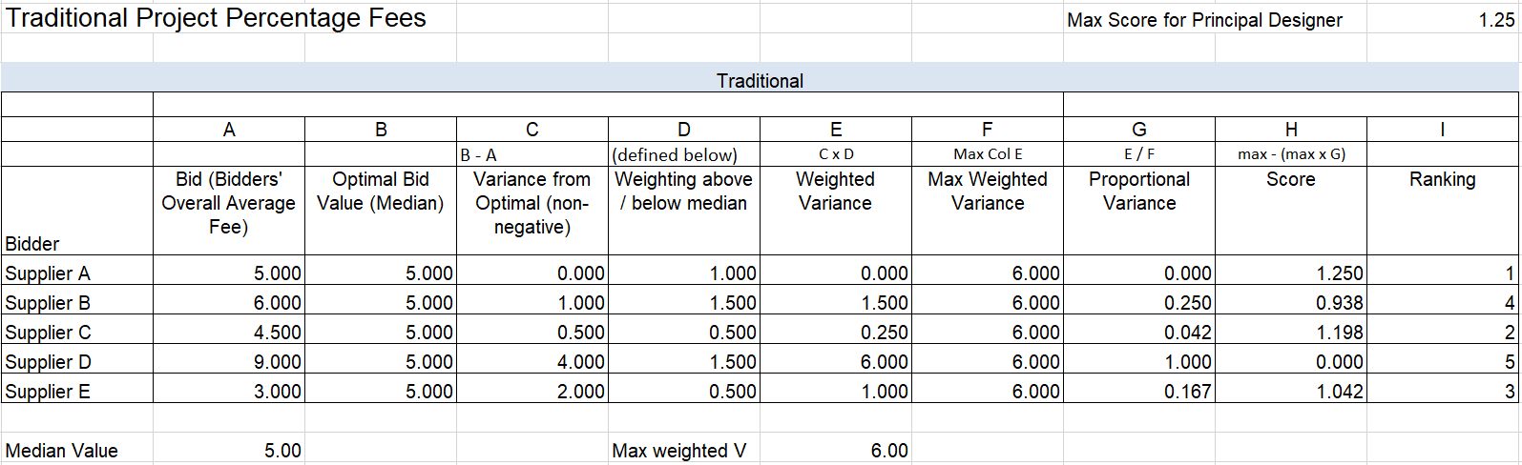

    - 8.2.20 The individual element score contributions are then collated to arrive at the total price score out of 5. This is illustrated below with example data:

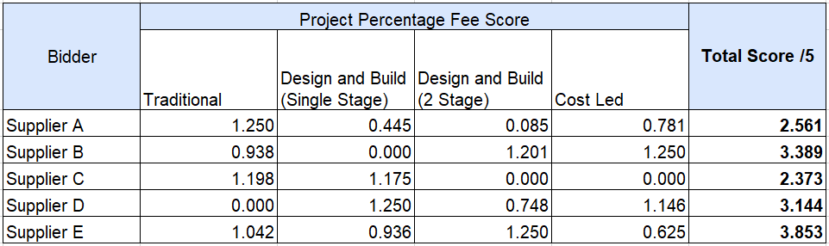

8.3 Weightings and Maximum Available Scores

8.3.1 Please note that grade and discipline weightings are used to calculate the maximum score available for each grade of each discipline, and are not applied directly to Bidders' rates.

8.3.2 The grade and discipline weightings, and resultant maximum scores available, for each lot are shown below.

Lot 1 - Built Environment & General Infrastructure

Weightings
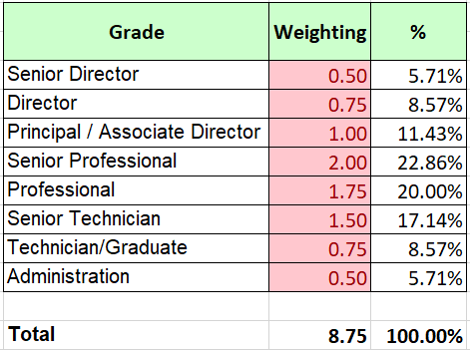
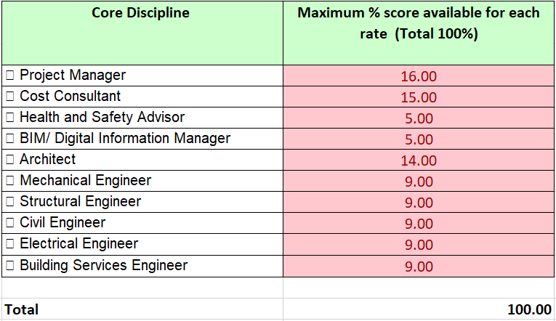

Maximum Scores

Hourly Rates Maximum Scores

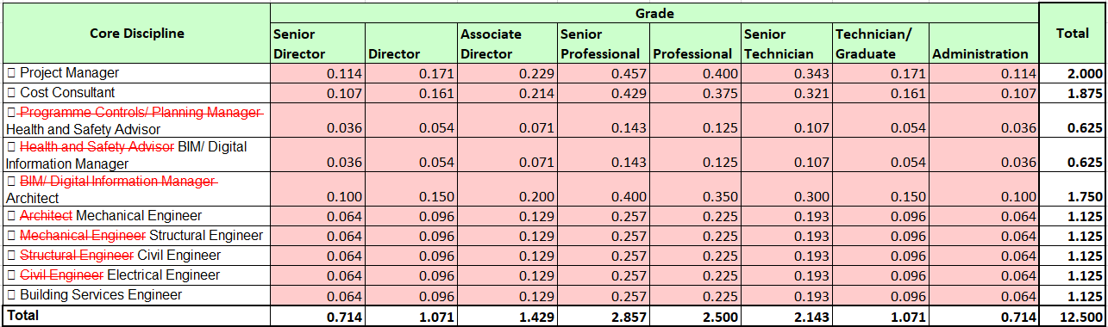

Daily Rates Maximum Scores

Lot 2 - Urban Regeneration

Weightings
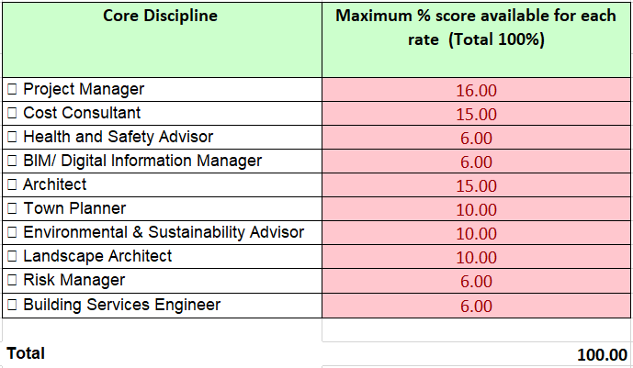

Maximum Scores

Hourly Rates

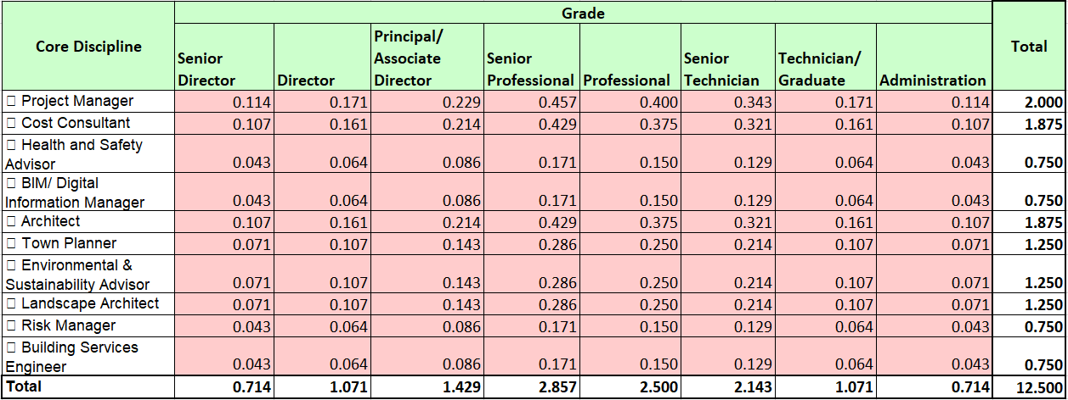

Daily Rates

Lot 3 - International

Weightings

Hourly and Daily Rates
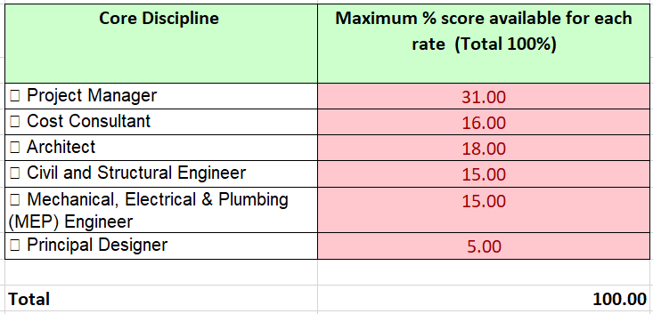
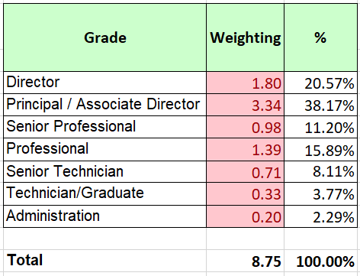

Project Percentage Fees

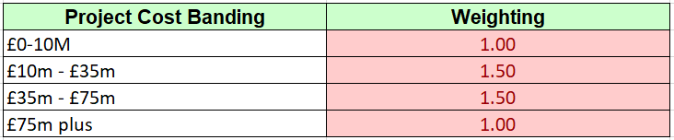

Maximum Scores

Hourly Rates

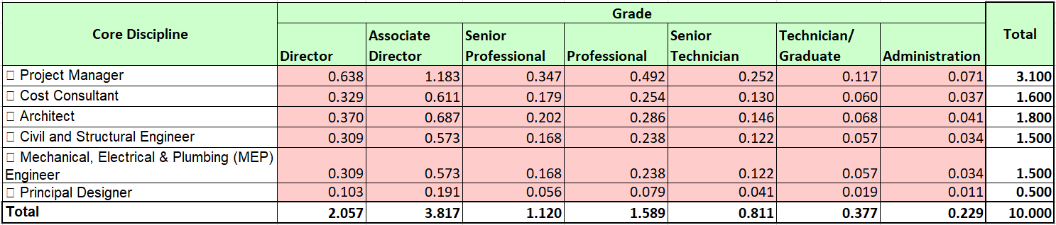

Daily Rates

Project Percentage Fees

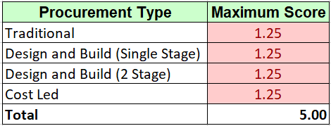

Lot 4 - High Rise

Weightings
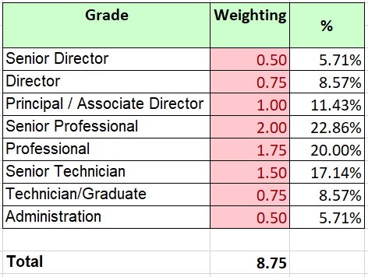
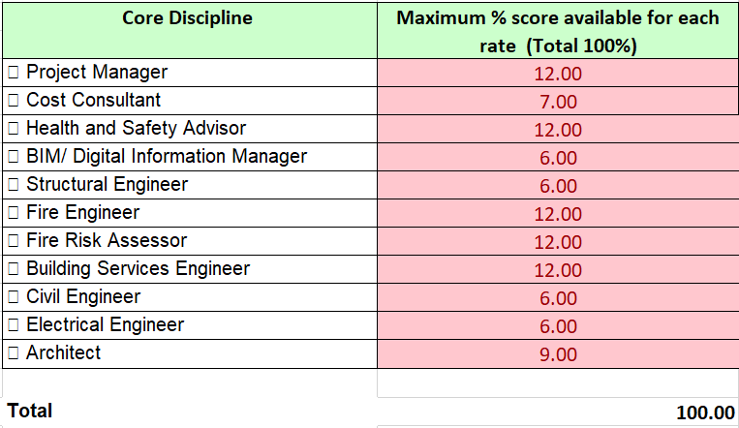
Maximum Scores

Hourly Rates

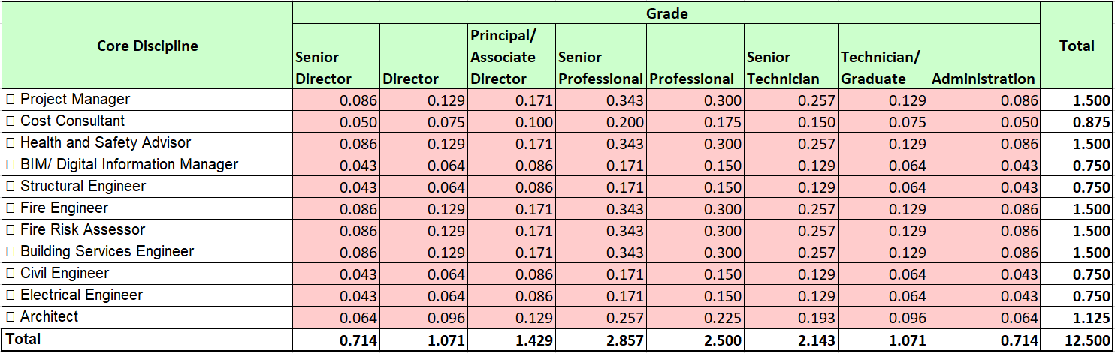

Daily Rates

Lot 5 - Defence

Weightings
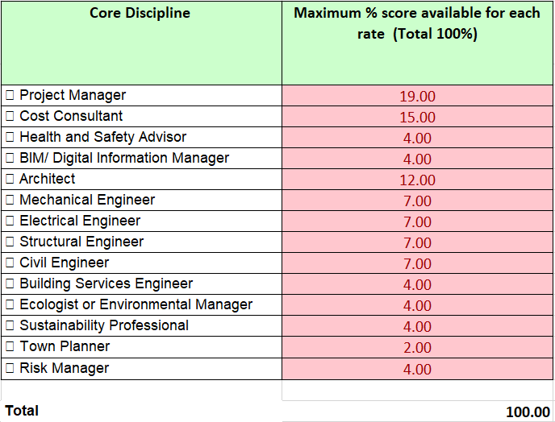

Maximum Scores

Hourly Rates

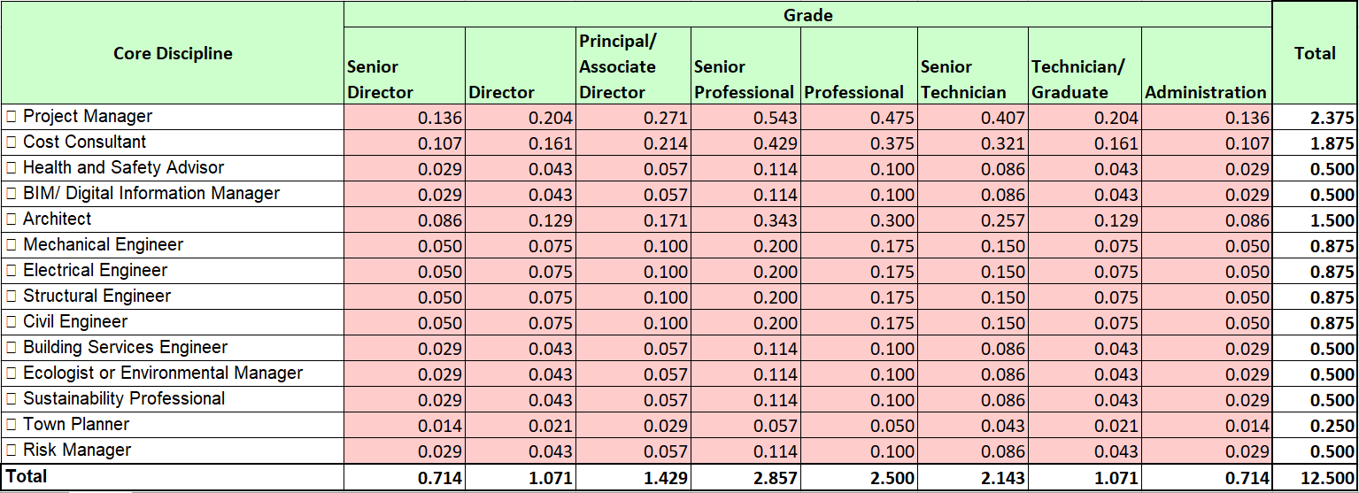

Daily Rates

Lot 6 - Environmental & Sustainability Technical Services

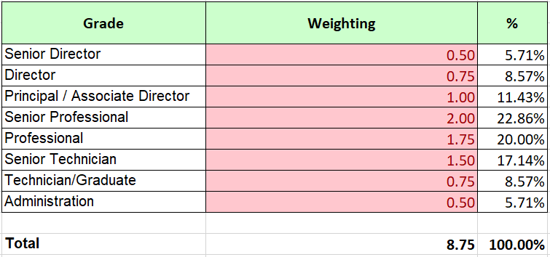

Annex A - Qualification and Definitions
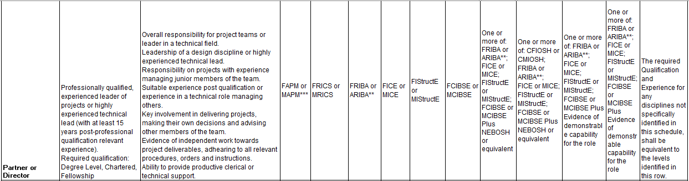
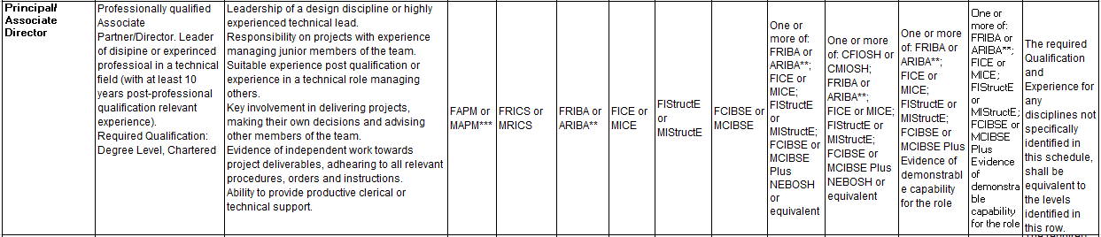
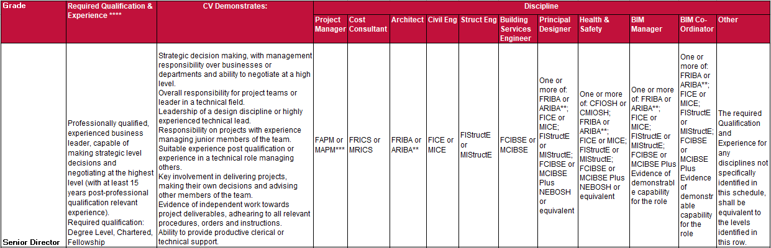
Continued on following page
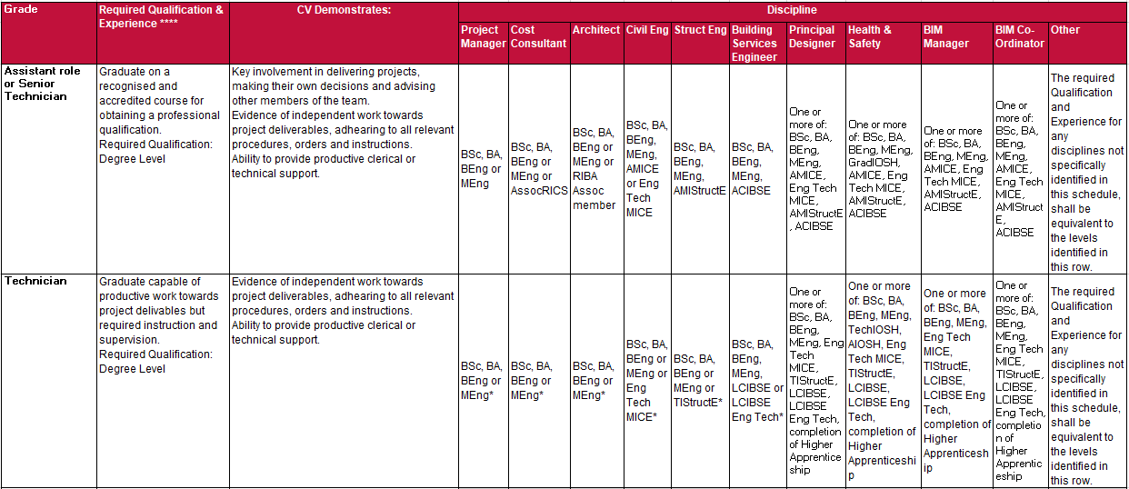
Annex A – Qualifications and Experience Definitions
*or completion of Higher Apprenticeship
**or on the UK Register of Architects administered by the ARB, or equivalent.
*** the qualifications for PM where stated as FAPM/MAPM may also include, as an alternative, personnel with the professional
qualifications listed for Quantity Surveyor, Architect, Civil Engineer, Structural Engineer and Building Services Engineer
**** the required Qualification and Experience for any disciplines not specifically identified in this schedule, shall be equivalent to the levels identified in this column.
(a) Qualifications & Experience Definitions for Building Services Engineer also apply to roles designated as Electrical Engineer / Mechanical Services / HVAC Engineer
/ Environmental Services Engineer and the like

Annex B - Glossary of Abbreviations

Annex C - Deployment Matrix

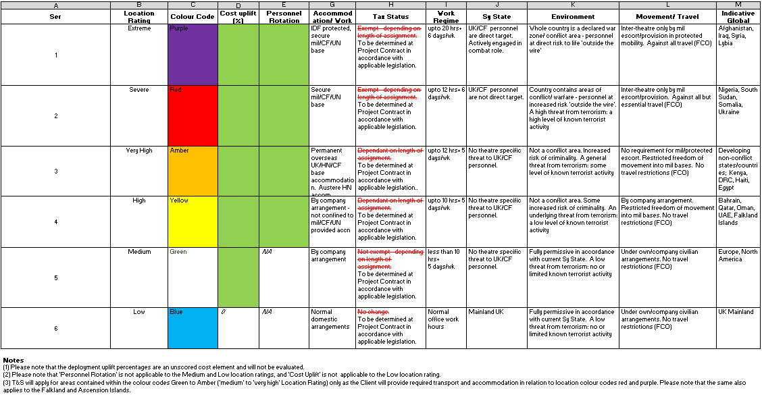

Attachment 3m - Price Model and Price Evaluation Guidance RM6165 – Construction Professional Services Version X

© Crown copyright 2019

