Invitation to Tender for
South Kelsey and Moortown Parish Council
South Kelsey Park Play Area Regeneration
Site location:
Waddingham Road, South Kelsey, Market Rasen. LN7 6PN

REQUIREMENTS AND AIMS
The main aims of our project are to: provide a safe and well-maintained play park, with a rural theme, in keeping with the area, for use by the residents of ours and neighbouring villages in order to: promote healthy-living; offer a safe area for children to have fun and socialise whilst learning about the benefits of exercise; provide a new and uplifted play space which provides and attractive environment for physical activity; support the valuable contribution that access to the best possible play equipment can make to life-long health and well-being.
South Kelsey Park is currently without a play area of any kind as the existing one was closed in December 2023 owing to safety issues.
This will require the refurbishment of some existing equipment and the installation/replacement of some new and accessible equipment, including appropriate surfacing where required. The play area is intended to be used by children aged 3 to 12 and should be accessible for all abilities.
Experienced play area installers are invited to tender for the contract.

The project budget is up to £33,000 + VAT. All prices are to be net, excluding VAT.

Companies must be registered with the API (Association of Play Industries) to tender for this contract. Please supply copies of current certificate for accreditations for the above membership plus details of any other relevant accreditations.

A timescale for commencing this project will be agreed between South Kelsey and Moortown Parish Council and the chosen Contractor.

1. TENDER PROCESS
Tenderers are required to comply with Parish Council tendering procedures and non-compliant responses may be excluded.

1.1 Tenders must be addressed to the Responsible Financial Officer in the ordinary course of post. Each tendering firm should send their Tender in a plain envelope and/or tube to Mrs C Major (Clerk/RFO), 11 Foxglove Close, Brigg, DN20 8FF. They shall remain sealed until 2 September 2024, being the prescribed dates for opening tenders for the contract.

Alternatively, tenders can be sent by email as a secured email attachment on the prescribed date for opening tenders, 2 September 2024, to: clerk@southkelseyandmoortownparishcouncil.gov.uk

The following should be submitted:

- Quotation Breakdown form
- A copy of your certificate of public liability insurance
- A copy of your company’s Health and Safety Policy
- A copy of your company’s API (Association of Play Industries) certification
- Concept drawing/equipment specifications
- At least one reference for a similar scheme

1.2 The Parish Council reserve the right to choose the supplier for each element separately; however, we have a preference to contract with a single ‘prime contractor’ or the minimum number of suppliers as is possible (subject to value for money being optimised). No payment will be made in respect of any expenses incurred by the tenderers in submitting a tender. The Parish Council reserve the right not to purchase one or more of the elements listed.

1.3 Tenderers should liaise with the Parish Clerk (clerk@southkelseyandmoortownparishcouncil.gov.uk) during the tender period regarding any queries or concerns on the content of this specification.

1.4 Any questions about the project are to be sent to the Clerk by 27 August any responses after this will not be responded to. All questions asked will be shared to all interested parties via blind copy email

2. SITE INFORMATION
2.1 The Contractor can visit the site to assess access, gain detailed measurements, and to satisfy themselves as to the conditions on site that may affect in any manner whatsoever the execution of the works detailed hereafter. Location of the site is Waddingham Road, South Kelsey, Market Rasen, LN7 6PN. What3words location: facelift,reverses,homework.

2.2 Compound - A designated compound will be agreed prior to works commencing. The area must be secure and safe. The area is currently closed to users. The Parish Council reserve the right to determine the final location of the compound.

3. DESIGN BRIEF
The design brief has been organised in sections. Please tick the sections you wish to include in your Tender, which are listed in Section 12. SMALL WORKS TENDER - SCHEDULE 4.
Small Works Tender – Schedule 1
Note: It is acknowledged that suppliers might offer variants to equipment listed.

Requirements/Specification - Refurbishment of Play Equipment:
- Swings – to include new seats
- Slide – to include new steps

Prepare all surfaces for repainting
Repaint (same colours as existing)
Refurbish/Replace any faulty items of equipment (e.g. Bearings and rotted surfaces,any remedial work encountered)
Supply and install replacement parts
Supply and install necessary safety matting suitable for each area.
Resolve ROSPA issues highlighted in report embedded at Schedule 6
Reinstall to necessary specification/regulations

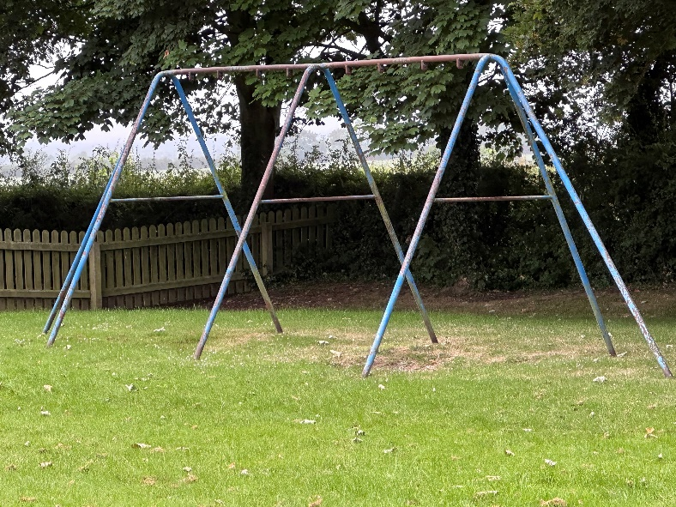 | Swings to be refurbished.  New swing parts may be adjusted accordingly to meet the budget.
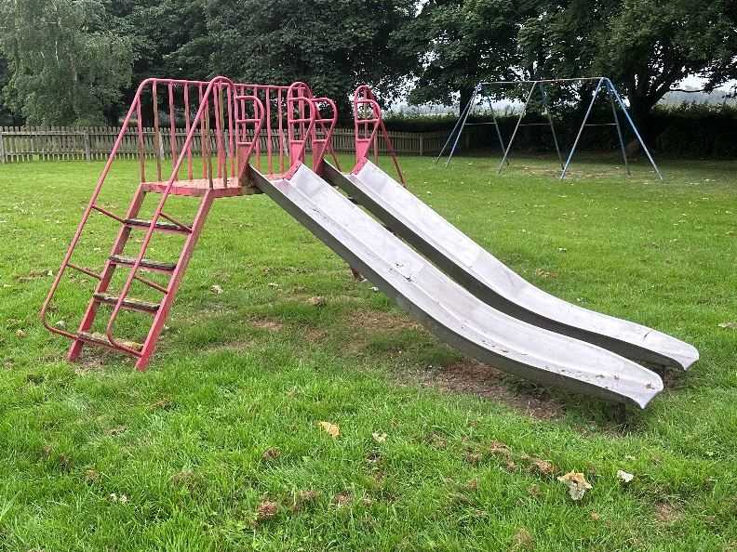 | Slide to be refurbished.  Replacement steps should be recycled non-slip material.  New slide parts may be adjusted accordingly to meet the budget.

Small Works Tender – Schedule 2
Supply and Installation of new Equipment
Note: It is acknowledged that suppliers might offer variants to equipment listed.

- To supply and fit new items as stated below:
  - Junior Climbing Frame suitable for 5 to 12-year-olds
  - Inclusive and accessible roundabout suitable for 3 to 12-year-olds
  - Accessible basket swing and frame for 3 to 12-year-olds.
- To install to necessary specification/regulations
- To supply and install necessary safety matting around the foot of each piece of equipment.
- Supply all necessary labour and material for above.

Small Works Tender – Schedule 3
Note: It is acknowledged that suppliers might offer variants to equipment listed.

Supply and Installation of plastic/rubber grid pathway from park entrance

- To supply and fit a plastic grid pathway suitable for wheelchair access from the park entrance to accessible items (see plan for location)
- Dispose of any displaced material
- Seed pathway for grass
- Install to necessary specification/regulations.
- Supply all necessary labour and material for above

3.1 All works equipment and IAS shall be manufactured, tested, installed and conform to the relevant British and European Standards (i.e. BSEN1176 and BSEB1177).

3.2 The play equipment must also comply with the DDA (Disability Discrimination Act) i.e. all-inclusive play and accessibility.

4. Preparation and groundworks:

4.1 Excess materials, spoil and surfacing from excavations must be disposed of at a licenced recycling centre at the Contractor’s cost.

4.2 The Contractor must provide skips when required and secure all skips behind Heras security fencing when unattended to avoid fly tipping.

4.3 Please identify the price within the Tender for any necessary reinstatement works that may be required following completion of works.

4.4 Liability and responsibility for insurance of the play area and installation works will lie with the Contractor until a satisfactory RoSPA Post-Installation Report has been accepted by North Kelsey and Moortown Parish Council. This will be confirmed in writing on the day of the handover of the site by the Parish Clerk or nominated representative and the Contractor.

4.5 Storage of new play equipment, machinery and equipment, etc during the construction period will be the responsibility of the Contractor.

5. SITE MANAGEMENT DURING INSTALLATION
5.1 A project co-ordinator or single point of contact must be nominated by the successful tenderer who should be readily contactable to deal with any queries and problems that may arise.

5.2 The play area must be contained within security fencing – Heras temporary security fencing or similar, supplied by the Contractor, whilst work is in progress and Heras temporary security fencing should remain in place until a satisfactory RoSPA Post-Installation Inspection and Report has been completed and submitted to the Parish Council.

5.3 Site working hours to be agreed with the Parish Council

5.4 Access to the remainder of the playing field open space must be available and safe at all times.

5.5 All equipment and machinery should be fit for purpose and maintained in accordance with current legislation, i.e. MoT, Tax, LOLER, PUWER, etc. The Contractor shall ensure that any construction noise does not cause nuisance to any users of the Open Space or neighbouring residential properties or roads, etc outside the site boundary.

5.6 Radios are permitted however the volume level should be kept at a reasonable level as not to cause a nuisance to residential properties.

5.7 The Contractor will need to supply the Parish Council with a copy of their site Risk Assessment, Method Statement and a copy of their public liability insurance at least 14 working days before the start of the project.

5.8 The Contractor shall advise the Parish Council immediately of any deficiencies in the Method Statement or Risk Assessment, or unforeseen hazards to Health and Safety which may become apparent as the project proceeds. The includes notification of any RIDDOR incidents during construction.

5.9 It is not known if there are any underground services within the play area, the Contractor is advised to have satisfied themself of the extent and location of all underground services in order to safely undertake the works. The Contractor is to allow for all costs associated with protecting from and working with the materials within this tender.

5.10 The Contractor shall take all precautions as are necessary to protect the health and safety of all persons employed by him and shall comply with all the requirements of any Acts, Regulations, orders or directions pertaining to the health and safety of employed persons, the employees of the Parish Council and all other persons.

5.11 The Contractor shall allow the Parish Council representatives such access as may be required to buildings, locations, vehicles or operations used in relation to this project.

5.12 The Contractor shall be required to attend such meetings as the Parish Clerk or their nominated representative may require for the administration and successful completion of this Contract.

5.13 The Contractor will be responsible for reinstatement works for any damage whatsoever caused to the interior and exterior of the play area or the surrounding open space, pathways, fencing, kerbing, signs, street furniture and private land/property resulting from installation works or deliveries. Carry out all reinstatement works in accordance with good landscape practices. Full payment may be withheld until the site and adjoining areas are left in a state deemed acceptable, and to the satisfaction of the Parish Council.

6. MAINTENANCE AND AFTERCARE

6.1 A full schedule of maintenance requirements is to be provided once the play area is completed. This should include a breakdown of items, specifications and maintenance requirements to assist with the future site management, inspections and maintenance.

6.2 Please provide details of your own and manufacturer guarantees and warranties on equipment, safety surfacing and installation works with the Tender.

6.3 The works will be subject to an independent Post-Installation Inspection (PII) before the project is signed off (as per the pricing and payment section). The Contractor shall undertake any remedial issues identified as part of the PII report, as part of the existing project cost. The play area must not be opened for public use until the PII has been signed off to the satisfaction of the Parish Council.

7. PRICING AND PAYMENT

7.1 The Contractor shall supply and do everything necessary for the proper execution and completion of the work that may be reasonably inferred from the Contract Documents whether described in detail or not, without any extra payment in respect thereof.

7.2 Payment will be upon satisfactory completion of the works and following receipt by the Parish Council of a satisfactory RoSPA Post-Installation Report. This report should be commissioned, paid for and supplied to South Kelsey and Moortown Parish Council by the Contractor before the play area is released back to South Kelsey and Moortown Parish Council.

7.3 The Parish Council will ensure that valid undisputed invoices will be paid by within 30 days of satisfactory completion and when the conditions in paragraphs 6.3 and 7.2 have been fulfilled. The Contractor should include similar provisions in their contracts, and so on down the supply chain.

8. TIMETABLE FOR TENDER PROCESS

Publish tender using Contract Finder and by email notification to companies that have expressed an interest. | Friday 2 August 2024
Deadline for questions on the project to the Parish Council. | Tuesday 27 August 2024
Question responses distributed to all parties. | Friday 30 August 2024
Tender Offer Submission time and place deadline. | Monday 2 September 2024
Tenders opened and full evaluation of anonymous tenders to select shortlist of preferred designs as per evaluation criteria by RFO and at least one Councillor. | Monday 2 September 2024
Tenders presented at Full Parish Council meeting to select preferred supplier. | Monday 2 September 2024
Tenderers notified. | Tuesday 3 September 2024

9. EVALUATION CRITERIA
To ensure that tenders are evaluated fairly, the tables below aim to identify the scoring criteria and evaluation methodology:

Scoring system

Play Value 35%
Design Rationale 10%
Inclusivity 25%
Durability and recyclability 25%
References 5%

A standard 0-5 point scoring system will be used and is detailed below:

0 Unacceptable: Non-compliant / deficient for the criteria used
1 Poor: Limited response which is lacking sufficient detail or is inaccurate
2 Below expectations: Minimal achievement of requirements with weaknesses or omissions
3 Adequate: Reasonable achievement of requirements with weaknesses or omissions (which would be difficult to overcome)
4 Good: Comprehensive response, detailed and relevant with no inconsistencies
5 Excellent: Exceptional submission, demonstrating high ability, understanding and experience to deliver the project to a high standard

The score for each section will then be divided by the maximum number of marks for that question and then multiplied by the weighting to give a weighted score for that element.

For example, the score for a 50% weighted section where 2 out of 5 possible marks is scored will be calculated as follows:
2/5 x 50 = 20% for that section
Each section will then be added together for an overall mark out of 10
The evaluation of the tender processes will be carried out by the Playground Working Group.

10. PROCUREMENT PROCESS

The procurement process will be conducted and in compliance with The Contracts Procurement Regulations 2015 as amended and the Parish Council’s Procurement Policy 2024. The objective is to be fair, transparent and proportionate based on the type of project and to ultimately selection the most economically advantageous tender.

The tender process will be by Open Tender.
The play area is an open site and suppliers are welcome to visit the site at their own convenience without penalty.

All questions and requests for clarification should be by email and will, subject to there being a confidentiality issue which cannot be resolved, all questions asked will be shared to all interested parties via blind copy email

11. EVALUATION AND AWARD CRITERIA

All Tenderers shall provide all the information requested in the tender pack.
In the interest of transparency, with the exception of the covering letter, all presented information within the tender including designs should be anonymised with no identifying logos or hyperlinks.

Unclear Tenders may be discounted in evaluation. The Parish Council reserves the right to seek clarification.

To ensure that Tenders are evaluated on a consistent basis it is essential that responses are made to all the requirements listed within this document and are clearly referenced to specific evaluation criteria.

The Parish Council will collate its findings and make the final selection of the preferred Contractor.

The Parish Council’s decision is final and will reflect the offer that most meets all the specifications and public expectations.

12. SMALL WORKS TENDER - SCHEDULE 4
Supplier Response Check List

Suppliers are asked to tick all elements which they have included in their final submission:
Quotation Breakdown - To be included with your Tender

Element Included in Bid | Please Tick
- Schedule 1 - Refurbishment of Play Equipment | - Swings
- Schedule 1 - Refurbishment of Play Equipment | - Slide
- Schedule 2 - Supply and Installation of new Play Equipment | - Climbing Frame
- Schedule 2 - Supply and Installation of new Play Equipment | - Accessible Roundabout
- Schedule 2 - Supply and Installation of new Play Equipment | - Accessible basket swing and frame
- Schedule 3 - Pathway

Plan of Play Area
Below is a plan showing the play area and the locations of the equipment and a satellite picture of the play area
.

