|  |  |
| --- | --- |
|  |  |
| Client | Stonewater Developments Limited |
| Project | Residential development of 90no dwellings with access, estate roads, parking, public open space,  play facilities and landscaping, adopted foul pumping station and surface water drainage. |
| Location | Madley Road, Clehonger, Herefordshire, HR2 9TE. |

**EXPRESSION OF INTEREST.**

|  |
| --- |
| **SUMMARY** |

|  |  |  |  |
| --- | --- | --- | --- |
| Project | Residential development of 90no dwellings; with access, estate roads, parking, public open space, play facilities and landscaping, adopted foul pumping station and surface water drainage. | Client | Stonewater |
| Value | £13,650,000. | Location | Clehonger, Herefordshire, HR2 9TE |
| Land ownership | Exchange of Contracts. | Planning | Outline planning consent granted – 17-11-2016.  Reserved Matters consent granted – 04-02-2021. |
| Procurement | Single Stage competitive tender.  Quality: Cost Tender and evaluation | Contract | JCT Design & Build 2016 within amendments |

|  |
| --- |
| **CLIENT** |

|  |  |
| --- | --- |
| Name: | Stonewater Development Limited |
| Type: | Housing Association. |
| Contacts: | Marc Howard – Regional Development Manager ([marc.howard@stonewater.org](mailto:marc.howard@stonewater.org))  Clare Bray – Development Manager ([clare.bray@stonewater.org](mailto:clare.bray@stonewater.org))  Andrew Russell – Head of Procurement ([andrew.Russell@stonewater.org](mailto:andrew.Russell@stonewater.org)) |

|  |
| --- |
| **EMPLOYERS AGENT.** |

|  |  |  |
| --- | --- | --- |
| Name | WP-Housing  Matthew Hunt  Tel: 01684 293040  Mob: 07701 289405  Email: [matthew@walkerpritchard.com](mailto:matthew@walkerpritchard.com) | WP-Housing  Greg James  Tel: 01684 293040  Mob: 07739 364847  Email: [greg@walkerpritchard.com](mailto:greg@walkerpritchard.com) |

|  |
| --- |
| **PRE-CONTRACT PROJECT TEAM.** |

|  |  |
| --- | --- |
| Planning Consultant | Pegasus Planning Group Limited  Chris Marsh  Tel: 01454 625945  Email: Chris.Marsh@pegasusgroup.co.uk |
| Architect | Rushbrooke  Lee Bryan  Tel: 0117 953 7043  Email: lee.bryan@rushbrookeuk.co.uk |
| Civil Engineer | Intrado Limited  Clare Cooke  Tel: 029 2081 1097  Email: clare.cooke@intrado.co.uk |

|  |
| --- |
| **PROJECT OVERVIEW.** |

**Project Description.**

Residential development for 90no two-storey dwellings comprising 1-, 2-, 3- and 4-bedroom houses for Affordable Rent and Shared Ownership tenures on a greenfield site which is former agricultural grazing land.

Infrastructure comprising of off-site highway works; adopted estate road throughout the development with unadopted shared surface roads, an on-site adopted foul pump station and surface water drainage including an attenuation basin and SUDS and outfall to an existing water course.

Landscape works including public open space, the retention of the existing mature trees and matures hedges which subdivide the site into three development zones: the retention of the existing orchard and the construction of a LEAP play facility on site.

The site totals approximately 5.22 hectares.

**Site Location.**

The site is in the village of Clehonger 4.3 miles south-west of Hereford as shown opposite.

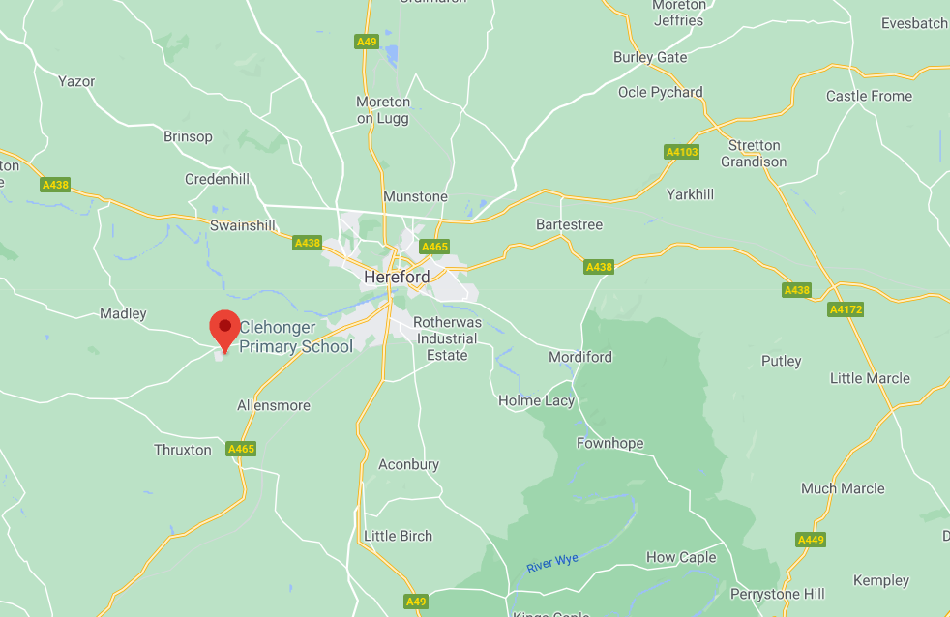

The site lies to the northwest of the B4349 (Kingstone Road) and to the south of the B4352 (Madley Road) at Clehonger.

The site is greenfield agricultural grazing land, divided in to five separate fields by trees and hedgerows which are to be retained. The central field contains an orchard, designated as a Priority Habitat in which no works are proposed under the build contract.

The site location plan is provided at **Appendix 1**.

**Proposed Dwellings.**

The proposed dwellings comprise of the following mix of units and tenures.

|  |  |  |  |  |  |  |  |  |
| --- | --- | --- | --- | --- | --- | --- | --- | --- |
| **Type** | **Description** | **Bedrooms** | **Configuration** | **Storeys** | **GIFA** | **Phase 1** | **Phase 2** | **Total** |
| A | 4-bedroom 6 person | 4 | Detached | 2 | 107 | 5 | 3 | **8** |
| P | 3-bedroom 5 person | 3 | Semi-detached | 2 | 86 | 8 | 10 | **18** |
| P | 3-bedroom 5 person | 3 | Terrace | 2 | 86 | 2 | 0 | **2** |
| P | 3-bedroom 5 person | 3 | End terrace | 2 | 86 | 1 | 0 | **1** |
| R | 3-bedroom 5 person | 3 | Detached | 2 | 86 | 2 | 0 | **2** |
| R | 3-bedroom 5 person | 3 | Semi-detached | 2 | 86 | 2 | 8 | **10** |
| S | 3-bedroom 5 person | 3 | Semi-detached | 2 | 86 | 10 | 2 | **12** |
| S | 3-bedroom 5 person | 3 | Detached | 2 | 86 | 2 | 1 | **3** |
| J | 2-bedroom 4 person | 2 | Semi-detached | 2 | 74 | 8 | 2 | **10** |
| M | 2-bedroom 4 person | 2 | Semi-detached | 2 | 74 | 14 | 4 | **18** |
| H | 1 bedroom 2 person | 1 | Semi-detached | 2 | 46 | 2 | 0 | **2** |
| H | 1 bedroom 2 person | 1 | End terrace | 2 | 46 | 2 | 0 | **2** |
| H | 1 bedroom 2 person | 1 | Terrace | 2 | 46 | 2 | 0 | **2** |
| **Total** |  |  |  |  | **7352** | **60** | **30** | **90** |

The dwellings have private enclosed rear gardens and driveways providing 2no car parking spaces per dwellings, or via small car parking court yards as shown on the proposed site layout plan provided at **Appendix 2**.

**Dwelling method of construction.**

Traditional and timber frame.

MMC will be considered where this provides improved value for money.

**Off-Site s278 Highway Works and Proposed Estate Roads.**

The s278 off-site highway works comprise of:

* Construction of a pelican crossing on the B4349.
* Constructing a pavement within an existing grass verge adjacent to the existing highway (Croft Road) and tactile cross overs.

This shown on Hydro drawing number C14193-003. This drawings is provided at **Appendix 3.**

The estate roads are to be adopted, except for the shared surface roads (shaded grey on the proposed site layout plan) which are to be constructed to be adopted standard, but not forming part of the Section 38 Agreement.

The principal contractor shall be required to procure the formal adoption agreements, the required Bond, and the associated legal costs.

**Surface water drainage.**

The surface water drainage will be put forward for adoption by Welsh Water and will be designed in accordance with sewers for Adoption 7th Edition. The proposal comprises:

* Surface water will discharge to the attenuation basin with cellular storage below.
* The outfall from the basin discharges to open vegetated ditch which opens into an informal basin on third party land for which agreements are in place prior to discharge to Cage Book.
* A hydrobrake positioned on the outlet of the attenuation basin.
* Silt is to be prevented from entering the system by trapped gullies and channels with silt traps.

The principal contractor shall be required to procure the formal adoption agreements, the required Bond and the and the associated legal costs.

**Foul drainage.**

The foul drainage will be put forward for adoption which will include the adopted foul pump station and compound.

The outline planning consent (Condition 18) relating to the upgrade of the off-site sewerage treatment works is addressed under the land contract and does not form part of the build contract scope of works.

The principal contractor shall be required to procure the formal adoption agreements, the required Bond and the and the associated legal costs.

**Play Facilitates.**

The proposal includes a LEAP located in the centre of site. The Reserved Matters planning included proposals (drawing no. P18 -1455_05B) for the proposal landscaping and natural play trail equipment aimed at infants and juniors 0 – 12 years olds.

**Public Open Space.**

The POS provision compromises of the existing orchard within the centre of the site which is to retained and open space at the north of the site.

**Collateral Warranties**

Required from:

* Design consultants – architects, structural engineer, civil engineer (£5.0m)
* Suppliers with a design element –pre-cast concrete floors, timber frame (if adopted £5.0m), truss roof suppliers. £2.0m except for timber frame.
* Sub-contractors with a design element – piling sub-contractor and mechanical sub-contractor (£2m)

**Warranty and Insolvency Cover.**

12-year warranty from NHBC/ LABC/ Premier Guarantee and to include:

* Any Damage cover.
* Contractor Insolvency cover for no less than 10% of the contract sum
* Professional fees and ancillary costs

**Performance Bond / Parent Company Guarantee.**

Performance Bond of 10% of the contract value.

Parent Company Guarantee where the Contractor is a subsidiary company.

|  |
| --- |
| **ESTIMATED VALUE** |

£13,650,000.

|  |
| --- |
| **LAND OWNERSHIP** |

Stonewater have exchanged contracts with completion conditional on:

1. Expiry of the Reserved Matters Planning Consent Judicial Review / Challenge Period.
2. The Landowner and Land Promoter concluding the Agreement with Welsh Water for the upgrade of the off-site foul sewerage treatment works and formal discharge of Outline Planning Condition 18.

|  |
| --- |
| **PLANNING.** |

**Outline Planning Consent.**

Outline Planning consent was granted on 17th November 2016 under application reference P141964/O and appeal reference APP/W1850/W/15/3140016 for a residential development of up to 90 dwellings with access, parking, public open space with play facilities and landscaping.

A copy of the Appeal Decision is provided at **Appendix 4**.

**Reserved Matters Planning Consent.**

Reserved Matters planning consent was granted on 4th February 2021 under application reference number RM193878.

The Decision Notice is provided at **Appendix 5** which contains nine planning conditions. This includes four pre-commencement Conditions (03, 04, 05 and 09).

Condition 09 – the proposed strategy is to provide rainwater butts to each of the dwellings.

The appointed main contractor will be responsible for the discharge of the Outline Planning consent Conditions and the Reserved Matters Planning Consent Conditions with the exception of Outline Planning Conditions 18 and 19 as set out below.

With regard to Informative Note 3 we advise:

* Surface water drainage – the client has instructed Pegasus Planning Group to submit a further planning application to discharge the Outline Planning consent Condition 19.
* Foul drainage – discharge of Condition 18 of the outline planning consent is being addressed by the Client under the land contract and will be concluded prior to works commencing on site.

**Section 106 Agreement / Unilateral Undertaking.**

The Unilateral Undertaking dated 16th September 2016 is provided at **Appendix 6.**

The Client will be responsible for payment of the financial contributions and affordable housing obligations.

The appointed main contractor will be responsible for:

1. Schedule 2; 2.1 – Prior to commencement of development submitting to the Council for approval the Open Space Works Specification and the Play Area specification.
2. Schedule 2; 2.3 to procure the Royal Society for the Prevention of Accidents post installation written inspection report and evidence of the manufacturer’s warranties of at least 5 years duration from the date of installation.

|  |
| --- |
| **BUILD PROGRAME AND PHASING** |

The contract will be awarded for the entire project (Phases 1 and 2) with a break clause provided for Phase 2 subject demand for the early dwellings handed over in Phase 1. The Break Clause Notice will be issued no less than 6 months before the proposed date of commencement for Phase 2.

The two phases comprise:

Phase 1.

* 60no dwellings and associated work (Plots 1 to 60 inclusive)
* Services to the above plots.
* External works and associated landscaping to the above plots.
* Proposed site access onto the existing highway including junction works and visibility splays from Madley Road
* Off-site highway improvement works including the pelican crossing and footway to Madley Road / New House
* Adopted and non-adopted estate roads, footways and car parking within Phase 1 and the spin road in Phase 2 to provide access to the proposed adopted foul pump station.
* Attenuation pond including the outfall, hydrobrake and connection to the water course.
* NEAP play space.

Phase 2.

* 30no dwellings and associated works (Plots 61 to 90 inclusive).
* Services to all plots.
* External works and associated landscaping to the above plots.
* Estate roads, footways, car parking in Phase 2

Target Date of Commencement: Monday 23rd August 2021.

Phase 1 Build programme: 86 weeks from the Date of Commencement.

Phase 2 Build programme: 29 weeks.

Total Build Programme: 115 weeks from the Date of Commencement.

|  |
| --- |
| **TENDER DOCUMENTS** |

Tender document will include:

1. Tender Instructions.
2. Mandatory requirements.
3. Selection Questionnaire (Reference Document Only)
4. Invitation to Tender Qualitative Questions (Reference Document Only)
5. Employers Requirements – including:
6. Preliminaries
7. Design Brief
8. Specification Matrix
9. Approved planning drawings
10. Surveys
11. Planning Decision Notices and S106 Agreement
12. Accommodation Schedule
13. Collateral Warranties.
14. Parent Company Guarantee
15. Contract Sum Analysis
16. Health & Safety Requirements
17. Equality and Diversity Policy
18. Anti-bribery Policy.
19. Anti-Fraud and Corruption Policy
20. JCT D&B 2016 contract amendments.
21. Form of Tender.

|  |
| --- |
| **TENDER PROCESS AND INSTRUCTIONS** |

The intention is to complete this tender exercise as an Open Procedure, in line with the instructions of the Public Contracts Regulations (2015). This single stage process will combine the Selection Questionnaire (SQ) and the Invitation to Tender (ITT), meaning that bidders will be expected to provide all requested information by one, clear deadline.

The SQ is the standard format required under UK and EU guidelines and requires all bidders to provided key information about their organisation’s financial and legal standing, as well as references of current/previous customers and details of their current insurance policies. In addition to this, Stonewater will also include questions, scored as either a “Pass” or “Fail”, based on key organisational initiatives and how well these match with Stonewater’s own policies. These will include, but not be limited to, Corporate Social Responsibility (CSR) and Equality, Diversity and Inclusion (EDI).

The ITT will require bidders to complete the Form of Tender and Contract Sum Analysis as well as providing responses to some additional questioning, specific to this site. The questions are still to be fully determined, but are likely to focus on Value for Money and Social Value benefits that a bidder is able to provide during this project. Answers to the questions will be scored by the Stonewater evaluation panel and will contribute 10% of weighted marks towards each bidder’s overall score. The remaining 90% will derive from pricing submissions through the Contract Sum Analysis.

All documentation for this tender will be stored in Stonewater’s e-tendering portal Delta eSourcing <https://www.delta-esourcing.com/>. All correspondence and clarification requests will also be conducted in the portal throughout the process. Stonewater and its Employer’s Agent partner WP-Housing reserve the right not to respond to any contact made by bidders through email or by phone, unless the request is to obtain the access code for the tender.

The indicative timescales for the tender are stated in the table below. Whilst Stonewater and its partners will aim to maintain all deadlines stated, there may be occasions of delay due to unforeseen circumstances. In the event that this happens, all bidders will be updated through the Delta portal immediately.

**Innovation and Value Engineering.**

We believe in providing the opportunity for innovation to improve value for money. The tender will therefore be seeking price submission based on the tender documents.

The tender will also invite innovation and value engineering proposals. This is to include a schedule which includes:

* An outline of the proposal.
* Where the contractor has used this before.
* Programme implications arising from the proposal(s).
* Price reduction arising from the proposal(s).
* Sustainability benefits arising from the proposal(s).

The innovation and value engineering proposal will be taken into consideration during the tender evaluation stage.

**Risk.**

The tender submission is to include a Risk Schedule which comprises:

* The project risk the Contractor has identified during the tender preparation.
* A risk rating (RAG rated)
* The programme impact of the risk
* The cost impact of the risk.

|  |
| --- |
| **TENDER PROGRAMME** |

The target programme is tabled below.

|  |  |  |  |
| --- | --- | --- | --- |
| **Activity** | **Start** | **Completion** | **Weeks** |
| Expression of Interest published | 26/03/2021 | 09/04/2021 | 2 |
| Contract Notice and Tender Published | 12/04/2021 | 07/06/2021 | 8 |
| Tender Clarification Questions Deadline | 12/04/2021 | 10/05/2021 | 4 |
| Tender Closes and Tender Evaluations | 07/06/2021 | 28/06/2021 | 3 |
| Tender Recommendation Report Completed | 28/06/2021 | 02/07/2021 | 1 |
| Provisional Award and Feedback Provided to Bidders | 05/07/2021 | 09/07/2021 | 1 |
| Standstill Period Commences | 09/07/2021 | 19/07/2021 | 2 |
| Contract Negotiation and Signatures | 20/07/2021 | 09/08/2021 | 3 |
| Contract Mobilisation | 20/07/2021 | 23/08/2021 | 4 |
| Contract Award Notice Published | 09/08/2021 | 09/08/2021 | 1 |
| Contract Commences | 23/08/2021 |  |  |

|  |
| --- |
| **COMMUNICATION** |

In the first instance all Expression of Interest communication is to be issued to Andrew Russell. Andrew’s contact details are:

Andrew Russell

Head of Procurement

Stonewater

Tel: 07387 024336

Email: ([andrew.Russell@stonewater.org](mailto:andrew.Russell@stonewater.org))

|  |
| --- |
| **APPENDICES** |

1. Site Location Plan
2. Proposed Site Layout Plan
3. Highway Improvement Plan
4. Outline Planning Appeal Decision
5. Reserved Matters Planning Decision Notice
6. Unilateral Undertaking.