Email Correspondence

The types of email correspondence which HOS receives are similar to the post correspondence.

- Open each email

- Check the details contained within the body and subject line of the email through the search function of Case management system determine if the correspondence is from an existing case or if it is a New Registration

- All emails relating to existing cases are forwarded to the assigned caseworker and to Case with the HOS reference number in the subject line

- If the correspondence has an existing case reference number but has not been assigned a caseworker as yet, forward the email to Case management system

- There are several other types of correspondence which are received via the @info email inbox:

- FOI
> If casework related then forwarded to the Dispute Resolution Manager on duty on the DRM Post Rota
> All other FOIs are directed to the Performance Improvement Manager

- Requests for a complaint form
> Fulfilled by the Support Team if there is no assigned caseworker
A complaint form is either sent by post (if an address is provided) or an electronic copy can be sent by email, along with the relevant leaflets and an acknowledgement in the body of the return email
> Fulfilled by the caseworker if it is an existing complainant referring to the same case

- Training related mail
> Direct to the HR admin email

- HR enquiries
> Direct to the HR admin email

- Junk Mail: deleted

- When should DRAdmin not log a new enquiry?

- It is not correspondence from an existing landlord/complainant

- An entirely blank email

- An email clearly sent in error followed by a recall message

- An email only containing a web-link to an unknown source

- An email clearly not relating to a housing issue, seeking to raise funds or advising that we have won money

- Requests for an emergency loan because they’ve been mugged on holiday

- Seeking assistance with the administration of an overseas estate worth $millions

- £multi-million investment opportunity

- Incoherent correspondence which has clearly been sent to a number of parties and is not specifically intended for HOS

- Advice on the benefits of bananas

- Details of ‘some helpful stuff found on the web’

- Information re. sound rigs & security at music events

- Correspondence re. volcanoes, the Koran, sexuality and Islam

- PDF / .doc Complaint Form: check that there is no Equal Opportunities form included, and if there is then remove it before forwarding the email to the assigned caseworker. If it is a new registration then mark it as such and set it aside; the equal opportunities form will need to be separated once the information is entered at case set up.

- General queries
> If they can be answered by the Support Team then a member of the team will respond
> If they cannot be answered by a member of the Support Team, they are forwarded to a relevant person within the organisation
> If they are related to an existing case they are forwarded to the assigned caseworker or the duty caseworker if the assigned caseworker is unavailable
> If it is related to casework and within our jurisdiction but not an existing case, it is considered a new registration, marked “Red” and set aside
> if it is housing related but not within our jurisdiction the support team should signpost to the relevant organisations

- Other
> Advice can always be taken from any of the casework teams
> Landlord advice: when a member of a landlord organisation requests advice,
this is treated as a new registration

- Emails are acknowledged by an automatically generated response by Outlook, which will create a signal that the email has been replied to

- There is a key for how emails are marked while being processed:

Red | New registration
Purple | FOI
Yellow | Take advice
Green | Request for a complaint form

- Once an email has been processed, it is moved to the shared Outlook “Back Up Emails” folder, which provides an alternative to deleting emails automatically. Although Outlook saves deleted mail, an email that has been deleted is only accessible to the person who deleted it. By keeping processed emails in a Back Up Folder, it is accessible to all Support Team staff.

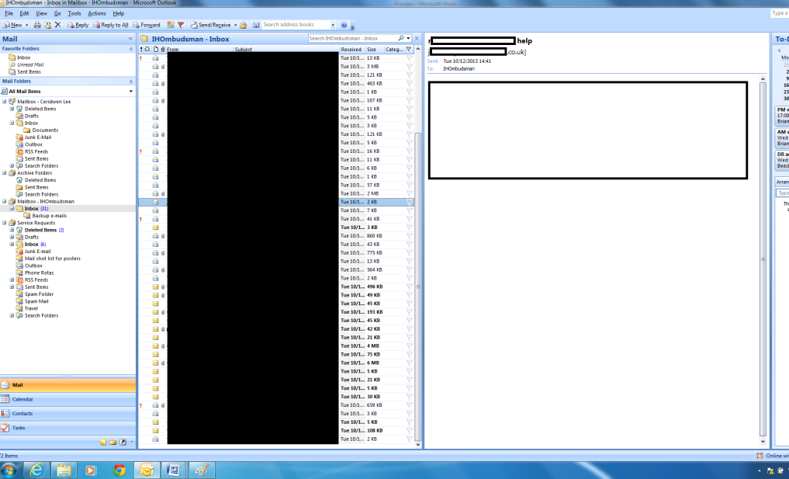
Back Up Email folder in shared view of @info inbox

- On Casework system “Incoming Email” section, emails that have been sent to Case work system must be attached to their related cases. To do this, select the email, type the reference number in the search box and click the “attach” button.

- Should an email be erroneously attached to a case, go into the case they were attached to and “Copy” the file to the correct reference number. Files cannot be deleted by administrative staff and will therefore remain on the case they were wrongly attached to. Therefore, the responsible caseworker should be informed of the files erroneously attached, in order to enable them to remove them.

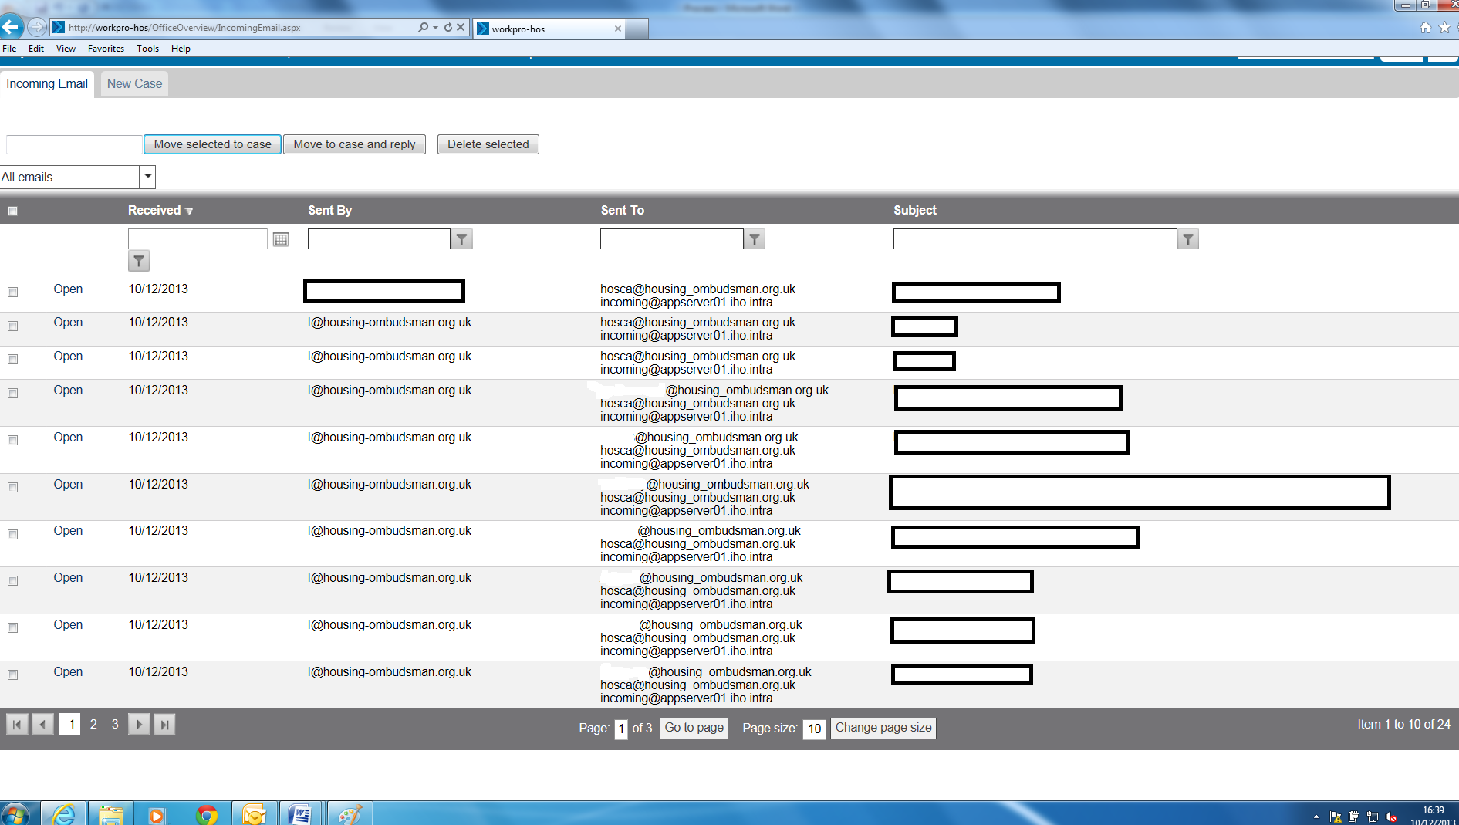
2. Type reference number here
3. Select “Move To Case”
1. Select email

Note
Caseworkers who are on Annual Leave should mark this on the General Office Diary. Their emails will then be printed and left on their desk, as well as forwarded to their personal email account and to Case work system if requested.

When caseworkers leave HOS or are on long-term leave: if their cases are at a point of LR1 or below, their emails are printed off and sent out with the new registrations to be reassigned. If the cases are at a point above LR2, they should be redistributed within the caseworker’s team – correspondence is printed and passed back to the team.

See Post Correspondence section
Complaint forms can be found on the shared drive: \\fileserver01\share\A transition\Corporate Identity
See New Registrations section of this processes document

