INVITATION TO TENDER

FOR

A COMMON SKATE SURVEY IN THE CELTIC SEA

Responses to be sent to:

Mrs Lisa Scott
Cefas
Lowestoft Laboratory
Pakefield Road
Lowestoft
Suffolk
NR33 0HT
lisa.scott@cefas.co.uk
Tel: +44 (0)1502 521349

To: Fishing vessel owner/ skippers
From: Stuart Hetherington

Tel: +44 (0)1502 527719

Date of issue: 24th August 2015
Response Deadline: 4th September 2015

SUMMARY OF REQUIREMENTS

- Cefas is seeking to commission a named fishing vessel for 7 days to undertake a common skate survey in ICES Division VIIe, VIIf and VIIh – ICES rectangles 27E2, 28E2 and 28E3.

- The vessel must be a netting vessel between 15 LOA to less than 24 m registered length and capable of deploying trammel/ tangle nets.

- The survey will take place during the second set of neap tides in September 2015, approximately 17th – 25th September 2015.

- The vessel must satisfy the accommodation, victualling and safety standards given within this Invitation To Tender.

- A single all-inclusive fixed price is sought for the provision of all the services required to cover Cefas staff including but not exclusively, the supply and repair of gear, crew, fuel, victuals, meetings and any additional insurance and accommodation. The price must include VAT.

GENERAL BACKGROUND

Once thought to be a single species, common skate is now considered to comprise of two separate species. This is referred to as the common skate complex (Dipturus batis complex). There are the larger bodied flapper skate (Dipturus cf. intermedia) and the smaller bodied blue skate (D. cf. flossada). It is generally thought that the flapper skate has a more northerly range in the deep water off the west of Scotland compared to that of the blue skate in the Celtic Sea area, with an overlap between the two species off the western Irish coast. The two separate species are yet to be formally recognised by the International Commission for Zoological Nomenclature (ICZN).
Under EU fisheries legislation, the common skate complex is classed as a Prohibited species, meaning that it cannot be targeted, retained, transhipped or landed. However, their size and aggregative nature make them hard to avoid and susceptible to bycatch, with the prohibition on landings leading to a high level of discards.
The fishing industry considers the prohibition of common skate to be a highly ineffective management measure and not in tune with what they encounter at sea. South-western fishermen believe the blue skate to be more locally abundant in several areas than the available science suggests. The Cornish Fish Producers Organisation (CFPO) suggest that the blue skate should not be listed as a prohibited species due to its common abundance within the South West fisheries.

Following the 2011 Fisheries Science Partnership common skate survey, and a second survey in 2014, additional Defra funds have been made available in 2015 for a further common skate survey to help better inform upon the most appropriate management of the common skate complex.

AIM
The primary aim of the common skate survey is to collect field data on the common skate complex in the Celtic Sea region. The data collected will assist Defra/Cefas in developing a robust case for more effective regional management of common skate in light of the new Common Fisheries Policy Landing Obligation and anticipated species split for common skate (formal recognition of the two species making up the common skate complex).

OBJECTIVE

Historically, the common skate complex had a much wider distribution in UK waters, than at the current time. Bycaught by several nations using fixed nets, beam trawls and otter trawls, there is some scientific evidence (albeit limited) and much anecdotal evidence that the population of blue skate extends over a large area of the continental shelf, extending from the Isles of Scilly, west and south west of the British Isles. A seasonal fishery-dependent survey in the Celtic Sea will be conducted to improve our knowledge of abundance, distribution and catches of common skate in relation to mixed demersal fisheries, whilst also increasing our biological understanding of the species.

REQUIREMENT

DETAILED SURVEY PLAN MEETING

The skipper is required to be available for a one-day meeting in early/ mid-September 2015. This will involve a discussion between the skipper and a Cefas scientist to jointly develop the details and structure of the survey activities. As much of the details as possible will be agreed at this meeting. A further meeting may be needed to finalise the Detailed Survey Plan agreed no later than the day before sailing. The vessel should be in a suitable port at the time and location of the meeting and available for inspection.

The tender must confirm the skipper’s and vessel’s availability for such a meeting.

VESSEL SPECIFICATION & ACCESS

The vessel must be a netting vessel between 15 LOA to less than 24 m registered length, capable of deploying trammel/ tangle nets.

The vessel must be capable of remaining at sea for a continuous period of 7 days.

The vessel must have a safe working deck area, well lit, with sufficient (6 m²) clear deck area to accommodate up to three scientists and their equipment.

Embarkation and disembarkation should be at a port giving appropriate access to the fishing grounds.

The tender must state the name, type and size of the vessel.

The tender must state the port, or ports, they would suggest for embarkation and disembarkation.

DATES, DURATION, FISHING GEAR & ACTIVITIES

Weather permitting, there will be one 7-day trip (7 consecutive days at sea), during the second period of neap tides in September 2015 (approximately 17th – 25th September 2015) These date and tide sets replicate the 2014 common skate survey, most closely. For the purpose of contingency, the next set of neap tides in early October 2015 would be the next available opportunity.
The fishing gear should be representative of the types fished by the southwest netting fleet, appropriate to the size of vessel, for the area and supplied by the vessel. An example specification of the gear type would be, but not exclusively, commercially rigged trammel nets (250–300 mm mesh size inners).

Trammel nets will be shot away in approximately twenty fishing locations, and soaked for approximately 24 hours, before hauling. The amount of gear shot in each of the survey locations will be agreed with the skipper in the Detailed Survey Plan.

The crew will be required to assist in the sorting and processing of the catch, as required by the Cefas scientists aboard, and to assist in the handling of the elasmobranchs (sharks, skates and rays) for training in the tagging and release of viable live discards, as well as biological sampling techniques, where appropriate.

There must be appropriate rest periods for the scientists which will be agreed in the Detailed Survey Plan.

No commercial fishing in addition to that specified in the Detailed Survey Plan will be allowed at any time during the period of the survey.

The tender must confirm that the fishing activities agreed in the Detailed Survey Plan will be undertaken.

The tender must confirm that no additional commercial fishing will be undertaken.

The tender must confirm that the crew will be willing and available to sort and process the catch, as described above.

The tender must confirm that the vessel, skipper and crew will be available for this period, excluding typical down-time for maintenance etc, reflected in typical commercial practice.

AREA OF OPERATION

The fishing area of operation showing ICES Divisions VIIe/f/h (black boundary lines), with the British fisheries limit as a blue line.
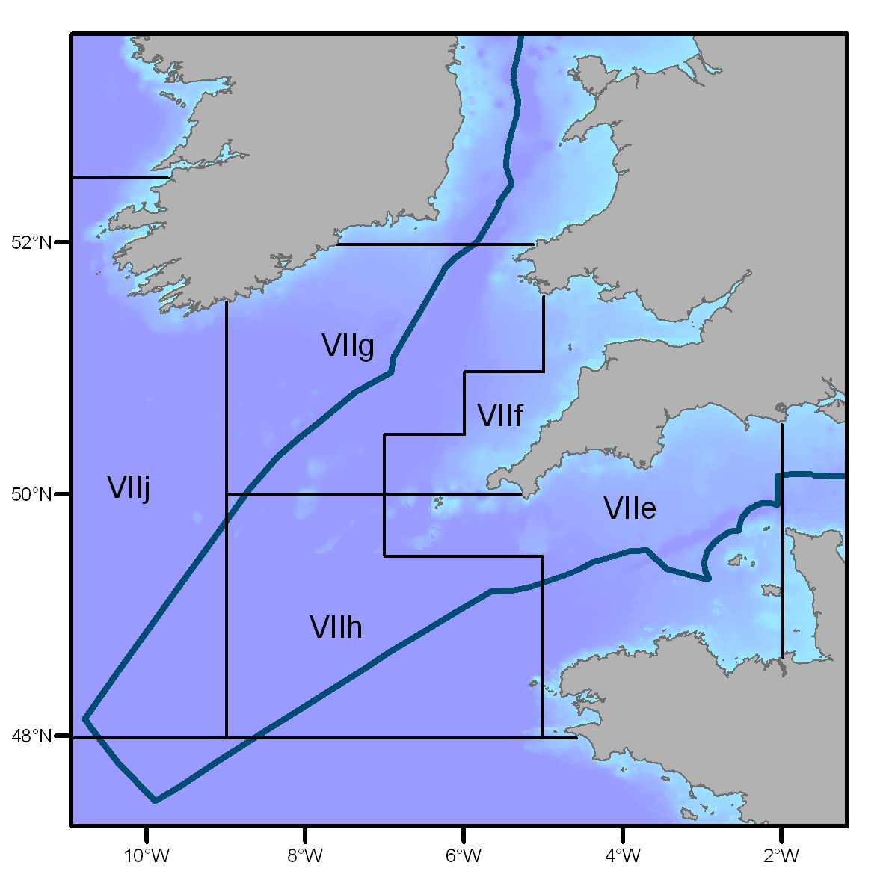

There will be approximately twenty survey stations over three ICES rectangles (27E2, 28E2 and 28E3) to be completed in the survey period.

The tender must confirm that the common skate survey will be undertaken in the area of operation.

SPECIAL PROVISIONS RELATING TO FISHING OFF-QUOTA

A dispensation will be sought by Cefas from the requirements to count landings of the main target species (e.g. monkfish) against quota for this project, so that all fish at or above legal marketable size can be landed and sold by the vessel’s owner. The vessel’s owner will retain the income from selling the fish. This income should be taken into account when pricing the tender. Only fishing agreed in the Detailed Survey Plan is permitted. Further, trips for scientific purposes do not count against a vessel's days-at-sea allocation.

A separate dispensation will also be sought by Cefas to allow the vessel to retain on board the elasmobranch (e.g. spurdog, porbeagle) catch, with those fish that cannot be tagged and released to be retained on board and/or landed for scientific study. These fish will not be landed for sale.

Paragraph 2 of Article 2 of EC Regulation 57/2011 requires that all catches from scientific investigations under dispensation shall be recorded and reported. Consequently, skippers will be asked to return a copy of the landings declaration, or a similar report, by species by TAC area.

It is considered very unlikely that dispensations will not be granted but in the event that this happens, the special provisions set out in this section will not apply.
Tenderers must declare in the tender whether they wish to tender in such circumstances and, if so, provide an alternative tender price for no dispensation.

EXPERIENCE

The skipper must be named and have a track record of fishing for mixed demersal fish in 2013 and/or 2014, using trammel/ tangle nets, of which there was a by-catch of common skate in the Area of Operation (see above). The skippers’ experience is crucial to the success of the project, and tenderers are encouraged to describe fully the skipper’s relevant experience. This will be a significant part of the tender evaluation.

The tender must detail the experience of the skipper as required above.

WORKING ENVIRONMENT

The vessel must be suitable for the area of operation and provide a safe working area, which will be dry, well lit under all sea conditions, and large enough (6 m²) to accommodate sampling equipment. The vessel must provide three clean, dry, single occupancy berths with mattress, and a separate lockable toilet and washing area for the scientists aboard.

The vessel shall provide food and bottled water.

The tender must confirm that accommodation standards above are met, and food and water will be provided.

SAFETY STANDARDS

a) Vessels that have a length of between 15 LOA - less than 24 metres registered length
must have and supply a copy of a valid Marine & Coastguard Agency Safety Certificate
issued by an appointed MCA surveyor after inspection to ascertain the vessels general seaworthiness and compliance with The Code of Safe Working Practice for 15m (LOA) to less than 24m (L) Fishing Vessels.

b) If a midterm inspection has been carried out by the MCA a copy of the report must be supplied.

c) A copy of the declaration for annual self-certification under The Code of Safe Working Practice must be supplied.

d) The vessel must have adequate marine insurance cover for the size of vessel, personnel on board and equipment. A copy of the insurance cover for the vessel and personnel on board including Cefas staff, must be supplied (Please detail your P&I and personnel insurance and financial limits on each).

e) The vessel must comply with the National levels of certification applicable to the area of operation and size of the vessel in respect of Deck officers and engineers.

f) All vessels must comply with the applicable code on safety equipment such as: Liferafts, lifejackets, distress rockets, flares, radio equipment and first aid consumables. The tender must confirm that the number of working lifejackets and life rafts, (where applicable to the vessel size) are adequate to cover both the ship’s personnel and Cefas personnel.

g) All crew on the vessel must have completed and hold the STCW certificates in (i) Personal sea survival techniques, (ii) Elementary first aid, (iii) Fire prevention and fire fighting and (iv) Personal safety and social responsibilities. The tender must confirm that all crew will have these certificates and they will be produced at the first planning meeting and prior to sailing.

h) The vessel must be Marine & Coastguard Agency coded in accordance with size of vessel and area of operation, including safe manning levels.

i) The MCA advises that it is good practice for vessels to have a written risk assessment.

j) Prior to contract award an inspection of the vessels lifesaving equipment may be carried out by a qualified surveyor. The tender must confirm the vessel will be made available for an inspection on the vessel’s lifesaving equipment.

k) The tender must confirm that there is a prohibition on the carriage of illegal drugs and alcohol, and that all crew members are free from any form of intoxication.
The tender must confirm that the skipper, crew and vessel meet the requirements of (a) to (k) above.

REVIEW OF THE SURVEY REPORT

The skipper will review and provide comments on the interim scientific report produced by Cefas within two weeks of receipt of the report.

The tender must confirm the skipper’s intent to either comment on or attend a joint meeting to review the report and results.

PRICE

In the tender, the tenderer must provide a single, all-inclusive fixed price for the provision of all the services above, including the supply and repair of gear, crew, fuel, any additional insurance and accommodation. The price must include a breakdown of VAT.

An alternative price, including a breakdown of VAT must be shown in the event that the special provisions relating to fishing off-quota are not granted.

OTHER CONSIDERATIONS

Cefas reserves the right to choose those individuals that it considers to be fit and proper persons for participation in the common skate survey. Cefas requires applicants to provide any information they consider relevant to its decision. An example of information that may be contained in such a statement is whether they have been shown not to have complied with fisheries legislation in the past 12 months. In making its decision as to whether applicants are fit and proper persons for participation in the common skate survey, Cefas will consider all relevant information available.

EVALUATION

The tender seeks to ensure delivery of the agreed science at an affordable price, so providing good value for money. All tenders will be evaluated and scored, and the highest scoring tenders, meeting all the criteria and offering best value for money, taking into account delivery and affordability will be selected, as funds allow.

Vessels may be subject to inspection prior to award of a contract. Cefas reserves the right not to fund any project or award any contract.

AWARD

Successful bidders will be expected to agree and sign a basic contract, detailing;

- Commencement and duration;
- Contracted work as detailed in this Invitation To Tender;
- Key personnel and vessel;
- Price and Payment arrangements;
- Terms and Conditions.

If the preferred tenderer fails to agree the contract within a reasonable period, then the next preferred tenderer may be approached or Cefas may decide not to continue with the project.

QUERIES ABOUT THE TENDER

Clarification of the tender requirements can be given. Please contact the Cefas Procurement Manager on 01502 521349 or lisa.scott@cefas.co.uk. Alternatively, please contact:

Stuart Hetherington at stuart.hetherington@cefas.co.uk or 01502 527719.

Please be aware that we will make clarification questions and answers available to all bidders.

TIMETABLE

Tenders must be delivered to Cefas by 17:00 Friday 4th September 2015. Late submissions will only be considered if the tender envelope is post-marked before this date.

Tenderers will be informed of the results as soon as possible.

SPECIAL PROVISIONS RELATING TO THE SAFETY OF TAKING SCIENTISTS TO SEA

The tender evaluation and contract award procedure will seek to ensure that the vessel and crew can ensure the safety of Cefas staff, and, accordingly, a survey may be made prior to contract award and at any time thereafter. There may be a delay between contract award and the actual fishing survey, and Cefas staff will be under instructions to ensure that all standard safety items and procedures are adequate before each sailing. It is a requirement of the MCA for the skipper to give an explanation to Cefas scientists of the vessel risk assessment and health and safety regime, including the stowage and use of life saving appliances, the procedures in an emergency and escape routes before embarking on the voyage, this requirement will be made clear when discussing the Detailed Survey Plan. Safety drills shall also be carried out prior to departure. If safety items and procedures are not as specified in the contract documents at the time of sailing, then the scientists will not sail and the Contractor will be deemed to be in breach of the Contract.
If the vessel is not fishing commercially during the period of the contract, in accordance with the Marine and Coastguard Agency, Guidance for the Survey and Inspection of Fishing Vessels, Chapter 1 Annex 14 , the names of the "scientists" should be added to "list of crew" for fishing vessels of 40 feet (12.2 metres) and over but less than 80 feet (24.4 metres) in length and should be added to the list of "Exempt Crew", form ALC(FSG)1(b) for fishing vessels of 80 feet (24 metres) and over in length. Vessels fishing commercially shall still comply with the relevant regulations for their size of vessel.

All operations for this contract need to be compliant with the obligations set out in MCA guidance MSIS 27 Chapter 1 Annex 14 or 15.

SUBMISSION OF THE TENDER

Provided below is a template which can be used to tender for the above work. It is not obligatory to use this template but all requirements detailed above must be covered in the tender submission, along with a statement of financial standing to support the "other considerations".

Failure to provide the requested information may result in disqualification of the tender.

One copy of the tender must be submitted to:

Mrs Lisa Scott
Procurement Manager
The Centre for Environment, Fisheries & Aquaculture Science
Lowestoft Laboratory
Pakefield Road
Lowestoft,
Suffolk
NR33 0HT
UK

The tender should be returned in a stamped envelope. To ensure confidentiality of the tenders the envelope must not bear any details indicating the name of the sender but must show on the outside a project reference such as Common Skate Survey – Tender application.

Common Skate Survey 2015

Submission of tender

Name of tenderer
Address
Daytime telephone
Mobile telephone
Email address

Name of vessel
Type of vessel
Length of vessel
Vessel registration number
Skipper
Port of operation

Confirmation that | YES/ NO
The vessel, skipper and crew will be available for the duration of the survey.
The skipper and crew will contribute to, develop and undertake the Detailed Survey Plan.
The skippers and crew undertaking the common skate survey will contribute fully and take part in all activities, conducting the required fishing in the given area and that no additional fishing will be undertaken.
The survey will be undertaken in the specific area of operation.
The skipper & vessel will be available for a port visit by a Cefas scientist &/or qualified surveyor before a successful Contract Award
All accommodation, food, water, safety and insurance requirements are met
Copies of the vessels MCA certificate, mid-term inspection report, annual self-certification & insurance certificate are supplied and enclosed
The skipper will be available for meetings and will comment on the survey report

EXPERIENCE:

FISHING GEAR TO BE SUPPLIED, SPECIFICATION & DIMENSIONS:

As part of the vessel safety assessment, all tenderers are required to complete the 3 tables below on vessel details, emergency equipment & radio/ navigation equipment.
VESSEL DETAILS
Vessel name
Call sign
MMSI
Small Ships Reg no.
Hull colour, upper
Hull colour, lower
Hull colour, deck
Length (m)
Beam (m)
Draught (m)
Make/ model
Max No. of persons aboard
VCU
MCA code no.
MCA code expiry
SVC code no.
SVC code expiry
Approved sea area
Approved water categories
Lifting equip register
Speed (kts)
Engine (hp)
MFV ID
Fuel type
Insurance company
Insurance expiry
Type of cover
Value of cover
EMERGENCY EQUIPMENT*
Equipment | Yes/ No | Quantity | Type / location | Expiry
Life raft
Flares
Life rings
EPIRB (406)
EPIRB (121.5)
SART
PLB(s)
Life jackets
First Aid Kit
Fire extinguishers
Fire blankets
Automatic Fire Suppression Engine Room
Emergency lighting

RADIO & NAVIGATION EQUIPMENT*

Equipment | Yes/ No | Type | Location
Chart plotter
VHF
MF
HF
Sat phone
DSC
GPS
AIS
Radar reflector
Radar reflector

*It is recognised that not all vessels will be required to have the emergency/ radio/ navigation equipment that is listed.
OTHER CONSIDERATIONS:

PRICE

FIXED COST (Dispensation granted) | Number of days | Day rate  (net cost) | VAT | Total price including VAT
Vessel & services |  | £ | £ | £
Meetings | 1 | £ | £ | £
Total Cost |  |  |  | £

FIXED COST (No Dispensation) | Number of days | Day rate  (net cost) | VAT | Total price including VAT
Vessel & services | - | £ | £ | £
Meetings | 1 | £ | £ | £
Total Cost |  |  |  | £

Signed: | For (Company Name):
Name:  (Block Capitals) | Date:
Name of contact to call in the event of a query (if different from above): | Direct telephone number of contact:

