Expression of interest

Title: Barriers to political representation: disability and the EnAble fund
Project reference: GEO2018/03
Deadline for expressions of interest: 1pm, Monday 15th October 2018

Summary
Expressions of interest are sought by the Government Equalities Office, to conduct research on barriers to political representation for people with disabilities and to examine how the EnAble fund has been used to support disabled candidates in local elections by meeting the disability-related expenses they face.
The research will involve a rapid evidence review, research with disabled MPs, councillors and people who have considered putting themselves forward for selection/election, research with the EnAble administrator, applicants and recipients of the EnAble fund and collation and analysis of the EnAble fund monitoring data.

Background
In May 2018, Penny Mordaunt, Minister for Women and Equalities, announced an interim fund (the EnAble fund) of up to £250,000 to support disabled candidates, primarily for the forthcoming English local elections in 2019.
The interim EnAble fund will support disabled candidates in local elections by meeting the additional disability-related expenses they face. The fund is an interim measure for the next 12 months, while a long term solution led by political parties, is being established.
The fund has been set up to support the local elections in England in 2019 (2nd May 2019, 192 District, 36 Metropolitan and 52 Unitary local authority elections in England + 4 Mayoral elections).
The LGA have agreed to oversee the delivery of this money, via their four Political Groups (Conservative, Labour, Liberal Democrat and Independent – made up of smaller parties and independents), with support provided by a commercial scheme administrator, which the LGA will tender through an open and competitive process. This a new model of delivery and there is particular interest in how this model works. The group offices oversee elections and membership of LGA Boards, Committees, Forums and Commissions, and act as a secretariat for the work of their group.
We are expecting in the region of 100 applications to the fund.

Project aims
The research will provide political parties and government with i) information on the barriers people with disabilities face and how these could be addressed and ii) information on how the interim EnAble fund has been used and the outcomes achieved by recipients of the fund.
The research will
- outline the barriers disabled candidates face
- highlight strategies that can be used to address the barriers
- highlight the extent to which recipients of the EnAble fund felt it helped them to address the barriers they faced
- show the types of adjustments that could be made to support disabled people to gain electoral office
- provide information on how the EnAble fund was used and the operation of the fund model (Political Groups having the final say)
- provide case studies that can be used in Comms to show how MPs and Councillors with disabilities have successfully overcome barriers they faced

Methodology
We expect the project to involve the following elements.
Barriers and strategies for success
- A rapid evidence review to examine barriers disabled people face when seeking selection and election at national and local level (England). This will synthesise the existing research on this subject (from the UK and international) and enable us to identify common themes from wider research on under-represented groups and in different contexts, such as in Scotland.

- Qualitative research focussing on barriers faced and strategies used (or attempted) to overcome these. This will involve interviews with the disabled people from a balance of political parties and independents:
  - MPs
  - Councillors
  - People who have considered putting themselves forward for selection/election but ultimately decided against it or withdrew or who campaigned but were not elected
GEO will provide support to identify a sample of participants with a broad range of disabilities using an intersectional approach.
This element of the research will complement the rapid evidence review by identifying if barriers reported in other contexts are also relevant to the English electoral system and at local and national level. It will also provide data to inform the development of case studies to provide role models and examples of how difficulties have been overcome.
Research examining the EnAble fund
- Research with all recipients of the fund focussed on their experience of applying and receiving the funding, what they used the funding for, the difference they feel the funding has made, outcomes from the funding. This could involve an online survey of all recipients followed by in-depth interviews with a small sub-set of respondents.

- Research with unsuccessful applicants focussed on their experience of applying for the fund, the perceived impact of not receiving the funding, what they did next. This could again involve an online survey.

- In-depth research interviews with the fund administrator, focused on how the fund has been implemented and the lessons learnt.

- In-depth research interviews with the four Political Groups focussed on their experience of making decisions on applications, how the process worked and their experiences supporting disabled applicants. This is a new element of the fund so more in-depth information on how this has worked will be useful.

- Collation and analysis of monitoring data. Monitoring data will be collected by the fund administrator and will form part of their contract.
Outputs
- Interim research report containing:
  - Synthesis of the evidence on barriers to electoral representation due to disability
  - Findings on barriers faced by disabled MPs, councillors and candidates and their strategies to overcome them
  - Case studies on strategies used to overcome barriers faced by disabled MPs, councillors and candidates

- Presentation at a workshop with stakeholders in March 2019 on the findings from the qualitative research, with a focus on barriers and strategies for success.

- Final report for publication. As the interim report but with the findings on how the EnAble fund was used and the outcomes achieved .
The fund will be demand-led and will be closed once the fund is exhausted or in March 2020, whichever is sooner. This will impact on the phasing of the fieldwork. The appointed research contractor will need to time fieldwork according to the flow of the fund awards.
The research will need to include people with a range of disabilities (visible and invisible) and recognise the distinct and broad range of issues/barriers people with different disabilities face. The methodology will need to be adapted to meet the specific needs of individual participants.
The appointed contractor will need to follow best practice for research with people with disabilities (e.g. guidance has been developed by the Office for Disability Issues).

Timing

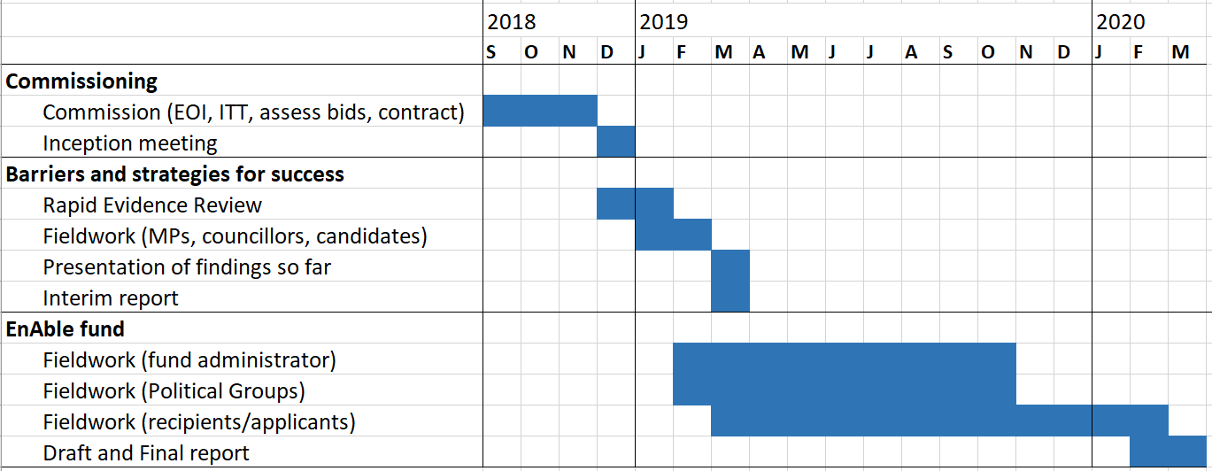

Budget
The budget for this work is £50,000. We are not expecting costs to be provided at this EOI stage.

Assessment criteria
- Relevant experience/expertise (subject matter expertise and experience): 33%
- Capacity to undertake the research (adequate numbers of staff with appropriate skills): 33%

- Professional/technical ability (expertise in the methodologies to be applied and ideally experience of research with people with disabilities): 33%

Closing date for EOIs: 1pm, Monday 15th October 2018
Send your EOI form to: sarah.barker@geo.gov.uk

How to submit an expressions of interest
You must submit an expression of interest (EOI) in order to be considered to be invited to tender. To do so, please complete the NEW EOI Form which can be found under attachments. A submission of an EOI does not guarantee an invitation to tender and the Department does not routinely advise organisations that they have not been successful in being invited to tender. Feedback is however available on request.
All contracts are let on the basis of the Department’s Terms and Conditions. You are encouraged to check these before submitting your expression of interest, as these form part of your contractual obligations.

© Crown copyright 2018

https://www.parliament.uk/business/publications/written-questions-answers-statements/written-statement/Commons/2018-05-17/HCWS695/
https://assets.publishing.service.gov.uk/government/uploads/system/uploads/attachment_data/file/321254/involving-disabled-people-in-social-research.pdf

