

London Borough of Havering

Guide for Registering as a

Prospective Supplier

to the Council

The purpose of this guide is to provide suppliers with details in how they can register as a prospective supplier on the Councils supplier portal.

As a prospective supplier, suppliers will be able to view and respond to tender opportunities but cannot, whilst a prospective supplier, receive purchase orders or be paid by the Council, for purchase orders and payments a supplier needs to be promoted to Spend Authorised. The process of promoting a supplier to Spend Authorised can depend on:

* a supplier successfully being awarded a contract
* the Council selecting to do business with a supplier, typically for low value purchase orders

To register as a prospective supplier there are 7 steps as shown below, if you have any questions regarding the process please contact [fusion.sourcing@onesource.co.uk](mailto:fusion.sourcing@onesource.co.uk)

**Step 1 – Company Details**

In this section add your core details plus additional information relating to business type.

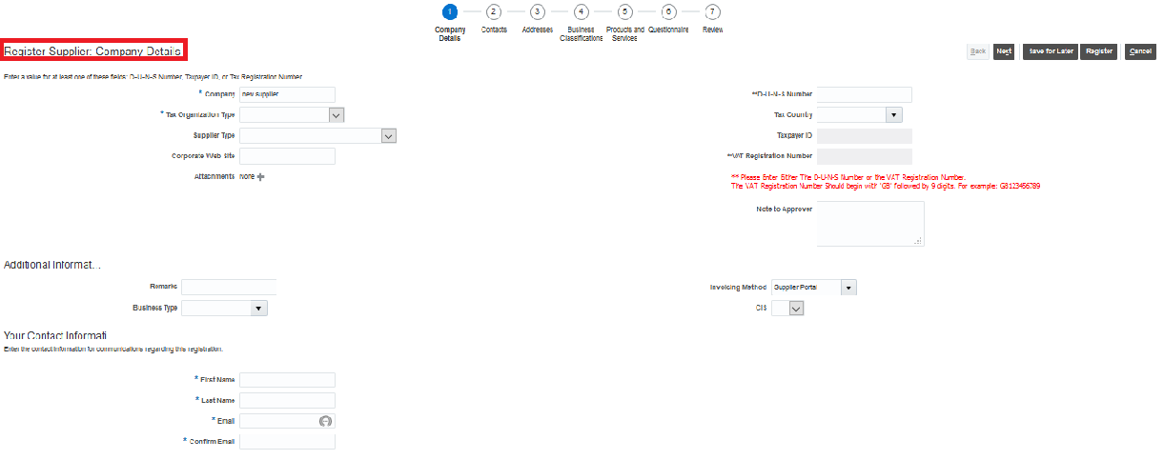

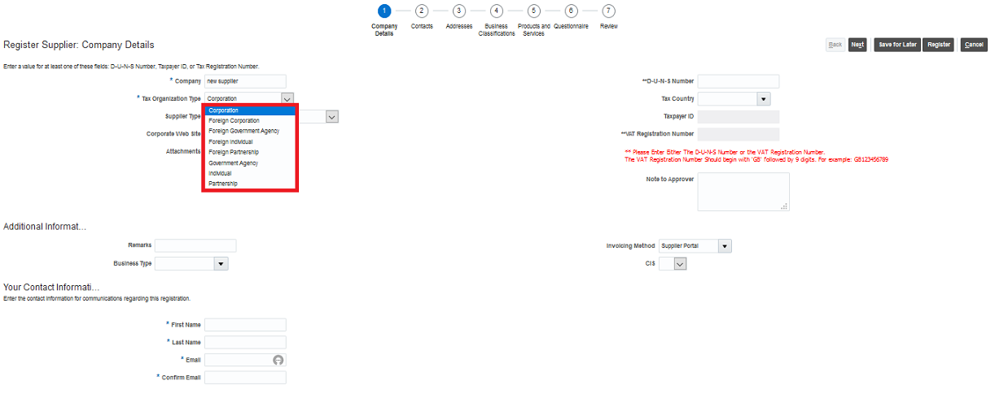

Select the drop down Tax Organisation type and select from the options the type that best describes your organisation.

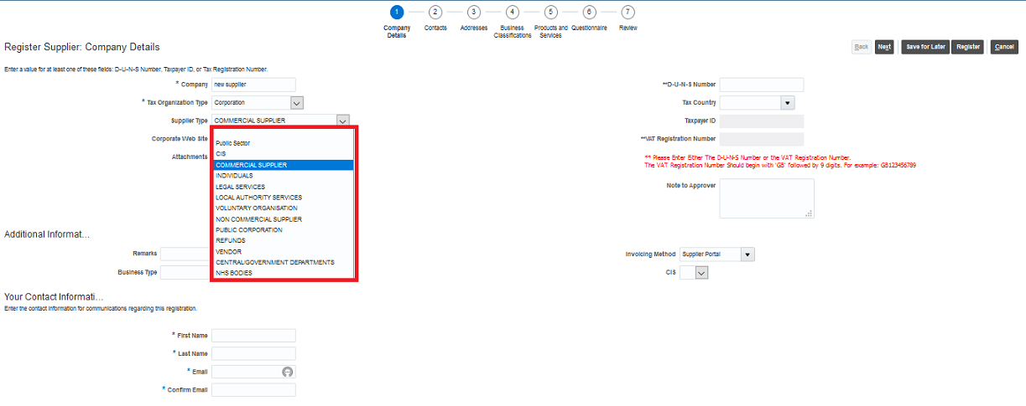

Select the drop down Supplier Type and select from the options the type that best describes your organisation.

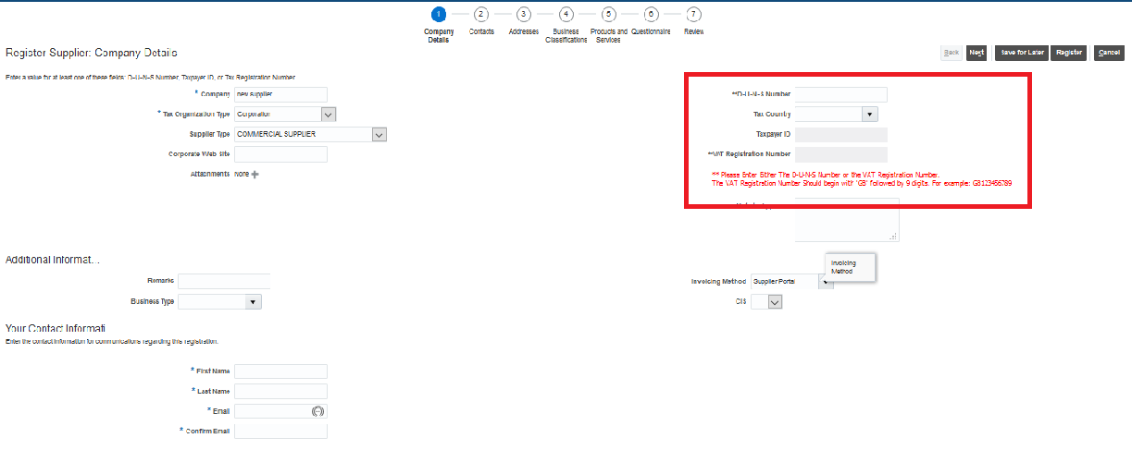

Add either your DUNS number or your VAT registration number as instructed, note – if the system recognises that either number has already been used you will not be able to proceed as an account already exists for your organisation.

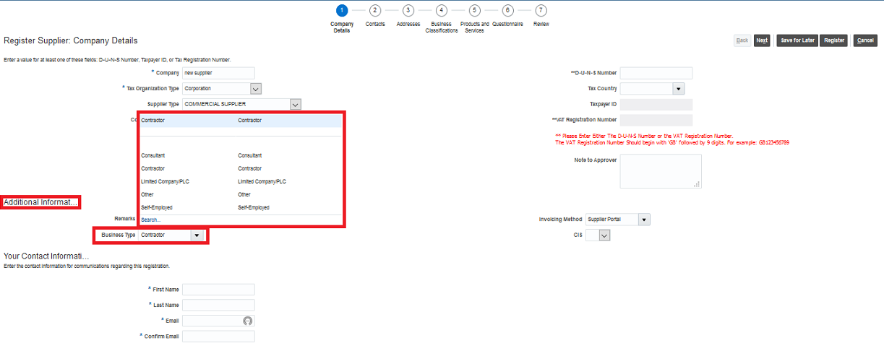

Select the drop down Business Type and select from the options the type that best describes your organisation.

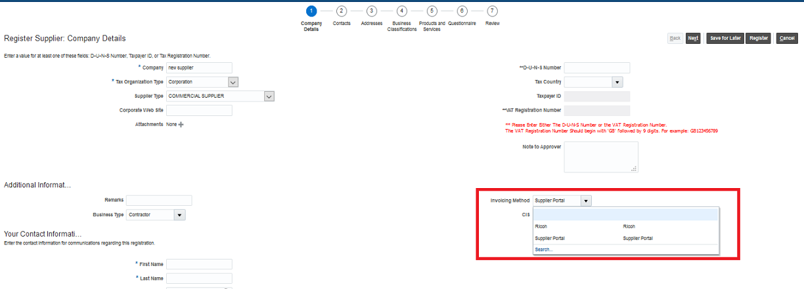

Select the drop down Invoicing Method and select from the options how you will submit your invoices – note the Councils preferred method is via the supplier portal, the reference to Ricoh is the scanning option.

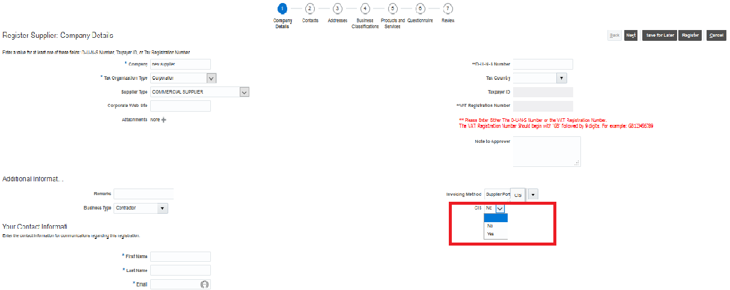

Select the drop down and answer if you are a registered Construction Industry Scheme (CIS) supplier.

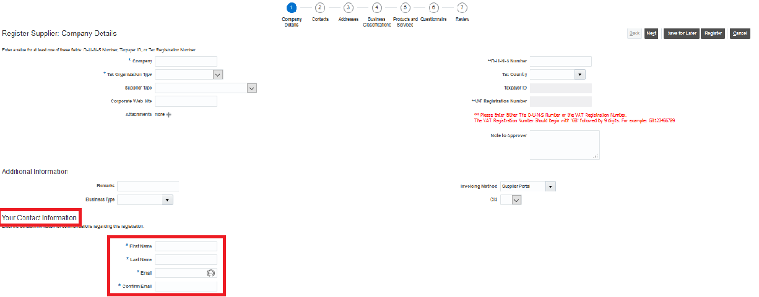

Provide your details

Click next to continue

**Step 2 – Contacts**

In this section you can add addition contacts for your organisation.

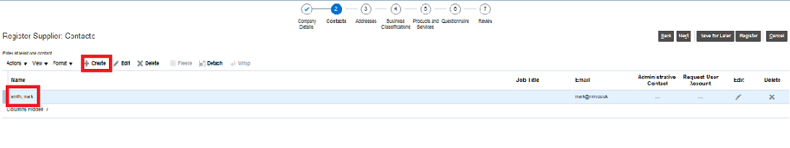

Click create to create another user account, the account shown was created in step 1

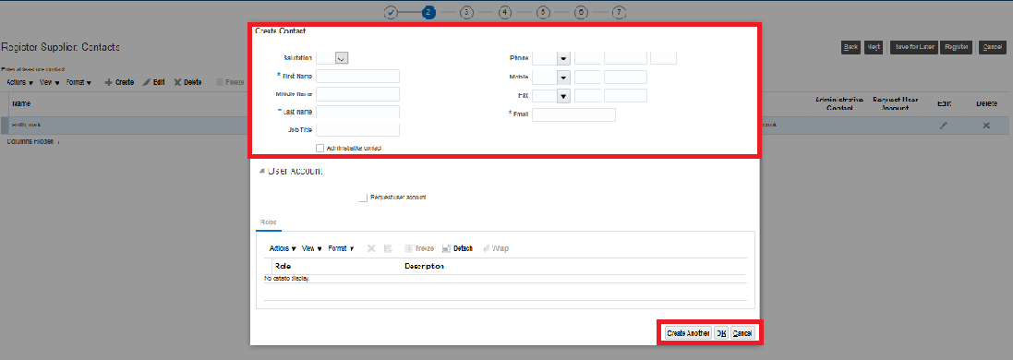

Complete section and click ok – note you can repeat this step to add additional contacts as required.

Click next to continue to next step.

**Step 3 – Create Supplier Address**

In this section you can add addition addresses for your organisation.

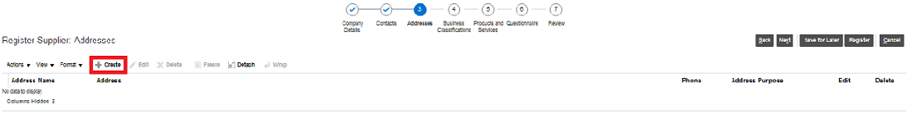

Click create

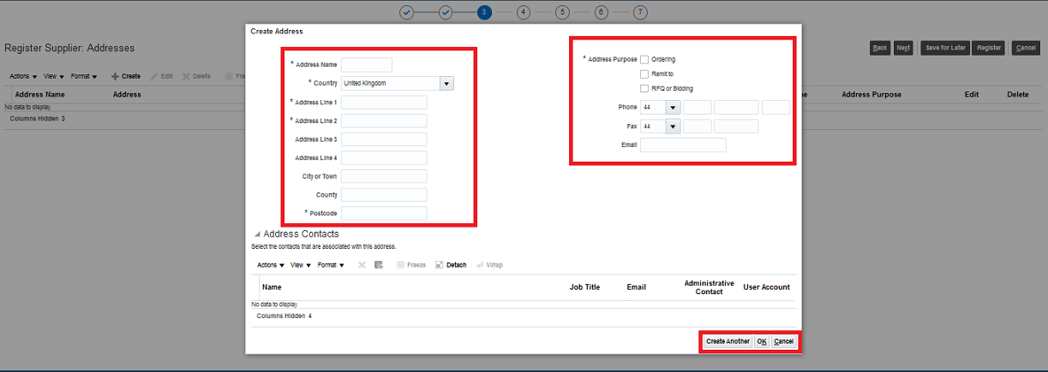

Complete section and click ok – note you can repeat this step to add additional addresses as required.

Click next to continue to next step.

**Step 4 – Business Classification**

In this section add the description of your business classification.

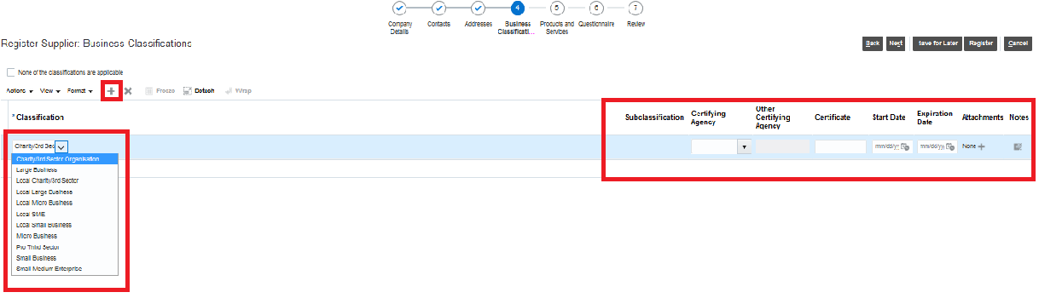

Click on the + icon and use the drop down to select the business classification that best describes your organisation, please note that you can repeat these steps if you feel your organisation is represented by additional classifications.

A local supplier is described as an organisation that is based in or operates predominantly from a base with the Boundaries of the Authority/Council.

The information on the right hand side is only applicable if your business classification is linked to being certified by an external organisation/body - otherwise this is not required.

For clarification the Council is using the following to classify the size of an organisation/company

* micro enterprises: with less than 10 employees
* small enterprises: with 10-49 employees
* small and medium sized enterprises (SMEs): with 1-249 employees
* large enterprises: with 250 plus employees

Click next to continue to next step.

**Step 5 – Products and Services**

In this section add the description of your products and services.

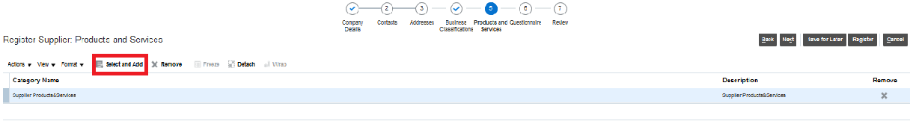

Click select and add

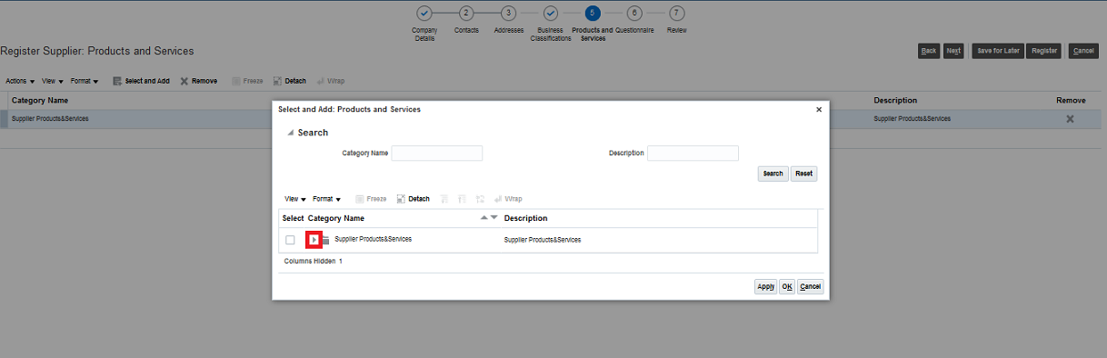

Click on the icon as above to open the options

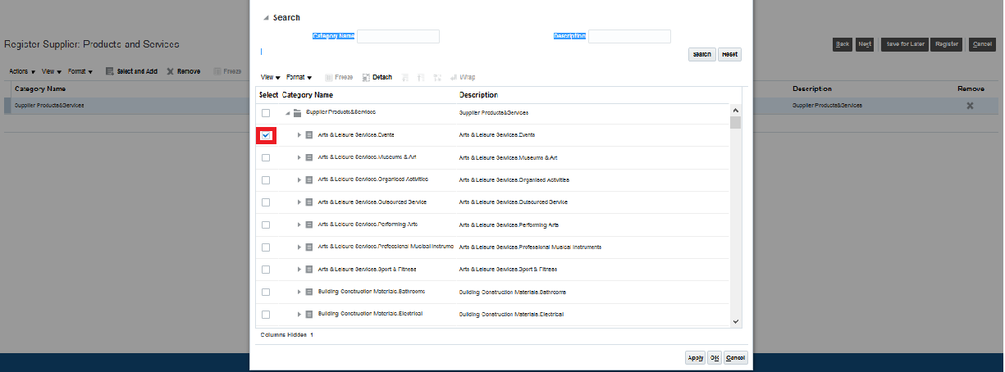

Click on the category that best describes the goods/services you provide to the Council, click apply and ok to save – note if you provide a range wide of goods and services you can add additional products and services.

The Council is using Pro Class to classify/map the products and services purchased, further information on Pro Class can be found here <https://proclass.org.uk/>

Click next to continue to next step.

**Step 6 – Supplier Questionnaire**

In this section complete the supplier questionnaires.

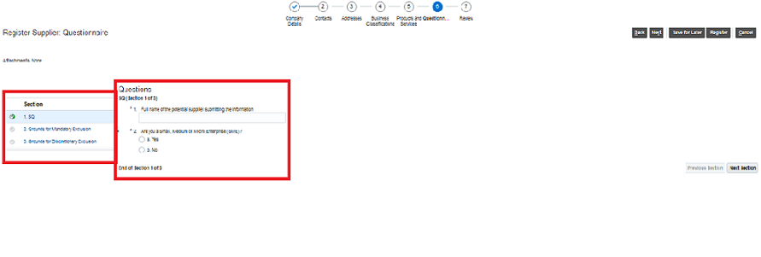

Complete the SQ, note – this information is required even though it has been provided in earlier sections.

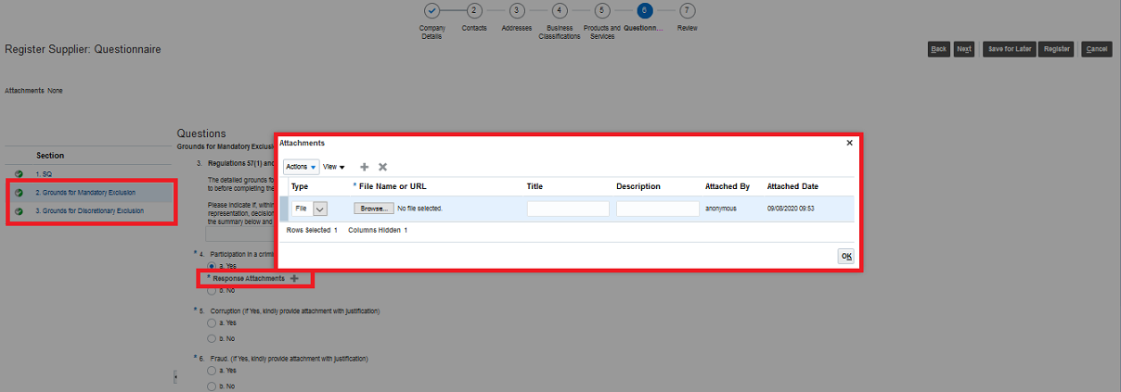

Please complete all questions in sections

* grounds for mandatory exclusion
* ground for discretionary exclusion

if you are asked for additional information please attach a statement using the example above.

Click next to continue to next step.

**Step 7 Review**

In this section you can review your submission prior to submitting your registration.

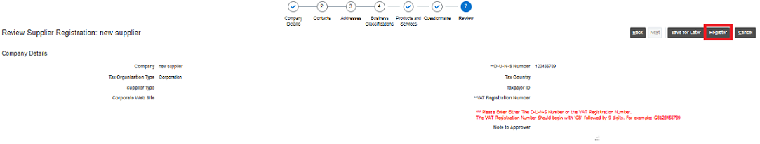

Review your submission and click register if you wish to proceed and register as a prospective supplier with the Council.