Version 1, 24th March 2014

NHS Standard Contract
Service Specification
West London Whole Systems Integrated Care – My Care, My Way
Rapid Learning and Organisational Development Process – Refinement of the Model of Care

SCHEDULE 2 – THE SERVICES

Outline service specification for Integrated Care provided directly to patients.

Mandatory headings 1 – 4: mandatory but detail for local determination and agreement
Optional headings 5-7: optional to use, detail for local determination and agreement.

All subheadings for local determination and agreement

Service Specification No.
Service | Whole Systems Integrated Care Programme (MCMW) – Rapid Learning and Organisational Development Process – Refinement of the Model of Care
Commissioner Lead | Jayne Liddle Assistant Director – Whole Systems
Provider Lead
Period | May 2017 – August 2017
Date of Review

1. Population Needs and Service Requirements
My Care My Way (MCMW) builds on the CCG Programme around a whole systems model of care working with people aged 65 and over with complex needs and conditions. The person is at the centre of holistic care planning across organisations such as health, social care and the voluntary sector. This way of working is a better, more coordinated way of providing care for people aged 65 and over with long term conditions in West London and requires people with commitment and passion for working with older people.
MCMW was developed in response to a number of key national and local drivers including patient feedback, the NHS 5 Year Forward View, increasing demand and the changing health and social care landscape in NW London. It was developed over a 2 year period and has been operational for approximately 12 months.
MCMW puts Patients are at the centre of the model, and in partnership with health and social care professionals, including GPs, Case Managers, Health and Social Care Assistants, they are fully involved in the development of a care plan that meets their holistic needs and supports them to maximise their wellbeing and help them to achieve outcomes they identify.
My Care My Way enables integrated care to be delivered from GP practices; in dedicated integrated care centres and also in patients’ own homes. Patients are also signposted to multiple third sector services that deliver multiple services and activities to support health and wellbeing.
MCMW has two Integrated care centres, with 24 GP practices currently participating and another 20 to join at a future date. There are currently around 50 newly recruited staff: Case Managers providing care coordination from diverse backgrounds (health/social work), HSCAs trained to cover variety of health, social work, care navigation and prevention tasks.
MCMW requires a multi-organisational shift to planning for anticipated care needs as well as reactive care and crisis management.
My Care My Way (MCMW) is an holistic approach to providing care to people and comprises the following key functions:
- Risk Stratification and selection of appropriate service users for active care planning.
- Holistic assessment for both health, social and wellbeing needs
- Person centred care planning
- Care Coordination.
- Patient centred multidisciplinary team working, supporting appropriate urgent care responses

MCMW embeds primary care led anticipatory, multi-disciplinary (including the voluntary sector services) assessment, coordinated care planning and review principally for people aged 65 and over, with long-term conditions, multiple frailty factors and at risk of crisis care or non-elective admission. It is achieved by using six key elements:

- Centred around the holistic needs of service users and their carer(s), involving them in all decisions while providing simpler access and a shared care plan
- Personalised and tailored to changing health as well as social needs, covering planned as well as reactive needs and one that empowers self-care
- Has a clear point of accountability (both for clinical & non-clinical outcomes) with a core team that reflects users’ needs and helps coordinate their care
- Is supported by a number of local operational whole systems bases (hubs) where joint teams work on a day to day basis coordinating the care and tracking outcomes
- Helps coordinate the services (via the base/hub) as needed from different organisations, on behalf of the service users and their carer(s)
- Is brought together by shared cultural values & ethos, with organisations working towards a Partnership that is commissioned to a single set of outcomes and is enabled by shared systems & incentives

The objectives can only be achieved through effective multi-disciplinary working and efficient interfaces between various co-located service providers in hubs. This is the critical success factor in successfully delivering the services set out in this specification.

2. Outcomes
2.1 NHS Outcomes Framework Domains & Indicators

Domain 1 | Preventing people from dying prematurely | √
Domain 2 | Enhancing quality of life for people with long-term conditions | √
Domain 3 | Helping people to recover from episodes of ill-health or following injury | √
Domain 4 | Ensuring people have a positive experience of care | √
Domain 5 | Treating and caring for people in safe environment and protecting them from avoidable harm | √

2.2 Local defined outcomes

Strategic Priorities

Individual Empowerment and Self Care
Access, Convenience and Responsiveness
Care Planning and Multidisciplinary Care Delivery
Population- and Prevention-oriented
Safe and High Quality
West London CCG Corporate Objective :- Integrating Care Out of Hospital
Developing and implementing Whole Systems Integrated Care, centred around the holistic needs of the service users and their carers

3. Scope

3.1 Aims and objectives of service

The aim of the service being commissioned is to provide Organisational Development to support the delivery of the full Model of Care in a number of exemplar teams. Working with multiple agencies to refine and test and refine again the Model of Care. This rapid learning process “Rapid And Small-scale Change Assessment Loops in which frontline staff and managers are empowered to make operational adjustments to the model of care to overcome barriers and achieve better outcomes, the impact of these adjustments are then monitored which informs further change as required through further rapid iterations” (Greenhaigh T, How To Implement Evidence-Based Healthcare, Wiley 2017) will ultimately lead to an enhanced Model of Care which can then be rolled out across the entire programme. It will enable commissioners to develop an alliance approach with providers to deliver the model of Care which can then be adopted to deliver a range of outcomes agreed across the alliance.

The overarching objectives of the OD approach are:

- To create and open and honest culture which supports people to be courageous in delivering better health outcomes
- Every individual member of the My Care My Way team and the wider community partners to understand their role and work towards a common purpose
- The organisational structure of the My Care My Way programme is clear and meets the highest standards of governance and enables WLCCG to achieve its strategic vision.
- This programme will assist in the refinement of the Model od Care, developing partnership working with the knowledge, skills, behaviours and qualities required to deliver the transformational changes required to meet future needs.

The main objectives are:

- To work with 6 practices as leaders across the patch as part of the rapid learning environment and to be exemplar practices going forward.
- Rapid improvement - The model of care is enhanced and refined, becoming a dynamic model that continues to improve even after the end of this piece of work. This brings to life the model we co-designed in advance, without the benefit of seeing our how our design works in practice. Our model is much more ambitious than the changes we have made so far, so we need an engine of change to propel us towards the full vision.
- Empowering the frontline - That the above outcomes are achieved because frontline staff are empowered to learn and on the basis of this learning make appropriate changes themselves and refer up other recommendations for quick decision.
- Building high performing teams - our staff involved in MCMW have a consistent understanding of their and each other’s roles, properly form as a team and are able to work together in new ways.
- Once all the above outcomes have been achieved, we use the demonstrably successful model and enthusiastic staff from exemplar teams to further roll out the model of care to clinicians and staff not currently involved or fully engaged.
- To provide intense support to this group of exemplar teams to fully embed the new model of care.
- To facilitate multi-disciplinary and user reflection on the model of care as it is working at the moment at both practice and integrated care centre level
- To make the work challenge based. The challenge will be chosen from the list by the teams with rapid learning techniques centred on a different challenge for each team.
- To identify the barriers and changes that can be implemented at practice and partnership level to improve the model of care, facilitating shifts in mind sets and behavioural patterns that unstick thinking and behaviours and generate new ways of working.
- To facilitate any changes be to applied once tested and prototyped
- To identify how to strengthen the clinical team and leadership to support the MCMW programme and enable it to challenge itself.
- To facilitate exemplar teams to have difficult conversations with GPs and other providers who have not yet ‘brought in’ to the model of care, with evidence and stories of success.
- Establishing spaces for thinking, reflecting and learning together which develop on going OD capability and robustness to handle change in the future.
- To assist in the development of likely outcomes for the Model of Care.
- To assist in the development of the costs of the refined Model of Care at both local and programme level.
- To facilitate practices involved to share learning across practices and explore opportunities for closer collaborations between these practices.
- To work closely with the MCMW Evaluation team

Work already done:
- Exemplar practices have been chosen to act as leaders throughout the process
- Agreement on the time commitment from practice and MCMW staff
- Backfill of GP/Practice staff costs agreed
- Common understanding that the exemplars practices will be part of the team disseminating the learning across primary care in West London

The problem we are trying to solve:
- Engagement with partners around the rapid learning process

3.2 Service description/care pathway

The rapid learning process is designed to focus on some key challenges that have been highlighted in the first 12 – 15 months of the MCMW programme. During this time more than 3,750 patients have been referred into the service. The most complex and vulnerable older adults (65 and over) have been actively case managed by the CMs and HSCAs. As with any new programme of work/service there can be a variety of issues, including operational, strategic etc. it is imperative for the success of this programme that we can improve the effectiveness of particular relationships, reducing non-elective admissions, improving patient’s outcomes and experiences

The pathway process will look to improve working at Practice Level, for example,
The working relationship between MCMW and Practice based staff, maximising the effectiveness of MDT work within the Practice, reducing duplication and improving the patient’s outcomes and experience
The pathway process will look to improve working relationships between MCMW and Partner Organisations, for example,
Adult Social Care and MCMW/Practices, reducing duplication and improving the patient’s outcomes and experience
District Nursing, the Community Independence Service and MCMW/Practices, reducing duplication and improving the patient’s outcomes and experience
Older Adult/ Geriatrician Services and MCMW/Practices (e.g. using IT more effectively in shared care)
The relationship between Community Living Well Service and MCMW/Practices, reducing duplication and improving the patient’s outcomes and experience
The pathway process will look to improve working at Integrated Care Centre Level, for example,
How to refine and improve the work at the Integrated Care Centres, maximising the efficiency and effectiveness of the MDT, reducing duplication and improving the patient’s outcomes and experience
We understand that the challenges listed above are not simple and developing solutions for all at once could be overwhelming and the outcomes will vary with each challenge, however we expect the pathway process to focus on the following areas:-

- Develop a programme of rapid learning and adaptation for the practices and MCMW staff in a structured way
- Understand the barriers to effective MDT working and system-wide implementation of the MCMW model of care, using the challenge areas identified by exemplar teams as a focus of rapid improvement and learning
- Explore opportunities across exemplar practice sites for joint learning and closer collaboration

We appreciate that the refinement and further development of the model of care in the selected practices will bring solutions and could potentially present new challenges. The provider will be expected to work with the exemplar practices to disseminate the solutions and this we hope will lead to better focus and understanding going forward for the alliance of the partnership.

The diagram below illustrates the West London Clinical Commissioning Group’s My Care My Way Model of Care.

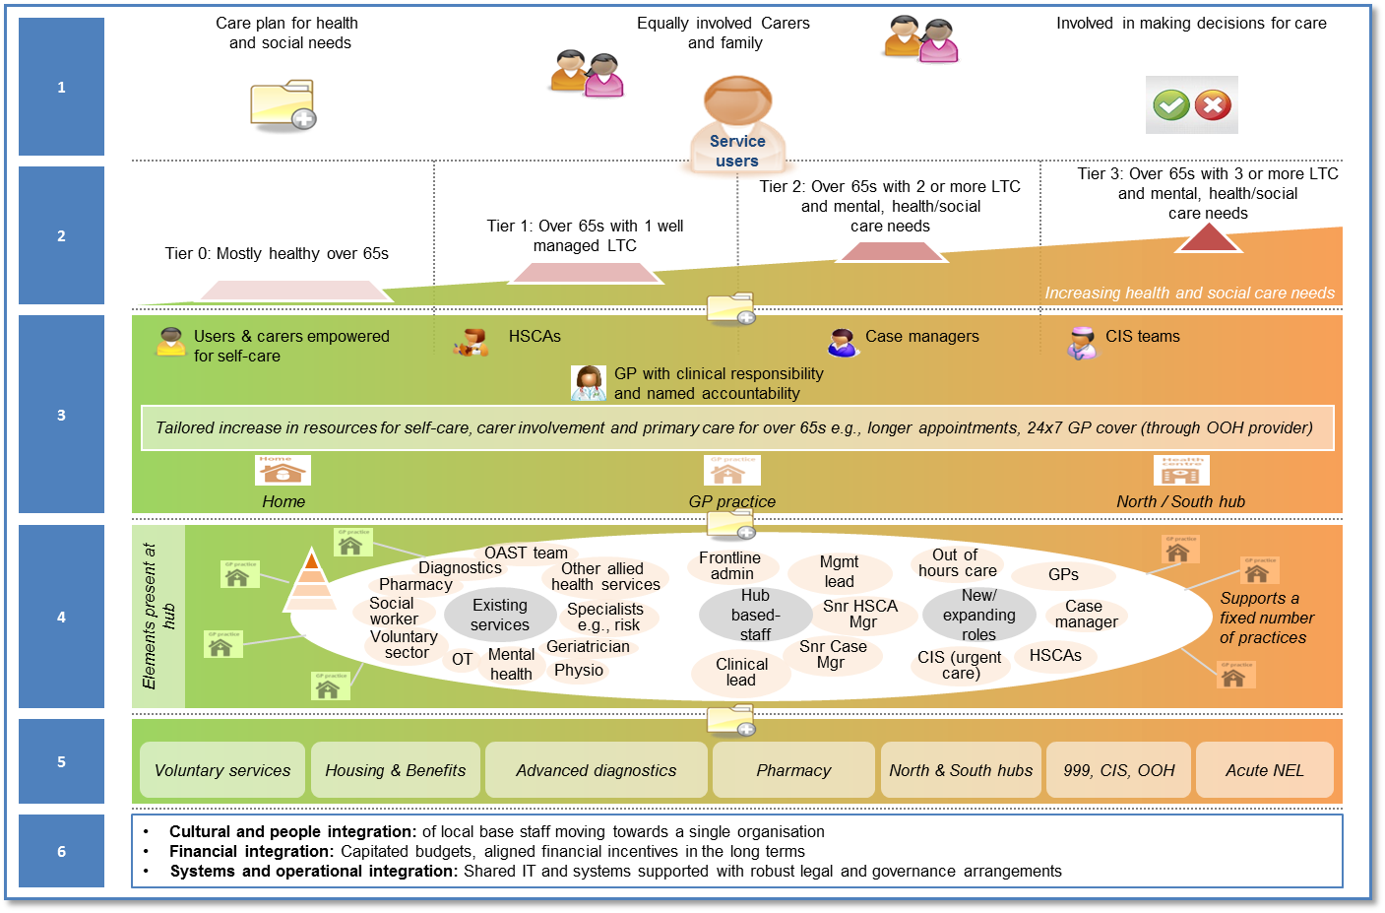

The target population for My Care My Way are patients who are aged 65 years and older. This cohort of patients will be divided into 4 tiers, based on their needs (including mental health and social care needs, in addition to their clinical needs). The support delivered to a patient is based on the tier that the patient has been allocated to through the use of risk stratification. The tiers of patients are as follows:
Tier 0: Those patients who are 65 years and older who are mostly healthy.
Tier 1: Those patients who are 65 years and older who have one well-managed Long Term Condition (LTC).
Tier 3: Those patients who are 65 years and older who have two well-managed LTC, mental health/ social care needs.
Tier 4: Those patients who are 65 years and older who have three or more LTCs, mental health /social care needs.
Different elements of the MCMW service will be delivered at different locations. These locations include the patient’s home or normal place of residence (incl. care home), GP practice, and the two Integrated Care Centres.

3.3 Key Deliverables

The key deliverables of the programme include the following:

- Leadership development – the provider will be expected to support the exemplar practices in setting direction for MCMW programme and encouraging leaders to emerge from this process.

- Relationship building – this will be vital in achieving joint ownership of the programme among different providers

- Motivation – a high staff turnover rate has been reported, the provider will be expected to work with MCMW staff to understand the core issues affecting staff morale. This deliverable is seen as the most important aspect which will deliver improvements across individual and organisational performance

- Standardisation of MCMW provision – one of the main issues reported has been the variation in the delivery of the programme. A standardised core offer is expected to result in improved performance and joint ownership of the programme among providers.

3.4 Any acceptance and exclusion criteria and thresholds

This will be delivered initially in six West London GP Practices, with the learning and outcomes shared widely amongst the rest of the Whole Systems community.

3.5 Interdependence with other roles/services/providers

The service provider will be expected to work and engage with multiple stakeholders including

- GPs
- Acute trusts
- Adult Social Care
- Multiple Voluntary sector organisations
- Community providers
- Mental Health providers
- GP federation
- Commissioners
- Governing bodies

They will also be expected to

- Bringing together different stakeholder perspectives to build a shared understanding of the wider system, organisational strengths, and the underlying issues and dilemmas.
- Creating a shared narrative and vision for change that supports MCMW’s core purpose and collective endeavour.

4. Service Delivery
The service provider is expected to provide a detailed description and plan about how they will set up and deliver a service/function that meets the aims and outcomes set in this spec. This will include developing and implementing a full programme plan with clearly defined timescales. They will also be expected to work together with MCMW team and partner organisations to gather data, define issues and determine a suitable course of action creating a common understanding and purpose and identify opportunities for innovation and change that will meet CCGs objectives.
5. Applicable National Service Standards and Quality Requirements

Quality and Governance
The service provider is expected to provide full details about how the service will meet any national standards on quality and governance including how this will be quality assured, monitored and reported on a regular basis to the commissioners

Information Governance, Management & Technology

The service provider is expected to work in accordance to the NHS IG governance requirements and within the relevant national regulatory framework.

Days/Hours of Operation and response times

My Care My Way operates between 9 and 5 Mondays to Fridays; however any interface work with GPs and urgent care providers and other partners may entail working outside of these hours.

6. Key Performance Indicators (KPIs)

- 6 Refinements to the Model of Care
- An agreed number of sessions per group with associated Action Plans.
- Evidence of more efficient processes and staff utilisation
- Evidence of better patient experience and improved staff motivation
- Standardisation of practice across practices and providers
- Improved relationship among providers
- Establishment of core leadership from among the providers for taking this programme forward
- We will work with the successful provider to refine KPI’s

7. Location of Provider Premises

GP provider premises are located within the West London CCG area.

St Charles Integrated Care Centre

Violet Melchett Integrated Care Centre

Cost of the venues is covered by the CCG.

8. Fee Level and Payment

The total contract value is: £160,000 (incl. VAT)
Payment Schedule:
The payments will be split in three equal instalments, as per the schedule below
1st Payment – start-up/mobilisation – made after award of contract
2nd Payment – made at midway point of the contract subject to the successful development and implementation of six pathways
3rd Payment – final payment – made at the completion of the contract, this is defined as the achievement of all key deliverables as described in section 3.3
9. Contract and monitoring arrangements

Fortnightly review reports from the 6 sites.

Monthly joint meetings with representatives from each site and WLCCG representatives

