

Request for Information
Stonewater Limited

Executive Team Development and Coaching Provision
February 2022
Table of Contents
Introduction 3
Current Position 4
Requirement 5
Replying to the Request for Information 6

Introduction

  - Stonewater
Our significant and progressive house-building programme aims to build a minimum of 1,500 new homes a year from 2022/23 and we have a good pipeline of development to achieve this, driven by our vision of everyone having the opportunity to have a place that they can call home. We plough our surplus into building new homes, improving our existing housing stock and investing in customer services.
We are also the largest management partner for Legal & General Affordable Homes, supporting the organisation in delivering its ambitious development plan of building 3,000 homes by 2022, by leading on Legal & General's housing operations across England.
We recognise that the way we work matters too. We are committed to providing homes that are energy efficient and are working towards Government's targets for carbon neutrality. Our Environment Strategy helps us minimise the resources we use as an organisation and manage our impact on the environment.
Our talented 800+ employees embody our values – being ambitious, passionate, agile, commercial and ethical. For the second consecutive year, we achieved a ‘One Star’ rating in the 2020 Best Companies Top 100 best not-for-profit organisations to work for and made the list for the top 25 best housing sector organisations to work for in the UK.
With an annual turnover of around £191 million and £1.8 billion in assets, Stonewater is a strong, dynamic and well-managed social business, with a long-term rating of A+ by independent credit ratings agency, S&P Global Ratings and a top G1/V1 governance and viability ranking from the Regulator of Social Housing.

  - Background to the Requirement
Stonewater currently has a dedicated partner working with our executive team on their personal and team development. This partnership has been in place for around 5 years and we would like to explore what opportunities there are in the market to refresh this approach and ensure it aligns closely to our newly refreshed Strategic Plan. The partner would work closely with the Chief Executive as the lead for this partnership. They would need to build a strong relationship to agree business and learning outcomes from the partnership, to design and deliver specific development interventions and be prepared for shifting priorities in line with an ever-changing strategic landscape.

  - Clarifications
If you have any clarification regarding the contents of this document, please contact sarah.newton@stonewater.org

2 Current Position

2.1 Current approach to Executive Development
Stonewater currently has a dedicated partner working with our executive team on their personal and team development; providing team development activities, 1-2-1 coaching opportunities and ad hoc interventions aimed at increasing their executive leadership skills, both as individuals and as a team. In the past these have ranged from Innovation Safaris (both off-site and virtual), tailored workshops aligned to our broader Leadership Program and coaching around individual challenges and providing feedback to others, including the CEO.
2.2 Current approach to Leadership Development
Stonewater has an established Values Based Leadership Model (see diagram below) and has delivered two iterations of Leadership Development based on this; the most recent being our “An Agile Leader” program (see diagram below) designed and delivered by an external partner. This program consisted of four modules:
- Ambi-dextrous thinking
- Authenticity
- External Perspective
- Continuous Learning

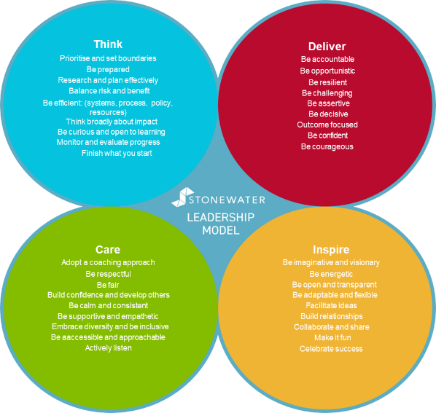
The audience for this program was our Executive team, our Operational Director Group (ODG) and our Senior Leadership Job House. This consists of around 80 people.
For wider context, it is important to note that this Corporate Leadership program we will also be going out to tender in the new financial year. There would be an expectation that the appointed partner under this provision/contract would align their offer to the overall Leadership program to ensure they complement each other.

Requirements

Requirement | Response | Fully Meets/Partial Meets/ Unable to Meet | Additional Comments
- We require a partnership that provides a personal service; one that encompasses a strong and trust based relationship directly with the CEO. The expectation is that this would be achieved through a dedicated person rather than a generic “team” of executive coaches.
- We need someone who can introduce the Executive Team to innovation/exploration opportunities that will spark ideas, drive innovative thinking and support the application of this new thinking within the sector context that Stonewater operates; supporting the ongoing organisational design and development as we progress towards our future operating model
- We would expect both individual and team development of our executive team, through a variety of experiences including 121 coaching.
- We would expect the partner to have a wide and trusted network from which they can draw and create opportunities and experiences for the executive team, preferably from beyond the immediate housing sector
- We expect the contract to have a potential lifespan of 3-4years, with the option to review after each 12mths

Replying to the Request for Information

  - Introduction
Suppliers are asked to complete section 3 – 4.5

  - Requirements Review
Please provide a response against each point in the table above as outlined within section 3, confirming whether you;
- Fully meets requirement
- Partially meets requirement
- Unable to meet requirement
Where a supplier is unable to provide a response that fully meets the requirement stated, more detail is requested in the third column of the table.

  - Indicative Costs
Using the information supplied about Stonewater’s requirement, suppliers are asked to provide potential contract costs. Costs provided are only indicative and will not be assessed as part of any future tender.

Details - Insert types of costs, dependent on the project | Costs (ex VAT.) | Comments
Total

  - Indicative Timescales
Interested parties are required to provide a high level estimate for the delivery of Stonewater’s requirement based on the information provided in this document.

  - References
Interested parties are required to provide three examples from within the past 2 years of projects delivered that match Stonewater’s requirements.
Customer Name | Contact Name and Email Address | Date Project went live | Summary of the project/Requirement

Customer Name | Contact Name and Email Address | Date Project went live | Summary of the project/Requirement

Customer Name | Contact Name and Email Address | Date Project went live | Summary of the project/Requirement

