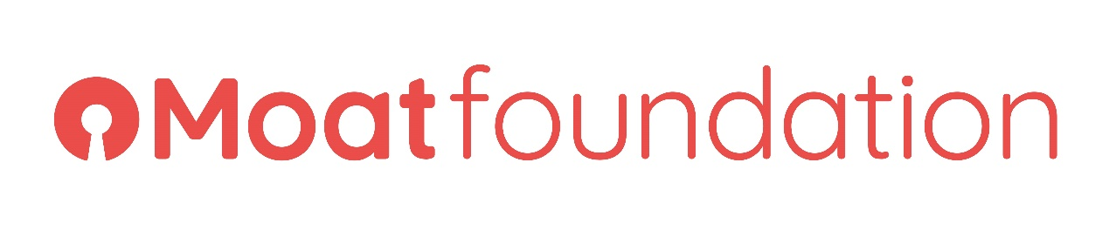

The Vision and background to the Moat Foundation Community Hubs

Introduction

Moat is one of the leading developers and providers of social housing across Kent, Essex, Sussex and South London. Moat Foundation is the charitable arm of Moat Homes Ltd. The charity’s purposes as set out in the objects contained in the company’s memorandum of association, which states its aim to:

“Relieve poverty and other charitable need amongst those in need, for the benefit of the public, in particular, but not exclusively, those in need by reason of youth, age, ill-health, disability, financial hardship or any other disadvantage.”

As such, in order to meet this objective, we have a dedicated Moat Foundation team responsible for co-ordinating social value activities and projects across Moat’s key regions. In addition, we have five Community Hubs across Kent and Essex, which are based in areas where we have the highest density of stock, alongside high levels of social deprivation, and a lack of key services and opportunities for local communities. Four of the Community Hubs are in Kent; Gravesham, Gillingham, Sittingbourne, and Stanhope.

Background

Our Community Hubs are dedicated spaces compromising of a combination of three-bedroom residential houses (Gravesham, Gillingham, and Sittingbourne in Kent), several dedicated rooms within one of Moat’s regional office (Maldon, Essex) and one large multi-functional community room (Stanhope, Kent) set-up as ‘community spaces’ to deliver social value activities from.

We want to use our Community Hubs to provide local people, including young people, with opportunities to access key activities and support services to enable them to have better life chances.

As such in 2017, we contracted with two partners to provide facilities management services and to organise activities for the whole community at the Community Hubs in Gillingham, Gravesham, Sittingbourne, and Stanhope in Kent.

In-line with Moat Foundation’s strategy the focus from 2017 to September 2019 at the Hubs has been to develop and run activities and projects that meet the Moat Foundation’s three priority objectives:

- To support young people (16-25) to become more employable through education, training and work experience. Such services are targeted, challenging and ‘aspirational’ to meet the changing training and employment needs of younger customers. We focus on employability, training and volunteering projects.

- To ensure communities thrive. The programmes within this strategy are designed to challenge, motivate and empower individuals and groups to utilise their interest, passion, and talent for further self- development and to help build stronger and happier communities together.

- To support our ageing population. The programmes are targeted for older customers (over 65’s) to provide advice and practical support.

Community Hubs’ successes to date

Over the last two years, collectively through the two partners a wide range of social value activities where offered to residents living in the hub regions from; basic coffee mornings, breakfast clubs, job search and IT drop-ins, term-time and half-term, (including summer holiday) programmes for young people, health and well-being advice and opportunities (including healthy eating projects), targeted mental health counselling for adults to strengthening minds programmes for younger people and the like.

As a result, in the last 2 years over 5000 social value-based customer engagement opportunities have been offered to Moat and non-Moat residents across Kent.

In addition;
- Recruited 28 local volunteers to contribute to the Hubs’ success
- Supported over 500 residents with job advice and secured employment for more than 50.
- Delivered 12 projects directly funded by the Moat Foundation charity.

Our vision for the Community Hubs

We want our Community Hubs to be a ‘focal point’ for the local community ‘the go-to place’ for advice, help, and support on a range of issues that affect individuals, families, and groups within the immediate hub community area.

We want to create ‘hubs of excellence’ where local people can benefit from having a place;

- Where they can be supported in a safe and comfortable space.
- That gives individuals and groups a sense of belonging.
- That supports the individual’s journey into accessing meaningful training & employment.
- That inspires and motivates people of all ages.
- That challenges the traditional way of thinking and doing things.
- That supports young people’s ‘life skills’ development and personal growth.
- That nurtures the next generation of customers into adulthood, creating cohesive future communities as a result.
- To socialise in, to combat social isolation in the community or just to regularly attend to cope with the challenges of life.
- Where local people feel empowered and take responsibility for putting something back into their community e.g. leading and delivering activities and sessions.

Each Community Hub should offer activities that make it feel like a ‘home away from home’ e.g. offers opportunities to celebrate cultural and other festivities in a relaxed and welcoming environment.

Hub's delivery of the social value activities must act as a ‘hook’ and are intended to inspire and widen customers’ participation in more substantive projects and activities.

We want our Community Hubs to be ‘focal point’ for the local community - ‘the go-to place’ for advice, help, and support on a range of key issues that affect individuals, families, and groups within the immediate community area.

The Community Hubs’ internal and external spaces

Over the last two years, we have invested heavily in improving the quality of the Community Hubs’ internal and external spaces. We want a new Hub management partner who will take on the refreshed spaces and continue to develop the spaces further so that both internal and external hub spaces look well looked after and loved, meeting all the necessary health and safety requirements.

Our vision for the services on offer at the hubs

We want each of our Community Hubs to have a ‘core offer’ which meets both local needs and is in-line with the Moat Foundation’s three core objectives (as set out in section 2). This core offers must include activities for all the key age groups. As such activities must be directed by local demographics. Each Community Hub could have its own specialism based on local demands and characteristics of the local community. However, all the hubs must operate within the same ethos and values when delivering customer activities.

The community services and activities on offer at the Community Hubs must be of a high standard and quality. Where possible, services and activities on offer must be underpinned by best practice in the sector, e.g. have best practice models for ‘Community Volunteering’ – we want an ‘Army of local Volunteers’ running activities and projects on-site and into the wider community.

All services and projects at the hubs must be sustainable, where possible local expert providers should be sourced to lead specialist projects and sessions and eventually these should be supported to take ownership of the activity or project.

The type of Hub management partner we are looking for.

Our arrangements with the two partners managing the hubs are coming to an end. We would like this opportunity to seek out a potential new partner to take on the management of all four Community Hubs in Kent (Gravesham, Gillingham, Sittingbourne, and Stanhope).

We would welcome the opportunity to hear from organisations that have a track record for delivering a wide range of impactful and specialist front-line social value activities to social housing residents. As such we would like the new partner to have an excellent understanding of local issues, be innovative and dynamic in its approach and be outcome driven in order to make lasting positive changes in the lives of individuals and communities living within our hub regions in Kent.

For further information about our Community Hubs project please come along to one of our Supplier Days, this is anticipated to be at the beginning of November 2019.

Interested parties must express their interest in this opportunity by October 25th, 2019 at 12:00 (noon). This can be done by emailing Procurement@Moat.co.uk and titling your email MT074 Moat Foundation Community Hubs.

