Request for Proposal (RFP)
DS01-127
CUSTOMER REQUIREMENTS

CONTENTS
WHATS INCLUDED WITHIN THIS RFP 1
OVERVIEW 2
LOTTING STRUCTURE 2
TIMESCALES 3
KEY DELIVERY DATES 3
TEST & DEVELOPMENT REQUIREMENTS 4
TERMS AND CONDITIONS 4
CAPABILITIES AND ROLES 5
EVALUATION STAGES, MINIMUM PASS MARKS & PRICE EVALUATION 6

WHATS INCLUDED WITHIN THIS RFP
Appendix A – Customer Requirements (this document)
Appendix B – Pricing Matrix (template to be completed)
Appendix C – Award Questionnaire (template to be completed)
Appendix D – Evaluation Guidance
Appendix E – Order Form and Call-Off Contract (Customer specific)
Appendix F - Supplier List for Consortium Possibilities

OVERVIEW
CCS Project Lead: | Lucy McCormack
Customer: | Met Office
Delivery Location: | Co-location is the preferred option at the Met Office headquarters in Exeter
Phase(s): | Discovery, Alpha, Beta and Live
Project: | DS01- 127
Required Capabilities: | Include, but are not limited to: (mark those that apply)  ☒ Software engineering and On-going Support  ☒ Product Development and Service Design  ☒ Agile Delivery Management  ☒ Front-End Design and Interaction design  ☒ Content Design and Development  ☒ System Administrations and Web Operations  ☒User Research
Subcontracting Permitted? | ☒Yes ☐ No
Supplier Partnering Permitted? | ☒Yes ☐ No
Contract Charging Mechanism (Discovery Phase): | Fixed Price
Contract Charging Mechanism (Alpha Phase): | Capped Time and Materials
Contract Charging Mechanism (Beta Phase): | Capped Time and Materials
Contract Charging Mechanism (Live Phase): | Capped Time and Materials
RFP Start Date: | 30/04/2015
RFP Response Deadline | 18/05/2015
Proposed length of phase: | Discovery: 30/06/2015 - 31/07/2015; Alpha: 01/08/2015 – 31/03/2016; Beta: 01/04/2016 – 30/04/2016; Live: 01/05/2016 – 30/05/2016
Proposed Commencement Date of Project: | 30/06/2015

LOTTING STRUCTURE

The Customer has structured this procurement as follows:
Lot 1 | Software Engineering and Ongoing support/ Product Development and Service Design/ Agile Delivery Management & Content Design and Development/Front End Design and Interaction Design
Lot 2 | System Administration and Web Ops
Lot 3 | User Research

TIMESCALES
The Customer or CCS may change this timetable at any time. The Potential Provider will be informed by email if there are any changes to this timetable.

It is the Potential Provider’s responsibility to monitor the online messaging facility (e-Sourcing).

KEY DELIVERY DATES

PROJECT PHASES | START DATE | COMPLETION DATE
Discovery | 30/06/2015 | 31/07/2015
Alpha | 03/08/2015 | 31/03/2016
Beta | 01/04/2016 | 29/04/2016
Live | 02/05/2016 | 31/05/2016

CURRENT SITUATION / BACKGROUND INFORMATION

The original WOW (Weather Observations Website) was developed in 2011 in partnership with the Department for Education and the Royal Meteorological Society and was funded by a capital grant from BIS. The technology was built by a third party, PA Consulting, and is hosted on the Google cloud platform. At the time this was an innovative use of technology for Government and has received a number of industry awards. The platform has become extremely well used and now contains over 440 million observations from around the world. WOW is also the primary operational system within the Met Office Observations Group for climate observers to submit their daily observations to the Met Office. A trial has been underway with the Australian, Dutch and New Zealand Met Offices to explore the feasibility of providing WOW to another National Meteorological Service. Although this has been successful, the pilot has identified a number of opportunities to improve the system especially in terms of creating a more flexible and adaptable system.

The ability of our supercomputers to accurately forecast the weather is built on the bedrock of high quality, information rich global observations along with the ability to understand the impacts of the resulting weather. Our partners in civil contingencies and the Natural Hazard Partnership are increasingly seeking to quantify the impacts of severe weather on infrastructure and people, and the ability of the next generation of WOW to capture this ground truth through photographs, video and social media will be a powerful tool to enable us to do this. As the capabilities of our new Supercomputer begin to come on stream and the £2 billion of benefits begin to be realised, there will be an increasing need for observations that we are unable to meet from our own resources. The next generation of WOW will be capable of ingesting third party observations from professional and amateur sources and this will allow our scientists to explore and understand the benefits that this data can bring. The technology will also enable us to capture non-standard observations, for example those provided automatically from moving platforms such as cars, and also to define new variables that have not been foreseen allowing us to respond with great agility to changing requirements.

Our work is increasingly global in nature and our partnerships with other National Meteorological Services have identified a shared need for the type of infrastructure that WOW delivers. An existing partnership is in place with the Bureau of Meteorology in Australia who are enthusiastically engaged with the process of identifying future developments and KNMI in the Netherlands and MetService in New Zealand who are also utilising the technology. All of these partnerships deliver global reach and extend the Met Office brand, alongside bringing in revenue and offsetting the running costs.

The current architecture used within WOW is shown in figure 1 below. At the current time WOW runs as a single application within the Google Cloud, handling all data ingestion, processing, and visualization. Any changes are difficult to make due to the integrated nature of the system and pose a risk to all aspects.

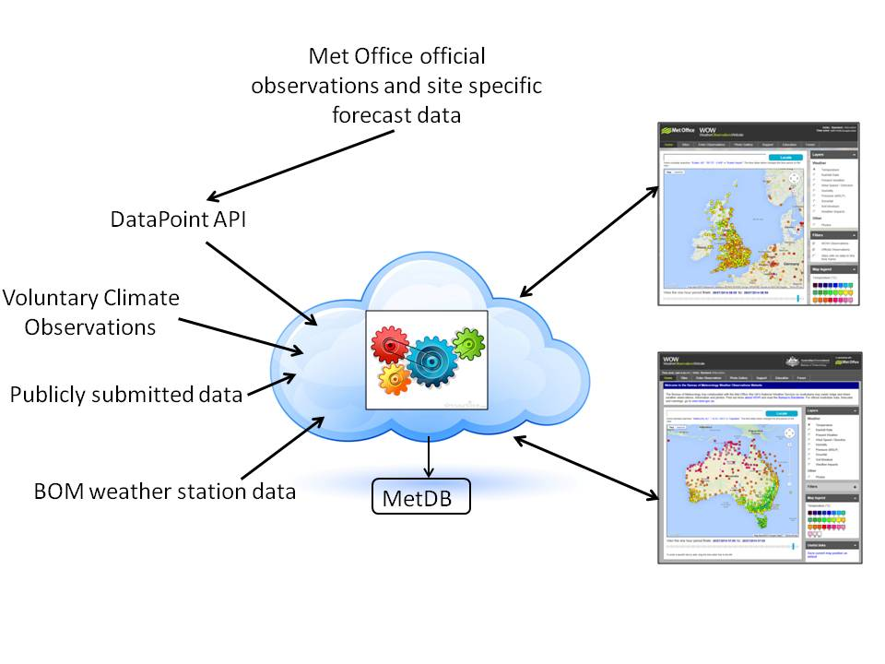
Figure 1: Current WOW Architecture

The intention is to replace WOW with a data collection platform (the WOW Engine), a flexible data store which is accessed via a set of standards based API interfaces for both ingesting and extracting data. This system will also support a much broader set of data parameters to allow the collection of information about the impacts of weather as well as a wider variety of weather parameters than the existing WOW platform.

In order to keep the number of future changes to the WOW Engine a minimum, data will be collected by separate custom ingestion applications which transform the data from the suppliers format into the canonical ingestion API's exposed by the WOW Engine. This will allow the easy addition of new data sources to the WOW Engine without impacting on existing users of the platform, it will also enable support for a wider range of ingestion mechanisms.

The API infrastructure for extracting data from the new WOW Engine will also simplify development of a new WOW website, which will be easier to modify, to respond to changing user needs as it will be a separate application and will therefore not impact on the data collection and storage platform. Exposing the information via API's will also allow approved third parties to build custom web and mobile applications, enabling the implementation of use cases for the data beyond those currently planned.

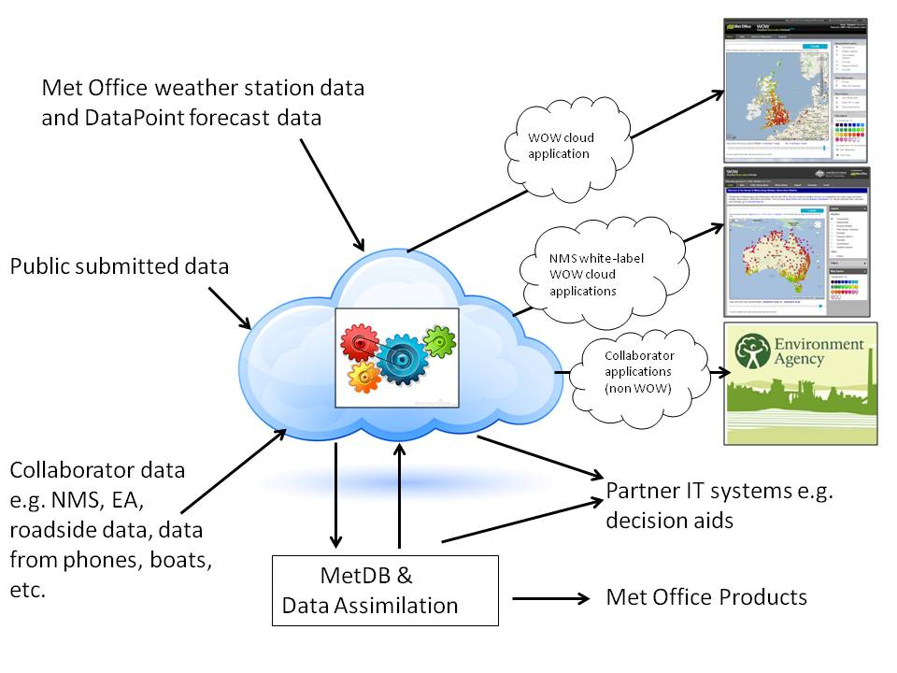
Figure 2: Proposed WOW Engine architecture

Current artifacts
Please see attached Annex A for user stories which explain our users needs for using WOW Engine and the Weather Observations Website.
Please also see Annex B for a High Level description of what is required for WOW Engine.

Current Technologies and Languages
Current system is a JAVA based Web Application hosted on the Google App Engine.
Data is currently stored in Google BigTable

REQUIRED OUTCOMES

The main aim of the Project is to deliver the WOW Engine capability and replicate the current WOW website by the end of 2016, and in addition deliver an improved architecture to support the benefits outlined above. The infrastructure will enable ease of addition of new collaborators and data types, and will also open up access to well-documented and well-managed ‘plug and play’ application programming interfaces (APIs) enabling collaborators to make maximum use of the WOW Engine capability.

The project timescales are as in the following table:

 | Most likely
Tender To Market | 30/04/15
Contract/Procurement completed | 29/06/15
Development Completed | 31/01/16
Testing and Operational Acceptance Completed | 31/03/16
Operational use | 30/04/16
Post project evaluation | 30/06/16

We have completed approvals internally at the Met Office and from GDS & BIS.
The supplier will also need to migrate all current data from the legacy platform on to the new Engine platform.
The supplier should replicate all legacy API’s and data feeds as well as creating updated API’s which will support the latest best practice standards.
Two of our main outcomes are:

- Supporting collaboration and increasing access to data: WOW Engine will offer a default approach for the collection and sharing of 3rd party data. It will ‘enhance our Data Services to deliver the ability to readily combine information from different sources’.
International Strategic Positioning: Development of this new capability, and opening it up for collaboration, will ‘expand our reput^{at}ion and reach internationally, building awareness and advocacy’.

Please see additional documentation for User Requirements and following points:
- Business outcomes: Outline specification, proposed functionality, story cards
- User Needs of different stakeholders and users
- Functional requirements such as data integrity and accessibility
- Volumetrics: This is Dynamic and can be obtained from Google Analytics and App Engine Dashboard.
- Technologies and Design Approach: New platform will be a cloud hosted platform and all current data from the legacy platform will need to be migrated on to the new Engine platform.
- External factors: Will need to meet Inspire Standards for view and download services

TEST & DEVELOPMENT REQUIREMENTS
- We will require representative testing and development environments.
- Test scripts for all functionality must be provided and automated where possible.

TERMS AND CONDITIONS
Please note that Customer specific Terms and Conditions apply to this agreement. Please refer to the Call-Off Agreement for further information.

CAPABILITIES AND ROLES

Current Roles and Responsibilities of the Customer
Role | Responsibilities
Project Board | From the below roles we will also have the Project Board and this represents the internal Met Office experts and suppliers and manages the project. The Project Board will look after the more detailed aspects of the project and ensure that the project remains on course to deliver the desired outcome, as defined in the PID.  The Project Board is responsible for:  - giving detailed direction and guidance to the Project Manager;  - monitoring progress of the project in accordance with the terms of the PID and any variances;  - reviewing any exceptions raised  - giving approval of technical decisions required that are within the project PID  - Ensuring that acceptance criteria have been met.  - reporting to programme management;  - reviewing the status at the end of each stage and approving the next stage;  - reviewing and approving any Exception Plans which cause the scope, cost or duration to exceed the set tolerances;  - approving significant changes to the project;  Making decisions concerning the project termination.
Project Manager | - Accountable to the Project Executive for the delivery of the project  - managing the risks on behalf of the Project Executive;  - providing the necessary management information to the Project Executive to enable them to carry out their project responsibilities;  - Providing project-life forecasts against the funds programmed for the project.
Project Executive | - Is accountable to the Programme Manager for the overall direction of the project summarized in the Project Brief.  The Project Executive is responsible for:  - making the key business decisions for the project;  - ensuring that the impacts of Corporate and Programme level decisions are communicated to those managing the project;  - owning the project risks unless they have explicitly escalated them to another named individual;  - ensuring that the agreed resources are provided;  - ensuring that the necessary user input is provided;  - Endorsing project-life forecasts made by the project manager against the funds programmed for the project.  The Project Executive may be advised by the Project Board but the responsibility for decision making remains entirely with the Project Executive. At any point during the project at which it becomes apparent that:  - key benefits will not be realised; or  - corporate or programme level changes render the current project untenable;  are likely to occur then the named Project Executive, must re-apply for/reconsider project approval.
Senior User | - Representing the interests of any User Group on the Project Board.  - Ensuring that user input is adequately resourced.  - Monitoring the Business Case.  - Representing generic user interests
Senior Supplier & Technical Lead (will be one person internally at the Met Office) | - Representing the interests of those designing, developing, facilitating, procuring and implementing the project products.  - Ensuring the quality and technical viability of the deliverables of the project are in line with current technical standards and strategies.  - Ensuring that the required technical resources are assigned.  - Providing ongoing strategic technical advice and guidance throughout to the Project Manager.  Reviewing and signing off technical aspects and reports

Required Capabilities and Outcomes of the Supplier

The Customer has specified the Capabilities required and although a description of all roles aligned to each Capability is provided, the Customer would like potential Providers to propose the roles, number of roles and level of seniority of the roles proposed, thinking of the optimum team structure to achieve the Customer’s desired outcomes.
Capabilities | Outcomes
Software Engineering and Ongoing Support | Developers – to build the software with the focus on how it will be used and to make sure the same output of the WOW Website are delivered along with our partners information for their versions.  Technical Architects – To write the code and make sure the current code for the original WOW website is available and any historical data is transferred over so there is no impact on our end users.
Product Development and Service Design | Product Manager – to work with the Project Manager and Technical Lead from the Met Office to insure the delivery of the WOW Engine and WOW Websites are completed. Use the Met Office provided User Stories to understand the requirements. To help continue the development of WOW Engine for our users for the continued Service Management.
Agile Delivery Management | Again as above the Product Manager to work with the Project Manager to insure timescales are met.  Delivery Manager – working with the Met Office Project Manager to make sure timescales and work packages are complete from the supplier.
Front-end Design and Interaction Design | Designer – to develop, design and implement the WOW Engine product. To make sure the current WOW website and partners website designs are not impacted only improved upon.
Content Design and Development | Content Designer – to develop, design and implement the WOW Engine product. To make sure the current WOW website and partners website designs are not impacted only improved upon.
System Administration and Web Operations | Web Operations, Security Specialist, Database Specialist and Network Specialist required. – Will need to work with Met Office to make sure that suppliers deliver the service at the level of security required by the Met Office and partners. Making sure that the Engine and Websites have a clear test plan and provide the test plan to Met Office to sign off and agree.
User Research | In partnership with the Met Office and their internal resource, complete User Research after each phase and test the market.

EVALUATION STAGES, MINIMUM PASS MARKS & PRICE EVALUATION

This RFP will be evaluated in the following approach:
Technical & Cultural evaluation | This will evaluate the Potential Provider’s proposed technical solution together with the makeup of the proposed team, including number, type and level of role and duration of key personnel including CVs of key personnel; and availability of the delivery team Roles at the Customer’s required location.  Potential Providers should include all Roles proposed to deliver the Customer’s required Capabilities over the duration of the Project, as the Price (day rates and travel and subsistence expenses) will be set at Call-Off Contract for any Schedule of Works (SOW) under that Call-Off Contract.  All Potential Providers who achieve the required Minimum Pass Mark for the written Technical questions will be eligible to continue to the Cultural Presentation.
Cultural Presentation Evaluation | All Potential Providers who achieve the required Minimum Pass Mark for the Cultural Presentation Evaluation will be eligible to continue to the Pricing Evaluation.  The purpose of the presentation sessions is limited to demonstrating the criteria outlined in Appendix C – Section C.  The presentation sessions will not be an opportunity to modify the written tender submission in any way or add any information in regards to the written criteria in Sections A and B.  The presentation will be evaluated and scored in isolation to the written submission and in line with the marking scheme outlined in Appendix C – Section C.  Each evaluator shall carry out the same process for each presentation in Section C. When this process has been completed the marks awarded by each evaluator will be reviewed in accordance with the Consensus Marking Procedure.  The presentations will last 40 minutes: 20 minutes for the presentation and 20 minutes for Q&A regarding the content presented.  All Potential Providers who qualify will be given the same opportunity to respond. Details of these presentations will be issued to those who have qualified post evaluation of Sections A and B, via the e-sourcing suite.
Pricing evaluation | Detailed below within the ‘Price Evaluation’

Minimum Pass Marks:

In order for Potential Providers to progress within the process, they must achieve or exceed the Minimum Pass Marks, as defined in the Award Questionnaire. In order for Potential Providers to progress beyond the Technical and Cultural evaluation stage of the process, Potential Providers must pass Section A (Availability) and must achieve the minimum pass mark for every criteria in Section B (Technical Solution). These Potential Providers will be invited to a presentation. For the avoidance of doubt, any Potential Provider who does not pass Section A and does not achieve the minimum pass marks in Section B will not be invited to the Supplier Presentations. Pricing will only be evaluated for those suppliers who pass Section A and achieve the minimum pass mark for every criteria in Section B and Section C.

Price Evaluation:
“Combined evaluation”:

The Potential Provider’s price mark for each Lot will be evaluated by comparing the Total Price offered against all other total prices submitted by other Potential Providers.

The Potential Provider who offers the lowest Total Price for a Lot will achieve the maximum score for that Lot. Every Potential Provider will, for each Lot, be awarded a percentage of the maximum score on a reducing basis based on the following formula:
Lowest Price Submitted Per Lot | x 100
Potential Provider’s Price Per Lot | x 100
= % of the maximum score, rounded to 2 (two) decimal places.

The pricing score, following the price evaluation; will be added to the scores already recorded for Sections A and B of the Award Questionnaire (Appendix C) to arrive at a final total score

For the avoidance of doubt, depending on the results of the evaluation, the outcome of this procurement could consist of a single Potential Provider being awarded all Lots, or each individual Potential Providers each being awarded one of the Lots.

