**About the Agency**

The VCA was established as an Executive Agency of the Department for Transport (DfT) in 1990. The VCA’s main business is delivering its responsibilities to the Secretary of State for Transport as the UK Type Approval Authority for new on and off-road vehicles, systems and components.

VCA is responsible for approving that products have been designed and constructed to meet internationally agreed standards on safety and environmental protection.

The VCA also publishes a database of CO2 emissions from new passenger cars, which underpins the graduated Vehicle Excise Duty (VED) and Company Car tax schemes. VCA is also the administrator for the approval of packages, tanks, and receptacles for the carriage of dangerous goods. We issue Vehicle Special Orders on behalf of DfT, to permit vehicles to use public roads that are unable to meet vehicle regulations because of their specialised design.

Our main headquarters office is in Bristol, with an office and test facilities on the MIRA site at Nuneaton and an office at the Millbrook Proving Ground near Milton Keynes. Our dangerous Goods team is based in Leatherhead Surrey. Worldwide we have offices in the US, Asia-Pacific (Japan), China, India, Italy and Australia.

Site Details

a) VCA Eastgate is located on the multi-occupancy site of Eastgate Office Centre in Bristol (~110 members of staff).

b) VCA Midlands is located just off the A5 (Watling Street Road) with easy connections to M42 and M69 (~39 members of staff ).

c) VCA Dangerous Goods Office is located in a small office within the PIRA (Packaging Industry Research Association) site at Leatherhead (~4 members of staff)

**Transformation work**

The Vehicle Commissioning Agency (VCA) has an aggressive programme of transformation work to meet Central Government requirements.

We are currently focused on the building blocks for the transformation which is the wide area network (including firewalls and web/email filtering).

**Wide Area Network**

The VCA WAN incorporates

* 2 * 100mb circuits (on 100mb bearers)
* 2* 10mb circuits

The circuits are based upon old technologies and as the data needs of the organisation are growing they are no longer fit for purpose and aren’t able to deliver high bandwidth, low latency broadband to the network.

With this in mind the VCA are seeking tenders to:

* upgrade all existing broadband connections (see Figure 1 for connections)
* provision of low latency connectivity to all sites
* are able to provide a service wrap (2nd and 3rd line support)
* provide the ability to easily ‘flex’ the available bandwidth as required (likely to require bearer upgrades)
* support for a 99.9% uptime SLA across all services
* supply a web & email filtering service
* apply standard security tooling to prevent/detect intrusion

A full requirements schedule is attached below.

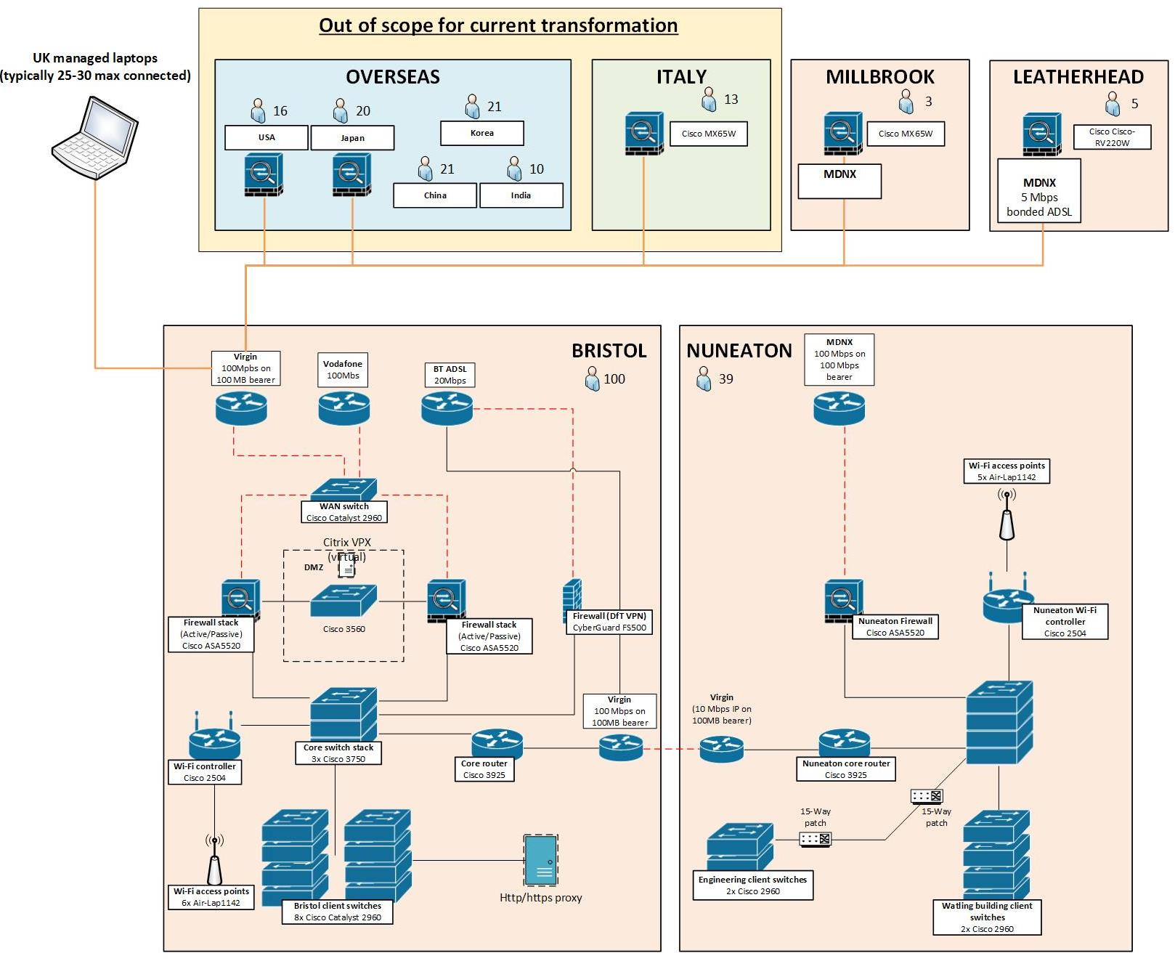

Figure 1 Outline of network connectivity

**WAN requirements**

