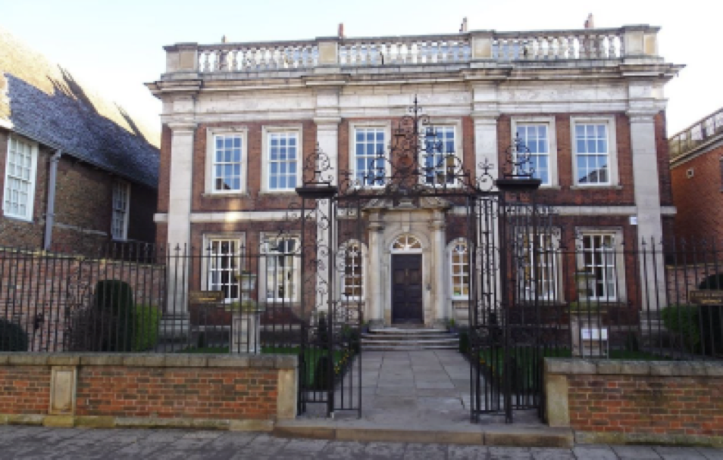

Fydell House- Gateway to Boston’s Cultural Quarter

FYDELL HOUSE
SOUTH STREET, BOSTON

Pre-Qualification Questionnaire

December 2024

1 INTRODUCTION

1.1 STATEMENT OF REQUIREMENTS

1.1.1 The Employer:

Boston Preservation Trust

1.1.2 Architect:

Soul Architects Ltd

1.1.3 Project Details:

Project Name: Fydell House- Gateway to Boston’s Cultural Quarter

Project Budget: £1.2m

Project Description:

Fydell House is a Grade I listed townhouse located within the ‘cultural quarter’ of Boston which is close to the Market Place and within the Conservation Area of Boston. The building was acquired by Boston Preservation Trust which was founded in response to the building being under threat of demolition in 1935. The building has had a variety of uses including residential, partial occupation by the Women’s Voluntary Service during World War 2 and a satellite campus for Nottingham University until 2015. Fydell House is steeped in history and both national physical (building fabric and interiors) and cultural significance.

Fydell House is now in urgent need of repair and re-servicing in order to ensure that it has a viable, economically sustainable use within the heart of the community of Boston and its cultural quarter as a community attraction.

Boston Preservation Trust have secured Listed Building and Planning Consent to undertake vital works to the property which include:

- Repair of the external building fabric including renewal of flat roof covering, chimney repairs and pointing of brickwork
- Undertake internal building fabric repairs including plaster and joinery repairs and decoration
- Provide inclusive access to the building and garden which will include ramped access
- Convert the external workshop to WC accommodation
- Improve WC facilities to the ground and first floor
- Improve kitchen facilities
- Provide a new heating solution for the building along with Photovoltaic Panels (a separate LBC application is to be submitted for these works in December 2024)
- Improve internal lighting
- Provide a timber building for garden volunteers

The listed building consent application for the works which already have consent can be found on the Boston Borough Council Planning Search. Reference B/23/0295. A link is also below:

https://services.boston.gov.uk/agile/planApp.aspx?ref=B/23/0295&query=weekly

The project is subject to the funding of the National Heritage Lottery Fund and match funding from other generous organisations and donors.

1.1.4 Project Strategy:

Boston Preservation Trust is now seeking to procure a Principal Contractor to deliver these works. The project procurement is being undertaken in two stages:

Stage 1: Pre-qualification process

The pre-qualification process is publicly advertised and seeks to identify contractors who meet the quality criteria through completion of the pre-qualification questionnaire and provision of copies of requested documents. This process will also help identify which contractors who pass all criteria, have the capacity to deliver the project within the outline programme dates.

Stage 2: Invitation of shortlisted contractors to formal tender

Following assessment and scoring of the pre-qualification documents submitted by interested contractors, it is anticipated that approximately six contractors will pass the process and be issued with the formal invitation to tender. Contractors will be invited to provide a fixed price tender sum with breakdowns based on supplied drawings and quantified schedule of rates. Site visits will be facilitated during this period. The works will be contracted under JCT Intermediate Building Contract 2024.

1.1.5 Outline Programme Dates:

PQQ Issue Date | 12th December 2024
Deadline For PQQ Queries | 10th January 2025
PQQ Return Date | 16th January 2025 by Midday
Anticipated Issue of ITT | 24th January 2025
Anticipated ITT Return Date | 21st February 2025
Proposed Date for Commencement of Contract Works | 16th June 2025
Proposed Date for Completion of All Works | 20th March 2026

2 INSTRUCTIONS FOR COMPLETION OF THE PQQ:

2.1 Please send the completed PQQ by the deadline of Midday on 16th January 2025, by email only, for the attention of Stephanie Hall-Stead, Evans & James Associates Ltd. Using the email address: stephanie@evansandjames.co.uk.

2.2 The returned PQQ must be received by email (max attachments size per email to be under 19MB) or digital link. CDs or hard copies will not be accepted.

2.3 Please answer all questions as accurately and concisely as possible in the same order as the questions are presented. Where a question is not relevant to your organisation, this should be indicated, with an explanation.

2.4 Questions should be answered in English.

2.5 Completeness and Further Information

2.5.1 The information supplied will be checked for completeness and compliance with the instructions before responses are evaluated.

2.5.2 Failure to provide the required information, make a satisfactory response to any question, or supply documentation referred to in responses, within the specified timescale, may mean that you are not invited to participate further. If none of the responses are deemed satisfactory, the Employer reserves the right to terminate the procurement and where appropriate re-advertise the procurement.

2.5.3 You should be explicit and comprehensive in your responses to this PQQ as this will be the single source of information on which responses will be scored and ranked. You are advised neither to make any assumptions about any past or current supplier relationships with the Employer nor to assume that such prior business relationships will be taken account of in the evaluation procedure.

2.5.4 Any information which exceeds the stipulated limits noted in this invitation will be discounted and will not be assessed. The Employer expressly reserves the right to request you to provide additional information supplementing or clarifying any of the information provided in response to the requests set out in this PQQ as they feel appropriate.

2.6 Disqualification and Selection

2.6.1 The Employer may disqualify you if you:

- Fail to provide a satisfactory response to any questions in the PQQ or inadequately or incorrectly complete any question or have not provided the required information.
- Fail to submit your completed PQQ before the deadline.

2.6.2 The potential providers who are not disqualified in accordance with the above grounds shall be evaluated on the qualification criteria which take account of the economic and financial standing and the technical or professional ability of each.

3 PRE-QUALIFICATION QUESTIONS

Maximum score Sections 1 to 5 = PASS and 15 points
Minimum score Sections 1 to 5 = PASS and 0 points
Disqualification Sections 1 to 5 = FAIL. Disqualification under Sections 1 to 5 means that respondents will not be assessed for section 6.

Item no. | Question | Please complete or attach information requested | Maximum mark | Scoring guidelines
Section 1 - general information
1.1 | Name of organisation in whose name tender would be submitted |  | No Score
1.2 | Business Address/Head Office |  | No Score
1.3 | Telephone Numbers |  | No Score
1.4 | Registered Office |  | No Score
1.5 | VAT Registration Number |  | No Score
1.6 | Type of Business (i.e. Sole Proprietor, Partnership, Private Company, PLC, Local Authority)  Company Registration Number (if applicable) |  | No Score
1.7 | Name of Parent or Holding (if applicable) |  | No Score
1.8 | Name of Ultimate Parent or Holding Company (if applicable) |  | No Score
1.9 | Please provide a one-page chart illustrating the ownership structure of your organisation including relations to any parent or other group or holding companies |  | No Score
1.10 | Main/Principal areas of business activity |  | 10 points | If conservation/ repair of historic structures is the company’s MAIN activity – 10 points  If conservation/ repair of historic structures is the company’s SECONDARY activity – 6 points  If conservation/ repair of historic structures is the company’s MINOR activity – 3 points  If conservation/ repair of historic structures is NONE of the company’s activity – 0 points
1.11 | Website address (if any) |  | No Score
1.12 | Name, position, telephone number and e-mail address of main contact |  | No Score
Section 2 – financial information

2.1 (a) | Group turnover for previous three years | 1) £  Year  2) £  Year  3) £  Year | No Score
2.1 (b) | Organisation turnover for the previous three years, or for the period the organisation has been trading (if less than three years) | 1) £  Year  2) £  Year  3) £  Year | 3 points | Constant growth = 3 points  Stable = 2 points  Decline = 0
2.2 | Organisation’s net profit for previous three years | 1) £  Year  2) £  Year  3) £  Year | 2 points | Constant growth = 2  Stable = 1  Decline = 0
2.3 | Please provide copies of one of the following for previous two years |  | Pass /Fail
 | Audited Accounts | Enclosed Yes/No
 | A statement of your turnover, profit & loss account and cash flow | Enclosed Yes/No
 | A banker’s letter confirming your cashflow is suitable for this project | Enclosed Yes/No
2.4 | Parent company guarantees of performance and financial standing may be required if  considered appropriate, as well as confirmation of your organisation’s willingness to arrange for a guarantee  or a performance bond.  Please confirm whether a parent company guarantee would be available if requested, or a performance bond could be provided | Yes/No | No Score
Section 3 – insuranceS

3.1 | Please give details of mandatory Insurances held  (Please attach copies of certificates) | Contractors all risks / Public Liability Insurance (£5,000,000 min)  Employers Liability Insurance (£5,000,000 min)  Other (please state) | Pass/Fail
3.2 | Please give details of other Insurances held  (Please attach copies of certificates) | Professional Indemnity Insurance  Other (please state) | No Score
Section 4 – health and safety policy

4.1 | Please enclose a copy of your Health and Safety Policy | Yes/No | Pass /Fail
4.2 | Does your organisation train its staff in Health and Safety? | Yes/No | Pass /Fail
Section 5 – membership of associations etc

5.1 | Are you CITB registered or have and exemption? | CITB Registration No:  _______________________  Reason for an exemption (confirm as appropriate):  - Employer is NOT engaged in wholly or mainly construction industry activities  - ‘Out of Scope’ occupation  - Small business paying less than £80,000 PAYE  - Labour only subcontractor | Pass /Fail
5.2 | Are you registered under the Considerate Constructor’s Scheme? | Yes/No  Registration No: | No Score
5.3 | Please provide the names of any professional, trade or other associations, societies etc to which you belong (please indicate whether this is as an organisation, or on an individual basis), eg. Society for the Protection of Ancient Buildings.

Section 6 – QUALITY QUESTIONS

Maximum score Section 6 = 85 points

PQQ 1. Case Studies: 39 points (Max. three A4 pages per case study inc images).

Provide 3 case studies which demonstrate works of a similar nature, which include external and internal conservation and repair works to grade 2 or higher listed buildings, of a value between £1m and £5m, and on which you have worked in the past 5 years. Include details of client and Lead Consultant / Architect (including contact details as references may be sought), the form of contract, procurement method, contract sum, timescale and date. Please outline any lessons you have learned from there projects which may impact however you have or will approach future projects. Also include any illustrations, or other supporting information which demonstrate the nature of the project and your involvement (within the stated page limit).

Please Include details of any awards or prizes (I.e. RICS, RIBA, SPAB, amenity groups etc) your organisation has gained or been shortlisted for in the past 5 years.

Please specifically Include details of how the 3 case studies were funded and by whom.

PQQ 2. Programme: 6 points (Max two A4 pages)

Please confirm whether you would be in a position to start on site on the 16th June 2025. If you would not, please provide details of the date that you would be in a position to commence works. Please confirm whether your last five projects were delivered to programme. If projects were delayed, please provide details of the length of delay, reason why, and any lessons learnt from these experiences for future improvement on delivery.

PQQ 3. Sub-Contracting: 10 points (Max two A4 pages)

Outline which specialist directly employed trades the company maintains and identify any key trades that your organisation would sub-contract in undertaking the works. Explain how sub-contractors will be engaged and what criteria will be used in their selection. Demonstrate how building fabric repair work, re-servicing and elements of new build activity on a spatially restricted site has been managed on other similar projects.

PQQ 4. Quality Assurance and Quality Control: 10 points (Max one A4 page)

Provide evidence in the form of a company policy or ISO certification of your quality assurance accreditations. Summarise your quality control procedure to ensure that projects are delivered to a high standard and demonstrate how this has benefited previous projects. Discuss what checking procedures you use to verify quality and reliability of products and services from subcontractors and suppliers. What are they? What are the results of any management? Outline how you will address and manage the snagging process and any subsequent defects.

PQQ 5. Health & Safety: 10 points (Max two A4 page inc HSE rulings)

Provide evidence of the implementation of good working practices with regard to health & safety, particularly in relation to the unstable nature of historic structures, working alongside or within public spaces, or constricted neighbouring sites, and adjacent to public access routes. Please provide details of how you intend to manage health and safety on the site and how your policies for managing subcontractors feeds into this. Provide details of any reportable accidents or events on sites under your control and any HSE rulings associated with the company or their activities for the past 5 years.

PQQ 6. Environment and Sustainability: 5 points (Max one A4 page exc policies or certificates)

Provide evidence in the form of a company policy or ISO certification of your environmental accreditation. Outline your approach to sustainability and demonstrate how this is implemented in your work, including details of your input into any projects involving BREEAM or similar assessments.

PQQ 7. Engagement & Social Value: 5 points (Max one A4 page inc images)

Provide examples of projects and events where you have been involved in public engagement activities or have provided added value through assisting local communities, supporting education or providing training opportunities.
Section 7 – PQQ SUBMISSION & Enclosures

7.1 By completing, signing and returning the Pre-Qualification Questionnaire you are confirming your interest in being placed on a list of potential tenderers for the Fydell House project for all parts of the contract operations.

7.2 Any attachments or separate supporting information shall be only as allowed for in the above questionnaire and shall be referenced with the question or item number and title to which it relates.

7.3 Please confirm that you have enclosed all such additional information with your completed questionnaire, where necessary/appropriate.

Form Completed By: __________________________________________________

Name: ______________________________________________________________

Signature: ______________________________________________________________

Position (Principal): ___________________________________________________

Date: _______________________________________________________________

Telephone No.: _______________________________________________________

Email Address: _______________________________________________________

Thank you for completing this questionnaire. The information it contains will be held in confidence by the Employer and used for determining your suitability for meeting the general requirements for the provision of the service and inclusion on a list of potential tenderers.

