

Competitive Dialogue
Information Pack
Wokingham for Children

Provision of
Alternatives to Care;
Placement support;
Foster Care for Permanency;
Foster Care for Challenging behaviour.

Wokingham Borough Council

- Background

Wokingham Borough council is seeking expressions of interest to deliver a range of Children’s Services. This information pack serves to provide the context, objectives and specifications relevant to these Services.

Using the competitive dialogue procedure we are seeking partnerships to develop and support our provision of:

- Intensive and effective support in order to provide support to children and to enable increased resilience within the family as well as build their own coping strategies and problem solving capacity.
- Children Looked After by Wokingham Borough Council which promotes placement stability, the building of secure attachments and positive outcomes and aspirations for our children.
- Foster Care for Children Looked After by Wokingham Borough Council which promotes stability, the building of secure attachments and positive outcomes and aspirations for our children.
- Foster Care for Children Looked After by Wokingham Borough Council which supports Children who demonstrate challenging behaviour to achieve stability, the building of secure attachments and positive outcomes and aspirations for our children.

- Purpose of this document

Wokingham Borough Council would like Suppliers to submit an initial proposal in response to the opportunity outlined above.
This information pack also serves to set the context, demand as well as outline the needs for the residents of Wokingham Borough.

This pack also contains the Service Specifications for:

- Alternatives to care
- Placement support
- Foster care for permanency
- Foster Care for challenging behaviour

It should be recognised that the Specifications will be developed through the Dialogue approach.

- Proposals

In order to better formulate the scope and nature of the competitive dialogue process, WBC is interested in receiving your proposals for the Lots set out above. Suppliers may submit a proposal for one or more Lots, there is no minimum requirement or restrictions.

Proposals should contain as much detail as possible based on the requirements of the Service Specifications as well as an indicative cost for each Lot.

Please note; these proposals are for indicative purposes only.

You are not obliged to respond but, if you choose not to, you should indicate your reasons for not responding in writing to Hayley Rees hayley.rees@wokingham.gov.uk.

Any pricing you offer will not be binding. The proposal submissions will not be scored or form part of the selection criteria used to shortlist Suppliers.

- Instructions for completion of proposals

Your proposal should be emailed to Hayley Rees
hayley.rees@wokingham.gov.uk by 5pm on 31st October 2015

- Queries

Any questions about the information contained in this pack should be submitted by e-mail or letter to Hayley Rees, Procurement Business partner, Wokingham Borough Council.

- TUPE-related information

This procurement process may be subject to TUPE Regulations 2006. Suppliers will be responsible for ensuring that they include any relevant information as this may be applicable to their final tender submission.

- Background to Wokingham Borough

Wokingham Borough, located within the Thames Valley, is made up of 17 parishes
and towns, each with their very own distinctive character. The Borough has
a population of 154,380.

Over the coming years, the Borough will see significant growth in housing and the planned expansion of four communities. Wokingham town centre will also be regenerated.

The Joint Strategic Needs Assessment (JSNA) identifies that Wokingham has a significantly younger person population resident in Wokingham LA with 25% of the population aged less than 20.

Wokingham is generally seen as a comfortable, safe and desirable place to live, however this broad picture can mask pockets of relative deprivation in the area. Within Wokingham LA, Bulmershe and Whitegates, Finchampstead South, Norreys, Shinfield North, Shinfield South, and Swallowfield are more deprived than the Wokingham LA average. Furthermore, Shinfield North is more deprived than the (former) NHS Berkshire West average.

People living in areas of relative deprivation are more likely than the area average to be unemployed and in receipt of benefits. They are also more likely to be disabled. The 45 to 54 year old age group is most likely to be unemployed and it is expected that this age group will migrate out of the area to other parts of the UK.

The JSNA provides further data on lifestyles and health improvement and health and wellbeing status. The JSNA for the Wokingham Borough can be found using the following link:

http://www.wokingham.gov.uk/communities/jsna/

- Wokingham’s Partnership Vision: Promoting children’s welfare and success, safeguarding children and strengthening families

Wokingham’s Vision is set out below:

Wokingham children are able to live, learn and thrive free from fear and harm, with a network of safe people around them. Families use their own resources so children live, learn and thrive in safety. Staff are supported to analyse and clarify the real issues with the family and to help effect change with families

Wokingham Children’s Partnership Plan sets out our ambition for our Children and Young People.
Our Plan sets out an overarching strategy which is informed by children and young people’s views and the needs of our community. Key drivers are summarised below.
Table 1: Key areas of Wokingham need
Social isolation, deprivation and intergenerational poverty  Wokingham has low levels of deprivation compared to other local authorities but there are some locally deprived and isolated pockets of deprivation within the community where families struggle.  In particular, some families struggle with intergenerational poverty and live in what could be defined as ‘hidden poverty.’ This poverty largely relates to issues of access and aspiration for some of our families.  Currently, only 50% of eligible vulnerable two year olds take up a place with an early years provider or child minder, which is an indication of a wider system concern that the most vulnerable families are not accessing the services that are available. | High usage of CAMHS and uncertain mental health outcomes  We have high and increasing usage of both Child and Adolescent Mental Health Services across the children population but with a relatively low number of Children in Care supported by CAMHS.  There is a need to reduce the length of time children and young people have to wait from CAMHS initial assessment to receipt of service.  Wokingham focus group work with children and young people identified emotional health needs as a high priority.
More Children in Need and children eligible for free school meals with Special Educational Needs  There are more children with Special Educational Needs among the Wokingham Children in Need population, including Children in Care.  Whilst there are relatively fewer children eligible for free school meals in Wokingham than seen nationally, it appears the percentage of these children with statements of Special Educational Needs is higher than seen elsewhere. | Too many Children in Care entering the system in adolescence  Wokingham has proportionally fewer Children in Care per 10,000 than seen elsewhere and the numbers of children in need are relatively small.  However, we recognise that we have a disproportionately higher number of adolescent males becoming looked after. As with wider Children in Need we have disproportionately more Children in Care with Special Educational Needs.
Disadvantage starts early  There are some disadvantaged children who do not achieve a “good standard of achievement”, measured through school readiness, the JSNA and the Public Health Outcomes Framework.  The main difficulty for children eligible for free school meals is that these children start school at a disadvantage and the gap in performance does not decrease as the children progress through school. | Our system does not always effectively hold children who need support  High numbers of initial contact to social care, low thresholds and an uncertain destination for a number of children who make contact with social care has led to high levels of re-referrals to social care.  Early identification and intervention for all children is required where they need it, as well as effective integrated support for children with most complex needs.

Our Children’s Partnership has the wellbeing of our children and young people at the centre of our priorities. This is reflected in our renewed focus on effective early intervention through our Early Help and Innovation Programme
Early Help is intervening as soon as possible to tackle problems emerging for children, young people and their families.
It includes;
- Help in the early years of a child or young person’s life (including pre-natal interventions);
- Anticipating where need may arise in priority groups, often by an understanding of wider family and community risks;
- Providing early response services at the right time to meet family’s needs and to keep them in control of resolving their issues and problems;
- Stepping in to prevent escalation of children, young people and families needing any sort of specialist service;
- When specialist intervention is needed, delivering permanent resolution in good time.
- Universal Services supporting independence, resilience and achievement;
- A more confident response from Early Support practitioners, moving from assess and refer to intervening and preventing escalation;
- Targeted support for those priority groups at risk and a more concerted effort to reach out to those hidden areas of need amongst Wokingham’s population;
- A transformation of specialist and statutory service, reaching out to work with others to identify need and ensure earlier intervention.

Early Help allows for the right support to be put in place, at the right time to meet families’ needs prior to issues reaching crisis point and to reinforce families’ own skills to determine their life course and therefore reducing poor life aspirations, outcomes and inequalities and lack of success for children and young people. It helps to break the cycle of families being dependent on services by empowering and enabling them to do things for themselves making them more resilient and independent. Finally it has a positive effect on cost effectiveness.
Our aim is radical change and innovation in both practice and service design across our whole children’s system, including transformation in specialist and statutory services.

- Wokingham’s Partnership model for change: Signs of Safety, Signs of Wellbeing, Signs of Success

Culture, values and an ethos of working together is our foundation. We do our work with a rigorous focus on child safety, child wellbeing and child success and we have our practice, policy, procedures and organisation set up so that we can do everything humanly possible to put the parents, children and everyone naturally connected to the children at the centre of the assessment, decision-making and give them every opportunity to come up with their ideas before we offer or impose ours.
Our Practice Framework brings together and combines building blocks from our experience and development journey:
Figure 1: Wokingham Children’s Practice Framework

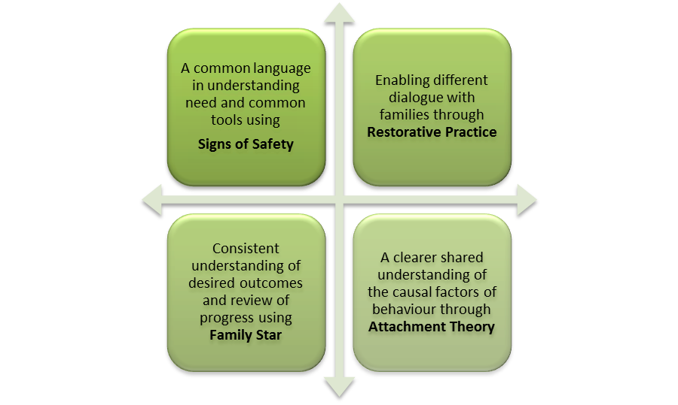

- Meeting the needs of Wokingham Looked After Children

Our Corporate Parenting Board has identified the following priorities

- Strengthen views of Children in Care in planning, reviewing & decision making
- Improve Independent Visitor take up
- Improve permanency: practice & placement options
- Deliver Young People’s Housing strategy: affordable housing, supported accommodation, Supported Lodgings
- Develop our apprentices, internships, work experience opportunities
- Develop our Family Nurse Partnership, pre FNP & Children’s Centre offer to young parent care leavers
- Ensure health support is effective

Key challenges that we experience in meeting needs of children through effective provision include:

- Sometimes we have a limited choice for children and young people
- Often we are not able to place children/young people with complex needs
- Some placements are not suitable long term
- Some placements are good enough at the time rather than best match
- We find a limited number of foster carers motivated to work with young people with complex needs including challenging behaviour. We have worked to meet this challenge internally by providing attachment training and therapeutic supervision to begin to repair and re-parent. We are seeing evidence of this contributing to placement stability and permanency
- We need to bring back our children/ young people out of residential placements to local area due to lack of family alternative

Wokingham Borough Council’s Sufficiency strategy details current service supply, future demand and desirable models of practice.

We currently place 23 children with independent fostering agencies across 12 providers. The providers commissioned do vary but the distribution has stayed relatively constant over the past three years:

Figure 2: current volume and distribution of IFA placements

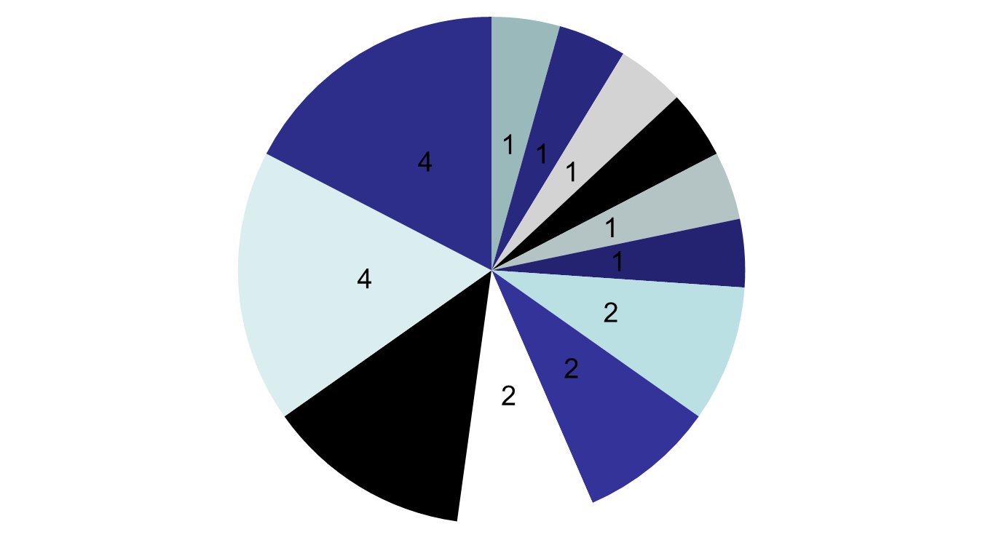
Our IFA annual unit costings have a high of £65,000 per annum, a low of £37,000 per annum and an average of £45,000 per annum.

Our overall placement budget breaks down as follows:

Table 2: Placement budget

 | £k
Total Management & Support | 733
Permanence Allowances | 495
Foster Placement Allowance Scheme | 698
Total Inhouse & Allowances | 1,193
Independent Fostering Agencies | 868
Residential Placements exc CHC contributions | 1,796
Total External Provision | 2,664
TOTAL BUDGET 15-16 | 4,590

- SERVICE SPECIFICATIONS

These Service Specifications describes the provision of a range of services, to be delivered under a three year Wokingham Borough Council (WBC) contract, with the opportunity of a year on year extension for a further two years, at the sole option of the Council, provided it is satisfied with the performance of the contractor. Any extension of a contract shall be on the terms and conditions agreed in the initial period of service provision.

We are seeking non-traditional contract models, i.e. partnership models as a preferred option.

Lot 1: Alternatives to Care

Description | There is clear evidence that accommodating a child so that they become Looked After by a Local Authority leads to a significant increased risk of poor life outcomes.  To prevent children from coming into Local Authority care, there is need for intensive and effective support for families by a skilled service to provide support to children and to enable increased resilience within the family, building their own coping strategies and problem solving capacity.  The crisis point will be defined as a ‘critical time within the family that would place the young person at imminent risk of entry to care.’  Our aims are to:  - Support development of positive relationships between parents or caregivers and their child;
Overview of Service | The aim of the service will be to address and provide support in relation to:  - Emotional and Behavioural issues;  - Attachment, bonding, relationship and separation issues;  - Social Communication difficulties.  Support is aimed at improving:  - Emotional wellbeing and development of child/young person;  - Attachment of child/young person to parents or carers;  - Stability of family or placement.
Outcomes | - Increased family stability for Wokingham children;  - A reduction in the risk facing a child, resulting in the removal of the necessity of taking the child into Local Authority care;  - Improved educational outcomes for Wokingham children, with particular improvements for those at risk of falling further behind;  - Improved health outcomes for Wokingham children;  - Parent/carers and children report that:  - The Service has supported them in establishing a stable and trusting relationship and effected meaningful change for the child and parent/carers;  - The Service has enabled children to share their thoughts and feelings;  - The Service has been conducted in a professional and appropriate manner.
Service Users | Children and families identified as being in need or children identified as being on the edge of care by Wokingham Borough Council.  Children’s behaviors are likely to include habitual substance misuse, persistent involvement in criminal behavior, severe disturbing and, or self-harming behaviors and psychological, psychiatric difficulties leading to family dysfunction and poor family relationships.
Staffing standards, skills & knowledge | Staff providing the service must have appropriate skills, training, qualifications and experience to deliver the service and a clear understanding of local children’s safeguarding issues and procedures.  We have established a Practice Framework in Wokingham with four key elements; Signs of Safety, Restorative Practice, Attachment Theory and Family Outcomes Star. Providers will ensure that work with children and parent/carers is compliant with our Practice Framework  All staff will be managed and supported by an appropriately qualified and experienced manager and be subject to regular supervisions and appropriate professional development and training.  All staff providing the service will comply with relevant professional regulatory requirements.

Lot 2: Placement Support for Looked After Children

Description | Provision of support for Children Looked After by Wokingham Borough Council which promotes placement stability, the building of secure attachments and positive outcomes and aspirations for our children.  Our aims are to:  - Support development of positive relationships between parents or caregivers and their child;  - Provide a safe space for a child to explore thoughts, feelings and memories;  - Build trust between parents or caregivers and their child;  - Support parents or carers to share the child’s emotional experiences and make sense of them together;  - Support the child to feel that his or her emotional experiences thoughts, wishes, feelings, perceptions and motives are understood, accepted, and valued.
Overview of Service | The aim of the service will be to address and provide support in relation to:  - Emotional and Behavioural issues;  - Attachment, bonding, relationship and separation issues;  - Social Communication difficulties.  Support is aimed at improving:  - Emotional wellbeing and development of child/young person;  - Attachment of child/young person to parents or carers;  - Stability of family or placement.
Outcomes | - Increased stability and permanency for Wokingham children;  - Improved educational outcomes for Wokingham children, with particular improvements for those at risk of falling further behind;  - Improved health outcomes for Wokingham children;  - Parent/carers and children report that:  - The Service has supported them in establishing a stable and trusting relationship and effected meaningful change for the child and parent/carers;  - The Service has enabled children to share their thoughts and feelings;  - The Service has been conducted in a professional and appropriate manner.
Service Users | Children Looked After by Wokingham Council, children and families identified as being in need or on the edge of care by Wokingham Borough Council.
Staffing standards, skills & knowledge | Staff providing the service must have appropriate skills, training, qualifications and experience to deliver the service and a clear understanding of local children’s safeguarding issues and procedures.  We have established a Practice Framework in Wokingham with four key elements; Signs of Safety, Restorative Practice, Attachment Theory and Family Outcomes Star. Providers will ensure that work with children and parent/carers is compliant with our Practice Framework  All staff will be managed and supported by an appropriately qualified and experienced manager and be subject to regular supervisions and appropriate professional development and training.  All staff providing the service will comply with relevant professional regulatory requirements.

Lot 3 Foster Care for Permanency

The Service will be delivered in accordance with the regional contract for Independent Foster Care Agencies with the following additions and in accordance with national policy expectations in line with Missing Children, Child Sexual Exploitation.

Description | We are seeking partnerships to develop and support our provision of Foster Care for Children Looked After by Wokingham Borough Council. We are seeking Foster Care which promotes stability, the building of secure attachments and positive outcomes and aspirations for our children.  Our aims are to:  - Ensure that Wokingham children are able to live, learn and thrive free from fear and harm, with a network of safe people around them  - Achieve this ambition for our Looked After Children through the development of positive, trusting relationships between a Foster carer and the child placed with them.
Overview of Service | - Direct delivery and/or partnership to increase the permanency and range of options available for our Looked After Children and increase the number of skilled and suitably qualified Foster Carers for our Looked After Children.
Outcomes | - Increased stability and permanency for Wokingham children;  - Improved educational outcomes for Wokingham children, with particular improvements for those at risk of falling further behind;  - Improved health outcomes for Wokingham children;  - Parent/carers and children report that:  - The Service has supported them in establishing a stable and trusting relationship and effected meaningful change for the child;  - The Service has been conducted in a professional and appropriate manner.
Service Users | Children Looked After by Wokingham Council.
Staffing standards, skills & knowledge | Staff providing the service must have appropriate skills, training, qualifications and experience to deliver the service and a clear understanding of local children’s safeguarding issues and procedures.  We have established a Practice Framework in Wokingham with four key elements; Signs of Safety, Restorative Practice, Attachment Theory and Family Outcomes Star. Providers will ensure that work with children and parent/carers is compliant with our Practice Framework.  All staff will be managed and supported by an appropriately qualified and experienced manager and be subject to regular supervisions and appropriate professional development and training.  All staff providing the service will comply with relevant professional regulatory requirements.

Lot 4 Foster Care for Challenging behaviour

The Service will be delivered in accordance with the regional contract for Independent Foster Care Agencies with the following additions of policy expectations in line with Missing Children, Child Sexual Exploitation, Substance misuse and exhibiting violence to others

Description | We are seeking partnerships to develop and support our provision of Foster Care for Children Looked After by Wokingham Borough Council. We are seeking Foster Care which supports Children who demonstrate challenging behaviour to achieve stability, the building of secure attachments and positive outcomes and aspirations for our children. Often this Foster Care will be provided in response to a Child experiencing escalating need who is at risk of experiencing or has experienced a family or placement breakdown.  Our aims are to:  - Respond quickly when Wokingham children are at risk or have experienced family or placement breakdown to provide a safe, caring environment;  - Ensure that Wokingham children are able to live, learn and thrive free from fear and harm, with a network of safe people around them;  - Achieve this ambition for our Looked After Children through the development of positive, trusting relationships between a Foster carer and the child placed with them.
Overview of Service | - Direct delivery and/or partnership to increase the permanency and range of options available for our Looked After Children and increase the number of skilled and suitably qualified Foster Carers for our Looked After Children.
Outcomes | - Children at risk or who have experienced placement breakdown are responded to quickly and kept safe, within a caring environment;  - Increased stability and permanency for Wokingham children;  - Improved educational outcomes for Wokingham children, with particular improvements for those at risk of falling further behind;  - Improved health outcomes for Wokingham children;  - Parent/carers and children report that:  - The Service has supported them in establishing a stable and trusting relationship and effected meaningful change for the child;  - The Service has been conducted in a professional and appropriate manner.
Service Users | Children in Need or Looked After by Wokingham Council.
Staffing standards, skills & knowledge | Staff providing the service must have appropriate skills, training, qualifications and experience to deliver the service and a clear understanding of local children’s safeguarding issues and procedures.  We have established a Practice Framework in Wokingham with four key elements; Signs of Safety, Restorative Practice, Attachment Theory and Family Outcomes Star. Providers will ensure that work with children and parent/carers is compliant with our Practice Framework.  All staff will be managed and supported by an appropriately qualified and experienced manager and be subject to regular supervisions and appropriate professional development and training.  All staff providing the service will comply with relevant professional regulatory requirements.

