SCHEDULE 2 – THE SERVICES

- Service Specification

Annex No.
Service | Adult & Older Adult Secondary Mental Health Services;  Memory Assessment & Treatment Service
Commissioner Lead
Provider Lead
Period
Date of Review

- Population Needs
National Context
- Dementia is an umbrella term used to describe chronic widespread cognitive impairment, associated with significant changes to functional abilities. The impairments may have a number of causes, including Alzheimer’s disease, and they are progressive and largely irreversible. Approximately 75% of people living in care homes have dementia.
- Dementia is a progressive, variable and largely irreversible condition that covers a wide range of symptoms. It is characterised by widespread impairment of mental function including; memory loss, communication/sensory difficulties and impairments, disorientation, personality change, self-neglect and behaviour that is out of character.
- Alzheimer’s disease accounts for around 62% of cases and 17% of cases being vascular dementia. However, increasing number of ‘mixed type’ dementia is being recorded and it is estimated vascular disease is a contributory factor in up - to 50% of cases.
- Alzheimer’s Research estimate there are 850, 000 people living with dementia in the UK, with 520, 000 having a formal diagnosis.
- The number of people living with dementia in the UK is expected to increase to 1.143 million by 2025 and 2 million by 2050, if current trends continue.
- The Five Year Forward View and the Department of Health’s Prime Minister’s Challenge on Dementia 2020 highlight the importance of good dementia care.
- Dementia is non-curable disease
- An estimated 25% of hospital beds are occupied by people with dementia and their hospital stays tend to be on average one week longer.
- It is also a leading cause of death for both men and women over 80 years old.

The Five Year Forward View and the Department of Health’s Prime Minister’s Challenge on Dementia 2020 highlight the importance of good dementia care and specific targets in relation to dementia are integrated into measurement of CCG performance. The cost of dementia across the UK is an estimated £26.3 billion each year (equivalent to £32,250 per person annually). Of this, £11.6 billion relates to support provided by families and friends, £10.3 billion is spent by social care and £4.3 billion by the NHS.

Local Context - Hull
- The current population in Hull is approximately 260, 000 and one in four people will experience a common mental health problem. Public Health England data estimates that 2, 499 adults in Hull are currently on the Care Programme Approach.
- Hull CCG and Hull City Council boundaries are co-terminus; whilst GP list size is 30,000 higher than the population.
- Life expectancy in Hull is lower than UK average (77 yrs for men and 80 yrs for women). The percentage of people aged 65+yrs out of the total population is currently estimated 15% but is expected to increase to 19% by 2030.
- Many of the wider determinants of mental health, long term unemployment, offending, addiction, smoking, obesity, deprivation, violent crime, statutory homelessness, and children in poverty are worse in Hull than its surrounding areas. (Public Health England Profile 2016).
- Recently published data specifically for Hull indicates lower than expected number of adults in contact with mental health services who are in paid work or have settled accommodation.
- It is estimated by 2030 there will be approximately 50,900 people aged 65+year living in Hull and that 3 in 100 of them will be aged 90+ years.
- In Hull data (as at February 2019) informs that there are 2, 154 people with a dementia diagnosis which gives a diagnosis rate of 77.1%. The estimated prevalence for Hull is 2,793 meaning that we potentially have 639 people in the city undiagnosed.

Local Context – East Riding of Yorkshire
- East Riding CCG is largely co-terminus with East Riding of Yorkshire Council with the exception of Pocklington where the registered GP population has services commissioned by the Vale of York CCG.
- A significant number of people living in East Riding of Yorkshire are registered with Hull CCG GP practices. This specification covers the registered population of East Riding of Yorkshire CCG.
- East Riding Clinical Commissioning group covers a large geographical area of approximately 1,000 square miles. This includes rural farming areas, urban areas, developing market towns, picturesque villages in the Wolds, and busy coastal resort towns
- Number of patients registered with GP practices in the East Riding of Yorkshire CCG area (at March 2019) – 306,139
- Number of people resident in East Riding of Yorkshire CCG area (mid-2012 est.) - 313,386
- Resident population of East Riding of Yorkshire Council area (mid-2012 est.) 335, 887
- Overall, the health of the population of East Riding is generally better than average, inequalities are highlighted by Lower Super Output Area Indices of Multiple Deprivation (LSOA IMD) scores with the areas in and around Bridlington, Goole, Driffield, Hornsea, Withernsea and some parts of Beverley and Cottingham experiencing the greatest multiple deprivation.
- In the East Riding we know that social isolation is a particular issue of concern for people who use care and support services.

The next steps on the NHS Five Year Forward View report reiterates the commitment to diagnosis and post-diagnostic support for people with dementia and their carers so that people can live independently in their own homes for longer, preventing crises and avoiding unnecessary admissions to hospital. This is also the ambition of NHS Hull CCG and forms the principles of this service specification and its implementation.

- Outcomes
2.1 NHS Outcomes Framework Domains & Indicators
Domain 1 | Preventing people from dying prematurely:
Domain 2 | Enhancing quality of life for people with long-term conditions:
Domain 3 | Helping people to recover from episodes of ill-health or following injury:
Domain 4 | Ensuring people have a positive experience of care:
Domain 5 | Treating and caring for people in safe environment and protecting them from avoidable harm:

2.2 Local Defined Outcomes
No Health Without Mental Health (2011) sets out a clear and compelling vision, centred around six objectives:
      - More people have better mental health
      - More people will recover
      - Better physical health
      - Positive experience of care and support
      - Fewer people suffer avoidable harm
      - Fewer people experience stigma and discrimination

Each of the above objectives is relevant to secondary mental health services, although some will be held jointly with primary health care and public health, especially physical health care, early intervention, de-stigmatisation and suicide prevention.

- Scope
3.1 Aims and Objectives of the Service

The fundamental purpose of the service is to ensure that people with memory impairment are appropriately assessed, diagnosed, supported and treated and they maintain or regain their place in the local community, achieving their full potential. This specification relates to memory assessment commissioned from XXX working with Humber Teaching NHS Foundation Trust (HTFT)
The service will;

- Deliver an integrated approach for assessment and diagnosis
- Increase the number of people being diagnosed with dementia, and starting treatment, within 6 weeks from referral
- Improve the quality of post-diagnostic treatment and support for people with dementia and their carers
- Provide people newly diagnosed with dementia and/or their family / carers written and verbal information about their condition treatment and the support options in their local area (Dementia Collaborative Booklet)
- Adhere to the standards set out in the Dementia Core Skills Education and Training Framework which sets out the essential skills and knowledge necessary for all employees involved in dementia care. It sets out standards needed in dementia education and training including raising dementia awareness, knowledge and skills for those that have regular contract with people living with dementia.

Benefits of a good quality, prompt, evidence-based dementia care;

- Reduces uncertainty, and fosters autonomy and the development of positive coping strategies.
- Improves delivery of person-centred care, increases quality of life and reduces non-cognitive symptoms.
- Minimises premature cognitive decline and the distress associated with coexisting physical and mental health comorbidities.
- Helps promote the wellbeing and overall health of the carer, as well as their competency and ability to care, which can delay the need for costly residential care.
- Promoting continuity of care can reduce the need for the person living with dementia, or their family or carer, to have to repeatedly provide basic information to services, which reduces the frustration they might feel.
- Enables short- and long-term person-centred care planning, including advance care planning, which enables people with dementia to live and die with dignity and in the place of their choosing while giving support to their families and carers.
- Enables optimal pharmacological, psychological and therapy interventions, including cognitive stimulation therapy, acetylcholinesterase inhibitors and memantine, which can slow the progression of dementia.
- Reduces the number and length of avoidable hospital admissions and readmissions, which can reduce poorer outcomes and the need for costlier crisis care.
- Increases early-phase research opportunities.

NICE Quality Standards need to be adhered to and these state that:
- People with suspected dementia are referred to a memory assessment service specialising in diagnosis and initial management of dementia
- People newly diagnosed with dementia and/or their carers receive written and verbal information about their condition, treatment and the support options in their local area
- People with dementia are enabled, with the involvement of their carers, to access services that help maintain their physical and mental health and wellbeing
- People with dementia have an assessment and an ongoing personalised care plan, agreed across health and social care, that identifies a named co-ordinator of care and addresses their individual needs
- People with dementia with the involvement of their carers, have choice and control in decisions affecting their care and support
- People with dementia receive care from staff appropriately trained in dementia

Dementia care encompasses the five elements of the well-pathway for dementia; preventing well, diagnosing well, supporting well, living well and dying well.

The service will be responsible in delivery of the elements relating to Diagnosing Well, Supporting Well, and Living Well.
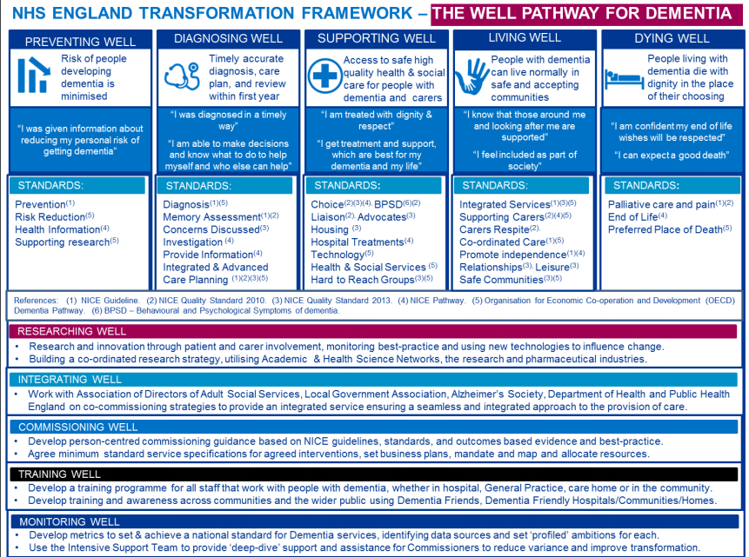

The statements below have been developed alongside people with dementia and carers. Five key themes emerged; identity, care, community, carers and research. Articulating the needs of people affected by dementia through a rights-based lens gives urgency and weight to this movement, and makes dementia something that no one can ignore.
The provider will ensure that throughout the service model and delivery the Dementia Statements below are adhered to and recognised by everyone delivering any part of the pathway. The Statements will also be used for audit purposes in terms of patient/carer feedback.

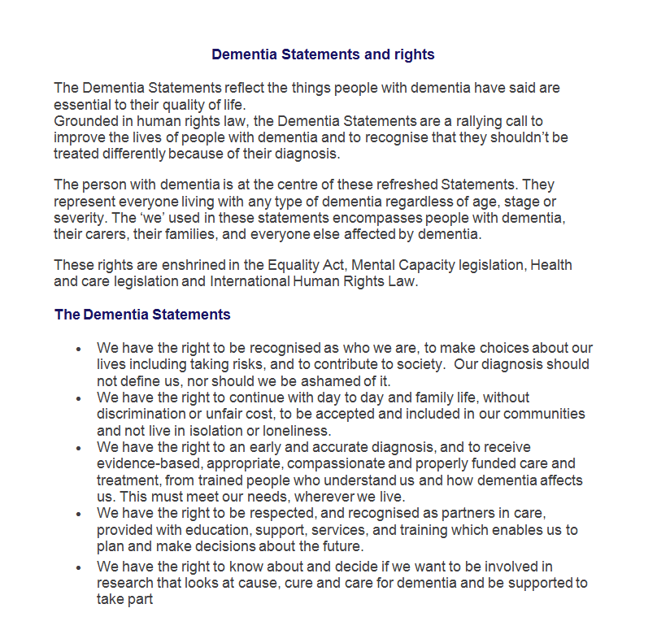

3.2 Proposed Service Care Pathway – provider undertaking white areas
Cog Stim Programme
Frailty Pathway Identification – assessment at ICC as part of integrated model
history taking, physical examination, blood and urine testing and cognitive testing
GP / Health Care Professional Referral
Referral following history taking, physical examination, blood and urine testing, cognitive testing and request for CT scanning

Single Point of Access (Potentially across H&ER)
Triage and Screening, Administrative Hub, Booking. Advice and Contact Point, Identification of Carer

Pre-diagnostic nurse assessment and risk assessment and elimination of functional cognitive elements
History gathering
Cognitive Testing
Carer Support Service

And / or neuropsychology testing, occupational therapy assessment/testing

Formulation and Diagnosis
Alzheimer’s
Society

Treatment
Post-diagnosis review and medication optimisation
Nursing or Medical

Care Plan Developed and Named Care Coordinator provided

Care managed in Service

Every patient; 12 week follow-up appointment. Review care plan

Specialist Nursing (including systemic family work, crisis prevention)

Psychological Intervention

Care discharged back to GP

Medicines Management

Occupational Therapy

Psychological Intervention

Dependent on suitability for discharge post service intervention

Direct link to Care Home Team/CMHT/Frailty Teams

Annual Care Plan Review

3.3 Service Description / Core Components of the Care Pathway
The provider will deliver a model that is multi-disciplinary.

The Provider will ensure they have the appropriate staff in place to deliver high-quality dementia care with the right skill mix. The Dementia Core Skills Education and Training Framework sets out the essential skills and knowledge necessary for all staff involved in dementia care. It sets out standards needed in dementia education and training including raising dementia awareness, knowledge and skills for those that have regular contact with people living with dementia. The Provider is required to adhere to these standards.

As the service will be provided by multi organisations; there will be the need for close liaison and communication in order to provide a streamlined service and care pathway. Regular team meetings to include all staffing who form part of the service will be required to take place.

XXX will only receive funding for the elements of the service that they directly provide

3.4 Referrals and Access to the Service
Referrals will be received from;
- Humber Teaching NHS Foundation Trust

A referral form will be provided giving clear details in terms of GP history taking & bloods. The service will utilise an electronic clinical database system to record all patient related information and communicate, as much as possible with HTFT, electronically.
The service will;
- Offer an appointment closest to the patients’ home and geographical areas, if this meets the required timescales, or soonest appointment at an alternative location.
- Book assessment appointments in a timely in order that time between referral and diagnosis can be minimal.
- Make every effort to understand the reason why someone has not attended their assessment appointment. Attempts to engage them (and their family and/or carer), including follow-up phone calls and reminders, should continue to be made. This is especially important when the person appears confused or has trouble remembering the purpose or time of the appointment.
- The provider will offer 3 appointments before sending referral back to HTFT
- Ensure that any referral deemed not to be suitable will be communicated directly to the referrer with the reasons why.

3.5 Assessment & Diagnosis
Principles of assessments;
- A holistic approach to assessment should be used. Where appropriate, assessments should be conducted in conjunction with family members, friends and informal and formal carers (including domiciliary support).
- Interpretation of assessments should fully take into account other factors known to affect performance, including educational level, skill, language and any sensory impairments, psychiatric illness or physical/neurological problems
- Referral, where appropriate, for further MRI or alternative scans
- Specialist input should be sought where necessary, including for the interpretation of investigations and scans in atypical presentations such as people with early onset dementia
- The assessment also identify the carer’s needs including support under the Care Act 2014 with HTFT making the onward referral

The service will ensure that the assessment includes;
- Appropriate cognitive examination and assessment of functional abilities should be completed by an appropriately qualified member of staff
- Utilisation of standardised tools such as Addenbrooke’s Cognitive Examination and should examine; attention and concentration, orientation, memory, praxis, language, visuospatial/perceptual skills and executive function as dictated by the clinical presentation
- If initial specialist assessment rules out reversible causes of cognitive decline, and where possible, diagnose a dementia subtype.
- If Alzheimer’s disease is suspected, include a test of verbal episodic memory in the assessment.
- If it is unclear whether the person has cognitive impairment or their cognitive impairment is caused by dementia, or what the subtype diagnosis is, consider neuropsychological testing.
- Utilises validated criteria to guide clinical judgement when diagnosing dementia subtypes, in line with NICE recommendations.
- Only consider further diagnostic tests if they would help diagnose and support management of a dementia subtype. See the Dementia NICE guideline for recommendations about further tests (https://www.nice.org.uk/guidance/ng97).
- Provide Carer’s assessment via the Carers Information & Support Service who will be an integrated partner in delivery of the service.
- Appropriate onward referral back to HTFT for any other service assessment e.g. Frailty

Confirmation of diagnosis should be given to the person and their carer by a member of the team.

Information on Diagnosis & Consent
The service will;
- Offer the person and their family members or carers oral and written information that explains:
  - what their dementia subtype is and the changes to expect as the condition progresses
  - which healthcare professionals and social care teams will be involved in person’s care and how to contact them how dementia affects driving
  - their legal rights and responsibilities
  - their right to reasonable adjustments (in line with the Equality Act 2010) if they are working or looking for work
  - how local support groups, online forums and national charities, financial and legal advice services, and advocacy services can help.
  - Diagnosis and driving (the service also linking with the Regional Driving Assessment Centre as appropriate)
- At diagnosis, ask the person for their consent to share information, which people they would like services to share information with, and what information they would like services to share. Document these decisions in the person’s records.

3.6 Responsiveness
The service will adhere to the required key performance indicators which are included below. The service must be flexible to meet the needs of the individuals.

3.7 Discharge / Signposting
The provider will discharge their caseload to the Trust Memory Assessment & Treatment Service under the following circumstances only;
- Memory assessment undertaken and diagnosis given

  - Population Covered
The services are available to all adults over the age of 18 who are registered with a Hull or East Riding GP or reside within the City of Hull or East Riding of Yorkshire but are not registered with a GP.

3.9 Acceptance and Exclusion Criteria
Accesses to the services are not constrained by a person’s gender, age, ethnicity, sexuality, faith, disability or diagnosis.

The service is available to;
- Individuals residing within or registered with a GP in the City of Hull
- Individuals experiencing, or potentially experiencing memory impairment consistent with the presenting features of dementia following appropriate screening being undertaken

The service is not available to;
- individuals who have a learning disability (liaison with the appropriate Community Learning Disability Team should take place)
- Individuals who have been diagnosed with Parkinson’s disease (they will have the required interventions and treatment from the Parkinson’s Service)

Inappropriate referrals from primary care/secondary care or other sources must be returned to the referring source with a clear explanation and alternative referral recommendation.

- Applicable Service Standards
  - Applicable National Standards

- NICE Guideline NG97; Dementia: assessment, management and support for people living with dementia and their carers.
- NICE Guideline TA217; Donepezil, galantamine, rivastigmine and memantine for the treatment of Alzheimer’s disease
- NICE Guideline NG16; Dementia, disability and frailty in later life – mid-life approaches to delay to prevent onset
- NICE Quality Standard QS30; Dementia: independence and wellbeing
- NICE Quality Standard QS1; Dementia: support in health and social care

- Applicable Quality Requirements and CQUIN goals
5.1 Applicable Quality Requirements

TBC

5.2 Applicable CQUIN goals
- Specific Service Location
The provider will ensure that service is provided within locations that are easily accessible for the population described.

