**West Chiltington Parish Council**

**Grounds Maintenance Contract**

**Technical Specification**

**2021-2024**



TECHNICAL SPECIFICATION 4

1 General Introduction 4

1.1 Pre Amble 4

1.2 Performance maintenance 4

1.3 Works to be undertaken 4

1.4 Work Progress 5

1.5 Allowances 5

1.6 Waste disposal 6

1.7 Access 6

1.8 Ground and weather conditions 7

2 Grassed Areas 7

2.1 General Conditions (Grass Cutting) 7

2.2 Grass cutting Machinery 9

2.3 Growth Regulators 10

2.4 Subterranean Animals 10

2.5 Variation to Grass Cutting Schedules 10

2.6 Boxed Grass Areas 11

2.7 Amenity Grass Areas 11

2.8 Rough Grass Areas 12

2.9 Naturalised Bulb Areas 12

2.10 Strimming 13

2.11 Sports Pitches 13

2.12 Turfing/Seeding 14

3 The Maintenance of Sports Pitch 15

3.1 General 15

3.2 Pitch Maintenance – Playing season 15

3.3 End of season winter pitch reinstatement 16

3.4 Cricket Outfield 16

3.5 Additional Works on Sports Pitches (to be at the request of the Authorised Officer) 17

3.6 Grass mowing 17

3.7 Performance Standard for Grass Maintenance 18

4 Vegetation Control and Pesticide Application 26

4.1 General 26

4.2 Legislation 26

4.3 Protection of the Environment 28

4.4 Selective Herbicides on Turf 28

4.5 Treatment of Paths, Drives and Other 'Hard' Surface Areas 28

4.6 Treatment of Fence Lines, Obstructions and Bases of Buildings 29

4.7 Other Spraying Works 29

4.8 Herbicide of Hedge Bases 29

5 Hedge Maintenance 31

5.1 General 31

6 Ditch Maintenance 34

6.1 General 34

6.2 Ditches 35

7 Voluntary Work 35

7.1 General 35

# TECHNICAL SPECIFICATION

# General Introduction

## Pre Amble

### West Chiltington Parish Council is committed to providing a comprehensive range of visual, landscape and amenity facilities and the overriding requirement of this Output Contract is that the standards laid down in this specification and associated documents will be achieved as a minimum. The Contractor should therefore provide for the making of such number of visits during the year to each site as considered necessary in order to achieve those standards

### The Authorised Officer will be responsible for inspecting sites in order to ascertain that the work has been carried out and to the standards required.

## Performance maintenance

### This specification is based on a performance model.

## Works to be undertaken

### The work to be undertaken is fully described in the Specification.

### All Services as specified are to be provided by the Contractor within the Annual Sum except where otherwise expressly provided in this specification or elsewhere in the Contract Documents.

### The whole of the work shall be carried out in a thoroughly professional manner in accordance with the principles and practices of accepted and recognised horticultural standards.

### For the purpose of this contract the Employer’s property includes all the land, fixed equipment, growing plants and vegetation, hard surfaces and water thereon. The Employer’s property shall not be used by the Contractor for any other purpose than herein specified. The Contractor shall not knowingly permit any other person to use the Employer’s property for any purpose except for those prescribed and permitted by the Employer.

### The Contractor shall ensure that the Employer’s property is protected against accidental or negligent damage likely to be occasioned through undertaking the works specified herein.

### Any damage occasioned by the Contractor in carrying out the works of this contract shall be immediately made safe and repaired to the satisfaction of the owner or agent of the property at the earliest convenient time, or as directed, and at the sole cost of the Contractor.

### The Contractor shall be responsible for acquiring the necessary permits and paying charges and fees for the utility services needed to complete the works.

### Any proposals relating to tree surgery on any site are to be referred to the Authorised Officer.

## Work Progress

### The Contractor will be required to record the progress of work on a weekly basis by means of records/report sheets provided by the Contractor and in a format to be agreed with the Authorised Officer prior to the commencement of the Contract.

### Where scheduled work is prevented from being completed by any public occurrence the Contractor shall return to complete the work not undertaken at the earliest possible time.

### The Contractor shall inspect all sites each time before commencing maintenance to ensure there are no visible hazards likely to cause injury to the public, and shall report such hazards immediately to the Authorised Officer

### The Contractor will at reasonable times when instructed so to do by the Authorised Officer, attend site or other meetings.

## Allowances

### Any changes to the sites resulting in permanent additions or reductions to those listed or permanent additions or reductions to the quantity of work at existing sites, will be at the discretion of the Parish Council and in the event of such permanent changes adjustments will be made to the Annual Sum in direct proportion to the increase or decrease in the amount of work required in accordance with the Condition of Contract.

### In accordance with the Conditions of Contract and Specification, the Contractor shall make appropriate allowance within his rates and prices to cover the cost of providing or undertaking the various minor and/or ancillary operations associated with the major tasks to be performed. These associated tasks, which if not sufficiently explained in the General Information and Instructions for Tendering or Conditions of Contract, may be described later and more fully in the appropriate parts of this Specification, include:

* the proper carting from site and disposal of all other arisings, debris etc. where appropriate, collected or produced during the course of the undertaking the required works,
* the removal of all mounds and filling in of all holes created by animals or caused through usage of sites and likely to cause danger to the public or others.

## Waste disposal

### The Contractor shall ensure that all waste collected, produced or arising from the undertaking of the Services is correctly and properly disposed of making use of licensed and approved tips or incinerators as appropriate.

## Access

### The Contractor shall provide necessary barriers and notices around works where public protection is deemed to be required. Wherever works impede pedestrian and vehicular access the Contractor shall provide and maintain safe alternative routes alongside or through the affected work area.

### The Contractor shall have the right to ask members of the public to move so that works can be progressed to completion. This should be done with tact and courtesy.

### The Contractor shall similarly make provision within his rates and prices to gain access to sites; if fencing is removed it shall be replaced in a secure and proper fashion on each and every occasion that the Contractor leaves the site.

### The Contractor shall allow for safeguarding and protecting against damage due to the carrying out of the services to all existing and completed works by others on or near the site.

### At all times, the entire sites right up to boundaries shall be kept in a clean and tidy condition, with surplus materials, debris, etc. being cleared away as work proceeds. Clearance must not involve the depositing of debris onto other areas beyond the working boundaries of the site.

### Should any damage or loss be caused to existing or completed works due to the carrying out of the Services, the Contractor shall be required to reinstate and make good such damage at his own expense and to the satisfaction of the Authorised Officer.

### The Contractor shall have free access to the sites for the duration of the works. Access shall only be by public roads or other agreed routes and using existing entrances to individual sites. Any special Contractor access points shall be locked immediately after entry and exit.

### Notwithstanding the foregoing, the Employer may at times restrict or prohibit Contractor access on specific days as considered by the Employer to be necessary or desirable.

### Public access must not be denied or impeded by contract activity unless previously approved by the Employer.

### Every courtesy and assistance shall be given by the Contractor’s staff to members of the general public using the Employer’s facilities specified in this contract.

## Ground and weather conditions

### The Contractor shall make due allowance for climatic variations which may at any time dictate a changed programme of operations.

### Work shall not be carried out with any machinery when ground conditions are such that puddling, deep rutting, or any other detrimental effects may occur.

### In the event of weather or ground conditions preventing the completion of works specified in the Schedules, etc., the Contractor may with the prior consent of the Authorised Officer modify his programme or method of working. In the event of such modifications being required, the Parish Council reserves the right to reduce payment to the Contractor in the event of a reduction in work undertaken.

### The Contractor shall be deemed to have included in his rates and prices for any additional cost of carrying out the works in adverse weather/ground conditions, and the Parish Council will not consider any additional payments for working in such conditions.

# Grassed Areas

## General Conditions (Grass Cutting)

### The Contractor shall make full provision within the Tendered Rates for all costs that the Council shall incur in maintaining the Features to the standards specified for Grass Cutting and for the periodic tasks that are stipulated therein.

### This section provides the specification for all operations relating to grass cutting carried out during the course of the Contract.

### The general conditions will apply to each type of cutting regime and should be allowed for in items referring to grass cutting. Some locations may have a mix of regimes which must be noted when cutting the site. Grass cutting shall take place whenever required to ensure standards are met throughout the full calendar year.

### A rota of grass cutting will be submitted to the Authorised Officer for approval and agreement annually.  Once agreed the Contractor will keep to the rota (where possible) and ensure all areas are cut on this basis.

### Ensure that all work on one site/plan is complete before moving onto the next site.  Grass will be cut up to the paving, fencing, walls and any other boundary and all obstacles will be cut around and beneath to the same height as the majority of the site at each visit.

### All temporary obstacles that can be moved, will be moved to facilitate cutting and replaced immediately the grass beneath has been cut.

### Allow for any parked vehicle or temporary obstacle on the site which may obstruct cutting operations and will allow for returning to the site to cut such sites when the vehicles or obstacles have been removed.

### Ensure that all tree bases are clear of vegetation.

### Prior to grass cutting operations being undertaken, inspect all areas to be mown and remove litter, including dog faeces, deleterious matter and all items and obstructions as may cause damage or injury to people, property or machinery irrespective of its source.  Where hypodermic needles are encountered, take all necessary handling and disposal precautions.

### All grass will be cut cleanly and evenly to the same height as per table 1 and without damaging the existing surface.  The finish shall be free of ribbing, skids, ruts, excessive tyre marks, or divots.  Any accumulations of arising’s in areas that are mown with un-boxed mowers will be removed.  Soft vegetative growth other than grass will be deemed to be part of the agreement where it falls within the sites of grass.

### All persons operating grass maintenance machinery must be satisfactorily trained, conversant with relevant legislation, including all relevant Health & Safety Legislation and competent in the operating methods.

### Ensure that all blades, guards, belts and boxes are of the correct type with the correct fixing nuts or bolts and all equipment is used entirely in accordance with the manufacturer’s instructions.

### All non-grass areas will be kept free from arisings created by any grass cutting operation and any arisings deposited on non grass areas will be removed immediately.

### Cutting will take place on each site and include all flat, sloped and banked areas, whether or not identified on plans of that site, using suitable machinery and regardless of terrain will be cut at the same time and frequency as the majority of the site.

### Allow for manoeuvring between trees and obstacles and for gaining access to all sites.

### Be responsible for the provision of all necessary barriers, traffic control and safety measures and must include for such in his rates.  All shall be in accordance with Traffic Sign Regulations and General Directions (1994), and subsequent amendments, and shall conform to Chapter 8 of the traffic Signs Manual published by HMSO or any amendments thereof.

### All arisings, litter including dog faeces, deleterious matter and all items and obstructions as may cause damage or injury to people, property or machinery, irrespective of its source, collected while carrying out operations in this section of the contract, are to be removed from site to an approved site, as per section 1.6

### Inform the Authorised Officer immediately if local site ground conditions prevent cutting taking place on a site in accordance with the prescribed standards and as a result excessive grass growth occurs.

### When conditions permit, undertake a sufficient number of remedial cuts to restore the area to the required standards.

### The Contractor shall ensure that mowing regimes are adhered to, using all relevant forms of cutting equipment.

### Extreme care shall be taken when cutting around tree bases to avoid damage to tree or plant material. If any damage occurs, the Contractor shall at his own expense replace any tree or plant damaged with a similar tree or plant species. Where low branches frustrate the Contractor’s ability to mow the natural ‘drip-line’ of the tree the drip-line will indicate the boundary of the feature. Contractors must not remove any such branches without the express permission of the Authorised Officer. All grass not mown for this reason shall be cut by hand and the arisings removed as part of the final cut of the season.

### The Contractor shall be aware some Locations can only be accessed through restricted entrances or gates. The Contractor shall obtain and securely keep any necessary keys and shall ensure gates are closed, and locked where applicable, upon completion of any grass cutting operation on each and every occasion. No claims for additional payment by the Contractor shall be admitted on the basis that access is inadequate or other site constraints exist

### If, in the opinion of the Authorised Officer, a poor quality of cut has been achieved after the first pass of the mower during any grass cutting operation, further cuts shall be made at the Contractor’s expense with a more appropriate or fully sharpened machine until the finish is approved by the Supervising Officer.

### The Contractor shall take due care whilst operating strimmer’s and blowers in respect of the possible health and safety hazard to people, property and animals.

### 

### 

## Grass cutting Machinery

### The Contractor shall at all times during the period of the Contract ensure that machines are properly guarded and maintained so as to present no danger to the operator or any person in the vicinity of operations. Motorised equipment must be fitted with effective silencers and television suppressers. The Contractor shall provide his staff with all necessary safety and Personal Protective Equipment (boots, reflective vests, etc.), risk assessments and safe systems of work, and shall ensure that staff use these as appropriate at all times they are engaged in work on the sites which form the subject of the Contract.

## Growth Regulators

### During the period of the Contract no growth regulators of any form shall be applied to any area of grass without the Authorised Officer sanctioning such applications.

## Subterranean Animals

### On all high amenity areas and sports pitches, clear all soil arising’s where moles are active prior to cutting of site. Areas which present mowing difficulties or become potentially injurious to players or members of the public must be communicated to the Authorised Officer. Other animal workings such as Badgers, Foxes, and Moles which spill soil onto grass areas that may cause injury or default to maintenance must be reported to the Authorised Officer.

## Variation to Grass Cutting Schedules

### In normal weather conditions the Contractor will be expected to keep to the schedule and programmes which has been submitted and which he has determined will enable the required standards to be achieved. However, variations to these schedules/programmes for grass cutting may arise, normally due to the vagaries of the British Climate, and the following paragraphs explain the procedure in particular circumstances

### The Contractor shall fully utilise the periods when ground conditions permit mowing operations. The Authorised Officer reserves the right to direct the Contractor to cease the cutting of grass on any area, or in total, should, in the opinion of the Authorised Officer, weather conditions be such as to result in a cessation of grass growth or ground conditions be so wet as to prevent grass cutting occurring without causing damage to the surface or levels of the ground.

### If site conditions make mowing operations undesirable because they may cause damage, the Contractor may with the agreement of the Authorised Officer delay operations until conditions are suitable. After any such delay the Contractor shall resume grass cutting as soon as conditions become suitable again and notify the Authorised Officer of his intended plan to re-schedule any work which has not been completed within the overall frequency requirement, which the Authorised Officer must approve. The Contractor shall be expected to provide sufficient staff and machinery to catch up if there is time lost. The Contractor will be responsible for taking any remedial action to bring the area back into contract standards. This will include additional cuts and the removal of excessive grass cuttings at no additional cost to the Council.

### Should the Contractor cause damage to the surface or levels of the ground, during grass cutting operations, the Contractor shall make good such damage to the satisfaction of the Authorised Officer.

### During periods of drought the Authorised Officer may instruct that grass cutting operations be suspended and may require the omission of a planned cut or cuts. In this event, additional alternative works will be identified by the Authorised Officer and carried out to the value of the work omitted.

### The Contractor must ensure that the timing of all grass cutting operations is such that the cutting precedes the marking of any sports facility where the markings could be disturbed by the passage of the machinery used.

## Boxed Grass Areas

* Grass height to be maintained to the lengths confirmed in Table 1. These are areas of fine quality turf it is expected that these areas would require at least weekly mowing frequency regime. These areas should provide-
* Grass to be maintained to the lengths confirmed in Table no 1.
* No shorter than 10mm.
* Cricket Wickets to be maintained by the West Chiltington Sports Association see section 3.4
* The Croquet lawns will be cut with an approved cylinder mower for the period from April to September and all arisings will be boxed off
* Uniform cut including perimeter edges / obstacles.
* Striped finish where appropriate.
* Clean, clipping-free, litter and debris-free finish.
* Green healthy looking sward, free from weeds / moss / bare patches-all year round.
* Paths and surrounds, free of clippings.
* Edges to beds should be maintained to provide neat, tidy and aesthetically pleasing perimeter, sympathetic to site’s design.
* All arisings will be collected as the site is cut and disposed of offsite, upon completion of cutting, in a previously agreed manner.

## Amenity Grass Areas

* This type of turf is found on, highway verges, recreation areas etc, and comprises of the majority of grassed areas in the contract. These areas should provide:
* Grass height to be maintained to the lengths confirmed in Table no. 1.
* Appearance of healthy sward.
* No unsightly weeds, litter, debris, clippings and bare patches.
* To provide a welcoming and useable area for general green space use, including informal games and picnics.
* All areas uniformly cut including perimeter edges and obstacles.
* Paths and surrounds free of clippings.

## Rough Grass Areas

* These areas should provide:
* Grass height to be maintained to the lengths confirmed in Table no. 1.
* Neat sightly appearance, all grass uniformly cut, including perimeter edges and obstacles.
* Free of all unsightly litter debris, and clumps of clippings
* Paths and surrounding edges free of clippings at all times
* Use of herbicide for grass edging is permissible by agreement with the Authorised Officer, but in compliance with neat and sightly appearance.

## Naturalised Bulb Areas

* Bulb growing in grass areas must be allowed to complete their growth cycle before mowing takes place. When grass cutting recommences on areas of naturalised bulbs, the areas will be gradually brought back to the same standard as the adjoining sward, normally using rotary mowers, strimmer’s or by hand hooking, scything or by other means, as may be approved by the Authorised Officer.
* The first cut should take place at least six weeks following the completion of flowering but no more than eight weeks.
* All clippings should be removed from site and disposed of in a manner agreed with the Authorised Officer.
* The area should then revert to the regime of the surrounding grass.

## Strimming

* The Contractor will be required to strim or clip around all obstacles within the confines of the various categories of grass areas described in this Specification, to maintain the height of grass to the mean level of the grass on the surrounding areas. all at no additional cost to the Parish Council. No quantities of obstacles are detailed: it is for the tenderer/contractor to determine at tender stage full implications of this task.

## Sports Pitches

* Pitches are to be maintained to the lengths confirmed in Table no.1.

## Turfing/Seeding

### Grass seed used for this contract shall be approved by the Authorised Officer.

### Turf for use in renovating existing grassed areas shall comply with BS3969 and shall have been delivered not more than one week before being laid.  Turves that have been dried out or etiolated shall not be used and shall be removed from the site.

### Topsoil for use in regulating and grading existing lawns and beds shall comply with BS 3882.  When placed, it shall be free of stones more than 25mm in gauge and all traces of perennial weed material.

### Where grass areas are to be re-sown or re-graded, the entire area concerned shall be cultivated by manual or mechanical means to a minimum depth of 100mm, graded, consolidated and raked to a fine and true seed bed.  All stones exceeding 25mm gauge, all weeds and other injurious matter resulting from these operations shall be removed from site.

### Where necessary, topsoil will be supplied and spread to make up levels. Supply and spread pre-seeding fertiliser, as agreed by Authorised Officer, to be spread at the manufacturers recommend rate and raked into the seed bed.  Work to incorporate pre-seed fertiliser will be undertaken at the sole discretion of the Authorised Officer at the unit rate quoted.

### Where a portion of existing grass is to be re-turfed, the entire affected area shall be cultivated and thoroughly broken by mechanical or manual means to a uniform depth of 100mm.  All stones exceeding 25mm gauge, all weeds and other injurious matter and sufficient soil to achieve a consolidated level of 25mm below the adjacent grass shall be removed from site in a previously agreed manner.  The bed shall be consolidated to true level by raking and rolling.

### Where grass seed is to be sown, the seed bed shall be prepared as described above.  Seed shall be supplied and sown, as specified and agreed by Authorised Officer and shall be evenly broadcast over the entire area at a rate specified – normally 35 gms/m2.  The bed shall be lightly raked to cover the seed and rolled with a light roller.  Any area which fails to germinate shall be re-sown within 4 weeks at the Contractors expense following the same method of operation throughout.

### Turfing - on bed prepared as previously specified, supply turf to BS 3969.  The turves shall be laid so as to break bond by half a turf length, shall be neatly cut to edges and around obstructions, tightly butted to each other and the surrounding grass and well firmed down.  Immediately after laying turf, top dress with fine sifted soil or sandy loam, brush well into the joints and lightly roll to a firm even surface.  Where gradients on banks necessitate, the turves shall be secured by wooden pegs driven through the turves into the bed. Ensure that the turfed area subsequently receives sufficient water (where appropriate) to ensure the proper establishment of the grass.

### Allow in rates for all materials required and disposal of waste.

# The Maintenance of Sports Pitch

## General

### This section provides the specification for all operation relating to the maintenance of sports areas carried out during the course of the Contract.

### All pitches to be marked by West Chiltington Sports Association with clear white lines in accordance with the appropriate Sports Governing Bodies Rules & Requirements, and to be visible from 30 metres at the time of play.

### Where provided, posts will be safe, straight, vertical, painted and installed in accordance with appropriate Sports Governing Bodies Rules & Requirements of the pitch and sport.

### Evidence of a maintenance programme will be required to achieve a true and playable surface throughout the season. (For guidance, when ground conditions are acceptable, a program of aeration, de-compaction, harrowing, rolling, sanding of eroded areas and divot replacement will be required and this may vary from site to site).

### During the growing season the playing surface should maintained to provide a uniform green, healthy sward consistent with the requirements of the sport.

## Pitch Maintenance – Playing season

### Harrowing of sports pitches shall be undertaken with approved tractor mounted reversible chain or light flexible spike harrow to establish an even and fine surface appropriate for the use being made of the area.  This operation to be carried out 8 occasions between September and April.

### Sanding of pitch areas shall be at the discretion of the Authorised Officer and shall be carried out at the scheduled unit rates tendered in the quantified schedule of rates. Supply Sand to be lime/salt free having a rounded to sub-angular grain shape and dominated by particles in the 0.125-0.5mm size range using a suitable approved mechanical spreader fitted with low ground pressure tyres. (This work will be classed as Additional Work as described in 6.9 below).

### Aeration and Decompaction of sports pitches shall be at the discretion of the Authorised Officer and shall be carried out at the scheduled unit rates tendered in the quantified schedule of rates, and shall be undertaken to ensure the topsoil is rigorously de-compacted. A range of machines can be used subject to the approval of the Authorised Officer, including Verti-draining when the soil is moist and friable and linear aeration (Earthquake, Shockwave or Ground-breaker) when the soil is drier and brittle. The objective shall be to maintain the soil porosity at a minimum of 10% porosity and bulk density in the soils upper profile to be no more than 1.1 to 1.2 Mg/m3.

## End of season winter pitch reinstatement

### Immediately after the completion of the playing season as determined for each site, the Contractor will undertake renovation works on pitches. Before undertaking these works the Contractor will inspect pitches submitting to the Authorised Officer details of reinstatement and materials required on a form to be provided by the Contractor and approved by the Authorised Officer.

### Inform the Authorised Officer of all pitches that need reinstatement work giving measurements for the total area two weeks before the end of the season, in order that an assessment of the work can be undertaken by the Authorised Officer. Having received instruction to carry out renovation works the Contractor shall undertake the following operations being allowed for within the Annual Sum as soon after the end of the season as weather conditions permit.

### The Contractor shall be required to carry out annual renovation of the e.g. goalmouth, penalty box or other areas of intensive wear, where surface level discrepancies occur, the Contractor will apply screened sandy loam sufficient to restore the surface level. The Contractor will cultivate the ground to ensure the top dressing is ‘keyed’ into the surface. The renovation work shall normally be carried out in the month of May (note that some fixtures may be extended) The Contractor shall overseed with a Sports Pitch Rye grass seed mixture at the rate of 35 g/m2 having applied pre-seeding fertiliser to all areas of seeding. All seeded areas shall be maintained until established at the Contractors own expense. It should be noted that the eastern penalty area of the football pitch co-insides with the cricket outfield.

## Cricket Outfield

### The Contractor will mow the Cricket Outfield in accordance with Table 1 below. The Contractor MUST liaise with the Authorised Officer to agree a mowing regime to fit in with the West Chiltington & Thakeham Cricket Club’s fixture list which will require flexibility of mowing frequency.

### The West Chiltington Sports Association will maintain the cricket Square on behalf of West Chiltington & Thakeham Cricket Club. Clippings shall be removed and disposed of as per as per section 1.6 and cutting height shall be specified as Table 1.

## Additional Works on Sports Pitches (to be at the request of the Authorised Officer)

### At the request of the Authorised Officer, the Contractor shall dress goalmouths and other specified areas with approved lime free sand. The rate of application will vary depending on the conditions of the areas. Before application, the area shall be lightly spiked with a fork to a depth of 100mm at 150mm intervals, the fork to be removed without causing major disturbance to the playing surface.

### At the request of the Authorised Officer the Contractor shall carry out Decompaction with Vertidrain, Earthquake, Groundbreaker, or Shockwave as additional work.

### At the request of the Authorised Officer the Contractor shall apply a pre-seeding fertiliser one week ahead of seeding, typical mix to be 6N/9P/6K applied @ 35gms/m2.

### At the request of the Authorised Officer the Contractor shall carry out overseeding in two directions with appropriate sports rye grass mixture; worn areas @ 35gms/m2, and other areas @ 20 gms/m2, using Verti seeder or equivalent.

### The Contractor shall complete all renovation work within 4 weeks of the end of the playing season.

### At the request of the Authorised Officer the Contractor shall carry out fertiliser application during the non playing season to the pitches of a mini-granular fertiliser, as agreed with the Authorised Officer, at the rate specified by the manufacturer (normally 35 g/m2)

### Application to be carried out when foliage is dry and when soil temperatures exceed 10oC.

### The material should be evenly distributed across the whole surface of the playing area.

### When weather conditions dictate the Contractor shall arrange to water the newly seeded goal mouth areas until directed otherwise by the Authorised Officer.

### At the request of the Authorised Officer the Contractor shall apply Turf herbicide when weather conditions permit in accordance with the conditions described in Section 4.

### The Contractor shall not cut grass for three days before or three days after application of the herbicide

### All Additional Works described in this section shall be carried out at the scheduled unit rates tendered in the quantified schedule of rates.

## Grass mowing

### The Contractor shall bring the grass height to the level appropriate to the intended use in time for the commencement of the playing season in accordance with heights specified in Table 1

## Performance Standard for Grass Maintenance

**Table 1:** Grass Areas – Performance Standard for Grass Maintenance

|  |  |  |  |  |
| --- | --- | --- | --- | --- |
| Feature | Summer season cutting height  (April– End of Sept) | | Winter season cutting height  (October – End of March) | |
| Min. | Max. | Min. | Max. |
| Whole Recreation ground for Winter Football(Except Cricket wickets)  (See Map 1 below) |  |  | 20 mm | 35mm |
| Whole Recreation ground (Except Cricket Wickets ) for Summer Cricket Outfields  (See Map 1 below) | 10mm | 20mm |  |  |
| Cricket Wickets to be maintained by the West Chiltington Sports Association |  |  |  |  |
| Croquet Lawn collect arisings using approved cylinder mower  (Within Map 1) | 10mm | 15mm | 20 mm | 35mm |
| Play park ( See Map 1 below) Blue outline | 10mm | 30mm |  |  |
| Feature / Location | Summer cutting Min | Summer cutting Max | Collect arisings | Primary cutting method |
| Parish Office  (See Map 2 below) | 20mm | 30mm |  |  |
| Pond Rise  (See Map 3 below) | 20mm | 30mm |  |  |
| Church Field  (See Map 4 below) | 20mm | 30mm |  |  |
| Boxed Grass Areas | 10mm | 15mm | Collect arisings | Cylinder/ Rotary Boxed |
| Amenity Grass | 20mm | 35mm |  | Cylinder/ Rotary |
| Rough Grass | 100mm | 150mm |  | Rotary/Flail |

Recreation Ground, Mill Road (Map 1)

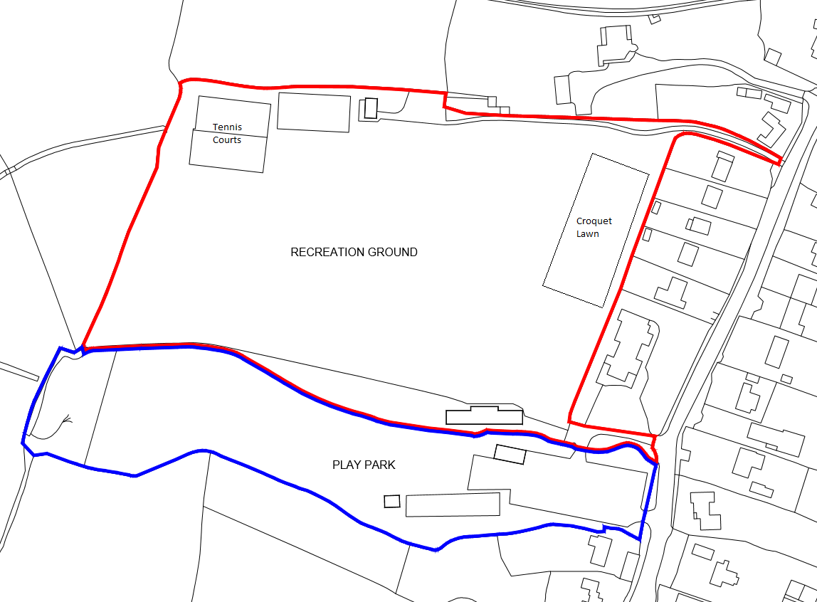

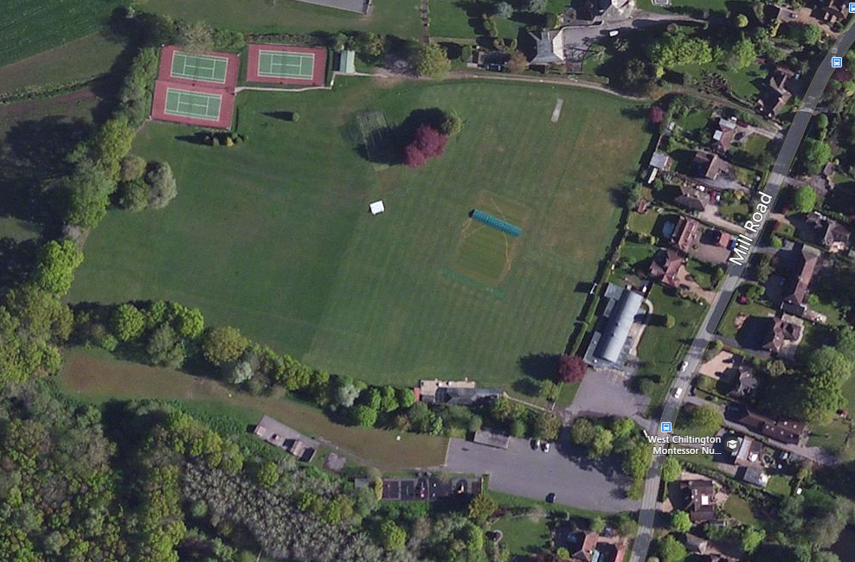

Parish Rooms, Church Street ( Map 2)

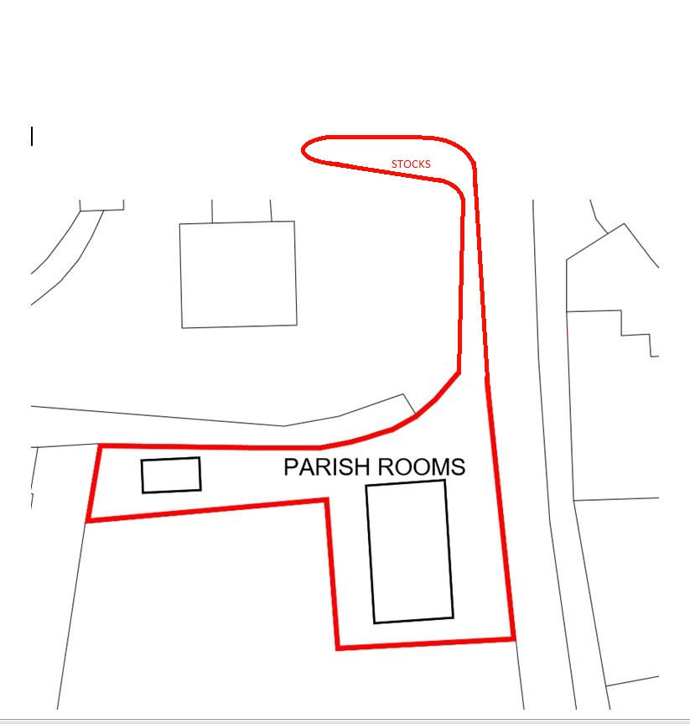

Pond Green/ Left verge towards Juggs Lane - Church Street (Map 3)

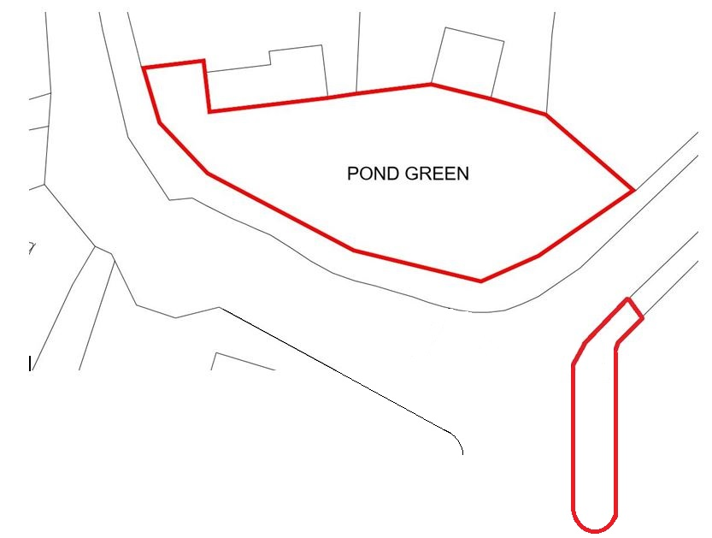

Church Field, off Church Street. Access via Church carpark. (Map 4)

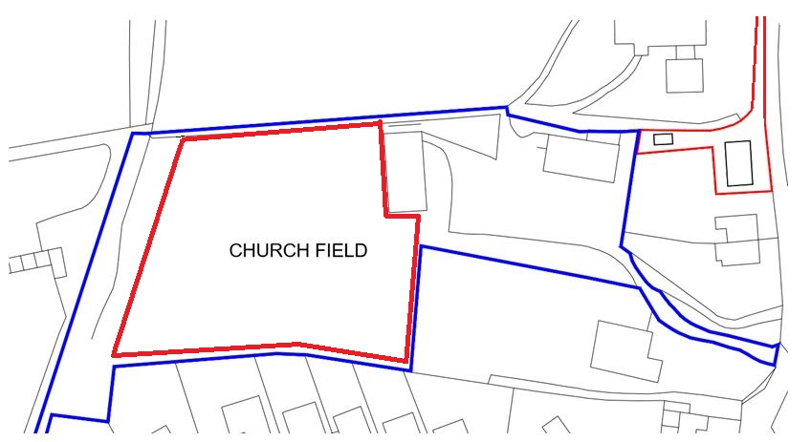

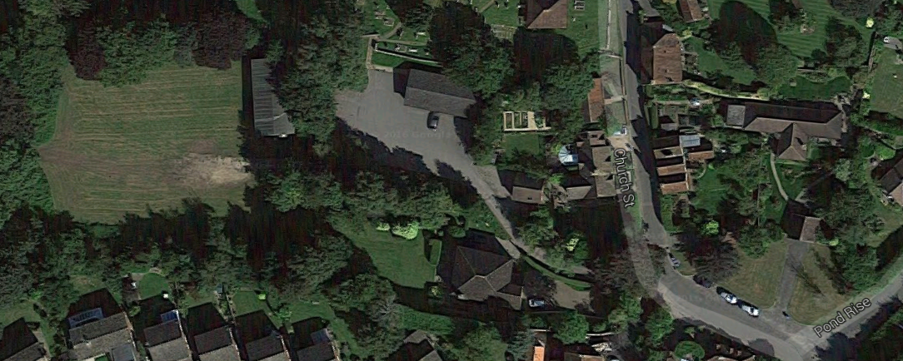

CHURCH FIELD

# Vegetation Control and Pesticide Application

## General

### This section provides the specification for all operations relating to the application of herbicide and growth regulators to be used during the course of the Contract.

### The Contractor shall make full provision within the Tendered Rates for all costs that the Council shall incur in maintaining the features to the standards specified for Vegetation Control and Pesticide Application and for the periodic tasks that are stipulated therein.

### All herbicides and growth regulators to be used in the undertaking of the works will be approved by the Authorised Officer. No other materials shall be used on any site included within the Schedules.

### All materials to be used and all methods of application and tank mixes shall be in accordance with appropriate current legislation and codes of practice.

### Performance Standards for Herbicide treatments are given in Table 2.

## Legislation

* The Health and Safety at Work Act etc 1974;
* The Food and Environment Protection Act 1985 Part III;
* The Control of Pesticides Regulations (as amended) 1986;
* The Plant Protection Products Regulations 2005;
* The Control of Substances Hazardous to Health Regulations as amended (COSHH) 2002;
* Environmental Protection Act 1990;
* The Water Resources Act 1991.
* Codes of Practice
* The Code of Practice for Using Plant Protection Products 2005
* The DEFRA Code of Practice for Suppliers of Pesticides to Agriculture, Horticulture and Forestry (PB3529)
* The Safe Use of Pesticides for Non-Agricultural (L9 Rev.)

### Code of Practice for the Use of Approved Pesticides in Amenity and Industrial Areas - The Orange Code - (British Agrochemicals Association and the National Association of Agricultural Contractors).All operative engaged in undertaking the application of any "pesticides" as defined within the terms of The Act shall be in excess of 18 years of age, and shall hold a certificate from a training establishment recognised by the Minister of Agriculture as being an approved assessment centre under the terms of The Act.

### Prior to the commencement of the Contract, the Contractor shall ensure that employees to be engaged in such works are suitably qualified and assessed, and shall ensure that only those operatives are engaged in the application of such materials.

### The Contractor shall provide his staff with all protective clothing (PPE) applicable to the materials being applied, and shall give his staff access to such washing and cleaning facilities necessary.

### The Contractor shall ensure that his staff whilst engaged in the application of materials wears such protective clothing as is required, and that they observe all safety precautions as required.

### The Contractor shall ensure that all materials are properly stored and transported, providing secure store as required under current legislation.

### All machinery used in the application of materials shall be carefully maintained throughout the period of the Contract to ensure correct application takes place, and that no leakage occurs.

### The Contractor shall ensure that the method of application and the undertaking of such works proceeds in such a manner as to cause no damage or injury to a desirable plant or vegetation, animal, machine or item of equipment. Any such damage will be held to be the responsibility of the Contractor and he will be required to make good any damage and will be responsible for any claims for compensation arising from his actions of omissions.

### In carrying out mixing of chemicals the Contractor shall ensure that no spillage of chemical takes place so that no damage results to vegetation, surfaces, plants or equipment. Any such damage will similarly be held to be the responsibility of the Contractor. In carrying out the application of materials the Contractor shall ensure that no area is over dosed, and that dosages of each particular treatment are in accordance with the manufacturer’s recommendations, or the instructions of the Authorised Officer, and that the total area specified is treated.

### The timing of works shall be such that no spraying takes place during inclement weather, or when rainfall is expected in a time period which is less than that specified by the manufacturer of the chemical being used.

### The Contractor shall ensure that the method of application and the undertaking of works does in no way lead to the pollution of any water course or water supply. Any such pollution shall be held to be the responsibility of the Contractor and he will be required to make good any damage and will be held to be responsible for any claim for compensation arising from his actions or omissions.

### The Contractor shall ensure that all waste containers and chemicals are disposed of correctly and safely in accordance with current legislation.

## Protection of the Environment

### The Contractor will undertake the works in such a manner as to avoid contamination of any person, animal or property, and take particular care to protect water, wildlife and natural habitats.

### Prior to carrying out any application of material the Contractor should notify the Authorised Officer of his working plans giving 2 working days’ notice and updating the Authorised Officer at regular intervals. The progress of such work should be reported daily using a form produced by the Contractor as approved by the Authorised Officer.

### The Contractor shall by methods approved under the terms of The Act notify the public, neighbours of sites and users of facilities of the fact that spraying operations are to be, and have been undertaken.

### No spraying work of any kind shall take place when sites are in use if this is likely to endanger or inconvenience users, and the Contractor shall modify his working cycles to take this limitation into account.

## Selective Herbicides on Turf

### The Contractor will apply a selective herbicide to the areas specified within the Schedules and at the frequencies required to maintain the required performance standards.

### The material should be applied during the period May to September as directed by the Authorised Officer, at times when the soil is moist and grass actively growing.

### If within 10 days of application the Authorised Officer is not satisfied with the degree of control shown on weeds within the turf sward, the Contractor shall repeat the treatment. This shall be undertaken within 5 working days (assuming weather conditions are suitable) following receipt of instruction and shall be carried out at the Contractors expense.

## Treatment of Paths, Drives and Other 'Hard' Surface Areas

### At times indicated within the Schedules or as appropriate to the material to be used, the Contractor shall apply at rates appropriate to the material supplied and the type of area being treated, liquid based residual herbicide to those areas specified.

### The treatment shall be such that it controls all weed growth for a period of 12 months from the time of application.

### If the treatment does not produce satisfactory results, the Contractor shall at his own expense, retreat areas as instructed to produce a satisfactory degree of control.

## Treatment of Fence Lines, Obstructions and Bases of Buildings

### The treatment shall be carried out in such a manner that growth of all vegetation is controlled for a period of 12 months from the date of application to a maximum width of 0.3 metres.

### Should, during the 12 months subsequent to the treatment, the areas, in the opinion of the Authorised Officer, show any excessive invasion by weed species, the Contractor shall at his own expense using materials approved by the Authorised Officer re-treat areas as instructed to produce a satisfactory degree of control.

## Other Spraying Works

### At certain times the Contractor shall undertake other spraying works as instructed by the Authorised Officer. These works shall unless otherwise agreed be carried out within 2 working days of receipt of instruction.

### In carrying out such spraying the Authorised Officer recognises that the density and range of weed species found will be large, however the spray operations should be carried out in such a manner that all weeds susceptible to the materials used exhibit signs of attached by herbicide.

### In the event of any large proportion of the weeds in the opinion of the Authorised Officer not showing such effect, the Contractor will repeat the spraying using materials provided by the Authorised Officer, the Contractor meeting the cost of all materials, labour and machinery used in undertaking the task.

## Herbicide of Hedge Bases

### At times indicated within the Specification, Schedules or as appropriate to the material supplied and the area being treated, liquid based herbicides. The application shall be such that all weeds are controlled for a period of 12 months from the date of application. Any weeds emerging after treatment shall be treated using a contact herbicide provided by the Authorised Officer but charged to the Contractor, all works being undertaken at the Contractor's expense.

### The application of such material shall be carried out in such a way that the effect of the herbicide is confined to an area of ground corresponding to the length and width of the hedge.

|  |  |  |  |
| --- | --- | --- | --- |
| Table2 Performance Standard For Herbicide Treatment | | | |
| DESCRIPTION | SUGGESTED  FREQUENCY | SUGGESTED  TIMING | FINISHED STANDARD  REQUIRED |
| Treat obstacles with residual herbicide – posts manhole covers etc. | 1 | November to March | 150mm wide vegetation free strip around treated posts/obstacles |
| Treat hard landscape areas with Glyphosate herbicide | 2 | May and September | 95% kill of all visible weeds above 5cm within 3 weeks of application |
| Treat fence lines/walls and hedge bases with residual herbicide | 1 | November to March | 150mm wide vegetation free strip along the treated fence lines/wall and hedge bases |
| Treat grass edges/paths/perimeters with Glyphosate | 2 | May and September | 150mm wide strip killed of visible vegetation with 3 weeks of application |
| Treat hard surfaces with moss killer | 3 | April / July / October | Maintain a moss free non-slip surface |
| Sports Pitches | 1 | May/June | 95% control of all broad-leaved weeds on Sports Pitches |
| Children’s play area | 3 | April / July / October | Maintain a moss free non-slip surface, 95% kill of all visible weeds within 3 weeks of application |
| Outdoor Gym area | 2 | May and September | 95% kill of all visible weeds above 5cm within 3 weeks of application |

# Hedge Maintenance

## General

### This section provides the specification for all hedge maintenance operations carried out during the course of the Contract.

### The Contractor shall make full provision within the Tendered Rates for costs that the Council shall incur in maintaining two hedge locations twice a year.

### At two locations as identified in the enclosed site maps below,

* Recreational Ground Hedge bordering the Village Hall, sides to be trimmed and cut to around 6 foot in height.
* Allotment hedge adjacent to Common Hill, sides to be trimmed and cut to around 8 foot in height.

### Hedges may denote a site boundary and the Contractor shall take care when undertaking hedges cutting operations not to damage or in any other way interfere with privately owned property on the 'far side' of Parish Council maintained hedges. In this respect, the Contractor shall notify the Authorised Officer immediately should he experience any difficulties or require further guidance.

### The following operations are to be carried out at those sites as scheduled twice a year, in the months of March and late August, so to fall outside the bird nesting season as per EU ruling, all scheduled work being allowed for within the Annual Sum:

* Report any major obstructions to the Authorised Officer in order that remedial work can be carried out.
* Cut and clear grass and other vegetation from hedge sides/banks and tops
* Remove all cuttings, debris and dispose as per section 1.6

Recreational Ground Hedge



Small Section of hedge (both sides up to the village hall) to be included twice a year cut in schedule of works. Around 6 foot in height in consultation with the authorised officer allowing to gap in hedge to access the Village Hall.

Allotment hedge adjacent to Common Hill

Section of hedge both sides to be included twice a year cut in schedule of works. Around 8 foot in height in consultation with the authorised officer.

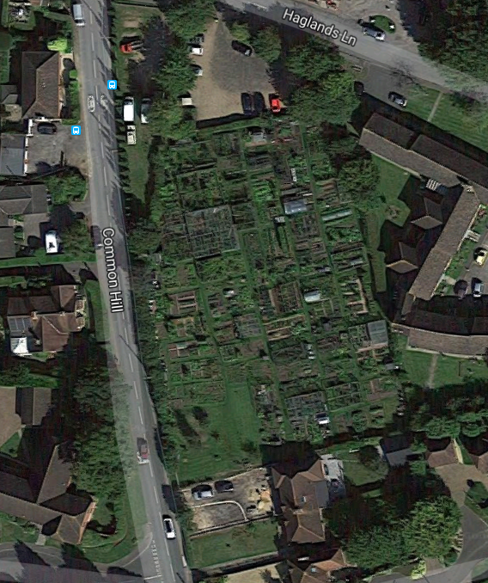

# Ditch Maintenance

## General

### This section provides the specification for all operation relating to ditch maintenance operations carried out during the course of the Contract.

### The Contractor shall make full provision within the Tendered Rates for all costs that the Council shall incur in maintaining the features to the standards specified for Ditch Maintenance and for the periodic tasks that are stipulated therein.

### At certain sites as identified in the Schedules, ditching operations are required to be carried out. Ditches are normally 'U' shaped, approximately three feet deep and with vegetation covered banks or sides.

### The ditches in question may be dry for at least part of the year. Their primary purpose is drainage and it is therefore important that ditches be kept free of obstructions that may cause damming and possible flooding.

### Additionally, ditches may denote a site boundary and the Contractor shall take care when undertaking ditching operations not to damage or in any other way interfere with privately owned property on the 'far side' of Parish Council maintained ditches. In this respect, the Contractor shall notify the Authorised Officer immediately should he experience any difficulties or require further guidance.

### The following operations are to be carried out at those sites as scheduled three times a year, in the months of May, August and November, all scheduled work being allowed for within the Annual Sum:

* Remove all rubbish, debris, litter and build-up of silt from ditch bottoms to ensure the free flow of water.
* Report any major obstructions to the Authorised Officer in order that remedial work can be put in hand.
* Cut and clear grass and other vegetation from ditch sides/banks and tops

### The Contractor's unit rate to be inclusive of the above operations, removal and proper disposal of arisings, necessary inspections, and liaison with adjoining owners and Authorised Officer.

## Ditches

### The Contractor shall make full provision within the Tendered Rates for all costs that the Council shall incur in maintaining the Features to the standards specified in for the periodic tasks that are stipulated therein.

### The Council may from time to time issue an Instruction Notice to the Contractor under 6.9 above requiring him to undertake Additional Works.

### The Contractor shall maintain watercourse surfaces, bases, banks, grilles and outletsand bridges free of litter, refuse, evergreen and deciduous leaf arisings and other extraneous material.

### The Contractor shall submit a written report to the Authorised Officer when instances of pollution are observed.

### The Contractor shall remove and dispose of silt accumulations from the watercourse base and natural silt traps twice per annum to maintain a free flow to fall levels.

### All small dispersed or accumulated items of any volume collectively and individual items up to and including 0.7m³ volume (i.e. this includes a standard shopping trolley) per individual occurrence shall be collected and removed from site and disposed of at the Contractor’s expense.

### The level areas of all ditch / streams shall be flail mown to a height of 75mm April, June, and October

### The Contractor shall cut down all bank weed growth in June and October removing all arisings.

# Voluntary Work

## General

### From time to time voluntary groups or commercial concerns may wish to carry out or sponsor one-off area "clean ups" for environmental or charity fund raising reasons. Any work carried out will be considered as additional to any works specified and no deduction will be made from payments to the Contractor. However, the Contractor shall recognise the contribution that such activity makes to his duties and assist in the planning of any such activity, and collect, transport and dispose of any arisings collected at his own expense