**Cothill Boardwalk Specification**

**Headline Info:**

* Site visit by contractor is mandatory part of the tender and failure to visit site will result in the contractor been removed from the process
* 120m raised boardwalk
* 3.6m passing bay roughly halfway along
* No handrail
* Toe rail
* Minor vegetation and tree branch clearance required, up to a height of 3m from ground level, where required to gain access to the site

**Background Info:**

Cothill Fen National Nature Reserve sits within the larger Cothill Site of Special Scientific Interest and Cothill Special Area of Conservation. The site is managed by Natural England and despite being one of the smallest NNR’s, it is an incredibly valuable and unique nature reserve. The NNR sits within a larger complex of calcareous fens and flushes in Oxfordshire. The wetland habitat is incredibly important, supporting a diversity of highly specialised flora and fauna; the invertebrate assemblage is particularly important, and the site is well regarded as a “hidden gem” by invertebrate specialists.

Predominately the site is visited by niche species specialists, however on a more day to day basis, is popular with the local community and dog walkers. Abutting the southern edge of the site is a private school which also regularly makes use of the nature reserve for field trips and outdoor lessons.

A horseshoe shaped permissive path has developed over the years, which starts through a wooden kissing gate at the bottom eastern edge of the site from String Lane, - a public right of way, running along the southern edge of the NNR. This permissive path heads along one of the many built-up causeways, entering the drier oak-hazel woodland at the northern edge of the site. Here it loops through the woodland (which is very popular for its carpet of bluebells), before coming back along the western edge of the NNR and re-joining String Lane through a wooden pedestrian gate.

This section of the permissive path along the western edge of the NNR, is close to one of the main groundwater fed seepages which emerge at the back of the fen – as such this section of the path struggles with wet, muddy conditions, hindering access. As a temporary solution, cut logs were laid on the path – years later these are still in place and now present a significant slipping hazard to visitors. As part of Natural England’s commitment to encouraging safe public access, we want to install a raise boardwalk over the current rotting, slippery logs.

**Location of Nature Reserve:**

Cothill Fen National Nature Reserve is accessed via String Lane – access is through a wooden field gate off a small car owned by the neighbouring school, found here ([what3words /// The simplest way to talk about location](https://what3words.com/dairy.since.unlisted))

(The school allows members of the public to park in their car park to access the nature reserves, and Natural England access through the field gate)

**Access Arrangements:**

**String Lane – off road vehicles required at all times – this lane gets wet and muddy in the winter. Parking is on String Lane, by the wooden pedestrian gate access point at the bottom western edge of the site**

**A site visit prior to tendering is essential, for contractors to be shown the access arrangements.**

**Access Map:**

New Boardwalk location

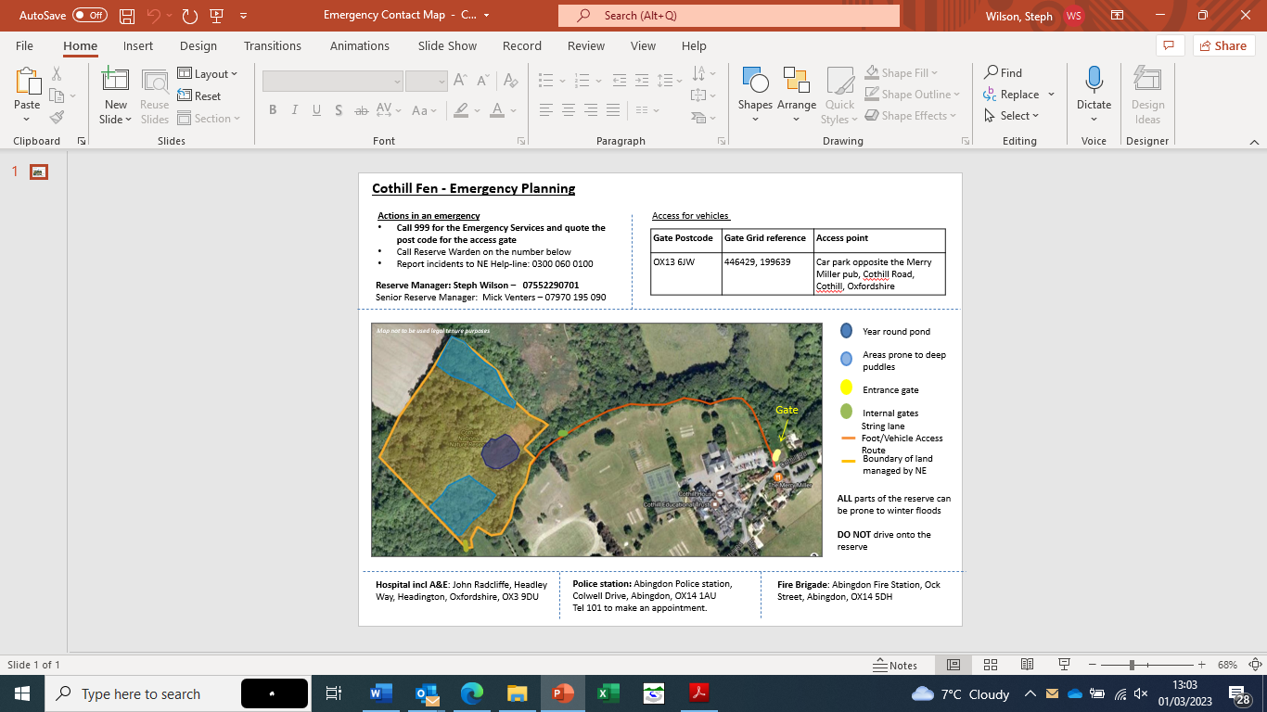

**Boardwalk location:**



**Compound Location:**

Parking for contractor vehicles is on String Lane, by the wooden pedestrian gate, at the bottom western corner of the nature reserve. Any welfare facilities will also be located here, off the main String Lane.

**Sensitives:**

* The site is a fen; thus, water quality is key for site management. No materials under any circumstances are to be put in the water. No chemical/pesticide/herbicide materials to come onto site.
* Vehicles are not to be taken on site and must remain on String Lane. Vehicles must not block the lane completely, as it is a busy PROW.
* The path this boardwalk will be on is not a PROW, however, is a popular permissive path. Handling of members of the public should be appropriate, and involve directing them to the alternative route, which the site manager will put in temporary signs for, before work begins.
* Under no circumstances should fires be lit - fires can burn extensively and deeply in peat.

**Construction Info:**

It is anticipated, timber boards will be supported on a raised recycled plastic structure: the recycled plastic element is inducive to a longer lasting structure in damp ground, whilst the timber boards are more aesthetically pleasing for visitors, with less of a visually impact on the site compared to a boardwalk constructed wholly of recycled plastic.

**Example images:**

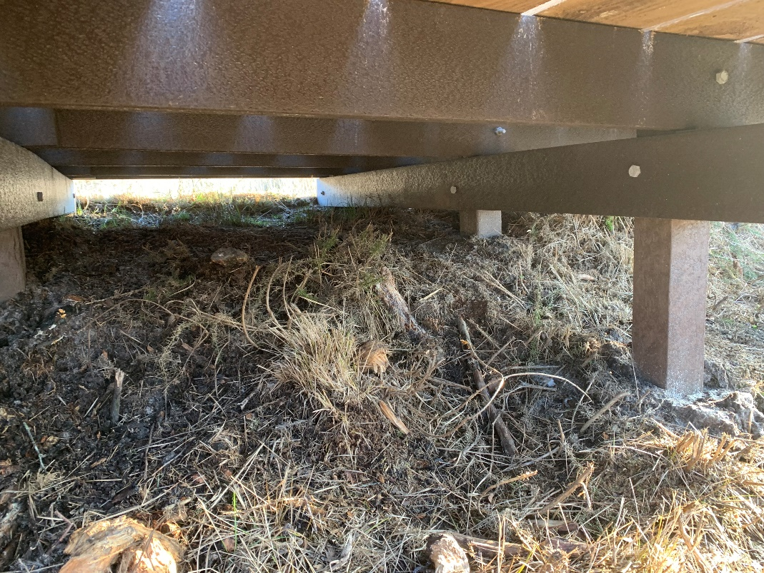

Recycled plastic used for the support frame

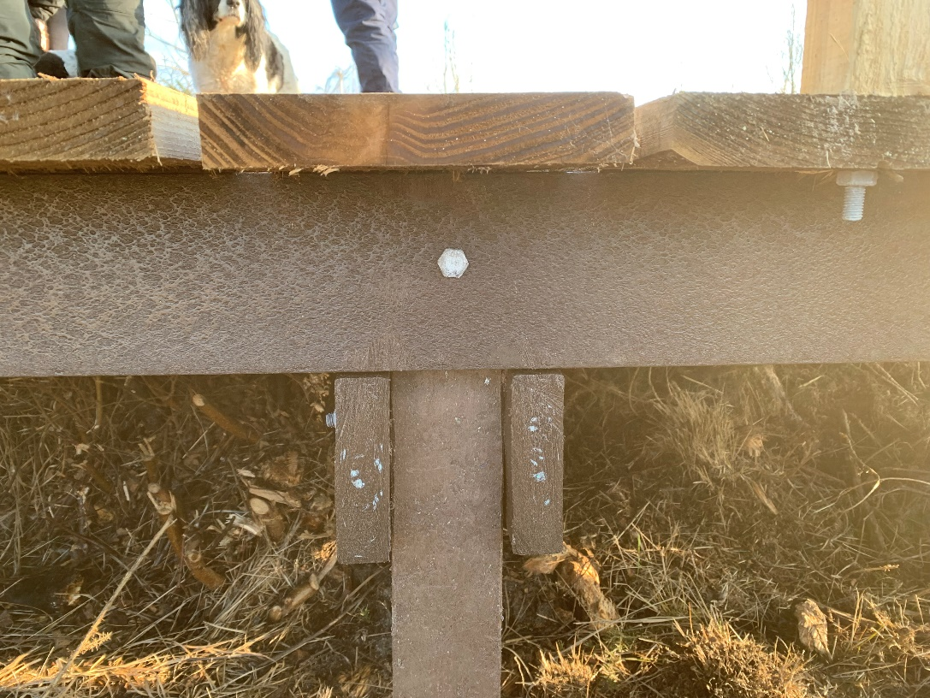

Recycled plastic for the support frame

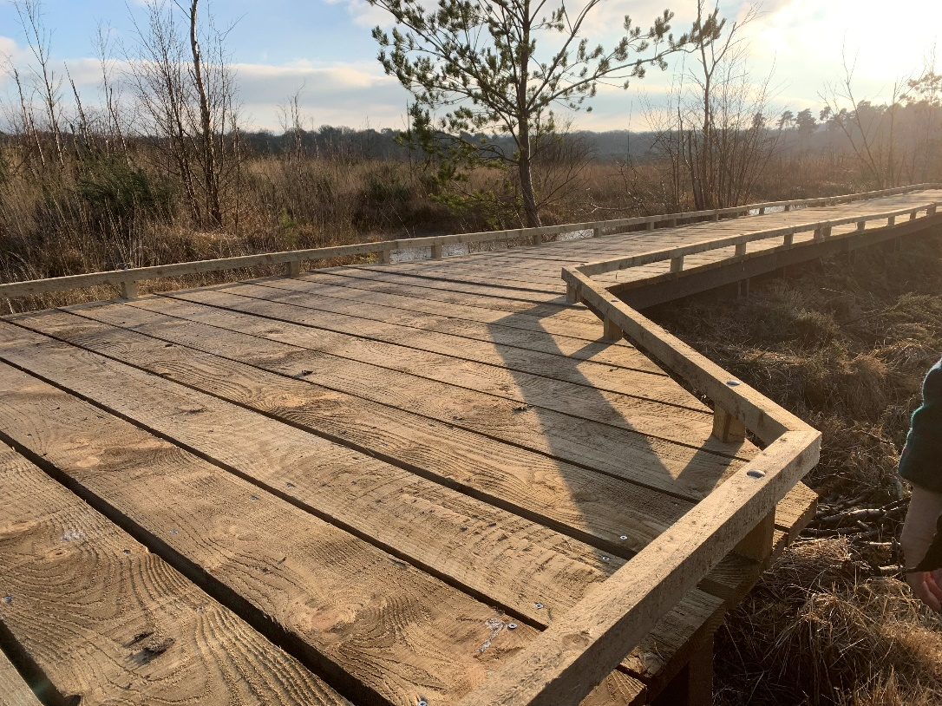

Timber boards - longer lasting material compared to other timber options. A toe rail also constructed from timber introduces a key safety element to the design