This Contract is made between:

Public Health England (which expression shall include its successors in title) of Wellington House, 133-135 Waterloo Road, London SE1 8UG (the "Authority")

and

Solutions for Public Health, of 1 Wootton Edge Barns, Holly Bank, Wootton, Oxford, Oxfordshire, OX20 1AE (the "Contractor")

The following is agreed:

- The Contract is made up of the following documents:

- This Form of Contract for PHE - Corporate - Alcohol Misuse Screening in Adults Evidence Map

- PHE Conditions of Contract (as included in the tender documents).

- The Contractor’s tender response (including prices detailed in the Commercial Envelope of the tender response).

- Specification for PHE - Corporate - Alcohol Misuse Screening in Adults Evidence Map as included in the tender documents.

(all of the above documents taken together (as amended in accordance with this Contract) being referred to as the “Contract”)

- If there is an inconsistency between any of the documents listed above, a higher listed document shall prevail over a lower listed document, i.e. document (a) shall prevail over all other documents; document (b) shall prevail over documents (c) and (d).

- The Contract will commence on the date that signatures are added by both the Authority and the Contractor.

- The duration of the Contract will be until completion of the project, but in any case, no later than the 31st January 2022.

Signature:  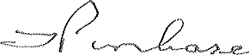 | Signature:  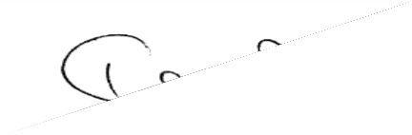
For and on behalf of the Authority | For and on behalf of the Contractor
Name: Timothy John Purchase | Name: Richard Davis
Job Title: Lead Category Manager | Job Title: SPH Managing Director
Date: 30th April 2021 | Date: 30th April 2021

