Request for Quotation

Allonby Bay candidate HPMA eDNA analysis for community assessment

16/06/2023

**Request for Quotation**

**Allonby Bay candidate HPMA eDNA analysis for community assessment**

You are invited to submit a quotation for the requirement described in the specification, Section 2.

Please confirm by email, receipt of these documents and whether you intend to submit a quote or not.

Your response should be returned to the following email address by:

Email:sarah.meek@naturalengland.org.uk

Date: **07/07/2023**

Time: **12pm**

Ensure you include the name of the quotation and ‘Final Submission’ in the subject field to make it clear that it is your response.

**Contact Details and Timetable**

Sarah Meek will be your contact for any questions linked to the content of the quote or the process. Please submit any clarification questions via email and note that, unless commercially sensitive, both the question and the response will be circulated to all tenderers.

|  |  |  |
| --- | --- | --- |
| **Action** | | **Date** |
| **Date of issue of RFQ** | **20/06/2023** at **09:00 BST / GMT]** | |
| **Deadline for clarifications questions** | **04/07/2023** at [12:00 **BST / GMT]** | |
| **Deadline for receipt of Quotation** | **07/07/2023** at **[12:00 BST / GMT]** | |
| **Intended date of Contract Award** | **14/07/2023** | |
| **Intended Contract Start Date** | **21/07/2023** | |
| **Intended Delivery Date / Contract Duration** | **31/03/2024** | |

**Section 1: General Information**

**Glossary**

Unless the context otherwise requires, the following words and expressions used within this Request for Quotation shall have the following meanings (to be interpreted in the singular or plural as the context requires):

|  |  |
| --- | --- |
|  |  |
| **“Authority”** | means Natural England who is the Contracting Authority. |
| **“Contract”** | means the contract to be entered into by the Authority and the successful supplier. |
| **“Response”** | means the information submitted by a supplier in response to the RFQ. |
| **“RFQ”** | means this Request for Quotation and all related documents published by the Authority and made available to suppliers. |

**Conditions applying to the RFQ**

You should examine your Response and related documents ensuring it is complete and in accordance with the stated instructions prior to submission.

Your Response must contain sufficient information to enable the Authority to evaluate it fairly and effectively. You should ensure that you have prepared your Response fully and accurately and that prices quoted are arithmetically correct for the units stated.

By submitting a Response, you, the supplier, are deemed to accept the terms and conditions provided in the RFQ. Confirmation of this is required in Annex 2.

Failure to comply with the instructions set out in the RFQ may result in the supplier’s exclusion from this quotation process.

**Acceptance of Quotations**

By issuing this RFQ the Authority does not bind itself to accept any quotation and reserves the right not to award a contract to any supplier who submits a quotation.

**Costs**

The Authority will not reimburse you for any costs and expenses which you incur preparing and submitting your quotation, even if the Authority amends or terminates the procurement process.

**Self-Declaration and Mandatory Requirements**

The RFQ includes a self-declaration response (Annex 1) which covers basic information about the supplier, as well as any grounds for exclusion. If you do not comply with them, your quotation will not be evaluated.

Any mandatory requirements will be set out in Section 2, Specification of Requirements and, if you do not comply with them, your quotation will not be evaluated.

**Clarifications**

Any request for clarification regarding the RFQ and supporting documentation must be submitted via email no later than the deadline for clarifications set out in the Timetable. The Authority shall be under no obligation to respond to queries raised after the clarification deadline.

The Authority will respond to all reasonable clarifications as soon as possible but cannot guarantee a minimum response time. The Authority will publish all clarifications and its responses to all suppliers via email unless deemed commercially sensitive.

If a supplier believes that a request for clarification is commercially sensitive, it should clearly state this when submitting the clarification request. However, if the Authority considers either that:

* the clarification and response are not commercially sensitive; and
* all suppliers may benefit from its disclosure,

then the Authority will notify the supplier (via email), and the supplier will have an opportunity to withdraw the request for clarification by sending a further message requesting the withdrawal of the clarification request. If not withdrawn by the supplier within 2 working days of the Authority’s notification, the Authority may publish the clarification request and its response to all suppliers and the Authority shall not be liable to the supplier for any consequences of such publication.

The Authority reserves the right to seek clarification of any aspect of a quotation and/or provide additional information during the evaluation phase to carry out a fair evaluation. Where the Authority seeks clarification on any aspect of the quotation, the supplier must respond within the timeframe requested by the Authority.

**Amendments**

The Authority may amend the RFQ at any time prior to the deadline for receipt. If it amends the RFQ the Authority will notify you via email.

Suppliers may modify their quotation prior to the deadline for Responses. No Responses may be modified after the deadline for Responses.

Suppliers may withdraw their quotations at any time by submitting a notice via the email to the named contact.

**Conditions of Contract**

The Authority’s standard Condensed Terms and Conditions provided as part of the RFQ will be included in any contract awarded as a result of this quotation process. The Authority will not accept any changes to these terms and conditions proposed by a supplier.

Suppliers should note that the quotation provided by the successful bidder will form part of the Contract.

**Prices**

Prices must be submitted in £ sterling, inclusiveof VAT.

**Disclosure**

All Central Government Departments, their Executive Agencies and Non Departmental Public Bodies are subject to control and reporting within Government. In particular, they report to the Cabinet Office and HM Treasury for all expenditure. Further the Cabinet Office has a cross-Government role delivering overall Government policy on public procurement, including ensuring value for money and related aspects of good procurement practice. For these purposes, the Authority may disclose within Government any details contained in your quotation. The information will not be disclosed outside Government during the procurement.

In addition, the Authority is subject to the Freedom of Information Act 2000 and the Environmental Information Regulations 2004, which provide a public right of access to information held by public bodies. In accordance with these two statutes, the Authority may be required to disclose information contained in your quotation to any person who submits a request for information pursuant to those statutes.

Further to the Government’s transparency agenda, all UK Government organisations must advertise on Contract Finder in accordance with the following publication thresholds:

* Central Contracting Authority’s: £12,000
* Sub Central Contracting Authority’s and NHS Trusts: £30,000

For the purpose of this RFQ the Authority is classified as a Central Contracting Authoritywith a publication threshold of £12,000 inclusive of VAT.

If this opportunity is advertised via Contracts Finder, we are obliged to publish details of the awarded contract including who has won the contract, the contract value, and indicate whether the winning supplier is a small and medium-sized enterprise (“SMEs”) or voluntary organisation or charity. A copy of the contract must also be published with confidential information redacted.

By submitting a Response, you consent to these terms as part of the procurement.

**Disclaimers**

Whilst the information in this RFQ and any supporting information referred to herein or provided to you by the Authority have been prepared in good faith the Authority does not warrant that this information is comprehensive or that it has been independently verified.

The Authority does not:

* make any representation or warranty (express or implied) as to the accuracy, reasonableness or completeness of the RFQ;
* accept any liability for the information contained in the RFQ or for the fairness, accuracy or completeness of that information; or
* accept any liability for any loss or damage (other than in respect of fraudulent misrepresentation or any other liability which cannot lawfully be excluded) arising as a result of reliance on such information or any subsequent communication.

Any supplier considering entering into contractual relationships with the Authority following receipt of the RFQ should make its own investigations and independent assessment of the Authority and its requirements for the goods and/or services and should seek its own professional financial and legal advice.

**Protection of Personal Data**

In order to comply with the General Data Protection Regulations 2018 the supplier must agree to the following:

You must only process any personal data in strict accordance with instructions from the Authority.

* You must ensure that all the personal data that we disclose to you or you collect on our behalf under this agreement are kept confidential.
* You must take reasonable steps to ensure the reliability of employees who have access to personal data.
* Only employees who may be required to assist in meeting the obligations under this agreement may have access to the personal data.
* Any disclosure of personal data must be made in confidence and extend only so far as that which is specifically necessary for the purposes of this agreement.
* You must ensure that there are appropriate security measures in place to safeguard against any unauthorised access or unlawful processing or accidental loss, destruction or damage or disclosure of the personal data.
* On termination of this agreement, for whatever reason, the personal data must be returned to us promptly and safely, together with all copies in your possession or control.

**General Data Protection Regulations 2018**

For the purposes of the Regulations the Authority is the data processor.

The personal information that we have asked you provide on individuals (data subjects) that will be working for you on this contract will be used in compiling the tender list and in assessing your offer. If you are unsuccessful the information will be held and destroyed within two years of the award of contracts. If you are awarded a contract it will be retained for the duration of the contract and destroyed within seven years of the contract’s expiry.

We may monitor the performance of the individuals during the execution of the contract, and the results of our monitoring, together with the information that you have provided, will be used in determining what work is allocated under the contract, and in any renewal of the contract or in the award of future contracts of a similar nature. The information will not be disclosed to anyone outside the Authority without the consent of the data subject, unless the Authority is required by law to make such disclosures.

**Equality, Diversity & Inclusion (EDI)**

The Client is striving to create a diverse and inclusive working environment where every individual has equality of opportunity to progress and to apply their unique insights to making the UK a great place for living. The Service Provider is expected to respect this commitment in all dealings with Natural England staff and service users.

Suppliers are expected to;

* support Defra group to achieve its Public Sector Equality Duty as defined by the Equality Act 2010, and to support delivery of [Defra group’s Equality & Diversity Strategy](https://www.gov.uk/government/publications/defra-group-equality-diversity-and-inclusion-strategy-2020-to-2024/defra-group-equality-diversity-and-inclusion-strategy-2020-to-2024).
* meet the standards set out in the [Government’s Supplier Code of Conduct](https://www.gov.uk/government/publications/supplier-code-of-conduct)
* work with Defra group to ensure equality, diversity and inclusion impacts are addressed (positive and negative) in the goods, services and works we procure, barriers are removed and opportunities realised.

**Sustainable Procurement**

Addressing global sustainability impacts and realising additional community benefits within commercial activity is core to Defra group’s approach, working with its supply chain is key to achieving sustainable outcomes. In addition to supporting Defra group to meet its outcomes we look to understand and reduce negative sustainability impacts associated with our commercial activity and realise benefits.

The Client encourages its suppliers to share these values, work to address negative impacts and realise opportunities, measure performance and success.

Suppliers are expected to have an understanding of the Sustainable Development Goals, the interconnections between them and the relevance to the Goods, Services and works procured on the Client’s behalf

**Conflicts of Interest**

The concept of a conflict of interest includes but is not limited to any situation where an Involved Person or Relevant Body has directly or indirectly, a financial, economic or other personal interest which might be perceived to compromise their impartiality and independence in the context of the procurement procedure and/or affect the integrity of the contract award.

We expect suppliers to mitigate appropriately against any real or perceived conflict of interest through their work with government. A supplier with a position of influence gained through a contract should not use that position to unfairly disadvantage any other supplier or reduce the potential for future competition

Where the supplier is aware of any circumstances giving rise to a conflict of interest or has any indication that a conflict of interest exists or may arise you should inform the Authority of this as soon as possible (whether before or after they have submitted a quotation). Tenderers should remain alert to the possibility of conflicts of interest arising at all stages of the procurement and should update the Authority if any new circumstances or information arises, or there are any changes to information already provided to the Authority. Failure to do so, and/or to properly manage any conflicts of interest may result in a quotation being rejected.

Provided that it has been carried out in an open, fair and transparent manner, routine pre-market engagement carried out by the Authority should not represent a conflict of interest for the supplier.

**Section 2: The Invitation**

**Specification of Requirements**

1. **Introduction**

This survey will contribute to evidence gathering in year one of the Highly Protected Marine Areas (HPMAs) pilot project.

HPMAs are areas of the sea that allow for the protection and full recovery of marine ecosystems. By designating areas of sea with high levels of protection, HPMAs will allow nature to fully recover to a more natural state, allowing the ecosystem to thrive. They prohibit extractive, destructive and depositional uses, allowing only non-damaging levels of other activities to the extent permitted by international law. HPMAs will protect all species and habitats and associated ecosystem processes within the site boundary, including the seabed and water column. This means gathering comprehensive evidence of the effectiveness of the HPMA in delivering biodiversity recovery will be critical.

The ecological monitoring of this Defra-funded programme will be led by Natural England and JNCC. Natural England’s marine remit includes biodiversity extending from the intertidal zone out to 12 nautical miles. Natural England will therefore gather baseline data and continue to monitor the inshore HPMA site Allonby Bay throughout the pilot project.

**1.2 Survey Area**

Allonby Bay candidate HPMA covers 27.6 km2 of the southern region at the mouth of the Solway Firth (Figure 1). The boundary follows the Mean High Water line along the shore from the western most building of Bank End Farm, Maryport to Christ Church south of Allonby and then extends seaward to approximately 5.6 km off the shore at its maximum width. The site has a maximum depth of 6.6m at lowest chart datum (Figure 2). The area is located within the 12 nm territorial sea limit of the Irish Sea region. It overlaps with Allonby Bay MCZ and the Solway Firth SPA and there is a very small overlap with the Solway Firth SAC and Upper Solway Flats and Marshes SSSI along the northeastern boundary.

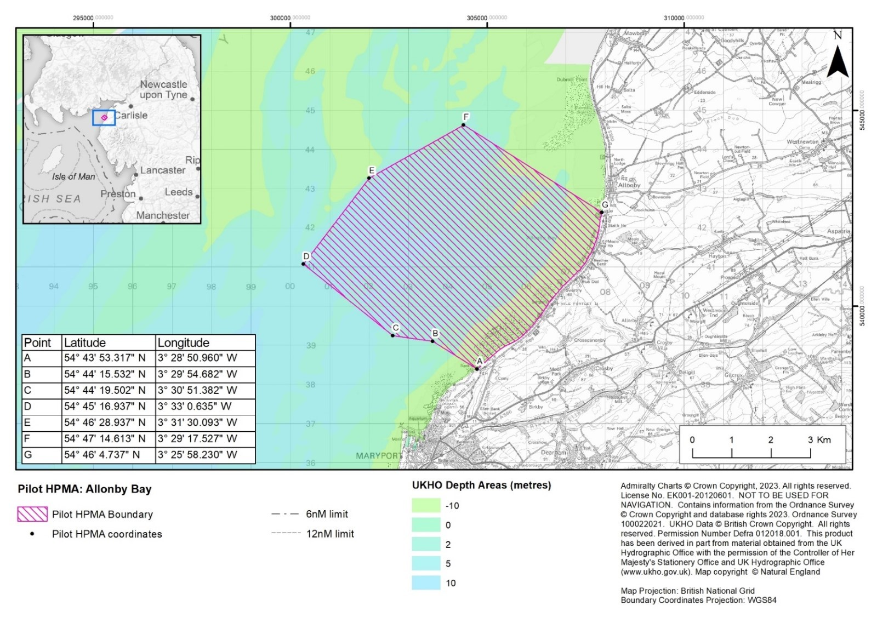  
Figure 1. Candidate HPMA Allonby Bay proposed boundary and coordinates.

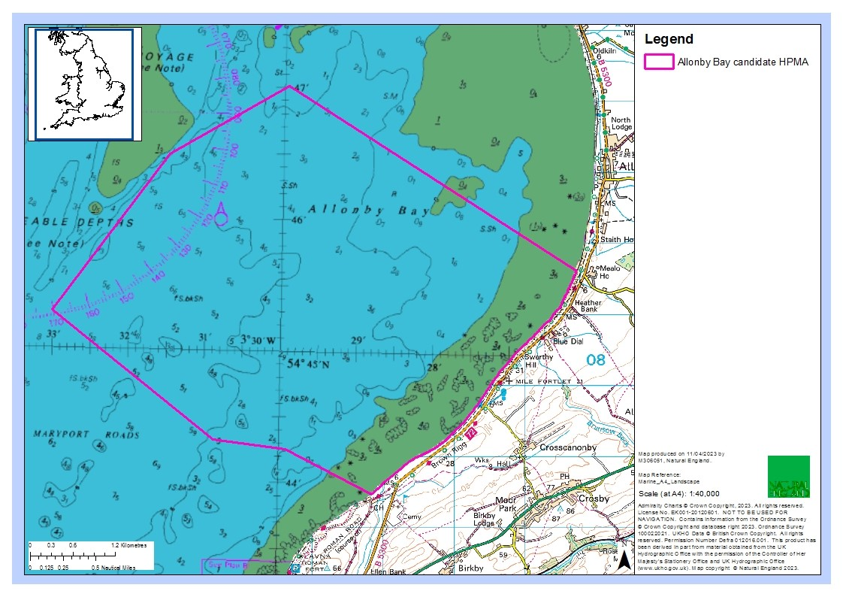  
Figure 2. Candidate HPMA Allonby Bay chart datum.

Allonby Bay consists of a mix of habitats, characteristic of an environment that is subject to dramatic currents and tides. The seabed consists of a range of rocky habitats and sediment dominated habitats, including mudflats, sandbanks, reefs, peat and clay exposures, and biogenic reefs (Figure 3).

The nutrient-rich sediments, dense mussel beds and intertidal rocky habitats in this area attract large densities of shore birds including species such as curlew and oystercatcher. The biodiverse subtidal habitats here provide a food source for fish species, such as flat fish and nursery areas for other species such as bass, cod and herring. In turn, these fish species attract diving, foraging seabirds including guillemots, gannets and razorbills. There is also one of the best examples of honeycomb *Sabellaria alveolata* reefs in the UK within the site, creating a complex sediment network of tubes attached to rock creating vital habitat for crustacea and molluscs.

For full site details please see: [Highly Protected Marine Areas (HPMAs) - GOV.UK (www.gov.uk)](https://www.gov.uk/government/publications/highly-protected-marine-areas/highly-protected-marine-areas-hpmas).

A designation order covering a HPMA will set out the protected features and the conservation objectives applicable within the HPMA site boundary. The protected feature is: “The marine ecosystem, habitats and species of flora and fauna, abiotic elements, and their supporting ecosystem function and processes, including the seabed, water column and sea surface, within the site boundary.” The proposed conservation objective for all pilot HPMAs, including Allonby Bay is: “To achieve full natural recovery of the structure and functions, features, qualities and composition of characteristic biological communities present within HPMAs and prevent further degradation and damage to the marine ecosystem subject to natural change.”

Natural England and JNCC advise within an HPMA:

* + 1. The ecosystem is allowed to fully recover in the absence of damaging activities such that:

• The ecosystem structure consists of a diverse range of benthic and pelagic communities, habitats and species, including biotic and abiotic components of the ecosystem. These fulfil a variety of functional roles, including supporting key life cycle stages and/or behaviours of marine species.

• The physical, biological and chemical ecosystem processes and functions proceed unhindered, so that the site realises its full ecological potential to deliver goods and services, including habitats and species considered important to the long-term storage of carbon, and habitats and species important for flood and erosion protection.

• The ecosystem is resilient to change and stressors.

* + 1. Any ecosystem changes brought about by the process of removing anthropogenic pressures should be considered in the context of a naturally recovering ecosystem.

3. The HPMA supports our understanding of how marine ecosystems change and recover in the absence of impacting activities

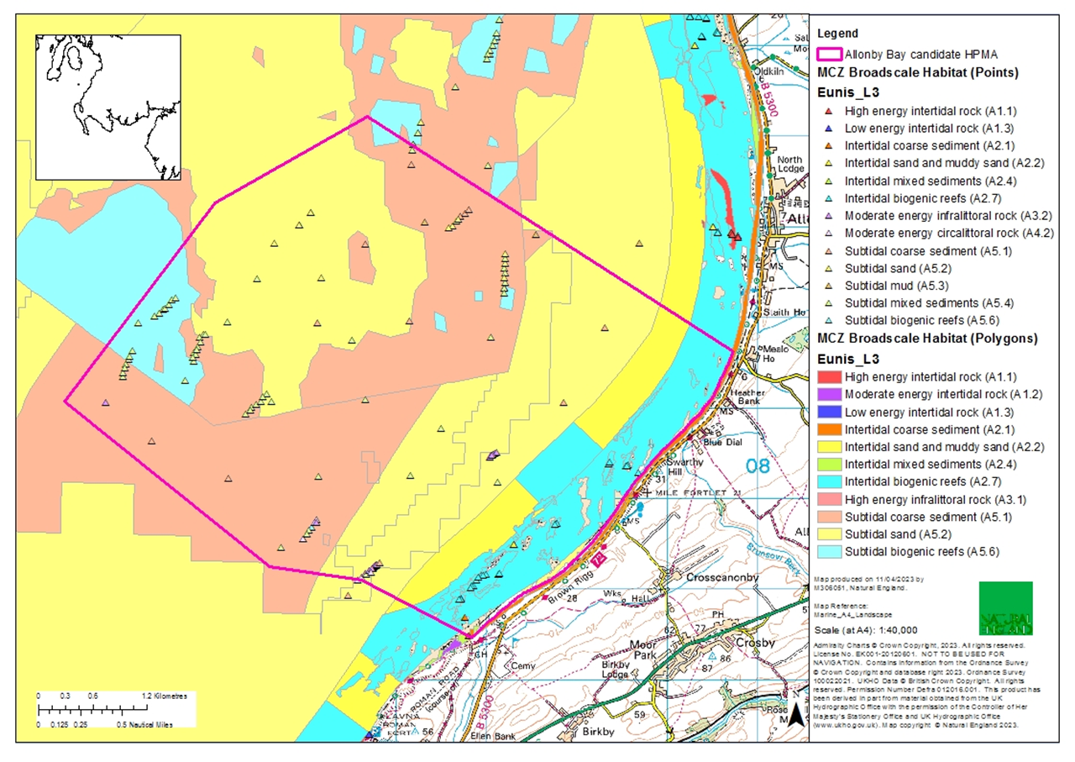

Figure 3.  Current map of the broadscale habitats in Allonby Bay with the candidate HPMA boundary.

**ims and Objectives**

**2.1 Aims**

**Natural England is commissioning analysis of water samples collected from within the Allonby Bay HPMA to understand species present in the site.**

The analysis design should achieve the following:

1. Acquire high quality data to establish a baseline of species present within the site, focusing on marine fish as the priority and other groups as supplementary.
2. (optional) Acquire high quality hydrodynamic modelling for the purpose of estimating likelihood of species detected originating in Allonby Bay HPMA.

Samples will be collected by NE and EA staff quarterly during the water quality surveys. All samples will be filtered on board the EA vessel at the time of collection and then posted to the contractor for analysis. The contract will run to the end of the 23/24 financial year and therefore it should be assumed that up to three sets of samples will be analysed (August/ September, November, February), with the contractor to suggest the number of replicates preferred.

1. **Main tasks:**

Field sampling

Samples will be collected by NE and EA staff quarterly during the water quality surveys. There is currently 1 sampling location planned for water quality samples due to the limited size of Allonby Bay cHPMA and eDNA samples will be collected quarterly. Water samples of between 1-2L will be collected from the EA vessel, the preferred volume should be stated in tender returns but can be discussed at initiation meetings. All samples will be filtered on board the EA vessel at the time of collection and then posted to the contractor for analysis. Contractors should advise the number of replicate water samples to be collected at the sampling location, with a minimum of 3 replicate water samples expected. NE have a supply of 0.22um sterivex filters available for this work, if contractors want to supply alternative filters for use, this must be clearly outlined in the proposal, with justification and costings. Contractors should cost in the supply of DNA preservative to be used on board the EA vessel at time of collection, ensuring to consider the H&S implications of using the preservative provided on board a vessel (i.e. unreactive and allows for storage at room temperature). Preservative would ideally be in prefilled syringes which can be posted to a central location in one batch before the first sampling event in August/ September. NE have a water sampler which can be used to draw the water from the sea, however contractors should supply enough water sample storage bottles to hold all replicate samples.

Please include in the tender return the cost of posting samples to the lab facility post collection (i.e. the supply of stamped return envelopes).

Sample Processing, Analysis and Taxonomic Assignment:

Please outline in the tender proposal (in sufficient detail) what methods will be used to extract DNA and amplify and sequence the DNA to identify the fish communities. A metabarcoding approach taken using open access Fish-specific primers, ensuring selection of primers allows for a comprehensive species list to be achieved. These primers should be outlined in the tender return. In the first instance Fish specific primers should be prioritised but please include in the tender return, the cost of each subsequent additional set of primers (i.e. addition of elasmobranch primers etc.).

Please outline briefly the bioinformatic pipeline you intend to use to match sequences to species data. Ideally, the bioinformatics pipeline should allow for direct comparisons of eDNA sequences between samples and between studies over time. Raw eDNA sequence data must be made available to Defra/NE.

Taxonomic assignments should characterise eDNA sequences to species level where possible and the lowest taxonomic rank where species level is not possible. The resulting list of species should be used to identify the fish communities and specified marine protected species. Performance metrics for the taxonomic assignment should be included to assist end-user’s decision-making based on the results presented.

All contractors must clearly state their policy for the storage of samples, to include standard storage duration, storage conditions and procedure in the event NE wishes to access samples or extend the storage period.

Hydrodynamic modelling

NE will also require hydrodynamic modelling of the water flow in the area. Due to the dynamic nature of the site, there will be input of water from the surrounding area of the Solway Firth, outside of the HPMA boundary. While this is unavoidable there must be some understanding of the level of this input regarding DNA transport to ensure when the data is interpreted, end users can understand the likelihood of a species being present within the HPMA boundary or within “X” distance of that boundary. If contractors have the capacity and expertise to fulfil this aim, then please include the costing for this work as an additional work package to the DNA analysis. This must be clearly outlined in the breakdown of costs in the tender return to enable the fair assessment of all returns.

If costing for hydrodynamic modelling, tender returns must include an outline of planned models, what data sources are planned, to include if NE needs to contribute any data, and the anticipated resolution of any outputs. Models should be a combination of hydrodynamic and deposition models and Contractors will need to use sufficient data to build and populate models, ensuring accurate predictions of eDNA transport and estimated catchment. The extent of the model should be sufficient to cover the whole predicted catchment of eDNA and where possible allow for DNA degradation and binding. For calibration and validation as much data as possible should be acquired from already available sources (I.e. we do not anticipate collecting any data other than the water samples for eDNA analysis) in order to achieve sufficient reliability in the model.

1. **Outputs and deliverables**

1. A final report ([in Natural England style](https://nepubprod.appspot.com/publication/5790636781600768)) describing the objectives of the study, and the methods, results and conclusions of the work. Recommendations for future work to further develop this method can also be included.

The methods section should cover in sufficient detail:

* DNA extraction methods – including the names of kits if used. State how the DNA was quantified and discuss the quality of DNA extracted.
* PCR amplification- specify the primers, PCR cycle conditions and reagents used.
* Sequencing: detail how the DNA products were prepared for sequencing including reagents, primers and conditions. State how the DNA was quantified, and the model of the sequencing machine used. In addition, the methods should allow the reader to understand the confidence in the sequences obtained.
* Bio-informatic processing: State in detail how the bio-informatic processing was completed, by specifying the steps taken. State any programs that were used.
* State any reference libraries used, and if a custom database was created the rules used
* Where sequences are being used for taxonomic assignment, please explain the methods used to assign a species and why any reads may have been discarded.

The results and discussion sections should include the following in sufficient detail:

* the efficiency of DNA extraction and correct amplification of expected PCR products at each stage.
* A discussion of any problems and how they were resolved, such as issues with PCR leading to a change of reagents or amplification conditions.
* A detailed discussion explaining the results and confidence levels of the bioinformatic processing.
* Detailed description of fish communities and haplotypes, and changes in assemblages at different spatial and temporal scales,
* Detailed results tables on fish species of interest, e.g. designated species, INNS and other species specifically mentioned by NE project lead
* A discussion on how this data can be used in Natural Capital assessments, showing the potential uses and highlighting opportunities and drawbacks of using this methodology.
* Comparison to other data that could be used for ground truthing, e.g. MMO landings data, EA WFD fish monitoring data for transitional waters, HPMA fish surveys etc.
* The report will be published on the Natural England Access to Evidence Catalogue.

1. A Microsoft Excel spreadsheet listing the species identified (Latin and common names), the fragment of DNA extracted as part of the study identified as that species, and the reference library and sequence ID used to identify the species.
2. All raw sequence data generated in the FASTQ format
3. In the methods section, please provide a clear field protocol detailing eDNA sampling and storage for method comparison and validation.

Deliverables for the modelling should also include the below:

* Detailed methods for model development, calibration and validation, including the software used
* Details of model including the resolution and extent
* Summary of model outputs and estimations of DNA source/ catchment.
* Models in a format which allows for future use by NE

1. **Timeline for project delivery**

|  |  |
| --- | --- |
| **Event** | **Date** |
| Successful contract awarded | **21/07/2023** |
| Finalise sampling design | **14/08/2023** |
| Preliminary lab report (and model if applicable) | **1/02/2024** |
| Draft final report and associated products to be delivered | **18/03/2024** |
| Final report to be delivered | **31/03/2024** |

Any delays to this timetable should be discussed with the Natural England Project Officer and delays not outside the control of the contractor will be penalised.

**6** **Other**

In support of this contract NE will provide the winning supplier with:

* Project support from dedicated Project Officer
* Opportunity to feedback and discuss progress and the project
* Supporting GIS datasets (if required) under licence for use in this contract:
  + Base map data from [Ordnance Survey](http://www.ordnancesurvey.co.uk/oswebsite/)
  + Aerial photography from [Next Perspectives](http://www.nextperspectives.co.uk/)
  + S-57 vector data from the UK Hydrographic Office (in ArcGIS format)*
  + Raster charts from [Oceanwise](http://www.infoterra.co.uk/)*

*(Not to be used for Navigation)

Please see the following site for information on how to obtain access to the GI datasets listed above: <https://www.gov.uk/how-to-access-natural-englands-maps-and-data>

* Additional reports to help with the analysis and report, such as those listed in Section 1.2

The intellectual property rights and copyright for all products (including photographs) will lie with Natural England. All data will be made available by Natural England under the [Open Government Licence](http://www.nationalarchives.gov.uk/doc/open-government-licence/) at the end of the project via [www.data.gov.uk](http://www.data.gov.uk)

**Payment**

The Authority will raise purchase orders to cover the cost of the services and will issue to the awarded supplier following contract award.

The Authority’s preference is for all invoices to be sent electronically, quoting a valid Purchase Order number. Invoiced as agreed with the Authority after certain project milestones**.**

It is anticipated that this contract will be awarded for a period of 8 months to end no later than31st March 2024. Prices will remain fixed for the duration of the contract award period. We may at our sole discretion extend this contract to include related or further work. Any extension shall be agreed in writing in advance of any work commencing and may be subject to further competition.

**Evaluation Methodology**

We will award this contract in line with the most economically advantageous tender (MEAT) as set out in the following award criteria:

Technical – 60%

Commercial – 40%

Evaluation criteria

Evaluation weightings are 60% technical and 40% commercial, the winning tenderer will be the highest scoring combined score.

|  |  |  |  |  |
| --- | --- | --- | --- | --- |
| **Award Criteria** | **Weighting (%)** | **Evaluation Topic & Weighting** | **Sub-Criteria** | **Weighted Question** |
| **Technical** | **60%** | **Service / Product Proposal** | **Methodology- Quality of Proposal** | **2 Questions**  **Q1.1 (+optional Q1.2 for modelling responses) (40% of technical score available)**  **Q1.3 (30% of technical score available)** |
| **Key personnel** | **1 Question**  **Q2.1 (20% of technical score available)** |
| **Quality Assurance measures** | **1 Questions**  **Q3.1 (10% of technical score available)** |
| **Availability/ capacity** | **1 Question (Pass/ Fail)**  Q4.1 |
| **Commercial** | **40%** | **Whole life cost of the proposed Contract** | **Commercial Model** | **1 Question**  **(100% of commercial score available)** |

**Technical (**60**%)**

Technical evaluations will be based on responses to specific questions covering key criteria which are outlined below. Scores for questions will be based on the following:

|  |  |  |
| --- | --- | --- |
| **Description** | **Score** | **Definition** |
| **Very good** | 100 | Addresses all the Authority’s requirements with all the relevant supporting information set out in the RFQ. There are no weaknesses and therefore the tender response gives the Authority complete confidence that all the requirements will be met to a high standard. |
| **Good** | 70 | Addresses all the Authority’s requirements with all the relevant supporting information set out in the RFQ. The response contains minor weaknesses and therefore the tender response gives the Authority confidence that all the requirements will be met to a good standard. |
| **Moderate** | 50 | Addresses most of the requirements with most of the relevant supporting information set out in the RFQ. The response contains moderate weaknesses and therefore the tender response gives the Authority confidence that most of the requirements will be met to a suitable standard. |
| **Weak** | 20 | Substantially addresses the requirements but not all and provides supporting information that is of limited or no relevance or a methodology containing significant weaknesses and therefore raises concerns for the Authority that the requirements may not all be met. |
| **Unacceptable** | 0 | No response or provides a response that gives the Authority no confidence that the requirement will be met. |

Technical evaluation is assessed using the evaluation topics and sub-criteria stated in the Evaluation Criteria section above.

Separate submissions for each technical question should be provided and will be evaluated in isolation. Tenderers should provide answers that meet the criteria of each technical question.

|  |  |
| --- | --- |
| **Methodology** | **Detailed Evaluation Criteria** |
| **Q1.1 Detail your proposed number of replicates/ preservation method, proposed assay meeting the requirements of the proposal, bioinformatic pathways** | Quality of proposal based on the appropriate sampling/ preservation method, proposed assay meeting the requirements of the proposal, bioinformatic pathways, statistical rigour, and power of the design. For the modelling this will include ability of outputs to inform the catchment of DNA and use of DNA data for HMPA monitoring. |
| **Q1.2 For modelling responses include modelling methods proposed.** | Will be assessed on appropriateness of models and rigour of development process |
| **Q1.3 Evidence of repeatability** | The ability of the sampling and analysis (assays and bioinformatics) strategy to be replicated in future years or for other applications |

|  |  |
| --- | --- |
| **Key Personal** | **Detailed Evaluation Criteria** |
| **Q2.1 Please provide evidence of experience of key staff** | could be demonstrated in providing CVs, staff profiles or evidence of completed relevant projects |

|  |  |
| --- | --- |
| **Quality Assurance** | **Detailed Evaluation Criteria** |
| **Q3.1 Please provide evidence of the quality assurance methods and metrics used in species allocation. For modelling responses please also include validation processes** | level of confidence in species allocation, and resolution and accuracy of model etc |

|  |  |
| --- | --- |
| **Availability** | **Detailed Evaluation Criteria** |
| **Q4.1 Provide a statement on your availability & capacity carry out the work** | **Please supply a proposed schedule of work, stating the timescales you will be able to execute and deliver the products specified above. See Section 5 Timeline for project delivery** |

**Commercial (**40**%)**

The Contract is to be awarded as a fixed which will be paid according to the completion of the deliverables stated in the Specification of Requirements.

Suppliers are required to submit a total cost to provide the deliverables stated in the Specification of Requirements. In addition to this the Commercial Response template must be completed to provide a breakdown of the whole life costs against deliverable/objectiveused in the delivery of this requirement.

Calculation Method

The method for calculating the weighted scores is as follows:

Commercial

Score = (Lowest Quotation Price / Supplier’s Quotation Price ) x40% (Maximum available marks)

Technical

Score = (Bidder’s Total Technical Score / Highest Technical Score) x 60% (Maximum available marks)

The total score (weighted) (TWS) is then calculated by adding the total weighted commercial score (WC) to the total weighted technical score (WT): WC + WT = TWS.

**Information to be returned**

Please note, the following information requested must be provided. Incomplete tender submissions may be discounted.

Please complete and return the following information:

completed Commercial Response template

separate response submission for each technical question (in accordance with the response instructions)

completed Mandatory Requirements (Annex 1)

completed Acceptance of Terms and Conditions (Annex 2)

**Award**

Once the evaluation of the Response(s) is complete all suppliers will be notified of the outcome via email.

The successful supplier will be issued the contract, incorporating their Response, for signature. The Authority will then counter sign'.

Annex 1 Mandatory Requirements

**Part 1 Potential Supplier Information**

Please answer the following self-declaration questions in full and include this Annex in your quotation response.

**Part 1.1 Potential Supplier Information:**

|  |  |  |
| --- | --- | --- |
| **Question no.** | **Question** | **Response** |
| **1.1(a)** | Full name of the potential supplier submitting the information |  |
| **1.1(b)** | Registered office address (if applicable) |  |
| **1.1(c)** | Company registration number (if applicable) |  |
| **1.1(d)** | Charity registration number (if applicable) |  |
| **1.1(e)** | Head office DUNS number (if applicable) |  |
| **1.1(f)** | Registered VAT number |  |
| **1.1(g)** | Are you a Small, Medium or Micro Enterprise (SME)? | (Yes / No) |

Note: See EU definition of SME <https://ec.europa.eu/growth/smes/business-friendly-environment/sme-definition_en>

**Part 1.2 Contact details and declaration**

By submitting a quotation to this RFQ I declare that to the best of my knowledge the answers submitted and information contained in this document are correct and accurate.

I declare that, upon request and without delay you will provide the certificates or documentary evidence referred to in this document.

I understand that the information will be used in the selection process to assess my organisation’s suitability to be invited to participate further in this procurement.

I understand that the authority may reject this submission in its entirety if there is a failure to answer all the relevant questions fully, or if false/misleading information or content is provided in any section.

I am aware of the consequences of serious misrepresentation.

|  |  |  |
| --- | --- | --- |
| **Question no.** | **Question** | **Response** |
| **1.2(a)** | Contact name |  |
| **1.2(b)** | Name of organisation |  |
| **1.2(c)** | Role in organisation |  |
| **1.2(d)** | Phone number |  |
| **1.2(e)** | E-mail address |  |
| **1.2(f)** | Postal address |  |
| **1.2(g)** | Signature (electronic is acceptable) |  |
| **1.2(h)** | Date |  |

**Part 2 Exclusion Grounds**

**Part 2.1 Grounds for mandatory exclusion**

|  |  |  |
| --- | --- | --- |
| **Question no.** | **Question** | **Response** |
| **2.1(a)** | Please indicate if, within the past five years you, your organisation or any other person who has powers of representation, decision or control in the organisation been convicted anywhere in the world of any of the offences within the summary below. | |
|  | Participation in a criminal organisation. | (Yes / No)  If yes please provide details at 2.1 (b) |
|  | Corruption. | ((Yes / No)  If yes please provide details at 2.1 (b) |
|  | Fraud. | (Yes / No)  If yes please provide details at 2.1 (b) |
|  | Terrorist offences or offences linked to terrorist activities | (Yes / No)  If yes please provide details at 2.1 (b) |
|  | Money laundering or terrorist financing | (Yes / No)  If yes please provide details at 2.1 (b) |
|  | Child labour and other forms of trafficking in human beings | (Yes / No)  If yes please provide details at 2.1 (b) |
| **2.1(b)** | If you have answered yes to question 2.1(a), please provide further details.  Date of conviction, specify which of the grounds listed the conviction was for, and the reasons for conviction.  Identity of who has been convicted  If the relevant documentation is available electronically please provide the web address, issuing authority, precise reference of the documents. |  |
| **2.1 (c)** | If you have answered Yes to any of the points above have measures been taken to demonstrate the reliability of the organisation despite the existence of a relevant ground for exclusion? (i.e. Self-Cleaning) | (Yes / No) |
| **2.1(d)** | Has it been established, for your organisation by a judicial or administrative decision having final and binding effect in accordance with the legal provisions of any part of the United Kingdom or the legal provisions of the country in which the organisation is established (if outside the UK), that the organisation is in breach of obligations related to the payment of tax or social security contributions? | (Yes / No) |
| **2.1(e)** | If you have answered yes to question 2.3(a), please provide further details. Please also confirm you have paid or have entered into a binding arrangement with a view to paying, the outstanding sum including where applicable any accrued interest and/or fines. |  |

**Part 2.2 Grounds for discretionary exclusion**

|  |  |  |
| --- | --- | --- |
| **Question no.** | **Question** | **Response** |
| **2.2(a)** | The detailed grounds for discretionary exclusion of an organisation are set out on this [webpage](https://www.gov.uk/government/uploads/system/uploads/attachment_data/file/551130/List_of_Mandatory_and_Discretionary_Exclusions.pdf), which should be referred to before completing these questions.  Please indicate if, within the past three years, anywhere in the world any of the following situations have applied to you, your organisation or any other person who has powers of representation, decision or control in the organisation | |
| **2.2(b)** | Breach of environmental obligations? | (Yes / No)  If yes please provide details at 2.2 (f) |
| **2.2(c)** | Breach of social obligations? | (Yes / No)  If yes please provide details at 2.2 (f) |
| **2.2(d)** | Breach of labour law obligations? | (Yes / No)  If yes please provide details at 2.2 (f) |
| **2.2(e)** | Shown significant or persistent deficiencies in the performance of a substantive requirement under a prior public contract, a prior contract with a contracting entity, or a prior concession contract, which led to early termination of that prior contract, damages or other comparable sanctions? | (Yes / No)  If yes please provide details at 2.2 (f) |
| **2.2 (f)** | If you have answered Yes to any of the above, explain what measures been taken to demonstrate the reliability of the organisation despite the existence of a relevant ground for exclusion? (Self Cleaning) |  |

**Annex 2 Acceptance of Terms and Conditions**

I/We accept in full the terms and conditions appended to this Request for Quote document.

Company ____________________________________________________

Signature ____________________________________________________

Print Name ____________________________________________________

Position ____________________________________________________

Date ____________________________________________________

Annex 3: HPMA Evaluation questions

**These are indicators identified as monitoring areas from which we will assess the success of HPMA designation. These are provided for context of the work, and it is not expected that eDNA can answer all of these.**

EQ 1: To what extent has the designation and management of HPMAs achieved recovery in the designated areas

EQ 1.1: How has the marine environment in the HPMA and the species it supports changed since designation?

EQ 1.2: How do these changes represent a trajectory towards ‘recovery’ and achieving specific conservation objectives?

EQ 1.3: How has HPMA designation and management affected the ability of marine assets to deliver ecosystem services?

EQ 1.4 How has HPMA designation and management affected the ability of marine assets to deliver ecosystem services that were selection criteria for HPMAs?

|  |  |
| --- | --- |
| **Linked Factor** | **Indicators of Change** |
| Transient biodiversity, abundance and function outside HPMA (commercial species) | Net productivity by transient commercial species |
| Transient biodiversity, abundance and function outside HPMA (commercial species) | Fish |
| Transient biodiversity, abundance and function outside HPMA (commercial species) | Quality of transient commercial species |
| Transient biodiversity, abundance and function outside HPMA (commercial species) | Quality of transient commercial species |
| Transient biodiversity, abundance and function outside HPMA (commercial species) | Changes in the function of habitats and species e.g. Number of trophic levels and community composition in each level |
| Transient biodiversity, abundance and function outside HPMA (commercial species) | Maintenance of sustainable ecosystems/life cycle stages of transient commercial species (Ecosystem Service Flow indicator) |
| Transient biodiversity, abundance and function outside HPMA (commercial species) | Changes in supporting processes on which transient commercial species and their supporting habitat rely eg nutrient recycling |
| Transient biodiversity, abundance and function outside HPMA (commercial species | Level of fish and crustacean by-catch |
| Transient biodiversity, abundance and function inside HPMA - Plankton (commercial) | Plankton diversity, abundance and distribution has changed (include larval stage of commercial transient species and fish eggs and larval stage of benthic habitat forming species) |
| Transient biodiversity, abundance and function inside HPMA- birds, mammals, fish, cephalopods and crustaceans *(Cultural)* | Abundance, diversity and distribution of transient species important for cultural services (eg recreational diving activity) have changed |
| Transient biodiversity, abundance and function inside HPMA- birds, mammals, fish, cephalopods and crustaceans (Cultural) | Visibility of wildlife (Quality) |
| Transient biodiversity, abundance and function inside HPMA- birds, mammals, fish, cephalopods and crustaceans (Cultural) | Presence of flagship species; Presence of rare (red list) (Quality) |
| Transient biodiversity, abundance and function inside HPMA- birds, mammals, fish, cephalopods and crustaceans (Cultural) | Numerical abundance and/or biomass density and/or size-class distributions of key prey species have changed |
| Transient biodiversity, abundance and function inside HPMA - Birds and their prey (Cultural) | Intensity of usage of areas within (or close to) the HPMA by a) non-breeding and b) breeding waterbirds have changed relative to usage of areas outside or distant from the HPMA |
| Transient biodiversity, abundance and function inside HPMA - Birds and their prey (cultural) | Abundance of the breeding seabird assemblage (and/or of specific species within the assemblage) at colonies within foraging range of the HPMA has changed. |
| Transient biodiversity, abundance and function inside HPMA - Birds and their prey (Cultural) | Abundance of the non-breeding wader/waterfowl assemblage (and/or of specific species within the assemblage) whose area of distribution overlaps with that of the HPMA has changed |
| Transient biodiversity, abundance and function inside HPMA - Birds and their prey (Cultural) | Diversity of the non-breeding wader/waterfowl assemblage whose area of distribution overlaps with that of the HPMA has changed |
| Transient biodiversity, abundance and function inside HPMA - Birds and their prey *(Cultural)* | Diversity of the breeding seabird assemblage at colonies using the HPMA has changed. |
| Transient biodiversity, abundance and function inside HPMA - Marine mammals and their prey *(Cultural)* | Seal abundance at haul outs has changed |
| Transient biodiversity, abundance and function inside HPMA - Marine mammals and their prey *(Cultural)* | Grey seal pup production of populations using adjacent land (as proxy for use of site by seal lifecycle stages) |
| Transient biodiversity, abundance and function inside HPMA - Plankton | Plankton diversity and/or abundance has changed (include larval stage of species and fish eggs) |
| Environmental: Transient birds, mammals, fish, cephalopods and crustaceans (Cultural) | Favourable condition of HPMA and other designated environmental sites |