

**INVITATION TO TENDER**

Tender instructions relating to the provision of:

UK Sport High-Performance Coach Apprenticeship Project (HiCAP)

**High-Performance Coach Apprenticeship Project**

**Invitation to Tender (ITT)**

**Documents and supporting documentation:**

1. ITT document including Appendix 1 – ‘ITT Application Form’

2. Appendix 2 – ‘Agreement’

3. Appendix 3 – ‘UK Sport Coaching Framework’

4. Appendix 4 – ‘UK Sport HiCAP proposed structure’

5. Appendix 5 – ‘UK Sport Forms’

6. Appendix 6 – ‘UK Sport HiCAP checklist’

1. **About UK Sport**

UK Sport is the trading name of The United Kingdom Sports Council which was established by Royal Charter on 19 September 1996. UK Sport’s mission is to work in partnership to lead sport in the UK to world-class success. UK Sport’s core responsibilities cover high performance sport and supporting sports to bid and staging of major international sporting events. UK Sport is a government agency responsible to the Department of Culture, Media & Sport and invests National Lottery and Exchequer funding in Great Britain’s best Olympic and Paralympic sports and athletes to maximise their chances of success on the world stage.

UK Sport also provides National Lottery Funding to help National Governing Bodies of Sport attract and stage some of the most important international sporting events to the UK. Through the Gold Event Series, UK Sport will support the bidding and staging of major international sporting events up to 2019.

Additional general information about UK Spot can be found at <http://www.uksport.gov.uk>

1. **Invitation to Tender**

In UK Sport’s most recent strategic cycle, the professionalisation of the role of a coach in high-performance environments has been highlighted as a strategic priority. The Coaching Team (sitting within the broader Performance People Development Team) at UK Sport have responsibility for delivering this strategic objective on behalf of the industry.

For the short to medium term, UK Sport will look to partner with the successful and qualified/accredited organisation to register learners, co-create and deliver the off-job learning and development opportunities, and certify learners.

Throughout 2019 UK Sport in collaboration with Sporting People and the Chartered Institute for the Management of Sport and Physical Activity (CIMSPA) led the process of consultation to create and implement a new national standard for coaching in high-performance environments. This was submitted to the professional development board for sign-off and in turn published by CIMSPA in December 2019. This standard supplemented previous work by CIMSPA in collaboration with other environment specific organisations to create sibling standards around the coaching in school sport environments and coaching in community sport environments.

The aim of the Apprenticeship is twofold; to provide a pathway high-performance coaching knowledge and skill development solution which supports individuals to grow the pathway coaching workforce, as well as growing the talent pool of future podium coaches across Olympic and Paralympic – summer and winter sports.

UK Sport will work with partner National Governing Bodies to access Apprenticeship Levy funding and use digital credits to ‘pay’ for new apprentice coaches to access the HiCAP and be employed as a coach in their respective sport.

The proposed model is based on findings from independent consultation with Sporting People and CIMSPA, plus extensive exploration of other model options and their associated benefits and risks. Importance of learner experience and funder feedback has also been fundamental to paving a way forward and creating this proposal.

UK Sport wish to commission one provider to deliver the HiCAP to a cohort of learners (number to be determined but expected to be circa. 10-30) who will be employed by their respective sports. The apprenticeship will begin from January 2021. It is anticipated that there will be approximately 20 p/annum over the course of the Paris 2024 cycle (number of cohorts not yet known) who will enrol knowing of the 12-15 month registration period on the apprenticeship (duration to be determined post Institute for Apprenticeships confirmation).

It is important for potential bidders to note that UK Sport are seeking one provider who will train all apprentices to help ensure improved returns on UK Sport strategic aims and alignment to UK Sport approved learning and development theory and practice, and coaching knowledge and skills development curricula.

The learners employed by each sport will be selected via a nomination and recruitment process, lead and managed by UK Sport in collaboration with the successful provider and NGB line managers/HR staff (“the Services”). As this process is conducted below the EU threshold for tenders there is no separate pre-qualification stage or questionnaire.

This open tender process presents a significant reputational and financial* opportunity for an organisation with national reach to become the commissioned training provider for UK Sport’s HiCAP.

*The funding band for the standard is yet to be determined based on the Level 4 Sports Coaching Apprenticeship remaining under development and consultation between CIMSPA and IfA. The amount the successful provider/employer is therefore able to draw down from the Education Skills Funding Agency to cover the cost of training and end-point assessment is yet to be determined. Funding bands are subject to review by the Institute for Apprenticeships and Technical Education.

1. **Service Requirements**

The specific requirements in an apprenticeship period are to provide national training provider coverage to the selected NGB apprentices that successfully obtain a place on the UK Sport HiCAP.

Services required;

1. **Duration**

In collaboration with UK Sport:

* Deliver the Level 4 Sports Coaching Apprenticeship standard across the determined length of time starting in January 2021 to a cohort of circa 10-30 learners
* There may be the opportunity to deliver further apprenticeships thereafter, however this will be confirmed subject to performance and receipt of funding

1. **Teaching and Learning**

In collaboration with UK Sport:

* Co-create a learning and assessment offer that will best prepare the learners to complete their apprenticeship
* Agree appropriate teaching and learning activities to meet the Level 4 standard as a minimum
* Provide teaching and learning for functional skills to meet the Level 3 standard if required
* Agree approaches to teaching and learning which serves a national spread of learners (inclusion of face to face visits and online methods with ability to host online learning via own platforms)
* Co-create clear, relevant and structured learning material
* Co-create a scheme of work for the apprenticeship, showing significant milestones such as assessments

1. **Assessment**

In collaboration with UK Sport:

* Agree an appropriate End Point Assessment Organisation and team of assessors
* Provide assessment across all modules
* Support all apprentices to complete assessments and progress through their apprenticeship by providing timely and regular feedback
* Prepare all apprentices to complete their end point assessments

1. **Locations**

In collaboration with UK Sport:

* Flexibly deliver at various premises throughout the UK, with additional training/support provided regionally and centrally (e.g. high-performance centres / HEIs ) on pre-arranged dates

N.B: Please note at this time we cannot confirm exactly how many students will be on the apprenticeship or what dates/venues we expect the off-the-job training to take place.

1. **Staffing**

In collaboration with UK Sport:

* Provide sufficient and suitably qualified / experienced staff. Must have proven expertise and a track record of teaching and learning in the context of high-performance sport, and as a work-based assessor

1. **Apprentice Selection**

In collaboration with UK Sport:

* Input during apprentice recruitment process to ensure eligibility of learners and academic suitability for the HiCAP
* Provide staff to peer review applications if requested by UK Sport

1. **Management**

In collaboration with UK Sport:

* Appoint a single point of contact (‘Account Manager’) for affiliated partners for queries and account management
* Provide a clear communication strategy to manage relationships
* Notify UK Sport of appointments of apprentices / employers / mentors for quality assurance purposes
* Report on individual learner performance outlining progress against required criteria

1. **Support for UK Sport**

* Attend monthly (in the first instance) and then six weekly review meetings with UK Sport (at a mutually agreed venue or via digital means if appropriate) to continually review the HiCAP
* Input into logistics for residential blocks of learning around the six core themes
* Work with and support UK Sport in providing further CPD for apprentices and employers
* Be willing to factor in any costs associated with existing UK Sport Coaching Framework delivery as part and parcel of the apprenticeship off-job-training. The ‘Coaching Framework’ consists of core components which, through research, were found to be critical in order to achieve success in the role of a coach in high-performance environments
* Be willing to use associated UK Sport learning and development frameworks, which will be validated for recruitment and learners will be assessed against at the recruitment days, as a way to obtain each learners’ ‘start point’ and individual development/learning plan

1. **Finance**

In collaboration with UK Sport:

* Manage negotiations of price for training and end-point assessment
* Clearly and transparently provide a breakdown of costs and budgets upon UK Sport request

1. **Quality Assurance**

In collaboration with UK Sport:

* Management reporting to be delivered in the required level of detail and within pre-defined timescales (to be discussed in planning and review meetings)
* Deliver apprenticeship within identified timescales and to agreed budget
* Provide a project evaluation
* Work to agreed process as per SLA
* Ensure best practice is observed in relation to equal opportunities and diversity in accordance with the Equality Act 2010

1. **Organisational Expectations**

|  |  |
| --- | --- |
| **Essential** | **Desirable** |
| Be in receipt of Skills Funding Agency (SFA) funding.  Be on the [Register of Apprenticeship Training Providers](https://download.apprenticeships.education.gov.uk/roatp) | N/A |
| Have achieved an overall grade 2 in most recent Ofsted inspection | Have achieved an overall grade 1 in most recent Ofsted inspection |
| Experience in delivering a [sports related apprenticeship](http://www.apprenticeshipguide.co.uk/apprenticeship-by-industry-sector/sport-and-fitness/) | Experience in delivering learning and development programmes in high-performance sport environments |
| Experience of working nationally | Experience of delivering an apprenticeship scheme nationally |
| Experience of collaborating with partners to deliver projects | Experience of collaborating with sport national governing bodies or similar to deliver projects |
| Assessors to be qualified and experienced in delivering and assessing against Level 4 standard | Assessors to currently be working full-time or on regular consultancy basis in high-performance sport environments |
| An understanding of UK Sport’s strategy | A thorough understanding and engagement within the UK high-performance system |

1. **Performance Indicators**

* Percentage of apprentices who complete their apprenticeship
* Percentage of apprentices who are retained in a full-time position on completion of the HiCAP
* Destinations of those who are not retained
* Delivery timescales of the apprenticeship are kept to
* Delivery of apprenticeship within the identified budget parameters
* The percentage of apprentices satisfied with the learning delivery and support given to them by the identified provider

1. **Planning**

A clear timeline will need to be put in place and adhered to which will include:

* A proposed start date for the apprenticeship in January 2021 (TBC)
* A proposed end- point assessment date (From April 2022)
* A proposed full work scheme (to be agreed later and confirmed in planning meetings between UK Sport and the successful provider) clearly demonstrating how the off-job training that is delivered will cover the listed apprenticeship knowledge, skills and behaviours
* Evidence of UK Sport’s Coaching Framework (Appendix 3) and desired HiCAP structure (Appendix 4) being used to inform the above

1. **Respondent Instructions**

You will be required to submit your tender including all appendices via email to Jay.Roper@uksport.gov.uk by 5pm on 17 July 2020 clearly marked ‘UK Sport HiCAP Training Provider Tender Submission’.

It should include the following:

* Copied tender statement followed by full answers to the questions contained within this ITT document **Appendix 1 ‘Application Form’**
* Any additional supporting documentation you think is relevant (please reference clearly in your response)

Any questions should be emailed to Jay.Roper@uksport.gov.uk. Please provide a minimum of 72 hours for any questions to be responded to prior to the submission deadline.

UK Sport will shortlist based on the proposals received by 5pm on the 17 July 2020 between 18-24 July 2020 and we will invite the shortlisted tenderers by 27 July 2020 to present their proposals on 31 July 2020 at our headquarters; 21 Bloomsbury Street, London, WC1B 3HF – or by virtual means dependent upon government guidance relating to the current situation relating to COVID-19. It is expected that the ATP will hold this date (31 July) wherever possible if tendering for this project.

1. **Tender evaluation**

Prior to evaluating Tenders, UK Sport will carry out an initial review of each Tender to confirm completeness and compliance with the requirements of this ITT and may, at its discretion, reject a Tender which is incomplete and/or non-compliant.

UK Sport will carry out a Tender evaluation after the closing date for receipt of Tenders. Tenders will be evaluated on the basis of the most economically advantageous offer to UK Sport against the following weighted factors:

|  |  |  |  |
| --- | --- | --- | --- |
| **Criteria** | **Score (Max 5)** | **Weighting** | **Score x Weight** |
| Organisation and Contact Details |  | 0 |  |
| Expectations |  | 15 |  |
| Services |  | 20 |  |
| The ‘why’ |  | 4 |  |
| The ‘who’ |  | 15 |  |
| The ‘how’ |  | 25 |  |
| Project management |  | 10 |  |
| Finances |  | 11 |  |
| References |  | 0 |  |
| **Total** |  | 100% |  |

The winner will be Tenderer with the highest score against the above criteria.

1. **Tender evaluation scores**

The response to each evaluation question will be awarded a score of between 1 and 5 according to the scale in the table below. The weightings set out in the table above will then be applied to each question. For clarity, proposals that meet the UK Sport’s requirements as set out in the tender documentation would be awarded a score within the range 3-4. Tenderers can gain scores of 5 on the evaluation scoring scale below by providing innovative submissions that exceed UK Sport’s core expectations as expressed in the Specification. UK Sport encourages Tenderers to present innovative pricing and methods of service delivery that will add value to the Services, such proposals are likely to attract the highest scores.

1. **ITT Quality Evaluation Scoring Methodology**

The basis for the scoring of Tenders will be in accordance with the following scale:

|  |  |  |
| --- | --- | --- |
| **1** | **Unsatisfactory** | A response that completely or almost completely fails to address the elements of the criterion. Such a response would normally evidence no strengths of any kind and many significant weaknesses and/or deficiencies. In general, the response would be described as unsatisfactory or without merit. |
| **2** | **Marginal** | A response that addresses a few elements of the criterion. Such response would normally be evidenced by few if any strengths, many significant weaknesses, and present a low level of successful performance expectation. In general, the response would be described as faulty or substandard. |
| **3** | **Satisfactory** | A response that adequately addresses the elements of the criterion. Such a response would normally be evidenced by few if any significant strengths, few if any significant weaknesses, offsetting strengths and weaknesses, and present a moderate level of successful performance expectation. In general, the response would be described as suitable or sufficient. |
| **4** | **Very Good** | A response that addresses a majority of the elements of the criterion. Such a response would normally be evidenced by significant strengths, few if any significant weaknesses, and present an above average level of successful performance expectation. In general, the response would be described as conscientious, competent or complete. |
| **5** | **Excellent** | A response that addresses all elements of the criterion in an exceptional manner. Such a response would normally be evidenced by significant strengths, no significant weaknesses, and present a high level of successful performance expectation. In general, the response would be described as excellent or superior. |

***NB: Please note there is a word limit for a number of questions. If the word limit is exceeded the moderator will not include any work after the maximum word limit has been reached within the allocation of marks. The decision of the Steering Group is final.***

1. **Timeline 2020-2021**

|  |  |  |  |
| --- | --- | --- | --- |
| **Date (deadline)** | **UK Sport + Apprenticeship Training Provider (ATP)** | **NGBs partners (the employer)** | **UK Sport Coaching Framework (UKSCF) Validation, Apprentice Recruitment and Assessment** |
| June – September 2020 | UK Sport ongoing talent identification of potential HiCAP learners | UK Sport engagement with NGBs, EIS Pathways and UK Coaching re upcoming HiCAP L+D opportunity for high-potential coaches |  |
| 06 July | ITT goes live |  |  |
| 13 July | Deadline for ITT questions |  |  |
| 17 July | Deadline for ITT responses | Deadline for nominations for enrolment onto HiCAP |  |
| 20-24 July | Marking of tender responses by UK Sport using common criteria | UK Sport shortlist appropriate cohort of learners for HiCAP |  |
| 27 July | UK Sport inform ATPs selected to attend for presentations to panel |  |  |
| 31 July | ATP tender presentations to selecting panel at UK Sport HQ or virtually |  |  |
| 5 August | ATP selected and informed |  |  |
| 5 – 12 August | Contract signing and standstill period |  |  |
| 13 August | Inception meeting between UKS and ATP |  |  |
| 28 August | ATP and UK Sport planning meeting (1) to discuss shortlisted learner cohort and logistics of apprenticeship kick off from October 2020 |  |  |
| September | Gain sense of probable learner cohort | UK Sport provide sight of application process and finalise discussions re contractual arrangements | UK Sport experiential learning team begin design of Assessment Centre for cohort of coaches around UKSCF criteria |
| w/c 5 October | Learner application launch |  |  |
| w/c 12 October | Cohort confirmed | Cohort confirmed with NGBs |  |
| w/c 19 October |  | Internal ILPs updated for all coaches |  |
| w/c 30 November | Confirm Coach Developer workforce  ATP ensure all dates finalized for 6 formal Blocks of learning inc. proposed venues  ATP support UK Sport to finalise broad logistics of curriculum design for HiCAP  ATP organize venue/virtual space for Coach Developer induction | Confirm commitment to Coach Developer workforce being made available to apprentices coach(es)  Learners reflect upon Assessment Centre feedback in collaboration with NGB and develop Individual Learning Plan (ILP)  NGB and related Coach Developer prepare questions for induction | UK Sport lead design and of learning and curriculum design for apprenticeship, and specifically focus on Block 1  UK Sport design induction for in-situ development staff |
| w/c/ 14 December |  |  | UK Sport experiential learning team finalise design of Assessment Centre |
| w/c 11 January 2021 | ATP attend UK Sport Assessment Centre | NGBs enable future HiCAP learners to attend and complete Assessment Centre | Delivery of Assessment Centre |
| w/c 18 January |  | Learners and NGB receive feedback from Assessment Centre | Assessment Centre feedback sent to learners and NGB |
| w/c 25 January | ATP support Coach Developer induction from logistics perspective | NGB release nominated development staff member to attend induction | UK Sport lead induction for Coach Developers |
| February (date/venue TBC) | ATP support delivery of Block 1 | NGB enable learner to attend all dates + single date specified for Coach Developer attendance | UK Sport lead facilitation of Block 1 |
| April (date/venue TBC) | ATP support delivery of Block 2 | NGB enable learner to attend all dates + single date specified for Coach Developer attendance | UK Sport lead facilitation of Block 2 |
| June (date/venue TBC) | ATP support delivery of Block 3 | NGB enable learner to attend all dates + single date specified for Coach Developer attendance | UK Sport lead facilitation of Block 3 |
| August (date/venue TBC) | ATP support delivery of Block 4 | NGB enable learner to attend all dates + single date specified for Coach Developer attendance | UK Sport lead facilitation of Block 4 |
| October (date/venue TBC) | ATP support delivery of Block 5 | NGB enable learner to attend all dates + single date specified for Coach Developer attendance | UK Sport lead facilitation of Block 5 |
| December (date/venue TBC) | ATP support delivery of Block 6 | NGB enable learner to attend all dates + single date specified for Coach Developer attendance | UK Sport lead facilitation of Block 6 |
| January 2022 | Apprenticeship learning offer ends and end point assessments begin to take place |  |  |
| March 2022 | If any apprentices do not continue in post at employer NGB then destination is logged, and case studies completed |  |  |
| Ongoing | Research / review of apprenticeship | Research / review of apprenticeship | Research / review of apprenticeship |

1. **Disclaimer costs and expenses and discontinuance of tender**

* Nothing in this ITT binds UK Sport to accept a Tender and award a contract. UK Sport reserves the right to discontinue this Tender at any time during the ITT process and not to accept a Tender or award a contract.
* UK Sport shall not be liable to the Tenderer in any way whatsoever for the Tenderer’s costs and expenses incurred during the tender process from its discontinuance or in relation to which a contract is not awarded.

* The Tenderer is responsible for preparing all information necessary for the preparation of its Tender and all costs, expenses and liabilities incurred by the Tenderer in connection with the preparation and submission of its Tender shall be borne by the Tenderer.
* Tenderers shall ensure that they are familiar with the nature and extent of the obligations they will incur if their Tender is accepted.

1. **Best value**

* In pursuit of continuous service improvement and efficiency, UK Sport will require a commitment from the successful Tenderer to provide management information on the development of the Services and to participate, free of charge, in projects associated with improvement to the Services and to implement required changes.

1. **Preparation of tender**

* This ITT (including all its appendices and attachments) has been prepared by UK Sport for the sole purpose of enabling Tenderers to submit Tenders to UK Sport. No guarantee can be given, however, and no representation is made, as to the accuracy of information contained within it and it is each Tenderer's responsibility to obtain for itself at its own expense all information which it deems necessary or desirable for the preparation of its Tender. UK Sport does not accept any liability, which might result from any inaccuracy of or omission from any such information. All information supplied by UK Sport in connection with this ITT shall be treated as confidential by the Tenderer, except where, as determined by UK Sport, such information may be disclosed:
  + - by the Tenderer in so far as it is necessary for the preparation, submission and evaluation of Tenders; and/or
    - by UK Sport in exercising its rights, powers, duties and obligations in relation to the exercise of its functions and to facilitate public access to information.

1. **Freedom of information and transparency**
   * Under the Freedom of Information (FOI) Act 2000 and the Environmental Information Regulations 2004 the public have a general right of access to information held by UK Sport. This right of access to information not only includes information about UK Sport contracts but also procurement arrangements with potential Tenderers. This right does not extend to information which is confidential and/or commercially sensitive or otherwise “exempt” from disclosure under FOI. As a consequence only information that is genuinely confidential or commercially sensitive or is otherwise exempt FOI information may not be disclosed under FOI.
   * Tenderers are therefore required to identify those areas in their Tender that they consider are confidential and/or commercially sensitive, giving reasons and evidence (where relevant) including proposed dates for lifting confidentiality in respect of those areas. The extent to which this information shall be held in confidence by UK Sport and for how long may be subject to discussion as part of the Tender process and during post-tender negotiations (if any). Unsuccessful Tenders will be disposed of in accordance with UK Sport’s document retention and disposal policy.
   * UK Sport reserves the right to hold all or any information contained in a Tenderers' Tender, in confidence, or to disclose it whether or not it is identified as commercially sensitive by the Tenderer where confidentiality or disclosure is necessary to comply with UK Sport’s legal duties and lawful discretion generally or in relation to the tender process.
2. **Staffing issues and TUPE**
   * UK Sport is neither the transferor nor transferee of the staff employed by its current contractors in the circumstances of any policy/contract awarded as a result of the procurement process of which this ITT forms part of.
   * Tenderers should satisfy themselves as to the application of the Transfer of Undertakings (Protection of Employment) Regulations 2006 ("TUPE") to this requirement and should make suitable provision for the implications (if any) of TUPE.
3. **Non-consideration of tender**
   * A Tender may not be considered if:
     + 1. it is not in accordance with these instructions or is in breach of any instruction or clause set out elsewhere in the ITT; or
       2. it makes or attempts to make any variation or alteration to any of the ITT save where authorised in writing by Jay Roper; or is expressly permitted; or
       3. the Tenderer fails to provide within 48 hours any relevant documentary evidence requested by UK Sport and not supplied with the Tender held by any signatory to the Tender; or
       4. it has attempted or does attempt to make its Tender conditional on the acceptance by UK Sport of any other Tender contract or proposal; or
4. **Rejection of tender**
   * UK Sport may reject any Tender (which shall be without prejudice to UK Sport’s legal remedies) submitted by a Tenderer who has:
     + 1. made a misleading or false declaration in any of the Tender Forms. Tenders must read the Declaration of Criminal Convictions, Tax Affairs and Controversial Situations carefully and immediately inform UK Sport if they are having difficulty completing it.
       2. directly or indirectly canvassed any official of UK Sport concerning the acceptance of any Tender or who has directly or indirectly obtained or attempted to obtain information from any such member or official concerning any other tender.
       3. fixed or adjusted the prices shown in accordance with any agreement or arrangement with any other person.
       4. communicated to any person other than UK Sport the amount or approximate amount of the price shown in its tender, except where such disclosure is made in confidence in order to obtain quotations necessary to the preparation of the Tender or for the purposes of insurance or the guarantee referred to in the ITT.
       5. entered into any agreement with any other company, firm or individual so that the other company, firm or individual refrains from submitting a Tender or limits or restricts his price or anything similar.
       6. made or offered to make any type of payment or gift to any UK Sport employee or member or to anyone else where or not the person is directly connected to UK Sport directly connected with this Tender exercise.
       7. offered or given or agreed to give any officer or member of UK Sport any gift or consideration of any kind as an inducement or bribe to influence its decision in relation to the tendering procedure.

In the context of the Declaration of Criminal Convictions, Tax Affairs and Controversial Situations please note:

Tenderers will be excluded from the tender process if there is evidence of convictions relating to specific criminal offences including, but not limited to, bribery, corruption, conspiracy, terrorism, fraud and money laundering, or if tenderers have been the subject of a binding legal decision which found a breach of legal obligations to pay tax or social security obligations (except where this is disproportionate e.g. only minor amounts involved).

If Tenderers have answered “yes” to question 2 of the declaration on the non-payment of taxes or social security contributions, and have not paid or entered into a binding arrangement to pay the full amount, Tenderers may still avoid exclusion from this Tender if only minor tax or social security contributions are unpaid or if a Tenderer has not yet had time to fulfil your obligations since learning of the exact amount due. If a Tenderer is in that position please provide details using a separate document. Tenderers may contact UK Sport for information about how to do this before completing this form.

UK Sport reserves the right to use its discretion to exclude a Tenderer where it can demonstrate the Tenderer’s non-payment of taxes/social security contributions where no binding legal decision has been taken.

The word “Tenderer” for these purposes shall be deemed to include any and all persons employed by the Tenderer or who are purporting to act on the Tenderers behalf whether the Tenderer is aware of their acts or not.

1. **Acceptance of tender**
   * Following evaluation of Tenders, the selection of a preferred Tenderer shall be subject to a seven day standstill period.
   * Until the formal signing of the contract together with the formal letter of acceptance shall constitute a legally binding contract which shall commence on the day after the seven day standstill period has ended. The seven day standstill period shall commence from the date of notification to the successful Tenderer.
   * After the seven day standstill period has elapsed, UK Sport will request the successful Tenderer to sign the contract. Failure to comply with UK Sport’s requests to promptly sign the contract under will amount to a breach of contractual obligation and UK Sport will accordingly be entitled at its sole discretion to withhold payment until such time as a formal contract is properly signed by the successful Tenderer.
2. **Publicity and branding**

Tenderers shall not make any advertisement, public statement or press announcement in relation to this Tender or award of the contract should they be successful. A joint public statement and press announcement will be made at a date agreed between the successful tenderer and UK Sport if it is felt appropriate to do so by UK Sport.

**Appendix 1**

**ITT APPLICATION FORM**

Please ensure that you have read the full ‘Invitation to Tender’ document before completing this form.

Completed applications must be emailed to Jay.Roper@UKSport .gov.uk by 5pm on the 17 July.

Instructions:

* Please note we will only be able to assess the information you submit on this application.
* Please submit your application in word format. No hard copies or pdf versions will be accepted.
* Please complete all sections; any sections not filled in will receive zero marks.
* Please keep within all word limits; any information provided over the word limits will not be read or taken into account when assessing and marking your application.
* Only one lead application can be submitted by any one organisation.

All tenders must contain, on the front page of the document, a statement in the following terms:

*“We, the Tenderer named below, confirm that our proposals are submitted subject to the terms contained in the draft contract included within the Invitation to Tender document issued by UK Sport dated June 2020.*

*This tender represents an offer to UK Sport and shall remain open for acceptance by UK Sport until 26th June 2020, notwithstanding any subsequent discussions that may take place about possible alternative terms.*

*We understand and agree that UK Sport:*

1. *is not obliged to accept the lowest or any tender received in response to its Invitation to Tender or otherwise; and*
2. *may, having received and considered all tenders, invite one or more of those who have tendered, and/or other persons, to submit a new or varied tender; and*
3. *that, in inviting additional or alternative tenders, UK Sport may invite other persons to tender on the same or a similar basis to the tender we have submitted.*

*We understand that if successful we would be expected to return a signed agreement as per Appendix 2 before any work commences.*

*{ signed} [ Chief Executive / Principal (or equivalent) ]*

*For and on behalf of [ full legal name of Tenderer ] (the “Tenderer”)”*

1. **Organisation and Contact Details**

|  |  |
| --- | --- |
| **Name of lead organisation:** |  |
| **Region base:** (tick appropriate box) | East Midlands  East England  London   North East  North West  South East   South West  West Midlands  Yorkshire and the Humber |
| **Main contact:** |  |
| **Job title:** |  |
| **Address:** |  |
| **Telephone:** |  |
| **Email:** |  |
| **Type of organisation:** (Please tick appropriate box) | General further education college  Sixth form college  Land-based college  Higher education institute  Specialist designated institute  Adult and community education institute  Independent training provider  Third sector provider  Other – please specify: |
| **Should you be shortlisted, please confirm that your are available to present to the Steering Group on 26th June 2020** | YES / NO (delete as appropriate) |

No marks will be awarded to this information

1. **Expectations**

|  |  |  |  |
| --- | --- | --- | --- |
| **2.1 Please detail which of the following criteria you meet (max. 200 words p/box):**  Weighting for this question: 15 | | | |
| **Essential** | **Desirable** | **Essential: Yes / No** (and provide further info to support) | **Desirable: Yes / No** (and provide further info to support) |
| Be in receipt of Skills Funding Agency (SFA) funding.  Be on the [Register of Apprenticeship Training Providers](https://download.apprenticeships.education.gov.uk/roatp) | N/A |  |  |
| Have achieved an overall grade 2 in most recent Ofsted inspection | Have achieved an overall grade 1 in most recent Ofsted inspection |  |  |
| Experience in delivering a [sports related apprenticeship](http://www.apprenticeshipguide.co.uk/apprenticeship-by-industry-sector/sport-and-fitness/) | Experience in delivering learning and development programmes in high-performance sport environments |  |  |
| Experience of working nationally | Experience of delivering an apprenticeship scheme nationally |  |  |
| Experience of collaborating with partners to deliver projects | Experience of collaborating with sport national governing bodies or similar to deliver projects |  |  |
| Assessors to be qualified and experienced in delivering and assessing against Level 4 standard | Assessors to currently be working full-time or on regular consultancy basis in high-performance sport environments |  |  |
| An understanding of UK Sport’s strategy | A thorough understanding and engagement within the UK high-performance system |  |  |

1. **Services**

|  |  |
| --- | --- |
| **3.1 Please tell us about how you propose to fulfil the “Service Requirements” outlined in section 3 of the ITT;**  Please do not exceed 200 words per Service Requirement area  Weighting for this question: 20 | |
| **Service Requirement** | **Proposal and evidence that you can fulfil the Service Requirement** |
| **Duration** |  |
| **Teaching and Learning** |  |
| **Assessment** |  |
| **Locations** |  |
| **Staffing** |  |
| **Apprentice Selection** |  |
| **Management** |  |
| **Collaboration with AoC Sport** |  |
| **Finance** |  |
| **Quality Assurance** |  |

1. **The ‘why’**

|  |
| --- |
| **4.1 Please tell us why you are tendering for this project**  Please do not exceed 500 words  Weighting for this question: 4 |
|  |

1. **The ‘who’**

|  |
| --- |
| **5.1 Please tell us about your team of staff, their qualifications and experience. Please ensure one staff member’s role is the designated ‘Account Manager’.**  Weighting for this question: 15 |
| |  |  | | --- | --- | | **Staff Name** |  | | **Job title** |  | | **Organisation** |  | | **Email address** |  | | **Tel number** |  | | **Role in HiCAP** |  | | **Qualifications / Skills / Experience** |  |  |  |  | | --- | --- | | **Staff Name** |  | | **Job title** |  | | **Organisation** |  | | **Email address** |  | | **Tel number** |  | | **Role in HiCAP** |  | | **Qualifications / Skills / Experience** |  |  |  |  | | --- | --- | | **Staff Name** |  | | **Job title** |  | | **Organisation** |  | | **Email address** |  | | **Tel number** |  | | **Role in HiCAP** |  | | **Qualifications / Skills / Experience** |  |  |  |  | | --- | --- | | **Staff Name** |  | | **Job title** |  | | **Organisation** |  | | **Email address** |  | | **Tel number** |  | | **Role in HiCAP** |  | | **Qualifications / Skills / Experience** |  |  |  |  | | --- | --- | | **Staff Name** |  | | **Job title** |  | | **Organisation** |  | | **Email address** |  | | **Tel number** |  | | **Role in HiCAP** |  | | **Qualifications / Skills / Experience** |  |   *Please copy and paste the above table if you need to list more than 5 staff members*  **5.2 Please tell us about any partners and their involvement in your proposal**   |  |  |  |  |  | | --- | --- | --- | --- | --- | | **Partner organisation name** | **Type and size of organisation** | **Role in delivery of apprenticeship** | **Formally on-board with project or suggested partner?** (On-board/suggested) | **Have you worked with this partner before** (Yes/No) | |  |  |  |  |  | |  |  |  |  |  | |  |  |  |  |  | |  |  |  |  |  | |  |  |  |  |  |   *Please add further rows to the above table if you need to list more than 5 partners* |

1. **The ‘how’**

|  |
| --- |
| **Please provide us with some further details on the services you are proposing**  Weighting for this question: 25 |
| * 1. Please outline your scheme of work and method(s) of assessment of individual’s progress against scheme of work. Please make use of Appendix 4 to complete this task. Please include the methods you would use to adapt to any needs according to progress.   Please do not exceed 200 words |
| * 1. Part 1- Please outline your communications strategy, specifying how you would feedback and communicate to learners and UK Sport, and your anticipated timeframes.   Part 2 - Reporting will be required on individual learner performance outlining progress against required criteria. Please provide an example. This can be uploaded as a separate document but must be clearly referenced.  Please do not exceed 400 words |
| * 1. Please outline your likely arrangements for end-point assessment and ongoing formative assessment.   Please do not exceed 200 words |
| * 1. Please explain how your provision is quality assured, and how you review apprenticeships in terms of how well they are going and how they can be improved.   Please do not exceed 200 words |
| 6.5 Please describe how you would evaluate success of the project at the start, mid-way point and at the end of HiCAP.  Please do not exceed 200 words |
| 6.6 Please explain how you would support students during their learning, which could include a mixture of learning needs such as dyslexia.  Please do not exceed 100 words |
| * 1. Please explain how you would assist apprentices who do not have level 2 Maths and English qualifications (should this be the case).   Please do not exceed 100 words |

1. **Project Management**

|  |
| --- |
| **7.1 Please provide milestones, deadlines and a simple project timeline** |
| You may wish to utilise the ‘Timeline’ and Appendix 4 contained within the ITT document adding your own rows as required, or you may wish to incorporate the dates within that timeline in to your own.  Please do not exceed 500 words  Weighting for this question: 10 |

1. **Finances**

|  |
| --- |
| Weighting for this question: 11   * 1. **Please provide a breakdown of costings.**   Details of the total estimated expenditure as per eligible costs for the delivery of training and on-programme assessment (included in field “TNP1” on the ILR) should be detailed in the below table: |
| |  |  |  | | --- | --- | --- | | **Cost Area** | **Amount (£)** | **Further Info** | | Off-the-job training (including any self-directed distance learning, interactive online learning or blended learning) to ensure delivery of the knowledge, skills and behaviours. |  |  | | Registration and certification costs associated with mandatory qualifications. |  |  | | Regular planned on-programme assessments (tripartite progress reviews). |  |  | | Materials (non-capital items) used in the delivery of the apprenticeship. |  |  | | Any administration directly linked to training and assessment, including end-point assessment (this includes costs relating to the ongoing development of existing teaching materials, lesson planning, the management of subcontractors, the processing of the ILR and quality assurance). |  |  | | Additional learning and/or the cost to re-sit an exam linked to a mandatory qualification. |  |  | | Additional learning required to retake an end-point assessment. |  |  | | Accommodation costs for training delivered through residential modules where the residential training is a mandatory requirement for all apprentices. |  |  | | **TOTAL** | **£** |  | |
| **8.2 If applicable, state the contribution being made by participating partner(s) and sponsor(s) in terms of direct financial contributions and contributions in kind.** |
| |  |  |  | | --- | --- | --- | | **Partner name** | **In kind contributions** (including financial worth) | **Financial contribution** | |  |  | £ | |  |  | £ | |  |  | £ | |  |  | £ | |  |  | £ | | **Total** | **£** | **£** | |
| **8.3 Additional funding. Have you, or will you, be seeking additional funding for this programme?**    Yes  No  If yes, please provide details: |
| **8.4 How will you ensure that all costs are, and remain, completely transparent?**  Please do not exceed 500 words |

1. **References**

|  |
| --- |
| * 1. **Please provide two references for organisations that you have worked with in a similar capacity**   No mark is awarded to this question |
| **Reference 1**   |  |  | | --- | --- | | **Name of organisation:** |  | | **Main contact:** |  | | **Job title:** |  | | **Address:** |  | | **Telephone:** |  | | **Email:** |  | | **Type of organisation:** |  | |
| **Reference 2**   |  |  | | --- | --- | | **Name of organisation:** |  | | **Main contact:** |  | | **Job title:** |  | | **Address:** |  | | **Telephone:** |  | | **Email:** |  | | **Type of organisation:** |  | |

**Appendix 2**

**AGREEMENT**

**UK Sport Coaching Apprenticeship Programme Training Provider Services**

**Effective date: April 2020**

**Between**

**UK Sports Council (UK Sport) of 21 Bloomsbury St, Bloomsbury, London WC1B 3HF**

**and**

**Limited of**  (“the Contractor”)

**It is agreed that**

1. This agreement will take effect on the date of signature and will continue for the duration of that apprenticeship cycle.
2. The Contractor is to provide the services described in it’s tender document dated (x) to UK Sport and to National Governing Bodies (“**NGBs**”) when requested by UK Sport or an NGB to do so.
3. UK Sport may terminate this agreement immediately by giving written notice to the Contractor if UK Sport does not receive the relevant authorisations from the Institute for Apprenticeships and/or CIMSPA.
4. The Contractor, in relation to its activities under this Agreement shall:
   1. Maintain (at all times) the bonding, guarantees and other protective and security measures described within its tender document
   2. Ensure that its operations are conducted to a high professional standard and comply with all statutory and non-statutory regulations, codes of conduct and other guidance applicable to the apprenticeship / education industry
   3. Issue only with the express permission of UK Sport on each occasion the use of the UK Sport name and logo and / or the use of the NGBs’ names and logos.
   4. Comply fully with all legislative requirements relating to the protection of Personal Data and, where it holds and processes data provided by UK Sort or its associate organisations of which UK Sport or an associate organisation is the data controller shall comply fully with all directions given by UK Sport as to the manner in which such data is held and processed
5. The Contractor will not do nor omit to do anything, and will procure that its personnel do not do or omit to do anything, which will damage the goodwill, reputation or image of UK Sport.
6. Either party may terminate this agreement with immediate effect by giving written notice to the other if the other has committed a breach of this agreement. If the breach can be remedied notice shall not be given until the party in breach has had 20 working days opportunity to remedy the breach after becoming aware that the breach has occurred.
7. This agreement is personal to the Contractor and the Contractor may not assign or sub-contract either the benefit or the burden of this Agreement without the agreement of UK Sport which may be given or withheld in UK Sport’s absolute discretion. Any consent given may be subject to conditions and to the acceptance of terms by the proposed assignee or subcontractor and to the giving of indemnities by the Contractor and the assignee.
8. This agreement is non-exclusive and shall not limit in any way the freedom of UK Sport to appoint other Contractors or to purchase services directly rather than via the Contractor. It is anticipated by UK Sport that the Contractor will be its primary training provider of the Services to the UK Sport Coaching Apprenticeship Programme 2020/2022.
9. This agreement shall be governed by English law and any dispute shall be determined by the courts of England. Before either party refers any matter for determination by the courts the issues shall be discussed directly between the represetatives of each party and the parties shall seek to resolve their dispute through a mediation process.
10. The contents of this agreement are confidential to the Parties and no information relating to the agreement or its terms shall be made public without the written consent of both Parties. This shall not limit the right of UK Sport to communicate the existence and terms of its agreement to associate organisations who have the right to require Services under this Agreement.
11. The terms in this document represent the entire agreement between the parties and no other material or representation shall be incorporated or implied. In the event of any conflict the terms in this Agreement shall apply.

Agreed on behalf of the Contractor, by Agreed on behalf of UK Sport, by

…………………………………. …………………………………

Name: Name:

Position: Position:

Date: Date:

**Appendix 3**

**UK Sport Coaching Framework**

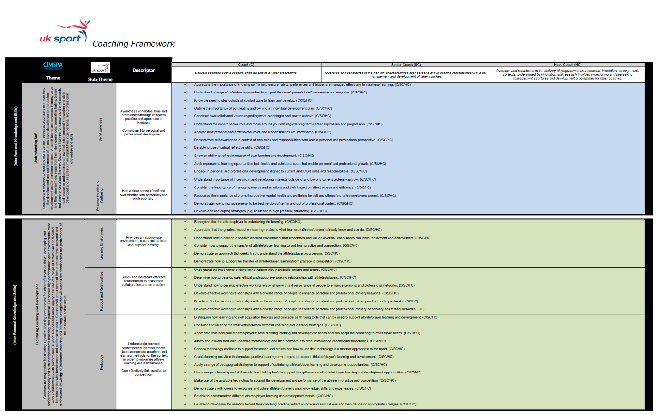

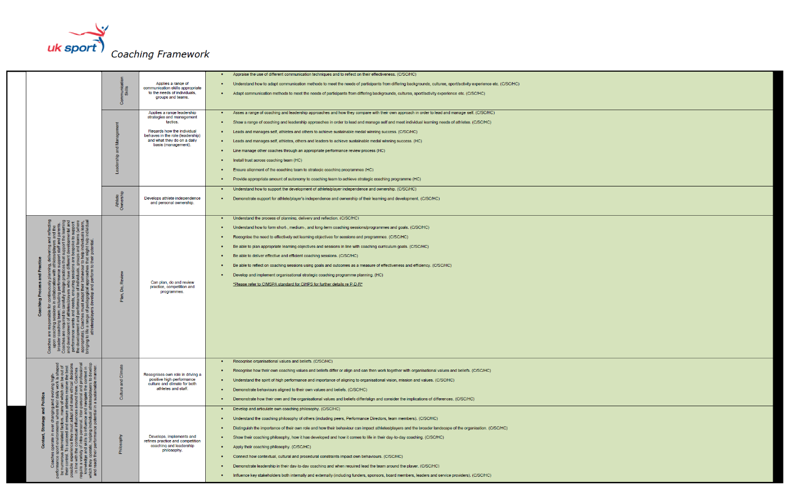

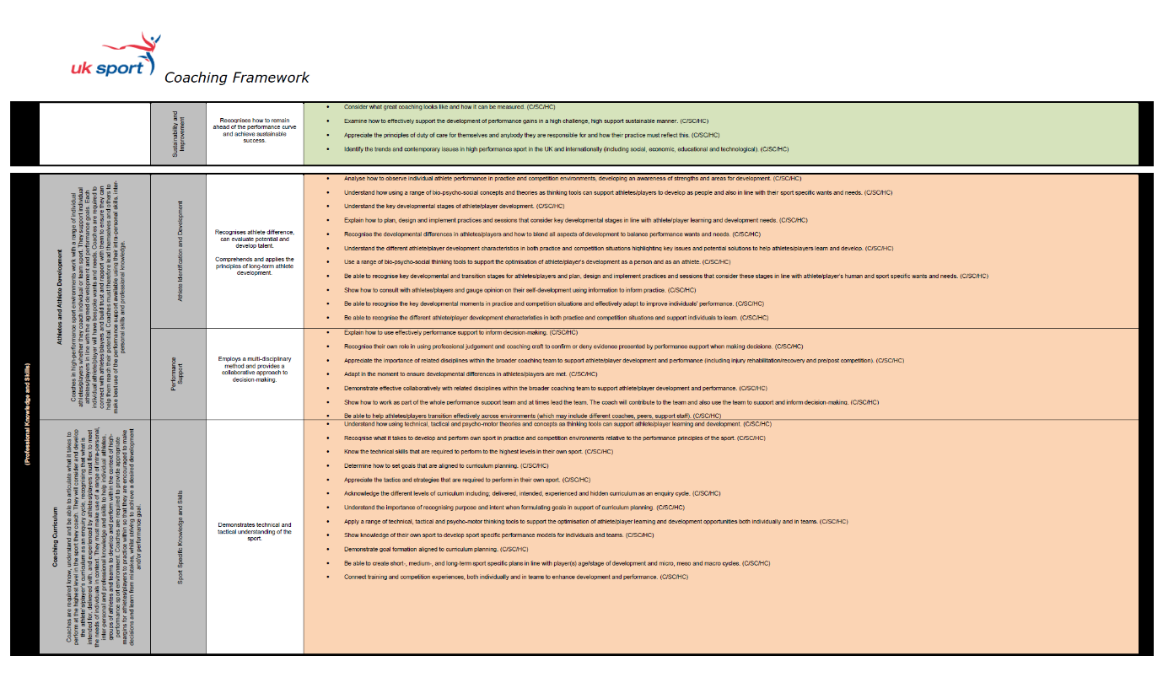

**Appendix 4**

**UK Sport proposed HiCAP structure**

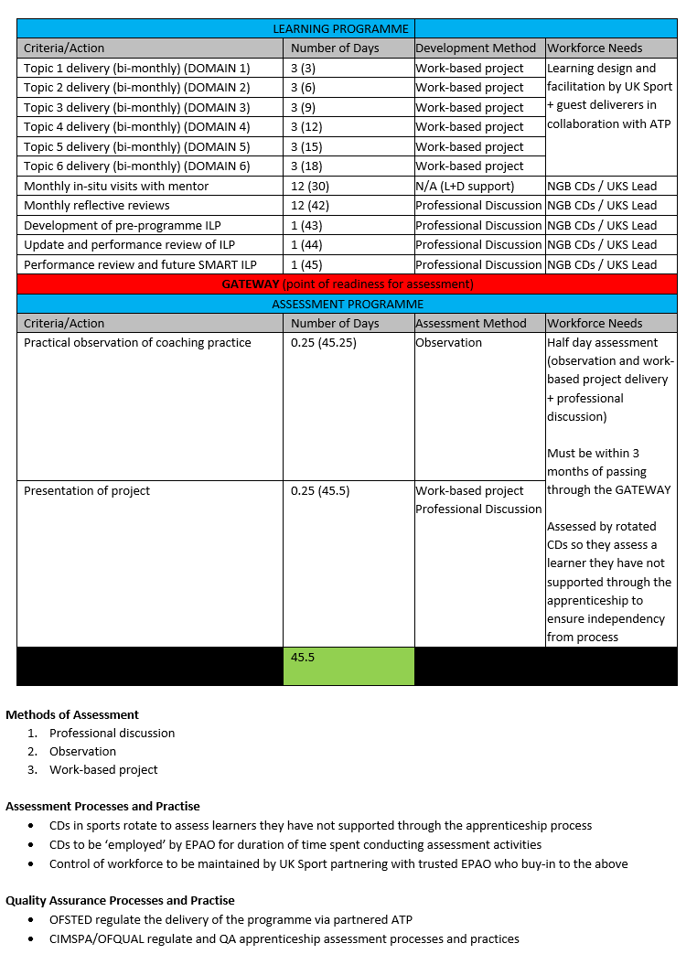

**Appendix 5**

**UK Sport Forms**

**THE UNITED KINGDOM SPORTS COUNCIL**

**PEOPLE DEVELOPENT TEAM**

PROVISION OF HiCAP

**FORM OF TENDER**

The completion of the documents will be taken as part of the contract between the Tenderer and UK Sport.

Please note that if any errors, omissions or mistakes are identified during the tender evaluation process UK Sport may:

1. Invalidate the tender; or
2. Ask the tenderer to stand by the Tender as submitted or withdraw it; or
3. Allow the Tender to be amended.

**TO: THE UNITED KINGDOM SPORTS COUNCIL**

I/we hereby undertake to

Provide the Services under the terms contained within this ITT which, for the avoidance of doubt include all of the following:

Contract

Specification & Pricing Matrix

Form of Tender

Certificate of Bona fide tendering

Declaration of Criminal Convictions, Tax Affairs and Controversial Situations

Certificates of Insurance

Tenderers statement in relation to Freedom of Information

Non-Canvassing, Non-Collusion and Non-Corruption Certificate

At the price given in the Tender.

Dated this……………………….day of……………………………………………2020.

Signature………………………position in company………………………………….

Name of Company………………………………………………………………………………………….

**THE UNITED KINGDOM SPORTS COUNCIL**

**PEOPLE DEVELOPENT TEAM**

PROVISION OF HiCAP

BONA FIDE TENDERING CERTIFICATE

**TO:** The United Kingdom Sports Council (‘UK Sport’):

We the undersigned having read the Invitation to Tender, the Specification and associated documents annexed hereto declare and hereby certify that we are not parties to any agreement or agreements under which:

1. We have communicated the amount of our tender to any other person before the time of submission of this tender;
2. any other tenderer was reimbursed any part of their tendering costs;
3. our tendered prices have been adjusted by reference to those of any other tenderer.

We understand that UK Sport reserves the right to seek clarification and/or negotiate pre – tender and post tender.

We further understand that the information contained in the tender documents is contained therein to other parties except as is absolutely essential for such purposes as those related to insurance matters or for the purpose of fulfilling our obligations under the Contract.

Dated this……………………….day of……………………………………………2020.

Signature………………………position in company………………………………….

Name of Company………………………………………………………………………………………….

**THE UNITED KINGDOM SPORTS COUNCIL**

**PEOPLE DEVELOPENT TEAM**

PROVISION OF HiCAP

DECLARATON OF CRIMINAL CONVICTIONS, TAX AFFAIRS AND CONTROVERSIAL SITUATIONS

**TO:** The United Kingdom Sports Council (‘UK Sport’):

1. We the undersigned having read the Invitation to Tender, the Specification and associated documents annexed hereto declare and hereby declare that, within the past five years, our organisation (or any member of your proposed consortium, if applicable), Directors or partner or any other person who has powers of representation, decision or control been convicted of any of the following offences:

|  |  |  |
| --- | --- | --- |
| **Offences** | **Please indicate your answer by marking ‘X’ in the relevant box.** | |
| **Yes** | **No** |
| 1. conspiracy within the meaning of section 1 or 1A of the Criminal Law Act 1977 or article 9 or 9A of the Criminal Attempts and Conspiracy (Northern Ireland) Order 1983 where that conspiracy relates to participation in a criminal organisation as defined in Article 2 of Council Framework Decision 2008/841/JHA on the fight against organised crime; |  |  |
| 1. corruption within the meaning of section 1(2) of the Public Bodies Corrupt Practices Act 1889 or section 1 of the Prevention of Corruption Act 1906; |  |  |
| 1. the common law offence of bribery; |  |  |
| 1. bribery within the meaning of sections 1, 2 or 6 of the Bribery Act 2010; or section 113 of the Representation of the People Act 1983; |  |  |
| 1. any of the following offences, where the offence relates to fraud affecting the European Communities’ financial interests as defined by Article 1 of the Convention on the protection of the financial interests of the European Communities: |  |  |
| (i) the offence of cheating the Revenue; |  |  |
| (ii) the offence of conspiracy to defraud; |  |  |
| (iii) fraud or theft within the meaning of the Theft Act 1968, the Theft Act (Northern Ireland) 1969, the Theft Act 1978 or the Theft (Northern Ireland) Order 1978; |  |  |
| (iv) fraudulent trading within the meaning of section 458 of the Companies Act 1985, article 451 of the Companies (Northern Ireland) Order 1986 or section 993 of the Companies Act 2006; |  |  |
| (v) fraudulent evasion within the meaning of section 170 of the Customs and Excise Management Act 1979 or section 72 of the Value Added Tax Act 1994; |  |  |
| (vi) an offence in connection with taxation in the European Union within the meaning of section 71 of the Criminal Justice Act 1993; |  |  |
| (vii) destroying, defacing or concealing of documents or procuring the execution of a valuable security within the meaning of section 20 of the Theft Act 1968 or section 19 of the Theft Act (Northern Ireland) 1969; |  |  |
| (viii) fraud within the meaning of section 2, 3 or 4 of the Fraud Act 2006; or |  |  |
| (ix) the possession of articles for use in frauds within the meaning of section 6 of the Fraud Act 2006, or the making, adapting, supplying or offering to supply articles for use in frauds within the meaning of section 7 of that Act; |  |  |
| 1. any offence listed— |  |  |
| (i) in section 41 of the Counter Terrorism Act 2008; or |  |  |
| (ii) in Schedule 2 to that Act where the court has determined that there is a terrorist connection; |  |  |
| 1. any offence under sections 44 to 46 of the Serious Crime Act 2007 which relates to an offence covered by subparagraph (f); |  |  |
| 1. money laundering within the meaning of sections 340(11) and 415 of the Proceeds of Crime Act 2002; |  |  |
| 1. an offence in connection with the proceeds of criminal conduct within the meaning of section 93A, 93B or 93C of the Criminal Justice Act 1988 or article 45, 46 or 47 of the Proceeds of Crime (Northern Ireland) Order 1996; |  |  |
| 1. an offence under section 4 of the Asylum and Immigration (Treatment of Claimants etc.) Act 2004; |  |  |
| 1. an offence under section 59A of the Sexual Offences Act 2003; |  |  |
| 1. an offence under section 71 of the Coroners and Justice Act 2009 |  |  |
| 1. an offence in connection with the proceeds of drug trafficking within the meaning of section 49, 50 or 51 of the Drug Trafficking Act 1994; or |  |  |
| 1. any other offence within the meaning of Article 57(1) of the Public Contracts Directive— |  |  |
| (i) as defined by the law of any jurisdiction outside England and Wales and Northern Ireland; or |  |  |
| (ii) created, after the day on which these Regulations were made, in the law of England and Wales or Northern Ireland. |  |  |
| (j) any offence under section 1, 2 or 4 of the Modern Slavery Act 2015 |  |  |

1. We also declare we are not subject to any a judicial or administrative proceedings or decisions having final and binding effect in accordance with the legal provisions of any part of the United Kingdom or the legal provisions of the country in which our organisation is established (if outside the UK), that our organisation is in breach of obligations related to the payment of tax or social security contributions.

|  |
| --- |
| **Non-payment of taxes or social security contributions**  If you are subject to judicial or administrative proceedings or decisions having final and binding effect, please provide further details in this box. Please also use this box to confirm whether you have paid, or have entered into a binding arrangement with a view to paying, including, where applicable, any accrued interest and/or fines. |

1. We also declare, that within the past three years, none of the following controversial situations have applied, or currently apply, to our organisation.

|  |  |  |
| --- | --- | --- |
| **Controversial Situations** | **Please indicate your answer by marking ‘X’ in the relevant box.** | |
| **Yes** | **No** |
| 1. your organisation has violated applicable obligations in the fields of environmental, social and labour law established by EU law, national law, collective agreements or by the international environmental, social and labour law provisions in the jurisdiction of England & Wales, Scotland or Northern Ireland as amended from time to time; |  |  |
| 1. your organisation is bankrupt or is the subject of insolvency or winding-up proceedings, where your assets are being administered by a liquidator or by the court, where it is in an arrangement with creditors, where its business activities are suspended or it is in any analogous situation arising from a similar procedure under the laws and regulations of England & Wales, Scotland or Northern Ireland; |  |  |
| 1. your organisation is guilty of grave professional misconduct, which renders its integrity questionable; |  |  |
| 1. your organisation has entered into agreements with other economic operators aimed at distorting competition; |  |  |
| 1. your organisation has a conflict of interest (see note below) that cannot be effectively remedied by other, less intrusive, measures; |  |  |
| 1. the prior involvement of your organisation in the preparation of this procurement procedure has resulted in a distortion of competition, that cannot be remedied by other, less intrusive, measures; |  |  |
| 1. your organisation has shown significant or persistent deficiencies in the performance of a substantive requirement under a prior public contract, a prior contract with a contracting entity, or a prior concession contract, which led to early termination of that prior contract, damages or other comparable sanctions; |  |  |
| 1. your organisation—   (i) has been guilty of serious misrepresentation in supplying the information required for the verification of the absence of grounds for exclusion or the fulfilment of the selection criteria; or |  |  |
| (i) your organisation has undertaken to |  |  |
| (aa) unduly influence the decision-making process of the contracting authority, or |  |  |
| (bb) obtain confidential information that may confer upon your organisation undue advantages in the procurement procedure; or |  |  |
| (j) your organisation has negligently provided misleading information that may have a material influence on decisions concerning exclusion, selection or award. |  |  |

**Conflicts of interest**

In accordance with question 3 (e), the authority may exclude the Supplier if there is a conflict of interest which cannot be effectively remedied. The concept of a conflict of interest includes any situation where relevant staff members have, directly or indirectly, a financial, economic or other personal interest which might be perceived to compromise their impartiality and independence in the context of the procurement procedure.

Where there is any indication that a conflict of interest exists or may arise then it is the responsibility of the Supplier to inform the authority, detailing the conflict in a separate document. Provided that it has been carried out in a transparent manner, routine pre-market engagement carried out by the UK Sport should not represent a conflict of interest for the Supplier.

**Dated this……………………….day of……………………………………………2020.**

**Signature………………………position in company………………………………….**

**Name of Company………………………………………………………………………….**

**(THIS CERTIFICATE MUST BE COMPLETED BY THE TENDERERS BROKER/INSURER)**

**THE UNITED KINGDOM SPORTS COUNCIL**

**PEOPLE DEVELOPENT TEAM**

PROVISION OF HiCAP

**CERTIFICATE RELATING TO EMPLOYERS LIABILITY INSURANCE**

**TO:** The United Kingdom Sports Council (‘UK Sport’):

1. This Certificate is to assure UK Sport that the Insurance Policy Number ............................ holds *[Insert Tenderer Name ]* covered throughout the Contract Period and in accordance with the Conditions in respect of any damage or compensation payable at law in respect of any accident or injury to any employee or other person in the employment of the *[Insert Tenderer Name ]* or their Agent.
2. UK Sport shall not be liable in respect of the above save to the extent that such accident or injury results from or is contributed to by any act or default of UK Sport or persons employed by UK Sport.
3. We have due regard to UK Sport's interests in the policy in respect of the risks to *[Insert Tenderer Name ]* employees and others and undertake to inform immediately the UK Sport's Legal Team if the insurance cover is discontinued or invalidated during the Contract Period.
4. We accept the obligation implied by this Certificate to produce on request irrespective of the timing, the Insurance Policies and Premium receipts.
   1. The insurance in respect of this Contract for any one incident without any limitation of the number of claims from……………………..to…………………………. in a contract year is not less than £5 million.
   2. Insurers address………………………………………………………………………………………………….

……………………………………………………………………………………………………………………………………

Insurers authorised signatory……………………………………………………….Date ………………..

Status/Designation……………………………………………………………Policy No……………………….

Expiry Date…………………………………………… Signed……………………………………………………..

On behalf of (company name and address)……………………………………………………………..

…………………………………………………………………………………………………………………………………..

Insurers/Brokers stamp……………………………………………………………………………………………

|  |
| --- |
| **FOR OFFICIAL USE** |
| **POLICY INSPECTION DATE ...................................... OFFICER'S SIGNATURE** |
| **PREMIUM INSPECTION DATE ..................................... OFFICER'S SIGNATURE** |

**THE UNITED KINGDOM SPORTS COUNCIL**

**PEOPLE DEVELOPENT TEAM**

PROVISION OF HiCAP

**CERTIFICATE RELATING TO PUBLIC LIABILITY/THIRD PARTY INSURANCE**

# TO: The United Kingdom Sports Council (‘UK Sport’)

1. This certificate is to assure UK Sport that Insurance Policy Number ………. with ……………………….holds *[Insert Tenderer Name ]* covered throughout the term of of the contract and in accordance with the contract terms, against any accident, damage, loss or injury which may occur to any property or to any persons by or arising out of the performance of the Services under the contract without limiting *[Insert Tenderer Name ]* obligations and responsibilities.
2. UK Sport shall not be liable in respect of the above save to the extent that such accident or injury results from or is contributed to, by any act or default of UK Sport or persons employed by them.
3. The terms of the insurance include an indemnity to principal’s clause whereby in the event of any claim, in respect of which *[Insert Tenderer Name ]* would be entitled to receive indemnity under its insurance policy being made against UK Sport, *[Insert Tenderer Name ]*] insurers will indemnify UK Sport in like manner against such a claim and any costs, charges and expenses in respect thereof.
4. We accept the obligation implied by this certificate to produce on request irrespective of timing, the Insurance Policies and Premium receipts.
5. The insurance in respect of the Services under the contract for any one accident without any limitation of the number of claims from………………to ……………………… in each year is not less than £5 million.
6. Insurers address………………………………………………………………………………………………

………………………………………………………………………………………………………………

Insurers authorised signatory…………………………………………………. Date………………………….

Status/Designation……………………………………………….. Signed…………………………………………

On behalf of (Company name and address)………………………………………………………………..

………………………………………………………………………………………………………………

Insurers/Brokers stamp……………………………………………………………………………………………….

|  |
| --- |
| **FOR OFFICIAL USE** |
| **POLICY INSPECTION DATE**……………… **OFFICERSSIGNATURE**…………………………………. |
| **PREMIUM INSPECTION DATE**………………**OFFICERS SIGNATURE**……………………………… |

**THE UNITED KINGDOM SPORTS COUNCIL**

**PEOPLE DEVELOPENT TEAM**

PROVISION OF HiCAP

**TENDERERS STATEMENT IN RELATION TO THE FREEDOM OF INFORMATION ACT 2000**

*Tenderers are required to read the following and complete the table below and sign/date the document*

We have read and understand paragraph 10 of the Invitation to Tender for the Services and acknowledge that UK Sport has obligations in relation to Freedom of Information.

In accordance with the provisions of sections 41 and 43 of the Freedom of Information Act and the Environmental Information Regulations 2004 (‘The Acts’) we wish/do not wish to request an exemption for the information provided to UK Sport in preparation and completion of our tender for redevelopment of the Site with UK Sport.

We understand that Section 41 of the Act provides an absolute exemption for disclosure of information held by a public authority, which would constitute an actionable breach of confidence.

We further believe that disclosure of the information referred to in Table 1 after the contract is awarded would, or is likely to, prejudice our commercial interests under section 43 of the Act. In particular, the disclosure of this information would be likely to weaken our position in a competitive environment by revealing market-sensitive information or information of potential usefulness to our competitors.

During the course of the tender process all the information provided to UK Sport by us under Table 1 is provided in confidence up to the date of the award of the Contract by UK Sport.

If we are awarded the contract we ask that the information in table 1 be put in a confidential and commercially sensitive schedule to the contract.

Table1: Section 41 - confidential and Section 43 - commercially sensitive information

|  |  |  |
| --- | --- | --- |
| **Exemption(s) claimed** | **Information** | **Minimum Period of exemption** |
| Section  41 |  |  |
| Section  41 |  |  |
| Section  41 |  |  |
| Section  41 |  |  |
| Section  43 |  |  |
| Section  43 |  |  |
| Section  43 |  |  |

If for any reason UK Sport considers releasing any of the above confidential or commercially sensitive information, we ask in the first instance that you contact [name of Tenderers representative]. This will enable us to review the nature of the material under consideration for release, and also provides the opportunity to support UK Sport in its decision whether or not to disclose the information.

We will use all reasonable endeavours to review the commercial sensitivity of the information and inform UK Sport (in writing) whether or not we agree that the information should be released within 3 working days of receiving the request.

Dated this……………………….day of……………………………………………2020.

Signature………………………position in company………………………………….

Name of Company……………………………………………………………………………

**THE UNITED KINGDOM SPORTS COUNCIL**

**PEOPLE DEVELOPENT TEAM**

PROVISION OF HiCAP

**NON-CANVASSING, NON-COLLUSION OR NON-CORRUPTION CERTIFICATE**

The essence of a formal selection process is that UK Sport receives bona fide proposals from all Tenderers.

In recognition of this principal we the Tenderer [Insert Company Name] certify that this is a bona fide proposal. We have not fixed or adjusted the submission by or in accordance with any agreement or arrangement with any other person or party.

We also certify that we have not done and we undertake that we shall not do at any time before the hour and date specified for the return of this submission any of the following acts:-

1. Directly or indirectly canvassed any official of UK Sport concerning the acceptance of this or any other tender or who has directly or indirectly obtained or attempted to obtain information from any such member or official concerning this or any other tender.
2. Communicate with any other person other than the person calling for the submission except where the disclosure of information is necessary to obtain insurance.
3. Enter into any agreement or arrangement with any person that he shall refrain from making a submission.
4. To offer to pay or give or agree to pay or give any sum of money or valuable consideration directly or indirectly to any person related to this submission;
5. made or offered to make any type of payment or gift to any UK Sport employee or member or to anyone else where or not the person is directly connected to UK Sport directly connected with this Tender exercise; or
6. offered or given or agreed to give any officer or member of UK Sport any gift or consideration of any kind as an inducement or bribe to influence its decision in relation to the tendering procedure.

Dated this……………………….day of……………………………………………2020.

Signature………………………position in company………………………………….

Name of Company……………………………………………………………………………

**THE UNITED KINGDOM SPORTS COUNCIL**

**PEOPLE DEVELOPENT TEAM**

PROVISION OF HiCAP

**REFERENCES**

|  |  |
| --- | --- |
| Organisation: |  |
| Address: |  |
| Contract Name: |  |
| Telephone No: |  |
| E-mail Address: |  |
| Approximate Value: |  |

|  |  |
| --- | --- |
| Organisation: |  |
| Address: |  |
| Contract Name: |  |
| Telephone No: |  |
| E-mail Address: |  |
| Approximate Value: |  |

**UK SPORT**

**QUESTIONNAIRE FOR PROSPECTIVE**

**DATA PROCESSORS**



**Introduction:**

UK Sport is required under the General Data Protection Regulations, the Data Protection Act 2018 and HMG Security Policy Framework[1] to ensure that existing and prospective contractors processing personal data and/or confidential information on behalf of UK Sport are doing so with an appropriate level of security and in accordance with statutory requirements.

This questionnaire is to be completed by potential data processors at tender stage or by contractors that have access or are party to confidential information.

Please complete and return this questionnaire, signed by an authorised representative for your organisation.

|  |  |
| --- | --- |
|  | **1. ORGANISATION DETAILS**  **Name:**  **Address:**  **Contact name:**  **Contact details:**  **Email:** |
|  |
| **2. DATA PROCESSING ACTIVITIES** | | |

|  |  |  |
| --- | --- | --- |
|  | In connection with the contract: |  |

**2.1 Describe the purposes for which your organisation uses personal data**

**2.2 Describe how personal data (tangible/ intangible form) is stored on your systems.**

**2.3 Describe all potential recipients of personal data held by your organisation (if any) and the likely uses of the data by those recipients.**

**2.4 Describe how data is transferred (a) internally within your organisation and (b) to external parties (if applicable).**

|  |
| --- |
| **3. SECURITY POLICIES AND PROCEDURES** |

|  |  |  |  |  |  |  |
| --- | --- | --- | --- | --- | --- | --- |
|  |  |  |  | |  |  |
|  | **3.1. Do you have an information security policy?** Yes [_] No [_]  (If yes, please provide a copy) | | | | |  |
|  |  |
|  | **3.2 Does your information security policy include the following:** | | |  |  |  |

|  |  |  |  |  |  |
| --- | --- | --- | --- | --- | --- |
|  | 3.2.1 | Physical security of premises and processing areas | Yes [_] | No [_] |  |
|  | 3.2.2 | physical entry controls | Yes [_] | No [_] |  |
|  | 3.2.3 | equipment security and maintenance | Yes [_] | No [_] |  |
|  | 3.2.4 | password and access controls | Yes [_] | No [_] |  |
|  | 3.2.5 | security of mobile equipment (eg laptops) | Yes [_] | No [_] |  |
|  | 3.2.6 | controls against malicious software | Yes [_] | No [_] |  |
|  | 3.2.7 | business continuity planning | Yes [_] | No [_] |  |

|  |
| --- |
|  |

|  |  |  |  |  |  |  |  |  |  |
| --- | --- | --- | --- | --- | --- | --- | --- | --- | --- |
|  | **3.3 Does your information security policy comply** Yes [_] No [_] Don’t know [_]  **with BS 27000?** | | | | | | | | |
|  | **3.4 Do you have HM Government Cyber Security Essentials Accreditation?[2]** Yes [_] No [_] Don’t know [_] | | | | | | |  | |
|  | **3.4 Do you have a policy for complying with the Data** Yes [_] No [_]  **Protection Act 1998?**  (if yes, please provide a copy)  **4. DATA QUALITY**  In connection with the contract:  **4.1 Describe any procedures[3] currently in place to ensure that all personal data is accurate**  **and up-to-date.**  **4.2 For how long is personal data usually kept by you?**  **4.3 Does your organisation have a policy regarding the periodic** Yes [_] No [_]  **destruction or deletion of obsolete data?**  (If yes, please provide details):  **5. DEALING WITH INDIVIDUALS RIGHTS**  **5.1 Describe any procedures[4] currently in place to deal with requests by individuals to be supplied with information about the data held by them**  **6. SECURITY MEASURES**  This section is intended to establish which security measures are in place in your organisation to ensure the confidentiality of personal data.  Please indicate whether you have the following: | | | | | | |  | |
|  | **6.1 A clear desk policy?** | |  | Yes [_] | No [_] | | | | |
|  |  |
|  |  |
|  | **6.2** **A clear screen policy?** Yes [_] No [_]  **6.3 Controls on access to information (inside and outside** Yes [_] No [_]  **your organisation)?** | | | | | | |  |
| **6.4 A secure disposal policy for equipment,** Yes [_] No [_]  **media and data (e.g. encryption)?** | | | | | | | |
| (If yes, please provide a copy)  **6.5 A back-up and disaster recovery policy?** Yes [_] No [_]  **6.6** **Internal training programme on security systems and** Yes [_] No [_]  **procedures?**  **6.7 Any equipment off-site or store any personal data off-site?** Yes [_] No [_]    **7. DISCIPLINARY RECORD**  **7.1 Have you been the subject of a complaint(s) to the** Yes [_] No [_]  **Information Commissioner?**  (if yes, please provide details) | | | | | | |
|  | | | | | |

**7.2 Have you ever had a security breach resulting in loss or unauthorised disclosure of personal data?** Yes [_] No [_]

(If yes, please provide details)

|  |  |  |  |  |  |  |
| --- | --- | --- | --- | --- | --- | --- |
| **8. INTERNATIONAL DIMENSION** | | | | | | |
|  |  |  |  |  |  | |
|  | **8.1. Do you share personal data with organisations outside the UK?** Yes [_] No [_]  If the answer to 8.1 is yes, please answer the following questions:  **8.1.1** (a) **Indicate which of those organisations are part of your Group of companies:**  **8.1.1** (b) **Is there any internal policy governing the use of personal data with organisations**  **listed above?**  Yes [_] No [_] N/A [_]    **8.1.2** (a) **Indicate which of those organisations are NOT part of your Group of companies:** | | | | |  |

**8.1.2** (b) **Is there a written contract governing the relationship between such organisations and CLIENT?**

Yes [_] No [_] N/A [_]

(If yes, please provide details)

**8.2. Does any third party process personal data on your behalf outside of the UK?** Yes [_] No [_]

(If yes, please provide details)

**9. SUPPLY CHAIN RISKS**

**9.1 Have you undertaken a risks assessment against your supplier’s role in the supply chain and the risks posed to delivery of the services? In particular have identified any cyber security dependencies and vulnerabilities?** Yes [_] No [_]

(If yes, please provide details and how you mitigate those risks)

**9.2 How often do you review your business relationships and risk management with these suppliers?**

**Appendix 6**

**THE UNITED KINGDOM SPORTS COUNCIL**

**PEOPLE DEVELOPENT TEAM**

PROVISION OF HiCAP

**CHECKLIST**

**[INSERT DATE]**

|  |  |
| --- | --- |
| Action Tenderer | Tick |
| Confirmed expression of interest |  |
| Submitted any clarification questions |  |

**[INSERT DATE]**

|  |  |
| --- | --- |
| Action UK Sport | Tick |
| Responses to clarification questions received from UKS |  |

**[INSERT DATE]**

|  |  |
| --- | --- |
| Action Tenderer | Tick |
| Submitted Tender |  |
| Completed and Signed Forms at Appendix 2 |  |
| Statement of Good Standing |  |

**[INSERT DATE]**

|  |  |
| --- | --- |
| Action UK Sport | Tick |
| Notification to successful/unsuccessful tenderers |  |

**[INSERT DATE]**

|  |  |
| --- | --- |
| Action Tenderers to Present | Tick |
| Attend Presentation Meetings |  |

**[INSERT DATE]**

|  |  |
| --- | --- |
| Action UK Sport | Tick |
| Notification to successful/unsuccessful presenters |  |
| Standstill period |  |

1. <https://www.gov.uk/government/publications/security-policy-framework>
2. See <https://www.gov.uk/government/publications/cyber-essentials-scheme-overview>
3. This may include writing to individuals to request confirmation as to the accuracy of the data held about them.
4. This may include the use of checklists or standard letters dealing with access requests