CONTENTS

1. PURPOSE 2
2. BACKGROUND TO THE CONTRACTING aUTHORITY 2
3. scope of requirement 2
4. The requirement 2
5. key milestones 4
6. Sustainability 4
7. quality 4
8. ACCEPTANCE & Payment 4

PURPOSE

Home Office require the supply of a specialist custody toilet facility (Specimen Isolation Units (SIUs)) for the examination of waste faecal matter, in support of officers engaged in the detection of narcotics smuggled within the body.

Border Force and the National Crime Agency have deployed officers to West Africa to up skill and reviews current detainee practices in Nigeria. A large number of arrested persons have ingested packages of class A drugs which could be potentially harmful to the individual whilst in their system. For welfare of both the detainee and the officer a specialist toilet facility SIU is needed to help with the recovery of ingested packages and avoid the spreading of germs & diseases.

BACKGROUND TO THE CONTRACTING aUTHORITY

The contracting authority is the Home Office and its representative is Border Force International (BFI). BFI deploys staff worldwide to help building border capability and enhance the economic stability and welfare of detainees in developing countries. There is a need to select and deploy suitable equipment in order to address operational needs and comply with Health & Safety requirements.

BFI has a requirement to ensure appropriate facilities are available within designated Custody areas for processing individuals suspected of being involved in the illicit importation of controlled drugs, by means of internal body concealments, and to allow the safe processing of biological material that has to be screened in such cases.

The purpose of this Statement of Requirements is to provide a description of the Goods that the Supplier shall be required to deliver to the Contracting Authority under an SIU Contract.

scope of requirement

To enable Border Force International I to meet a key objective it is imperative an SIU is purchased and installed in the newly built custody suite by July 31st 2017.

The requirement

The requirement is for a single SIU for the newly built Custody Suite located in;

NAHCO,

NDLEA Head Quarters and Custody block,

Airport Road MMIA,

Ikeja,

Lagos

4.2 Border Force International has a requirement for:

A reliable method of recovery of substances that is protected, hygienic, odour-free, straightforward and efficient to use. It must provide a sterile environment with the potential of filtering through faecal matter that may attach itself to other substances in a controlled environment. A unit that is easy to maintain and will work without specialist chemicals

The detection recovery area should be fully isolated from the toilet and be completely visible at all times behind a secure dividing screen to enable the officers to monitor the detainee as well as look through the faecal matter.

The facility should have minimum pressure preferably none and incorporate a mechanism to maximise protection from viruses and odours. The entire unit should be constructed from durable stainless steel together with an impact-resistant transparent screen for safety and security screening. The unit should be able to withstand local temperatures.

The unit must be custom built to the available measurements at the new custody build.

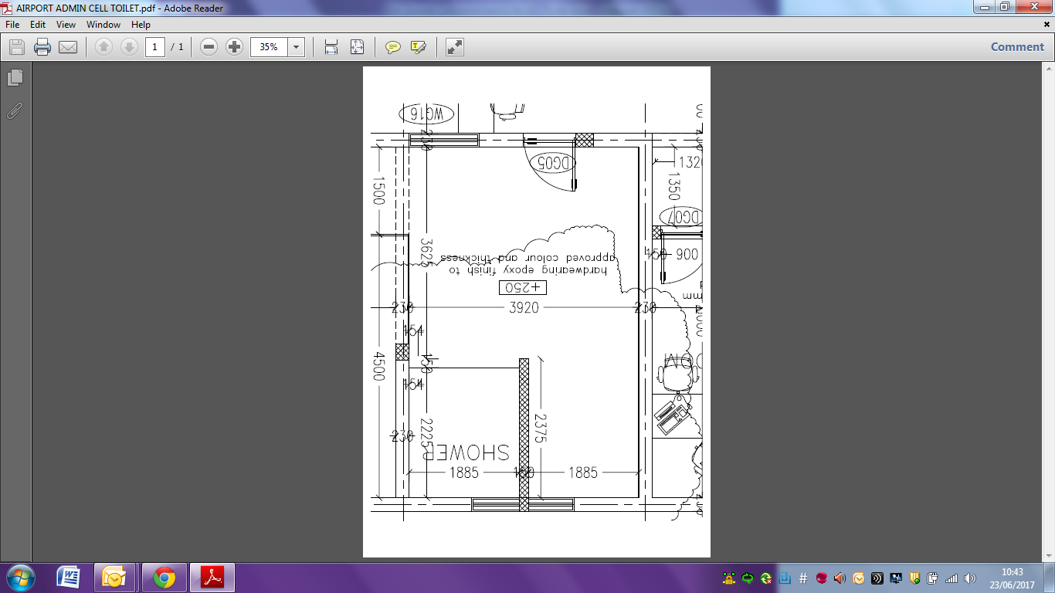

The SIU facility must include as a minimum:

Handrail,

Rear screen which is easy to clean, sanitise and durable,

Rear privacy screen which ensures that the detainee cannot be viewed from the rear of the unit,

Separate specimen recovery area,

Water filtration Unit to kill microorganisms or stop their development,

Foul air extraction

Provide the capability to sift through any faecal matter in an environmentally controlled, sanitised manner

The ability to contain spilt liquid

key milestones

To provide, install and provide relevant training package/materials by last week of July for official opening.

Sustainability

The facility should minimise the transmission of infection to the officers using it as well as adhering to human rights of the detainee.

The bidder is required to provide adequate training or provision of suitable guidance/materials in the safe use and operation of the equipment. The anticpated number of officers that will require training is six

quality

The bidder will provide a warranty for a minimum of 12 months from the date of installation.

The Bidder is required to complete and pass safety & commissioning testing following installation which will be part of the acceptance process leading to payment

ACCEPTANCE & payment

The SIU will be accepted once the Authority is satisfied that the item is installed to the relevant pre-agreed certified standard and the products are assured.

For payment to be released, the Authority must satisfy themselves that each invoice includes a detailed elemental breakdown of work completed and the associated costs.

