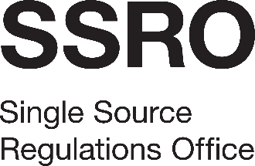
Assuring value, building confidence

Legal Services Framework
Response to Tender Questions
[Name of bidder]

Objectives and approach

Please explain how you propose to go about delivering the requirements of the Brief. In answering this, please tell us how you will support the work of the SSRO and how you will manage the relationship.
[This section must not exceed 1200 words.]

Experience and expertise

By reference to each practice area covered at paragraph 2.1 of the Brief, please set out the relevant experience and technical expertise of your proposed team. Please also provide details of any relevant, independent rating or evaluation of your work. In doing so, you may attach a maximum of 3 relevant references.
[This section must not exceed 600 words, excluding any references.]

Team

Please tell us about the team you propose to make available to carry out the work, including specifically: the size of the team; key personnel; and how work will be assigned between personnel to deliver best value for the SSRO.
[This section must not exceed 400 words.]

Conflicts of interest

Please outline what conflicts of interest you envisage may arise and, specifically, how you will address these.
[This section must not exceed 300 words.]

Project management

Please explain how you will manage the delivery of the work to ensure it meets the SSRO’s expectations in terms of quality, timeliness and cost.
[This section must not exceed 400 words.]

Additional benefits

What value-added benefits do you propose to provide as part of the engagement?
[This section must not exceed 300 words.]

Security arrangements

What arrangements do you propose to maintain to comply with the Security Conditions, set out in Schedule 1 of the Terms and Conditions, and in Section 5 of the Specification; and how would you deal with a case involving a Secret Matter to comply with the requirements set in Schedule 2 of the Terms and Conditions, and Section 5 of the Specification? Please also detail your readiness to receive Sensitive Information electronically from the SSRO either as rights management protected documents or encrypted, password protected documents. Please also address whether your team includes any staff with SC clearance or higher.
[This section must not exceed 500 words.]

