Connecting Innovation
High Impact Project Advert Template

Company Name | Alliance Transport Technologies Ltd
Company Address | Registered at: The Arc, High Street, Clowne, Derbyshire, S43 4JY
Company Contact | Bernard Keane
Description of Company Activity | Our current business activities include the remanufacturing of electronic components, energy storage systems and emission products to operators and repairers of commercial and public service vehicle operators.  Remanufactured parts are channelled through a sales and parts distribution centre (Cleckheaton) and commercial workshop (Featherstone) in the Leeds City LEP area. These centres support our current customer base across the UK with a team of specialist field service and emissions retrofit engineers. We currently employ 60 people over three sites.
Objective of the proposed project (Please explain what is required in the project) (max 250 words) | The ‘ATT Connect’ project is to create a single Enterprise Resource Planning (ERP) platform to allow bus and truck operators to identify and source remanufactured engineering/electronic components for their vehicle fleets.  The objective is to increase the awareness of remanufacturing and the benefits it brings to the environment in reducing carbon emissions.  This will be achieved by linking together the current stand-alone systems being used by ATT to manage financial information, operations, commerce, remanufacturing and supply chains under a single ERP platform.  The ‘ATT Connect’ project will incorporate an innovative ‘app’ which gives end users direct information on the availability of remanufactured products specific to their vehicle fleets. It will give customers the ability to obtain quotations, place & track orders, authorise payments. A live customer dashboard will show purchase history, current order/repair status and show the amount of carbon savings achieved via remanufacturing.
Tenders are Invited from suppliers who can provide the necessary skills and expertise to deliver the specification  Successful applicants should be aware that this project is part-funded by the England European Regional Development Fund as part of the European Structural and Investment Funds Growth Programme 2014-2020 and the Local Growth Fund.  Successful applicants should be aware that award of the contract is reliant on the successful issue of a grant funding agreement following the close of the tender process. | Suppliers will be expected to have previous experience in ERP/App design and can demonstrate successful projects they have completed for previous clients. The skills needed include web-based app design, using the Outsystems platform through Agile methodology.  This will include experience in the delivery of both front and rear end development, testing environments and the development of user experiences, utilising Jira. The supplier will need to demonstrate the proposed content and number of sprints to the stakeholder group.  The sectors the ‘ATT Connect’ project are focused on are; Commercial Vehicle operators (CV), Public Carrying Vehicles (PCV) operators, repairers and automotive factors who purchase remanufactured parts for maintaining their vehicle fleets.  The current way of managing and processing orders is through telephonic systems which are inefficient and unreliable. We are seeking to move the management of this onto a digital platform through development of the ‘ATT Connect’ app.  Suppliers must demonstrate at least 5 previous projects which have delivered a similar digital transformation in changing customers’ buying behaviours.  Ability to map out current state and deliver user experiences that simplify current processes  A schematic of the proposed work packages associated with the project is shown below.  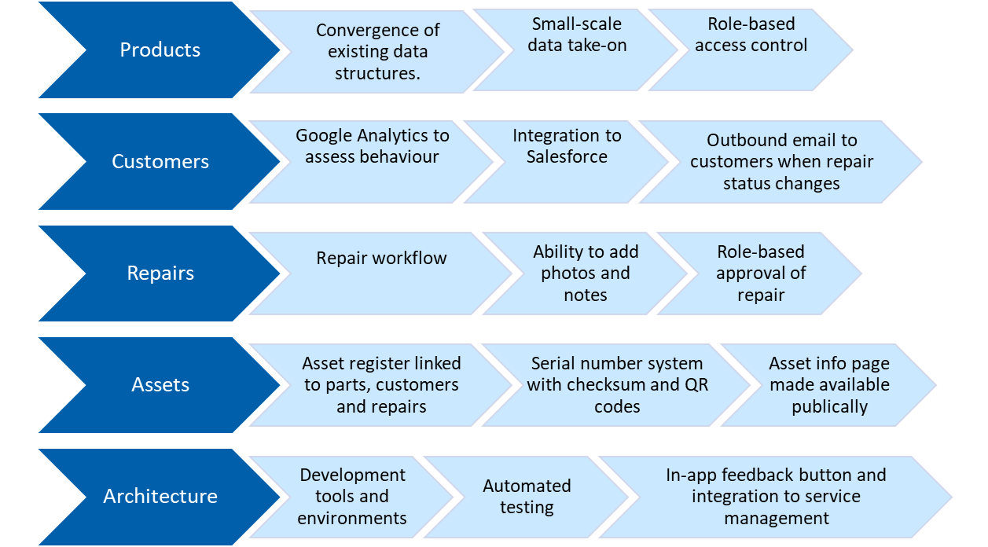
Required project timescales (start and duration of project?) | Project commencement date 1st September 2022  Completion deadline 30th December 2022
Total Anticipated Project Value  (Please note that the procurement will only go ahead to contract once the funding has been agreed) | Total anticipated project value £100k
Required response date (this must be at least 10 working days from posting of advert) | TBC upon notification of application status
How to apply? | Applications will be submitted via email on the Form provided on Contracts Finder.  https://www.contractsfinder.service.gov.uk/Notice/d9037536-3852-46ba-b106-4889fd971a7f  For any further questions around the procurement opportunity please contact Bernard Keane via the email address below  bernard.keane@alliancett.co.uk
Criteria for decision making  (Examples of Assessment Criteria could include:  Price  Expertise fit  Timing Fit  Suitability of proposed methodology)  Weighting of the criteria to be determined by SME | Criteria % Points  Experience of using the ‘Outsystems’ business design platform (minimum 5 previous projects) 35 35  Competencies in ‘Agile’ software development methodology (minimum 5 previous projects) 15 15  Experience with Jira software for issue tracking & project management (minimum 5 previous projects 15 15  Pricing 20 20  Ability to deliver sprints to stakeholders 15 15
Scoring | 100 points will be allocated, weighted to the five criteria above. Applicants will be awarded points against each of the five criteria above which will be added together to achieve a final score. The applicant with the highest score will be awarded the contract.
Date for Contract Decision (i.e. how long before the SME will inform the successful respondent) | TBC upon notification of application status

