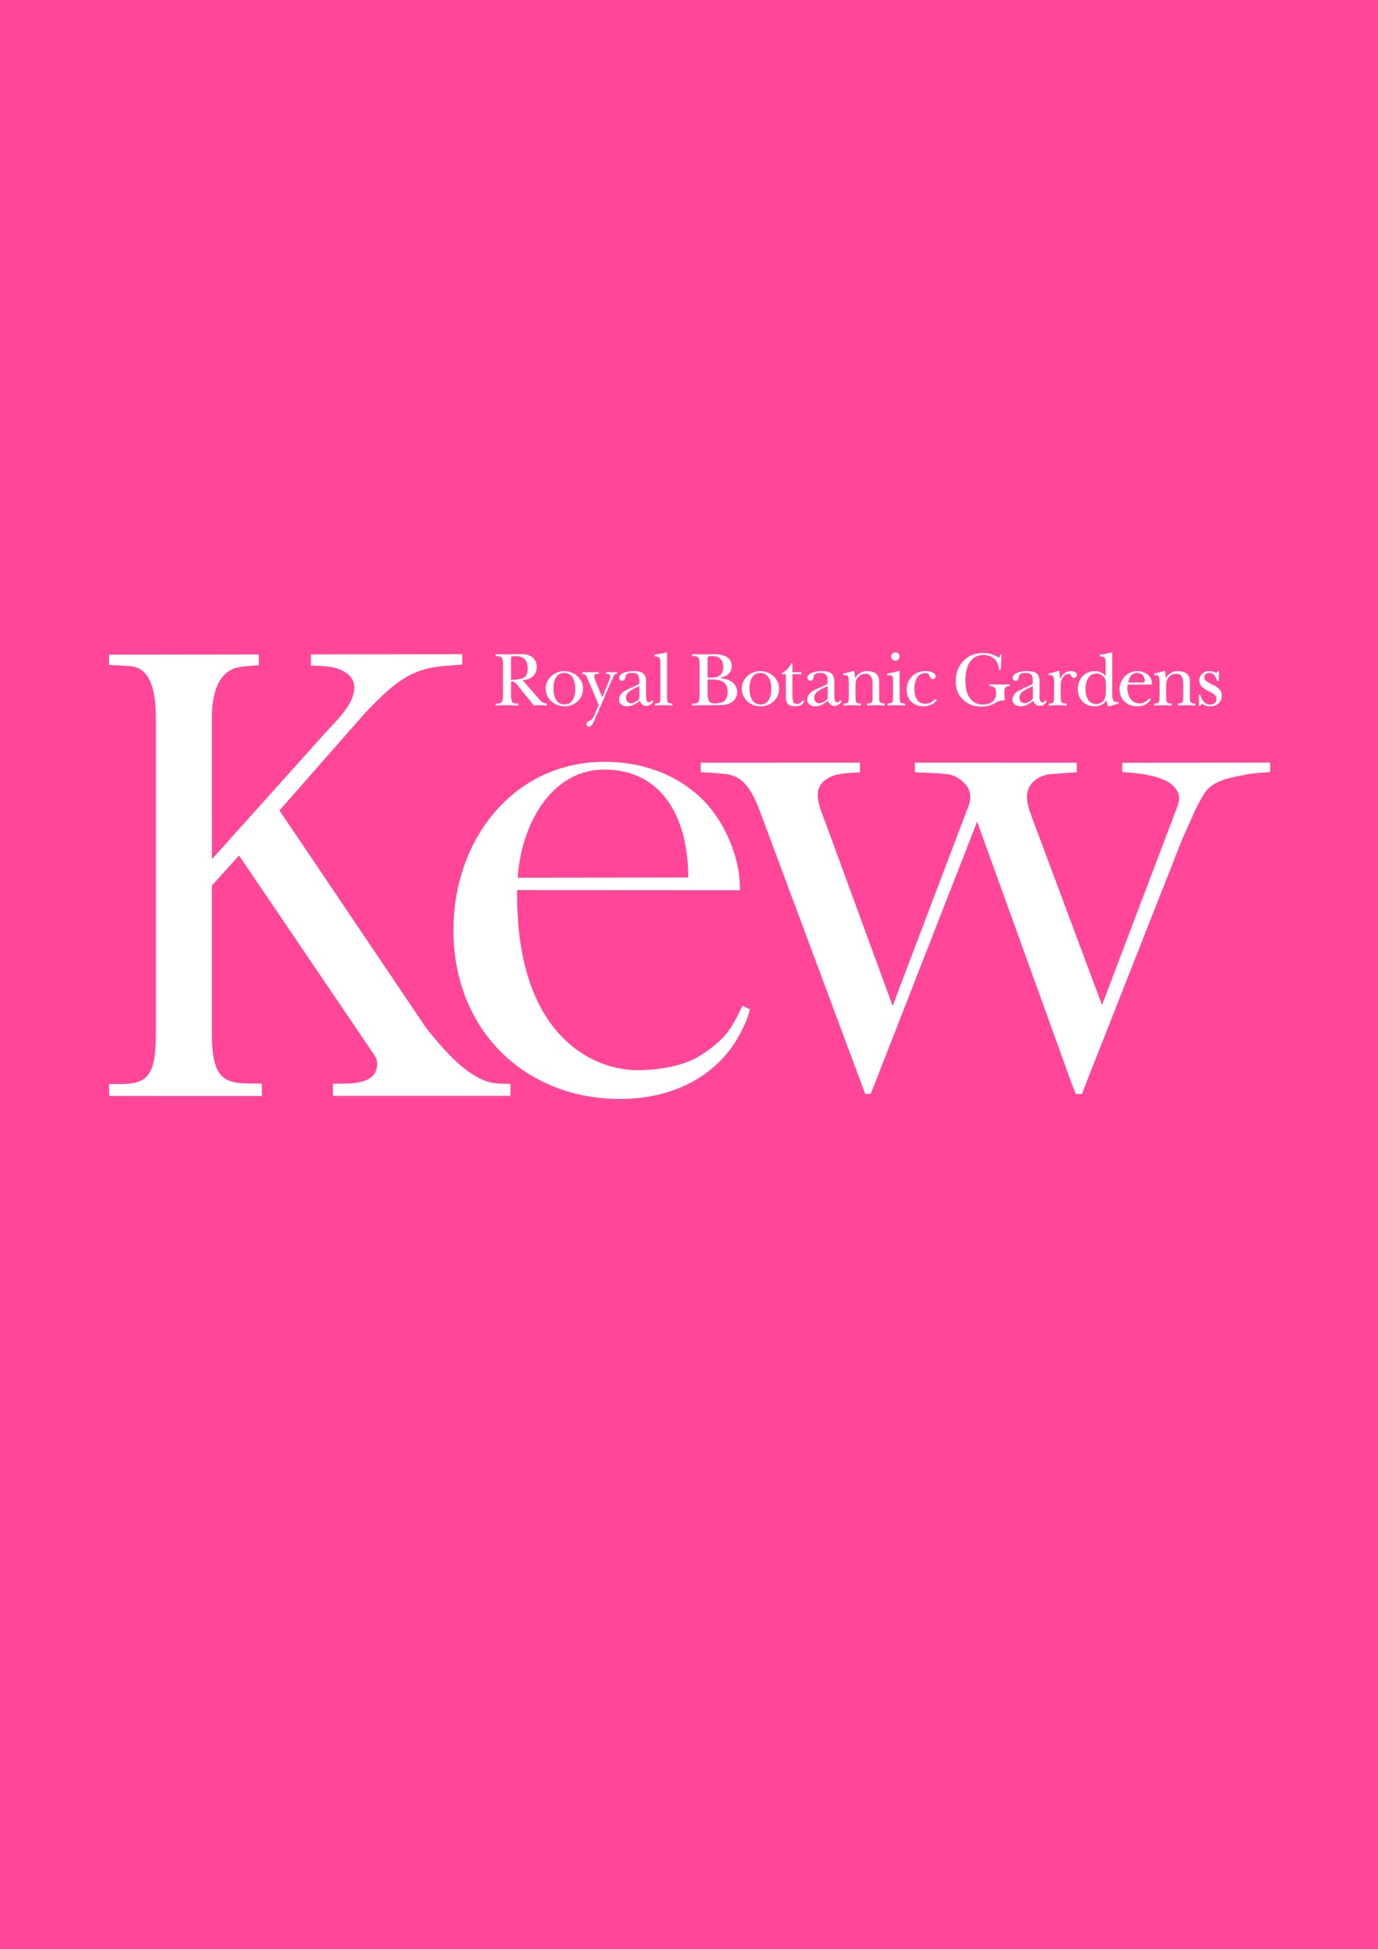
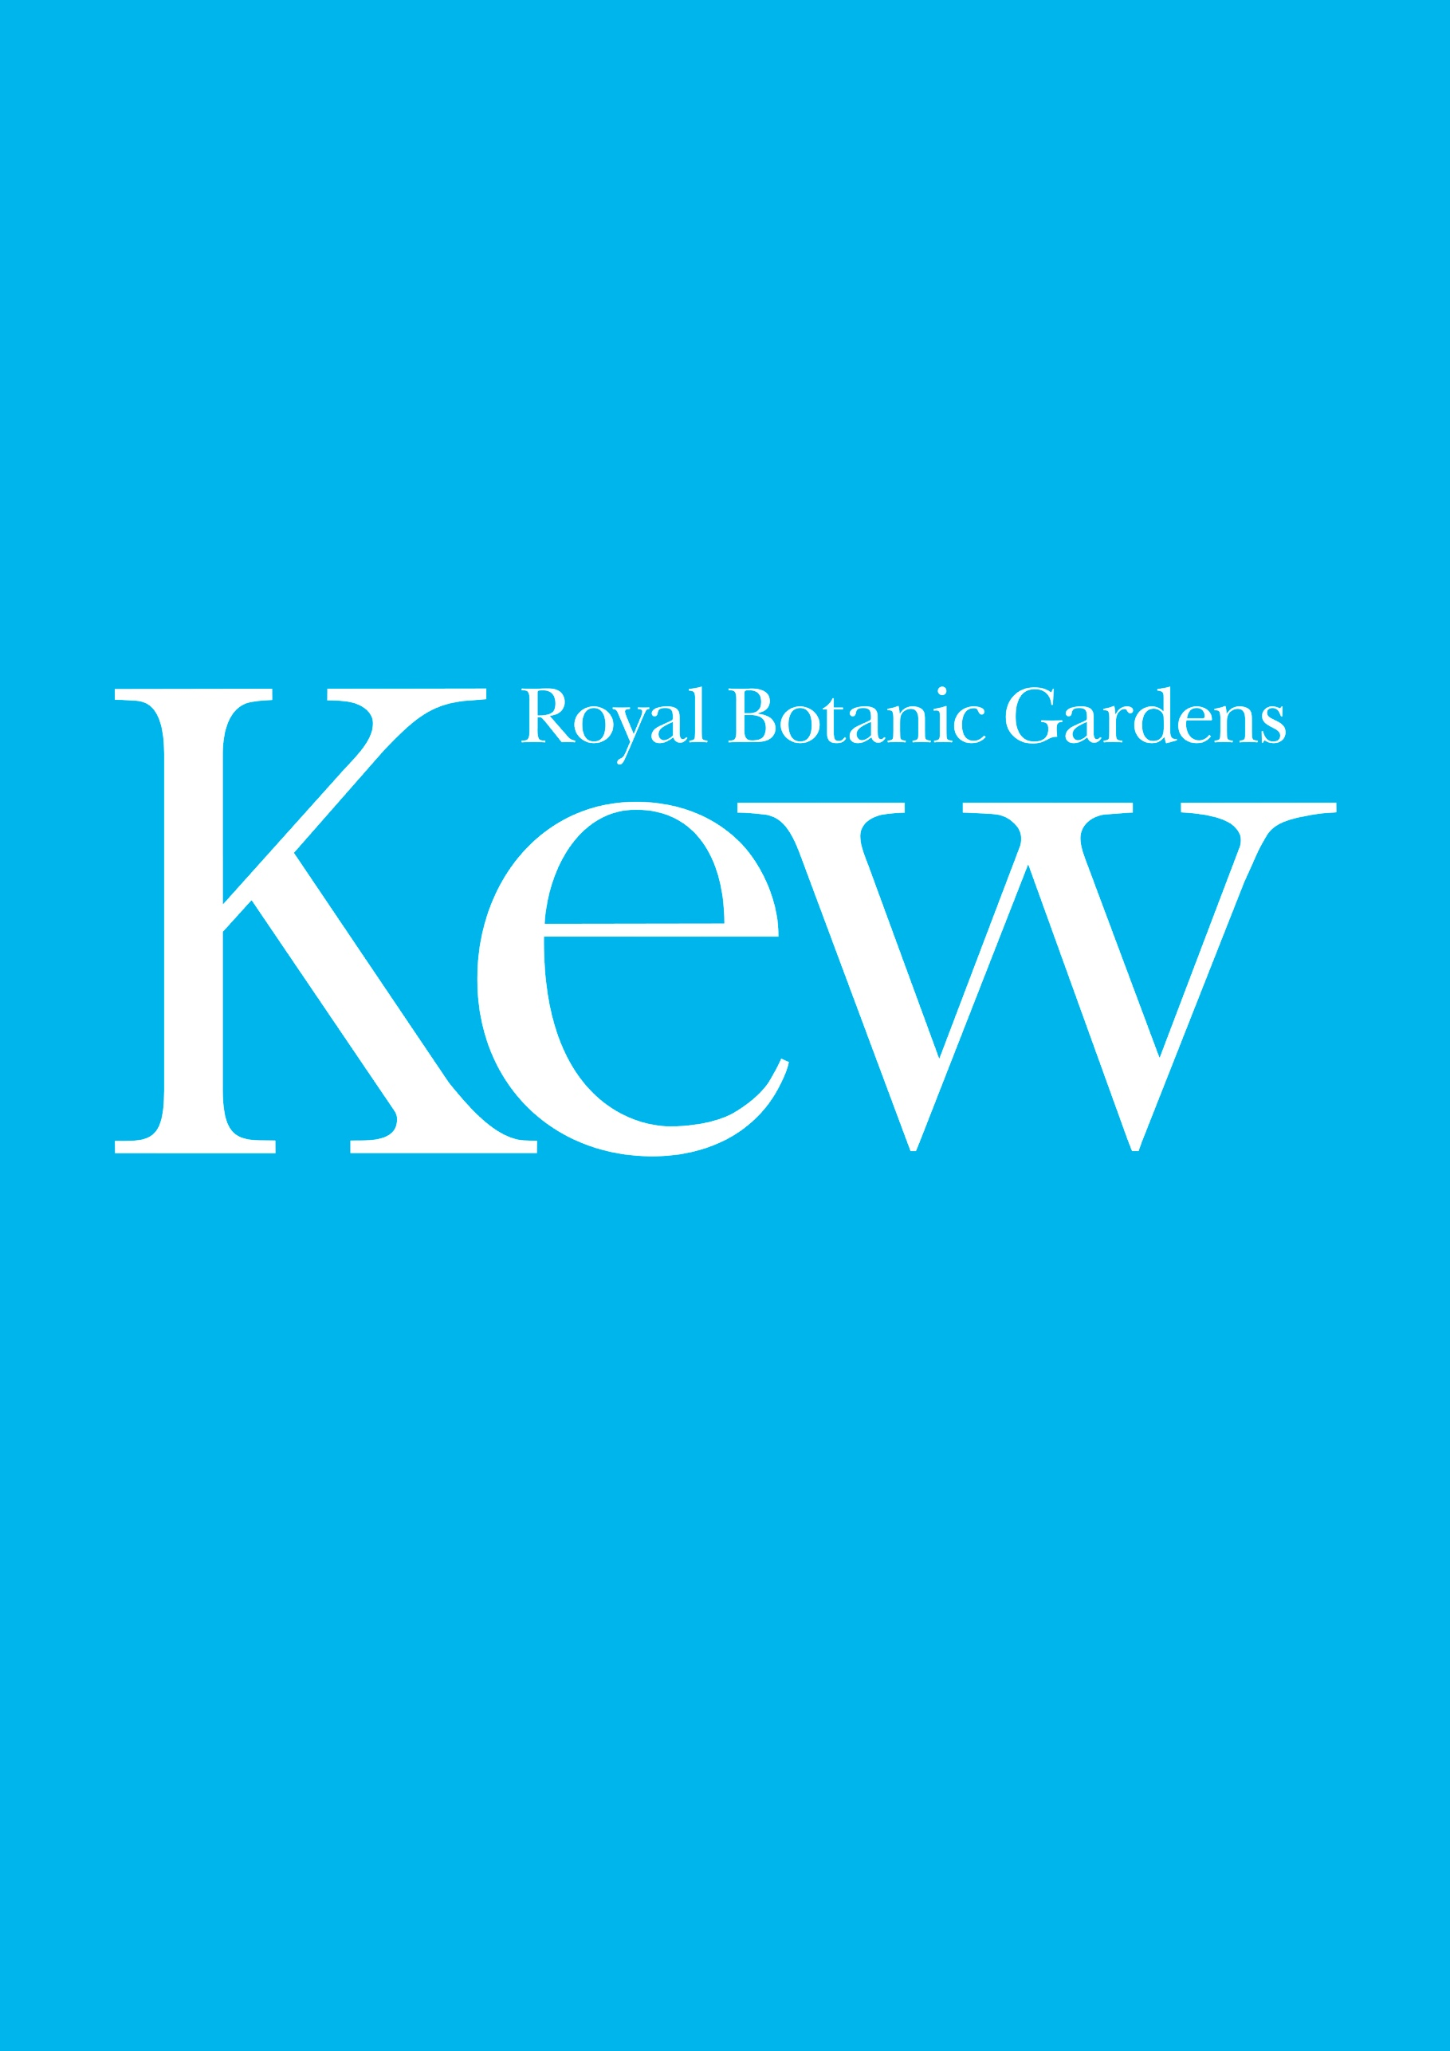
Provision of External Catering for Christmas at Kew
Part 2 - Tender Specification
RBGKEW/914
This document is for information

Contents
1. Summary
2. Scope of Requirements
3. 2020 Event Dates
4. Operational Information
5. Health and Safety
6. Historical sales information
7. Contract Management
8. Submission details

Appendices
Appendix 1 Contractor Health, Safety, Environment and Sustainability Code of practice
Appendix 2 Kew Biosecurity Guidelines
Appendix 3 Map of Oxen house gate access

- Summary
Royal Botanic Gardens Kew (RBGK) is seeking a catering partner to provide the external catering offer for our largest commercial event - Christmas at Kew.

The event itself runs for 49 non-consecutive nights from the 17th November to 9th January (16th November is preview night) with a potential extension of 7 nights until January 16th. The event attracts over 300K people and the external catering offer has become a key feature of their visit. The light trail showcases both UK and international artists' work that complement Kew’s existing infrastructure. The catering spaces are curated as part of the experience and should feel integrated into the event.

For this tender, suppliers should note the RBGK’s objectives in relation to all catering activities are:

Quality

  - We are seeking to achieve a food experience that is as well-curated as the event itself - with concessions that provide the quality that our audience expects both in presentation and taste.
  - We expect each product to be of a high quality and want to avoid cheaper products being used to achieve cost cutting, e.g., our preference is to avoid powdered hot chocolate but we note it is available in varying qualities and a higher quality is preferred over a basic brand.

Presentation

  - The presentation of the food offer is as equally as important as the speed in which it is served. There needs to be a consistency of presentation of each product throughout the entire run of the event.
  - As well as food presentation, the look and feel of each unit should be considered as integral to the event. Thought must be given to how each unit looks while trading at the event and when closed during the day.

Variety

  - Aside from the Christmas classics we want to encourage people to have the opportunity to experience something new. This could be achieved through the offer itself, using independent traders that specialise in one core offer and by using a variety of different structures.
  - We are still seeking a strong and exciting vegan and vegetarian offer. We expect each individual unit to include at least one vegetarian and vegan dish from day one. Over the course of the contract we expect the supplier to expand the plant-based food and drink offer, reducing the use of animal products, and actively encouraging visitors to choose plant-based dishes to minimise the climate and biodiversity impacts of the food and drink sold.

Operational excellence

  - We require the supplier to provide a full operational plan that demonstrates experience in working on large events with high volumes at speed.
  - We require the supplier to understand crowd management and have plans around how to effectively manage queues.
  - We expect any back of house areas to be will managed and considerations to be made for how stock and staff will move across the site, including how deliveries are made and transported from gate to store to trader.

Policies and Practices

  - To operate to the highest standard of Health and Safety and food hygiene practices.
  - COVID 19. In planning for the event an Event Management Plan must be produced with a robust Risk Assessment, with specific considerations around COVID-19 risks and how these will be mitigated.

As the situation and restrictions relating to COVID-19 are fluid, it will be important to review and follow the latest guidance from Government and importantly the local Licensing Authority, throughout the event planning process. This could result in significant changes in terms of the food and drink offer permitted as in 2020 when alcohol and seating had to be removed. We will at all times work in close partnership with our catering partner to communicate and adapt the offer as best fits this advice.

Sustainability

  - To operate in accordance with RBG Kew’s sustainability strategy by promoting plant-based food products, minimizing waste, an awareness of energy consumption, types of food packaging, and use of innovation to identify novel solutions to reduce environmental impacts and enhance customer experience
  - To provide RBG Kew with data relating to the sustainability credentials and sourcing criteria for products used – including working in partnership to develop carbon footprint data for some products.
  - RBG Kew is seeking to work with suppliers who have set rigorous sustainability targets – including those who have set a Science-Based carbon reduction target and have established a clear pathway to reach net zero emissions.
  - RBG Kew is seeking to work with suppliers who can demonstrate collaboration for sustainability innovation and performance – such as membership of sustainability networks, pledges, certifications or working groups.

- Scope of the Requirements
There is currently a total of 7 food offering locations on this trail - listed below in order of location around the trail – these are subject to change as the routes are developed.

1. Victoria Plaza Café (managed by our internal catering contractors and not part of this tender)
2. Victoria Plaza outside area
3. Pavilion Restaurant (managed by our internal catering contractors and not part of this tender)
4. Food Village (location TBC)
5. Freixenet (Drinks partner and not part of this tender)
6. Brentford Joining Point (location TBC)
7. Botanical (managed by our internal catering contractors and not part of this tender)
The following locations are those included in this tender specification, the design of these spaces will be agreed between Kew and the successful supplier.

Victoria Plaza
This location is the start and end of the trail for 50% of the visitors with the remaining 50% entering through Brentford and Lion gate (this is subject to change) and passing through this area 1/3 and 1/2 of the way around. This is a main hub area, with some space constrictions but a large dwell time. In this space, we require 2/3 food units offering hot food and a sweet offer and 1 bar large bar offering a full range of drinks.

Food Village
This is the largest food area on the trail, it is likely to be part of the fairground area and visitors are encouraged to dwell with outside seating, picnic benches and lots of family-friendly activity.
This is a hub space that needs to offer a wide range of choices that suppliers for all the family. We would ideally expect up to 6 to 7 traders including a bar in this area depending on the offers.

Brentford Joining Point
This is the point where 20% of our visitors arrive first so is an ideal welcome point offering - the remaining 80% also pass on the trail, it. It has capacity to operate one unit, we suggest a mulled wine type of offer.

Various other small locations
There will be opportunities for a mixture of mulled wine/snack stops these locations will be decided as the route develops.

*In future years these locations are subject to change.

The following details are required to be demonstrated as part of the tender submission:

Core Requirements
- Experience in delivering event catering solutions with a high volume and providing enough food for the duration of the night, whilst still delivering a quality product each time.
- Inclusion of a catering manager to oversee the nightly operation working with the Kew event management team to ensure the smooth running of the event.
- Quality innovative offering with a varied product range including a strong vegetarian and vegan offer.
- Strong operational plan that demonstrates and understanding of working on a complicated and sensitive site

Product offering
- Proposals for each unit
- Full product and price list
- Throughout the Opening Times, the supplier shall maintain a minimum range and must include the following core products;
  - Mulled wine and cider
  - Quality Hot Chocolate
  - Mince pies
  - Christmas treats
  - Family favourites including products like hot dogs and chips
  - Vegetarian and vegan offer that is fully integrated into each unit
- Details of all products and how they will be served and presented.

Operational
- Details of the management of units and how products will be transported across the site including the management of hot liquids and oil.
- Waste management plan including water
- Details of all Health and Safety systems including food hygiene, allergen details, HACCAPS, COVID-19
- Visitor management systems including how queues will be managed and the customer journey at each unit.
- A full mobilization plan including key milestones and deadlines
- Full sustainability plan
- Details of the types of mobile units you would consider using for each offer with details of how each would be installed

Look and Feel
- The look and feel of the catering outlets is a very important factor and your proposal should include detail on the vision for this.

- 2020 Event Dates
49 nights 16th November 2021 – 9th January 2022 (not all consecutive):
Press night Tuesday 16th November
Wednesday 17th November – Sunday 21st November
Tuesday 23rd November – Sunday 28th November
Tuesday 2nd December – Sunday 5th December
Tuesday 9th December – Friday 24th December
Sunday 26th December – Sunday 9th January 2022

- Operational Information
Key dates
Rig Dates – 1st November – 16th November 2021
Show dates – 16th November 2021 – 9th January 2022 (non-consecutive)
Derig Dates – 10th January 2021 – 17th January 2022

Deliveries
Supplier deliveries shall be made to either Oxen House gate or the Shaft yard, maps for these locations can be found in Appendix 3 Kew Road. The supplier shall provide a schedule for such deliveries before the event. A member of the catering team must be on-site to accept deliveries and these must be stored appropriately in allocated back of house areas.
All deliveries must aim to arrive outside of Kew gardens opening hours, which are 10am – 3:30pm except in exceptional circumstances as agreed with the events team.
Stocks may be stored only in designated areas, to be finalised once the contract is awarded, and complainant with Health and Safety regulations regarding temperature controls and avoidance of risk of cross-contamination.

Power
Power will be provided by generators brought on to site by the event, these generators will be powered between 2pm and 11pm, no overnight power will be provided to the units. During the build some power can be available on request for testing of equipment.
The distribution of power will be done by the events technical team managed by Culture Creative Ltd all power requirements including all catering units, back of house units and fridges must be submitted and agreed no later than two months before the event.
All units must be fitted with emergency lighting, which will be provided at an additional cost.
There is a power contribution cost of £15,000 + VAT that will be charged to the supplier alongside an equipment deposit of £2500 + VAT, this will be returned once all equipment has been returned from each unit at the end of the event.
This power contribution includes:
  - All power generated by the event generators during the hours of 2pm – 11pm
  - 24hour power provided to fridges.
  - All power distribution to the units
  - Installation by a qualified electrician
  - All equipment required to distribute the power to each unit and
  - Technical power support during the event by the onsite technical team.

Water
Potable water will be provided from pre-agreed standpipes in the gardens for use for the duration of the event. These will be labelled and must be the only ones used. All wastewater is the responsibility of the supplier and must be disposed of offsite.

Storage
An area back of house will be provided to allow the supplier to place fridges, dry storage and office space, the location of this is depend on the route and will be agreed with the supplier. It will be no larger than 14mx10m, the exact size will need to be agreed with both the cater and the event team. The event will ensure that the back of house space in placed in an appropriate place in relation to the catering units. There will also be additional space provided in our shaft yard to help service Victoria Plaza, there will be space for a small fridge, 3x3m dry storage and 1x1m wastewater tank.

Waste
There will be a £10,000 + VAT waste contribution, this includes:
Trader waste being collected by the appointed RBG Kew cleaners, bin sheds will be provided where our cleaners will then take it to the skips on site to be disposed of. Will also provide cleaners to maintain the cleanliness of the catering areas during the event.
Bins will be provided across the trail to manage waste generated by the visitors.
Wastewater will be the responsibility of the supplier and will have to be disposed of off-site, the space required for these tanks should be accounted for in the back of house space provided taking into consideration vehicle access, but all disposals will have to be managed by the supplier.
Removal of oil from the site is the responsibility of the supplier.

Sustainability
In line with the work that we are doing with permanent onsite supplier’s RBG Kew would like to see sustainability innovations from the temporary catering for Christmas at Kew.
The Supplier will work with RBG Kew to achieve the following sustainability targets across the course of the contract:
- Where possible avoid single-use packaging, particularly plastics
- Collaborate with RBG Kew to maximise recycling of post-consumer waste
- Minimise post-consumer food waste
- Minimise back-of-house waste & maximise recycling
- Monitor, report and reduce back-of house food waste
- Ethical sourcing standards e.g. Organic certification, MSC fish, Rainforest Alliance or Fairtrade coffee[1], and RSPO-certified sustainably sourced palm oil.
- Further develop our plant-based food and drink offer, reduce use of animal products, and encourage our audiences to choose plant-based dishes to minimise the climate and biodiversity impacts of food choices.
- Work to understand, measure and report the carbon and biodiversity impacts of food and drink at RBG Kew.

Bearing this in mind the supplier shall provide and be responsible for:
- Food packaging (including consumables and food packaging)
- Water and oil waste
- Energy usage
RBG Kew welcomes innovative solutions for the Supplier on how to achieve these sustainability targets.
Signage
All unit signage is the responsibility of the supplier; all signage is subject to Kew’s sign off.
Trail signage will be provided by the event and will include details of the unit locations with directional signage for each area. This will be subject to supplier and event sign off.
Cash Handling
All external units must be cashless and use a Debit or Credit card system only, Kew will provide proficient Wi-Fi with 4G back up and IT call out to allow this to run smoothly.
Sub-contractor management
The Supplier shall be responsible for the induction and safe work on-site by any Sub-contractors working at Kew Gardens in accordance with Kew’s policy and procedures and must sign up to Kew’s Contractor code of practice.
Vehicle Movement
Personnel shall not be permitted to move motorised vehicles through Kew Gardens, including within the service yards, without having first undertaken Kew’s Safe Vehicle Movement Training Course. All vehicle movement must be agreed with the Kew events team and be escorted by a competent person.
Accessibility
The supplier shall ensure that the services provided are accessible to all regardless of ability for example lower counters or a person available to take orders outside of the unit.

- Health & Safety
The supplier must at all times follow Kew’s contractors' code of practice found in Appendix 1.
The operation will be subject to inspection by an independent EHO at any time arranged by Kew. All traders must have at least a level 5 food hygiene rating.
The supplier shall be responsible for all health and safety and food safety within all catering units and shall provide all associated paperwork including:
- Public Liability (£10M) and employer’s liability (£5M minimum)
- Risk Assessments
- Fire Risk Assessments
- Gas Safety Certificate
- Food Hygiene certificates
- HACCP and all food hygiene management systems
- COVID-19 Plan
- Written allergen information on all food.
- PAT testing
- Written Scheme of Examination for all pressurized Systems (including coffee machines)
- Personal licence holder information
- Trader local authority registration
Your approach to health and safety must be included in your response to this tender.

- Historical sales information – 2020 and 2019
Due to the unusual circumstances of 2020, we have included the sales data of 2019 as this will be a more comparable year.
The total value of the external catering in 2019 was £1.2m
Food accounts for 56% of all sales.
That includes:
• 69044 drinks sold, mulled wine being the most popular at 74,302
• 23799 hot dogs
• 14245 churros
• Over 10000 Pies
The spend per head based on the covers sold for 2019 was £8.37 there was a 50% conversion rate based on tickets sold.

- Contract Management
The contract will be managed by the Commercial Events Manager within the Commercial Events team.
Key performance indicators (KPI’s) will be agreed with the suppliers at the commencement of trading and will be monitored on a weekly basis by the Commercial Events Manager at weekly review meetings, it is the supplier’s responsibility to ensure all KPI’s are met.
The KPI’s will be expected to include, but not limited to;
- Installation completed safely and on time in accordance with agreed specifications
- Quality of service including queue times, food quality and customer service
- Speed of service measured by monitoring queue times
- Maintenance of Health and Safety and Food standards, measured by way of weekly internal checks and one-off independent food safety audit
- Response time to problems/queries
- Commitment to sustainability
- Standard of cleanliness front and back of house
- Unit sales measured by daily reporting of figures per unit to the Commercial Events team.

Appendix 1
Contractor Health, Safety, Environment and Sustainability Code of practice

Appendix 2
Kew Biosecurity Guidelines

Appendix 3
Map of Oxen house gate access

[1] Coffee at Kew Gardens – our standard bean is Fairtrade, our specialist roast is Union coffee, supporting Kew’s partnership project to conserve the Yayo Coffee Forest (https://unionroasted.com/blogs/union-direct-trade-in-action/yayu) and our Botanical Bean is Organic, Rainforest Alliance and Fairtrade.

