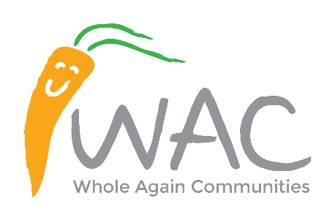
Form of Tender

TENDER FOR: Whole Again Communities,
The Treneere Community Space, Colinsey Road, Penzance, TR18 3NZ

Tender Document No. WAC012022

To: Whole Again Communities I/We .................................................................................. (Name of Tenderer) having read the Invitation to tender and Specification delivered to me/us and having examined the drawings referred to therein do hereby offer to execute and complete the whole of the works within 24 weeks from the date of possession for the Fixed Price of

Item | Cost
Prelims
Site Preparation
Contractor Cost Items (Management, Site accommodation, temporary services, hoarding, etc)
Substructure and Foundation Works
Timber Frame Construction and associated superstructure works to water tight stage
First Fix, Second Fix, & Decoration
Mechanical & Electrical inc platform lift
External Works
External Drainage
External Services (BT Open reach, WPD and SWW)
Soft Landscaping
Cost of consultancy fees
Building regulation fees
Overheads and Profit
Total Contract Sum (Excluding VAT)

I/We undertake in the event of your acceptance of any of the above offers to execute with you a form of contract embodying all the Conditions and terms of the offer.

Should my/our offer be accepted I/we intend to employ sub-Contractors whom I am/we are fully satisfied are technically proficient and able to carry out the works to the requirements of the programme and comply fully with the criteria which is as follows:-
(a) Compliance with relevant Health and Safety legislation and having a safety policy and practice similar to that which the Employer has approved of its own employees.
(b) Financially viable in relation to Building Industry norms and to the standards required by the Employer.
(c) Ability and experience in efficiently organising contracts to meet the time-scale requirements of the contract
(d) Ability and experience in producing work of high quality and to the standards set out by the Employer in its' contract documents.
(e) That the sub-contractor complies with all relevant equalities legislation including (but not limited to) the Equalities Act 2010

I/We further agree to make available to your officers such facilities and information as might be required by them to monitor by personal inspection the organisation performance and compliance with the criteria of the sub-Contractors listed above.

I/We agree that my/our offer shall remain open for a period of four months from the date for the receipt of tenders.

I/We agree that should obvious errors in pricing or errors in arithmetic be discovered before acceptance of this offer in the priced Specification submitted by me/us these errors be dealt with but contacting Whole Again Communities as soon as possible.

The essence of selective tendering is that the client shall receive ‘bona fide’ competitive tenders from all those tendering. In recognition of this principle, I/we certify that this is a ‘bona fide’ tender intended to be competitive, and that I/we have not fixed or adjusted the amount to the tender by or under or in accordance with any agreement with any other persons. I/we also certify that I/we have not done, and I/we undertake that I/we will not do at any time before the hour and date specified for the return of this tender, and of the following acts: -
(a) Communicating to a person other than the person calling for those tenders the amount or appropriate amount of the proposed tender, except where the disclosure, in confidence, of the approximate amount of the tender was necessary to obtain insurance premium quotations required for the preparation of the tender.
(b) Entering into any agreement or arrangement with any other person that he shall refrain from tendering or as to the amount of any tender to be submitted.
(c) Offering or paying or giving or agreeing to pay or give any sum of money or valuable consideration directly or indirectly to any person for doing or having done or causing or having caused to be done in relation to any other tender or proposed tender for the said work any act or thing of the sort described above.

Return Of Tender
As per the instructions in the Invitation to Tender Document “Whole Again Communities: document tender No. WAC012022”.

Name of Provider _______________________________________________________
Companies House Registration No. ________________________
Address of Provider: ________________________________________________________________________________________________________________________________________________________________________________________________________________________________________________________________________________________________________________________________________

Telephone No. ___________________________
Email Address: ______________________________________________

Name of person signing on behalf of the provider: _______________________________________
Signature of Provider*: ____________________________________________________
(Principle/Director/Partner/Company Secretary)

Name of person signing on behalf of the provider: _______________________________________
Signature of Provider*: ____________________________________________________
(Principle/Director/Partner/Company Secretary)

* Where the Provider is an incorporated association, the company secretary and a duly authorised director should sign. In the case of a partnership at least two duly authorised partners should sign.
NOTE: The Employer does not bind itself to accept the lowest or any other tender

