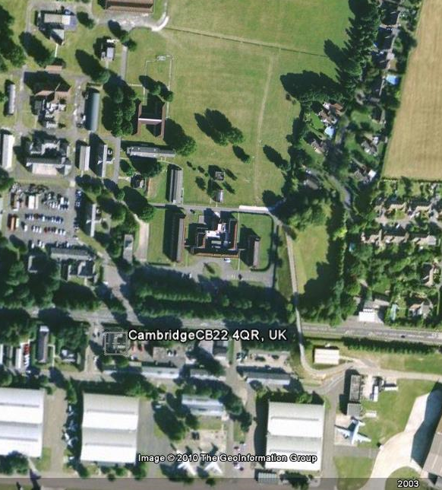
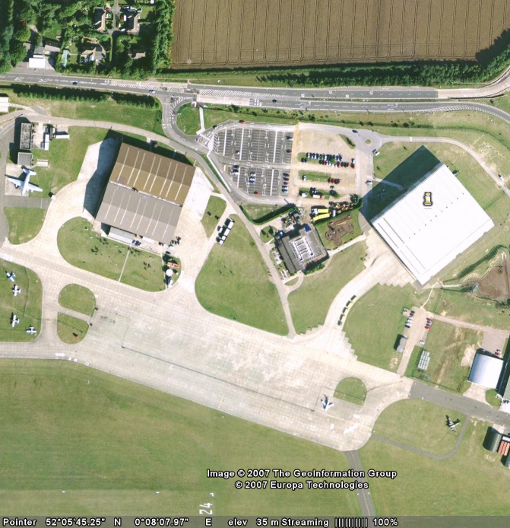
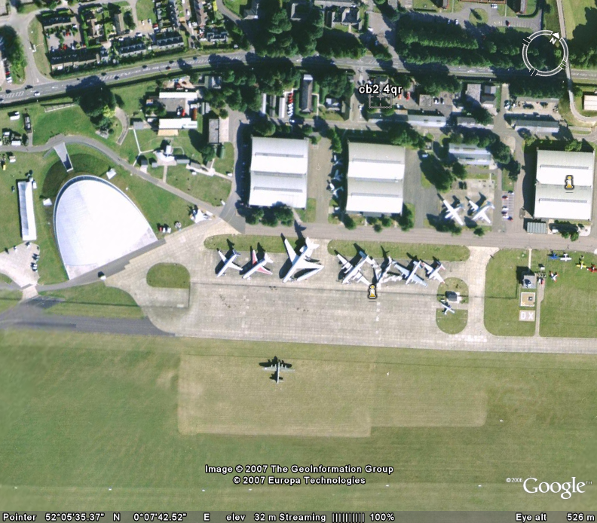
PA System Requirements
IWM Duxford 2016
Site plan as of 9th February 2016
Jetpan area
Additional PA system for north car park
North car park
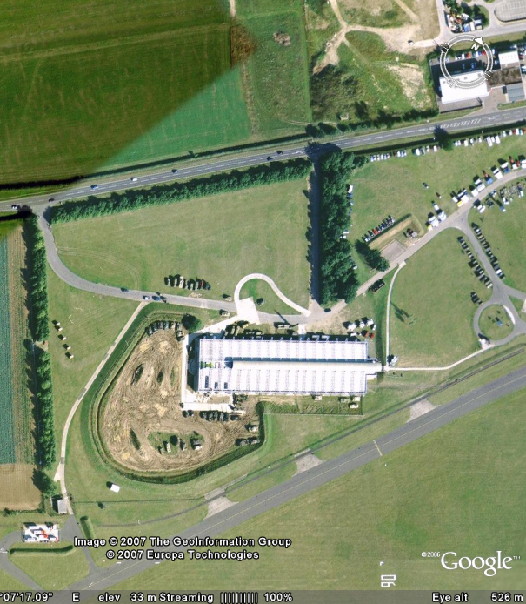
Duxford control room
Location of media marquee – small speaker required

Control tower
Pilots marquee area – stand alone PA required
Location of hospitality marquee – low level speakers required
Location of commentary box / PA feed
Airfield / runway
Additional 13amp power available here

Key
Line of speakers required (live side fence)

Low level speakers required for hospitality marquee (yellow dotted line)

