**Online Engagement Tool – Requirements Brief**

# Instructions to tenderers

## The East West Railway Company (EWR Co.) reserve the right to amend this Request for Quote (RFQ), and/or not to award a contract(s).

## Any canvassing may exclude tenderers from further consideration.

## Should you have any questions – please email them as soon as possible to [iain.puddephatt@eastwestrail.co.uk](mailto:iain.puddephatt@eastwestrail.co.uk)

## Other than those requested, no supporting material should be included – as this may exclude tenderers from further consideration.

## Any costs incurred by tenderers will not be reimbursable by EWR Co.

## Bids submitted must remain open for acceptance for 90 days.

## Bids submitted will become the property of EWR Co.

# Summary

As part of our goal to better engage with the public and our stakeholders, we at East West Railway Company (EWR Co) are looking for a supplier that is able to provide us with licenses for a dynamic online engagement tool, and provide support to build, integrate, launch and maintain it.

Currently, our engagement with stakeholders and the community is mainly through traditional channels (face-to-face, email, social media), with the majority of engagement taking place a few times a year when there are major milestones (a preferred route option is announced, a consultation on a route). We have a desire to change this and engage people throughout the entire lifecycle of our project – and as a lean team – see an online engagement tool as an effective, centralised way to do this.

While we are not overly prescriptive with the types of features the tool can provide (show us what good looks like!), it should be able to effectively integrate with our [website](http://www.eastwestrail.co.uk) (we want a consistent look and feel), it must be facilitate conversations and feedback through functions such as consultation surveys, forums and questionnaires, and it must be able to feed data and responses through to our CRM, Salesforce.

The appointed supplier would have a strong background in completing projects of this type and providing ongoing support. Additionally, the supplier should be experienced in project management and the application of various skills to achieve the contract objectives as detailed in the RFQ scope below.

# Timeline

|  |  |
| --- | --- |
| **Description** | **Date** |
| Request For Quote (RFQ) issued | 07/05/2020 |
| Supplier Clarification Period Ends | 14/05/2020 |
| RFQ Submission Date | 21/05/2020 |
| EWR Co bid clarification process completed | End-May 2020 |
| Release of Final Award/Regret of Letters | End-May 2020 |
| Scope and build tool | June 2020 |
| Launch tool | July 2020 |

# Background:

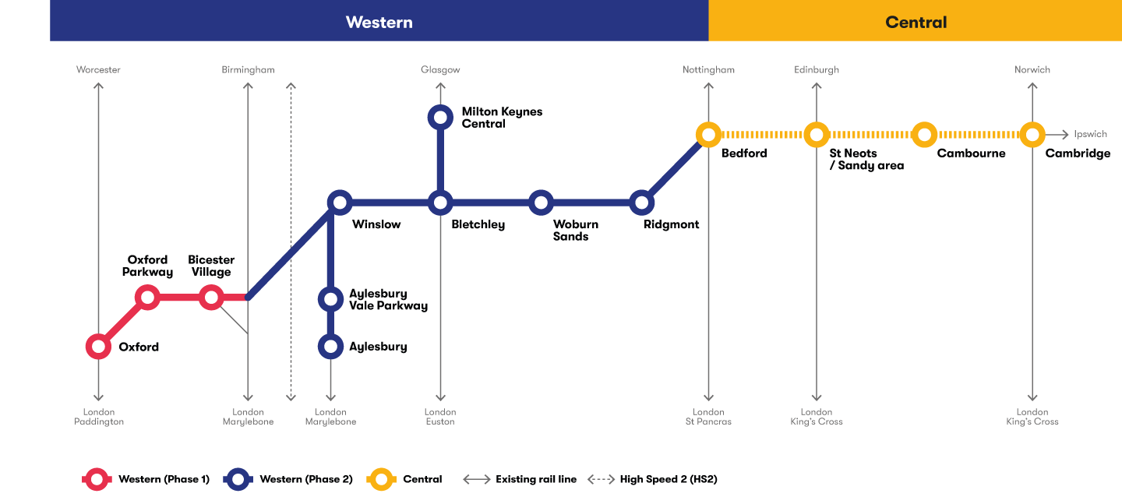

The vibrant mix of urban and rural communities between Oxford, Milton Keynes, Bedford and Cambridge blend beautiful landscapes and a rich cultural heritage with globally renowned centres of education, business, technology and an increasingly dynamic business scene.

It’s a fantastic place to live and work, but people are being let down by a lack of good transport links, limiting their ability to enjoy everything the area has to offer – from easy opportunities to commute between home and work, to days out with friends and family. Creating better transport will be critical in building opportunities for prosperity among local communities.

East West Rail is a proposed new rail link under development which would connect communities between Oxford, Milton Keynes, Bedford and Cambridge, creating new opportunities for people right across the area by:

* **Making it cheaper and quicker to get around the area** - connecting people to their jobs, homes and families, as well as businesses to their employees, suppliers and customers.
* **Supporting new housing to make it more affordable and help your money go further** - so people can afford to live and work in the area, and businesses can afford to create more jobs and increase productivity.

As well as improving quality of life for people locally, it would help the local economy by:

* **Making places more appealing for people wanting to start and grow businesses** - attracting and retaining the best talent in the region, while encouraging new investment to support the economy.
* **Spreading prosperity across the UK** - creating growth for towns and cities outside of London. The National Infrastructure Commission estimated that creating these transport links and supporting the area between Oxford and Cambridge was worth nearly £80bn extra each year for the British economy.

The project is split into multiple sections, with each section at different stages of delivery. The main focus for this tool will be for the section between Bedford and Cambridge, which is in its early stages of planning. We, the East West Railway Company (EWR Co), were created to develop this railway with customers and communities at its core. We are passionate about developing a railway which best serves people living and working between Oxford, Milton Keynes, Bedford and Cambridge. We also live by our values, and ask that our partners do the same, to ensure our identity is reflected through everything we do. Our five values and behaviours are shown below:

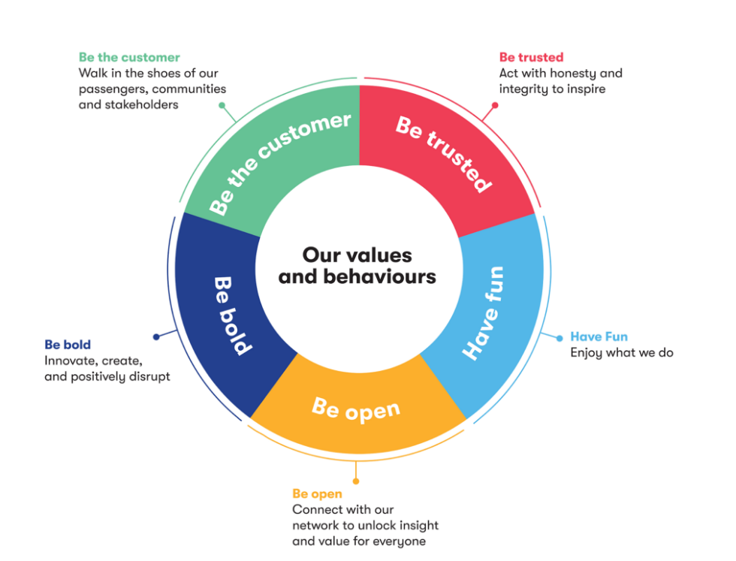

# Context & rationale:

At East West Railway Company, we’re set on doing things differently. And that’s not just for the sake of being different – we want to use our project to create real change in the infrastructure and rail industries, for the benefit of the public.

In the engagement space specifically, too many major projects only engage with communities at formal stages of consultation, with no mechanism for meaningful conversations in between. This results in a lack of intelligence and understanding on our side, and a lack of awareness and trust on theirs – which can ultimately lead to the downfall or delay of a project.

Over the coming months and years, we’ll be engaging heavily with the public and our stakeholders on a wide variety of topics as we progress closer to delivery. This includes route design, station design, and property acquisition, to name a few. Some of this will be informally, some of it will be through public forums and reference groups, and some of it will be through formal, structured consultations. Added to this, the future success of East West Rail is dependent on community support in order to secure a Development Consent Order (DCO) – which will allow us to build the project. Therefore, it is important for us to engage with, and build and maintain trust with our community across the entire lifespan of the project. We need to show people that we value their input and ideas, and that means engaging with our communities throughout the entire project lifecycle– not just during formal consultations.

Part of our challenge at East West Railway Company is that we’re a lean organisation. While we’d love to throw one hundred staff at our stakeholders and local communities, the reality is that we’ve been set up to remove bureaucratic red-tape, and that means we have a small external affairs team.

We therefore see an online engagement tool as a keyway to removing these barriers and achieving our objectives of better engaging with our stakeholders and the public. Some of the benefits we’d like to see realised from such a tool include:

* Communities will better understand the project and feel like their voices are being heard – leading to an increase in trust and project support
* Communities will have a single place to engage with East West Rail – regardless of the topic of conversation.
* East West Railway Company resources are better utilised – a shift towards online engagement means savings in time, travel, venue, collateral costs.
* With additional data and ways of engaging, community views can be better taken into account during the planning process and fed through to planning teams.
* East West Railway Company can better reach hard-to-reach members of the community who ordinarily do not engage with traditional methods of engagement.

Further, by procuring an online engagement tool this early in the project, this will set us apart from other major infrastructure projects, who from what we’ve seen, generally only launch similar tools much closer to delivery, to manage construction impacts. We therefore have an opportunity to show our boldness, and potentially lead the industry in community engagement. We want to partner with someone who shares this ambition and is excited about the opportunity to work with us.

If procured and onboarded at pace, this tool will also allow for us to engage effectively with our communities during the Covid-19 crisis, where traditional face-to-face engagement is no longer practical, and online video tools not always appropriate, particularly for general members of the public.

# Outputs & proposal:

## Required outputs:

We would like the supplier the deliver the following outputs:

**Systems, licenses and support:**

* An annual license to a public-facing, externally hosted online engagement tool, with at least 2t site/tool admins
* A dedicated Account Manager
* An ability to provide periodic face-to-face or online training
* Readily available troubleshooting support
* Access to more-in depth technical support, if more detailed integrations and enhancements are required.
* Access to an unlimited number of features within the tool (e.g. we want the ability to use the tool to its full extent, and not be limited by how many features we use at a single time – for example, we may want to run 3 concurrent consultations on 3 mini-projects, 2 general surveys, four private forums etc.).

**Functionality**

While we would like you to use your proposal to show us the possibilities your tool can provide, regardless of the tool or platform, we would expect at minimum it could deliver:

* User-friendly platform that looks and feels like our website (e.g. must not look like an external platform, must have our website navigation bar), and ability for us to maintain control over its content and appearance
* A variety of unique engagement functions and features, such as surveys, questionnaires, forums, issue mapping, news feeds.
* A public-facing interface which is a one-stop-shop ‘community hub’ for all-things East West Rail engagement (e.g. current consultations, previous consultations, current surveys, upcoming events, latest news etc.)
* An ability to lock a portion of sections of the tool to certain users (e.g. a forum which can only be accessed by Parish Councillors)
* Ability to integrate with our CRM, Salesforce (for example, if someone logs in and adds a comment, we want that to be recorded in our CRM so that we have a single view of our customers). While we recognise this may take some development work, we would not want to this to be overly onerous – so an ability to connect with an existing API would be beneficial.
* Ability to easily consume and display GIS data (e.g. if you have a mapping tool, we would want to add our preferred route option GIS layer to it).
* Detailed user analytics and reporting, which can be easily exported via .csv
* Compliance with relevant privacy, security and GDPR laws and regulations
* Seamless compatibility across mobile, tablet and desktop
* Easy-to-use content management system, so that information can easily be updated without external support

**Immediate requirements (launching the tool by end July 2020)**

* Help us define how best to use the tool and get the most out of it – helping us scope its initial build (e.g. what features are available, what will take to get them up and running)
* Work with us to build, skin and launch the tool (design its architecture, help integrate it with our website, skin its interface (with our design support) and test its functionality)
* Set up relevant analytics
* Provide training to EWR co on how to use the tool
* Work with EWR Co to integrate the tool with our CRM, Salesforce

## Form of Proposal

This RFQ is a one-stage process, divided into three sections.

**6.2.1 Written Submission** (40% points)

In line with section 7.1 of Appendix A (Evaluation Criteria), tenderers are requested to provide the following:

* An overview of your company, how you operate, and how you are compatible with our values and behaviours outlined in section 4.
* An overview of your tool and how it can meet our desired outputs outlined in section 6.
* An overview of your licensing and support structure
* Proposed methodology in relation to our immediate requirements, and ongoing support thereafter.

The total response document should be no greater than 10 pages in length, excluding appendices.

**6.2.2 Capability Questionnaire** (30%)

In line with section 7.2 of Appendix A, tenderers are requested to fill in a capability questionnaire (4 questions).

**6.2.3 Commercials** (30% Points)

In line with section 7.3 of Appendix A, tenderers are requested to complete a proposed pricing spreadsheet, detailing what tools and services you could provide in response to our requirements (set out in section 6.1).

**6.2.4** **Compliance to Appendix D - Draft Contract** (Pass/Fail)

Compliance to the terms of the draft contract Appendix D

# Appendix A – Evaluation Criteria

## Written Submission

The total response document should be no greater than 10 pages in length, excluding appendices.

|  |  |  |
| --- | --- | --- |
| **Written Proposal – 50 Points Available** | | |
| **Criteria** | **Description** | **Points Available** |
| **Company overview** | In no more than 500 words, please provide an overview of:   1. your Company – including ownership and structure 2. how you operate, 3. how you are compatible with both our values and behaviours, provided in the background section of this document. | 5 |
| **Tool overview** | Please demonstrate in detail the various features, benefits and functionality of your engagement tool, using relevant case studies as appropriate to demonstrate its functionality.  We’re interested to know what you can realistically deliver for us, so please clearly frame this in the context of the following three areas:   * The required outputs in section 6.1 * The proposed scope in section 8.1 * The project budget in section 8.1. * The tenderer must ensure that all three areas are clearly shown within their submission. Points will be lost if any of the elements are not included. | 20 |
| **Licensing and support structure** | With regard to the outputs (6.1), scope (8.1) and budget (8.1), please provide an overview of your licensing and support structure for each of the three areas.  In particular, we’re interested to know how you issue licenses, how you provide day-to-day support, and how you provide further development/integration support.  Along with providing your detailed overview, consider including flowcharts and diagrams. | 5 |
| **Proposed methodology in relation to output development** | With a minimum 500 words, tell us how you’ll help us set up, skin, integrate and deliver the tool (launching it before 31 July 2020), and then provide us with ongoing support.  In addition, tenderers should include a project timeline with key dates clearly displayed. | 10 |

**Quality Criteria Scoring Methodology:**

The scores for the quality element of Written Proposals and the entirety of the Presentation will be allocated in line with the following marking methodology:

|  |  |
| --- | --- |
| **Mark** | **Comment** |
| 20% | Failed to provide confidence that the proposal will meet the requirements.  An unacceptable response with serious reservations. |
| 40% | A poor response with reservations.  The response lacks convincing detail with risk that the proposal will not be successful in meeting all the requirements. |
| 60% | Meets the requirements – the response generally meets the requirements but lacks sufficient detail to warrant a higher mark. |
| 80% | A good response that meets the requirements with good supporting evidence.  Demonstrates good understanding. |
| 100% | An excellent comprehensive response that meets the requirements.  Indicates an excellent response with detailed supporting evidence and no weaknesses resulting in a high level of confidence. |

## Capability questionnaire

Tenderers are requested to fill in the below capability questionnaire. All responses should be supported with a maximum of 2 examples as evidence (screenshot, link to a live tool etc.), and **should not exceed 200 words per question**.

|  |  |  |
| --- | --- | --- |
| **Questionnaire – 20 Points Available** | | |
| **Criteria** | **Description** | **Points Available** |
| Responses to questionnaire | Please provide responses to the questions below. | **20** |

### Questionnaire

1. Can your tool meet all of the required outputs noted in section 6.1, either out of the box or with relatively minimal development work (excluding Salesforce integration)?
   1. If yes, please provide up to 2 examples of a similar service/scope of work you’ve delivered.
   2. If no, please state which outputs you’re unable to deliver, and provide up to 2 examples of the closest service/scope of work you’ve delivered.
2. It is essential that this tool can be embedded within the East West Rail website, or at the very least, be hosted externally but look and feel very much like it is part of the East West Rail website (similar URL structure, similar navigation bar, strong branding, ability to easily navigate between this tool and our website). Can your tool do this, and if so, please provide up to 2 live examples.
3. It is also essential that this tool can connect with our CRM, Salesforce – so that we have all of our customer and stakeholder data in a single place. Have you integrated your tool with CRMs in the past, and if so, tell us how you’ve done this providing a minimum of two examples.
4. As our project progresses closer to delivery, we are providing the public and stakeholders with increasingly more detailed maps about our preferred route option and seeking feedback. What sort of engaging mapping functions does your tool provide, and how could we use this to increase engagement? Please provide up to 2 live examples.
5. This tool will be as much for the public as it will be for certain stakeholder groups. Does your tool have the ability to restrict access to certain features for certain groups (e.g. dedicated forums, dedicated questionnaires)? If so, please provide up to 2 live examples.

**Quality Criteria Scoring Methodology:**

The scores for the quality element of Written Proposals and the entirety of the Presentation will be allocated in line with the following marking methodology:

|  |  |
| --- | --- |
| **Mark** | **Comment** |
| 20% | Failed to provide confidence that the proposal will meet the requirements.  An unacceptable response with serious reservations. |
| 40% | A poor response with reservations.  The response lacks convincing detail with risk that the proposal will not be successful in meeting all the requirements. |
| 60% | Meets the requirements – the response generally meets the requirements but lacks sufficient detail to warrant a higher mark. |
| 80% | A good response that meets the requirements with good supporting evidence.  Demonstrates good understanding. |
| 100% | An excellent comprehensive response that meets the requirements.  Indicates an excellent response with detailed supporting evidence and no weaknesses resulting in a high level of confidence. |

## Commercials

Tenderers are requested to complete the below pricing spreadsheet, detailing what tools and services you could provide in response to our requirements (set out in section 6.1) and scope (set out in section 8.1).

Please also be cognisant of our budget, which has an upper ceiling of £40,000, including development work.

**Notes:**

* The below spreadsheet has been broken into three sections:
  + **Core offering:** what can you give us out of the box (number of licenses, type of hosting, account management, general support, training etc.)
  + **Additional services**: some of our required outputs may be in addition to what you provide out of the box, such as skinning. Please list these elements here, and their associated costs.
  + **Technical support day rate**: we will need your support with integrating Salesforce, our CRM, with your tool. As we do not yet know the scope of this, we would like to know what your technical support day rate is.

|  |  |  |
| --- | --- | --- |
| **Commercial – 30 Points Available** | | |
| **Criteria** | **Description** | **Points Available** |
| Core offering & additional services | Please state how much it would cost to deliver the requirements set out in section 6.1. Items which you are unable to deliver should be explicitly noted in question 1 of the capability questionnaire. | **25** |
| Technical support | Please identify how much it would cost to access your technical support staff, to assist with integrations/new features etc. | **5** |

**Appendix E - Commercial Assessment:**

Tenderers are to complete Appendix E.

The pricing offered by tenderers attracts up to 30% of the total points available.

The best (lowest) price receives the maximum score available in this section: the remaining bids will receive a score pro rata to the best price using the following calculation:

Lowest bid = maximum points of 50%

Lowest Bid x 50% (maximum points available)

Tenderers Bid

# Appendix B: Scope

## Scope

The anticipated contract term is 12 months. The contract will be awarded in May 2020, with an expectation that the tool is launched before the end of July 2020. The initial term is set to expire in May 2021, and EWR Co retaining the option to extend the contract term subject to three months’ written notice being provided to the supplier.

The estimated contract value range is £40,000. This includes both the licensing of the tool, and any ongoing troubleshooting and technical support.

The supplier will work predominantly with the EWR Co External Affairs team to help scope and deliver the tool. The supplier will also work with our technical support partners where integrations with other tools and systems are required (e.g. Our CRM support partner, our website support partner, our creative design support partner).

We would like to launch the tool before the end of July 2020, and envisage that this project will comprise of three phases:

**Discovery/scoping (2 weeks)**

Forming part of the discovery phase, the supplier will meet with our team to learn about our goals and objectives, and work with us to determine the appropriate modules and features we should use, and a suitable a path to delivery. Specifically, we would expect then that at the conclusion of this phase, the supplier will have provided us with:

* Detailed overview of the tool
* Suggestions about what functions within the tool can be used to meet our immediate goals and objectives
* Advice on how best to integrate the tool with our website and skin it appropriately
* Advice about what is required to integrate the tool with our CRM, Salesforce
* Logins to the tool

**Build & launch (1 month)**

Following the discovery phase, we expect the supplier to provide the following:

* Support with skinning the tool
* Support with building out the various features of the tool
* Support with integrating the tool with our CRM, Salesforce
* Support with launching the tool
* Training sessions

**Ongoing support**

Once the tool is launched, we would then look to the supplier to provide ad-hoc ongoing support where required. This may include:

* Additional training sessions for new staff
* Support with setting up new functions within the tool
* Support with integrating the tool with additional business tools

## Commissioning Services

## If we seek to commission services from the supplier above and beyond the initial launch and day-to-day support, we will submit a completed task order to the supplier.

## Following receipt of a task order from the customer, the supplier shall provide us with a proposal detailing the following:

* Their proposed approach to delivering the work order outputs
* A project plan
* The resources they nominate to undertake this project
* Any dependencies/risks
* The impacts (if any) on any other services currently being delivered under this contract
* The cost (excl.VAT) of delivering the requirements of the work order in full

## Location

We currently operate from a single office location at 4th Floor, Albany House, 94-98 Petty France, London, SW1H 9EA, however all staff are working remotely due to Covid-19. We are likely to be moving to Milton Keynes sometime between July-September 2020, Covid-19 implications pending.

It is not a requirement for staff of the appointed supplier to be located within EWR Co offices during this contract. However, it is expected that during the weeks immediately following the commencement of the contract, this will require numerous video conference-style meetings.

## Systems

The supplier will be required to provide EWR Co with direct access to their chosen tool, likely via logins to a Content Management System. At least 2-4 licenses should be made available, and East West Railway Company should control the ability to easily publish and remove content, as required.

Significant or notable changes to this system should be flagged at least four weeks in advance with EWR Co, and it must have a robust uptime (99.95% or similar), to ensure the tool is available at all times during statutory consultations.

# Appendix C: Management and Contract Administration

## Key Personnel

On a day-to-day basis, the supplier’s key customer contact will be an EWR Co External Affairs Executive, and they will be the individual who provides the supplier with instructions and whose formal approval is required for any payment of any sums due. The supplier will be required to nominate an individual to be its primary representative for the contract and provide day-to-day account management of these services. The supplier’s account manager will be classed as key personnel for the purposes of the contract, any removal or replacement of key personnel will require prior approval from EWR Co.

## Management Information

Prior to the launch of the tool in July 2020, the supplier’s account manager will be required to participate in weekly calls with the EWR executive and may also be requested to join ad-hoc meetings with EWR Co’s wider supply chain, where systems integrations are required.

The successful supplier will be provided with a purchase order within fourteen days of the contract award date. Invoices are to be submitted in arrears on the last working day of the month, commencing one month from the contract commencement date. All invoices are to reference the PO number and the activities to which the invoice amount relates.

The Government Prompt Payment Policy is a government commitment to pay 90% of undisputed and valid invoices from SMEs within 5 days and 100% of all undisputed and valid invoices to be paid within 30 days.

The commitment to 30-day payment terms must also be present within all sub-contracts. EWR Co is required to report their performance against these payment targets on a quarterly basis, therefore the appointed supplier may be required to provide information pertaining to its payment practices at various points in time.

In order to maintain the privity of the contractual relationship between EWR Co and the appointed supplier, all subcontracts should compel the parties to garner EWR Co’s express approval should they wish to make any announcements pertaining to the services.

## Security

All tenderers will need to be in possession of the following certifications and accreditations in order to be considered for the delivery of these services:

* Cyber Essentials Plus
* ISO 27001

If a tenderer is not in possession of one or more of the above, they will need to, as part of the pre-qualification process, demonstrate the way in which they will ensure the security of information and assets in delivering the services. Moreover, each tenderer will need to make a formal commitment to achieving all the required certifications and accreditations within a defined period, subsequent to award of the contract.

All staff whom are engaged in delivery of the services, at any tier of the supply chain, must be subject to pre-employment checks that meet the Baseline Personnel Security Standard (BPSS).[1]

## Data Protection

The supplier will be required to comply with all applicable requirements of the Data Protection Legislation (including the General Data Protection Regulation ((EU) 2016/679) (“GDPR”), the Law Enforcement Directive (Directive (EU) 2016/680), and all applicable Law about the processing of personal data and privacy). The Supplier will ensure that Personal Data is not transferred to a country outside of the EEA unless it can prove, to the satisfaction of EWR Co, that appropriate safeguards will be in place. This will be a requirement of the pre-qualification process for this procurement and suppliers whom cannot ensure adequate safeguards for Personal Data will be excluded from this competition.

The EWR Co IT Data Policy will be provided to the successful tenderer subsequent to the award of the contract. Detailed instructions for the processing of personal data will be agreed between the successful tenderer and EWR Co upon award of the contract.

## Documentation

All documentation must be produced in line with the EWR Co brand guidelines; these will be provided to the supplier upon the commencement of the contract. To ensure that EWR Co teams are able access and make any necessary amendments to documentation which is produced, all documentation must be produced or converted to the format specified by EWR Co.

## Arrangement for End of Contract

During any re-procurement process, the supplier shall fully cooperate with EWR Co to ensure a fair and transparent re-tendering process for this contract. This may require the supplier to demonstrate separation between teams occupied on the existing contract and those involved in tendering for the replacement contract to prevent actual (or perceived) conflicts of interest arising.

In the event that the services are to be transferred to a new supplier or EWR Co itself, the supplier will be required to do the following, at no extra cost to the customer:

* Act in good faith to support the transfer of the services to the new provider in an orderly fashion, without any detriment to the customer.
* Hand over all deliverables, including any background information which is necessary to fully understand or operate these documents, to the new service provider.
* Provide an irrevocable, royalty-free, licence for the new provider to utilise any background intellectual property rights which are necessary

1.