Bid Pack For Open Market Competition
This procurement event will be conducted in accordance with the Public Contract Regulations 2015, specifically Chapter 8, Below Threshold Procurements.
Attachment 2 – How To Bid Including Evaluation Criteria

Contract Reference: CCZP19A07 – The Provision of National Leadership Centre Programme – Module 3

Contents

1. How To Make Your Bid 3
2. How The Questionnaires Are Structured: 4
3. Award Criteria 11
4. Marking Scheme 13
5. Technical Evaluation 14
6. Commercial Evaluation 15
7. Final Decision to Award 17
8. Further Information 18

How To Make Your Bid

Your bid must be made by the organisation that will be responsible for providing the deliverables if your bid is successful.

The requirement is not lotted but work will be split, with the work to be allocated to the top three suppliers within 10% of the first placed supplier. Module 3 will be delivered three times, once by each of the top three suppliers. In the event that there are only two winning suppliers the 1st placed bidder will deliver Module 3 twice. If only one supplier wins the competition they will deliver all three courses.

There is a fixed budget of £150,000 Ex- Vat for this requirement. In the event that there is more than one successful supplier and the costs are higher than £150,000 Ex-Vat, only one supplier will be awarded the contract for all three deliveries of Module 3.

Remember to:

Accept or Decline this Bid Pack. If you Decline please provide a reason for doing so.

Enter your bid into the e-Sourcing Suite. We can only accept bids that we receive through the e-Sourcing Suite.

Make sure you answer every question.

Each question must be answered in its own right. You must not answer any of the questions by cross referencing other questions or other materials e.g. reports located on your website.

Submit your bid in good time and before the bid submission deadline.

Upload ONLY those attachments we have asked for in line with the requirements specified – any other supporting evidence, certificates for example, will be requested separately by us.

If we do not require attachments and have specified this please only use the Text Boxes provided for your answer.

Check for messages in the e-Sourcing Suite throughout the competition.

Press the Submit all Draft Bids button when your bid is ready, otherwise we will not be able to see it.

If you are unsure, ask questions before the Clarification Questions Deadline.

How The Questionnaires Are Structured:

A summary of all the questions in the quality questionnaire, along with the marking scheme, and weightings for each question is set out below:

QUESTIONNAIRE 1 – QUALIFICATION - KEY PARTICIPATION REQUIREMENTS

QUESTIONNAIRE 2 – QUALIFICATION - CONFLICTS OF INTEREST

QUESTIONNAIRE 3 – QUALIFICATION - INFORMATION ONLY

QUESTIONNAIRE 4 - TECHNICAL - PROJECT SPECIFIC EXPERIENCE AND PROJECT RESOURCES

QUESTIONNAIRE 5 - TECHNICAL - METHODOLOGICAL EXPERTISE AND APPROACH

QUESTIONNAIRE 6 - COMMERCIAL EVALUATION

QUESTIONNAIRE 7 – TECHNICAL EVALUATION (STAGE 2) – PRESENTATION
QUESTIONNAIRE 1 – QUALIFICATION - KEY PARTICIPATION REQUIREMENTS

Response Guidance

The following questions are ‘Pass/Fail’ questions. If Potential Bidders are unwilling or unable to answer “Yes”, their submission will be deemed non-compliant and shall be rejected. Potential Bidders should confirm their answer by selecting the appropriate option from the drop down menu.

Question Number | Question |  | Your Response
1.1 | Do you accept the competition rules as described in Attachment 1 – About the Procurement? | Yes/No
1.2 | Have you read, understood and accepted the Bid Pack and all associated attachments, specifically Attachment 3 - Statement of Requirements? | Yes/No
1.3 | Do you agree, without caveats or limitations, that in the event that you are successful Attachment 5 - Terms and Conditions will govern the provision of this contract? | Yes/No
1.4 | Do you confirm your Organisation’s e-Sourcing suite profile is complete and accurate at the time the bid closed and that any amendments made following acceptance of this event will be notified to the buyer in writing? | Yes/No
1.5 | Please confirm that you understand that CCS reserve the right to use a credit reference agency to obtain a financial risk score for you and any members of your consortium or any nominated guarantor(s)? | Yes/No
1.6 | Do you agree without caveat or limitations that you will provide upon request any relevant Insurance or Accreditation certificates? | Yes/No

QUESTIONNAIRE 2 – QUALIFICATION - CONFLICTS OF INTEREST

Response Guidance

Question 2.1 is a ‘Yes/No’ question and will dictate whether or not question 2.2 needs to be answered.

Question 2.2 is a Pass / Fail question. Potential Bidders are required to provide details of how the identified conflict will be mitigated. The Contracting Authority will review the mitigation in line with the perceived conflict of interest, to determine what level of risk this poses to them.

Therefore, if Potential Bidders cannot or are unwilling to suitably demonstrate that they have suitable safeguards to mitigate any risk then their Bid will be deemed non-compliant and will be rejected.
Question Number | Question | Your Response
2.1 | Please confirm whether you have any potential, actual or perceived conflicts of interest that may by relevant to this requirement. |  | Yes/No
2.2 | We require that any potential, actual or perceived conflicts of interest in respect of this Bid Pack are identified in writing and that companies outline what safeguards would be put in place to mitigate the risk of actual or perceived conflicts arising during the delivery of these services. |  | Text Box

QUESTIONNAIRE 3 – QUALIFICATION - INFORMATION ONLY

Response Guidance

The following questions are for information only and do not form part of the evaluation. Information provided in response to these questions may be used in preparation of any Contract Award and any omissions may delay completion of this procurement exercise.
Question Number | Question | Your Response
3.1 | What are your details:  - Name (registered name if registered)  - Office address (registered address if registered)  - Website address (if applicable)  - Date of registration (if applicable) or date of formation  - Registration number (company, partnership, charity etc.) if applicable  - DUNS number (of head office, if applicable)  - VAT number | Text Box
3.2 | What is your trading status:  - Public limited company  - Limited company  - Limited liability partnership  - Other partnership  - Sole trader  - Third sector  Other | Text Box
3.3 | Are you a Small, Medium or Micro Enterprise (SME)?  See the definition of SME | Text Box
3.4 | Please provide details of where the Award Outcome should be directed. Your response must include their;  - Full Name  - Role/Title  - Registered Address  - Email Address | Text Box
3.5 | Please provide details of any sub-contractors you propose to use in order to meet your obligations should you be awarded a Contract. Your response must include their;  - Trading Name(s)  - Registered Address(es) and contact details  - Goods/Services to be provided | Text Box

QUESTIONNAIRE 4 - TECHNICAL - PROJECT SPECIFIC EXPERIENCE AND PROJECT RESOURCES WEIGHTING 15%

Response Guidance
Potential Bidders MUST answer ALL the following questions. The method of response, page limit on attachments and evaluation criteria is set per question.

Unless otherwise specified, response must be uploaded as Attachments.

Attachments may be submitted in Microsoft Word, Excel. PDF format and must be in Arial font size 11. The total page limit for questions 4, 5 and 6 is 25 sides of A4. Page limits include the use of headers footers and diagrams. Upload ONLY those attachments we have asked for – any other supporting evidence, certificates for example, will be requested separately by us.

Please upload one attachment on the e-Sourcing portal at Question 4.1
No costings should be included in responses to this Questionnaire.
Question Number | Question | Your Response | Minimum Acceptable Score | Maximum Available Score | Weighting
4.1 | Please outline your proposed project team that will be used to deliver the requirement detailed in Attachment 3 (Statement of Requirements). The key detail required for each individual is:  - Name.  - Role.  - Summary of relevant qualifications/experience/ expertise/knowledge.  - Demonstrable experience of working with CEOs (and equivalent) in the public or private sector to deliver high quality training on leadership and futures. | Attachment | 66 | 100 | 100%

QUESTIONNAIRE 5 - TECHNICAL - METHODOLOGICAL EXPERTISE AND APPROACH
WEIGHTING 35%
Response Guidance
Potential Bidders MUST answer ALL the following questions. The method of response, page limit on attachments and evaluation criteria is set per question.

Unless otherwise specified, response must be uploaded as Attachments.
Attachments may be submitted in Microsoft Word, Excel. PDF format and must be in Arial font size 11. The total page limit for questions 4, 5 and 6 is 25 sides of A4. Page limits include the use of headers footers and diagrams. Upload ONLY those attachments we have asked for – any other supporting evidence, certificates for example, will be requested separately by us

Please upload one attachment on the e-Sourcing portal at Question 4.1.
No costings should be included in responses to this Questionnaire.
Question Number | Question | Your Response | Minimum Acceptable Score | Maximum Available Score | Weighting
5.1 | Please outline your proposal for the design and delivery of Module 3, clearly demonstrating how you will address all of the objectives and requirements outlined in the Statement of Requirements (Attachment 3), including but not limited to:  - Providing delegates with a tangible understanding of the challenges and opportunities for public services over the next 5-10 years, through practical and experiential learning.  - Embedding the concepts of systems leadership, and the key NLC behaviours, throughout.  - Ensuring the delegates leave with ambitious and tangible actions at an individual, organisational and collective level which will support them in delivering better public services through systems leadership now and in the future.  - Proposed plans for evaluating the design and delivery of each Cohort (up to three) and the overall project (if delivering more than one cohort).  If possible, you should include details of your past experience of working on Public Sector projects at this level. | Attachment | 66 | 100 | 70
5.2 | Please outline how you will meet the quality standards and values associated with the NLC at all times, noting the prestige of our programme and seniority of our delegates. | Attachment | 66 | 100 | 30

QUESTIONNAIRE 6 - TECHNICAL - PROJECT MANAGEMENT
WEIGHTING 15%
Response Guidance
Potential Bidders MUST answer ALL the following questions. The method of response, page limit on attachments and evaluation criteria is set per question.

Unless otherwise specified, response must be uploaded as Attachments.

Attachments may be submitted in Microsoft Word, Excel. PDF format and must be in Arial font size 11. The total page limit for questions 4, 5 and 6 is 25 sides of A4. Page limits include the use of headers footers and diagrams. Upload ONLY those attachments we have asked for – any other supporting evidence, certificates for example, will be requested separately by us

Please upload one attachment on the e-Sourcing portal at Question 4.1.
No costings should be included in responses to this Questionnaire.
Question Number | Question | Your Response | Minimum Acceptable Score | Maximum Available Score | Weighting
6.1 | Please explain how your organisation will manage the time, cost and quality of this project to ensure effective delivery of the requirement and objectives outlined in the Attachment 3– Statement of Requirements.  Also include:  - An outline of how you will ensure your product is delivered to time, on budget and high quality.  - Your understanding of potential risks to time, cost and quality, and how you plan to manage these risks. (This could include a risk management plan). | Attachment | 66 | 100 | 100%

QUESTIONNAIRE 7 – COMMERCIAL WEIGHTING 25%
Response Guidance

Potential Bidders must enter costs by uploading the relevant Attachment 4 - Price Schedule at the question level on the e-Sourcing event.

Prices should be submitted in pounds Sterling inclusive of any expenses but exclusive of VAT.

Potential Bidders will be scored in accordance with the marking scheme at Section 2.
Question Number | Question | Your Response | Weighting
7.1 | Please confirm, by selecting ‘YES’ that you have attached a completed Price Schedule to the response to this question. In so doing, you are also confirming that prices offered are inclusive of any expenses, exclusive of VAT and firm for the period following the Deadline for Submission as stated in the Attachment 1 - Bid Pack. | Attachment | Max Score – 100

QUESTIONNAIRE 8 - TECHNICAL (STAGE 2) - Presentation
WEIGHTING 10%

Response Guidance
Potential Bidders MUST answer ALL the following questions.

No costings should be included in responses to this Questionnaire.

Question Number | Question | Your Response | Minimum Acceptable Score | Maximum Available Score | Weighting
8.1 | Please provide detailed insight into what you plan to deliver and how you will ensure it is experiential, at the appropriate level for the delegates (CEO and equivalent) and meets the prestige and values of the National Leadership Centre.  Attendees must not exceed 4.  Names and contact details of attendees must be provided. | Presentation | 66 | 100 | 65%
8.2 | Please provide information/detail on the resources you plan to utilise. Potential providers should include a timeline.  Attachments should not exceed 3. | Attachment | 66 | 100 | 35%

Award Criteria

The award stage consists of a technical evaluation and a commercial evaluation.

The award of the resultant contract will be on the basis of the ‘Most Economically Advantageous Tender’ (MEAT).

The weighting for the technical evaluation is 75%; and, the commercial evaluation is 25%.

Award process - What you need to do

Answer the questions in section 2 above in the e-Sourcing suite.

Complete the Attachment 4 – Price Schedule.

You must upload your completed Price Schedule into the e-Sourcing suite at questionnaire 7.

What we will do
Compliance Check
First, we will complete a mandatory evaluation to make sure that you have answered all questions and have completed the Attachment 4 - Price Schedule in line with our instructions. All bids passing the mandatory evaluation will be progressed to the technical Evaluation.
Technical Evaluation
We will give your responses to the TECHNICAL questionnaires to the Contracting Authority’s evaluation panel. Each evaluator will independently assess your responses to the technical questions using the response guidance and the evaluation criteria.
They will give a score and a reason for their score for each question they are assessing. The evaluators will enter the scores and reasons into the e-Sourcing suite.
If the evaluation panel wishes to clarify any areas of your bid, bid clarification questions will be issued via the e-Sourcing suite on an individual basis.
Consensus
Once the evaluators have independently assessed your answers to the questions we will arrange for the evaluators to meet. We will facilitate the discussion.
At this meeting, the evaluators will discuss the technical responses and review their scores and reasons for that score. The discussion will continue until they reach a consensus regarding the score, and reason for that score, for each question.
These final scores will be used to calculate your technical score.
If the evaluation panel wishes to clarify any areas of your bid, bid clarification questions will be issued via the e-sourcing suite on an individual basis.
Technical Threshold
If you have not met the minimum acceptable score for each question, you will be excluded from the competition. We will tell you that you have been excluded from the procurement and why at award stage. If this is a 2 Stage Evaluation, we will advise you at the point in which Stage 2 invitations are sent.
Evaluate Commercial
We will then evaluate your price and calculate your price score using the evaluation criteria specified.
If we wish clarify any areas of your bid, bid clarification questions will be issued via the e-Sourcing suite on an individual basis.
Final Score
Your technical score will be added to your commercial score, to create your final score.
2 Stage Evaluation
This procurement is being run in 2 stages.
Your final score up to this point will be the final score for Stage 1 of the procurement and will be used as a gateway to Stage 2 of the procurement.
Bidders who are within 10% (this percentage does not exceed the total weighting of Stage 2) of the first ranked Bidder at Stage 1 will be invited to Stage 2 of the procurement.
Stage 2 will be in the form of a Presentation and Written Submission
The Stage 2 Questionnaire and Evaluation Criteria are set out above at Questionnaire 8.
The evaluation process for Stage 2 will be conducted in line with the points outlined above.
The scores from Stage 2 evaluation will be added to the final scores from Stage 1. This will be the final score and the bids will be ranked accordingly.
Award
Awards will be made to the successful bidders, subject to contract.
We will notify successful and unsuccessful bidders providing feedback.

Marking Scheme

The evaluation criteria set out below will be used during the Technical Evaluation:

Marking Scheme | Description
100 - Good | The response fully meets all requirements with detail provided minimising risks to delivery.  The response is comprehensive and unambiguous, demonstrating a thorough understanding of the requirements and provides details of how the requirement will be met in full without additional support from the Contracting Authority, other than that outlined within the Statement of Requirements.
66 – Acceptable – Minor Concerns | The response is acceptable and meets all the basic requirements. However, the response, is not sufficiently detailed to minimise risk and/or the proposed approach may require additional support (in addition to that outlined in the Statement of Requirements) from the Contracting Authority to meet its deliverables.
33 – Non Acceptable - Major Concerns | The response has met some, but not all elements of the requirement, which poses risk that the proposal will not meet the deliverables required.  The response does not demonstrate a full understanding of the requirement posing major concerns.
0 - Unsuitable | The response does not meet any of the requirements or no response has been provided. An unacceptable and/or non-compliant response with serious reservations, demonstrating no understanding of the requirement.

Technical Evaluation

Questionnaires Q1 and Q2 are mandatory question(s) and will be evaluated PASS / FAIL. If you fail any of these questions, you will be excluded from the competition. We will tell you that your bid has been excluded.

When the consensus meeting has taken place and the final score for each question has been agreed by the evaluators, your final score for each question will be multiplied by that question’s weighting to calculate your weighted score for that question.

Each weighted score for each question will then be added together to calculate your technical score.

Please see table A below for an example of how your technical score will be calculated.
Table A – EXAMPLE ONLY
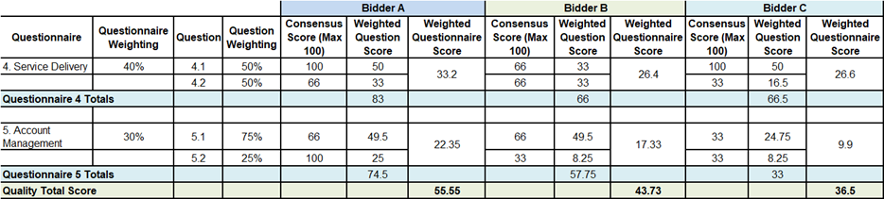

Commercial Evaluation

This section contains information on how to complete Attachment 4 - Price Schedule and the commercial evaluation process.

How to complete your Attachment 4 – Price Schedule

Read and understand the instructions in the Attachment 4 - Price Schedule, and in this section before submitting your prices.

Your prices should compare with the technical of your offer.

Your prices must be sustainable and inclusive of all costs for example your operating costs and profit.

Your prices are to exclude VAT.

Pricing is to be inclusive of expenses.

The currency is British pounds sterling, up to two decimal places.

The percentages submitted shall be up to two decimal places.

Pricing will be based on:

A call off cost for fixed tasks

Zero bids will not be allowed.

We will investigate where we consider your bid to be abnormally low.

The prices submitted shall not exceed the overarching commercial agreement rates.

You must download and complete the Attachment 4 – Price Schedule you are submitting a bid for. Further detail may be provided within the Attachment 4 – Price Schedule.

When you have completed your Attachment 4 - Price Schedule, you must upload this into the e-Sourcing Suite at question Q7. If you do not upload your Attachment 4 – Price Schedule your bid may be rejected from this competition.

Do not alter, amend or change the format or layout of the Attachment 4 – Price Schedule.

Commercial Evaluation Process

This is how we will evaluate your pricing:

We will check you have completed the Attachment 4 – Price Schedule as instructed.

Failure to complete the Attachment 4 - Price Schedule as instructed may result in your bid being deemed non-compliant and it may be rejected from this competition.

The commercial evaluation will be undertaken separately to the technical evaluation process.

The Potential Bidder with the lowest total price for each pricing table will be awarded the maximum score available for that pricing table.

All other Potential Bidders will get a price score relative to the lowest total price.

The calculation we will use to evaluate your total price per element, you are bidding for, is as follows:
Price Score = Lowest total price * maximum score available Potential Bidder’s total price

Please see table B below for an example of how your Price score will be calculated.
Table B – EXAMPLE ONLY
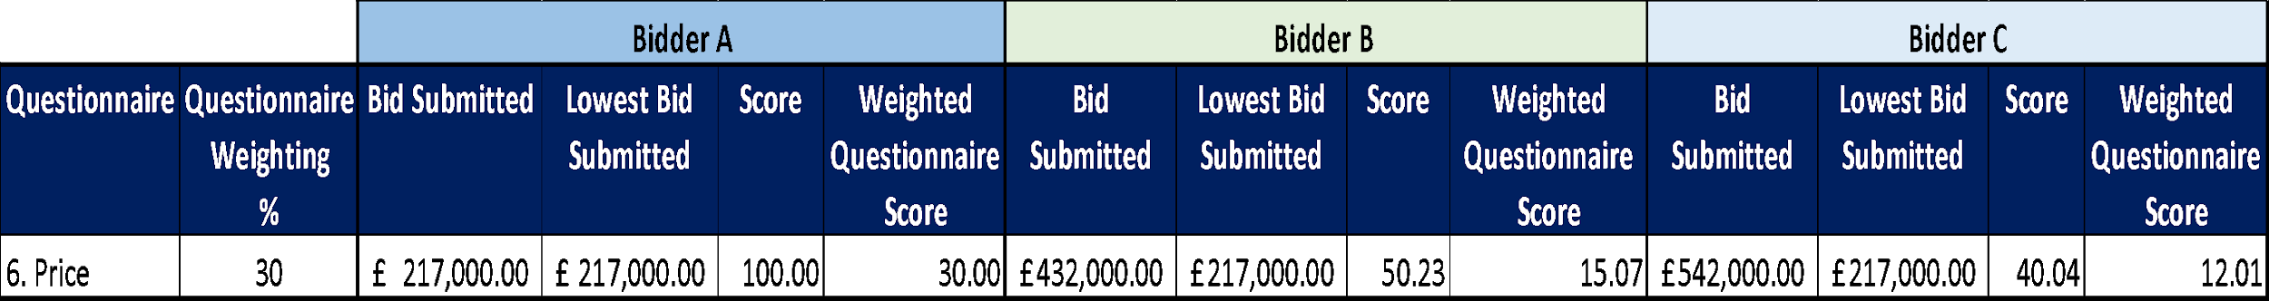

The total score for each pricing table will be added together and the potential bidder with the highest total score will be award the maximum available commercial score.

All other bidders will get a score relative to the total highest score.

The calculation we will use to evaluate the total commercial score is as follows:
Commercial Score = Potential Bidders Total Score * maximum score available
Highest Total Score

Where we consider any of the total price(s) you have submitted to be abnormally low will ask you to explain the price(s) you have submitted (as required in regulation 69 of the Public Contract Regulations 2015).

Final Decision to Award

We will add your quality score to your price score to calculate your final score.

Please see table C below for an example of how your Quality score and Price score will be added together to identify your final score.
Table C – EXAMPLE ONLY:

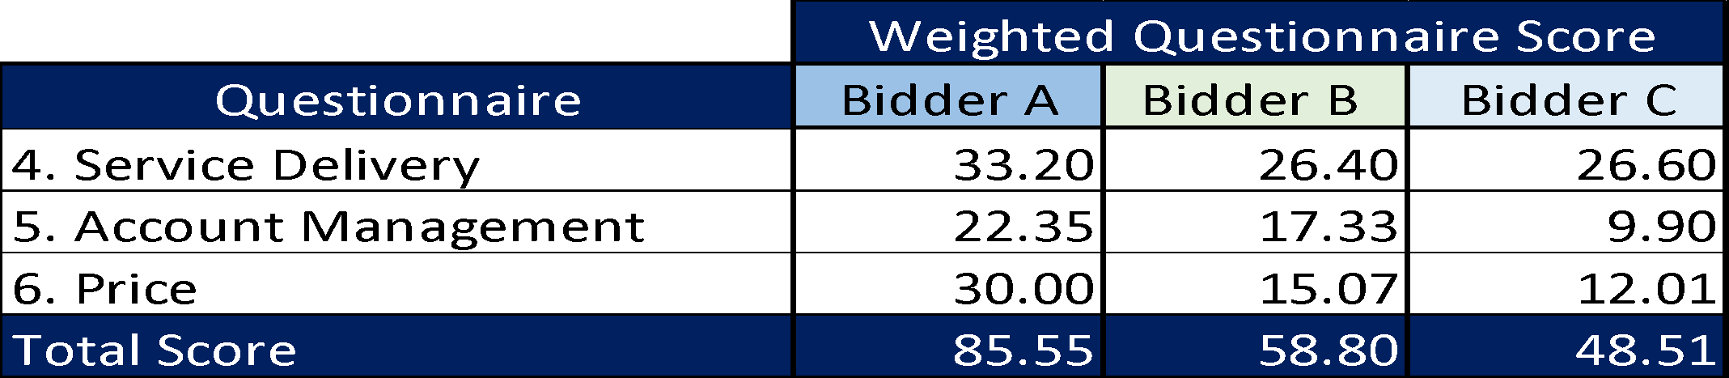

The bidder with the highest final score will be awarded the contract. However, if this is a 2 Stage Evaluation the final scores up to this point will act as a gateway to Stage 2 as outlined in “What we will do”.

Two Stage Evaluation

The following will only apply if a 2 stage approach is adopted as outlined in the table “What we will do” above in section 3.

Where a 2 Stage Evaluation has been conducted the final score from Stage 1 will now be added to the score from Stage 2 to show a final score as demonstrated in the table below:

Please see table D below for an example of how your Stage 1 score and Stage 2 score will be added together to identify your final score.
Table D – EXAMPLE ONLY:
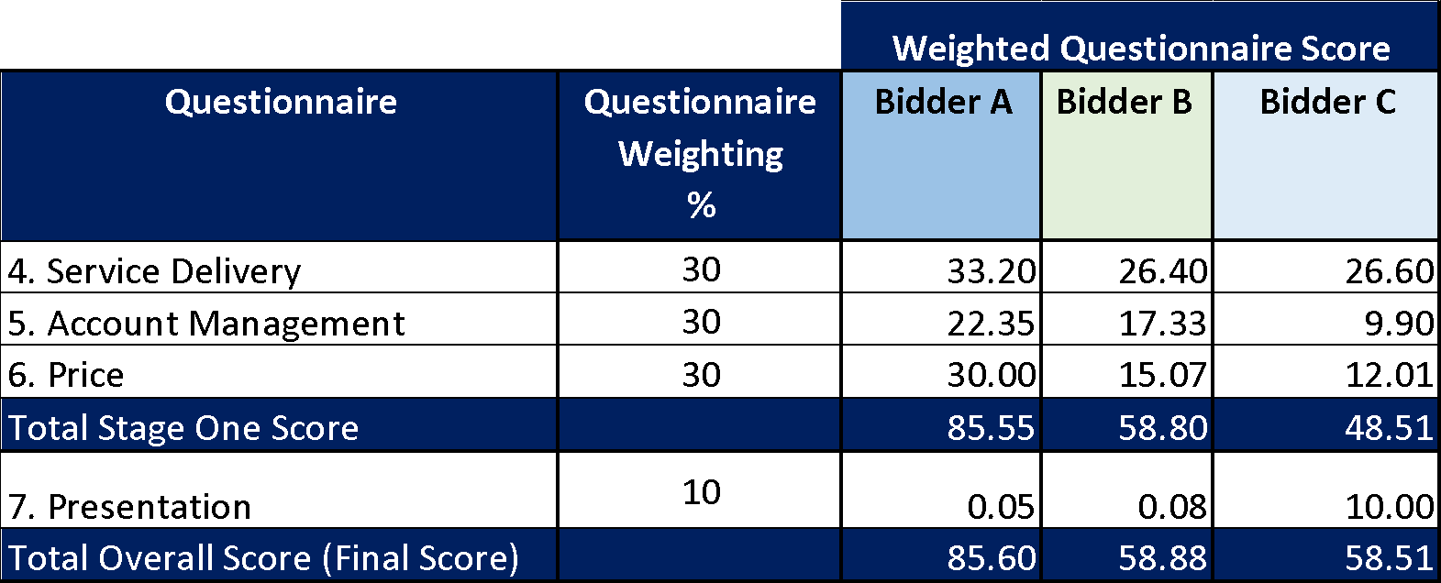

Further Information
  - We will tell you if you have been successful or unsuccessful via the e-Sourcing Suite.

