WWF UK WHOLESCAPE PROGRAMME, NORFOLK

Feasibility of multi-habitat coastal restoration, in North Norfolk

WWF UK invitation to tender - March 2023.

PROJECT INFORMATION AT A GLANCE

|  |  |
| --- | --- |
| Name of Project | Feasibility of multi-habitat coastal restoration, in North Norfolk. |
| Date | 31st March 2023. |
| Location | North Norfolk, UK |
| Key words | Restoration, Wholescape, seascape, coastal habitats, connectivity, ecosystem services |
| Project idea | To make an initial determination on whether multi-habitat coastal restoration in North Norfolk will be feasible and will deliver ecological and socio-economic benefit to the area. For this research piece, feasibility of restoration has been primarily identified as reliant on quality and extent of existing habitat type and the scale of pressures, such as poor water quality, within North Norfolk. Further identification of potential ecosystem indicators of success would be beneficial to determine effects of functional connectivity between multiple habitat types.  This is a desk-based feasibility study and, depending on the outcome of this research, aims to develop into a larger project looking to actively restore multiple habitat types within North Norfolk. This work sits within the wider WWF-UK Wholescape Programme across the county of Norfolk. |
| Project duration | Approx start date: May 2023  Approx end date: September 2023  5-month feasibility study |
| Budget | Anticipated budget: **GBP £35,000 - £50,000 inc VAT** |

We are committed to supporting potential applicants through early discussion and recommendations on how to deliver the contract, particularly if applicants are from a trust and/or small local organisation.

INTRODUCTION

1. The Triple Challenge and Wholescape Programme

Humankind faces a Triple Challenge: averting dangerous climate change, reversing biodiversity loss, and supporting the wellbeing of a growing population. Action to address each of these issues is inherently dependent on action to address the others” (Baldwin-Cantello et al., 2019).

The term ‘Wholescape’ has been developed by WWF-UK to mean a collection of functional ‘scapes’ (land, river, coastal and marine), defined by biological processes, but within an area delineated by the most relevant social construct.

WWF-UK’s Wholescape Programme will develop an integrated approach to the management of the UK’s land, rivers, and seas by designing and testing methodologies that will address the three interlinked pillars of the Triple Challenge, whilst creating space to consider any trade-offs and unintended consequences. We will operationalise the Wholescape Programme by applying the concepts practically through pilot studies; the first Wholescape pilot will be delivered in Norfolk, with an initial focus on North Norfolk.

1. The Wholescape Pilot and North Norfolk and Project Background

The scope of this particular component of the Wholescape pilot focuses on the North Norfolk coastline and its corresponding river systems. The coastal and marine zones of North Norfolk have an incredible 45 miles of diverse coastline embedded with a rich heritage, providing a suite of socio-ecological functions and economic benefits. There are several habitats of international importance in the area, including saltmarshes, mud flats and sand dunes, with critical interactions between other marine habitats such as kelp, seagrass, and various shellfish. The Norfolk coast is additionally recognised as an internationally important wintering and breeding ground for seabirds.

As is common across much of England, such habitats have become increasingly degraded in recent decades with pressure mounted from numerous sources such as coastal development, increased storm surges and sea level rise accelerating erosional activity, nutrient loading and eutrophication, alongside recreational disturbance, and the combined effect of these. Such stressors threaten the valuable ecosystem services that such habitats can provide and the need to address the root cause of these problems, at meaningful scales, has become increasingly apparent. Through the initiation of this Wholescape Pilot in Norfolk, WWF will explore and consider the myriad of processes and problems that lead to environmental degradation across ecosystems.

Through working in partnerships across the country, and the county of Norfolk, WWF can now find the solutions to firstly; integrate nature recovery into planning and decision-making frameworks so that that policy, regulatory and legislative barriers to restoring nature and mitigating climate change are being overcome, and secondly; active, on-the-ground action to revive nature can be implemented.

WWF has been invested in North Norfolk’s rivers (Glaven, Stiffkey and Burn) for ten years, and the following proposed project offers the opportunity to progress and compliment several ongoing and future projects within the area. WWF is supporting the North Norfolk Landscape Recovery Pilot within this scape, providing funding to local partners to invest in the pilot, and to additionally restore locations across the area that may not have otherwise benefitted from the pilot. Within the Landscape Recovery Pilot, a consortium of environmental organisations and landowners are working with Norfolk County Council to restore an area that includes the three river catchments and the adjacent coastal strip. Over the next decade, alongside additional workstreams, such as quantification of saltmarsh and kelp farming capacity to mitigate for nitrogen and phosphorus pollution (here), these workstreams will fundamentally change how land, rivers and the coast are managed in North Norfolk. From this perspective, multi-habitat restoration within North Norfolk would represent the culmination of our work in North Norfolk to date, because through the provision of healthy and functional river systems can healthy and productive seascapes be achieved.

1. Multi-habitat Restoration

To progress the WWF Wholescape Programme, WWF is now seeking to explore the feasibility of multi-habitat coastal restoration in North Norfolk, to achieve wide-reaching ecological and socio-economic benefit. WWF recognises that healthy seascapes are characterised by many interacting species and interconnected habitats that co-create ecological functions of substantial socio-economic value, combining to enhance ecological productivity far greater than the sum of individual habitats (McAfee et al., 2022).

The scientific premise behind multi-habitat restoration is founded upon the study conducted by McAfee et al. (2022). Coastal ecological complexity, the number of components in a system and the connectivity between them, is critical to a healthy seascape and creates ecological functions to build stability and resilience at larger scales, while enhancing productivity, beyond what is possible with single habitats (McAfee et al., 2022). For an area to reach its full socio-ecological potential in delivering benefits, restoration needs to move beyond single-species and single-habitat work to encompass several species and habitats across a seascape. Within North Norfolk, WWF knows there to be a variety of different coastal habitat types (both wild or farmed), including saltmarsh, seagrass, oyster, and kelp. The interactions between these four habitats, and the positive feedback cycles initiated through co-existence, were explored in the study by McAfee et al. (2022), and are outlined below:

* Restoration of oysters and kelp requires a stable substratum. The provision of this substratum could come from the placement of rock-reefs. The reduction of hydrodynamic energy behind these reefs would additionally lead to sediment accumulation and stabilisation, which is beneficial for seagrass development and subsequently facilitating local accretion of saltmarsh.
* The rock-reefs would be populated with oyster spat, which would settle and grow into permanent oyster beds.
* The oyster-filter feeding will improve water clarity and nutrient loading, which would benefit the adjacent seagrass who are less tolerant to very nutrient rich waters. In turn, oysters will also benefit from the oxygen produced by the seagrass itself, creating one positive feedback loop.
* A second positive feedback is created through the synergies between oysters and kelp. Oysters and kelp produce a mutually beneficial water chemistry, and kelp canopies help maintain an exposed rocky substrate for the oysters by shading, and physically abrading, their understory habitat. This keeps the rock-reef free from turf-forming algae, which would exclude both kelp and oysters if left unchecked.
* As the oyster habitat recruits and expands, more substrate then becomes available for kelp settlement.

The benefits of such restoration activity have the potential to be vast; economically, socially, and ecologically. Such natural capital includes developing fish nurseries and enhancing fish productivity, bolstering blue carbon habitat, improving coastal resilience through wave dampening effects and significant improvements in localised water quality.

SPECIFIC ACTIVITIES

Multi-habitat restoration of such complexity would be one of the first of its kind in the UK, and due to its novelty, it is essential to initially determine the feasibility of a project like this in North Norfolk.

WWF UK envision this project to be a desk-based study to collate the data and evidence needed to establish whether multi-habitat coastal restoration would be possible at one or more areas in North Norfolk, as defined by the area in Map 1, and identify data gaps where they are apparent.

The above is to be explored and presented in one report that functions to answer the overarching question:

**Is functionally connected restoration of multiple coastal habitats ecologically feasible in North Norfolk, and if so, where within North Norfolk would this work be best placed and what are the most relevant ecosystem indicators to monitor success?**

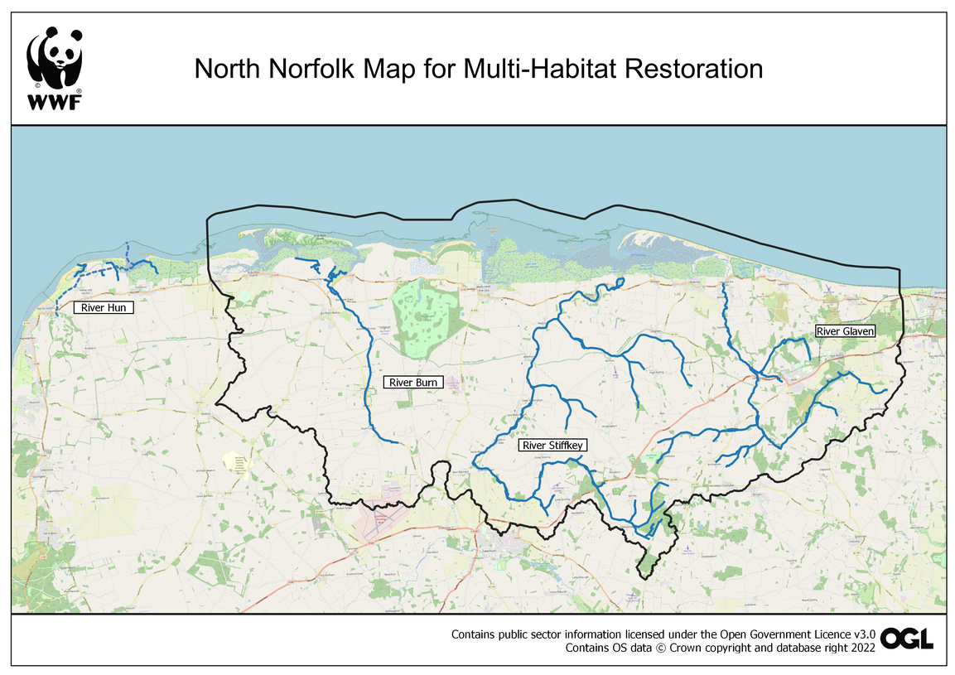

Map 1 WWF UK Wholescape Pilot, Norfolk. North Norfolk focus area.

The following Draft Research Framework has been designed by the WWF-UK Wholescape Programme Team and aims to provide further detail, as well as form the basis of a subsequent contract and the exact value of the work. Early meetings to explore and discuss the research framework will form the inception phase and subsequent first payment.

DRAFT RESEARCH FRAMEWORK

For this desk-based research piece, feasibility of coastal restoration in this scenario is to be explored across two key areas:

1. Habitat quality and extent
2. Pressures within the defined system

Further consideration is to be given to a third research question, designed to determine which ecosystem indicators should be monitored when evaluating the possible success of multi-habitat coastal restoration.

It should be additionally acknowledged that, due to the scale of the works, there are numerous ongoing and planned projects within the WWF-UK Wholescape Pilot. Overlap with any existing or planned projects has been intentionally avoided and as such, has shaped the research questions and deliverables of this ToR.

**Research Question I – What is the quality and extent of coastal and riverine habitats in scope?**

Research Question I Outputs:

1. Presentation of the location of coastal habitats (saltmarsh, seagrass, native oyster, and kelp) on a map with quantification of their geographical extent.
   1. Identification of natural habitat and farmed habitat (established and planned). E.g., unlikely presence of wild kelp forests in North Norfolk but it is known that a farm is planned in Blakeney Harbour.
   2. Supplementary material to be provided on any historical records and/or baseline data surrounding coastal habitat extent.
2. A general overview of habitats ecological quality, evidenced and explained by accompanying text. For example:
   1. Saltmarsh – e.g., sward type and stability (e.g., accreting / eroding).
   2. Seagrass – density of existing seagrass habitat and species (*Zostera noltii / Zostera* *marina*).
3. Produce a map and accompanying information around RPA registered land and its current use.
   1. Indication of land that is agricultural, private reserve, a charitable reserve, etc. within each river catchment (Burn, Stiffkey and Glaven) and along the coastal strip. Where possible, provide contact details of the landowner and/or site manager.
   2. Indication of land / sea area that is protected and is actively monitored across the Norfolk Coast, e.g. SSSI, NNR, SAC, SPA
4. Indicate where multiple coastal habitat types co-exist (currently and/or historically) and as such may be suitable for further investigation into multi-habitat restoration (max. 3 locations)

**Research question II – What are the key pressures within North Norfolk that may implicate restoration of coastal habitats?**

Sub Questions:

1. What are the key pressures within the area defined in Map 1, that may impact the coastal zone and coastal habitat restoration?
   1. What are the factors inhibiting natural expansion of coastal habitat types?

In already recognising that water quality is a key issue within North Norfolk:

1. What is the current status of water quality in the coastal area as defined in Map 1?
   1. What parameters define the system and what are the primary limiting factors? I.e. chemical and nutrient inhibitors.
2. What is the current status of water quality in the rivers Burn, Stiffkey and Glaven as defined in Map 1?
   1. What parameters define the system and what are the primary limiting factors?
3. What are the sources of different pollutants within the system, where are they located, and what are their relative contributions? E.g., CSO and STW outfall (rivers, coastal or marine), agriculture, construction, shipping, etc.
4. To what degree does the relevant literature suggest that upstream river projects contribute to bioremediation of chemical and nutrient pollutants (e.g., wetland creation, sustainable agriculture, land-based habitat restoration, etc)?
5. Based on relevant literature, what levels of chemical and nutrient pollutants can exist within the coastal system, where coastal habitats can remain ecologically productive?

Research Question II Outputs:

1. Presentation of multiple data-layers into digestible report format with maps and graphs, ensuring that information is accessible and covers the area of North Norfolk selected for study.
2. Top-level identification of key pressures within the area and the relative contribution of each pressure identified in a risk matrix (no more than 2 A4 pages).
3. Presentation of the most critical nutrient and chemical inhibitors that have implications on restoration potential in the area. Presentation to include:
   1. A list of pollutants and ascertain to what degree they are present within the system (rivers Burn, Stiffkey and Glaven, and coastal/marine area).
   2. A list of the pollutants and the primary source of their input into the system.
   3. An overview as to what degree these pollutants go through bioremediation in the primary coastal habitats identified, and through upstream river works.

Based on findings from research questions I and II, provide an initial recommendation of one or more locations for coastal multi-habitat restoration that would benefit from further investigation (max. 3 locations).

**Research Question III – What ecosystem indicators can be used to assess habitat connectivity and potential restoration success?**

Sub Questions:

1. What are the key ecosystem indicators of restoration success, common to and applicable across multiple coastal habitats in North Norfolk?
   1. To inform future monitoring frameworks, what data is currently available about the identified indicators, how frequently is data collected, and who holds this data?
   2. In determining future restoration success, over what time periods should ecosystem indicators be monitored?

Species specific sub-questions:

1. What species or suites of species (and/or higher taxa levels as appropriate), would serve as indicators of improved coastal habitat condition?
   1. Are there species present in North Norfolk that are currently identified on the IUCN Red List and what is their population/conservation status?
2. Are there species (and/or higher taxa levels as appropriate) in North Norfolk that could serve as indicators of interconnectedness between the habitats in question?
   1. Which species utilise more than one of North Norfolk’s coastal habitats?
   2. Which species utilise both saltwater and freshwater environments in North Norfolk and do any species undergo ontogenetic habitat shifts?

Research Question III Outputs:

1. Provide a top-level summary of ecosystem indicators, including species or suites of species, that can be used to evaluate restoration success across multiple coastal habitats (no more than 2 A4 pages).
2. Provide all data and metadata associated with identified indicators.
3. Provision of a list of relevant species across the geographical area defined in Map 1, and their current conservation status.
4. Provision of a list of species that are known to utilise one or more coastal habitats throughout their life stages and species that utilise both saltwater and freshwater environments.
5. Identify key species most relevant in determining connectivity between multiple habitats and present all available data and metadata associated with these key species.
6. Identify the time periods over which indicators of success should be monitored into the future.

EXPECTED DELIVERABLES

The main outcome of this work will be to enhance our understanding of the coastal zone and associated river catchments of North Norfolk which will be used to target future coastal restoration work, as well as defining areas upstream that need targeting primarily in terms of water quality.

The preferred time frame for work delivery(some flexibility may be possible):

* Assessment of proposals week commencing 24th April 2023.
* Successful contractor appointed by 5th May 2023.
* Inception meeting(s) week commencing 8th May 2023.
* Confirmed/detailed research framework in place and agreed schedule by 19th May 2023.
* Draft report of all findings of desk-based research for Research Question I presented before 23rd June 2023.
* WWF reviewal and feedback on draft report for Research Question I received by 1st July.
* Draft report of all findings of desk-based research for Research Questions II and III presented before 25th August 2023.
* As a result of desk-based review of habitat extents and providing recommendations on locations for multi-habitat coastal restoration, as requested in Research Questions I and II, on-site validation of these locations to be confirmed by 25th August 2023.
* WWF reviewal and feedback received by 8th September 2023.
* Final report delivered by 30th September 2023.

TIMEFRAMES & PAYMENT SCHEDULE

The contract will be for a 5-month period between 5th May 2023 to 30th September 2023. The tasks and deliverables will be implemented over the course of these 5 months as outlined above.

The budget is £35,000 - £50,000 in total, inclusive of VAT.

The successful contractor will be issued with a contract and/or purchase order through WWF’s Panda Purchasing system. Payments will be made to the contractor according to the following schedule:

* Submissions are to be sent by **Monday 24th April 2023,** with an awarding decision to be made by Friday 5th May 2023.
* 10% of the contract value by 19th May 2023, following inception meetings and interrogation of the research framework.
* 40% of the contract value by 23rd June 2023, following provision of report which addresses Research Question I.
* 25% of the contract value by 25th August 2023, following provision of report addressing Research Questions II and III, and on-site data validation.
* Review of WWF feedback on first draft of all three Research Questions by 8th September 2023.
* 25% of contract value by 30th September 2023, following provision of final and agreed upon report.

TENDERING PROCESS

Please provide by overview of relevant skills, knowledge, and experience by **Monday 24th April 2023** in-line with all the detail provided in this Terms of Reference and the accompanying Annexes / Links.

**Note that all submissions longer than 8 pages will be automatically discounted, therefore link or signpost to any additional information e.g., policies, statements etc.**

The contractor’s budget should include any expected travel and accommodation costs. The consultant will be expected to provide all their own office and communication facilities.

Guidance on Proposals

Proposals should include:

* The approach and methodology you would take to answer the defined research questions.
* A list and description of deliverables, key milestones, and any additional outputs that could be provided (I.e., slide deck summarising main findings).
* A schedule of works in line with WWF’s proposed timeline.
* The relevant experience of the proposed consultant(s) and examples of previous relatable work.
* A quote for the work. We need fees to be clear and structured in a flexible way. Please state day / hourly rates and price per project element, ideally with capped fees.

Additional checks:

* Please confirm you are willing to work to the WWF-UK standard T&C’s
* Please confirm your acceptance of the WWF-UK 3rd party expenses policy
* Please confirm you will work to the WWF-UK supplier code of conduct.

**For further information and submission of documents for consideration, please email:**

**Daisy Durden, WWF-UK at** [**ddurden@wwf.org.uk**](mailto:ddurden@wwf.org.uk)