**Tendring District Council**

**Specification**

**Security Arrangements for Jaywick Sands New Build Property**

**31st March 2022**

**Version 0.1**

**Our Vision**

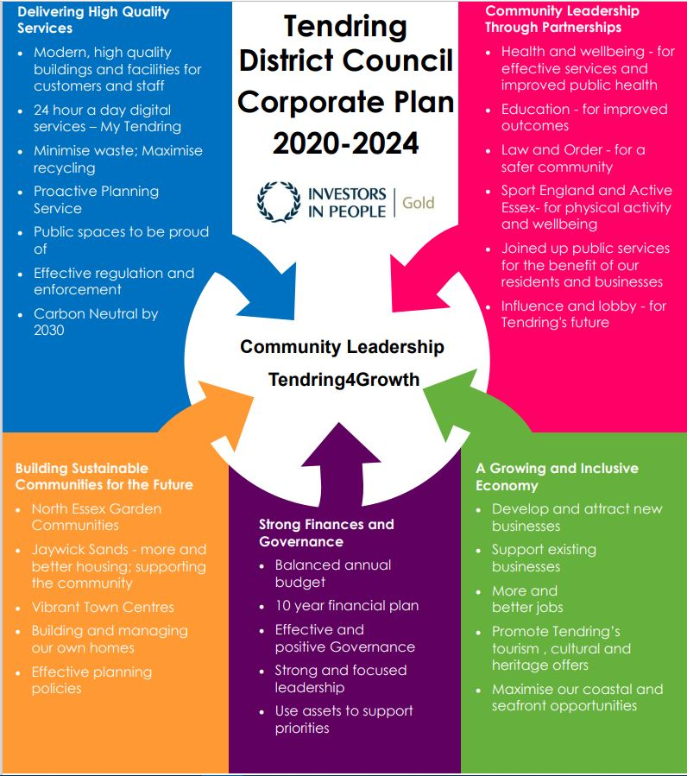***To put community leadership at the heart of everything we do through delivery of high quality, affordable services and working positively with others.***

**Our Values**

♦ Councillors and staff uphold **personal integrity, honesty** and **respect** for others

♦ **Innovative, flexible, professional** staff **committed** to delivering excellence

♦ Recognising the diversity and equality of individuals

♦ Working **Collaboratively**

1. **Specification**

|  |
| --- |
| Tendring District Council are seeking a quotation to contract for the service of an SIA Licensed Security Guard to monitor five new build, vacant houses at Boathouse Halt, Jaywick Sands.  Provision is to start from the 27th April 2022 up to 27th October 2022.  If the properties are sold prior to the 27th October 2022, Tendring District Council will give two weeks’ notice before the end of the contract.  There is also the option for a possible extension of up to six months post 27th October 2022.  **Requirement:**  1x SIA Licensed Security Guard to visit once daily at random times during the night Monday to Friday and twice, one day one night, on the weekends and bank holidays. To undertake a full external inspection to check the buildings remain fully secure and free from damage.  Damage to be reported to the Council immediately and any intruders / trespassers found to be apprehended / reported to the Police as appropriate.  CCTV to also be monitored daily.The CCTV is separately owned and that the signal will be diverted to the successful bidder’s nominate offices at the cost of the Council |

1. **Timetable**

The proposed timetable for this employment for guidance:

|  |  |
| --- | --- |
| *Publish RFQ* | 31.03.2022 |
| *Clarifications* | 11.04.2022 |
| *RFQ Submission deadline* | 14.04.2022 |
| *Evaluations* | 19.04.2022 |
| *Award notification* | 25.04.2022 |
| *Contract start* | 27.04.2022 |
| *Contract end date* | 27.10.2022 |

1. **Payment**

Terms of payment is 20 days from receipt of invoice.

1. **Tender Evaluation**

The RFQ will be evaluated on passing the mandatory requirement and a quote submission.

**SECTION A – QUALITY**

**You must pass the Mandatory question to be considered for the RFQ.**

|  |  |  |
| --- | --- | --- |
| **Question** | **Evaluation Criteria** | **Page Limit** |
| The bidders must be SIA accredited and must not sub-contract the work to anyone else | Submission of SIA accreditation and license evidence | 1x A4 page maximum (plus relevant attachments) |

**SECTION B – PRICING**

A pricing spreadsheet has been included as part of the RFQ documentation issued.

Please complete the spreadsheet as per the instructions stated within the document and return the completed spreadsheet as part of your RFQ submission.

All prices should be exempt of VAT and include any expenses.

For more information, please refer to the Bidder’s Guidance.

1. **The** **Authority’s Policies** **& Statements**

The bidder will need to adhere with the below policies and statements.

* Data Protection (please see Appendix D)
* Freedom of Information (please see Appendix F.

**Modern Slavery**

The bidder self-certifies that they are taking steps to ensure that there is no modern slavery or human trafficking (as defined in the Modern Slavery Act 2015) in their organisation or supply chain relating to the requested services/supplies requirements.

Here is a link to the Act: <http://www.legislation.gov.uk/ukpga/2015/30/contents/enacted>

**Health and Safety**

The bidder self-certifies that they adhere to the Health & Safety at work Act. Any Here is a link to the Act: <http://www.hse.gov.uk/legislation/hswa.htm>

**Environment**

The bidder confirms that they are aware of Tendring District Council’s Environmental Statement, and should they be successful, they are committed to working with the Council fulfil the vision outlined in the Statement.

<https://www.tendringdc.gov.uk/environment>

1. **E-procurement requirements**

Tendring District Council has an fully automated Purchase to Pay (P2P) system.

The successful bidder will be able to:

* View their orders online;
* Update their status;
* Notify delivery; and
* Submit and monitor the status of electronic invoices, once they have been submitted.

Orders will be sent electronically to the successful bidder’s central e-mail address from the contract start date.

The successful bidder will be expected to submit electronic invoices from the contract start date. On approval of the electronic invoice an automatic payment will be made via BACS, direct to the successful bidder’s bank account supported by an e-mailed remittance advice, in line with Tendring District Council’s contracted payment terms.

1. **Submission**

Clarifications to be sent to: [rula.dymond@essex.gov.uk](mailto:rula.dymond@essex.gov.uk) these must be sent by 12 noon on the 11th April 2022.

RFQ submissions to be sent to: [tenderbox3@tendringdc.gov.uk](mailto:tenderbox3@tendringdc.gov.uk)

by 12 noon on the 14th April 2022.