**Location**Azalea Park  
Azalea Gardens  
Church Crookham  
GU52 8UY

**Specification**Church Crookham Parish Council would like to renovate its very popular playground at Azalea Park to include items of inclusive play, replacement of some and refurbishment of other existing equipment, aimed at children between the ages of 2 to 12 years. The playground was last renovated in 2011/12 and due to its heavily trafficked nature any equipment must be robust and vandal-proof.   
Azalea Park used to be the site of a military barracks and investigations have shown that there is some contamination underground in this area. All contractors will be required to carry out their own risk assessment and ensure that they follow safe working practices. Contaminants identified include Asbestos, Polycyclic Aromatic Hydrocarbons and Lead.  
Tenders must include all elements of play equipment, surfacing, delivery, construction, installation and safe removal and disposal of contaminated soil and rubbish.  
Due to the current pandemic, it would be desirable for the construction work to be carried out in such a way that at least half of the play area is always available to the public.  
Tenders will be shortlisted and put out to public consultation before the contract is awarded.

The budget for the project is **£35,000** and the design should include the following:

|  |  |  |  |
| --- | --- | --- | --- |
| 1 | Scooter track | Extension on scooter track to include remarking of existing track and any remedial works required.   To include imaginative play garage & road signs | Track extension & brick edging |
| Play markings |
| 3 x assorted play scenes: roadway themed |
| 3 x assorted road signs |
| Renew and refresh existing track to match extension |
| Removal & redistribution of soil from bund at rear of scooter track (contaminated soil) |
| 2 | Swing set | Replace oldest double swing set to include accessible swing seat & replace surfacing, to include realignment of play equipment to allow better accessibility to/from path | Replacement frame |
| Accessible/ inclusive swing seat |
| Second swing seat |
| Replacement surface and appropriate edging |
| 3 | Play markings on footpaths | To encourage increased activity as part of the school run along this access route | Fun exercise-based play markings |
| 4 | Wheelchair springer | Wheelchair springer - to increase proportion of accessible play equipment | Wheelchair springer with appropriate surfacing Located to allow accessibility from path |
| 5 | Dino springer | Replace |  |
| 6 | Springer lion | Replace |  |
| 7 | Springer dog | Replace |  |
| 8 | Various repairs & refurbishments | Activity trail | Clean wooden activity trail - to remove moss etc. |
| 2 bay 2 flat 1 basket seat set | Replace basket seat |
|  | Paint swing frames |
|  | All other swing seat & chains to replaced |
| Replace or renew spring on gate to Lynwood |  |
| Cone climber | Replace nets |
| Mini basket swing | Replace seat |
| Car | Paint frame Tighten steering wheels |
| 9 | Optional extras: | Roundabout | Refurbishment / replacement -to mitigate uneven distance from ground |
|  | Activity trail | Replace cross member high beam and ropes attached to it. Replace vertical struts showing signs of rot. |

* All equipment be meet current EU / British Standards / ROSPA specifications and standards.
* Equipment to be appropriately robust and able to withstand use by adults. It is recognised that whilst the equipment is intended for use by children, inevitably older children and adults may use the equipment and it should therefore be of appropriate quality, sturdiness and sufficiently robust to withstand use by adults.
* Equipment should be free from entrapments, crush points, sharp edges, and unrestricted pendulums.
* Warranties on steel parts, paint, bearings, plastic parts
* Replacement parts must be available in the UK with short lead time.
* All contractors must hold the following liability insurance:
* Employers liability: £10,000,000
* Public liability: £5,000,000
* Products liability: £5,000,000

Evidence of this cover must be provided at the initial quotation stage.

* Risk Assessments and method statements must be provided by the contractor before any contracts of works are awarded.  
  **Site visits can be arranged, contact details as below**.

Please provide the following to Sally du Gay (Deputy clerk)

* Completed questionnaire.
* Draft design and quotation
* Product details
* Warranty details for Structural parts, paintwork, bearings, plastic parts
* Maintenance requirements and lead time for availability of spare parts
* Testimonials
* Delivery and installation timetable

If you have any questions, please address them to Sally du Gay via email: [deputyclerk@churchcrookham.org.uk](mailto:deputyclerk@churchcrookham.org.uk)

Timetable:

1. **5pm 1st March 2021**- Full response (Questionnaire, Design, Quotation etc) to be received by Sally du Gay – Parish Clerk - Church Crookham Parish Council), Church Crookham Community Centre, Boyce Road, Church Crookham, GU52 8AQ
2. **1st to 15th March 2021** - All responses will then be reviewed by working party and a short list of three schemes selected for public consultation.
3. **22nd March to 12th April 2021** – short listed schemes will be put on social media and residents will be asked to comment before the final scheme is selected by the Parish Council at the Parish Council meeting on **26th April 2021.**
4. Installation to commence in **May 2021.**

**Photographs of the site:**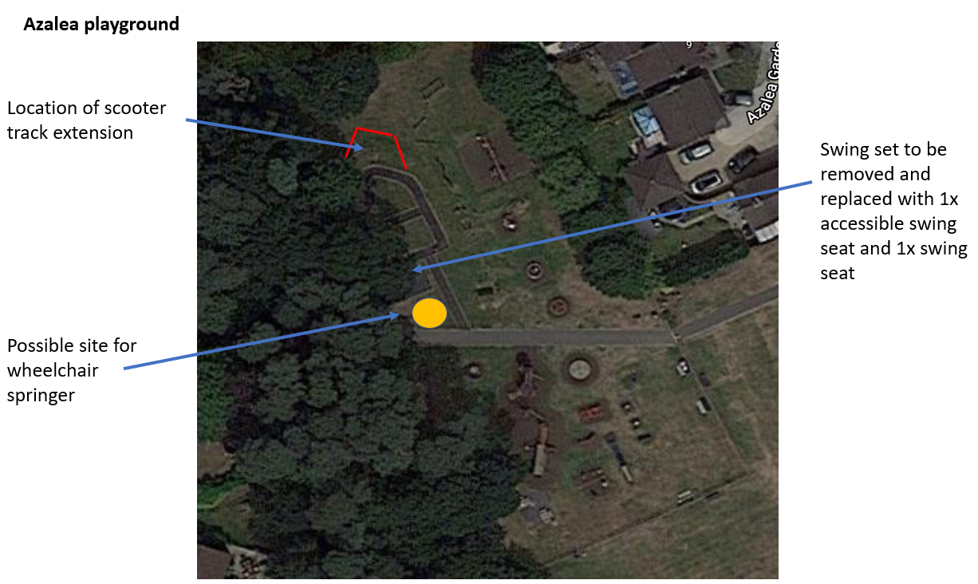

**Swings to be replaced with accessible seat and standard seat, location to be realigned to increase accessibility to path**

