

Victoria Park and MacAndrews Field
Site information

Victoria Park
- Site location – Victoria Park, Ivybridge, PL21 0AQ
The site lies within Victoria Park towards the south west side of the park (opposite the Erme Primary School). It currently has a vehicular wooden gate at the eastern perimeter and a pedestrian self closing metal gate on the northern boundary.
Victoria Park is owned by Ivybridge Town Council and lies towards to the west of Station Road where pedestrian access is via a kissing gate, and the Erme Primary School is located to the south east of the park.
The park lies to the north of Blachford Road, from which there is a small access lane leading into it. St John’s Evangelical Church and cemetery is located between Blachford Road and the southern edge of the park and there is a pedestrian access through the cemetery into the park.
There is also a pedestrian access at the south west corner of the park leading to a residential estate. This estate runs along the western edge of the play area and the rear gardens consist of trees and hedging.
North of Victoria Park lies Beacon Road and this is the vehicular access to the site. This will be the logical access for construction. Within the park there is access to the amenity grass and MUGA and vehicular access to the play area will involve traversing across these.
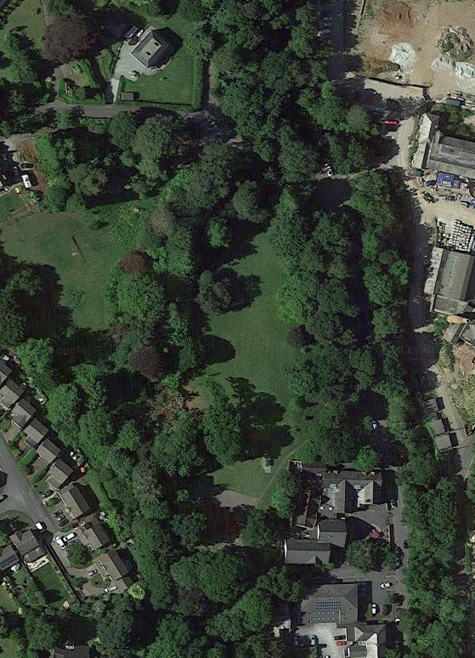

- Land ownership
Land ownership indicated by blue line. Fenced play area boundary edged in red.

Possible extension area in orange:
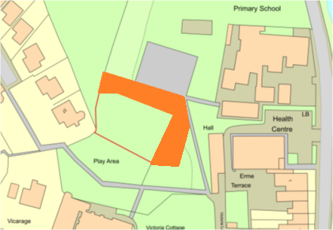
- Vehicular access
Is through the gate at the northern tip of the park.
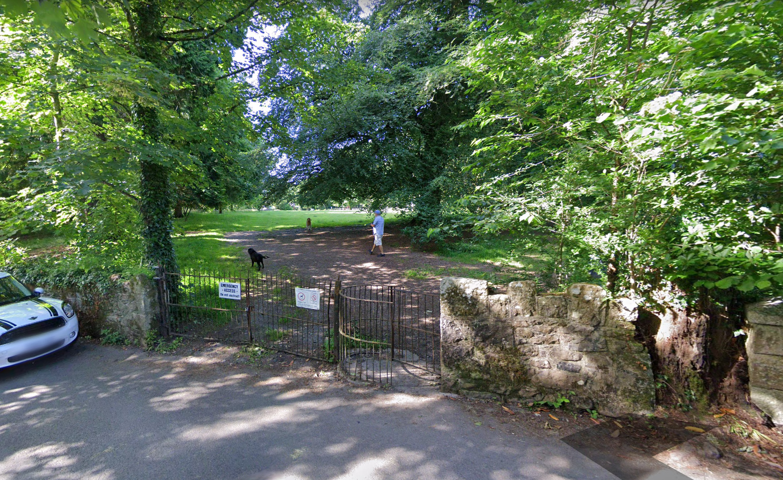

- Photographs of the site
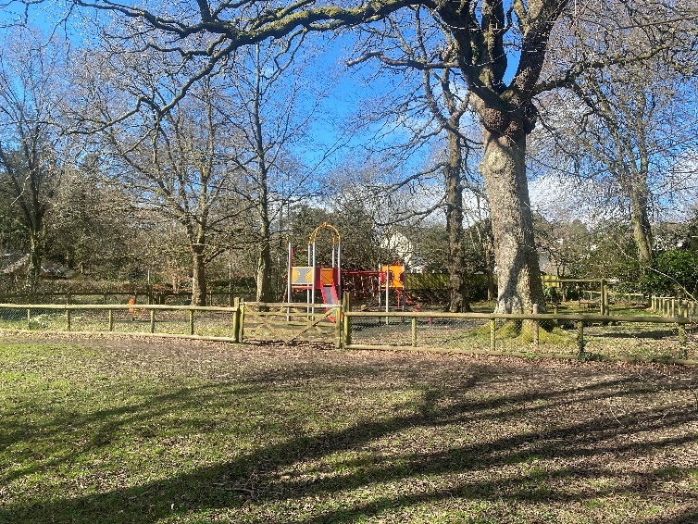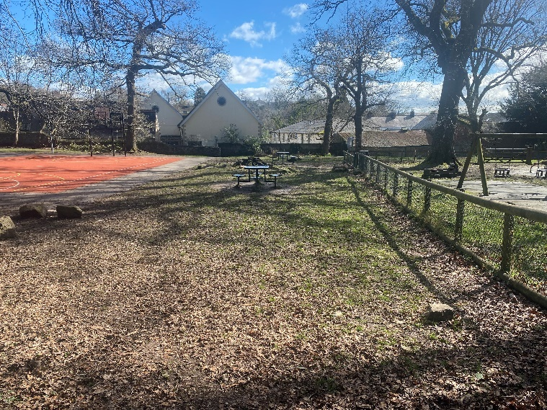
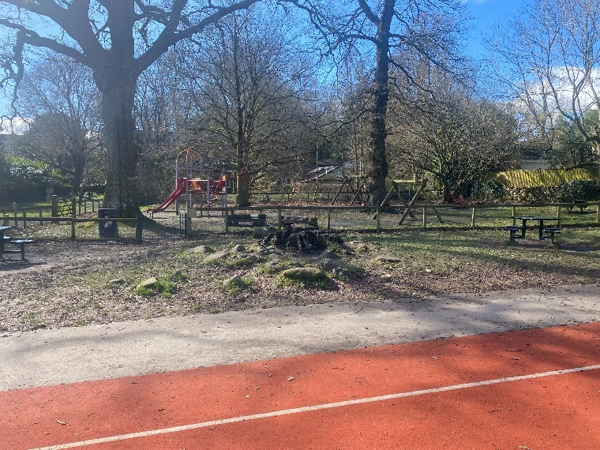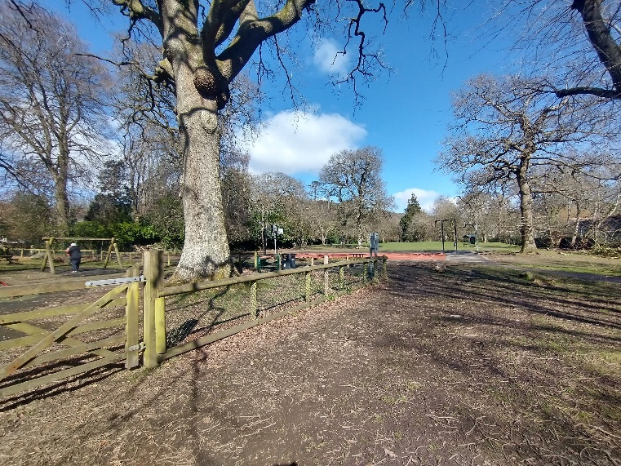
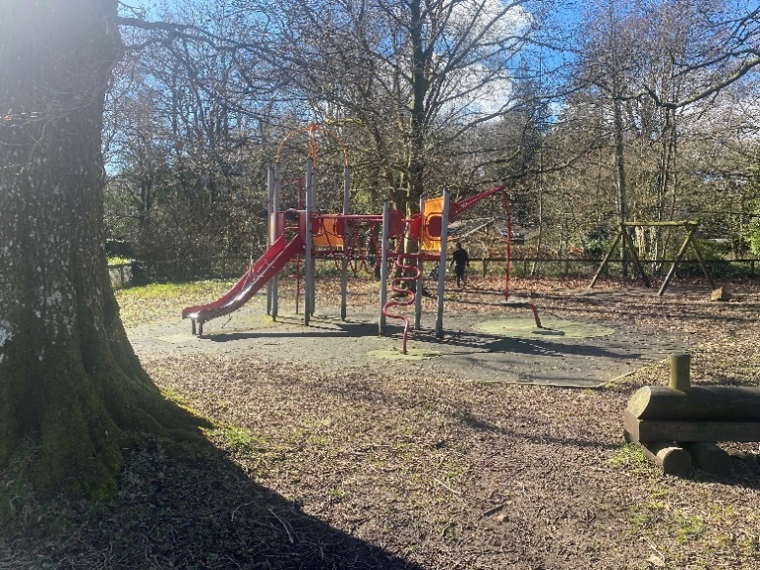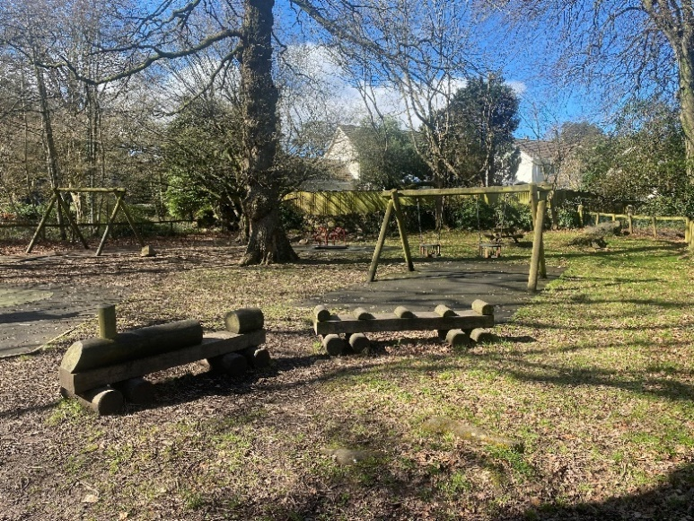
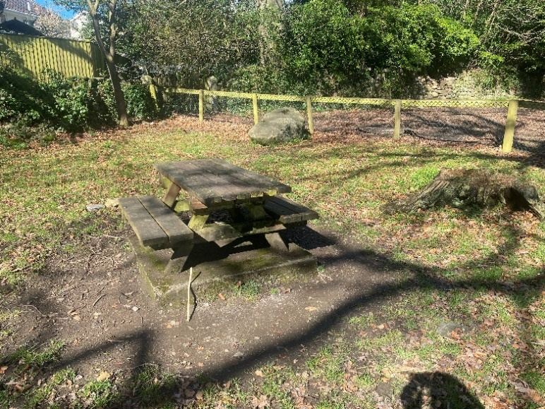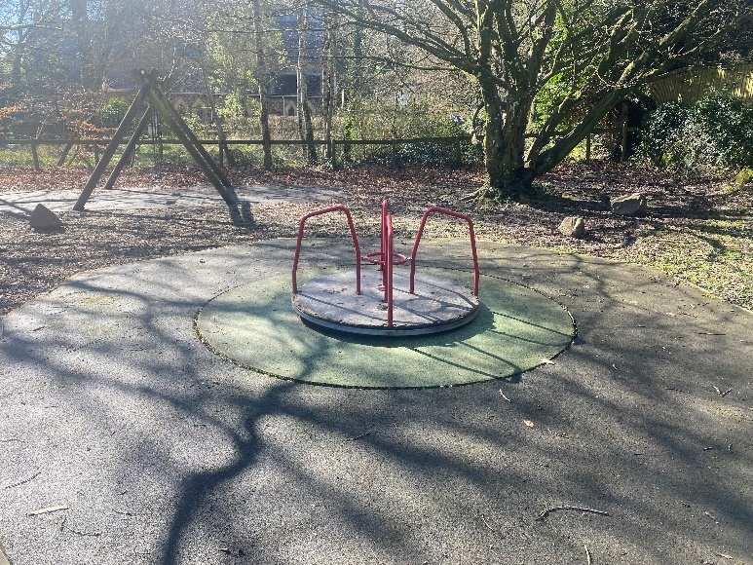
- Site description and any known constraints
The site lies within Victoria Park which is a planning conservation area. The play area is surrounded by post and rail with galvanised chain link fencing. Whilst there is a works access wooden gate, fencing is to be removed and replaced as part of the works. The pedestrian entrance is accessed via a metal self closing gate to the north eastern boundary of the site. This is a new gate which is stand alone and concreted into the ground and removal may not be necessary. There is also wooden pedestrian gate on the southern edge connecting the site to the adjoining nature garden.
Beyond the northern and eastern boundary is a possible water course running downhill west to east. There are manhole accesses to the water course beyond the site boundary at the north and east within the park.
There is a well-used natural path connecting from a surfaced path at the cemetery entrance and running beyond and alongside the eastern boundary of the play area. There is also a surfaced path running from Blachford Road and Station Road which both meet at the perimeter of the MUGA. A natural path connects the southern edge of MUGA to the play area entrance, approximately 3m distance between the site and MUGA. Situated between the MUGA and the northern boundary are two metal tables square tables with four connecting stools each.
The site is in close vicinity to a primary school located on the eastern side of the park.
The western boundary of the play area is a dry-stone wall. The southern boundary is adjacent to a nature garden.
The site contains mature trees with some exposed roots and small boulders, and has a natural earth surface. There are wet-pour surfaces beneath and surrounding existing play equipment.
There is a metal litter bin within the site immediately west of the self-closing gate entrance and a wooden table with two benches set on a concrete plinth within the north western corner of the site.
The site currently contains a multi-play unit with slide and spinning seat, a carousel, rocker duck, a double junior swing set, a double toddler swing set and a play train and carriage. The multi-play unit and carousel will require removal but the remaining play equipment can remain in place and be integrated with the new play equipment.
- Service plans
Service plans have been attached where they have indicated services onsite. Where plans from other companies have indicated no services, the plans have not been attached.
Please note: these are standard service enquiries and that the contractor must dial before they dig to ensure the services are where they are shown. It remains the contractor’s responsibility for not damaging services and the contractor is required to be covered for any repairs to the services should they drill through one.
South West Water – there is a SWW public sewer pipe near the play area. It is not believed to be a constraint at this stage – this can be confirmed during site visits.

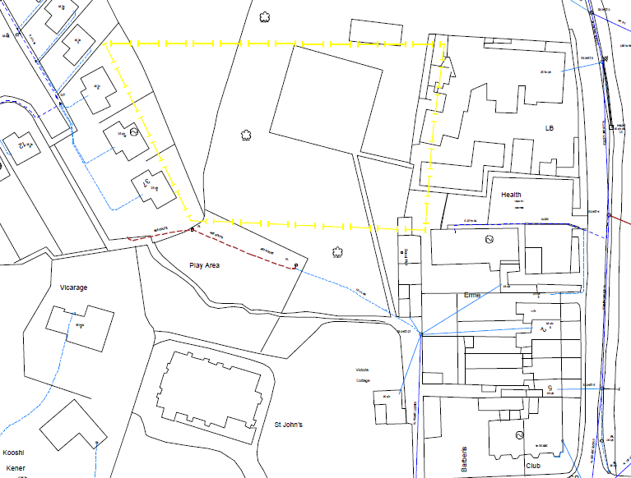

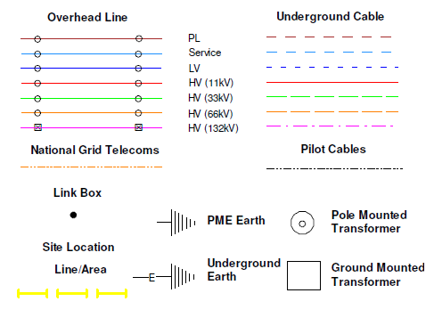

Site information
MacAndrews Field
- Site location – MacAndrews Field, Ivybridge,

The play area site lies within the north west corner of MacAndrews field which is owned by Ivybridge Town Council. It has open access into the field from all sides and is not surrounded by any gates or fencing.

The field lies to the north of Exeter Road, which is the vehicular access into the field via a wooden gate. There is also pedestrian access via this entrance. The field is surrounded on three sides by residential estates, to the west, north and east. At the north westerly edge of the field is an open pedestrian access leading from Speakers Road with steps down towards the play area site, and to the north east there is a pedestrian access from Buddle Close.
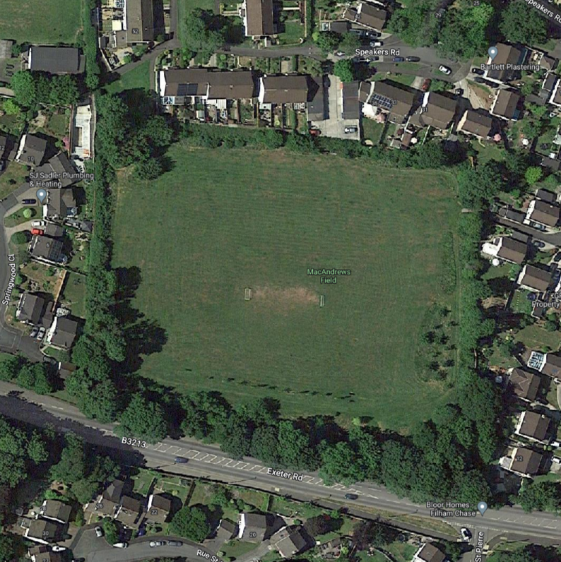

- Land ownership
Land ownership lined in blue. Current play area approximate boundary edged in red.

- Vehicular access
Via field gate off Exeter Road to eastern end of southern edge
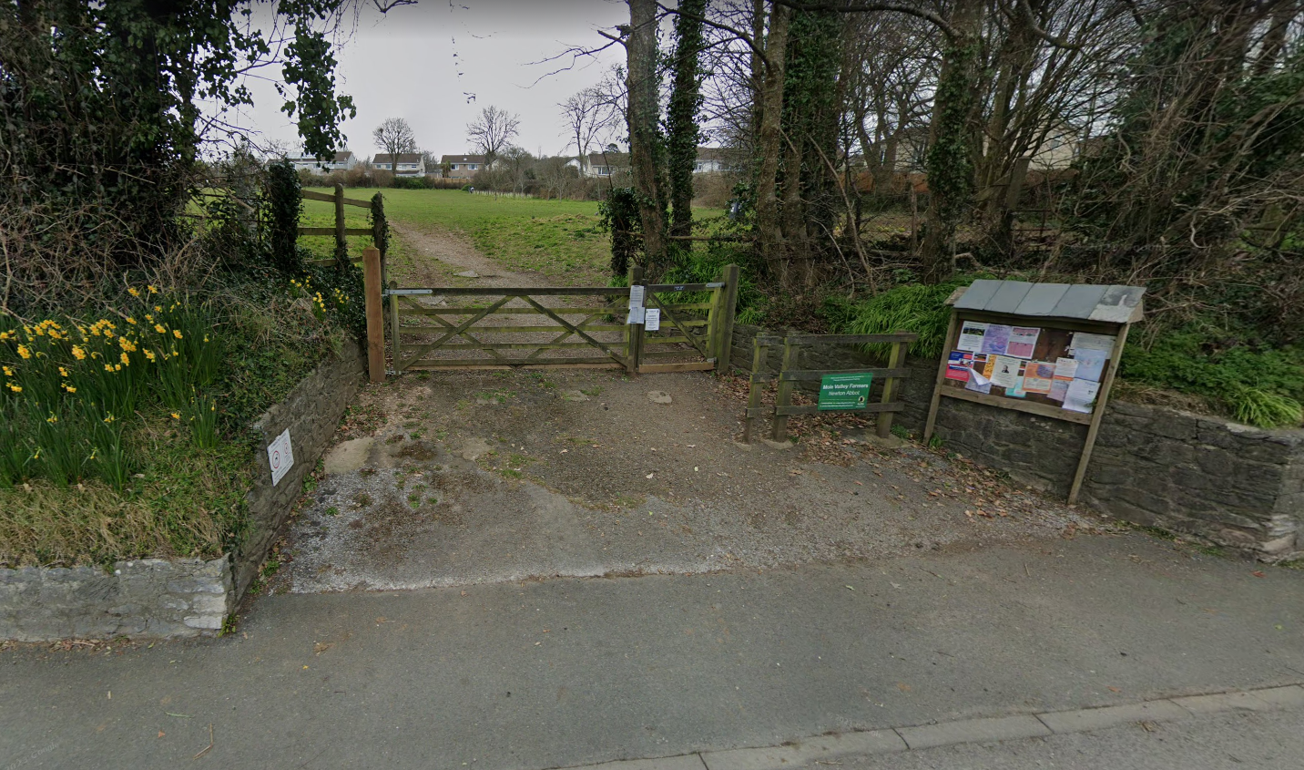
- Photographs of the site
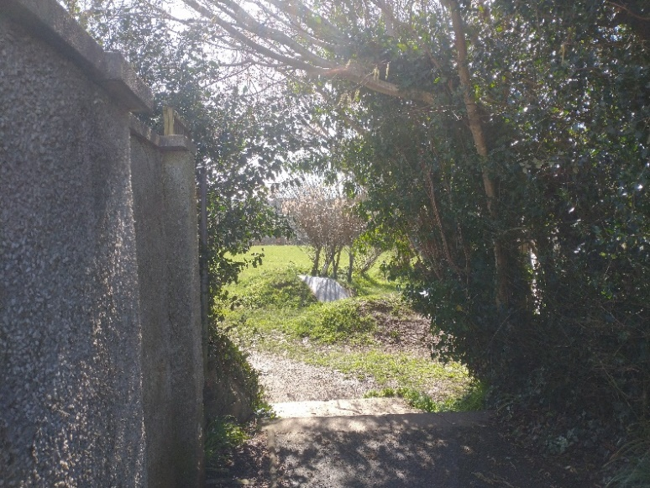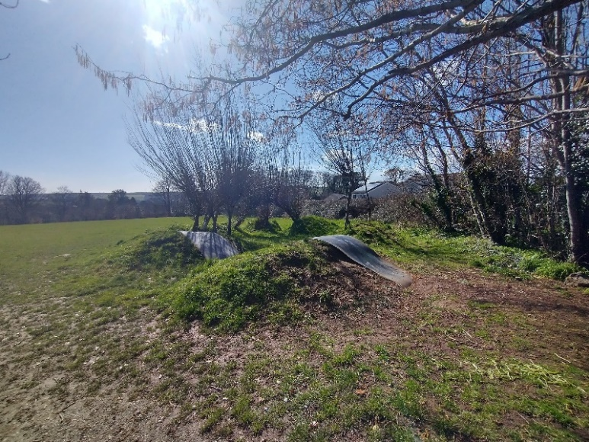
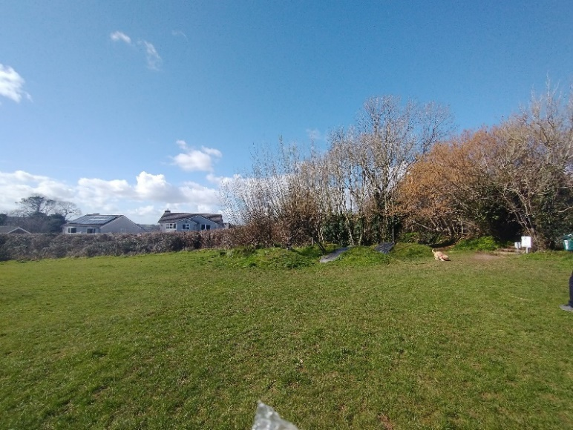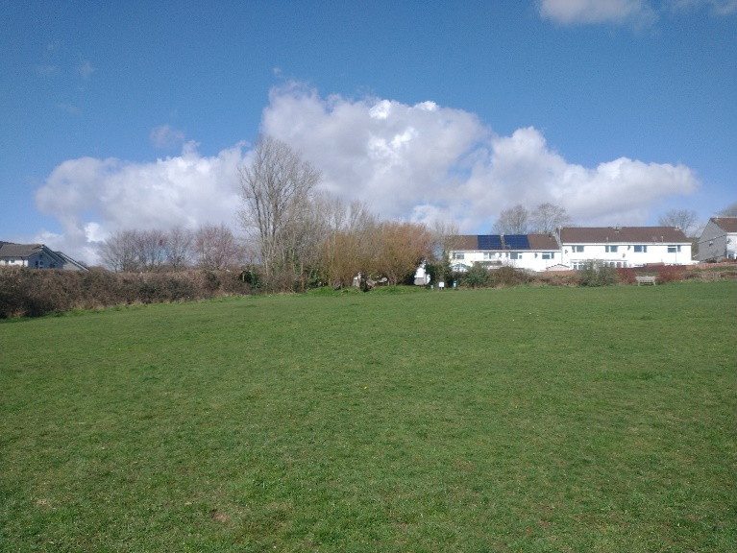

- Site description and known constraints
The play area site is accessible on all sides and has no fences or gates.
The boundaries of the field are formed by a range of rear residential boundary fences, primarily hedges.
The north edge of the field hosts a memorial area to the 2nd World War American Soldiers billeted on the field. There is also a wildflower planting section. Trees have been planted on the southern edge of the site.
The middle of the field sites two moveable goal posts.
The north western corner of the site was a designated play area containing timber balancing posts and stepping logs that have since been removed. The logs were set into concrete into the ground and these will require removal. There are earth mounds and two belt ramps still remaining, and these may be incorporated into the design.

- Service plans
Service plans have been attached where they have indicated services onsite. Where plans from other companies have indicated no services, the plans have not been attached.
Please note: these are standard service enquiries and that the contractor must dial before they dig to ensure the services are where they are shown. It remains the contractors responsibility for not damaging services and the contractor is required to be covered for any repairs to the services should they drill through one.

