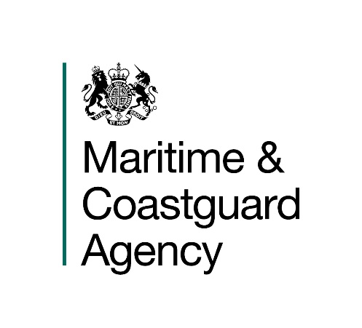

Introduction

The Maritime and Coastguard Agency (MCA) is an Executive Agency of the Department for Transport. The MCA is responsible throughout the UK for implementing and developing the UK Government's maritime safety and environmental protection policy. That includes co-ordinating Search and Rescue (SAR) at sea through Her Majesty’s Coastguard 24 hours a day, and checking that ships meet UK and international safety rules. The MCA work to prevent the loss of lives at the coast and at sea, to ensure that ships are safe, and to prevent coastal pollution: Safer Lives, Safer Ships, Cleaner Seas.

The MCA provide a full range of search and rescue, counter pollution, survey, inspection and enforcement activities and has 12 major business activities:

- Survey | - Seafarers Services
- Inspection | - Search & Rescue
- Enforcement | - Pollution Response & Salvage
- Ship Registration | - Stakeholder Communication
- Navigation Services | - Ministerial Services
- Strategic Prevention Design/Development | - Regulatory Process

These activities are supported by support services responsible for providing a range of administrative functions including; infrastructure, MCA people, financial management & administration and corporate management.

You are invited to submit a tender to the following Specification:

CONTRACT REFERENCE: TCA 3/7/1134
OIL RECOVERY AND CONTAINMENT SYSTEM

1. General requirement

1.1 The Maritime and Coastguard Agency requires a one-off oil containment, collection and recovery system for operations at sea in varying current speeds and sea energy. The requirement is for a complete fully self-contained package with all the necessary elements for an effective, efficient and cost-effective operation, these are detailed below.

1.2 The System must have the capability to capture an oil slick, separate the oil and water (minimising water recovery), whilst moving at various speeds through the water. All elements of the system should be robust and effectively contain and control the oil at up to 4 knots towing speed in sea water. It must be capable of collecting and containing a significant proportion of encountered oil ready for recovery by a separate skimmer system (for the purposes of clarity, the skimmer system does not form part of this requirement).

The winning tender must be able to provide evidence that the system has been reliably tested in marine conditions and operated in oil emulsions with varying viscosities.

1.3 The Oil Recovery and Containment System will be part of the MCA’s stockpile of Counter Pollution Equipment and will be used, in the event of a major marine oil spill, for the recovery of oil spilled into the seas around the UK. The System will also be used on a regular basis for training exercises.

- Technical Specification

2.1 A full system specification, including all major critical parts and assemblies, together with a complete comprehensive method statement, describing and explaining how your system operates is required with your tender submission.

2.2 The method of deployment and retrieval of your system should be explained in detail, to facilitate the assessment of ease of operation.

2.3 The system should be deployable from the deck of the towing vessel or from an appropriate dockside/quayside. We require the system to be deployed and towed by a single vessel.

2.4 Using medium viscosity oil, the recovery rate per hour of your system should be clearly quoted as a percentage of oil to emulsion, together with wind speed and wave height at the following towing speeds:

a) 1.0 Knot towing speed
b) 2.0 Knots towing speed
c) 3.0 Knots towing speed
d) 4.0 Knots towing speed

2.5 Tenderers are also to ensure that solutions/statements relating to the following requirements are clearly stated in the tender:

- A list of oil types (by viscosity) your system can recover from an oil spill should be provided.
- Overall weight of the whole unit.
- Overall dimensions of the whole unit.
- Number of operators required to deploy from and recover to storage container directly, plus time required by each operator per deployment & retrieval in calm conditions.
- Operating noise levels and advice on any Health & Safety issues for staff.
- Operational life of your proposed system before replacement is required, in terms of deployments and storage under normal usage.
- If your system’s oil containment method uses a boom, please provide the following information:
a) Material **
b) Draught
c) Freeboard
d) Length & diameter
e) Storage method for example a reel – including method of powering.

** Please provide two samples – no larger than a A4 sheet of paper, of any proposed boom material with your tender.

- Storage and Distribution

3.1 In an emergency situation, it is vital that the counter pollution equipment is capable of being deployed rapidly.

3.2 For ease of storage the complete system is to be housed in a single container and must have the ability to be deployed directly from the container into a water environment. The layout and dimensions of this container must be included in your tender.

3.3 A description of the equipment fully packaged indicating forklift pockets, rope holds and other lifting or moving mechanisms, must be detailed to assess the effectiveness of deployment.

3.4 The Tenderer shall detail how the proposed equipment is to be stored, including suitable environmental conditions.

- Warranty

4.1 We regard warranties as an important component of achieving overall best value for money. Full details of your warranty on the tendered equipment is required and in particular the period of cover. Please explain if in-house maintenance affects your warranty terms.

- Technical Support

5.1 The Tenderers shall detail what technical support and back up they are able to provide. This is to include as a minimum:

- Customer Support Contact numbers and email addresses,
- Standard and emergency response times,
- Spares/Repair Packages
- Options for on-site maintenance provision

Current costs are to be included in the Price Schedule as separate costs.

- Maintenance

6.1 The maintenance of this equipment will be carried out in-house. Tenderers are to provide an operating manual in MS Word or PDF electronic format including maintenance requirements and schedules.

6.2 Details and expected life of all major components and consumables, with recommendations of what should be held in our stock, are to be included in your tender. Current prices of those items to be detailed in the Price Schedule under Ancillaries and Spare Parts.

- Commissioning

7.1 Details are to be provided of the first testing and commissioning of the proposed system. Commissioning and training charges should be incorporated into the cost of the system as detailed in the Pricing Schedule.

- Delivery

  - The delivery price should be included in the overall cost as per the pricing schedule.

  - Suppliers must state in their tender the lead time for delivery to Barnsley, UK. Delivery on or before 31st March 2020 is a critical factor and an essential component of any bid if it is to go through to the evaluation stage.

- Selection Process

9.1 Tenderers should be aware that where appropriate, selected suppliers may be asked to clarify their tender or elements of it. It is anticipated that this can be achieved remotely without the need for a face to face meeting.

10. Proposed Procurement Timetable

Description | Date
Tender published on OJEU | 15th November 2019
Tender published on Contracts Finder | 20th November 2019
Bid Submission date and time | 11am 20th December 2019
Standstill period | 10 days
Proposed Contract Award | 6th January 2020
Delivery date | By 31st March 2020

