Bude-Stratton Town Council

Provision to design, rebuild/relocate Katy’s Corner Playpark

**To be submitted no later than 16 Jan 2023**

|  |  |
| --- | --- |
| **Employer** | **Contract Administrator** |
| Bude-Stratton Town Council  The Parkhouse Centre  Ergue-Gaberic c Way Bude  EX23 8LY | Steve Hayes  Facilities Manager (FM)  Bude-Stratton Town Council |

* General Requirements
  + Overview of project

Bude-Stratton Town Council (BSTC) is seeking a suitably qualified company to provide a two-stage service to design and build a new play area for 0–6-year-olds. The project seeks to remove the existing play equipment within Katy’s Corner and relocate the play area to the lower tier of the Bencoolen park.

The location of the site is at Bencoolen Road, Bude, EX23 8PJ

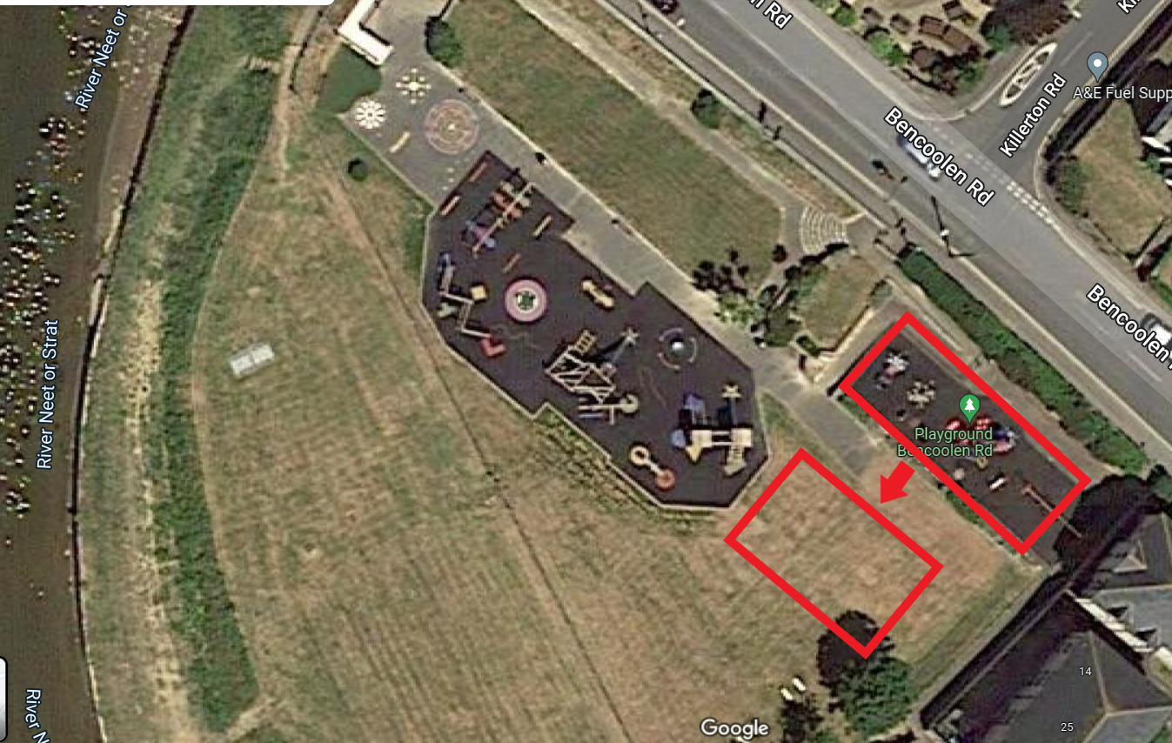

* Brief

We are excited to offer a design and build opportunity for a new play park within Bude. We’re looking for a team that can provide a complete solution and that can offer the following services over two stages;

Stage One - Design and Consultation

* Help consult with local users and stakeholders to explore design requirements, learning possibilities, desired story-telling direction and capture the culture of Bude
* Produce a design to fulfil the requirements of the project brief as determined by the consultation
* Work with the Town Council and their Facilities Manager to ensure that the design, materials and workmanship ensure long life and repairability
* To help write up documents required for planning permission - if required
* To provide technical assistance in the production of grant applications as necessary (with final submission being done by BSTC)
* To assist in BSTC vision of being carbon neutral by 2030 with sustainable materials, delivery and construction and be able to provide carbon audits if required

Stage Two - Reconfigure and Install

* Provide project management,
* Remove previous equipment and make safe the flooring of the upper area
* Manage safe site access and security
* Groundworks and installation of flooring in the lower area
* Construction and installation of equipment
* Safety sign-off
* Provision of warranties and aftercare repairs service

We are interested in a range of solutions – from off the shelf equipment to completely unique designs. The direction taken will be directed by the local community and budget/grant funding available.

The project will be in two stages with a break between. The design/s produced will go onto a final vote to the Town Council and if approved we will then commit to a chosen design & budget, and commission the second stage with the actual build.

* Site and Location

The main Bencoolen playground is centrally located and well used due to a recent complete redevelopment of the main play area. Due to the age and condition of the equipment and surfacing within Katy’s Corner, BSTC has prioritised funding to completely re-develop Katy’s corner and relocate the new play park onto the same level as the existing play park.

The Bencoolen Road Park is a central area in Bude, visible on the drive into town, next to the Tourist Information Centre and River Neet. The playground is located next to a main road but has good pedestrian access at 3 main points and a large Cornwall Council owned car park located approximately 100 yards away. The area is very close to the beach so does get the sea salt air, and gets very humid.

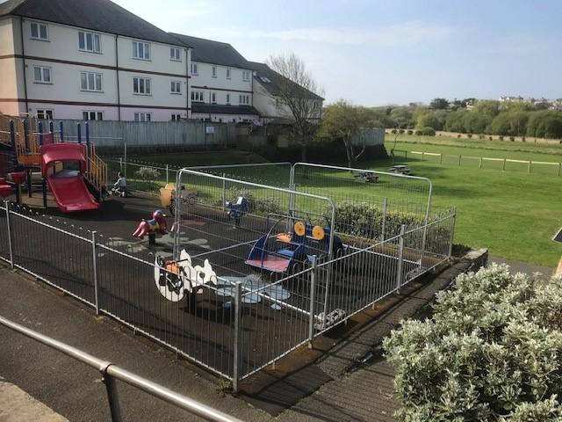

The current 0-6 play area measures 25m X 10m approx. and we believe that an area of a maximum 20m * 20m could be made available next to the lower play area for older children. Ideally the time spent between the closure and removal of the upper area and the build and commissioning of the new area will be minimised.

As the site adjoins the main route into Bude, access from that road is limited. Access from the Rugby Club and along the riverside is possible but must be carefully managed with our neighbouring landowners.

* Budget and Pricing

Bude-Stratton Town Council has a figure of £100,000 set aside in its reserves for the renewal of play equipment in the parish.  The Council may also wish to explore options for applications for further grant funding or sponsorship income to supplement its budget. Companies should provide quotations based on this information; however, the Council reserves the right to reduce the allocated budget dependent on the design and user group input with a preferred contractor. Town Council finances are excluding VAT.

All pricing should be exclusive of VAT and valid for a minimum of 90 days from the due date of the response.

Prices will be fixed and firm for the duration of the contract.

* Non-Consideration of a Tender Response

BSTC has the right to refuse any or all submissions without tenderers being able to claim any compensation.  All costs associated with the tender process and response is the responsibility of the suppliers that have been invited to participate.

BSTC may refuse a tender response if there has been any attempt to vary or alter the details within the tender document or is not able to provide all the information required by BSTC to make a full evaluation.

Any offence or inappropriate actions by the provider/supplier, including an offence under the Prevention of Corruption Act 1906 (2), or the supplier directly canvasses any member of the council concerning the tender other than “appropriate” contact made to the individuals named within this document for the purposes of clarifying the requirements or raising any questions pertaining to the tender.

* Contract Conditions

The successful contractor will enter into an agreement by way of a purchase order (PO), with BSTC.  In addition, a binding contract with agreed terms and conditions will be created for both BSTC and preferred contractor to jointly authorise.  The agreement will not be final until both parties have signed the contract.

The work is for the design, budgeting, documentation, removal, relocation, supply and installation of playground equipment, surfacing and all associated works which must all comply with European Safety Standards primarily EN1176 and EN1177 (taking into account any revisions).

The successful contractor must provide evidence of Public Liability Insurance of no less than £5 million and Employers Liability Insurance to BSTC within the tender process.

Confirmation of works hours, storage of materials, access/egress, location of skips (if any), and a final programme of works including RAMS will need to be finalised and provided to BSTC before work begins, most likely at the “pre-start” meeting, along with a detailed **Construction Phase Plan**.

* Overview Of Requirements
  + Project Design Phase

The design phase of the project will consist of;

* Creation and engagement of a User Group - of BSTC Councillors, nursery staff, engaged parents and BSTC Staff and Facilities Team
* Forming requirements from the User Group, and design iteration or workshop with them
* Working with BSTC on grant, partnerships and planning applications - support in writing documents (if required)
* Delivery of two final design and budget scopes for BSTC Town Council to decide and commit to 6 play move to Phase 2 of Project Build Phase
* Budget and Build Plan setting
* The Council wishes to own the Intellectual Property of the design that has been produced from this commission

*For this section we would wish you to provide case studies of how you have worked with organisations, together with user groups, to ensure the design is to the specification of the client.*

* Project Build Phase

Once planning/grant applications (if required) have been successful and a design chosen by BSTC; the Katy’s Corner physical build will include:

* Removal and disposal of existing play equipment (unless it is possible to relocate to new site)
* New safety surfacing (supplier to provide a number of options) and groundworks required to make good and ensure regulations are met over the entire area
* Pre-Cast Concrete (PCC) edging or alternative options that the supplier may offer or recommend
* New play park equipment suitable for 0-6 years of age with a selection of themes to compliment the surface colours and markings
* No seating or bins required
* Fencing may be required
* A selection of play park equipment suitable for use by disabled children

The materials used will be judged on the quality of the material, along with the aesthetic look and feel that is suitable for the desired outcome, local area and play park already in situ - as well as their cost.

*For this section we would like you to provide case studies of a range of builds for the age group within the current £200k allocation, of varying materials, ability to fit within the existing environment, carbon reports and recyclability, playability and learning, and warranty.*

* Surfacing

The choice of surfacing will be up to the supplier, the use of coloured wet pour would be encouraged to create an inviting and unique experience, whilst still providing a good level of longevity in terms of location, recyclable and environmental consideration, maintenance and potential vandalism.  The current play park has experienced vandalism in the past, mainly on the wet pour areas by means of cutting strips out near to the edges where it is most likely to shrink.

*For this section we would like you to provide case studies of what flooring options have been used, and evidence of how they have held up long term.*

* Removals

All existing equipment and flooring are to be removed, however, if the supplier feels that any existing equipment from Katy’s corner could be utilised within the new play park and still meets the safety regulations, this could be set aside for future use. All seating and fencing are to remain at the old Katy’s corner site for future projects.

* Value Add

The Council will be open to any additional value-added options within the proposal such as (but not limited to) 

* Open day Event support and giveaways
* Aftercare service (outside of any standard warranty inclusions)
* Creating press graphics
* Working with BSTC Communications staff to keep community informed of developments via a community webpage
* Ability to provide accurately coloured and to scale 3D models for visualisation (FBX, DAE, OBJ) and work with BSTC in-house pre-vis
* Post Installation Inspection

Please allow for a RPII qualified inspection following completion of the project and any noted defects or medium to high-risk reports that need to be attended to and resolved before the open date noted on the table below.

* Additional Requirements
* Rugby Club Access
* Ensuring play availability for as long as possible during build for 0-6 age group
* Ensuring that the older age group play area remains open during the construction works - or that any closures are minimised

The original Katy’s corner play park should stay as functional as possible for the public until the new play park is opened for us. The remaining area from Katy’s corner will require new flooring which is yet to be decided, and will need to be made safe.  The main use of this area will become a family seating area which will require shade and cover from the elements. Ideally this will be within the scope of this project, but options are open if it is deemed out of scope due to budget.

* Timetable

|  |  |
| --- | --- |
| **Action** | **Expected Date** |
| Tender Release Date |  |
| Site meeting for interested contractors |  |
| Tender Response Due |  |
| Selection of Preferred Supplier and any revisions to design |  |
| User Group, Design and Budget |  |
| Planning / Grant / Partnership Applications (if req) |  |
| Order placed with supplier |  |
| Works commence date |  |
| Works completion date |  |
| Snagging, inspections and open to general public |  |

Suppliers are to provide details of expected lead in times to start work from the time the purchase order is received, expected duration of the build.

* General Quality and Method of Works

1.1 Level of skill required

Appointed suppliers must ensure all workers are appropriately skilled and experienced for the type and quality of work.

The contractor shall inspect all components and materials carefully before using and reject and report any that are defective.

1.2 Supervision

In addition to the constant management and supervision of the works provided by the contractor in charge, all significant types of works must be under the close control of a competent person or supervisor to ensure the satisfactory quality and progress of the works alongside the external project manager (FM) who will meet with the contractor at the pre-start and weekly during construction.

1.3 Repairs

The contractor shall make good any damages as a consequence of carrying out works described within this tender.

In respect of any action shall therefore be deemed to be included in each clause.

1.4 Noise and Pollution

The contractor shall take all necessary precautions to prevent nuisance from smoke, dust, rubbish and all other causes including excessive noise to the general public.

1.5 Site Security and Safety

The employer (BSTC) expects this site to be safe and requires appropriate safety wear to be worn as identified in the contractor’s risk assessments. The contractor shall comply in all respects with the requirements and intent of the Health & Safety at Work Act 1974 etc. and the Construction Health, Safety and Welfare Regulations 1996 (CHSW 96) and associated current legislation, good practice as well as local rules (if they apply).

The contractor is to provide all Risk assessments, Method statements and/or RAMS before commencing any works to the facilities Manager (BSTC). The contractor’s method of works must also comply with the CDM 2015 regulations.

The Facilities Manager acting on behalf of BSTC as Health and Safety Officer reserves the absolute right to suspend any works at site should any continuing breaches of Health and Safety are observed or take place.  Such closure will be at no cost to BSTC and no extension of timings be entertained. This will include breaches and incidents noted by the FM or advised to by BSTC.

1.6 Lighting and Power

The contractor shall make their own arrangements for light and power as and when required.

1.7 Small Plant and Equipment

The contractor shall provide all tools, plant and equipment necessary for the safe and correct execution of works required.

* Tender Return

2.0 The following documentation is required to be submitted:

* Cost of design and consultation process
* Case study based on previous actual project or potential Bude Scheme detailing:
  + Plan and description of play park equipment
  + Indicative costs of project elements
  + Approach to consultation process
  + Approach to design process
  + Project management methodology
  + Communication Plan
* Two Client references - whom we may approach
* Confirmation of insurance
* Bidders will be invited to a Teams meeting in which they can present their approach and clarify any questions that the assessment panel may have.
* Scoring of Tender

2.1 Scoring Table

These are to be provided by the supplier; however, BSTC and the FM will examine the responses and verify the scoring using your existing case studies and the scoring matrix and tables provided in Appendix 1;

|  |  |  |
| --- | --- | --- |
| Criteria | Overview | Percentage |
| Play Assessment | Scoring will be made according to the play values of designs provided. Will be values such as variation of play offered, accessibility, suitability to age group, learning, storytelling, and play flow. | 20% |
| Creativity and ability to solve Design Briefs | Showing previous briefs and how the end result is the best solution to previous client requests. Ability to capture the culture of a location and translate that into a play park. Please provide references to those organisations. | 20% |
| Value for Money | Cost of Design and Consultation Stage  Cost of case study / indicative Bude Scheme | 30% |
| Physical Product Quality and Materials | Scoring based on eco-friendly/carbon neutral material and build options, material and build quality, suitability of this specific location, maintenance expectations, material aesthetics, repairability, warranties. | 20% |
| Communication | Proven ability to work with multiple stakeholders, quality of written briefs or applications, well written design documentation, user group and workshop moderation, visualisation quality. Any supporting information specifically to answer any requirements set out in the tender. | 10% |

2.2 Scoring Matrix

*(Per 10%)*

|  |  |  |
| --- | --- | --- |
| 8-10 | Superior | Exceptional demonstration of the relevant ability, understanding, experience, skills, resources and quality measures required to meet the project’s aims or requirements.  Response highly relevant with comparable contract value |
| 6-8 | Good | A comprehensive response submitted in detail and relevance and clearly meets most of the projected aims or requirements with no or little negative indications or inconsistencies |
| 4-6 | Adequate | Reasonable achievement of the requirements specified within the tender offer.  Some errors, risks or weaknesses or omissions which can be corrected/overcome with minimum effort. |
| 2-4 | Below Expectations | Minimal achievement of the requirements specified in the tender offer and presentation for that criterion. Several errors, risks, weaknesses or omissions which  are possible but difficult to correct or overcome. |
| 0-2 | Poor to deficient | Limited response provided, or a response that is inadequate, irrelevant, inaccurate, misleading and does not achieve the basic requirements or specification of the tender |

* Site Meeting and Questions by Suppliers

There will be a site meeting to give all suppliers the opportunity to meet with the Facilities Manager and Councillor(s) in 30-minute slots to clarify any questions.

However, this is not mandatory and suppliers are welcome to visit the site at their own convenience without penalty.

* Project Lead

The Facilities Manager for Bude-Stratton Town Council has been appointed to coordinate with regards to both the tender process and project management of the new playground.

Bude-Stratton Town Council Facilities Manager (FM):

Steve Hayes,  
[shayes@bude-Stratton.gov.uk](mailto:shayes@bude-Stratton.gov.uk),   
07442337714

* Format and Response

The tender response should be both digital and hard copy (including a copy of Appendix 1) with design visuals being in A1 size or as close to A1 as possible. Digital copies to be delivered via download link and physical USB Storage.

Tenders are to be returned in a plain white envelope marked only with:

Tender-Katy’s Corner Play Park and Ancillary Works

Bude-Stratton Town Council

The Parkhouse Centre

Ergue-Gaberic Way

Bude

EX23 8LG

Tenders are to arrive no later than 16 Jan 2023

APPENDIX 1

Play Assessment

For each submitted case study, please provide the following score table;

Score from 0 to 10 for each Value - 10 being highest. Add justification if required.

|  |  |  |
| --- | --- | --- |
| Value | Score | BSTC Score |
| **Traditional** |  |  |
| Swinging |  |  |
| Sliding |  |  |
| Rocking |  |  |
| Climbing |  |  |
| Balance |  |  |
| Rotating / Spinning |  |  |
| Inclusive / Less-abled |  |  |
| **Development** |  |  |
| Social Play - similar age |  |  |
| Social Play - with parents/older siblings |  |  |
| Role Play / Pretend Play |  |  |
| Storytelling / Imagination |  |  |
| Calculated Risk |  |  |
| Pushing Boundaries |  |  |
| Physical Skills |  |  |
| Sensory |  |  |
| Problem Solving |  |  |
| Artistic / Creativity |  |  |
| Education |  |  |

Creativity and ability to solve Design Briefs

For each submitted case study, please provide the following score table;

Score from 0 to 10 for each Value - 10 being highest. Add justification if required.

|  |  |  |
| --- | --- | --- |
| Value | Score | BSTC Score |
| **Brief Response** |  |  |
| Translation of Brief into Response |  |  |
| Capture of Local Location and/or Culture and/or educational opportunity |  |  |
| Fit for Immediate Surrounds |  |  |
| Working within Budget / Scope |  |  |
| **Public Response** |  |  |
| Satisfaction of Client |  |  |
| Response of Press / Media |  |  |
| Response of Users / Reviews |  |  |
| **Budget and Cost - £200k case study** |  |  |
| Design review |  |  |
| Value for Money |  |  |

Physical Product Quality and Materials

Please provide the following - using supplement pages if required;

Locations

State source locations of materials:

State manufacturer location:

State storage location:

State build team location:

Warranty

State Warranty of Materials by Type:

State Warranty of Manufacture:

State Warranty of Floor:

State Warranty of Fitting:

For each submitted case study, please provide the following score table;

Score from 0 to 10 for each Value - 10 being highest. Add justification if required.

Materials here must also include flooring.

|  |  |  |
| --- | --- | --- |
| Value | Score | BSTC Score |
| Longevity of Materials |  |  |
| Suitability to Local Beach Climate |  |  |
| Aesthetics of Materials |  |  |
| Repairability of Materials |  |  |
| Recyclability of Materials after end of life |  |  |
| General Build Quality |  |  |
| **Eco/carbon Considerations of** |  |  |
| Materials |  |  |
| Manufacture |  |  |
| Delivery |  |  |
| Build |  |  |

Communication

For the submitted case study / Indicative Bude Scheme, please provide the following score table;

Score from 0 to 10 for each Value - 10 being highest. Add justification if required.

|  |  |  |
| --- | --- | --- |
| Value | Score | BSTC Score |
| Focus Group / User Testing Management |  |  |
| Diversity of User / Focus Group |  |  |
| Workshop Moderation |  |  |
| General Communication with Stakeholders |  |  |
| Pitch Documentation |  |  |
| Design Documentation |  |  |
| Project Planning Documentation |  |  |
| Budget Documentation |  |  |
| Planning Permission Documentation |  |  |
| Grants / Partnership Documentation |  |  |
| Visualisations / 3D Models Quality |  |  |
| Opening Event support and giveaways |  |  |
| Press Communications |  |  |

Value for Money (BSTC Only)

Score from 0 to 10 for each Value

|  |  |
| --- | --- |
| Value | BSTC Score |
| Stage one - Design and Consultation |  |
| Stage two - Reconfigure and Install |  |
|  |  |
|  |  |