Excerpts from Eunomia Report

Data for ‘Sites’

GHG Sources to Include
This section considers the broader emissions arising from the day-to-day operations of organisations receiving funding from the Heritage Fund, irrespective of the funding received and what it was spent on. This approach will enable, once GHG calculations have been completed, the Heritage Fund to present a more general overview of the emissions arising from heritage organisations. Figure 2 presents where GHGs arising from ‘sites’ sits within the overall the Heritage Fund GHG footprint.
Figure 2 Scopes within the Heritage Fund's emissions footprint
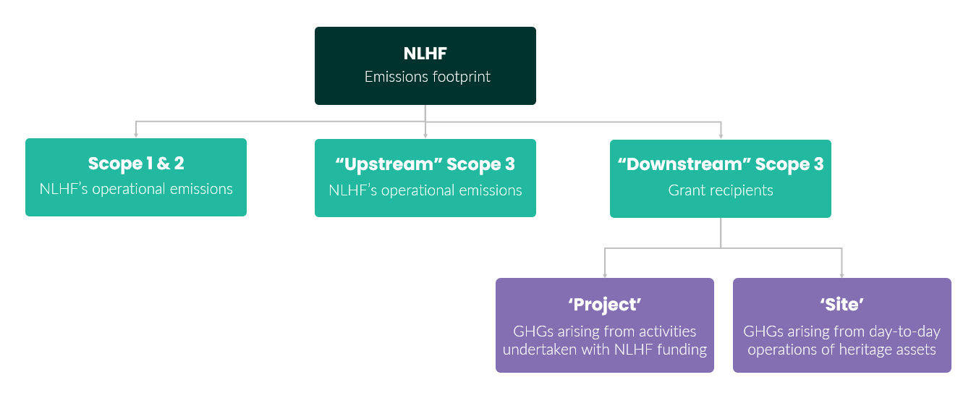
Within ‘site’ emissions, as a starting point the grant recipients’ Scopes 1 (direct fuel combustion), 2 (purchased electricity), and 3 (indirect) emissions should be considered (our recommendations for what should be included in the assessment are set out below). To be clear, there is overlap between the downstream ‘Scope 3’ GHGs of the Heritage Fund, and the Scope 1/2/3 emissions of grant recipients. When combined together, the Scope 1/2/3 emissions of grant recipients become the downstream Scope 3 emissions of the Heritage Fund. This is illustrated in Figure 3. The sizes of the rectangles are not to scale, but the larger size of the grant recipient rectangle indicates this will make up the vast majority of the Heritage Fund’s Scope 1-3 GHG emissions.
Figure 3: Illustration of Interaction Between the Heritage Fund and Grant Recipient GHG Scopes
Grant recipient Scope 1, 2 and 3 GHGs
the Heritage Fund Scope 3 GHGs

The Heritage Fund Scope 1 & 2 GHGs

Scope 1 and 2 emissions represent the minimum that should be accounted for within an emissions baseline, and Eunomia therefore recommends that data on these areas be collected from grant recipients as a high priority. In addition, certain Scope 3 categories can contribute significantly to emissions footprints and are therefore also recommended as a priority for inclusion where data is available. Eunomia’s recommendations for high priority GHG emission sources for inclusion from sites are detailed in Table 2-1.
Table 2-1 High Priority Recommendations for ‘Sites’ GHG Sources for Inclusion
Scope 1 | Scope 2 | Scope 3
Natural gas consumption (for heating) | Electricity consumption | Business travel
Fuel consumed by owned fleet vehicles |  | Land-use GHG fluxes
Any other fuel combustion
Further Scope 3 GHG sources may either represent only a small portion of overall emissions, or be more challenging for grant recipients to collect relevant data on despite contributing significantly to emissions. the Heritage Fund should consider including these GHG sources where possible, as their inclusion would paint a more accurate picture of grant recipients’ overall emissions. This includes GHG sources such as:
Employee commuting
Procured goods and services
Water consumption
Waste generation and destination
Visitor travel
Procured goods and services in particular can be a significant contributor to emissions, and data obtained for this purpose may also be beneficial for the calculation of ‘Project’ emissions ( see Section 2.2). There is, however, a need to balance the importance of the GHG emission source and the accessibility and ease of collection of data. The following section considers data accessibility, and provides our recommendations based on this balance.

Data Needs and Sources Considered
Following Eunomia’s consideration of GHG generating activities, and discussions with the data steering group, two approaches are put forward for collecting the data required for the calculation of ‘site’ emissions. It should be noted that both methods are likely to require primary data collection as, unlike the financial data that can be used for ‘project’ emissions (Section 2.2), the Fund does not already hold the type of data required for these calculations.
Option 1: Activity-based data: This approach to calculating GHG emissions would utilise data regarding actual consumed resources. While using this data would enable a very accurate calculation of GHG emissions, the needs are, however, quite specific, and may therefore be more onerous for grant recipients to obtain. Table 2-2 sets out the data which could be collected using this approach. Those marked with an asterisk would be essential, and the remainder optional, albeit best practice to include.
Table 2-2 Option 1 Activity Based Data Needs for 'Site' Emissions
Emissions Source | Data Needs | Units
Fuel combustion for heating and vehicles* | Quantities of fuel, broken down by type, consumed in the reporting year. | kWh, litres
Electricity consumption* | Quantities of electricity consumed by the organisation during the reporting year. Any renewable electricity generation or consumption should be specified. | kWh
Refrigerant use | Quantities of refrigerant leakage, or additional refrigerants purchased during the reporting year. | Litres of each refrigerant
Business travel* | Mileages travelled by mode of transport. | Miles or kms by mode
Water | Quantity of water consumed in the reporting period. | Litres or m³
Waste | Quantity of waste generated classified by end-of-life treatment | Tonnage by end-of-life
Procured Goods & Services | Total spend by category within the reporting year | £
Land-use typology* | Predominant type(s) of land across the organisation’s estate. This should only be relevant for organisations with significant land use. | Woodland, arable land, pasture land, wetland etc
Land area* | Total land area of the organisation | M², Hectares
Visitor travel | Number of visitors per annum and information relating to their general travel trends | No. of visitors  Average distance travelled by different transport mode
Option 2: Proxy Data: In light of the potential challenges collecting the data described in Option 1, it may also be pragmatic to consider whether ‘proxy’ indicators could be used to help calculate GHG emissions. Taking the approach of using proxy data to calculate emissions would still require a level of data collection from grant recipients. These data needs are much less detailed and would likely be less burdensome for grant recipients to collect and provide, however they will not result in the same level of accuracy and granularity in GHG emissions calculations as Option 1.
Table 2-3 Option 2 Proxy Data Needs for 'Site' Emissions
Proxy Data Source | Priority | Unit
Total Useful Floor Area (TUFA) (or similar) | High | m²
Building age | High | Year (could be banded, e.g. 1800-1900)
Building Type | High | Classification would need to be developed (e.g. museum, historic house, ancient monument)
Visitor Numbers | Medium | Number
Total Staff | Medium | Number

Data for ‘Projects’

GHG Sources to Include
This section considers the GHG emissions arising from ‘projects’, which we define as the specific activities that are undertaken as a result of grant recipients spending their grants.
The GHG sources associated with projects can be broadly determined through the goods and services purchased with the grant financing. This spend breakdown is likely to vary across different types of projects, although it is possible that within project types (e.g. new-build construction; renovation; exhibition curation etc.) broad categories of GHG emitting activities could be determined. Examples may include construction materials, tools and equipment, chemical products, or labour costs. These GHG sources would largely be considered the ‘Scope 3’ of grant recipients, and therefore the ‘Scope 3 of the Heritage Fund’s Scope 3’. (We recommend not being too focussed on the Scope definitions, as these can become unhelpful and overly cumbersome).
It is also important to note that as set out in Figure 1, some grant financing is spent on day-to-day operations of grant recipients, particularly grant-in-aid. As per the decision set out in Section 1.2.2, the Heritage Fund needs to decide which funding streams to include within this research, as this will have repercussions for exactly what GHG sources are included under the ‘project’ definition. If revenue funding is included the exercise would include grant financing spent on day-to-day operational activities.
An additional consideration within the ‘projects’ category of GHG emissions is how the funded project may impact the ongoing GHG emissions of the Heritage Fund’s grant recipients. For example, if a grant recipient used their funding from the Heritage Fund to improve energy efficiency within their buildings, this would reduce the ongoing operational GHG emissions of the grant recipient. This type of impact is not within the current scope of analysis of this review exercise, though may well be worthy of further thinking. For example, it may be possible for the Heritage Fund to integrate tracking of whether grants provided are spent on ‘green’ activities, and estimate GHG savings which result from these. Eunomia would be happy to consider this further with the Heritage Fund separately to this present report.

Data Needs and Sources Considered
Two approaches have been identified as potential routes for calculating these emissions, each requiring a different set of data to be collected.
Option 1: Activity based data regarding goods and services purchased: This approach would require granular data, ideally on an item-by-item basis, regarding what grant financing was spent on within projects. This may be more suited to certain project types (e.g. construction), than regularly purchased typical types of goods. An example of data needs if following this route are displayed in Table 2-4.
Table 2-4 Recommended Data Needs for 'Project' Emissions
Emissions Source/Indicator | Data Requirements | Units
Construction materials | Quantities of materials purchased by item type | Kg
Area Footprint | m² constructed of usable/habitable space, and auxiliary | m²
Year of construction | Year | N/A
Capital Spend / Value of Project | Spend broken down by category (e.g. capital costs, staffing costs etc) | £
Project Type | Is the project a refurbishment, a new build, or other type | N/A
Habitat created | Hectares broken down by habitat type | Ha

Option 2: Proxy data - assigning quantities of spend into categories, with GHG calculations based upon the categories: This is a less granular approach, but is likely to be more achievable given the data already available through the Fund’s database. If this approach were followed, each project would be assigned a spend category, and Eunomia would create an emission factor for every GBP spent on goods and services in this category. Table 2-5 gives initial suggestions of such categories. The Heritage Fund data steering group has looked at a early draft of this categorisation and report that spend data categorised into staff costs, repair work, and professional services may be available – a more thorough assessment of possibilities would be required as a next step.
Table 2-5 Potential Spend Categories for 'Project' Emissions
Potential category | Description | Unit
New building work | Costs associated with the construction of new buildings | £
Staff costs | Costs associated with the salaries of staff working on the project | £
Repair work | Costs associated with repair or restoration work required for a project | £
Professional services | Costs associated with the external procurement of professional services associated with a project | £
Events costs | Costs associated with events, e.g. implementing a new exhibition | £
Utilities | Costs associated with paying utility bills | £
Habitat creation | Costs associated with creating or restoring green spaces | £

The benefits and drawbacks of each approach are summarised below:
For the activity-based data approach:

Pros
Calculating emissions at a product/activity level is likely to give more accurate results than when using spend-based emissions factors
The Heritage Fund will receive more granular information about what is being purchased with grant payments
Cons
Primary data likely required, as not currently held on the Heritage Fund’s databases
Potential lack of data availability, even from grant recipients

For the ‘spend categories’ approach:
Pros
With the Fund’s existing data on project funding, this method is unlikely to require additional data collection from grant recipients.
Cons
The use of spend categories obscures much of the detail of what is actually purchased with grants
Lower accuracy and confidence in emissions calculations due to uncertainties of spend-based emissions factors
Time will be required by the Heritage Fund data team to extract the relevant spend information
Emissions factors will need to be updated over time to reflect the changing emissions intensity of spend

