**Network Services Agreement RM1045 Framework Schedule 4**

I

**(Template Order Form and Template Call Off Terms) Part 1a**

**Direct Award Order Form**

##### This Order Form must be used to place a Direct Award under the Network Services Agreement

Before completing this Order Form, please refer to the guidance provided **(How to complete a direct award order form)** which is available from the Crown Commercial Service (CCS) website on the agreement web page: <http://ccs-agreements.cabinetoffice.gov.uk/contracts/rm1045>

**Order Form completion**

##### The Order Form consists of the following sections, please complete as fallows:

**Section A** - **General information**

##### The Customer must complete this section for all Orders.

**Section B** - **Direct Award information**

##### The Customer must complete this section for all Orders.

**Section C** - **Location details/requirements**

##### The Customer must complete this section for all Orders.

**Section D** - **Call Off Contract award (Direct Award)**

The Customer must complete and sign this section for all Orders before sending the Order Form to the Supplier.

The Supplier must complete the grey boxes in this section and return a copy of the Order Form to the Customer. The Supplier may sign as acknowledgement of receipt of the Order.

**Section A**

**General information**

This Order Form is issued in accordance with the provisions of the Network Services Framework Agreement RM1045.

The Supplier shall supply the Services specified in this Order Form to the Customer on and subject to the terms of this Order Form, the appendices to this Order Form, as· completed by the Customer and the Call Off Terms (together referred to as the "Call Off Contract") for the duration of the Call Off Contract Period.

For a Direct Award the following appendices may apply to the Call Off Contract:

#### Appendix 1 - Testing

Annex 2 Test Certificate

Annex 3 Satisfaction Certificate

* to be completed by both Parties as required throughout the life of the Call Off Contract, where testing has been requested in section B of this Order Form. · ·

Reference: Direct Award and Short Form Further Competition Call Off Terms, Schedule 4

#### Appendix 2 - Variation Form

* to be used, if required, by both Parties throughout the life of the Call Off Contract. Reference: Direct Award and Short Form Further Competition Call Off Terms, Schedule 12

The Call Off Terms that will apply to the Call Off Contract are as specified in the Direct Award and Short Form Further Competition Call Off Terms (Framework Schedule 4, part 2).

#### Customer details

**Customer Organisation name**

Department for Education

Your organisation's billing address, please ensure youInclude a postcode Address for lnvoici is:

#### Customer Representative and contact details:

The name of your point of contact for this requirement





#### Supplier details

**Supplier name**

The Supplier organisation name. Call Off Contracts must be awarded to the Supplier name as It appears In the Supplier Framework Agreement.

These are avaliableon the agreement webpage, httt>;ll oos-aoreamems,cab)Mtoffiee.goy.uk/contraQts/nn104§. Please see

the documenst tab, and refer to Suppliers by lot.

Vodafone Limited (company no: 01471587)

#### Supplier address

The Supplier's regislered address, please see the documents tab on the agreement webpageand refer to Supplei rs by lot.

# http://QCS:eareemen1s.cabjoetoffice,goy.uWcontracts1t:m1045.

Vodafone House, The Connection, Newbury, Berkshire, RG14 2FN

**Section B**

**Direct Award information**

#### Customer Order reference number

**Please** provide a unique reference for this I OH Contract

### ICT2016/025

##### Service C:>ffer reference

The Item number/a for, the Service Offer/s (called S ier item ID in the CataloguePublication Portal) this can be conflimed

by the Supplier if required.

RM1045-l10-SSO#03

##### Description of Services required

Please provitle a descnpllon of Services required to enable the Supplier to ensur-ethat-the requirement Is fully provfdedtby the Service Offe- r selected. Please ensure allrequired options listed.

are

Where additional :resting or Testing as an option Is required, please ensure these requirements are clearly listed. Please proVfde details of quantity required where this is relevant.

The Ser:vices required are as described in the Vodafone RM1045 Lot 10 SSO 03 and consist of a unified communicationsservice to provide enterprise telephony and a multi-channel cloua communicationsservice to provide contact centre services.

Jhe Customer does not require to purchase Equipment in support of these services but will make use of

existing devices.

The unified communicationsservice is to be based on Cisco Systems Hosted Collaboration Solution (fiCS) platform and Clsco's Unified Communications Man ger. This is to be integrated with the Suppliers PSTN and mobile networks. This integration to be already In place and require minimalconfiguration to•pro vide a functional service.

ifhe multi-channel cloud communications service is to be based on STORM. lihis is to be integrated with the Supplier's PSTN networks. This Integrationto be already In place and require minimal configuration to provide a functional service.



The Services support the Customer's strategy to:

Move away from platforms based on the Customer's premises to "Cloud-Based" platforms hosted

off-site "in the cloud".

Move to a flexible solution enabling end users to use mobile and fixed telephone hand-set devices to make and receive enterprise telephony calls.

Provide reliable, robust, scalable and flexible telephony and contact centre platforms.

Ultimately allow the Customer's staff to work and be contactable from any location on any device of their choice.

Connectivity services are also required to link theCustomer's network totheunified communicationsservice and multi-channel cloud communications service. i'he following IP VPN links are required:

**Lot or Lots covered 6y·this requirement**

Lot10

Call Off Commencement Date

The Call Off Commencement Date is the date of dispatch of this signed Order Fonn . This date can be found in section D of

this Order Form.

Call Off Initial Period Call Off Extension Period

Anyperiodin months, up to themaximum Cal OIi initialPeriod The maximum CaU Off Extension Period is 24 Months of 36Months

36 months 24 months

**Last price** p@id

Please provide·theexpenciiture in the lastifull financial1 r by your organisation coverin, gt he services being replaced by this

CaR Off Contract (it applicable).

Please provide any relevant details to explain the figure.

NIA

**Implementation Plan required?**

A draft ImplementationPlan will form part of the Service Offer, if you require the Supplier toprovide a planbased on this draft, please select. See clause 6 of theCall Off Terms

□

Yes l8l No

**Testing**

Testing may be included In a Service Offer.

Options for additional Testing, or Testing as an option, may also be described in a Service Offer.

Please indicate if you require *any* of the described Testing options. These must be Included In your 'Descriptionof Services

required' section of this fonn.

If testing is required the forms attached at appendhc 1 (Call Off Schedule 4) willbe used by both Parties throughout the life of the Call Off Contract.

Testing options are required l8l Testing options are not required □

##### Service Maintenance Level (SML) required

The Supplier's Servci e Offer will have a default Servci e Maintenance Level; opt{ons for other SMLs may be available and wlU be described in the Sefvice Offer. Where optionsare provided, please indicate therequired level See clause 10 of the CaU Off Terms and Schedule 6 of the Call Off TemlS.

Call Off Schedule 6 shall not apply to the Services provided under, this Call Off Contract The Service

Levels, Service Credits and Perfonnance Reporting shall be as set out in the Service Offer.

The level of Service Management included in the Charges section is Standard as defined in the SSO documents.

#### Charges

These will either appear as anitem price or will be derived from the Price Card attachedto the Service Offer. Please note that if a Service Offer is indicated as'free' this is due to the functionality of the softwareof the Catalogue Publci ation Portal. You must Identify the relevant optionsand cosls from the Price Card attached.

Installation and commisisoningService

The Customer requires the following Professional Serviceswhich Is underst od are sufficient for the setup

of the Services and commissioninginto live operation. Unified communications (VONE-C)

**Im lementation** & **Trainln Sub-Total £143,075.00**

Multi-channel cloud communications (STORM)

**Im lementatlon** & **Trainin Sub-Total** £7.2,400. 0 0

The resource usage will be continually monitored between the Customer and the Supplier and is not expected to exceed that the in the above table. Any costs incurred over and above this profile would need to be justified and formally agreed in advance of any work being undertaken and in accordance with the Change Control process.

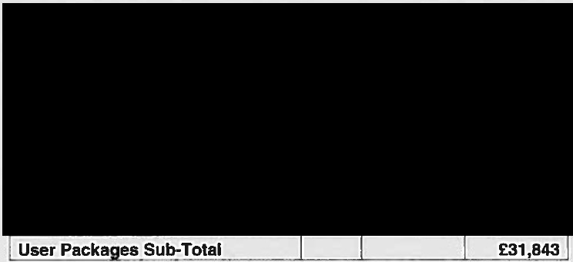Other Service Charges VONE-C





STORM

Total Monthlv

'

**Licenses**

Total Upfront

Monthly Per Unit

-

Unit

Upfront Per

Qty

Description

##### 6

AM1045 Direct Award Order Form, v4, March 2016

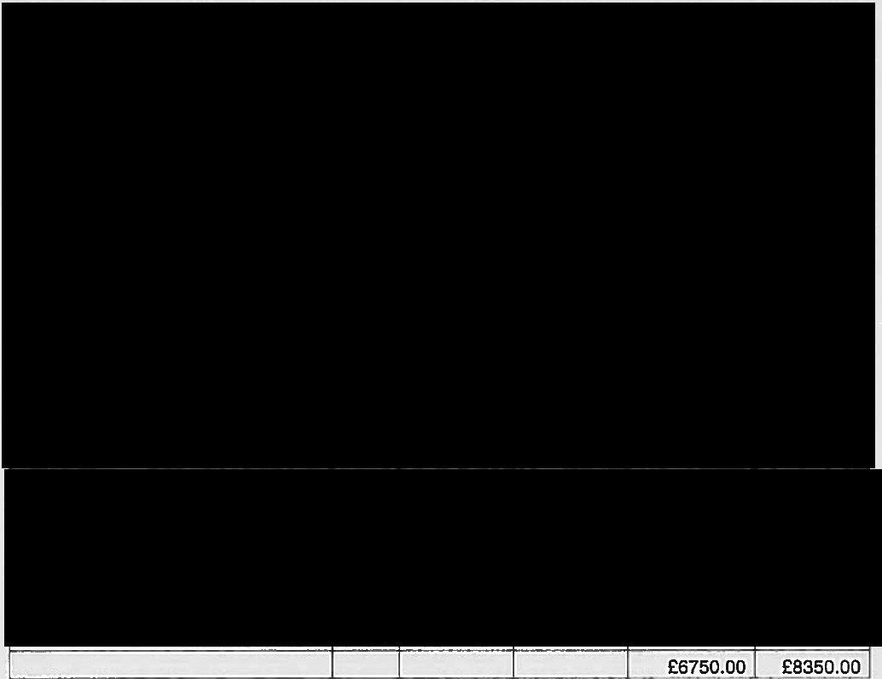



|  |  |  |  |  |  |  |  |
| --- | --- | --- | --- | --- | --- | --- | --- |
| Security/ Access |  | -- - | Qty | Monthly Per Unit | h  Total Upfront | Total Monthly |  |

7

RM1045 Direct Award Order Form, v4, March 2016

Crown Commercial Service

-

IP VPN CONNECTIVITY

For the Service as outlined in the Description of Services to charges for connectivity are as follows:



###### Total contract value

Cost of Project and contract over **3** years - £2,212,911

###### Scots Law required?

**Tick as required.**

See Call Off **Schedule** 13, **clause 2.1.1**

Yes D **No 181**

Non-Crown Body?

Please indicate'if you are a Crown or non-Crown Body, See Call Off Schedule 13, clause 2.1.3

□

Crown Body 181 Non-Crown Body

Northern Ireland Law required?

Tick as reguired.

See Call Off Schedule 13, clause 2.1.2

Yes□No

**Non FOIA** Public Body?

Please lndJcate if you are an FOIA Public Body or non-FOIA Pu61ic Body, See Call Off Schedule 13, clause 2.1.4

□

FOIA Public Body 181 Non FOIA Public Body'

###### Dispute Resolution - role

Please provide details of the role within your organisation (if different from the contact provided in section A of this form) that would deal with Disputes.

See Call Off Schedule 11. clause 3.1 for details.

NIA

Dispute Resolution - **arbitration**

The default location for arbitration under this framework is London. If you wish to identify a more convenient location (for youand **the Supplier)** you **are able lo do so.**

See CallOff **Schedule 11, clause 6.4.6**

**NIA**

**Section C**

**Location details/requirements**

Please provide details of all the locations where the Supplier will be required to deliver the Services requested.

For each Site to be covered by this Order Form, please providethe full postal address, including postcode. If a postcode is not available please provide an appropriate reference such as a National Grid reference, which can be found using_an internet search such as Grid Reference Finder.

The required date of delivery of the Services must be in accordance with the Outline Implementation Plan described in the Service Offer.

Ser\lice _



**Site address Site postcode Required serivice**

**commencement date** ;

**Section D**

**Call Off Contract award (Direct Award)**

This Call Off Contract is awarded in accordance with the provisions of the Network Services Framework Agreement RM1045.

The Supplier shall supply the Services specified in this Order Form to the Customer on and subject to the terms of this Order Form, the appendices to this Order Form, as completed by the Customer and the Call Off Terms (together referred to as the "Call Off Contract'') for the duration of the Call Off Contract Period.

#### Unique can Off Contract Identifier

A unique Order reference number provided by the Suppfter for this Call Off Contract.

Click here lo enter text.

#### Supplier Representative

The name and contact **details** of the Supplier point ol contact for this requirement

9

AM1045 Direct Award Order Form, v4, March 2016



**Dispute** Resolution - Supplier

Please provide details of the role within your organisation that would deal with Disputes (if different from the contact given above.) See Call Off Schedule 11, clause 3.1 for details.

***NIA***

#### Call Off Contract Commencement Date

The commencement date of the Call Off Contract will be the date of dispatch of this signed Order Form by the Customer to the successful Supplier in accordance with Framework Schedule 5 (Call Off Procedures) paragraph 8 (Call Off Award Procedure.)

## ISIGNATURES

#### For and on behalf of the Customer



|  |
| --- |
| Name |
| Job role/title |
| Signature |
| IDate of dispatch |

Please note that if anOrder Form is sent to a supplier bypo st, thepostal address provided on the agreement webpage http:l/ccs­

agreements.cabinetoffice,qov.uk/contracts/rm1045 should beused.

Pleasesee the documents tab, and refer to Suppliers by lot. This document also provides an email address for each supplier.

#### For and on behalf of the Su lier

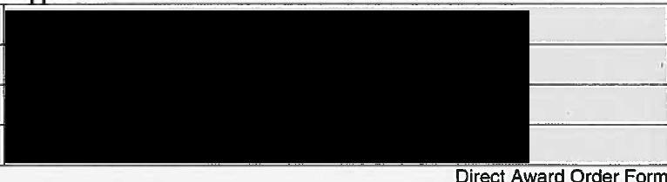

|  |
| --- |
| Name |
| Job role/title |
| Signature |
| Date |

Crown Commercial Service

-

Appendix 1

### CALL OFF SCHEDULE 4: TESTING ANNEX 2: TEST CERTIFICATE

To: Vodafone Limited

From: Department for Education

[insert Date dd/mm/yyyy]

Dear Sirs,

Delive rables :

### TEST CERTIFICATE



We refer to the agreement **("call Off Contract")** relating to the provision of the Services between the Department for Education **("Customer")** and Vodafone Limited **("Supplier")** dated *[insert Call Off Commencement Date dd/mm/yyyy].*

The definitions for terms capitalised in this certificate are set out in this Call Off Contract. [We confirm that all of Deliverables listed above have been tested successfully in accordance with the Testing Strategy Plan relevant to those Deliverables.}

## [OR]

[This Test Certificate is issued pursuant to paragraph 13.1of Call Off Schedule 4 (Testing) of this Call Off Contract on the condition that anyTest Issues are remedied in accordance with the Rectification Plan attached to this certificate.]*



Yours faithfully [insert Name] [insert Position

acting on behalf of Department for Education

### CALL OFF SCHEDULE 4: TESTING ANNEX 3: SATISFACTION CERTIFICATE

##### To: Vodafone Limited

From: Department for Education

[insert Date dd/mm/yyyy]

Dear Sirs,

Milestone:

#### SATISFACTfON CERTIFICATE



We refer to theagreement **("Call Off Contract")** relating to theprovision of th e Services between the Department for Education **("Customer")** and Vodafone Limited **("Supplier")** dated *U!1_sertCall Off Commencement Date dd/mm/yyyy* ].

The definitions for terms capitalised in this certificate are set out in this Call Off Contract

[We confirm that all the Deliverables relating to Milestone [number] have been tested successfully in accordance with the Testing Strategy Plan relevant to this Milestone [or that a conditional Test Certificate has been issued in respect of those Deliverables that have not satisfied the relevant Test Success Criteria.)]*

[OR]

##### [This Satisfaction Certificate is granted pursuant toparagraph 13.1 of Call Off Schedule 4 (Testing) of this Call Off Contract on the condition that any Test Issues are remedied in accordance with the Rectification Plan attached to this certificate.]*

[You may now issue an invoice in respect of the Milestone Payment associated with this Milestone in accordance with the provisions of Call Off Schedule 3 (Call Off Contract Charges, Payment and Invoicing)]*



Yours faithfully [insert Name] (insert Position]

acting on behalf of Departmentfor Education

12

RM1045 Direct Award Order Fonn, v4,March 2016

Crown Commercial Service

•

Direct Award Order Form

Appendix 2

### CALL OFF SCHEDULE 12: VARIATION FORM

No of Order Form being varied:

Variation Form No:

BETWEEN:

Department for Education **("the Customer0 )**

and

Vodafone Limited **{"the Supplier")**

1. This Call Off Contract is varied as follows and shall take effect on the date signed by both Parties:



1. Words and expressions in this Variation shall have the meanings given to them in this Call Off Contract.
2. This Call Off Contract, including any previous Variations, shall remain effective and unaltered except as amended by this Variation.

Signed by an authorised signatory for and on behalf of the Customer Signature

Date

Name (in Capitals) Address

Signed by an authorised signatory to sign for and on behalf of the Supplier Signature

Date

Name (in Capitals) Address