Site Information

NOC Roof Renewal Project

May 2019

|  |  |  |  |  |  |  |  |  |
| --- | --- | --- | --- | --- | --- | --- | --- | --- |
| Site Information   |  |  | | --- | --- | | Project name | NOCS Roof Renewal | | Project no. | 1620004524 | | Recipient | National Oceanography Centre | | Document type | Site Information |   Roof Renewal |

Revision History

|  |  |  |  |  |
| --- | --- | --- | --- | --- |
| Revision | Date | Purpose / Status | Document Ref | Comments |
| 02 | 23.11.2018 | Draft issue to Client | BAA4300-RAM-ZZ-SCO-BR-KA-0002 | For review by NOC Estates |
| 03 | 14.12.2018 | Issued to UKSBS | BAA4300-RAM-ZZ-SCO-BR-KA-0003 | For review by UKSBS |
| 04 | 30.05.2019 | Final | BAA4300-RAM-ZZ-SCO-BR-KA-0004 | Minor updates, comments incorporated |
| 05 | 11.12.2019 | Final | BAA4300-RAM-ZZ-SCO-BR-KA-0005 | Prepare for issue. |

|  |  |  |  |  |
| --- | --- | --- | --- | --- |
| **Prepared by** |  | **Reviewed by** |  | **Approved by** |
|  |  |  |  |  |
| **Ben Frampton** |  | **Ben Rowe** |  | **Ben Rowe** |
| Graduate Project Manager |  | Director |  | Director |

|  |
| --- |
| This report is produced by Ramboll at the request of the client for the purposes detailed herein. This report and accompanying documents are intended solely for the use and benefit of the client for this purpose only and may not be used by or disclosed to, in whole or in part, any other person without the express written consent of Ramboll. Ramboll neither owes nor accepts any duty to any third party and shall not be liable for any loss, damage or expense of whatsoever nature which is caused by their reliance on the information contained in this report. |

|  |
| --- |
| Contents  **Site Information** |

1. INTRODUCTIoN 4

1.1 Introduction 4

1.2 About NOCS 4

1.3 Project Description 4

1.4 Project History 5

2. PROJECT INFORMATION 6

2.1 Site location & Overview 6

2.2 Topography and Previous Land Use 7

2.3 Ecology Assessment 7

2.4 Ground Conditions 7

2.5 Existing Utilities and Services Infrastructure 7

2.6 Works by Others Concurrent to the Project 11

3. Appendices 12

LIST OF FIGURES

Figure 1: National Oceanography Centre, Southampton 6

Figure 2: NOCS Location and Access 6

Appendices

Appendix A: Work Stage 2 Report

Appendix B: Morgan Tucker Pavement Design Study

Appendix C: Ecology Report

Appendix D: HRA Screening Letter

Appendix E: NOCS Asbestos Register

Appendix F: NOCS Policies & Procedures

Appendix G: NOCS Significant Hazard List

Appendix H: Structural Assessment and Conditions Report

Appendix I: NOCS Visitor Map

GLOSSARY

|  |  |
| --- | --- |
| ABP | Associated British Ports |
| CDM | Construction Design and Management Regulations |
| EA | Environmental Assessment |
| HRA | Habitat Regulations Assessment |
| HV | High Voltage |
| MEDA | Mechanical Electrical Distribution Areas |
| MARSIC | Marine Robotics Innovation Centre |
| NERC | Natural Environment Research Council |
| NOC | National Oceanography Centre |
| NOCS | National Oceanography Centre Southampton |
| NOC PM | NOC Project Manager |
| UKRI | UK Research and Innovation |
| UoS | University of Southampton |

# INTRODUCTIoN

## Introduction

This Site Information document has been prepared to inform the Contractor of the Works to be carried out in relation to the Roof Renewal at the National Oceanography Centre in Southampton and should be read in conjunction with the Project Scope document reference BAA4300-RAM-ZZ-SCO-BR-KA-0005.

## About NOCS

The National Oceanography Centre in Southampton (NOCS) is the UK’s centre of excellence for integrated oceanography. It delivers science of the highest international standard and supports the UK’s strategic and economic interests in the ocean. This includes global oceanographic change, the sustainable use of ocean resources, increasing resilience to marine related hazards and innovating and transforming technologies for ocean monitoring. It also hosts large-scale research infrastructure (the blue water research vessel fleet and submersibles), data and pooled specialist scientific equipment for use by the wider scientific community. NOCS has an annual income of £42m and employs approximately 540 staff.

The National Oceanography Centre was originally constructed in 1993 under a development agreement with Landlord, Associated British Ports (ABP). NERC hold the head lease for the site until 2114. In collaboration with our partners UoS this is managed as a shared site with UoS, who occupy around 45% of the available floor space. The operational costs are shared on occupancy basis, and UoS are a key funder of this roof renewal project. Overall the site:

* Accommodates circa 2,600 staff, students and tenants
* Occupies circa 48,899 m2 including approximately189 labs occupying circa 4,842m2
* Hosts over 30,000 visitors annually

The NOCS site is home the Marine Robotics Innovation Centre (MARSIC), which benefits from high tech start-up companies developing marine autonomous systems technologies, and who work with NOC world leading autonomous underwater fleet.

In April 2018 NERC became part of UK Research and Innovation (UKRI). UKRI is an independent organisation with a strong voice for research and innovation, both to government and internationally, UKRI are supported and challenged by an independent chair and board. UKRI are principally funded through the Science Budget by the Department for Business, Energy and Industrial Strategy (BEIS).

## Project Description

Unfortunately, the main building is now exhibiting some failings within the pitched roof coverings due to them reaching the end of their operational lifespan and incorrect installation. This has resulted in the existing roofs being temporarily covered by netting to prevent any displaced slates from damaging property, cars or resulting in injury to persons. The roof comprises man made Eternit 2000 slate over battens, felt and rafters with insulation between the rafters and a ventilation space maintained. The roof is at about 25-degree pitch. Most areas of slating appear to date back to original building construction in 1994.

The slates are moderately weathered. The coating has eroded because of the normal weathering process and will now accelerate. There is widespread lichen growth and some moss growth on slate joints. This type of organic growth will itself cause further water retention on the roof surface and accelerated deterioration. Localised star crazing, usually corresponding to the position of hard points beneath, typically nail heads is evident as is localised tail rivet deterioration and damage. This and the observed curling will lead to accelerated deterioration and failures of the slates with inherent safety risks of falling slate. Because of good management, a series of replacement slates are evident. Older fixings are also deteriorating and will loosen and pull out more readily.

The head laps to slates were found to be below minimum standards required and since they are at the minimum pitch recommended are vulnerable to wind lift and driven rain. Battens are also undersized compared to the normally required sizes and the underlying membrane is also damaged and perforated providing limited secondary protection.

Wind loading calculations undertaken by our structural engineer indicate that there are roof locations where wind suction exceeds the expected manufacturer’s design capacity. This may well be a contributory factor in the deterioration of condition and slate failure described in this report. Ridges are dry fixed and now porous and fragile and beginning to fail. Ventilation to ridges is compromised and ridges do not provide the level of cover required to the top of the slate courses. Plastic slate ventilators provided in several places to the roof to ventilate above the insulation are a source of weakness to the construction as well.

As a result, it is expected that water penetration will occur through the slate roof coverings in severe weather conditions, and that ridges, eaves and lower parts of roof slopes will be especially vulnerable, along with node wall abutments. There is now no option other than to replace the Eternit roof slates with another product.

The existing detailing to the nodes is also sub-standard, allowing water to penetrate internally.

This is caused by several details that are difficult to construct and which have been undertaken badly. The NOCS have spent significant sums on attempting to address this defect and it is now necessary to take a longer-term solution to provide some form of rainscreen to the relevant faces to remove the problem at source.

In July 2018 UKRI, NOCS and UoS approved the business case to replace the roof covering to the main building. The recommendation was to replace the roof coverings and to over clad the brickwork to the abutting nodes to correct these defects. The project encompasses the removal of the existing roof tiles to be then replaced with a VM-zinc covering as well as additional works to clad over the brickwork to the abutting nodes with a similar zinc material. This also includes the security hut, not currently included on the drawings.

## Project History

In 2016, Savills (UK) Limited were appointed to investigate these defects and carried out several inspections of the roof and adjacent internal spaces. The Savills Report, which was comprehensive in terms of analysing the defects, concluded that the roof coverings suffer from numerous defects and inadequacies. The Savills report made no mention of how the defects and issues could be resolved. In December 2017, NOCS commissioned Ramboll under the NERC framework to carry out a Work Stage 2 assessment study to progress the design solution(s) prior to committing itself to a major capital investment project to replace the pitched roof coverings.

As part of their Technical Advisor role Ramboll were instructed to carry out an Assessment Study of the Savills report. Their scope was to provide a solution to the issue of water penetration into the NOCS building in Southampton alongside their sub-consultants to provide options. Analysis of the options, considerations and conclusions of the Assessment Study were set out at Work Stage 2 and concluded in August 2018. The Work Stage 2 report is attached in Appendix A. If there are any discrepancies between the WS2 report and the WS3 drawings, and this Site Information (accompanied by the Project Scope document), then the latter two will prevail, with the Site and Project Scope taking first precedence.

The Work Stage 2 report outlined a recommendation with a solution to remove the roof tiles and replace the roof covering with a warm VM Zinc roof, retaining the roof structure below.

In August 2018 NOCS instructed Ramboll to carry out a Work Stage 3 developed design, cost estimate and submission enabling a planning application. A Pre-Application was submitted to Southampton City Council on 24 August 2018. On 17 September 2018 Southampton City Council confirmed that a full planning application would not be required on the basis of the technical and detailed information supplied by the Technical Advisory Team’s Architect Stride Treglown, further details are included in the Project Scope.

# PROJECT INFORMATION

## Site location & Overview

The National Oceanography Centre is located within the Eastern Docks in the Port of Southampton, shown on Figure 1. The building is situated on an active quayside as well as being within the boundary of port occupied by ABP (Association of British Ports).

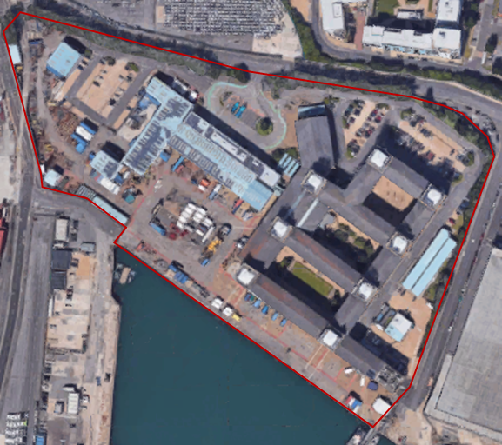

Figure 1: National Oceanography Centre, Southampton

The NOCS site lies within the Eastern Docks in the Port of Southampton and is accessed via Dock Gate 4 on Platform Road. The National Oceanography Centre is clearly signed from the Dock Gate and is accessed via Central Road and by turning left onto European Way. See Figure 2 for location and site surroundings. See the Project Scope document for details on access to NOCS.

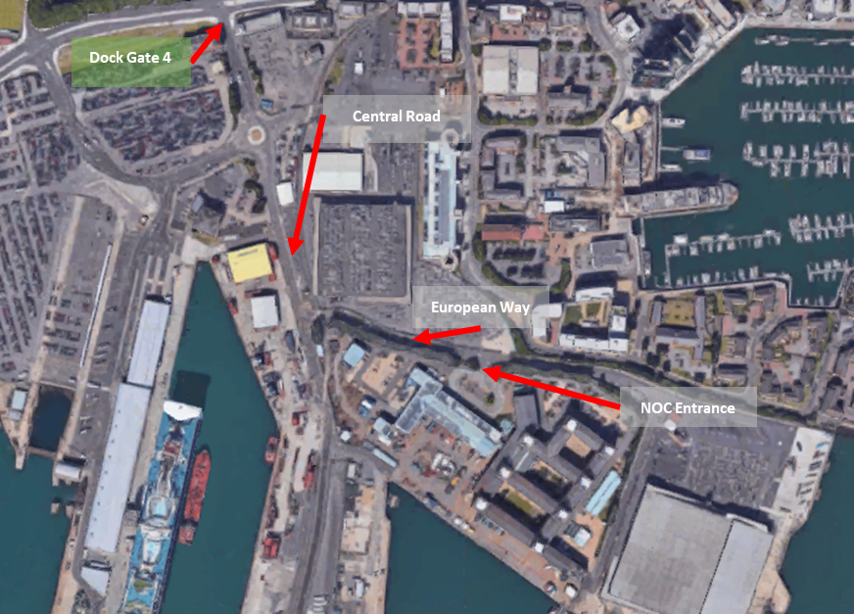

Figure 2: NOCS Location and Access

## Topography and Previous Land Use

Extract taken from the RIBA Stage D Design Report by the consultants September 1990:

The site is in an area of Southampton docks known to have been reclaimed from Southampton Water about 125 years ago. A layer of fill material between 1 and 4 metres deep overlays the original alluvium. This fill consists primarily of dredged material similar to the original alluvial deposits. Below the alluvium is a layer of gravel which varies in thickness from 1.5m to 3.4m. The gravels overlay the silty sands of the Bracklesham beds. The top of the Bracklesham Beds varies from 7 to 9 m below ground level. Standing groundwater level is about 2.5 to 3m below ground level and appears to be unaffected by tidal variations. The fill material and the alluvial deposits are very soft and shallow foundations can only be used for small, isolated buildings where a degree of differential settlement can be tolerated. For high loading, and where differential settlement is critical, piling will be required.

## Ecology Assessment

Below is a summary of the Ecology works undertaken during WS3. Full details are presented in the ecology report and HRA screening letter, which are attached in Appendix C and Appendix D respectively.

### Surveys Undertaken

An extended Phase 1 habitat survey of the application site was undertaken by Ramboll Principal Ecologist Chris Hodsman (MCIEEM) and environmental consultant James Fraser on 31st July 2018. The main habitats present were recorded using standard Phase 1 habitat survey methodology as described in the Handbook for Phase 1 habitat survey (JNCC, 2010[1]). The works also included the following:

* Internal inspection for roosting bats;
* Assessment of potential of the buildings to support roosting bats; and
* Inspection for invasive plant species.

### Findings

The habitats on site are dominated by buildings and hardstanding. Further habitats recorded include introduced shrub, trees and amenity grassland. These are common and widespread. The buildings present on-site were considered to offer negligible potential to support foraging or roosting bats. Other findings include:

* A small pond is located in the central courtyard which typically accommodates several ducks.
* The buildings and vegetation on-site offer habitat suitable for nesting birds.
* No invasive Schedule 9 plants e.g. Japanese knotweed were identified during the survey.
* No further protected or notable species were recorded.

### Mitigation and Enhancement

Mitigation and Enhancement measures are outlined within the Project Scope document.

## Ground Conditions

Ground surveys were carried out in 2014 and an investigative review carried out in September 2016 for the purposes of understanding the ground conditions on the quayside only. The Morgan Tucker Design Study report in 2015, ref P16-168-LDN-0000, is included in Appendix B.

## Existing Utilities and Services Infrastructure

### Existing Weather Data

Existing weather data can be obtained from the Met Office. The Contractor may find the following link to the Met Office website useful, as it offers free historical weather information for locations and, or, regions across the UK:

UK Climate Data: <http://www.metoffice.gov.uk/climate>

Alternatively, if the Contractor requires more site specific information, they can contact [enquiries@metoffice.gov.uk](mailto:enquiries@metoffice.gov.uk) so that they can identify your nearest weather station(s) to NOCS, noting that there would be a charge for the data. The Contractor can contact the Met Office Weather Desk on +44 (0)1392 88 5680.

### Existing Services

### Extract taken from the RIBA Stage D Design Report by the consultants September 1990:

### *“Summary*

*The laboratory areas will be serviced by means of “on floor” fresh air plant to those areas with significant fume exhaust requirements. A flexible arrangement of architectural detail and services concept will permit plant to be located in different on floor locations in the future, for changes in user requirements. Laboratory areas without fume exhaust requirements but having heat gains from equipment, will be provided with fan coils units located within the laboratory and providing cooling. Dedicated hot and cold water systems will be provided from water storage located in the Energy Centre.*

*Drainage is provided in the MEDA’s with vertical stacks dropping in the Nodes. Gases are provided in accordance with HSE requirements with external manifold rooms and/or internal distribution, dependant on the hazard of gas service required. Lighting to suit the nature of the area will be provided with connection points in the MEDA to provide future flexibility. Automatic lighting control with manual override/extension provides for economical operation. Power, data and telecom cables rise from service ways in the MEDA into the laboratory equipment and benches. Specialist power is provided from local plant within the MEDA.*

*Office areas are provided with radiator heating and ventilation by means of openable windows. Offices with high heat gains from computer equipment will have local fan coil units capable of cooling. Cost effective lighting from overhead fluorescent, up lighting and task lighting is provided to suit requirements for general lighting, low glare for computer VDU’s and user flexibility. Power, data and telecom cables distribute from the MEDA to floor outlet pedestals to provide flexibility across the area.*

*The library and archive is provided with dedicated air handling plant to provide the correct room conditions. Natural and artificial lighting are integrated by use of fenestrations design and concealed lighting fittings to illuminate the internal ceilings and walls.*

*Dedicated air handling plant is also provided for the reception/entrance areas and kitchen areas, plant being located in “on floor” plantrooms and the MEDA.*

*The computer room is provided with “on floor” air conditioning units as requested by the building user. The recirculation units supply air into a void below the computer floor tiles. Specialist power and data wiring facilities are provided to the computer room, with connections into the site primary mains distributing both power and data cables.*

*The workshop and store areas are provided with high level heating systems, together with ventilation and specialist exhaust systems where necessary.*

*The horizontal connection from the MEDAs servicing the user floor areas are taken to the Nodes for vertical distribution to the primary mains distribution through the roof zone. The MEDA’s contain duct and pipework together with electrical switchgear and local plant and equipment e.g. plant coolers, demin water plant etc. Located within the Nodes at MEDA level are the local plant rooms for the primary/secondary services interface. Water tanks, calorifiers, heat exchangers and fume exhaust plant are located at high level within the Nodes.*

*The primary systems within the Energy Centre comprise heating boilers, refrigeration plant, pumps, water treatment plant and heat exchangers with provision for sea water heating/cooling. This provision whilst technically feasible requires the further evaluation of effects on the dock marine ecology together with permission of the Ports/River authority. Main electrical plant comprise HV switchgear and standby generator facilities. The primary distribution mains run from the Energy Centre plant into the main building roof zone via the workshop building. The Energy Centre includes facilities for the Building Energy Management computer-based control system. A total of 5 No. hydraulic lifts are provided throughout the building.*

*External works include incoming utilities mains and firefighting mains with dry risers within the main building.*

*Services are taken to the Gate House with external security floodlighting, a closed-circuit television system and car park/service road/quay-side area external lighting provision. Facilities for the future quay-side electrical supplies is provided by means of connections and space within Nodes 3 and 4 transformer rooms.*

*Servicing Principles: Servicing Strategy*

*The primary plant for services (e.g. boilers, refrigeration, plant, HV switchgear etc) will be located in the Energy Centre. Primary distribution services from the Energy Centre run via a high-level service void to the north/west of the workshops in Node 2, where the rise to distribute to all the Nodes via the interconnecting roof voids.*

*Secondary services vertical distribution occurs in service risers in all Nodes which are then branched off into further secondary distribution zones at each MEDA level. The Nodes also contain fume exhaust fans, water storage, and electrical distribution equipment.*

*The air handling plants associated with fresh air make up to fume cupboards and other fume exhaust are sited at user floor level in plant rooms, the areas and locations for which have been agreed for the immediate scheme.*

*Laboratory Areas: Ventilation Services*

*For development purposes two basic categories of laboratory have been identified with alternative services strategies to match their different needs. The first category covers those laboratories with fume cupboards or other significant fume exhaust requirements. For this category the room ventilation balance is catered for by supply air from a local “on floor” plant room containing an air handling unit which makes up the air extracted from fume cupboards or other processes requiring fume exhaust.*

*The makeup supply air is treated to provide tempered air to the laboratory and is also automatically balanced to maintain the correct ratio between supply air and fume exhaust flow rates with respect to the number of fume cupboards in use at any given time.*

*Supplementary heating to the laboratories is provided by means of a perimeter heating system which offsets the building fabric heat loss during periods of low ambient temperatures.*

*In these laboratories cooling would be provided by means of fan coil units located within the laboratory with provisions for introducing fresh air to meeting occupancy levels. In areas where humidity control is critical to a particular process, local means of humidification will be provided. Both categories of laboratory would incorporate provisions for the users to have control of the laboratory environment within the capabilities of the systems.*

*Certain specialist laboratories such as those requiring clean room conditions and fume exhaust would be accommodated by a mixture of the systems provided on a local basis.*

*Fume cupboards and other laboratory exhaust systems on the first and second floors will drop from their equipment connection point in the laboratory, through the laboratory flor and connect to exhaust ductwork systems in the MEDA. At ground floor level ductwork will rise into the high level MEDA. These ducts then run to an adjacent node before rising to individual extract fans at the highest point in the node. In the next stage of detailed design-development user requirements for fume cupboard operation will need to be agreed so that the exhaust and makeup air ventilation systems can be deigned to operate efficiently whilst ensuring user safety is maintained.*

*Fume cupboards having an exhaust scrubbing requirement will be provided with integral fume scrubbers to minimise containment carry over into the main exhaust ducts. It is possible that local small-scale fume exhaust needs may be accommodated by combining them into a single extract system to serve the needs of a complete floor plate.*

*Laboratory Areas: Piped services*

*Laboratory/Process water systems*

*Dedicated laboratory/process hot and cold water systems will be provided with their water storage, calorifiers and pumps located in the Energy Centre. Systems will operate at pressures appropriate to the equipment needs.*

*Domestic water systems*

*Local provisions in the nodes will be made for domestic hot and cold water storage which will feed by gravity to sanitary accommodation together with any wash hand basins, emergency showers, etc in laboratories.*

*Drainage*

*Main laboratory drainage stacks will run vertically in the nodes with connections from horizontal laboratory drainage systems in the MEDAs. Separate systems will be provided where necessary to receive radio-active discharges for separate monitoring. Systems will be based on single stack principles where possible with vent pipes as necessary to maintain pressure equilibrium and prevent syphonage.*

*Laboratory Gases*

*The briefing database calls for a variety of laboratory gases in addition to compressed air and vacuum. Manifold rooms for bottled gases will be provided at ground level in the nodes where required. The design of manifold rooms, manifolds and pipework systems will be in accordance with the Health and Safety Executive (HSE) and British Standards/Codes of Practice. Hazardous gases, such as acetylene, will be surface mounted within laboratories and primary distribution will be external to give compliance with HSE requirements. Non-hazardous gases will be routed vertically through the nodes and then horizontally within the MEDAs before rising to laboratory areas above the MEDA.*

*Electrical services*

*To the laboratory areas a modular system of lighting has been provided to suit local needs, task lighting is provided where required. The supplies to power circuits for portable and fixed equipment will be derived from distribution fuseboards located in the MEDAs. Circuits at 415/240volts, 110 volts and 24 volts ac and dc will be provided to the laboratory areas. Dedicated power circuits for computer equipment has been provided with dedicated clean earth supply. Local frequency generator sets will be provided in the MEDA for unusual frequency requirements. Final connections to fixed equipment at 415/240 volts supplies will be by means of isolators and/or socket outlets. Portable equipment will be provided with 13 Amp type socket outlets for final connections. Data and telecom trunkings and cable trays will be provided for cabling by the building user. These trunking and tray systems will extend from the MEDAs and rise into each laboratory area via perimeter trunkings or mid floor pedestal units, serviced from the MEDA.*

*Office areas*

*Mechanical services*

*A substantial area of the main building consists of general office accommodation for which it is proposed to provide natural ventilation by means of openable windows with internal temperatures maintained by means of radiator type heating system. Radiators would be provided with thermostatic radiator valves which would give users local control of their environment during the heating season. Any office areas containing significant levels of computer equipment would be catered for by means of local perimeter fan coil units capable of heating or cooling the air.*

*Electrical services*

*To office areas a modular system of lighting will be provided by means of low glare lighting, connecting into the MEDA to permit future circuit changes.*

*Power, data and telecom will be provided by means of pedestal flor outlet units that can be located at any point on the floor. Cables will rise into these pedestal units from services trunkings and trays within the MEDA. The pedestal units will be capable of extension to provide power, dedicated computer power, telephone and data outlets. The pedestal units will have facilities for connection into desk cable management systems and/or cable ducts to conceal trailing leads.*

*Amenity areas*

*Library and archives*

*The library area will be served from dedicated air handling plant located in the MEDA. The system will be of recirculating air type with a proportion of fresh air introduced to match occupancy levels. The archives will be fully air conditioned to provide the environmental requirements defined in BS5454:1989 “Storage and exhibition of archival documents”. This standard lays down specific requirements for temperature and humidity requirements needed for long term storage of valuable documents. The systems would consist of a dedicated air handling unit located adjacent to the archives room with which air would be recirculated, heated, cooled and humidified as required with a small amount of fresh air make up to meet limited occupancy levels and to provide room pressurisation. The natural lighting of the library employs overhead roof lights with blinds to minimise glare but maximise indirect sunlight.*

*Reception/entrance areas*

*Each of these areas will be provided with dedicated air handling units located in plant spaces adjacent to the areas. The systems will provide environmental conditions within each area to reflect the occupancy levels and deep plan nature of these areas of accommodation.*

*Restaurant/catering*

*It is proposed that this area be served by means of dedicated air handling units operating on full fresh air. The air from the restaurant areas would be exhausted via a special ventilated ceiling in the catering/kitchen area from which extract ducting would run to an extract fan at high level in the adjacent node. The south facing glazed conservatory requires to optimise solar gains during the heating season but not at the expense of overheating in summer. Blinds are included to obstruct direct sunlight.*

*Computer rooms*

*The computer rooms have dedicated air handling units some with air conditioning depending upon the usage and location.**”*

Existing services data is contained within the Appendix G: NOCS Significant Hazard List, NOCS Chemical Data Portfolio, NOCS Asbestos Register, NOCS Policies & Procedures which need to be fully read and understood in conjunction with the site plans.

## Works by Others Concurrent to the Project

It is likely that other maintenance works shall be undertaken at NOCS during the life of this project. The Long Term Maintenance Plan is currently under development and will be made available during the Contractor during the Pre-construction Phase.

# Appendices

Appendix A: Work Stage 2 Report

Appendix B: Morgan Tucker Pavement Design Study

Appendix C: Ecology Report

Appendix D: HRA Screening Letter

Appendix E: NOCS Asbestos Register

Appendix F: NOCS Policies & Procedures

Appendix G: NOCS Significant Hazard List

Appendix H: Structural Assessment and Conditions Report

Appendix I: NOCS Visitor Map

1. Joint Nature Conservation Committee (JNCC) (2010). Handbook for Phase 1 habitat survey – a technique for environmental audit. JNCC Peterborough