Date: Thursday 23rd February 2023  Ref No: LTMN/Chippenham Fen/Vegetation Survey/Contract/2023 | 

Contract lead: Sarah Grinsted
Natural England
LTMN@naturalengland.org.uk

Specification

Long Term Monitoring Network: Chippenham Fen - Vegetation Survey - 2023

- Long Term Monitoring Network
The Long Term Monitoring Network (LTMN) is building on the work of the Environmental Change Network (ECN) and the Environmental Change Biodiversity Network (ECBN) to develop, with our partners, a cost-effective, long-term and integrated approach to meeting long term evidence needs. ECBN sites form the core of our Long Term Monitoring Network.

There are 37 LTMN sites in England where a number of physical, chemical and biological variables are measured in a standardised way in order to allow comparability between sites. This includes re-surveying the vegetation at each site on a 4 -5 year cycle.

The protocol for the vegetation monitoring is included in Appendix 1 – contractors should familiarise themselves with this.

- REQUIREMENT
This specification covers a number of activities that are required on the LTMN site: Chippenham Fen. The baseline survey was undertaken in 2013 and a subsequent survey in 2018. This contract aims to repeat the survey again i.e. 50 plots, carrying out the standard vegetation survey methodology on all 50 plots. The target habitats for the site are Purple Moor-grass and rush pastures, Lowland Fens and Reedbeds. The tasks are described in detail below, and summarised here:

Survey preparation
- Provide Natural England with a site-specific risk assessment before the survey - YOU MUST SEND THIS TO THE LTMN MAILBOX AND THE NNR MANAGER PRIOR TO THE SURVEY.
- Locate feno markers already in place at the permanent plots and flag these with a temporary cane.
- You will need a metal detector (equivalent to X Terra 705) to help find the feno markers.
- Precise recording of marker position using High Accuracy GPS, to within 10 cm. High Accuracy GPS is ideal but not always necessary. At the last survey in 2018, HA GPS was used. Please provide two quotes, one with HA GPS and one without. Please note that in woodland, HA GPS is unlikely to work and in areas of low mobile signal you may need a base station to improve triangulation. Please provide detail on the make, model and accuracy of any HA GPS to be used, and the method for transferring data from and to GIS - both in your quotation and in the required short report at the end. Please ensure that you provide both latitude & longitude, and British National Grid co-ordinates in your final results.
- If a plot/feno marker cannot be found, you will need to install a replacement feno marker using the same accurate co-ordinates. You must order the feno markers from M&P Survey Equipment and bill Natural England for the amount purchased.

Please complete the LTMN site plot tracker with updated GPS co-ordinates, for latitude & longitude, and British National Grid, and any changes to plot numbers/names (see Appendix 3), and return at the end.

For more detail on the methodology, see Appendix 3.

Vegetation survey
Use the vegetation survey – standard methodology, on all 50 plots – see Appendix 1.

Order and timing
From experience, finding markers can take longer than perceived as they are often obscured by vegetation and soil over time. If feno markers cannot be found they will need to be re-marked in the same location. Please do not underestimate the length of time required to survey the plots. We need all the species that are rooted in the cell to be identified. It will take at least 2 -3 hours to complete a plot and often longer in species-rich habitats.

This contract is a re-survey, where surveyors must re-find markers and take high accuracy GPS readings. Fifty 2m x 2m vegetation plots are to be found and re-surveyed. All this work must be completed by the end of the survey period stated. Contractors must bid for the full contract.

Preferred dates for the vegetation survey to be completed: previous surveys were end July / early August.

Site | a) Provide NE with site specific risk assessment before survey. | (b) Refind and flag markers | (c) High accuracy GPS | (d) Marking new plots if old plot cannot be found | (e) Vegetation survey | Tasks a,b,c,d,e
Chippenham Fen | Yes | Yes - 50 | Yes | If needed | Yes - 50 | End July/ early August

Tasks
- Provide Natural England with a site-specific risk assessment.

- Re-find existing permanent markers – Appendices 1, 2, 3.

- High accuracy GPS – Appendix 3. The precise location of each marker should be confirmed using high accuracy GPS. Please ensure that you provide both latitude & longitude and British National Grid co-ordinates, if possible to 1m or even 10cm accuracy.

- If a plot cannot be relocated you as the contractor must install a new feno marker using the existing map co-ordinates and update the LTMN site plot tracker spreadsheet.

- Vegetation survey - standard methodology - see Appendix 1. This includes taking a photo from the south side of each 2m² plot, showing the quadrat and feno marker, and labelled with plot number and map co-ordinates.

- Quality assure the data, using the QA methodology that will be provided as a separate document. This includes writing data entry comments and using QA codes, where relevant, in the LTMN vegetation data input spreadsheet provided.

- Whilst in the field, make a judgement on the National Vegetation Classification type and subsequently use the MAVIS tool or similar to analyse the plant species data for each plot (single plot analysis only), to provide NVC types and % matches. Include this information in the LTMN vegetation data input spreadsheet.

- Provide a short report (one side A4) about the survey noting any issues that were encountered during the survey e.g. the make, model and accuracy version of any HA GPS used, any advice to help smooth the process next time and how you QA’d the data.

Available data
- Map co-ordinates of permanent plots (including HA GPS if previously carried out), from previous surveys.
- For some sites, we can supply sketch maps and previous plot photos.
- Baseline and subsequent vegetation survey data for the site – also found on Natural England’s Access to Evidence Catalogue LTMN pages.
- LTMN vegetation data input template that can be used on a tablet – or printed.
- LTMN vegetation survey collation and QA guidance – updated January 2023.

Mobile phone signal
Please make sure you consider mobile reception when creating your risk assessment. We cannot guarantee mobile reception so make sure that you have considered alternative means of communicating and discuss this with the NNR reserve manager.

Access
For access, please contact: Mr. Chris Hainsworth, Chippenham Fen NNR base, Natural England, Snailwell Road, Chippenham, Ely, Cambridgeshire, CB7 5QB; tel. 01638 721329, m. 07799 657428; chris.hainsworth@naturalengland.org.uk

Please make arrangements directly with the Reserve Manager.

Terrain, distances and conditions
Chippenham Fen National Nature Reserve is of national and international importance for its wide range of wetland habitats, flora and invertebrates.

Where: Cambridgeshire.

Main habitats: The reserve's habitats include beds of saw-sedge and common reed, grazed wet short-fen meadows rich in wild flowers, meadows cut for hay, chalk grassland, carr woodland, scrub and mature woodland.

Chippenham Fen covers 117 Ha and is designated as a Site of Special Scientific Interest (SSSI) and Ramsar site. It is part of the Fenland Special Area of Conservation (SAC) for its species-rich fen meadows on calcareous peaty soils and its species-rich calcareous fen community dominated by saw sedge.

The combination of rainfall draining through a narrow valley and springs emerging through the underlying chalk bedrock have allowed the calcareous fen conditions to be created with frequent ditches, pools and wet depressions making this a really diverse wetland. The peat soils on site vary from a few centimetres to 2m thick.

Important species:
- Cambridge milk-parsley Selenum carvifolia grows well on the site. This plant is only found in 3 other sites in the UK and is protected under the Wildlife and Countryside Act.
- Over 500 moth species have been recorded, including Silver Barred and Reed Leopard. Many nationally scarce, rare invertebrates particularly diptera.
- In 2010 Rosser’s sac spider Clubiona rosserae was rediscovered at the site for the first time in 19 years.
- More than 400 species of wild flowers have been recorded including marsh helleborine, black bog rush, bogbean, bog pimpernel, saw-wort, southern marsh and fragrant orchids.

- REQUIRED OUTPUTS
- Site-specific risk assessment.
- Fully completed LTMN site plot tracker (including full information on any new plots, as per Appendix 4).
- Fully completed LTMN vegetation data spreadsheet including NVC classifications.
- Labelled plot photos (method described in appendix).
- Sketch maps if required (method provided in appendix).
- A short report (side of A4), including a description of how you quality assured the data.

- TIMESCALES and OUTPUTS
All finding markers and survey work to be completed by timescales outlined in the table in section 2, with the vegetation survey data input spreadsheet and other outputs submitted to Natural England by Friday 20th October 2023.

- SUSTAINABILITY
As a delivery partner, the successful contractor is expected to pursue sustainability in their operations, thereby ensuring Natural England is not contracting with a supplier whose operational outputs run contrary to Natural England’s objectives. The successful contractor will need to approach the project with a focus on the entire life cycle of the project. The successful contractor is likely to be able to provide a copy of their environmental policy and any environmental accreditation schemes such as ISO 14001 or EMAS which they have been awarded or are working towards.

Please indicate how you will minimise the impact of travel as part of this contract (e.g. minimise number of trips, use of cleaner fuels etc.).

- RISK MANAGEMENT
Though this contract is considered relatively low risk, it does involve fieldwork on Chippenham Fen NNR and the contractor must provide a risk assessment for the project. The responsibility for Health & Safety lies solely with the contractor, and the contractor is expected to provide suitable personal protective equipment for the work.

The nature of the contract requires staff with a high level of botanical identification expertise - please confirm that sufficient qualified staff will be available to undertake the work. Please also detail how you will mitigate against any potential time delay within the project.

Ticks
Even if ticks are a low risk on this site please make sure that you include them within your risk assessment. You will be travelling across the site over a range of habitats so we cannot guarantee that you will not be bitten. Please see Appendix 6 for Natural England’s Medical Support Card.

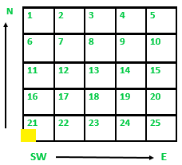
Appendix 1
LTMN Vegetation Survey – standard methodology

The methods have been developed under the ECBN coarse-grain protocol.

The permanent marker indicates the SW corner of the 2m x 2m plot. Each plot is divided into 25 cells, measuring 40 cm x 40 cm. Cells within the 2m x 2m plots should be labelled from 1 to 25 with 1 being the north-west cell, 2 being the next cell to the east, and 25 being the SE cell. These correspond to the 25 numbered columns on the vegetation survey data input spreadsheet. Table 1 lists the variables recorded in each cell. Table 2 lists the variables recorded at plot level.

Please also take a photo of the plot from the south side of the quadrat, showing the quadrat and feno marker, and labelled with plot number and map co-ordinates.

Please take the following measurements listed in the tables below:

Table 1 Variables recorded in each cell

Variable | Method/comments
Presence of vascular plants, bryophytes and lichens | The presence of all vascular plants rooted in the cell is recorded, with the exception of those growing on rock or wood. Non-vascular plants are recorded in the same way and for Sphagna, other bryophytes and lichens, the main species in these groups are recorded to species level whenever possible.
Sward height | A 200g drop disc and ‘sward stick’ is used to measure height in each cell location. Height is read at the centre of the cell on a graduated dowel passing through the centre of the disc.
Litter | Litter is assessed by recording presence by a visual assessment through the vegetation from above during botanical recording.
Bare ground | Bare ground is assessed by recording presence by a visual assessment through the vegetation from above during botanical recording.
Bare rock | As above.
Dead wood | As above.
Open water | As above. This is only to be recorded for permanent/semi-permanent water such as bog pools and edges of water bodies.

Table 2 Variables recorded for each plot

Variable | Method/comments
Cover of vascular plants, bryophytes and lichens | The total percentage cover of each species present is estimated for the whole 2m x 2m plot.
Cover of litter, bare ground, bare rock, dead wood and open water | The total percentage cover for each attribute present is estimated for the whole 2m x 2m plot.
Altitude | Measured at the centre of the plot using a GPS.
Aspect | Measured at each plot using a hand-held compass (from the highest point facing down to the lowest point).
Slope | Measured at each plot using a clinometer (from the lowest point facing up to the highest point).
Slope form | Use the codes given
Land use | Use the codes given
Broad and Priority habitats | Use the standard names given
Grazing levels | Presence of dung (and origin – rabbit, deer, sheep, cattle) is recorded along with other obvious signs of grazing impact (e.g. presence of pulled vegetation).
Disturbance/anthropogenic problematical features | Vehicle tracks, fires, dumping of farm or garden waste, and any other disturbance should be recorded. This is assessed qualitatively in the field and can also be assessed from aerial photographs.

Note: if a formerly grassland plot has turned to impenetrable scrub, and the feno marker is presumably somewhere within but not possible to reach, it is acceptable to assume the approximate outline of the plot and record the plot attributes and plant species as best one can. It is better to record this change in vegetation than to ‘lose’ such a plot and create another one.

Appendix 2
Background information: selection of sample plots

Fifty (50) (unless otherwise specified) 2m x 2m plot locations are distributed across the site (usually stratified according to the main vegetation types present). Natural England has identified the locations of these plots using GIS software and a random point generator.

The coordinates identify the south-west corner of the 2m x 2m quadrat and this is where the feno marker was installed. All quadrats are marked with feno markers, except in exceptional circumstances. Different feno marker heads may have been installed depending on the habitat and site.

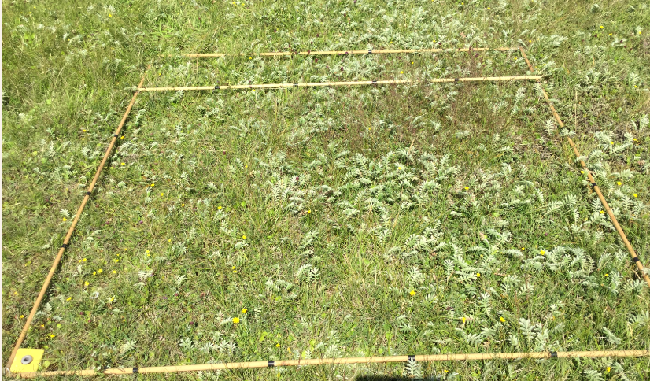

Figure 3: Example 2m x 2m plot, photo taken from south side.

Appendix 3
What to do if a plot/feno marker cannot be re-located

If you are unable to re-locate a plot then we require you to install a new feno marker with the same grid reference. Prior to doing this please consult with the LTMN team and NNR manager; and complete the site plot tracker spreadsheet.

Plot locations should be confirmed using a handheld GPS unit or a high accuracy GPS unit with a roving receiver as required in the specification. Handheld GPS devices have been used in the past, however if you have access to and experience of using high accuracy GPS equipment, please could you state what impact using such equipment would have on the cost and delivery timescale of this work.

Please use the following plot numbering/naming system:

For any plots needing a new feno marker, they must have a new name e.g. plot 2 becomes plot 2a on the site plot tracker. If the map grid ref. changes because of using HAGPS but it’s the original feno marker, a new name is not needed. When using HA GPS, record using latitude and longitude, and convert to British National Grid co-ordinates – please provide both sets of co-ordinates. Also record the HA GPS accuracy at each plot, as this will vary according to the mobile data signal and correction service, tree cover etc.

For any completely new plots (shouldn’t often be needed), upon reaching the designated location, the contractor should take a decision as to whether the location is appropriate for the intended survey. If the proposed location of a plot falls in a slightly unsuitable place, but a more representative area can be identified within close proximity (<20 metres away) then the plot should be re-positioned as such. If the proposed location is considered unsuitable and cannot be rectified with a small adjustment to the location, then the plot should be rejected and the first of the reserve plots should be used instead. Reserve plots should be used in this manner, in order according to their numerical ID, not geographic proximity to the rejected plot. Please note the sampling methodology is based on a random sample within a habitat and we do not want the plots to be placed in locations biased towards ‘good’ examples of a given habitat. The plots should be broadly representative of the habitat on that site as a whole.

Installing the permanent marker
The marker should be installed according to the instructions provided. The feno marker should be positioned so that the grooves in the top of the polyroc head are orientated at a north-south bearing.

In addition to installing the permanent marker, a temporary visual marker should also be installed next to the permanent marker to facilitate quick re-location during survey over the coming weeks. This temporary marker should be easy to spot and state the ID of the plot (e.g. 1.5m tall bamboo cane or similar, with a piece of gaffer tape stuck on it with the plot ID written on). The temporary marker should be installed to the western side of the permanent marker head so that it doesn’t fall within the 2m x 2m area to be surveyed.
The installation of feno markers requires the use of three accessories: the driving tool (reusable), fixing tool (reusable) and a mallet or hammer.
- Position the polyroc head and clip the white plastic spacer onto the spike. Drive in the spike using the driving tool and a hammer.
- Stop driving when the handle of the tool is 1cm from the polyroc head, with the white plastic spacer in position in the polyroc head.
- Replace the driving tool with the fixing tool.
- Hit the fixing tool with the hammer, which has the following effect:
  - it drives the anchorage fully home
  - it applies high pressure, ensuring a perfect seating for the marker in the ground
  - if causes the extension of the three high-strength prongs which will firmly anchor and lock the marker
- Stop driving when the fixing tool handle is a few centimetres from the polyroc head.
- Withdraw the fixing tool (reusable).

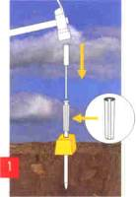
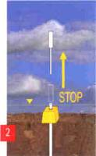
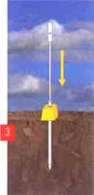
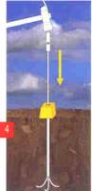

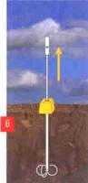
Appendix 4
Information required if a completely new plot is needed.
In order to assist future re-location of plots, sketch maps and photographs of the marker locations should be provided – just if it’s a new location.

Variable | Method/comments
Location of permanent marker | Taken from GPS to at least 10-figure (1m) accuracy or higher accuracy if available. Grid reference or the equivalent x, y coordinates should be given.
Description of location | Should contain description of location with respect to local landmarks e.g. plot is located in NW corner of ‘Smith’s Field’, approx 20m east of small oak tree.
Description of habitat/ features | For example, tall mixed grass/sedge sward, bare/trampled area close by.
Sketch map of marker location | Sketch map of location of markers in the context of any local landmarks with distance and bearings given. Example map given below. As an alternative, an Ordnance Survey map may be marked up with plot locations and local landmarks referred to in location descriptions. The aim is to assist surveyors in locating the feno markers rapidly at each four yearly re-survey with vegetation growth up around the markers.
Photographs | Four photos to be taken per plot of the surrounding area facing N, S, E & W from the permanent marker, with the marker in view in the photograph.
Plot ID of marked plots, grid references and plot descriptions should be recorded in the plot tracker. Sketch maps (if drawn by hand) should be scanned and provided in jpeg format. Photos should also be provided as jpegs with the plot ID and direction of view included in the filename in a consistent format.
Example sketch map: Chippenham Fen, Plot 2
The plot is located at TL 65195 –69410, close to a small oak tree (see Figure 2)
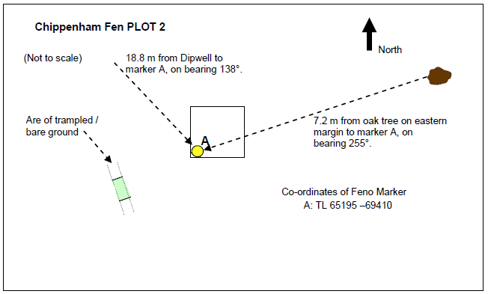
Figure 2: Chippenham Fen, view from Dipwell 8, looking south-east towards Plot 2, June 2011.
Oak tree on left, Plot 2 is towards the right hand side of the shot.

Appendix 5
Quality Assurance methodology
- Check all data has been captured and is complete.
- Spend time on the first day on site familiarising yourselves with species commonly present on the site and then practicing the methodology to ensure all survey team members are fully keyed into the botany of the site and the methodology particularly for the woodland method. Depending on the size of the team it would be good to all carry out the first plot together.
- After data collation using the LTMN vegetation data spreadsheet template identify a different person from your team to carry out a second check of the following:
  - Species names against latest Stace edition and commonality for the site and habitat type. Check against the LTMN baseline and repeat surveys data. For any rare or unusual species, if possible, check with BSBI records and county records for the site.
  - Apply the LTMN data issues and quality assurance codes, found in the vegetation data survey template. For any queries around data entry, see ‘LTMN vegetation survey collation and QA guidance – updated Jan 2023’ which will be provided.
  - Produce NVC types using analytical software (MAVIS - Modular Analysis of Vegetation Information System - or similar) providing the first three classes, and provide a final NVC classification using your considered opinion and the NVC publications as to which community the plot is most closely aligned to. Populate the LTMN vegetation survey data template.
  - Optional: a Twinspan analysis (Two-way indicator species analysis) is undertaken to try and reduce bias in grouping samples. When this is undertaken where quadrats are assigned based upon the surveyors judgement i.e. where the quadrats are located within the plant community and potentially not an ecotone, this generally produces a dendrogram which matches what the surveyor recorded in the field.
  - Ensure sign-off of finalised data from your lead botanist.

Appendix 6
Natural England’s Medical Support Card



