Title: Intercalation Studies

Procurement Ref: NNLC497.06

Date of Issue: TBC

Approvals

|  |  |  |  |
| --- | --- | --- | --- |
|  | Name | Signature | Date |
| Checked  By |  |  |  |
| Technical Approval  By |  |  |  |
| Projects Approval By |  |  |  |
| Contract Manager: |  |  |  |
| Procurement Lead Approval: |  |  |  |
| Work Order  Number |  | | |

Verification Statement

This document has been verified and approved in accordance with NNL's procedures for the reporting of work.

History Sheet

|  |  |  |
| --- | --- | --- |
| Issue Number | Date | Comments |
| Draft 1 | 26/10/2023 | Draft sent to procurement checker. |
| Draft 2 | 20/11/2023 | Draft ready for Request for Information (RFI) process. |
| Issue 1 |  |  |
| etc. |  |  |

Contents

1. Introduction 4

1.1. Specification Outline 4

2. Scope 4

2.1. What is included 5

2.1.1 – Other obligations 5

2.2. Mandatory Requirements 5

2.3. Environmental conditions 6

2.4. Programme of works 6

3. Policy and Standards 6

4. Performance testing, certification and documentation 7

4.1. Work test requirements 7

5. Constraints 7

6. References 8

|  |  |
| --- | --- |
| List of Figures | Page |
| Figure 1. Electrical fragmentation of fuel compacts 5 | |

1. Introduction

National Nuclear Laboratory (NNL) has recently been awarded a government contract as part of the UK government Advanced Modular Reactor, Research, Development and Demonstration Programme. Under this contract the UK aims to support the development of high temperature gas‑cooled reactors (HTGRs). NNL in collaboration with the Japan Atomic Energy Agency (JAEA) are participating in Lot 2 of this work which is concerned with fuel demonstration. The project aims to deliver an indigenous commercial fuel supply for HTGR fuel to ensure security of supply and generate economic growth in line with the UK Net Zero Strategy. This is supported by complementary work carried out under the Advanced Fuel Cycle Programme (AFCP) which aims to conduct R&D and develop skills and expertise in fuel manufacturing processes for UK benefit.

* 1. Specification Outline

The purpose of this document is to capture the requirements for a single supplier to support with a study on the use of high voltage fragmentations (intercalation) of SiC and carbon layer as a reprocessing technology.

HGTRs use coated particle fuel (CPF). The current CPF design is tristructural isotropic (TRISO) fuel. A TRISO particle comprises a kernel of fuel covered with four separate layers of three different materials. These are a porous carbon layer, an inner pyrolytic carbon layer (IPyC), a layer of silicon carbide (SiC) and a final outer pyrolytic carbon layer (OPyC). These particles are dispersed in a carbon matrix. A key aspect of a possible future vendor is to develop options to allow recovery of uranium for reuse. NNL is investigating two areas: recovery from manufacturing residues and from irradiated fuels. A key part of the recovery process is the rupture of the fuel matrix and TRISO particles to allow extraction of the useful uranium. One of the alternative methods to break the very stable SiC layer is the High Voltage (HV) fragmentation, also called intercalation that uses electrical currents applied to the particles to break the solid layers of carbon and SiC and expose the inner layers. In general, HV fragmentation is still in development in the nuclear sector, however, a similar method of size reduction has been successfully used in full scale geological applications for the fragmentation of rocks. [1, 2] The main advantage of the fragmentation technology is that it requires simple and relatively inexpensive materials such as a potential generator and an electrode. Moreover, the technology is expected to have sufficient selectivity to prevent damage to TRISO particles which is an attractive feature with a further positive effect in the subsequent separation steps.

Fuel rupture must be carried out in a manner that minimises carbon evolution, which would require abatement. Several head‑end options for the recovery of uranium are being explored at NNL. One of the low technology readiness level (TRL) techniques is to remove the outer layers of the particles is the high voltage fragmentation, also known as intercalation, of the SiC and carbon layers.

1. Scope

It is recognised that intercalation is at an early stage of development, low TRL method. Hence the first step is to carry out development work to repeat literature experiments. The purpose of this experimental piece of work is to get a first-hand experience to understand the potential risks and challenges to scale up to industrial scale the intercalation technique used to remove the carbon outer layer and SiC layer of CPFs, by the application of high voltage to the material immersed in a liquor at room temperature if in aqueous electrolyte.

The experimental procedure will be undertaken by the consultant who shall develop equipment for testing and uses the equipment for preliminary experiments. The experiments should identify optimal electrical conditions and the best acidic electrolyte chemistry (composition and concentration) and subsequent separation and analysis of the removed layers/materials.

* 1. What is included

Figure 1 shows a general diagram of the steps required for the development of the intercalation technology. In general the following materials and conditions are required for the technique development:

* Efficient management of carbon within the particle: the development of the technique will need to consider how to achieve fragmentation of outer carbon without SiC kernel damage, and how to fragment SiC separately.
* Layers high voltage fragmentation:
  + Carbon layer fragmentation: the electrical power required to separate the fuel particles from the carbon matrix, according to some of the literature would be around 2000‑5000 kWh t-1. [3, 4]
  + SiC layer fragmentation: the fragmentation of the SiC layer requires an energy increase to 8000 kWh t-1 to access the kernel centre. To achieve these power densities, a voltage range of 40‑400 kV has been reported to use with maximum currents of approximately 10 kA. [1, 4, 5, 6, 7]
* Equipment:
  + Electrically insulated container with base that acts as the energy receiving electrode.
  + Stainless steel rod, positioned from above the vessel that acts as the second electrode applying the voltage.
* Separation (e.g.: sieving) of remaining fuel particles and any fine graphite material.
* Separation of the SiC pieces based on density or size and recovery of “kernel”.

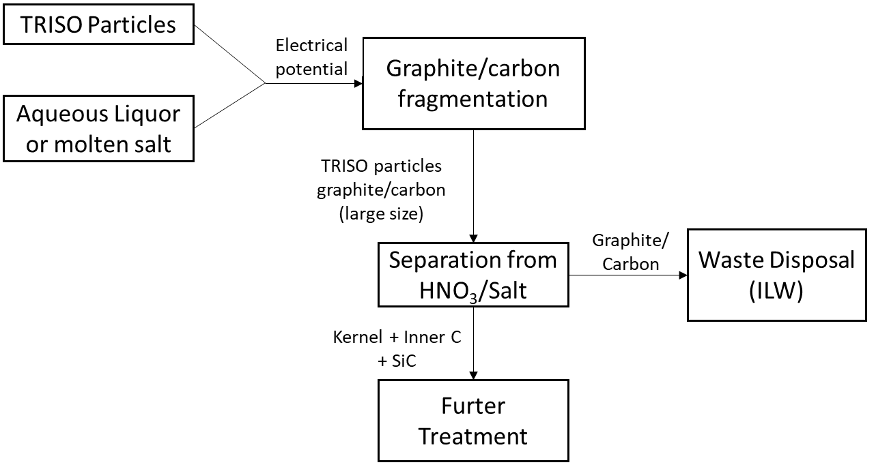

Figure 1. Electrical fragmentation of fuel compacts

2.1.1 – Other obligations

The national nuclear laboratory, NNL, are conducting this research on behalf of the Department for Energy Security and Net Zero (DESNEZ). The contractor will be engaging with teams focusing on reprocessing research (at Sellafield) and treatment of manufacturing residues (at Preston).

* 1. Mandatory Requirements
* The fuel will be comprised of blocks or pebbles, containing TRISO particles. The aim of the project will be to:
  + Fragment blocks/pebbles and “liberate” spheres.
  + Fragment TRISO particles. The standard diameter of a TRISO particle is at least 920µm, with outer carbon layer of approximately 40µm and a SiC layer of around 35µm. See Figure 2.
* Initial studies will use surrogate materials identified by research company. Inactive TRISO particles may be available later in project for further testing.
* Characterisation of the fragmented particles/remaining spheres will also be required by the supplier.

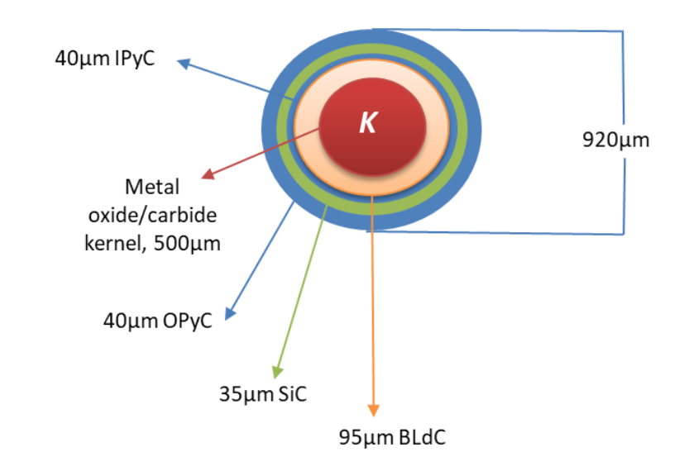

Figure 2. TRISO particle fuel design

* 1. Environmental conditions
* The work will take place in the contractor facilities.
* Chemical liquor to be determined in initial discussions, most likely an acidic (e.g. nitric acid) aqueous liquor.
  1. Programme of works

The key requirements for this project are:

* Project plan
* Monthly project update reports
* Regular technical update meetings
* Technical report detailing practical studies and areas for further work
* In person presentation of results and practical demonstration

1. Policy and Standards

Accreditation in ISO standards is advantageous. Please detailed company accreditation.

1. Performance testing, certification and documentation
   1. Work test requirements

Although the tests and experimental procedures will be achieved by the supplier, a visit from NNL technical team to oversee the procedure once it has been proved will be required.

1. Constraints

* The project end date is 29th February 2025.
* Work with 3rd party suppliers, must be approved by NNL prior to the contract is placed. It is preferrable that 3rd party suppliers should be detailed in tending process.

1. References

|  |  |
| --- | --- |
| [1] | M. A. Fuetterer, F. Van Der Weid and P. Kichmann, “A high voltage head-end process for waste minimization and reprocessing of coated particle fuel for high temperature reactors,” in *Proceedings of the 2010 International Congress on Advances in Nuclear Power Plants - ICAPP '10*, San Diego, US, 2010. |
| [2] | S. H. Cho, S. S. Cheong, M. Yokota and K. Kaneko, “The Dynamic Fracture Process in Rocks Under High-Voltage Pulse Fragmentation,” *Rock Mech Rock Eng,* vol. 49, pp. 3841-3853, 2016. |
| [3] | M. Masson, S. Grandjean, J. Lacquemont, S. Bourg, J. Delauzun and J. Lacombe, “Block-type HTGR spent fuel processing: CEA investigation program and results,” *Nucl. Eng. Des.,* vol. 236, pp. 516-525, 2006. |
| [4] | J.-H. Lee, J.-B. Shim, E.-H. Kim, J.-H. Yoo, S.-W. Park and C. T. Snyder, “A feasibility study for the development of alternative methods to treat a spent TRISO fuel,” *Nucl. Tech.,* vol. 162, no. 2, pp. 250-258, 2008. |
| [5] | M. Futterer, P. Hoppe, J. Singer and B. Hansjoachim, “Head-end process for the reprocessing of reactor core material”. USA Patent US8498371B2, 30 July 2013. |
| [6] | M. Lecomte, CEA Treatment and recycling of spent nuclear fuel: Actinide partitioning - Application to waste mangement (Monograph), Gif-sur-Yvette: CEA Saclay, 2008. |
| [7] | L. Junfeng, “Treatment and disposal of the readioactive graphite wste of high-temperature gas-cooled reactor spent fuel,” IAEA, Beijing. |