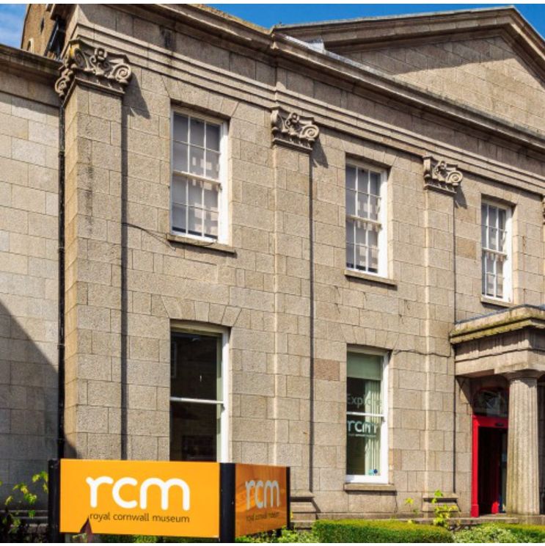
Design Tender
Roof Repair Works (MEND) – Royal Institution of Cornwall
APPENDIX 1 - Brief
October 2023

Introduction
The site of the works is at the Royal Cornwall Museum, River Street, Truro. The building itself is a Grade 2 listed building, built in 1845. The primary works to be carried out onsite relate to the following:
- Works to the roof to repair and re-covering of pitched roofs using slates dry laid to the Royal Cornwall Museum.
- Associated works including gutters, rainwater goods and associated works such as fascia.
- Access and access protection works to roof.
- Associated works to upgraded insulation,
- Provision of new windows to room 4.01, re-pointing to east elevation and re-rendering to north elevation.
Planning Permission has been obtained and granted under applications PA21/10106 and PA22/07417 through a separate engagement with Scott and Company (Cornwall) Limited, 3 Lemon Villas, Truro, Cornwall, TR1 2NX which has taken the work from RIBA Stages 1 to 3.
The key objective of this tender will be to lead the completion of RIBA Stages 4 to 6.
The construction phase of the work for a Principal Contractor will be through a separate below threshold procurement in line with the Public Contracts Regulations 2015.
Key activities required:
The key activities which will be required by the design team which will constitute the output from this tender activity will be:
- Undertake design details for roof and ancillary works, which will include both drawings, details and specification works. This will enable Building Regulations application to be undertaken and signed off, planning conditions to be discharged and tendering for a main contractor and enabling the construction works to be carried out.
- In undertaking the work, the following planning information and associated conditions must be adhered with:
PA21/10106
https://planning.cornwall.gov.uk/online-applications/applicationDetails.do?activeTab=documents&keyVal=R0LP4YFGMWI00

PA22/07417
PA22/07417 | Listed building consent for the repair and re-covering of pitched roofs R1, R3, R4 and R5 using slates dry laid. | Royal Cornwall Museum 25 River Street Truro TR1 2SJ
- Development of bills of quantities for pricing related to works tender and subsequent associated cost control for the works, including the sign off for the final accounts.
- Acting as Client agent for the Contract administration of the programme phases, including supporting meetings with client and contractor(s), site supervision of the construction phase and producing necessary interim and final reports.
- Programme management and associated works in this role through stages RIBA 4 to 6. This will include supervision of the construction phase, managing both quality of outcomes by the main contractor, defects liability period and Health and Safety matters.
- Managing compliance with the delivery of the works in line with the approved plans and specification, defects and practical completion and the necessary formal final certificates and approvals with the relevant authorities, e.g. Planning / Building Control.
- Principal Designer as designated under the Construction Design and Management (CDM) Regulations 2015. This will include the development of the Pre-Construction Document, managing the Health and Safety File and management of the construction works with the Principal Contractor.
- Undertaking necessary adequate surveys and reports to support a delivery of the programme.
- Providing ongoing related professional technical support and input during the programme to ensure the outcomes are in line with the objectives of the programme as well as ensuring value for money and accountability.
- Supporting the evaluation of tenders received for the Principal Contractor in line with Public Contracts Regulations 2015.
- Where appropriate to bring insight to support recommendations or decisions to be made, including benchmarking, case studies, reference sites.
- Provide written monthly reports which will form part of the funding agreement with the Funder.

KEY TIMESCALES AND GOVERNANCE SIGN OFF
Following appointment of the principal design team the below provides an indicative timeline for the programme.
STAGES | DATE DUE
MILESTONE 1 – Design work
Delivery by Appointed Supplier of detailed design work, final specification for review and sign off by client. | 20/01/2024
GATEWAY 1 – PROJECT BOARD Go / No Go
Review of detailed design work consideration and approval for tendering for Principal Contractor and Building Control approvals and Planning Conditions. | 31/01/2024
MILESTONE 2 – Tender Phase (Principal Contractor)
Completion of tender and evaluation process with evaluation report outlining preferred supplier(s) | 30/04/2024
GATEWAY 2 – PROJECT BOARD Go / No Go
Review of evaluation outcome and decision to proceed to appoint Principal Contractor(s) or not | 25/05/2024
MILESTONE 3 - Construction Phase
Works contract commences with Principal Contractor | 1/06/2024
GATEWAY 3 – PROJECT BOARD Go / No Go
Review of Final Account and sign off | Jan 2025

