**Invitation to tender for the design, supply and installation of playground equipment Ingham Recreation Area**

Tenders will be received by The Clerk to Ingham Parish Council, Mr Gavin Monks, Bramley House, Church Street, Glentworth, DN215DG Phone: 07974704628, Email: [inghampc@gmail.com](mailto:inghampc@gmail.com) until 12:00 noon on 11th September 2021

All queries related to the invitation to tender shall be submitted to The Clerk.

**Summary**

Ingham Parish Council (The Council) is inviting tenders for the removal of end of life equipment and for the redesign, supply and installation of playground equipment at The Recreation Area adjacent to Ingham and Cammeringham Village Hall, The Green, Ingham, Lincolnshire.   
  
An itemised tender is required identifying all costs together with an illustrated layout that will be presented to the community whose views will be taken into account when awarding the contract.   
  
The Council is inviting tenderers to propose up to 2 design options. Tenders should not exceed £100,000 and should allow for a phased implementation as funding is secured.

**1.0 Scope of Work**

1.1 The scope of work includes layout design, supply, and installation of playground equipment (Red Map 2). Removal of existing equipment, preparation of site and construction as per tendered design.

**2.0 Summary of requirement**

Following a community consultation below is an interpretation of results; full survey is located in Appendix 1 & 2

* Greatest users are pre-school (0-3 years) and primary school age children (4-12 years)
* Secondary age users (12-16 years) have roughly a third of the usage of the pre-school and primary age school children.
* Adults have high usage both in the supervision of children, and as adults wanting to use the space for socialising. Older children also use the area for socializing mainly in the evenings.

The conclusions drawn from the village questionnaire, engagement work with the children at Ingham Primary School and The Council regarding a) the needs of village residents; and b) the layout of the site adjacent to the village hall are:

* There should be innovative play equipment that offers risk, adventure and challenge and which enhances the value of play and choices to cater for the needs of mainly pre-school (0-3 years) and primary (4-12) aged children.
* The play equipment must cater for children with a wide range of abilities and restrictions.
* The play equipment may be zoned by age group but must allow easy progression between the zones.

The most popular ideas identified from the engagement work with the residents and children were:

**Climbing** : Monkey Bars, Climbing Nets, Ladders

**Swinging**: Swings, Swing Seat

**Sliding and Rolling**: Slides

**Movement**: Zip Wire, Balance Bars, Summersault Bars, Obstacle Track, Bridges

**Other Play Features**: Roundabout, Tunnels, See Saw, Stepping Stones

The existing wooden pavilion, which provides a covered seating area, close to the play equipment for adults supervising children and for socialising is to remain.

The existing picnic tables and waste bins are to remain.

Sufficient green space should be left for general use and for activities associated with the running of the village hall and its events (i.e. bonfire night) (Blue highlighted area map 2)

Outdoor facilities should be such that the likelihood of damage to the buildings close by (school, village hall) is reduced to as low as is reasonably practicable

Maintenance cost is kept as low as practicable

There should also be provision for use of some equipment by children with disabilities.

It is judged unlikely that all the requirements listed above will be met simultaneously. Therefore, it is important that consideration is given to all the requirements when a layout is adopted, so future developments will not be inhibited.

**3.0 Design Criteria**

All play components shall be configured such that the overall layout for each facility consists of inter-connecting areas that provide a variety of play activities while achieving a vandal-resistant system;

The play equipment must be of a durable nature;

All play equipment shall be exceptionally durable and allow for integration of multiple children at any given time. It shall provide spacious circulation with more than adequate entrances and exits;

Work shall consist of equipment that is appropriate for pre-school and school age children and should incorporate a good balance between active and creative play elements

The playscape will incorporate the widest array of possible activities to stimulate the physical and social growth of the user group.

Hard surfaced features should be kept to a minimum in keeping with the natural appearance of the site, however the site must be fully accessible for wheelchairs, pushchairs and prams.

**4.0 Location and site description**

4.1 The location for the proposed work is Ingham Recreation Area, Ingham, LN1 2XT. (See Maps 1 & 2

**Map 1**

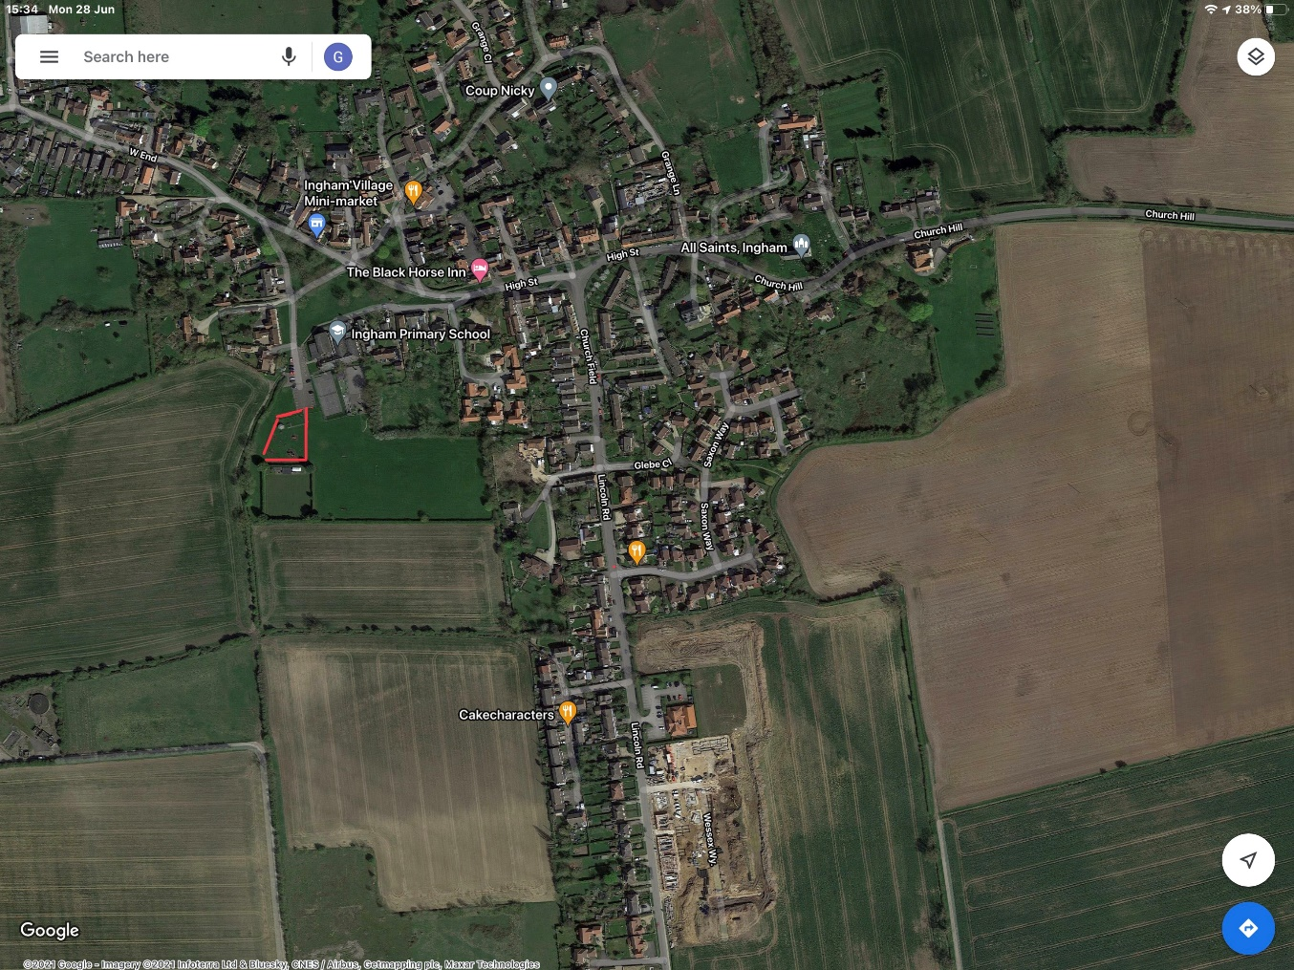

The recreation area is located adjacent to the village hall and school, and forms part of the playing fields. The current village provision includes a Tennis Court, Play Park, Football pitch, field rented by the school, Bowls Green and car park.

For the purposes of this tender, the focus should be on the replacement of the existing play equipment in the red outlined area. There are currently 8 items of play equipment including 3 swing items, 2 multi play frames, balance beams and 2 spring items. The most popular of these are the large multi-play frame and swings. There are 4 picnic benches and 2 litter bins which can remain in place/ repositioned along with the pavilion/ shelter.

There is also a tarmacked pathway from the gates that leads both to the Bowls Green or to the shelter/ pavilion and picnic table for disabled use adjacent to the shelter/ pavillion.

The current play park includes play items that are now showing signs of age and do not appeal to all age groups. The entry to the play park and pitches is via the car park and is surrounded by a dog control fence and double gated. The bonfire site is also adjacent to the play park.

The play park dimensions are approximately 40m * 28m as shown in the map below.

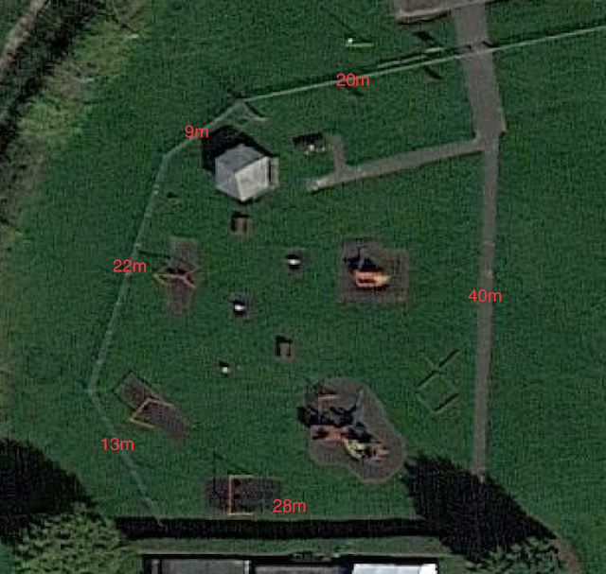

**Map 2 Location of Ingham Recreation Area**

Yellow: Football Pitch Blue: Area used by the school Orange: Car Park

Red: Current play park equipment Green: Tennis Court Purple: Bowls Green

Red circle: Pavillion/ shelter Orange circle: Bonfire site

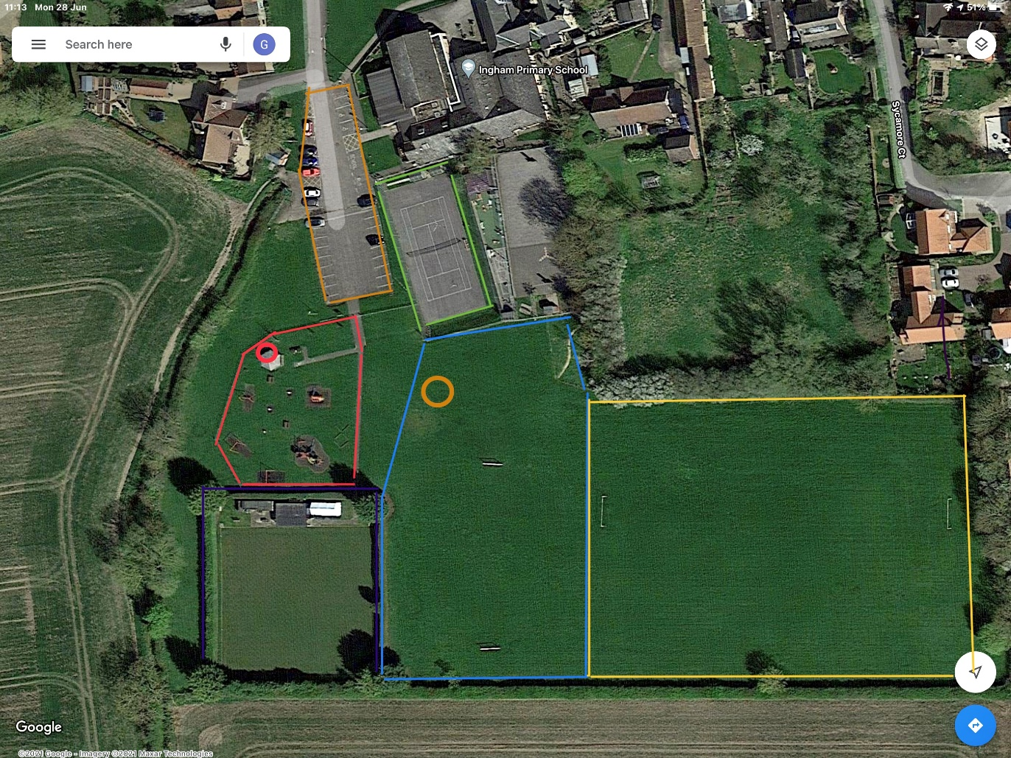

**5.0 Budget**

5.1 The budget for the scope of work described above is up to £100,000. The funding for this project will be raised from The Council and applications to Community Funding Grants. It may therefore be necessary to construct in phases as funding is unlocked. Tenderers must submit itemised designs and a separate price for removal of existing equipment.

In the event that any items or work included on designs requires specific planning permissions, the cost for the contractor to secure this should be itemised.

In the event that not all items can be afforded The Council will work with the successful tenderer to identify and prioritise parts of the quotation.

**6.0 Safety and DDA**

The design, construction and safety surface areas must conform to the European Standards for Playground Equipment EN1176 and EN1177 and DDA standards.

The following areas must be covered by impact surfacing:

Underneath Static Equipment – At least 1.75m beyond the extremity of the equipment or other greater dimension determined in accordance with the standards.

Moving equipment (excluding swings) – At least 1.75m beyond the maximum travel of the equipment or other greater dimension determined in accordance with the standards.

Swings – The surface should extend 1.75m beyond the limit of motion in each direction when the swing has travelled through an arc of 60 degrees. The width should be 1.75m for each swing, or extend to the internal faces of the supports, whichever is the least or other greater dimension determined in accordance with the standards.

The severity index of the safety surface material used must be consistent with the potential fall height from any item of equipment. Evidence of conformance will be required from the contractor.

**7.0 Submission of tender**

7.1 The response to this invitation to tender submitted by the tenderer must be received up to the closing time on the date and in the place shown on the title page of this invitation to tender document. The tender shall be submitted in a sealed envelope or package, marked with the tenderers name and the invitation to tender title - Design, Supply and Installation of Playground Equipment at Ingham Recreation Area. Tenderers are prohibited from contacting councillors or staff to encourage or support their tender outside the prescribed process.

7.2 The tender must include:

1. A model, or three dimensional drawings, to scale, of the assembled playground structures
2. Layout of the play structure to scale, based on the site plan provided
3. A description of each component to be incorporated within the playground structures proposed
4. All material specifications
5. A product brochure
6. Itemised cost of each item
7. Photos and or designs from a similar project your company has undertaken in the last 12 months and contact details for the client.
8. A presentation board no larger than A1 showing all play components proposed for the structure. This will be shown to the Community, Ingham School Children and Parish Councillors as part of the tender evaluation process
9. Availability and cost of any spare parts/maintenance tools
10. Details of associated warranties/guarantees

7.3 Tenders received after the closing time or in locations other than the address indicated, will not be accepted and will be returned unopened.

7.4 All costs associated with the preparation and submission of the tender, including any costs incurred by the tenderer after the closing time, will be borne solely by the tenderer.

**8.0 Evaluation of tenders**

8.1 The tender shall be awarded on the basis of the best overall design and value offered. The following factors will be used to assess this;

Suitability, creativity and play value of design and equipment

Quality and environmental impact of construction and materials

Length and scope of warranty/guarantees

The overall cost including maintenance and repair

Project Management and any quality control procedures

References from former customers

Feedback from the Community, The Council and The Children of Ingham School

8.2 All sub-contractors of the tenderer will be subject to the same evaluation process. It is the responsibility of the tenderer to guarantee that all its sub-contractors will comply with all the requirements and terms and conditions set out herein.

8.3 Preference may be given to quotations offering environmentally beneficial products or services.

**9.0 Acceptance and rejection of quotations**

9.1 Notwithstanding any other provision in the tender documents, The Council has in its sole discretion, the unfettered right to:

Accept any quotation;

Reject any quotation;

Reject all quotations;

Accept a quotation which is not the lowest quotation;

Accept a quotation that deviates from the requirements, specifications or the conditions specified in this quotation;

Reject a quotation even if it is the only quotation received by The Council;

Accept all or any part of a quotation; and

Split the requirements between one or more bidders.

All quotations shall be irrevocable and remain open for a minimum of 6 months after the closing time, whether or not another quotation has been accepted.

In the event that a quotation is accepted and required permissions are refused, The Council reserves the right to cancel the contract.

9.2 The Council will acknowledge receipt of all accepted tenders within 14 days of the closing date. The Council will then notify the successful tenderer/s within 3 months of the closing date, but the final contract will be awarded when the funding is secured.

**10.0 Insurance and Safety Checks**

10.1 The tenderer will be required to have £10,000,000 public liability insurance which shall be submitted to the Ingham Parish Clerk before works are undertaken.

10.2 Safety checks and risk assessments must be carried out by ROSPA or equivalent registered organisation and any recommended modification carried out by the contractor prior to handover to the council.

**11.0 General Construction**

The tenderer shall provide;

All labour, equipment, welfare facilities and material required for the supply and installation of the play equipment

A risk assessment covering all aspects of construction

The tenderer will be responsible for acquiring all services needed for construction and will undertake a utilities check prior to construction.

Site shall be secured at the end of each working day to ensure safe usage by children after hours.

It is the tenderers responsibility to leave the project clean and debris free.

The tenderer must comply with all current health and safety legislation, have the relevant certification relating to risk assessments when working in a public space.

**12.0 Rectification of damage and defects**

12.1 The tenderer shall rectify any loss or damage for which, in the opinion of The Council the Contractor is responsible for, at no charge to The Council and to the satisfaction of The Council. Alternatively, the Council may repair the loss or damage and the Contractor shall pay to The Council the costs of repairing the loss or damage forthwith upon demand from The Council. Where, in the opinion of The Council, it is not practical or desirable to repair the loss or damage, the Council may estimate the cost of the loss or damage.

**13.0 References and examples**

13.1 The tenderer shall provide details of a similar project that have been completed in the last 12 months including the initial design, photos of the completed project and contact information for the client should the Council wish to seek a reference.

**Appendix 1**

**Ingham Community Recreational Area Project Questionnaire - Results**

Ingham Parish Council wishes to improve the recreation facilities and to gather opinion from the community 430 questionnaires were distributed. 45 questionnaires were completed and returned giving a response rate of 12.5%. The findings in the tables below are based on the responses received. These findings have since been further enhanced through a piece of complementary work undertaken with the children of Ingham Primary School.

**How frequently do you visit?**

|  |  |
| --- | --- |
| Daily | 5.8% |
| 2-3 times a week | 29.4% |
| 2-3 times a month | 29.4% |
| < 1 a month | 23.5% |
| Never | 11.7% |

**Ages of children visiting or using the recreation area?**

|  |  |
| --- | --- |
| 0-3 | 26.4% |
| 4-8 | 35.2% |
| 8-12 | 27.9% |
| 12-16 | 10.2% |

**Overall Impression?**

|  |  |
| --- | --- |
| Excellent | 2% |
| Good | 22% |
| Fair | 44% |
| Poor | 46% |
| Unusable/dated | 6.6% |

**Sufficient variety?**

|  |  |
| --- | --- |
| Yes | 16% |
| No | 84% |

**Style of Equipment?**

|  |  |
| --- | --- |
| Modern | 19% |
| Traditional | 8.5% |
| Wooden | 29.7% |
| Metal | 2% |
| Combination | 40% |

**If area improved how frequently would you use?**

|  |  |
| --- | --- |
| Daily | 29% |
| 2-3 times a week | 31% |
| 2-3 times a month | 18.5% |
| <once a month | 18.5% |
| Never | 1.8% |

**What equipment would you like?**

|  |  |
| --- | --- |
| Zip Wire | 7.3% |
| Monkey Bars | 6.9% |
| Swings | 6.0% |
| Climbing Walls | 5.8% |
| Toddler Zone | 5.8% |
| Climbing Net | 5.6% |
| Slides | 5.6% |
| Roundabout | 5.3% |
| Skate park | 5.1% |
| Obstacle Track | 4.9% |
| Basket Ball Net | 4.9% |
| Youth Excersize | 4.5% |
| See Saw | 4.3% |
| Swing Seat | 4.3% |
| Tunnel | 4.3% |
| Adult Excersize | 4.0% |
| Bridges | 3.4% |
| Balance Bars | 2.8% |
| Summer sault Bars | 2.5% |
| Stepping Stones | 2.1% |
| Ladders | 1.9% |
| Raised Platforms | 1.7% |

The equipment identified from the community wide questionnaire and the work undertaken with the children shows much in common with the top 8 items of equipment being common to both.

There is also a desire for exercise equipment, and if youth exercise and adult exercise were added together it would rank above the zip wire!

**Appendix 2**

**Ingham Play-park Refurbishment: Views of Pupils of Ingham Primary School.**

Following communication with the Parish Council regarding the proposed refurbishment of the playpark views have been sought from the pupils of Ingham Primary School and this report provides a summary of those results. We really value the opportunity this has provided to build on the strong relationships with the Parish Council and to provide the opportunity for the children of the school to engage with local democracy.

**Summary**

Across the whole school, most children go to the park at least once per week, with many going several times per week, especially in the better weather. It is true to say that the younger the children, the more likely they were to go more often, though this wasn’t universally the case. With a careful reading of the surveys, it was clear that although the children may have ideas for improvements they value the park and hold it with some affectionbecause it is a place where they can meet with their friends, challenge themselves and imagine. It was also interesting to note that the children really value the space itself – being able to run around. Even from the youngest class, the majority of the children felt the equipment was too easy for them and as the children became older this quickly grows to almost all the children.

**Overall the most popular current items by far (and therefore the ones the children wanted to keep) were:**

* The swings (“because it feels like you are flying”)
* The climbing frame and fireman’s pole
* The large slide

The shelter also was popular “because you can shelter from the rain.”

There are countless ideas for new pieces of equipment with a few children mentioning equipment at other parks they have visited locally.

The most popular ideas for new equipment across the school were:

* Zip line
* Monkey bars (this may be because we have just had some fitted at school and they are proving very
* popular)
* Different types and more challenging slides, including wavy, multi-person, spiral, tunnel etc
* Roundabout

but there were many other ideas, many of them drawn in detail on the forms!

As the children grow older across the school, they become more ambitious and more focused on the fun of exercising. Exercise equipment was quite popular in the oldest class and a skate or BMX park received quite a few mentions too.

**Willow Class: Reception/Year 1 (Aged 5-6 years)**

13 children completed the survey, all of whom went to the park at least once per week. The average number of visits was 2.92 per week with a range of 1-5 days per week.

The most popular items in the current park with this age group were the swings, the fireman’s pole and the slide with mentions for the climbing frame and the ‘springs’.

At this age group over half the children felt the equipment was too easy for them.

The pieces of equipment they most wanted to keep the same were the swings, the fireman’s pole and the ‘bars’ with some mentioning the climbing frame and ‘springs’.

The most popular suggestions for improvement were:

* **Changes to the slide (bigger/longer/slide for multiple people at once/wavy (5 mentions)**
* **Zip lines (5 mentions)**
* **Monkey bars (3 mentions)**
* **Roundabout (3 mentions)**
* **Seesaw (3 mentions)**

Other ideas were a wavy path, bouncy stepping stones and more swings.

**Rowan Class: Year 2/Year 3 (Aged 6-8 years)**

24 children completed the survey. Unlike the previous class almost a quarter said that they never or rarely go to the park. The average number of visits was 1.19 visits per week, with a range of 0-3 times per week.

The most popular items in the current park with this age group were the slide, the fireman’s pole and the swings with mentions for the climbing frame, dens and shelter.

In this class 70% of the children felt the equipment was too easy for them.

The pieces of equipment they most wanted to keep the same were the swings, the fireman’s pole, the slide, the climbing frame with some mentioning the space/big play area and the goals.

The most popular suggestions for improvement were:

* **Trampoline (12 mentions)**
* **Monkey bars (11 mentions)**
* **Zip line (9 mentions)**
* **Castle (9 mentions)**
* **Death/Drop slide (8 mentions)**
* **Roundabout (7 mentions)**
* **See-saw (5 mentions)**

Other ideas included water jets, tunnel or tunnel slides, sand-pit, bridge and helter-skelter.

**Maple Class: Year 4 (Aged 8-9 years)**

15 children completed the survey. Most children went at least once per week. The average number of visits was 1.8 times per week with a range of once a month to 7 days per week.

The most popular items in the current park with this age group were the swings, the big climbing frame and the shelter with mentions for the balance beams, the large slide and the fireman’s pole.

In this age group all but one of the children felt the equipment was too easy for them.

The pieces of equipment they most wanted to keep the same were the swings, the big climbing frame and fireman’s pole and the slide.

The most popular suggestions for improvement were:

* **Zip line (14 mentions)**
* **Group/team swing (8 mentions)**
* **Skate Park (6 mentions)**
* **Climbing wall/stack (6 mentions)**
* **Roundabout (6 mentions)**
* **Trampoline (4 mentions)**
* **Monkey bars (3 mentions)**
* **Tree house (3 mentions)**

Other ideas included Death slide, obstacle course, slide and BMX track.

**Oak Class: Year 5/Year 6 (Aged 9-11 years)**

20 children completed the survey. Most children went at least once per week. The average number of visits was 1.7 times per week with a range of twice a month to 5 days per week. A few children mentioned that they went more when it was warmer weather.

The most popular items in the current park with this age group were the swings, the goals, the big climbing frame and the field with mentions for the fireman’s pole, the slide and the shelter.

At this age group all but one of the children felt the equipment was too easy for them.

The pieces of equipment they most wanted to keep the same were the swings, the goals and the big climbing frame.

The most popular suggestions for improvement were:

* Zip line (10 mentions)
* Exercise equipment (8 mentions)
* Skate Park (7 mentions)
* Monkey bars (7 mentions)
* High climbing frame (6 mentions)
* Trampoline (4 mentions)
* Enclosed football pitch (3 mentions)

Other ideas included see-saw, seats/benches, roundabout, goals with nets, running track and BMX track.

It was interesting to note that a lot of children who mentioned the swings as a positive feature talked about being able to swing and chat to their friends at the same time.

**Conclusion**

It will always be difficult to please everyone when it comes to play equipment as different ages have different needs.

However, from their survey responses, what the children value most of all is the space, the chance to be with their friends and to challenge themselves. It is probably true to say that now, more than for many generations, is such an important time for being with friends, enjoying the open air and taking comfortable risks that help us to feel braver and more confident.

On behalf of the school I would like to thank the Parish Council for this opportunity to engage with you and to give voice to the children of the school. If there is any more that we can do to support you with this or any future venture we would consider it a privilege to assist.