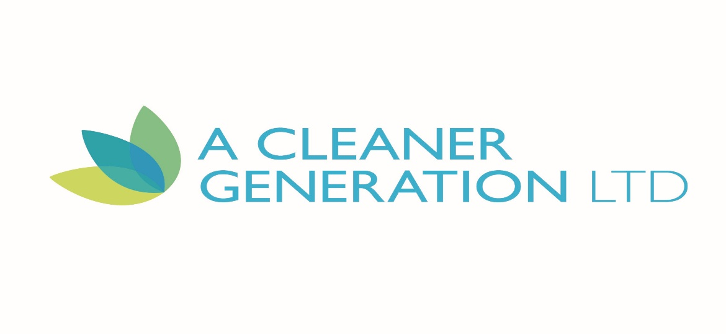
Clarification to answers from interested parties.

Q. Is the product needed primarily for ground mounted or roof mounted arrays?
A. The product we require will be used primarily for ground mounted solar farms.

Q. Does the clean need to be done in a single pass?
A. Yes, other than heavy soiling, the cleans must be completed in 1 pass. Brush heads need to be able to be adapted to suit complete height of particular array.

