INVITATION TO TENDER
&
STATEMENT OF REQUIREMENT

Data Warehouse and Data Portal Support

CPV Code: 72000000
Supplementary Code: 72300000, 72500000
Tender Reference: ORR CT 19-64

Purpose of document
The purpose of this document is to invite proposals to support the Information and Analysis Team (I&A) Data Warehouse and Data Portal for the Office of Rail and Road (ORR).
This document contains the following sections:
1. Introduction to the Office of Rail and Road
2. Statement of Requirement
3. Tender Proposal & Evaluation Criteria
4. Procurement Procedures

1. Introduction to the Office of Rail and Road (ORR)

The Office of Rail and Road is the independent safety and economic regulator of Britain’s railways who now also hold Highways England to account for its day-to-day efficiency and performance, running the strategic road network, and for delivering the five year road investment strategy set by the Department for Transport (DfT).

ORR currently employs approximately 300 personnel and operates from 6 locations nationwide. The majority of personnel are located at ORR’s headquarters, 25 Cabot Square, London.

Our strategic objectives

1. Drive for a safer railway:

Enforce the law and ensure that the industry delivers continuous improvement in the health and safety of passengers, the workforce and public, by achieving excellence in health and safety culture, management and risk control.

2. Support a better service for customers:

Use our powers to hold the industry to account for performance and standards of service across the railway network, for passengers and freight. Promote on-going improvement in the experience of passengers by encouraging the industry to work together, including to provide greater transparency of information.

3. Secure value for money from the railway, for users and funders:

Strengthen incentives for the whole industry, including through competition and contestability in the supply chain, to drive greater efficiency from the use and maintenance of existing railway capacity and more cost-effective investment in the network.

4. Secure improved performance and value for money from the strategic road network:

Secure improved performance, including efficiency, safety and sustainability, from the strategic road network, for the benefit of road users and the public, through proportionate, risk-based monitoring, increased transparency, enforcement and robust advice on future performance requirements

Supplying ORR
The ORR procurement unit is responsible for purchasing the goods and services necessary for ORR to achieve its role as the economic and health & safety regulator of the rail industry.
The ORR Procurement unit subscribes to the following values:
- to provide a modern, efficient, transparent and responsible procurement service;
- to achieve value for money by balancing quality and cost;
- to ensure contracts are managed effectively and outputs are delivered;
- to ensure that processes have regard for equality and diversity; and
- to ensure that procurement is undertaken with regard to Law and best practice.
For further information on ORR please visit our website: www.orr.gov.uk
Small and Medium Enterprises

ORR considers that this contract may be suitable for economic operators that are small or medium enterprises (SMEs) and voluntary organisations. However, any selection of tenderers will be based on the criteria set out for the procurement, and the contract will be awarded on the basis of the most economically advantageous tender.
Small and Medium Enterprises and Voluntary Organisations:
Enterprise Category | Headcount | Turnover | or |  | Balance Sheet Total
Micro | <10 | ≤ € 2 million |  | ≤ € 2 million
Small | <50 | ≤ € 10 million |  | ≤ € 10 million
Medium | <250 | ≤ € 50 million |  | ≤ € 43 million
Large | >251 | > € 50 million |  | > € 43 million

Please ensure that you indicate how your organisation is categorised on the Form of Tender document which should be submitted along with your proposal.
2. Statement of Requirement
2.1 Background to the project
The Information & Analysis Team (I&A) at the Office of Rail & Road (ORR) is responsible for the collection, validation and publication of data, providing internal colleagues and external stakeholders access to accurate, timely information on railway performance.
The IS department forms part of Corporate Operations, providing the IT support and service desk as well as managing the IT infrastructure and IT vendor relationships for the ORR.
During 2018-19, the I&A and IS team migrated their existing Data Warehouse and Data Portal to a cloud based platform (Azure), in the process updating their Data Warehouse from the SQL 2008 applications to their 2017 equivalents and switching their front end Data Portal solution to an Umbraco-based CMS. This went live in July 2019.
2.2 Project Objectives & Scope
The objective of this project is to manage and support the new Data Warehouse and Data Portal applications and infrastructure with responsibilities shared between one dedicated third party support and ORR’s IS Team. For details on the split of responsibility, please see Annex 2.
The Data Portal infrastructure is hosted on PAAS platforms on Azure and built on an Umbraco platform (v7.14.0) with custom functionality written in C#. All source code is hosted in a GitHub repository.
The Data Warehouse infrastructure is built on an SQL Server 2017 platform, utilising SSIS, SSAS and SSRS. All core objects are contained in Visual Studio 2017 project files and are hosted in the relevant GitHub repositories.
The Data Warehouse has LIVE, UAT and DEV environments and the Data Portal has LIVE and UAT environments. A graphical overview of the Data Warehouse and Data Portal is available in Annex 1.
The scope of the contract covers the availability, support, maintenance, problem handling and recovery of the areas specified in Section 2.3.
It will require close liaison with both the I&A Team and IS Team
2.3 Project Outputs, Deliverables and Contract Management
Outputs and Deliverables

The supplier will be required to provide for the following areas:

Data Warehouse

SQL Server Analysis Services (SSAS) – consists of four cubes
- Enhancing usage
- Maintaining consistency
- Housekeeping
- Troubleshooting

SQL Server 2017 Reporting Services (SSRS) – consists of approx. 250 reports
- Usage tracking
- Feature utilisation
- Security
- Housekeeping
- Troubleshooting

GitHub
- Repository ownership
- Policy enforcement
- Troubleshooting

Data Portal

GitHub
- Repository ownership
- Policy enforcement
- Troubleshooting

Umbraco (currently v7.14.0)
- Updates and mentoring
- Maintenance
- Troubleshooting

Custom Code (C#)
- Updates
- Umbraco version compatibility
- Maintenance
- Troubleshooting

RIDDOR webform (developed in Umbraco Forms)
- Updates
- Enhancements
- Maintenance

During the period of the contract, we require:

- Service Desk available between 09:00-17:30 on all working days with an SLA to respond to all calls raised within one hour of initial call.
- Weekly teleconference to provide updates on ongoing problem resolution.
- Proactive monitoring of Data Portal performance.
- Reactive monitoring of activity logs to identify causes of service disruption.
- Scheduled backups for the Data Portal (Data Warehouse will be managed by ORR IS Team)
- At least one month ahead of contract expiry, all documentation and knowledge transferred to new supplier.

2.4 Project Timescales
The contract will be for an initial 12-month period, covering 6th February 2020 to 5th February 2021.

Extension option:

Subject to mutual agreement between the two parties the contract let as a result of this tender may be extended for the provision of similar or complimentary goods or services, for up to 12 month(s), or part thereof.

2.5 Budget and Payment Schedule
Payment of the fee will be on a monthly basis and will be paid on successful delivery of all required outputs and/or deliverables.
2.6 Further project related information for bidders
Intellectual Property Rights

ORR will own the Intellectual Property Rights for all project related documentation and artefacts.
Transparency requirements
Please note ORR is required to ensure that any new procurement opportunity above £10,000 (excluding VAT) is published on Contracts Finder, unless the ORR is satisfied it is lawful not to. Once a contract has been awarded as a result of a procurement process, ORR is required to publish details of who won the contract, the contract value and indicate whether the winning supplier is a SME or voluntary sector organisation.
Confidentiality

All consultants working on the project may be required to sign a confidentiality agreement and abide by the Cabinet Office’s protective marking guidelines, which ORR uses to protectively mark a proportion of its information. In addition, the consultant may be required to sign additional confidentiality agreements as required by external stakeholders.

Sub-Contractors
Contractors may use sub-contractors subject to the following:
- That the Contractor assumes unconditional responsibility for the overall work and its quality;
- That individual sub-contractors are clearly identified, with fee rates and grades made explicit to the same level of detail as for the members of the lead consulting team.
Internal relationships between the Contractor and its sub-contractors shall be the entire responsibility of the Contractor. Failure to meet deadlines or to deliver work packages by a subcontractor will be attributed by ORR entirely to the Contractor.
3. Tender Response & Evaluation criteria
3.1 The Tender Response
The proposals for this project should include an outline of how bidders will meet the requirement outlined in section (ii) “Statement of Requirement”. The following information should be included:
a) Understanding of customer's requirements

- Demonstrate an understanding of the requirement and overall aims of the project.

b) Approach to customer's requirements:
- Provide an explanation of the proposed approach and any methodologies bidders will work to;

- Details of your assumptions and/or constraints/dependencies made in relation to the project

- An understanding of the risks, and explain how they would be mitigated to ensure delivery
- What support bidders will require from ORR;
c) Proposed delivery team
- Key personnel including details of how their key skills, experience and qualifications align to the delivery of the project; and

- Project roles and responsibilities

- Some relevant examples of previous work that bidders have carried out (e.g. case studies)
d) Pricing
A fixed monthly fee (exc. VAT) for the project inclusive of all expense.

3.2 Evaluation Criteria
Tenders will be assessed for compliance with procurement and contractual requirements which will include:

- Completeness of the tender information
- Completed Declaration Form of Tender and Disclaimer
- Tender submitted in accordance with the conditions and instructions for tendering
- Tender submitted by the closing date and time
- Compliance with contractual arrangements.

Tenders that are not compliant may be disqualified from the process. We reserve the right to clarify any issues regarding a Bidder’s compliance. It will be at ORR's sole discretion whether to include the relevant Bidder’s response in the next stage of the process.
The contract will be awarded to the Bidder(s) submitting the ‘most economically advantageous tender’. Tenders will be evaluated according to weighted criteria as follows:

Methodology (15%)
The proposal should set out the methodology by which the project requirement will be initiated, delivered and concluded. In particular, it must:
a) Explain the methodology and delivery mechanisms to ensure that the requirements of this specification are met in terms of quality;
b) Explain how your organisation will work in partnership with ORR’s project manager to ensure that the requirement is met
c) Outline how the proposed approach utilises innovative consultation methodologies to develop a diverse and comprehensive evidence-base

Delivery (15%)
The proposal should set out how and when the project requirement will be delivered. In particular, it must:
a) Explain how this work will be delivered to timescale and how milestones will be met, detailing the resources that will be allocated to each stage;
b) Demonstrate an understanding of the risks, and project dependencies and explain how they would be mitigated to ensure project delivery;
c) Explain the resources that will be allocated to delivering the required outcomes/output, and what other resources can be called upon if required.

Experience (40%)
The proposal should set out any experience relevant to the project requirement. In particular, it must:
a) Provide CVs of the consultants who will be delivering the project;
b) Highlight the organisation’s relevant experience for this project, submitting examples of similar projects.

Cost / Value for money (30%)
A fixed fee for delivery of the project requirement (inclusive of all expenses), including a full price breakdown for each stage of the project and details of the day rates that will apply for the lifetime of this project.

Name of consultant | Grade | Role | Day rate | Number of days | Total cost (ex VAT)

Please note that consultancy grades should align with the following definitions:
Grade | Requirement
Junior consultant | Demonstrable experience in a wide range of projects in their specialist field. Evidence of client facing experience and support services to wider consultancy projects.
Consultant | Notable experience and in-depth knowledge of their specialist field. Evidence of a wide range of consultancy projects and client facing experience. Support work in process and organisational design and leading workshops and events.
Senior Consultant | Substantial experience in their specialist field and in a consultancy/training role. Previous experience in project management and working in a wide range of high quality and relevant projects. Familiarity of the issues/problems facing public sector organisations.
Principal Consultant | Substantial experience in their specialist field and in a consultancy/training role. Sound knowledge of the public sector and current policy and political issues affecting it. Previous experience in project management on at least three major projects, preferably in the public sector and using the PRINCE2 or equivalent method.
Managing Consultant | Substantial experience in their specialist field and in a consultancy role. In depth knowledge of the public sector and of current policy and political issues affecting it. Previous experience in project management on at least 5 major projects, preferably in the public sector and using PRINCE2 or equivalent methods.
Director / Partner | Extensive experience in their specialist field, in which they are nationally or internationally renowned as an expert. Extensive experience of leading or directing major, complex and business critical projects; bringing genuine strategic insight. In depth knowledge of the public sector and of current policy and political issues affecting it.

Marking Scheme
Score 0 | Unanswered or totally inadequate response to the requirement. Complete failure to grasp/reflect the core issues
1 | Minimal or poor response to meeting the requirement. Limited understanding, misses some aspects
3 | Good understanding and interpretation of requirements, providing clear evidence of how the criterion has been met
5 | Excellent response fully addressing the requirement and providing significant additional evidence of how the criterion has been met and how value would be added

4. Procurement procedures
Tendering Timetable
The timescales for the procurement process are as follows:

Element | Timescale
Invitation to tender issued | 10th December 2019
Deadline for the submission of clarification questions | 20th December 2019
Deadline for submission of proposals | 3rd January 2020
Shortlisted suppliers notified | 8th January 2020
Interviews and presentations* | 15/16th January 2019
Award contract | w/c 20th January 2020
Project Inception Meeting | 22nd/23rd January 2020
Project Commencement | 6th February 2020
*Please ensure that the Project Manager and other key consultants who will be delivering this work are available to give presentations on the interview date

Tendering Instructions and Guidance
Amendments to ITT document
Any advice of a modification to the Invitation to Tender will be issued as soon as possible before the Tender submission date and shall be issued as an addendum to, and shall be deemed to constitute part of, the Invitation to Tender. If necessary, ORR shall revise the Tender Date in order to comply with this requirement.
Clarifications & Queries
Please note that, for audit purposes, any query in connection with the tender should be submitted via the ORR eTendering portal. The response, as well as the nature of the query, will be notified to all suppliers without disclosing the name of the Supplier who initiated the query.
Submission Process
Tenders must be uploaded to the ORR eTendering portal no later than the submission date and time shown above. Tenders uploaded after the closing date and time may not be accepted. Bidders have the facility to upload later versions of tenders until the closing date/time.
Please submit the Form of Tender and Disclaimer certificate along with your proposal. If you are already registered on our eTendering portal but have forgotten your login details, please contact the portal administrator.
An evaluation team will evaluate all tenders correctly submitted against the stated evaluation criteria.
By issuing this Invitation to Tender ORR does not undertake to accept the lowest tender, or part or all of any tender. No part of the tender submitted will be returned to the supplier

Cost & Pricing Information
Tender costs remain the responsibility of those tendering. This includes any costs or expenses incurred by the supplier in connection with the preparation or delivery or in the evaluation of the tender. All details of the tender, including prices and rates, are to remain valid for acceptance for a period of 90 days from the tender closing date.
Tender prices must be in Sterling.
Once the contract has been awarded, any additional costs incurred which are not reflected in the tender submission will not be accepted for payment.

References
References provided as part of the tender may be approached during the tender stage

Contractual Information
Following the evaluation of submitted tenders, in accordance with the evaluation criteria stated in this document, a contractor may be selected to perform the services and subsequently issued with an order.

Any contract awarded, as a result of this procurement will be placed with a prime contractor who will take full contractual responsibility for the performance of all obligations under the contract. Any sub-contractors you intend to use to fulfil any aspect of the services must be identified in the tender along with details of their relationship, responsibilities and proposed management arrangements.

The proposal should be submitted in the form of an unconditional offer that is capable of being accepted by the ORR without the need for further negotiation. Any contract arising from this procurement will be based upon ORR’s standard Terms & Conditions (see Form of Agreement attached). You should state in your proposal that you are willing to accept these Terms & Conditions.

The ORR does not expect to negotiate individual terms and expects to contract on the basis of those terms alone. If you do not agree to the Conditions of Contract then your tender may be deselected on that basis alone and not considered further.
The ORR may be prepared to consider non-fundamental changes to the standard terms and conditions in exceptional circumstances. If there are any areas where you feel you are not able to comply with the standard ORR terms and conditions, then details should be submitted as a separate annex to the proposal using the following format:

Clause Number | Existing Wording | Proposed Wording | Rational for amendment

Any services arising from this ITT will be carried out pursuant to the contract which comprises of:

- ORR Terms & Conditions;

- Service Schedules;

- this Invite to Tender & Statement of Requirement document; and

- the chosen supplier’s successful tender.

ORR’s Transparency Obligations and the Freedom of Information Act 2000 (the Act)
The ORR is a central Government department and as such complies with the Government’s transparency agenda. As a result, there is a presumption that contract documentation will be made available to the public via electronic means. The ORR will work with the chosen supplier to establish if any information within the contract should be withheld and the reasons for withholding it from publication.
Typically the following information will be published:
- contract price and any incentivisation mechanisms
- performance metrics and management of them
- plans for management of underperformance and its financial impact
- governance arrangements including through supply chains where significant contract value rests with subcontractors
- resource plans
- service improvement plans
Where appropriate to do so information will be updated as required during the life of the contract so it remains current;

In addition, as a public authority, ORR is subject to the provisions of the Freedom of Information Act 2000. All information submitted to a public authority may need to be disclosed by the public authority in response to a request under the Act. ORR may also decide to include certain information in the publication scheme which it maintains under the Act. If a bidder considers that any of the information included in its proposal is commercially sensitive, it should identify it and explain (in broad terms) what harm may result from disclosure if a request is received and the time period applicable to that sensitivity. Bidders should be aware that even where they have indicated that information is commercially sensitive ORR may be required to disclose it under the Act if a request is received. Bidders should also note that the receipt of any material marked “confidential” or equivalent by the public authority should not be taken to mean that the public authority accepts any duty of confidence by virtue of that marking. If a request is received ORR may also be required to disclose details of unsuccessful bids
Please use the following matrix: to list such information:
Para. No. | Description | Applicable exemption under FOIA 2000

Annex 1 – Overview of Data Warehouse infrastructure
The Data Warehouse is hosted on IAAS platforms on Azure, organized into 3 distinct resource groups. All Azure infrastructure is contained within a single ORR subscription. File storage is included in the below overview, though it can be considered as forming part of both the Data Portal and Data Warehouse elements of the system. Separation of LIVE, UAT and DEV file storage locations is via folders, with all storage being contained within the same storage account.
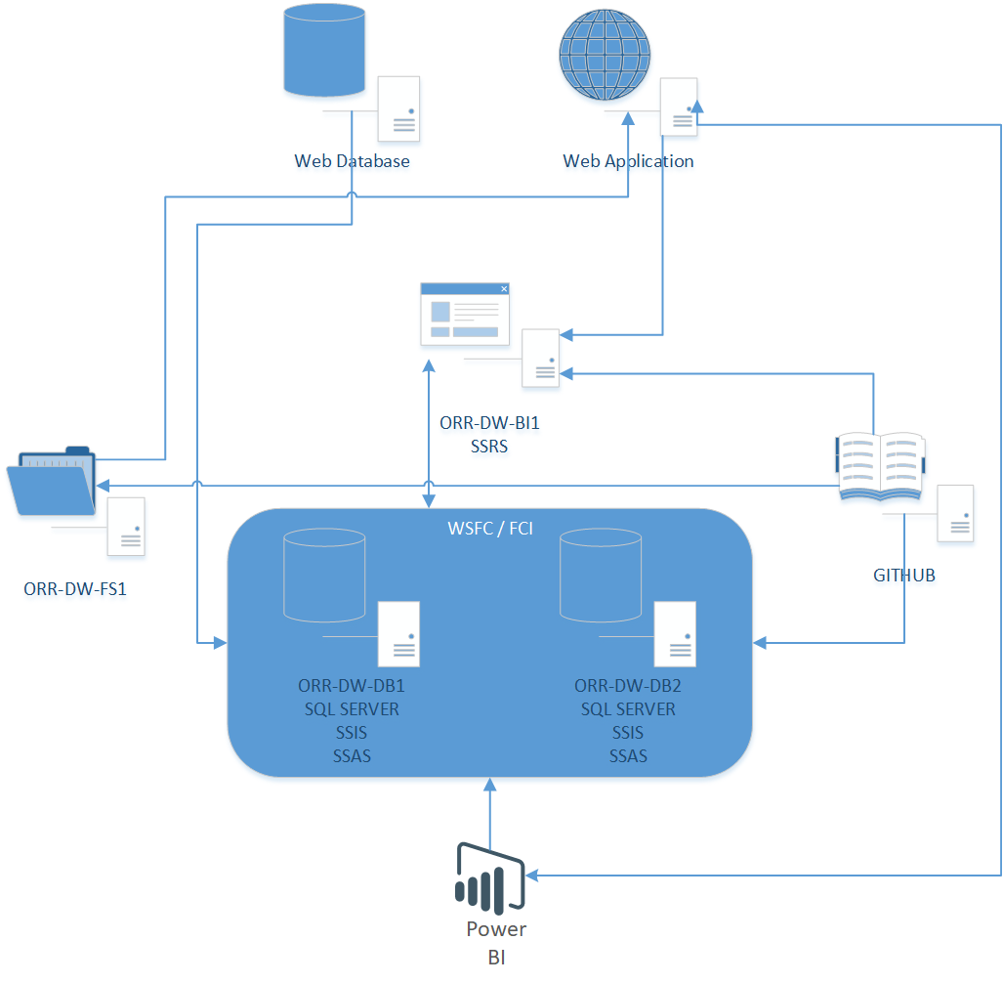
Further details on the systems included in the LIVE, UAT and DEV environments will be made available to the successful bidder.

Annex 2 – Overview of Data Portal infrastructure
The underlying technology of the Data Portal is an Umbraco CMS (v7.14.0).
The Data Portal is hosted on PAAS platforms on Azure, organized into 3 distinct resource groups. All Azure infrastructure is contained within a single ORR subscription. File storage is included in the below overview, though it can be considered as forming part of both the Data Portal and Data Warehouse elements of the system.
Separation of LIVE, UAT and DEV file storage locations is via folders, with all storage being contained within the same storage account.
Further details on the systems included in the LIVE, UAT and DEV environments will be made available to the successful bidder.

